E2. Quartz Crystal Oscillator (Simulation) (10.0 points)
https://taisoncar.github.io/quartz/
Credit: Russian Team Selection Test (X) 2026 [https://pho.rs/p/4788]
A quartz crystal oscillator is a type of electrical circuit that utilizes the piezoelectric properties of quartz crystal to generate electrical oscillations. Quartz crystal oscillator is widely used to keep track of time in watches and computers due to its stability and accuracy.
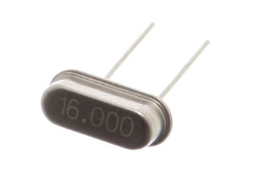
To analyze the behavior of a quartz crystal in electrical circuits, we can model it as an equivalent circuit shown in the figure below.
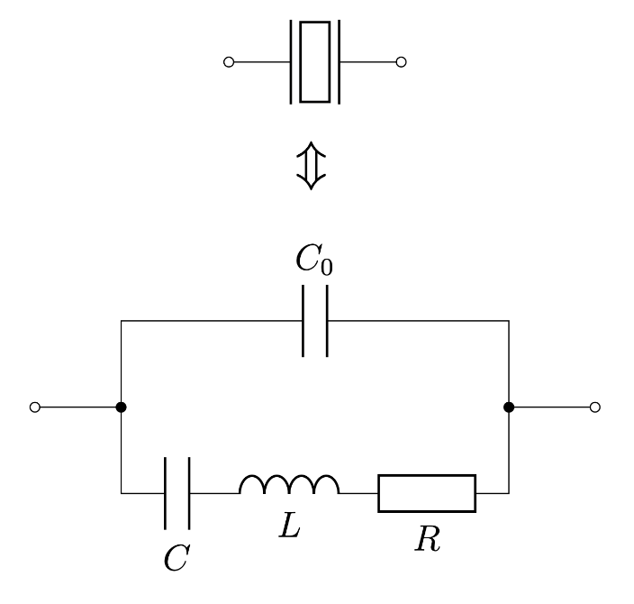
In this problem, we will investigate the parameters of a quartz crystal through a program that simulates the following circuit:
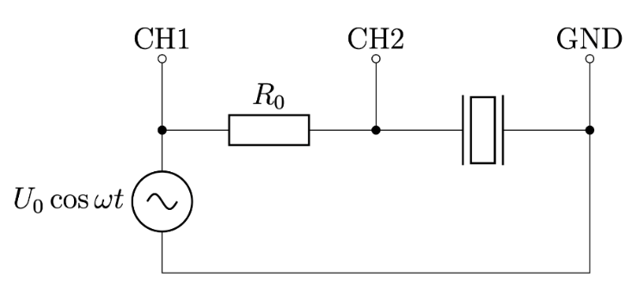
The resonant frequency of the quartz crystal used in this simulation is known to be close to $f_{0}=2 MHz$. The circuit is powered by an AC source $U=U_{0}cos⁡(ωt)$ with angular frequency $ω=2πf$. The voltage amplitude of the AC source $U_{0}$ can be assumed to be constant at $500 mV$. A resistor $R_{0}=5.1 kΩ$ is connected in series to the quartz crystal.
Note: Refer to the end of this paper for the instructions of the simulation program.
Part A. Measurements without external capacitor (5.7 points)
For this part, avoid connecting any external capacitor by inputting $C_{ext}=0$.
A1. | Determine the frequency $f_{max}$ at which the voltage amplitude $U_{2}$ across the quartz crystal is maximized. | 0.2 pt
$$f_{max}=2000040 Hz$$
A2. | Determine the frequency $f_{min}$ at which the voltage amplitude $U_{2}$ across the quartz crystal is minimized. | 0.1 pt
$$f_{max}=1999931 Hz$$
A3. | Measure the voltage amplitude $U_{2}$ across the quartz crystal and the phase difference $φ$ between the signals on the two oscilloscope channels as frequency $f$ changes. | 2.8 pt
$$Just collect the data$$
A4. | Express the magnitude of the impedance of the quartz crystal $\left|Z\right|$ in terms of $R_{0}, U_{2}, U_{0}$and $φ$. | 0.5 pt
$$\frac{U_{2}e^{i\left(ωt+φ\right)}}{U_{0}e^{iωt}}=\frac{Z}{R_{0}+Z}$$
$$\frac{U_{2}}{U_{0}}e^{iφ}=\frac{Z}{R_{0}+Z}$$
$$Z=\frac{R_{0}e^{iφ}}{\frac{U_{0}}{U_{2}}-e^{iφ}}$$
$$\left|Z\right|=\frac{\left|R_{0}e^{iφ}\right|}{\left|\frac{U_{0}}{U_{2}}-e^{iφ}\right|}$$
$$\left|Z\right|=\frac{R_{0}}{\sqrt{{\left(\frac{U_{0}}{U_{2}}-\cos{φ}\right)}^{2}+\sin^{2}{φ}}}$$

A5. | Plot the magnitude of the impedance of the quartz crystal $|Z|$ against frequency $f$. | 2.0 pt
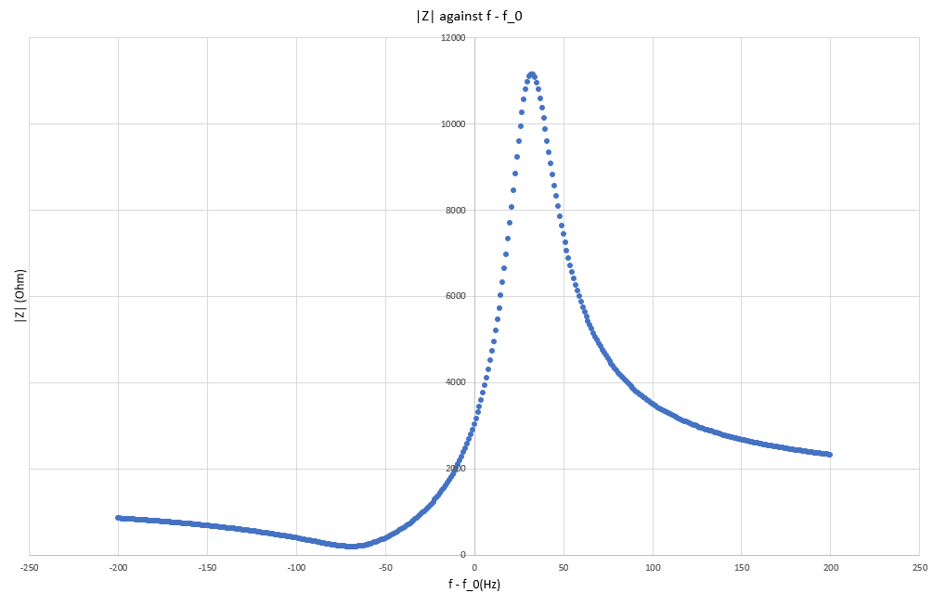
A6. | From the plotted graph, find the resonant frequency $f_{res}$ and anti-resonant frequency $f_{anti}$ at which $|Z|$ reaches its maximum and minimum values respectively. | 0.1 pt
$$f_{res}=2000032 Hz$$
$$f_{anti}=1999933 Hz$$

Part B. Deriving useful expressions (0.6 points)
The impedance of a quartz crystal can be written in the form
$$Z\left(ω\right)=\frac{ω_{s}^{2}-ω^{2}+iωα}{iωC_{0}(ω_{p}^{2}-ω^{2}+iωα)}$$
where $ω_{s},ω_{p}$ and $α$ do not depend on $ω$.
B1. | Express $ω_{s},ω_{p}$ and $α$ in terms of $R,L,C$ and $C_{0}$. | 0.3 pt
$$\frac{1}{Z}=\frac{1}{\frac{1}{iωC}+iωL+R}+iωC_{0}$$
$$\frac{1}{Z}=\frac{1+iωC_{0}\left(\frac{1}{iωC}+iωL+R\right)}{\frac{1}{iωC}+iωL+R}$$
$$Z=\frac{\frac{1}{LC}-ω^{2}+\frac{iωR}{L}}{\frac{iω}{L}+iωC_{0}\left(\frac{1}{LC}-ω^{2}+\frac{iωR}{L}\right)}$$
$$Z=\frac{\frac{1}{LC}-ω^{2}+\frac{iωR}{L}}{iωC_{0}\left(\frac{1}{LC_{0}}+\frac{1}{LC}-ω^{2}+\frac{iωR}{L}\right)}$$
By comparison:
$$ω_{s}=\frac{1}{\sqrt{LC}}; ω_{p}=\sqrt{\frac{1}{LC_{0}}+\frac{1}{LC}}; α=\frac{R}{L}$$
B2. | Express ${\left|Z\right|}^{2}$ in terms of $ω,ω_{s},ω_{p},α$ and $C_{0}$. | 0.1 pt
$${\left|Z\right|}^{2}=\frac{{\left|ω_{s}^{2}-ω^{2}+iωα\right|}^{2}}{{\left|ωC_{0}\left(i\left(ω_{p}^{2}-ω^{2}\right)-ωα\right)\right|}^{2}}$$
$${\left|Z\right|}^{2}=\frac{{\left(ω_{s}^{2}-ω^{2}\right)}^{2}+{\left(ωα\right)}^{2}}{{\left(ωC_{0}\right)}^{2} \left({\left(ω_{p}^{2}-ω^{2}\right)}^{2}+{\left(ωα\right)}^{2}\right)}$$

From here onwards, assume the following approximations hold for the range of frequencies we are working on in this problem:
$$Z\left(ω\right)≈\frac{ω_{s}^{2}-ω^{2}+iω_{p}α}{iω_{p}C_{0}(ω_{p}^{2}-ω^{2}+iω_{p}α)}$$
$$α≪ω_{p}-ω_{s}; α≪ω_{p}; α≪ω_{s}$$
$$φ\left(f_{anti}\right)=φ\left(f_{res}\right)=0$$
B3. | Show that $ω_{p}=2πf_{res}$ and $ω_{s}=2πf_{anti} .$ | 0.2 pt
$$ω=2πf_{res} , ω=2πf_{anti} when\frac{d\left|Z\right|}{dω}=0$$
$$Let {\left|Z\right|}^{2}\left(ω\right)=\frac{f(ω)}{g(ω)}$$
$$\frac{d\left|Z\right|}{dω}=\frac{1}{2|Z|}\frac{f^{'}g-fg'}{g^{2}}$$
$$Since\frac{1}{\left|Z\right|g^{2}}≠0 for all ω,$$
$$\frac{d\left|Z\right|}{dω}=0 when f^{'}g-fg^{'}=0$$
$${\left|Z\right|}^{2}≈\frac{{\left(ω_{s}^{2}-ω^{2}\right)}^{2}}{{\left(ω_{p}C_{0}\right)}^{2}{\left(ω_{p}^{2}-ω^{2}\right)}^{2}}$$
$$-2ω\left(2\right)\left(ω_{s}^{2}-ω^{2}\right){\left(ω_{p}C_{0}\right)}^{2} {\left(ω_{p}^{2}-ω^{2}\right)}^{2}-{\left(ω_{p}C_{0}\right)}^{2}{\left(ω_{s}^{2}-ω^{2}\right)}^{2}\left(-2ω\right)\left(2\right)\left(ω_{p}^{2}-ω^{2}\right)=0$$
$$\left(ω_{s}^{2}-ω^{2}\right)\left(ω_{p}^{2}-ω^{2}\right)\left(ω_{p}^{2}-ω_{s}^{2}\right)=0$$
$$Since ω_{p}≠ω_{s}, ω=ω_{s},ω=ω_{p}$$
$$Plugging the two frequencies into {\left|Z\right|}^{2}:$$
$${\left|Z\right|}^{2}\left(ω_{p}\right)>{\left|Z\right|}^{2}\left(ω_{s}\right)$$
$$Thus, ω_{p}=2πf_{res} and ω_{s}=2πf_{anti}$$

Alternative:
$$-2ω\left(2\right)\left(ω_{s}^{2}-ω^{2}\right){\left(ω_{p}C_{0}\right)}^{2} \left({\left(ω_{p}^{2}-ω^{2}\right)}^{2}+{\left(ω_{p}α\right)}^{2}\right)-{\left(ω_{p}C_{0}\right)}^{2}\left({\left(ω_{s}^{2}-ω^{2}\right)}^{2}+{\left(ω_{p}α\right)}^{2}\right)\left(-2ω\right)\left(2\right)\left(ω_{p}^{2}-ω^{2}\right)=0$$
$$\left(ω_{s}^{2}-ω^{2}\right)\left({\left(ω_{p}^{2}-ω^{2}\right)}^{2}+{\left(ω_{p}α\right)}^{2}\right)-\left(ω_{p}^{2}-ω^{2}\right)\left({\left(ω_{s}^{2}-ω^{2}\right)}^{2}+{\left(ω_{p}α\right)}^{2}\right)=0$$
$${\left[ω_{s}\left(ω_{p}^{2}-ω^{2}\right)\right]}^{2}+{\left(ω_{s}ω_{p}α\right)}^{2}-{\left[ω\left(ω_{p}^{2}-ω^{2}\right)\right]}^{2}-{\left(ωω_{p}α\right)}^{2}-{\left[ω_{p}\left(ω_{s}^{2}-ω^{2}\right)\right]}^{2}-ω_{p}^{4}α^{2}+{\left[ω\left(ω_{s}^{2}-ω^{2}\right)\right]}^{2}+{\left(ωω_{p}α\right)}^{2}=0$$
$$\left(ω_{s}ω_{p}^{2}-ω_{s}ω^{2}-ω_{p}ω_{s}^{2}+ω_{p}ω^{2}\right)\left(ω_{s}ω_{p}^{2}-ω_{s}ω^{2}+ω_{p}ω_{s}^{2}-ω_{p}ω^{2}\right)+{\left(ω_{p}α\right)}^{2}\left(ω_{s}^{2}-ω_{p}^{2}\right)+ω^{2}\left(ω_{s}^{2}-ω_{p}^{2}\right)\left(ω_{s}^{2}+ω_{p}^{2}-2ω^{2}\right)=0$$
$$\left(ω_{p}-ω_{s}\right)\left(ω_{p}+ω_{s}\right)\left(ω_{s}ω_{p}+ω^{2}\right)\left(ω_{s}ω_{p}-ω^{2}\right)+\left(ω_{s}^{2}-ω_{p}^{2}\right)\left[{\left(ω_{p}α\right)}^{2}+ω^{2}\left(ω_{s}^{2}+ω_{p}^{2}-2ω^{2}\right)\right]=0$$
$$\left(ω_{s}^{2}-ω_{p}^{2}\right)\left[ω^{4}-{\left(ω_{s}ω_{p}\right)}^{2}+{\left(ω_{p}α\right)}^{2}+ω^{2}\left(ω_{s}^{2}+ω_{p}^{2}-2ω^{2}\right)\right]=0$$
$$\left(ω_{s}^{2}-ω_{p}^{2}\right)\left[{\left(ω_{p}α\right)}^{2}+ω^{2}ω_{s}^{2}+ω^{2}ω_{p}^{2}-ω_{s}^{2}ω_{p}^{2}-ω^{4}\right]=0$$
$$\left(ω_{s}^{2}-ω_{p}^{2}\right)\left[{\left(ω_{p}α\right)}^{2}+ω_{s}^{2}(ω^{2}-ω_{p}^{2})+ω^{2}(ω_{p}^{2}-ω^{2})\right]=0$$
$$\left(ω_{s}^{2}-ω_{p}^{2}\right)\left[{\left(ω_{p}α\right)}^{2}+(ω^{2}-ω_{p}^{2})(ω_{s}^{2}-ω^{2})\right]=0$$
$Since ω_{s}≠ω_{p}$,
$${\left(ω_{p}α\right)}^{2}+\left(ω^{2}-ω_{p}^{2}\right)\left(ω_{s}^{2}-ω^{2}\right)=0$$
$$-ω^{4}+\left(ω_{s}^{2}+ω_{p}^{2}\right)ω^{2}+{\left(ω_{p}α\right)}^{2}=0$$
$$ω=\sqrt{\frac{\left(ω_{s}^{2}+ω_{p}^{2}\right)±\sqrt{{\left(ω_{s}^{2}+ω_{p}^{2}\right)}^{2}+4ω_{p}^{2}(α^{2}-ω_{s}^{2})}}{2}}$$
$$Using the approximation α≪ω_{s},$$
$$ω=ω_{s},ω=ω_{p}$$
$$Plugging the two frequencies into {\left|Z\right|}^{2}:$$
$${\left|Z\right|}^{2}\left(ω_{p}\right)>{\left|Z\right|}^{2}\left(ω_{s}\right)$$
$$Thus, ω_{p}=2πf_{res} and ω_{s}=2πf_{anti}$$

Part C. Measurements with external capacitor (1.2 points)
When an external capacitor $C_{ext}$ is connected in parallel to the quartz crystal, the resonant frequency $f_{res}$ shifts while the anti-resonant frequency $f_{anti}$ remains constant.
C1. | Measure $f_{res}$ and $f_{anti}$ as $C_{ext}$ changes. | 0.4 pt

$$f_{res}-f_{0} (Hz)$$ | $$f_{anti}-f_{0}(Hz)$$ | $$X=\frac{1}{f_{res}^{2}/f_{anti}^{2}-1}$$ | $$C_{ext} (pF)$$
32 | -67 | 10100.42 | 0
17 | -67 | 11904.11 | 10
7 | -67 | 13512.81 | 20
-1 | -67 | 15150.76 | 30
-8 | -67 | 16948.33 | 40
-13 | -67 | 18517.65 | 50
-17 | -67 | 19999.08 | 60
-21 | -67 | 21738.15 | 70
-23 | -67 | 22726.26 | 80
-26 | -67 | 24389.18 | 90
-28 | -67 | 25639.92 | 100

C2. | Plot a linear graph using the measured data. | 0.8 pt
When an external capacitor $C_{ext}$ is connected, we only need to make a simple change to the expression of $ω_{p}$ using the concept of equivalent capacitance:
$$C_{0}→C_{0}+C_{ext}$$
$$ω_{p}\left(C_{ext}\right)=\sqrt{\frac{1}{L(C_{0}+C_{ext})}+\frac{1}{LC}}$$
$$LCω_{p}^{2}=\frac{C}{C_{0}+C_{ext}}+1$$
$$C_{ext}=\frac{C}{LCω_{p}^{2}-1}-C_{0}=C\left(\frac{1}{ω_{p}^{2}/ω_{s}^{2}-1}\right) -C_{0}=C\left(\frac{1}{f_{res}^{2}/f_{anti}^{2}-1}\right) -C_{0}$$
$$Let X=\frac{1}{f_{res}^{2}/f_{anti}^{2}-1}$$
A linear graph of $C_{ext}$ against $X$ is plotted:
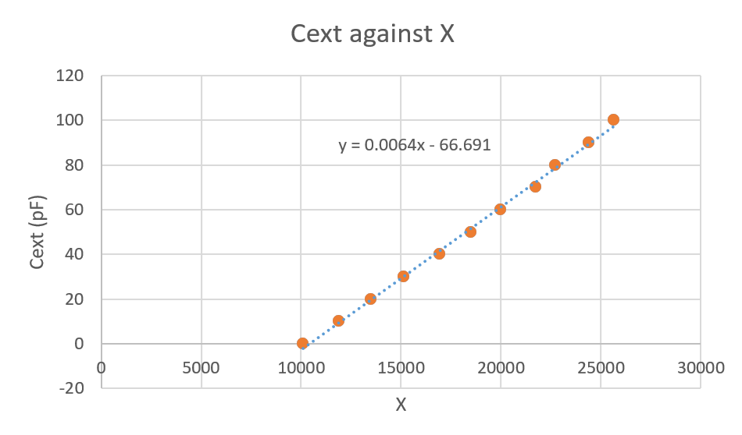

Part D. Determining the quartz crystal’s parameters (2.5 points)
D1. | Determine the values of $L, C$ and $C_{0}$. | 1.3 pt
From the graph in C2,
$$C=0.0064 pF=6.4 fF$$
$$C_{0}=66.7 pF$$
$$2πf_{anti}=\frac{1}{\sqrt{LC}}$$
$$L=\frac{1}{4π^{2}f_{anti}^{2}C}=0.99 H$$
D2. | Determine the value of R. | 1.2 pt
Using the result from B2,
$${\left|Z\right|}^{2}=\frac{{\left(ω_{s}^{2}-ω^{2}\right)}^{2}+{\left(ωα\right)}^{2}}{{\left(ωC_{0}\right)}^{2} \left({\left(ω_{p}^{2}-ω^{2}\right)}^{2}+{\left(ωα\right)}^{2}\right)}$$
Using $C_{ext}=0$, $ω=ω_{s}$ and $ω=ω_{p},$
$${\left|Z\right|}_{anti}^{2}=\frac{{\left(ω_{s}α\right)}^{2}}{{\left(ω_{s}C_{0}\right)}^{2} \left({\left(ω_{p}^{2}-ω_{s}^{2}\right)}^{2}+{\left(ω_{s}α\right)}^{2}\right)}$$
$$α=\frac{ω_{p}^{2}-ω_{s}^{2}}{\sqrt{{\left(\frac{1}{{\left|Z\right|}_{anti}C_{0}}\right)}^{2}-ω_{s}^{2}}}=\frac{2π(f_{res}^{2}-f_{anti}^{2})}{f_{anti}\sqrt{{\left(\frac{1}{2πf_{anti}{\left|Z\right|}_{anti}C_{0}}\right)}^{2}-1} }=211.473$$
$${\left|Z\right|}_{res}^{2}=\frac{{\left(ω_{s}^{2}-ω_{p}^{2}\right)}^{2}+{\left(ω_{p}α\right)}^{2}}{{\left(ω_{p}C_{0}\right)}^{2} {\left(ω_{p}α\right)}^{2}}$$
$$α=\frac{ω_{p}^{2}-ω_{s}^{2}}{ω_{p}\sqrt{{\left({\left|Z\right|}_{res}ω_{p}C_{o}\right)}^{2}-1}}=\frac{2π(f_{res}^{2}-f_{anti}^{2})}{f_{res}\sqrt{{\left(2πf_{res}{\left|Z\right|}_{res}C_{o}\right)}^{2}-1}}=136.246$$
$$R=Lα_{avg}=172 Ω$$

Instructions for the simulation program
The program simulates the voltage measurements of an oscilloscope with two channels CH1 and CH2 connected to the circuit as shown in the diagram on the first page.
The oscilloscope measures voltage as the electric potential at the point of connection with respect to the ground (GND).
The program takes two inputs within given range:
Input | Description | Valid Range
$$C_{ext}$$ | The capacitance in pF of the capacitor connected in parallel to the quartz crystal  Note: input zero for part A to represent no capacitor connected in parallel | 0 to 100 pF
$$∆f$$ | The difference between the frequency $f$ and $f_{0}=2 MHz$, $∆f=f-f_{0}$ in Hz | -200 to +200 Hz
After some calculations, the program will display two outputs that simulate the readings from an oscilloscope:
Output | Description
$$U_{2}$$ | The amplitude of the voltage reading on CH2 in mV
$$∆t$$ | The time delay in nanoseconds (ns) between the two closest peaks of the waveforms on CH1 and CH2, with positive values representing CH2 leads CH1 and vice versa
