E2. Quartz Crystal Oscillator (Simulation) (10.0 points)
https://taisoncar.github.io/quartz/
**Error analysis is not required**
A quartz crystal oscillator is a type of electrical circuit that utilizes the piezoelectric properties of quartz crystal to generate electrical oscillations. Quartz crystal oscillator is widely used to keep track of time in watches and computers due to its stability and accuracy.
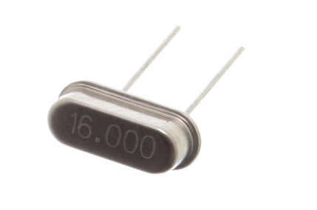
To analyze the behavior of a quartz crystal in electrical circuits, we can model it as an equivalent circuit shown in the figure below.
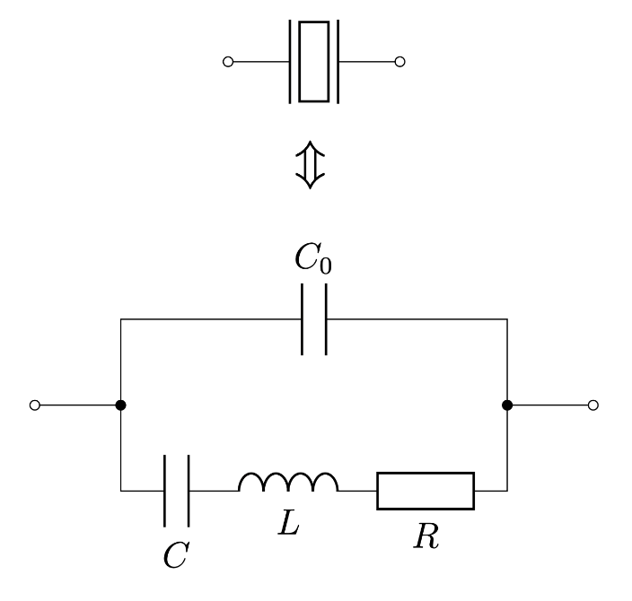
In this problem, we will investigate the parameters of a quartz crystal through a program that simulates the following circuit:
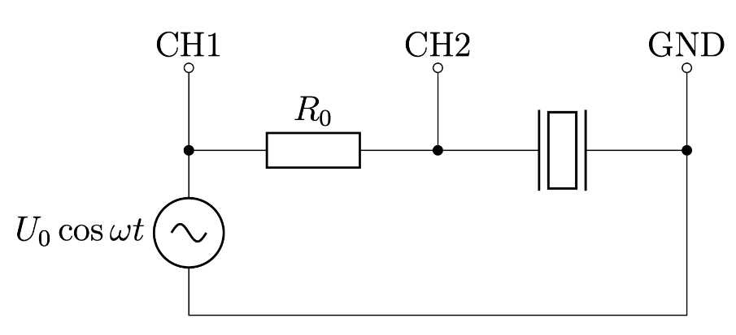
The resonant frequency of the quartz crystal used in this simulation is known to be close to $f_{0}=2 MHz$. The circuit is powered by an AC source $U=U_{0}cos⁡(ωt)$ with angular frequency $ω=2πf$. The voltage amplitude of the AC source $U_{0}$ can be assumed to be constant at $500 mV$. A resistor $R_{0}=5.1 kΩ$ is connected in series to the quartz crystal.
Note: Refer to the end of this paper for the instructions of the simulation program.
Part A. Measurements without external capacitor (5.7 points)
For this part, avoid connecting any external capacitor by inputting $C_{ext}=0$.
A1. | Determine the frequency $f_{max}$ at which the voltage amplitude $U_{2}$ across the quartz crystal is maximized. | 0.2 pt

A2. | Determine the frequency $f_{min}$ at which the voltage amplitude $U_{2}$ across the quartz crystal is minimized. | 0.1 pt

A3. | Measure the voltage amplitude $U_{2}$ across the quartz crystal and the phase difference $φ$ between the signals on the two oscilloscope channels as frequency $f$ changes. | 2.8 pt

A4. | Express the magnitude of the impedance of the quartz crystal $\left|Z\right|$ in terms of $R_{0}, U_{2}, U_{0}$and $φ$. | 0.5 pt

A5. | Plot the magnitude of the impedance of the quartz crystal $|Z|$ against frequency $f$. | 2.0 pt

A6. | From the plotted graph, find the resonant frequency $f_{res}$ and anti-resonant frequency $f_{anti}$ at which $|Z|$ reaches its maximum and minimum values respectively. | 0.1 pt

Part B. Deriving useful expressions (0.6 points)
The impedance of a quartz crystal can be written in the form
$$Z\left(ω\right)=\frac{ω_{s}^{2}-ω^{2}+iωα}{iωC_{0}(ω_{p}^{2}-ω^{2}+iωα)}$$
where $ω_{s},ω_{p}$ and $α$ do not depend on $ω$.
B1. | Express $ω_{s},ω_{p}$ and $α$ in terms of $R,L,C$ and $C_{0}$. | 0.3 pt

B2. | Express ${\left|Z\right|}^{2}$ in terms of $ω,ω_{s},ω_{p},α$ and $C_{0}$. | 0.1 pt
From here onwards, assume the following approximations hold for the range of frequencies in this simulation:
$$Z\left(ω\right)≈\frac{ω_{s}^{2}-ω^{2}+iω_{p}α}{iω_{p}C_{0}(ω_{p}^{2}-ω^{2}+iω_{p}α)}$$
$$α≪ω_{p}-ω_{s}; α≪ω_{p}; α≪ω_{s}$$
$$φ\left(f_{anti}\right)=φ\left(f_{res}\right)=0$$
B3. | Show that $ω_{p}=2πf_{res}$ and $ω_{s}=2πf_{anti}$. | 0.2 pt
Part C. Measurements with external capacitor (1.2 points)
When an external capacitor $C_{ext}$ is connected in parallel to the quartz crystal, the resonant frequency $f_{res}$ shifts while the anti-resonant frequency $f_{anti}$ remains constant.
C1. | Measure $f_{res}$ and $f_{anti}$ as $C_{ext}$ changes. | 0.4 pt

C2. | Construct a linearized plot using the measured data. | 0.8 pt
Part D. Determining the quartz crystal’s parameters (2.5 points)
D1. | Determine the values of $L, C$ and $C_{0}$. | 1.3 pt

D2. | Determine the value of R. | 1.2 pt

Instructions for the simulation program
The program simulates the voltage measurements of an oscilloscope with two channels CH1 and CH2 connected to the circuit as shown in the diagram on the first page.
The oscilloscope measures voltage as the electric potential at the point of connection with respect to the ground (GND).
The program takes two inputs within given range:
Input | Description | Valid Range
$$C_{ext}$$ | The capacitance in pF of the capacitor connected in parallel to the quartz crystal  Note: input zero for part A to represent no capacitor connected in parallel | 0 to 100 pF
$$∆f$$ | The difference between the frequency $f$ and $f_{0}=2 MHz$, $∆f=f-f_{0}$ in Hz | -200 to +200 Hz
After some calculations, the program will display two outputs that simulate the readings from an oscilloscope:
Output | Description
$$U_{2}$$ | The amplitude of the voltage reading on CH2 in mV
$$∆t$$ | The time delay in nanoseconds (ns) between the two closest peaks of the waveforms on CH1 and CH2, where positive value shows that CH2 leads CH1 and vice versa
