Các lệnh cơ bản thao tác với Docker

- docker –version
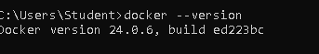
2 docker run hello-world 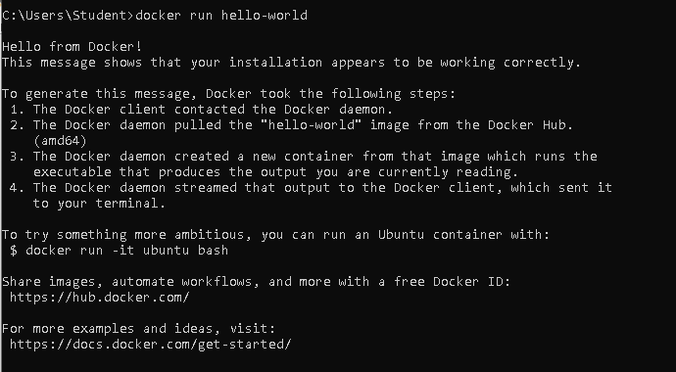
3 docker pull nginx 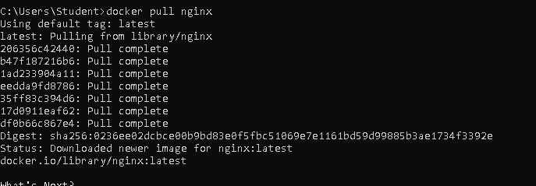
4 docker images 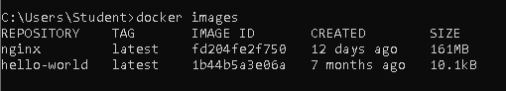
5 docker run -d nginx 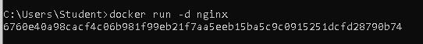
6 docker ps
7 docker ps -a
8 docker logs <container_id> 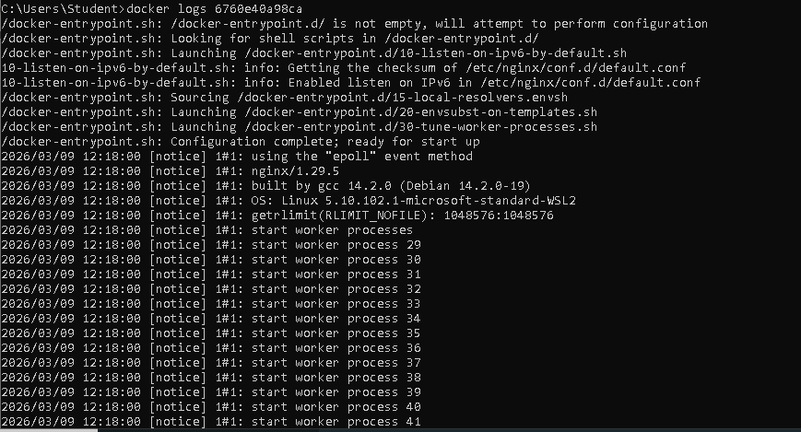
9 docker exec -it <container_id> /bin/sh
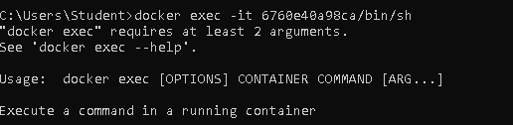
10 docker stop <container_id>
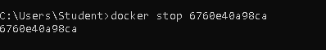
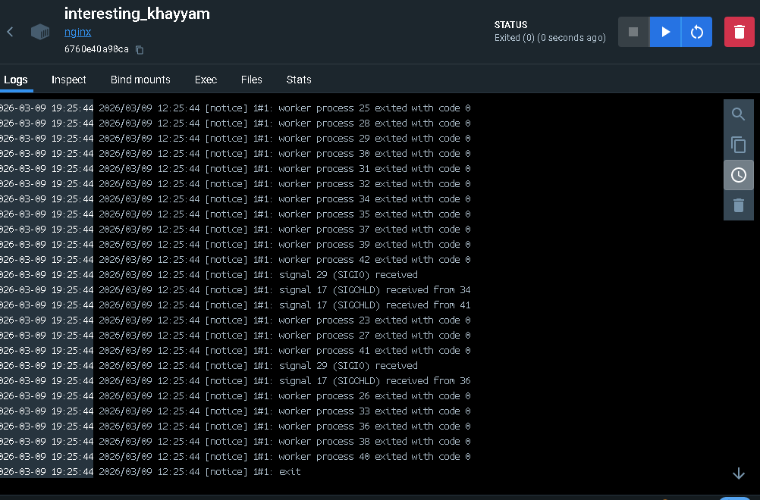
11 docker restart <container_id>
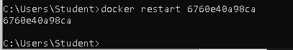
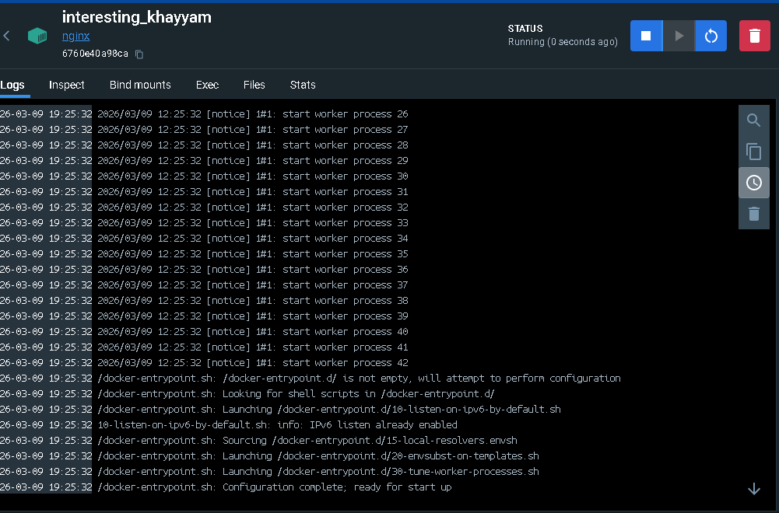
12 docker rm <container_id>
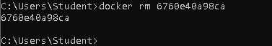
13 docker container prune
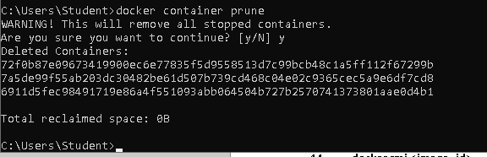
14 docker rmi <image_id>
15 docker image prune -a 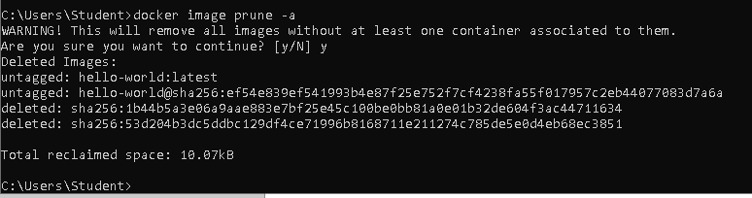
16 docker run -d -p 8080:80 nginx 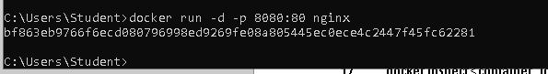
17 docker inspect <container_id> 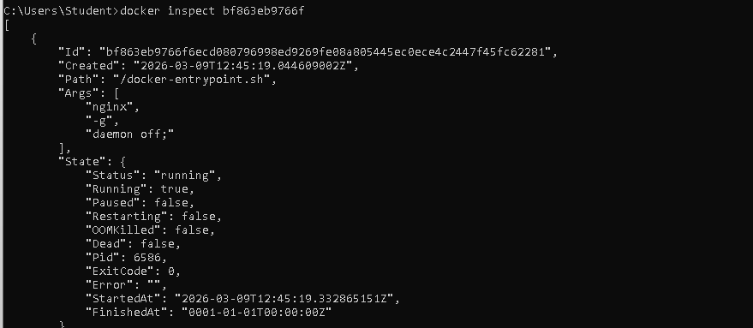
18 docker run -d -v mydata:/data nginx 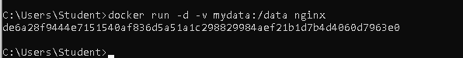
19 docker volume ls
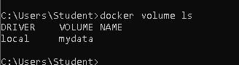
20 docker volume prune
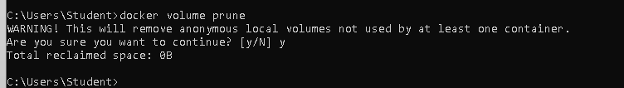
21 docker run -d --name my_nginx nginx
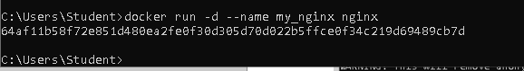
22 docker stats
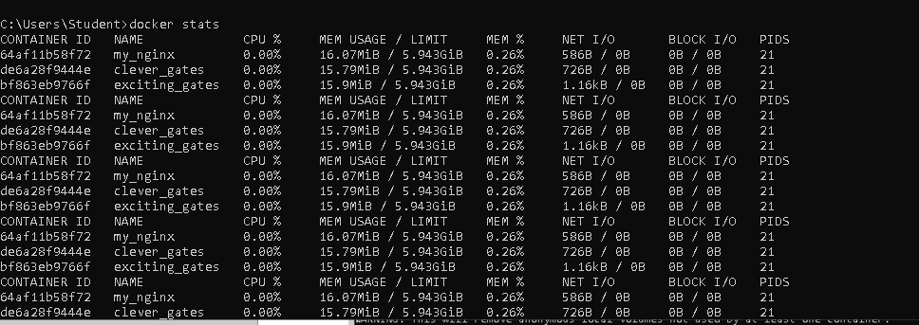
23 docker network ls
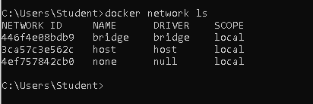
24 docker network create my_network
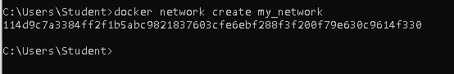
25 docker run -d --network my_network --name my_container nginx
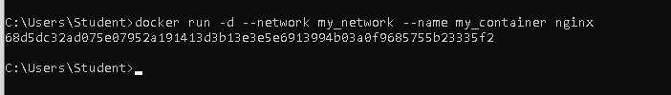
26 docker network connect my_network my_nginx
27 docker run -d -e MY_ENV=hello_world nginx
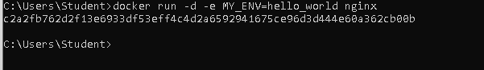
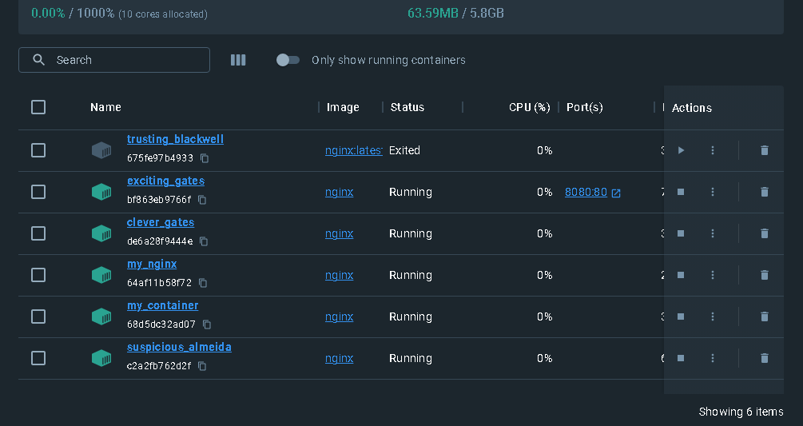
28 docker logs -f my_nginx
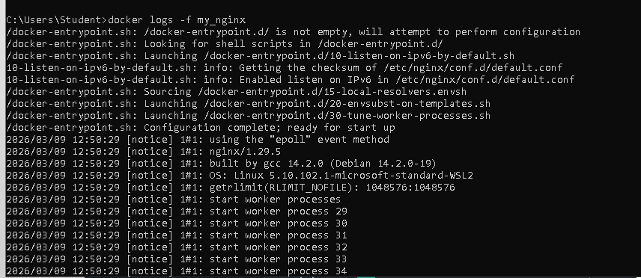
29 FROM nginx COPY index.html /usr/share/nginx/html/index.html
30 docker build -t my_nginx_image .
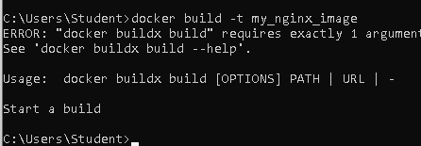
31 docker run -d -p 8080:80 my_nginx_image 