ARPS Instructions

# Setting up a GSM modem

The GSM modem is a device capable of sending and receiving SMS modems and communicating with a computer. A GSM modem with a working SMS card is necessary to run ARPS.

An example of a suitable GSM modem for ARPS is the Wavecom GSM modem. The Q2303A model can be purchased online, including here:

<http://www.ebay.com/itm/GSM-Modem-Wavecom-Q2303A-Module-USB-Interface-AT-Commands-SMS-900-1800Mhz-/271676849278>

These instructions will refer to the Wavecom modem, although other brands are likely similar.

In order for the GSM modem to send and receive messages, it must be equipped with a SIM card and cell phone subscription that includes texting. This can be purchased from a service provider like a regular missionary phone subscription, although it’s probably more cost-effective to pay for a plan centered on texting with minimal voice calls. The SIM card can be inserted into the slot on the top of the Wavecom GSM modem, next to the antenna, which you can open by using a pointed object to depress the yellow button.

After inserting the SIM card, the GSM modem must be attached to 1) a power source; 2) the computer. Use the provided power adapter to plug the modem into a wall outlet. Then, use the broad HDMI cable provided (with screws on each connector head) to connect the modem to the computer. The Ethernet cable does not need to be connected to anything.

To test if the modem is functioning, run ARPS. Click on “Terminal.” Then, type the following command:

AT

Press enter. If the modem is connected properly, you should see (in blue text) the response:

OK

If you see the response TIMEOUT, the modem is most likely connected improperly. Make sure you are using the thick HDMI cable to connect the GSM modem to the COM port of the computer (usually located on the back of the computer).

# Setting up the mission phone list

ARPS must know the following information for every companionship in the mission:

1. The unique companionship name or identifier;
2. The companionship phone number;
3. The companionship “pretty” name (a name or ID that is readable to human eyes);
4. (Optional) The companionship’s name in a second language;
5. The name of the district to which the companionship belongs;
6. The name of the zone to which the companionship belongs;
7. The name of the ward to which the companionship belongs;
8. The name of the stake to which the companionship belongs;
9. (Optional) The name of the English teaching unit to which the companionship belongs;
10. Whether or not the companionship is required to report key indicators / English key indicators;
11. (If using for referrals) The geographical areas served by the companionship.

All of this information is stored in two places: 1) the COMP_LIST sheet in the report_sheet Excel workbook (used to populate information in the report sheets); 2) the file config/phone_list.txt, which ARPS reads directly. Ideally, you should first enter the information in the COMP_LIST Excel sheet, copy the entire sheet by pressing CTRL+A CTRL+C, and paste it into the config/phone_list.txt file using notepad++ or a similar text editor. Save the file with UTF-8 (no BOM) encoding. DO NOT use Notepad; it inserts problematic characters that will prevent the file from being read properly.

If a companionship has multiple phones, create two entries, one for each phone number, with all other fields the same.

When a referral is sent, it will be directed to the companionship responsible for its geographic area. If multiple companionships are responsible for the same area, it will be randomly assigned to one of the companionships.

If no companionship can be found for the geographic area entered in the text, it will be sent to the LOST_MESSAGE_HANDLER number specified in the file config/config.txt. This phone will receive the referral text, and the phone’s owner must manually direct the referral. When the TYPE of a message is unclear, it will also be sent to the same lost message handler.

# Setting up the report sheets

Almost all of the information on the report sheets and graphs is automatically extracted from ARPS’ database files. However, you must first create a report sheet with the proper companionship IDs for each zone (and, if desired, districts, stakes, and wards).

The report_sheet workbook contains two types of worksheets: red-green key indicator tables and graphs. If you like, some units can have graphs without tables.

To set up the report sheets for your mission, do the following:

1. Use Excel to open the file report_sheet.xlsx.
2. Navigate to the first example zone sheet, ZONE_EXAMPLE.
3. Unhide the first four columns of the sheet by selecting all, then right-clicking on the line between the left side of the sheet window and the column:

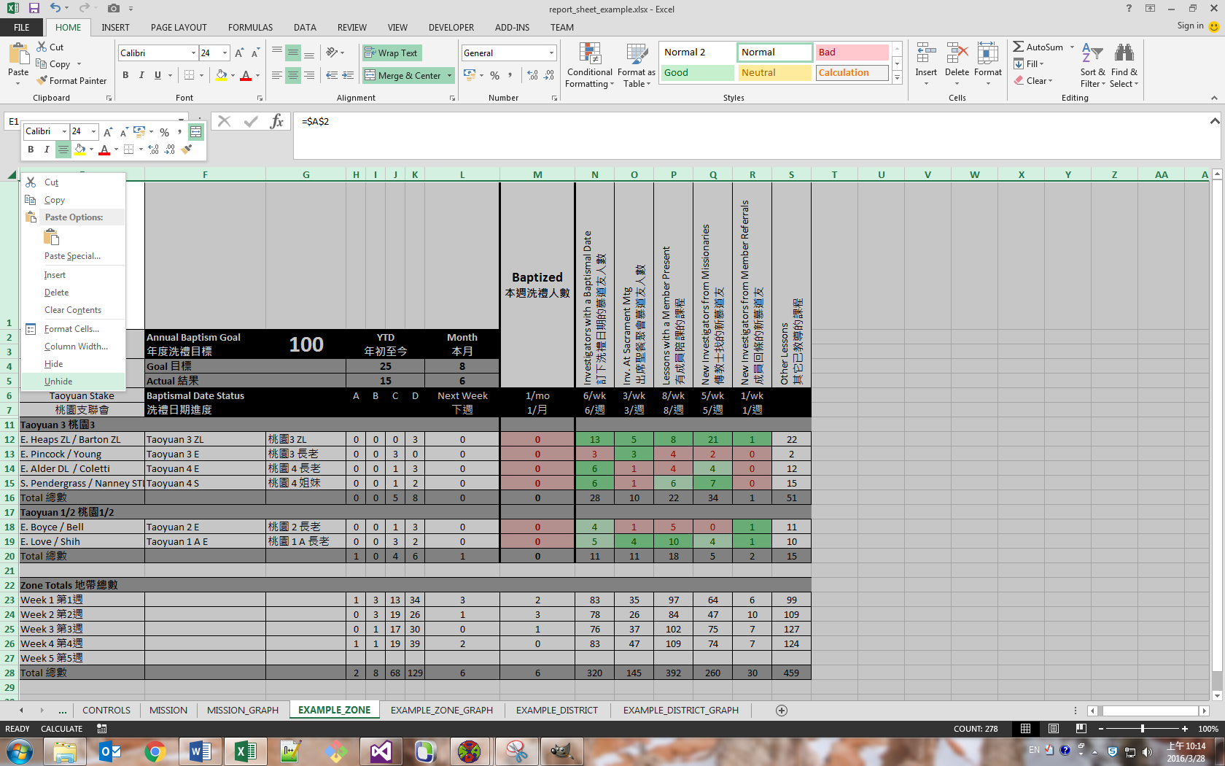

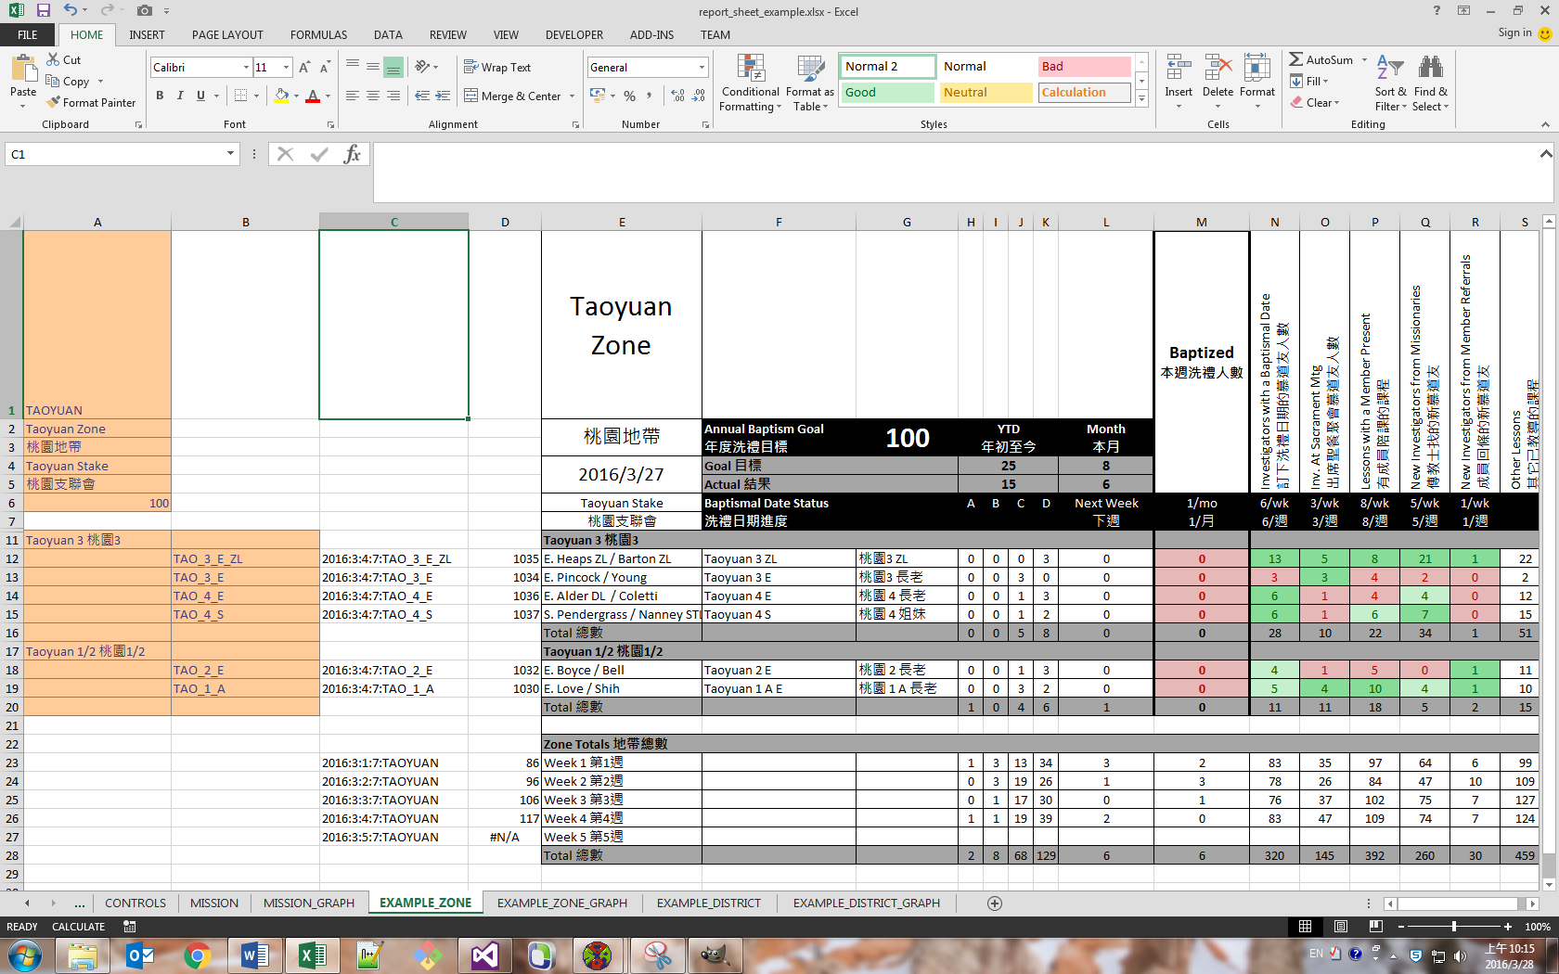

1. Every cell that is orange must be filled in with correct information.
2. To add a companionship to a district, select a row in the district by clicking on the row number on the left of the screen. Right-click on the row number and select Copy. Right-click again and select “Insert copied cells.”
3. To add a district, select all the rows of an existing district, copy, and insert the copied cells.
4. To remove companionship(s) or district(s) from the sheet, select all rows to delete, right-click, and delete the rows.
5. IMPORTANT: You should never insert or remove individual cells or groups of cells other than rows. The only way you should ever need to edit the sheets is by adding and removing rows and editing the contents of orange cells. If you do otherwise, you risk breaking the formulas that draw data from the raw text produced by ARPS.
6. Fill in the zone’s information in the corresponding ZONE_EXAMPLE_GRAPH worksheet.
7. Rename both worksheets to the actual name of the zone, e.g. ZONE_NORTH and ZONE_NORTH_GRAPH.
8. Repeat the above steps for every zone and, if desired, district. To add a zone or district, right-click on the bottom tab of an existing zone or district sheet and its corresponding graph, then select “move or copy.” Check the box “create a copy,” and place the new duplicated sheet where desired. Then, rename the duplicate sheet, and change the information in the orange cells of the new sheet to match the information in the target unit.
9. After changing the worksheets, press F9 to re-calculate. If data has changed in the meantime, first update the data by clicking (in the top ribbon of Excel) Data->Update All, and then press F9 to recalculate with the updated values.

# Running ARPS for the first time

After filling in the correct information, you can run ARPS. Double-click on the shortcut “Run ARPS.” Wait for ARPS to load.

ARPS consists of two windows. One is a user interface which allows the user to communicate indirectly with the modem and which handles the processing and saving of messages and reports. The other is a terminal window, which displays with colored text the raw data passed to and from the GSM modem. Yellow text is data passed to the modem; cyan text is data received from the modem. Notifications are in green (high-priority), gray (low-priority), or red (errors). Text input by the user is white. To enter the terminal, click the “Terminal” button on the bottom of the window. To exit the terminal, type ‘q’ (without quotes) and press ENTER.

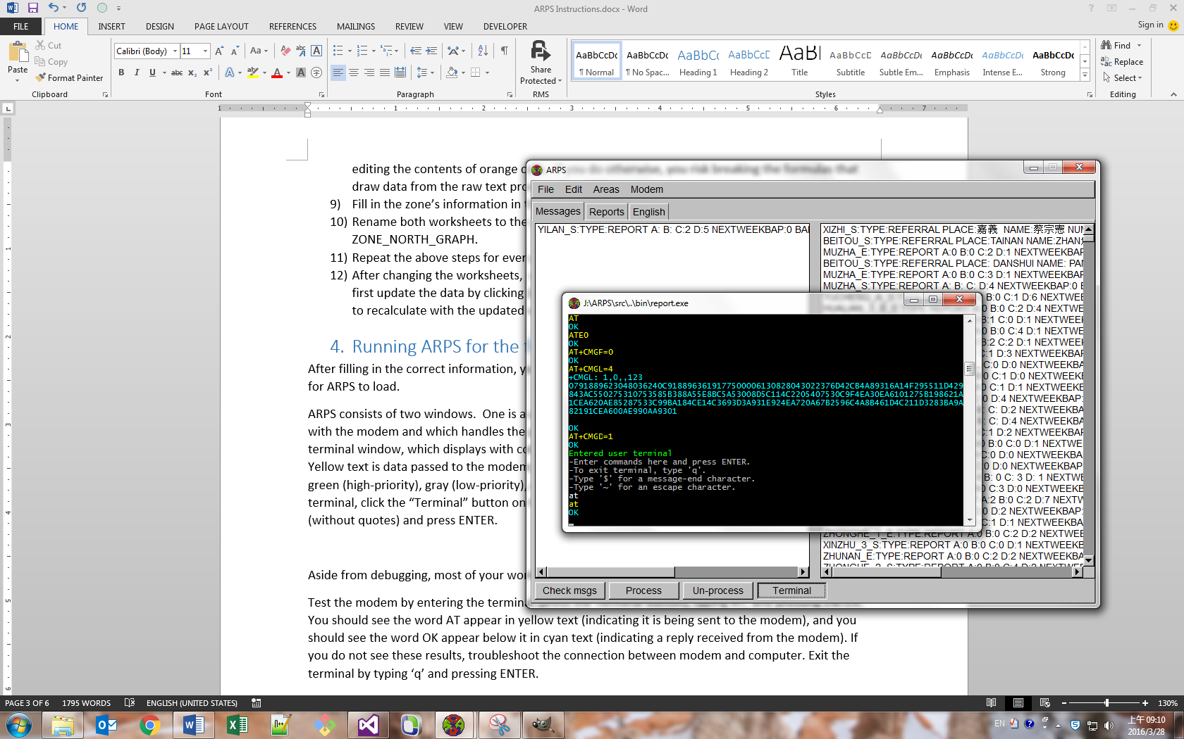

Aside from debugging, most of your work is done in the graphical interface.

Test the modem by entering the terminal (press the Terminal button), typing AT, and pressing ENTER. You should see the word AT appear in yellow text (indicating it is being sent to the modem), and you should see the word OK appear below it in cyan text (indicating a reply received from the modem). If you do not see these results, troubleshoot the connection between modem and computer. Exit the terminal by typing ‘q’ and pressing ENTER.

Before you do anything else, select from the top row menu: Modem->Configure Modem. This will enter the correct modem settings for ARPS. This only has to be done the first time ARPS is run and later if the modem has been disconnected from its power source.

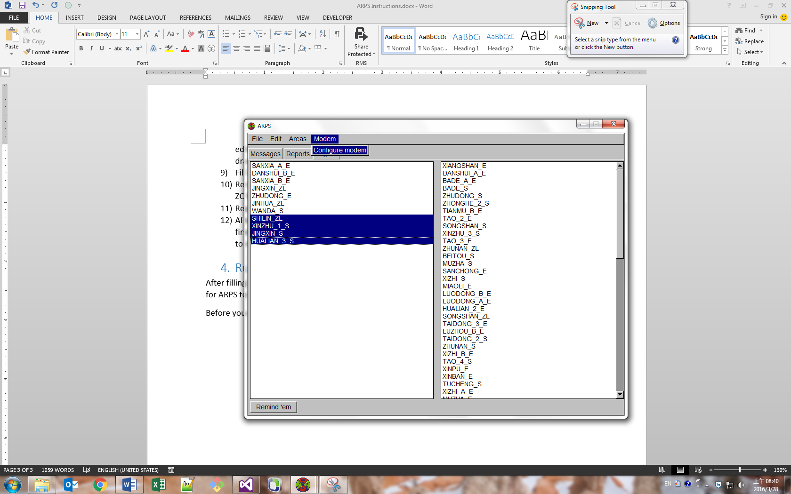

ARPS reads messages from the SIM card, which are then interpreted as various types of reports depending on the contents of the message. To check for messages, click the Check Messages button on the bottom left of the window.

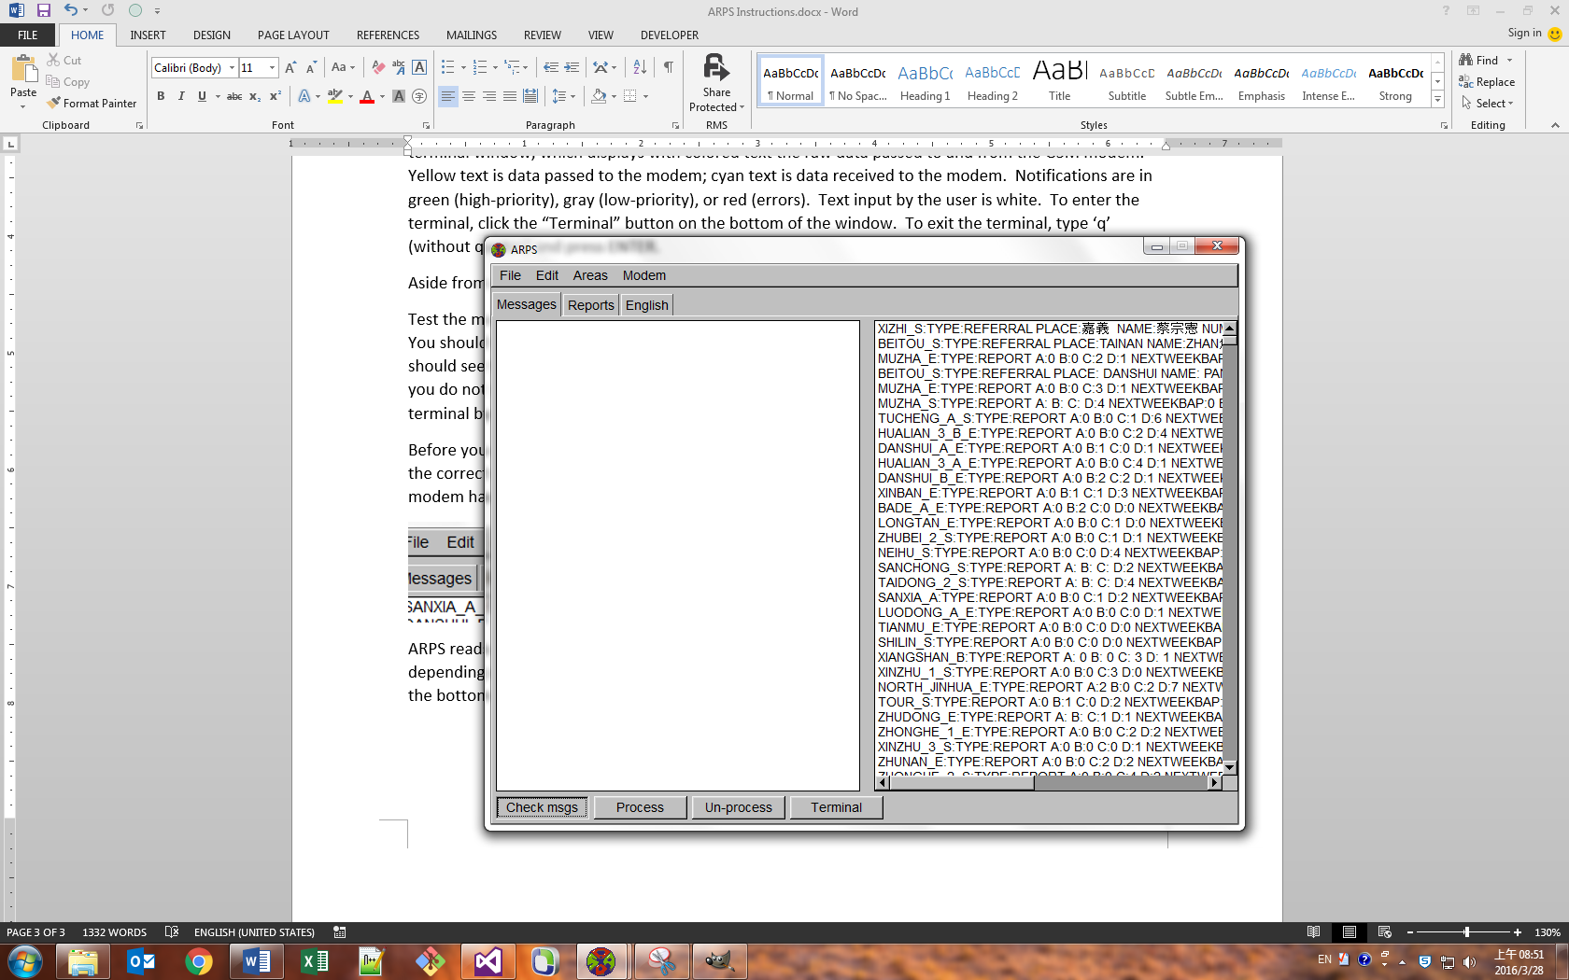

The button will gray out as text appears in the terminal. Wait for the button to assume its normal appearance. If messages were found on the SIM, they will appear in the left panel of the Messages tab. These messages are unprocessed. They have not yet been translated into reports or sent as referrals.

If you close ARPS without saving after receiving these messages, they will be lost. Press CTRL+S, or select File->Save, to save all unsaved messages, reports, and referrals. You should do this frequently to avoid data loss.

To view the full text of a message, double-click on it, or press ENTER with the message selected.

To process the messages, click and drag to select the ones you want to process. Then, click the Process button at the bottom of the window.

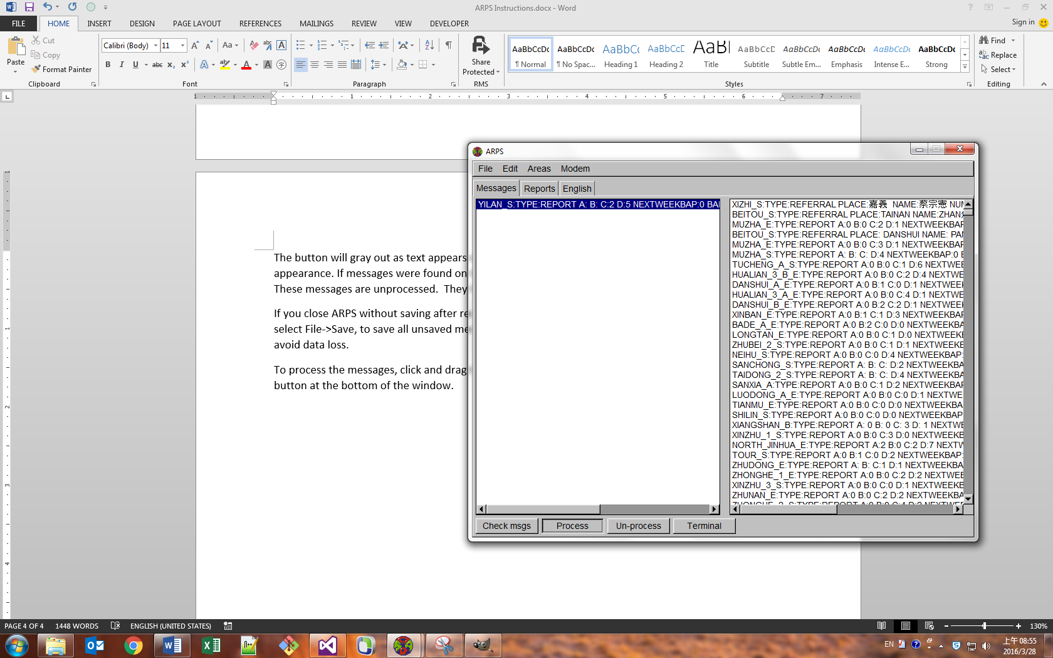

The message will move to the right pane of the Messages tab (processed messages), and the appropriate action will be taken.

The Reports tab displays which companionships have and have not sent in their key indicator reports in the current reporting time frame. The reporting time frame starts on the day reports are due (e.g. Sunday) and ends right before the next reporting day begins (e.g. midnight on the next Saturday). When you receive and process messages of the type REPORT, the relevant companionship will move from the unreported pane (the left pane) to the reported pane (the right pane). By clicking and dragging, you can select companionships that haven’t reported and click the “Remind ‘em” button to send a reminder text message to the selected companionships.

The English tab is functionally identical to the Reports tab, but it displays which English reports have and have not been submitted in the relevant English reporting time frame.

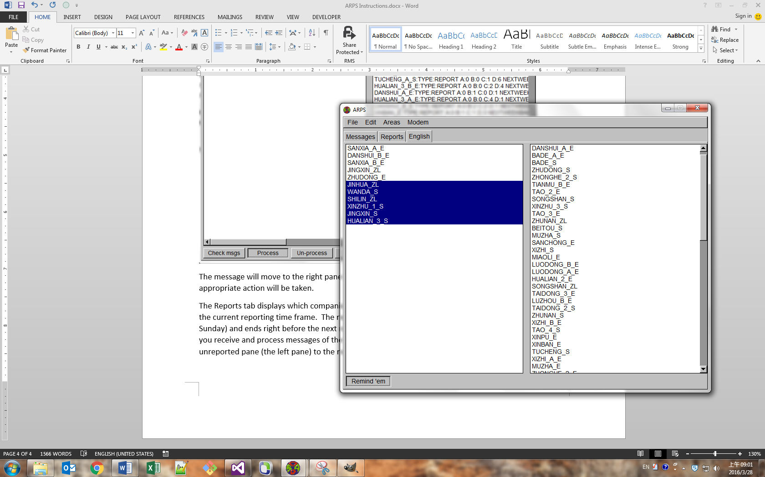

Only the companionships that are required to report key indicators / English key indicators are displayed in the Reports / English tabs. If the left and right panes of either one of the tabs are blank, the file config/phone_list.txt is incorrect or cannot be read properly.

After receiving and processing report texts, you’ll want to total the results to obtain district, zone, ward, stake, and mission totals. Do this by clicking Edit->Total Reports and Edit->Total Baptism Source. Don’t forget to save afterwards, or the totals saved in the data files won’t be updated.

After entering the phone list information for the first time, or after transfers, it’s a good idea to verify that all areas are entered correctly. You can do this by clicking Areas->Send Verification Text. This will send a text to every phone number in the system verifying that the phone does indeed belong to the companionship listed in the file. Warning: this is a time-consuming operation, and also could cause you to exceed your phone plan’s allotted texts if overused.

# Text templates

ARPS reads data from texts sent in by missionaries. These texts must follow a set format exactly or they cannot be read properly.

All texts begin with the phrase TYPE: followed directly by the text REPORT (a report), ENGLISH (an English report), BAPTISM (a baptism report), or REFERRAL (a referral). The content after the TYPE field varies depending on what kind of message it is. To ensure accuracy, missionaries should save the following templates on their phones and add information to the blanks before sending it in to ARPS.

## Report

TYPE:REPORT

A:

B:

C:

D:

NEXTWEEKBAP:

BAP:

BD:

SAC:

PK:

NIMISSFIND:

NIMEMREF:

OL:

Note: the report fields can be changed to anything your mission wants to report on. Just change the template; rename, add, or remove data columns in the data/report text files; first open the text in Notepad++ then copy all and paste into an Excel spreadsheet for editing, afterwards re-paste into the text file. Make sure the Report Sheets that display these indicators are also properly edited by changing the report fields listed in (hidden) Row 8 of the Excel spreadsheets. (For more explanation on switching the reporting fields, see “9. Changing reported key indicators”)

English

TYPE:ENGLISH

CLASSLEVEL:

TOTALSTUDENTS:

TOTALNONMEM:

NEWSTUDENTS:

NEWINV:

These can also all be changed, except the CLASSLEVEL field.

Baptism

TYPE:BAPTISM

CONV_NAME:

BP_DATE:  
CONF_DATE:

WARD:

HOME_ADDR:

PH_NUM:

BAP_SOURCE:

1=Missionary contacting

2=LA referral

3=RC referral

4=Active member referral

5=English class

6=Temple tour

This template is used to report on the source of a baptism, and these reports can be used to enter a baptism in CDE even if the baptismal form hasn’t been received yet.

Referral

TYPE:REFERRAL

PLACE:

NAME:

NUMBER:

INFO:

# Printing report sheets

To print report sheets, first make sure you have updated the data in the Excel file (Data->Refresh All) and re-calculated (F9). Ensure that the columns you don’t want to print (A-D, rows 8-10) are hidden. Then, select all of the worksheet tabs in the bottom of Excel that you want to print by holding down CTRL and clicking. Click File->Export->Create PDF/XPS. Save as a PDF.

You can then print and send the PDF file.

It is also recommended to save a copy of the Excel file after every reporting period. This provides a history, and also serves as a backup of the text file data (which is loaded into the worksheets at the beginning of the workbook) in case of unanticipated data loss.

# Dealing with errors

It is inevitable that missionaries will send reports incorrectly. If a report has been sent incorrectly, here are the options for handling it:

1. The same companionship can re-send the report with the numbers corrected. This is the simplest option. The report will replace the previous report. However, this only works within the same reporting period (a week), so if a week has already passed since the reporting date, the new text will be interpreted as a report for the current week.
2. You can manually edit the data file.

All data that ARPS takes from texts is stored in the folder data. Report data is in data/reports, English in data/english, and so on. There is one file for every data scope: companionship, district, district by month, zone, zone by month, and so forth. The most basic level of data is by companionship, stored in a file simply titled report.txt (or english.txt, or baptism_source.txt…). This is usually what you want to edit. All the other files are simply calculated by adding these values in different combinations.

Always close ARPS before editing these files. Otherwise, you could save over your revisions, or you could lose data collected by ARPS if you choose not to save.

Data is organized in a table. Each row represents a companionship’s report for a given week. Each column represents a given data field. The row is headed with an ID string, composed of the date (YYYY:M(M):W:D) followed by a colon and the companionship name. You can directly change this data by opening the file in a text editor (notepad++ is optimal; DO NOT use Notepad), finding the relevant report (e.g. 2016:3:3:7:OFFICE_E for the office elders’ report for Sunday, the third week in March, 2016), and changing the reported values.

To re-total the zone and district totals that depend on this report, run ARPS again, click Edit->Total Reports (or Edit->Total Baptism Source, if the report changed was a baptism source report), and click File->Save.

Note: to maintain data stability, ARPS by default will not re-total zone/district/etc. reports from previous reporting frames. You must open the relevant files and delete the lines that need to be recalculated in a text editor. Then, when you click Edit->Total Reports in ARPS, it will calculate a new total to replace the missing line.

# Backing up and deleting old data

Back up regularly to avoid data loss. The report files are not large. Copy them to another folder for safety. Use a cloud storage service to back them up. If you know how, use Git to store revision history for all key indicators. It is best to back up after every reporting period.

Because ARPS never deletes old data, you may want to delete already processed messages to free up space or make it load faster. To do this, either 1) select messages in the right-hand panel of the Messages tab in ARPS, right-click, and select Delete; 2) with ARPS closed, open the file data/messages/handled.txt, select all, and delete.

# Changing reported key indicators

If you want to change which key indicators your mission reports on, there are three things you need to change:

1. The columns in the text data files located in data/. Delete unused columns and add new ones. It is helpful to copy the text from notepad++ over into Excel, make the revisions, and then copy and paste it back.
2. The fields in the report text template the missionaries send in. If a data field is not present in the text, but is in the data file, it will be left blank. If a data field is present in the text but not the data file, it will not be recorded.
3. The columns in the Excel file. The true names of the fields Excel searches for are located in Row 8 of every report sheet, which is usually hidden. To unhide, click and drag on the left row bar to select rows 7-11, right-click on the thick dividing line on the left that separates rows 7 and 11, and select Unhide.

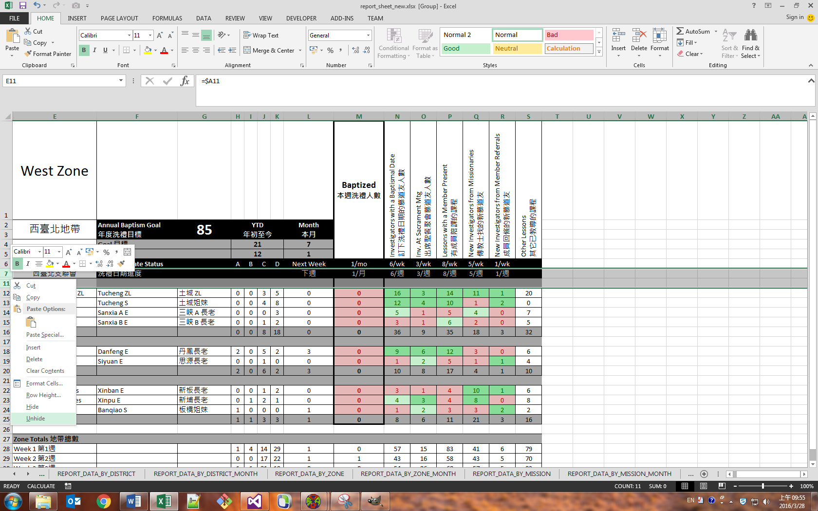

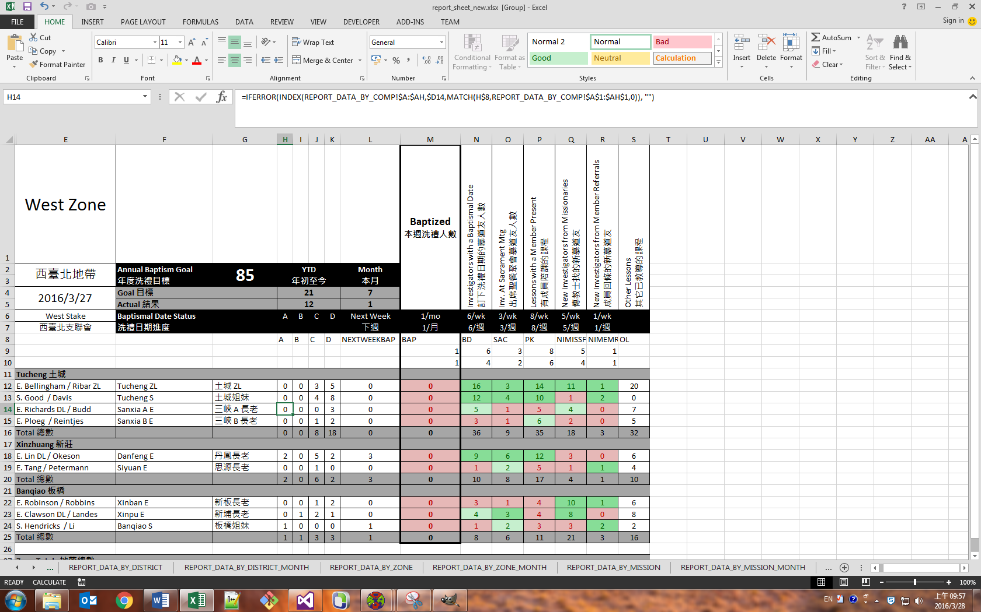

Row 8 is the name of the key indicator (corresponds to the column name in the data file and the field name in the text template). Row 9 is the ‘standard of excellence’ as established by your mission president. If the key indicators in the column of this value are greater than or equal to this value, their cells will be dark green. Row 10 is the light-green threshold. If the key indicators in this column are greater than or equal to this value, but do not reach the standard of excellence, the cell will be light green. If the value is less than the light-green threshold, it will be red. If these lines are both blank, the cells below them will always be white.

Just as you add or remove companionships and districts by duplicating or deleting rows, you should add and remove key indicators by duplicating or deleting columns.

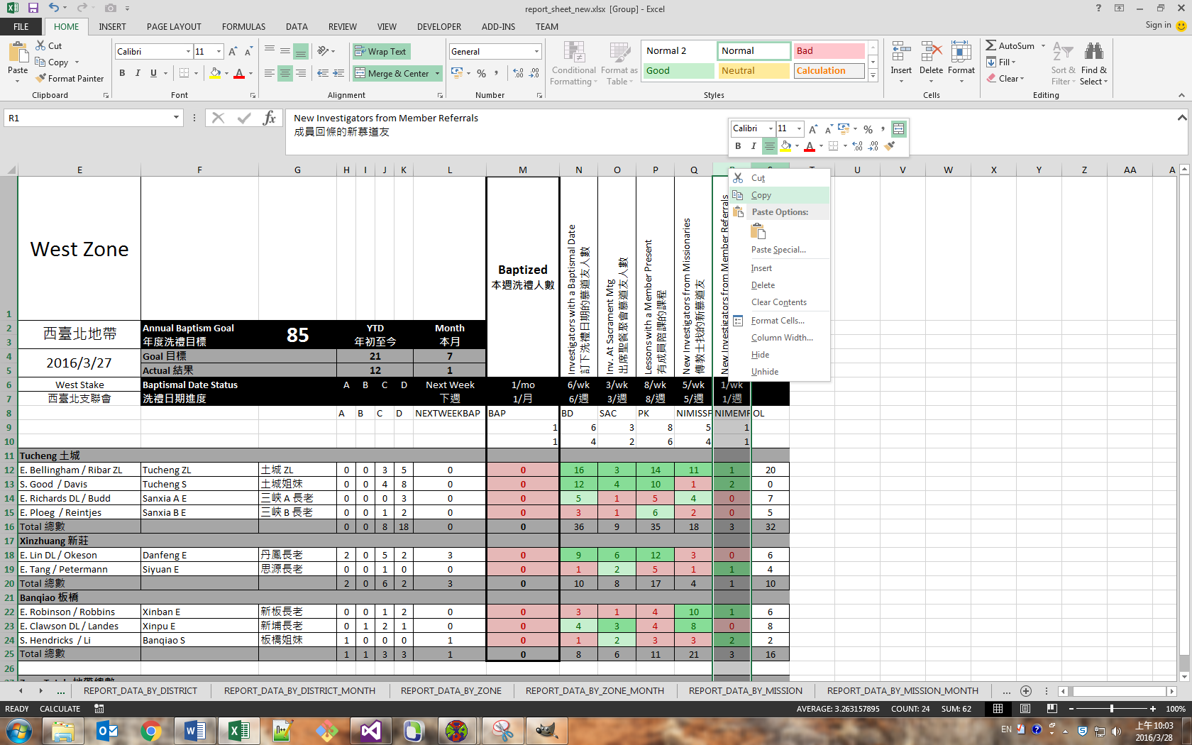

Right-click on the column bar and select Copy. Then, right-click on the column bar to the right of where you want to place the new key indicator and select Insert Copied Cells.

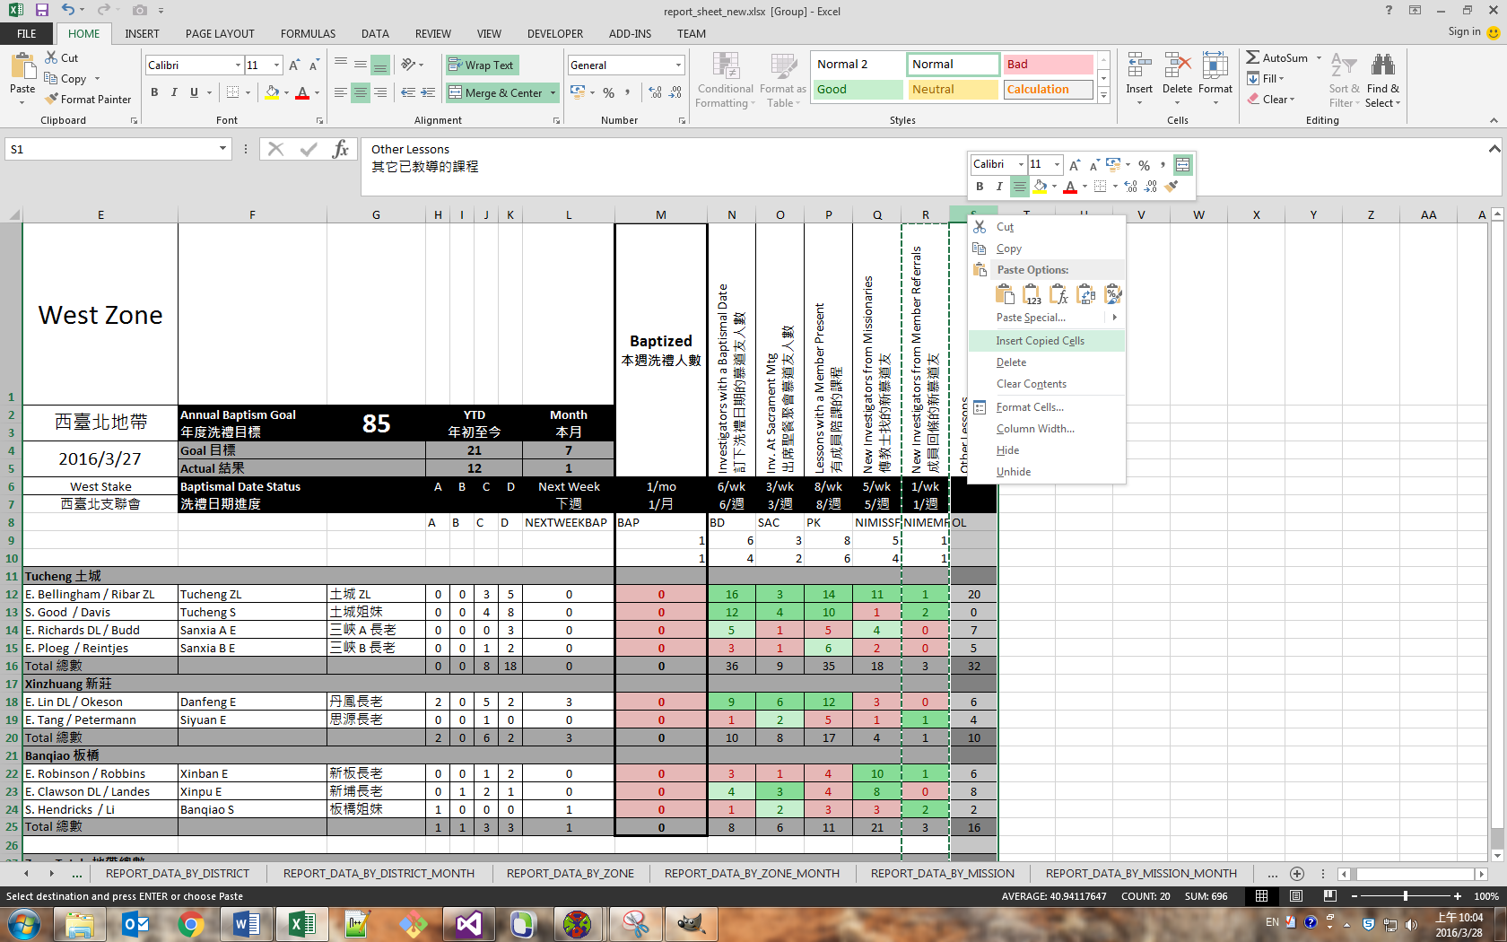

Edit the key indicator name, standard of excellence, and light-green threshold as desired.

You can select multiple worksheets in the workbook at once before performing the above steps to add or remove the key indicators in multiple sheets.

To remove a key indicator, simply right-click on the column in the column bar and select Delete.