FoodPanda

Project documentation

Student(s):

* Bogdan Tailup

**Group: 30434**

**Contents**

I Project specification 2

II Use-Case model 2

2.1 Users and stakeholders 3

2.2 Package diagram 4

2.3 Class diagram 5

2.4 Database (E-R/Data model) diagram 7

# I Project specification

The new FoodPanda provides users the best experience with a revolutionary front-end design.

# II Use-Case model

There are two types of users which can access and use the application such as : Restaurant Administrator and Customer.

The Restaurant Administrator should be able to:

log-in to the application

add restaurant to the application ( information needed: name, location, available delivery zones)

select category and add foods for each category

view menu (with all existing foods, separated into categories)

accept/decline order

view orders (with status)

filter orders by status

change status of order (in order)

The Customer should be able to:

register into the application

log-in into the application

view restaurants

view menu for the selected restaurant

add foods to cart

place order

see status of the order

see history of all orders placed

search the restaurants by name

## 2.1 Users and stakeholders

Users

* Restaurant Administrator
* Customer

Stakeholders

* Dev team
* PO
* PM
* Glovo
* Tazz

## 3.2 Package diagram

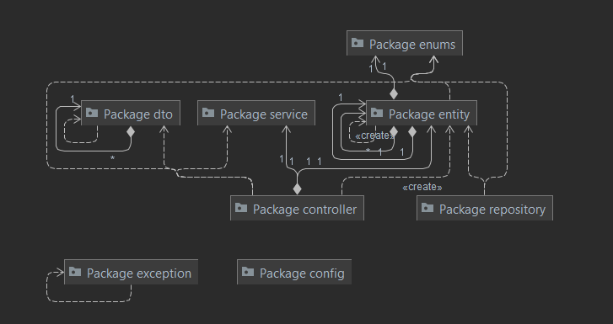

## 3.3 Class diagram

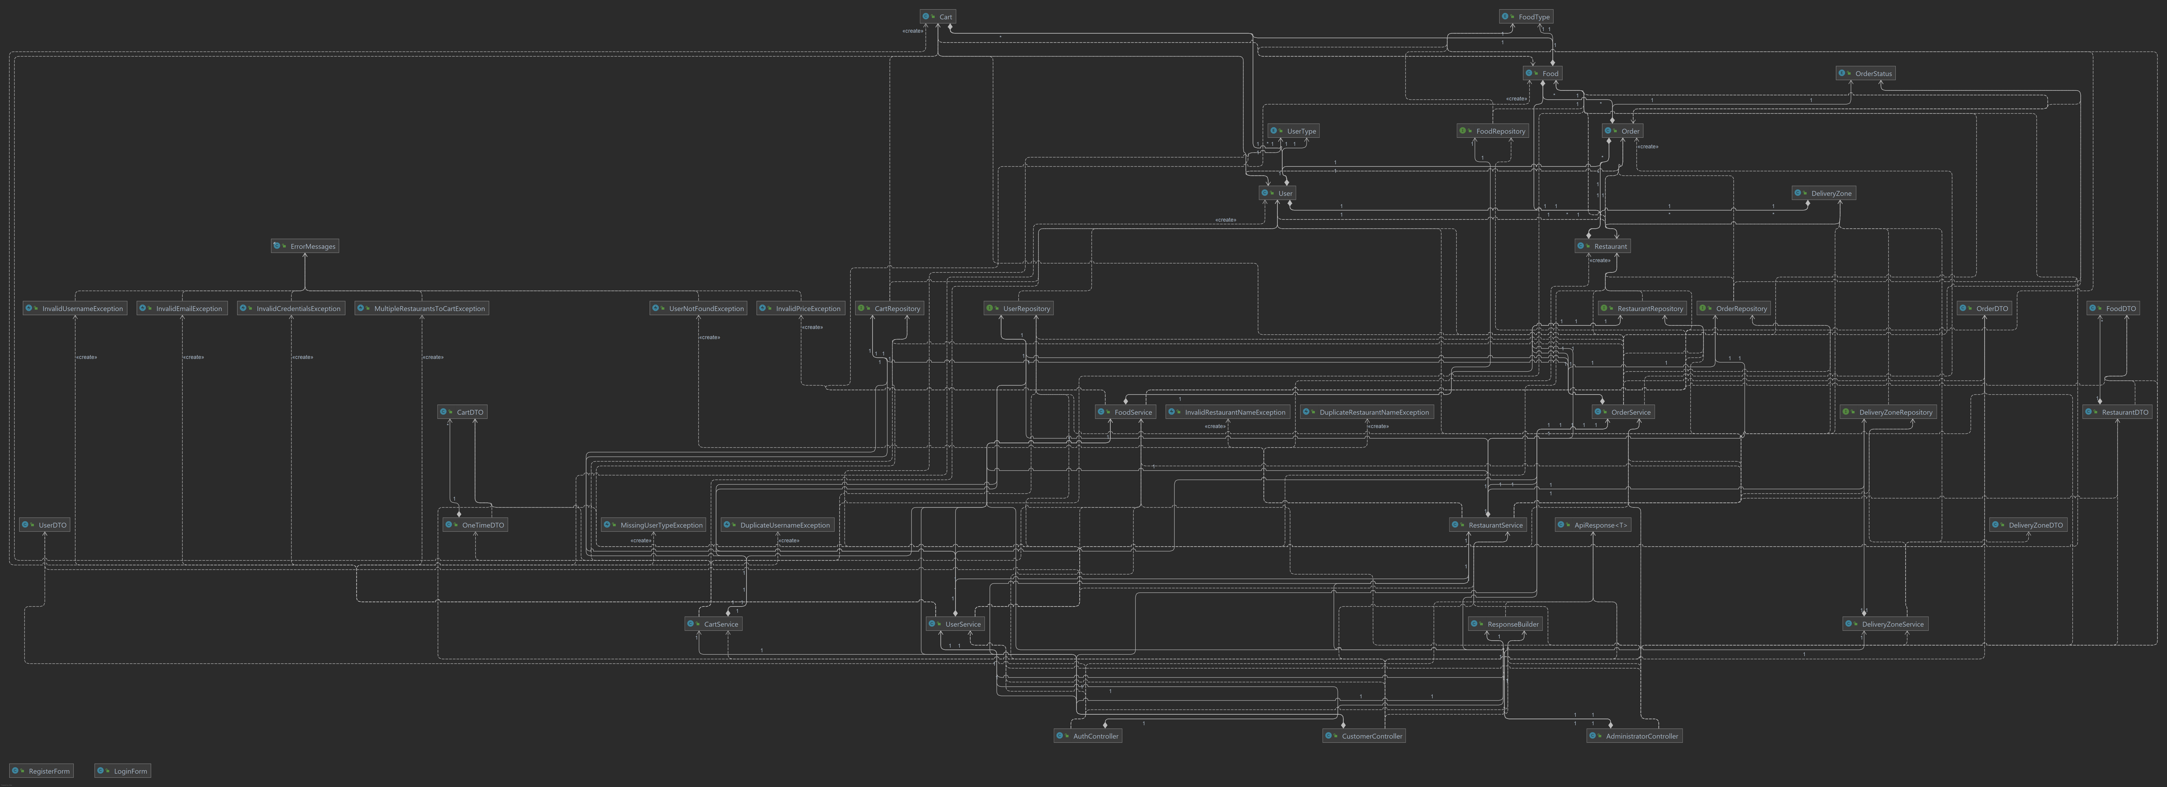

## 3.4 Database (E-R/Data model) diagram

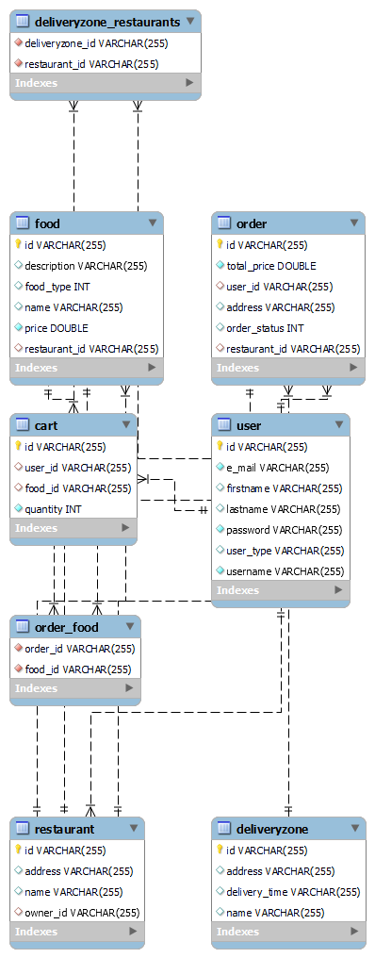

## 

## 3.5 Usecase diagram

