Chapter 1: INTRODUCTION

1.1 Project Overview
In the Bachelor of Computer Science programme in the Faculty of Computing and Informatics (FCI), Multimedia University (MMU), all students are expected to undertake a Final Year Project (FYP). The FYP is an important course because it offers students an opportunity to apply what they have learnt over a number of trimesters to a real problem, from identifying the problem and proposing a solution, to developing a system and writing a formal report. The quality of supervision during this process has a strong impact on whether students are able to finish their projects on time and to the expectations of the faculty.
Based on observation of previous batches of FYP in FCI, the supervision process is often dealt with in a less structured manner. Students and supervisors typically use a combination of emails and messaging apps, printed logbooks, spreadsheets and shared folders to manage proposals, meetings and progress reports. Information such as meeting dates, feedback on draft and decisions made during consultations may be recorded in different places. When everything is spread out like this, it is hard for both students and the superiors to keep track of what has been discussed and what needs to be done in the next step. This can end in confusion, missed deadlines and last-minute rushing around close to the end of the trimester.
The FYP Supervision System is proposed to help deal with these problems in the FCI context. It is a web-based system which puts the main supervision activities in a single platform. Through this system, students will be able to register, submit their proposal for the projects, request/confirm supervisor, book consultation sessions and upload progress reports. Supervisors will be able to see their supervisees, keep track of the progress of each project, record the notes of meetings and review the uploaded documents and give feedback. By centralising these activities, the system does aim to make the FYP supervision process in MMU FCI more transparent, consistent and easier to manage - both for students and lecturers!
Besides the basic supervision features, the system will also include a number of components that will make use of Artificial Intelligence (AI). A supervisor recommendation feature will help to match students to suitable supervisors based on project topics and current supervision load of the supervisor(s). A proposal analysis module, with the help of simple Natural Language Processing (NLP) techniques will help to check whether a submitted proposal is following a required structure and touches important sections like introduction, problem statement, objectives and methodology. A simple chatbot assistant will also be integrated into take care of frequently asked questions and guide users on how to use the system's main functions.
The system will be developed as a web application in Java based on Spring Boot framework and MySQL as the primary database. The modules associated with AI like the supervisor recommendation and proposal analysis will be implemented using python and will be implemented as separate microservices that will communicate with the core system using restful APIs. The project will be conducted in two trimesters: The first trimester will focus on the background study, requirements analysis and system design (FYP1) and the second trimester would be the implementation, integration and testing and evaluation of the project (FYP2).
Overall, this project is aimed at developing a working FYP supervision management system for use specifically for Computer Science students and supervisors in MMU FCI. By replacing manual and scattered practices with a structured online platform that can be augmented by assistance in an AI, the system is expected to help the students manage their projects in a more responsible manner and the supervisors monitor their supervisees in a more effective way.

1.2 Problem Statement
Final Year Project supervision in Multimedia University (MMU) Faculty of Computing and Informatics (FCI) is currently managed using a combination of disconnected tools and manual practices such as email, messaging applications, shared folders, spreadsheets and printed supervision logbooks. Because these tools are not integrated, important supervision information such as versions of proposals, supervisor feedback, consultation schedules, outcomes of meetings, action items, and document submissions, etc. often are scattered in multiple locations and maintained inconsistently by different parties. This fragmentation makes it hard for students and supervisors to have a complete and up-to-date picture of the progress of a project at any given time.
As a result, there are a number of operational problems that follow. Students can be at risk of missing deadlines or making necessary revisions due to the lack of systematic tracking of feedback. Supervisors may face problems in monitoring more than one supervisor effectively due to lack of central dashboard of progress and regular supervision records. The discussions and agreed to action items that meet can be or may not be informally written down at all, which leads to misunderstandings, repetitious discussions and less accountability. For FYP coordinators and committee members, monitoring whether students have met minimum supervision requirements (e.g. required meeting logs) and monitoring the overall progress of the project is time consuming and prone to human error because evidence is scattered and not standardised.
In addition, the existing supervision process provides little assistance with the early guidance and decision-making. In many cases students find it difficult to find appropriate supervisors in terms of topic fit and availability, meaning that the supervisor pairing process can slow down and there can be uneven supervisor workload. Proposal quality can also be variable with a large number of students submitting incomplete proposals that don't adhere to the proper structure that requires repeated cycles of revision, and wasted time for both parties. The lack of a structured and centralised system thus means that transparency, consistency and efficiency in the supervision of FYPs are reduced, especially where a large number of projects are being used at one time.
Therefore, there is a need for an integrated web-based FYP Supervision System for MMU FCI which centralises the core supervision workflows including registration, supervisor request and confirmation, proposal submission and revision tracking, meeting schedule, supervision logs, document management, announcements etc. Controlled access for different roles. To further improve the efficiency and decision making, it also should support and improve decision making capabilities such as supervisor recommendation, proposal structure checking and chatbot to give common decision making guidance..

1.3 Project Objectives
The main objective of this project is to design and develop a web-based system to help to manage and monitor the supervision activities of Final Year Project (FYP) efficiently. The system will make it easier for the students and supervisors to deal with the project registration, supervision tracking and communication in a single place.
The objectives of this project are:
- To identify and analyse the requirements of FYP supervision system.
- To design a secure, user-friendly web solution that meets those requirements.
- To develop a working prototype based on the requirements.
- To make supervision management easier via progress tracking, meeting logs, and document sharing.
- To integrate the AI modules to be more efficient in supervision and decision making.
- To maintain data security and control access of data for various user roles (i.e. students, supervisors, committee and admin).

1.1 Goals of project
The primary goal is to optimize and enhance the lifecycle of the FYP supervision process by digitalizing manual work and introducing intelligence support. Concretely, the system aims to:
- Save supervisors and coordinators time on administrative tasks.
- Make tracking student progress easier and more transparent.
- Improve proposal quality through automated analysis and guidance.
- Reduce friction for students when registering projects and communicating with supervisors.
- Provide an extensible platform that can be evolved beyond the prototype (modular architecture, clear APIs).

1.4 Project Plan

1.4.1 Milestones
Table 1.1 Milestones for Trimester 1
Week | Milestones | Due Date
2 | Project Plan | 16/11/2025
3 – 4 | Background Study | 30/11/2025
5 - 8 | Requirements  - Use Case Diagram & Description  - ERD | 28/12/2025  14/12/2025  21/12/2025
9 | First Draft of Report | 04/01/2026
9 - 12 | Design & Process Models  - Software Architecture  - Sequence Diagram  - Screen Design  - Data Dictionary | 25/01/2026  11/01/2026  11/01/2026  18/01/2026  25/01/2026
13 | Prototype | 01/02/2026
14 | Report Submission | 08/02/2026
15 | Presentation | 15/02/2026

1.4.2 Gantt Chart

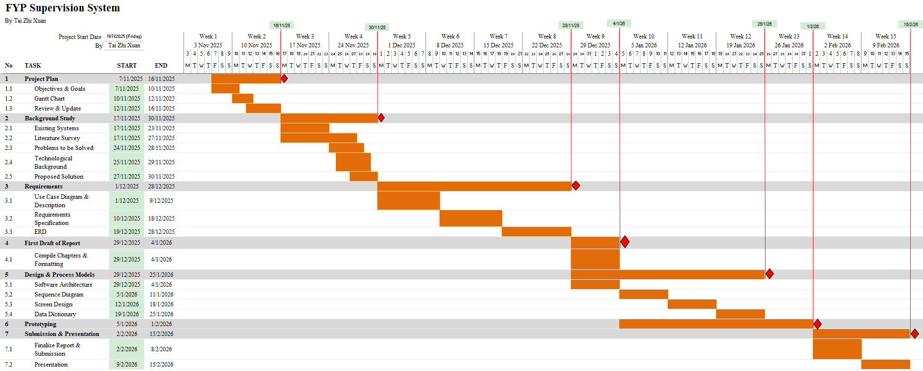
Figure 1.1 Gantt chart for Trimester 1
The above Gantt chart gives the complete work plan for Final Year Project 1 (Trimester 1) from Week 2 to Week 15, and how each task is planned and how the deliverables are planned towards the final submission and presentation of the project. The plan begins with the phase of Project Plan in which the objectives and goals of the project are set, the Gantt chart is prepared, and review and update are done to ensure that the scope and time of the project are realistic. After that, Background Study phase is carried out to strengthen the project foundation; analysing existing systems, literature survey to identify key problems in current FYP supervision practices, explaining the relevant technological background and lastly, concluding the phase with a proposed solution direction for the system.
Next, the project goes into the Requirements phase, which is one of the major phases in Trimester 1. During this time, the functional scope and user interactions are specified through the use case diagram, use case descriptions, while the system data structure is modelled using the ERD. In addition, the requirements specification is improved to ensure that the user requirements, functional requirements, and non-functional requirements are clearly documented and traceable. Once the requirements are done a first draft of the report is made to put the written chapters in a consistent format and provide a chance for feedback and improvement early on before the final report is submitted.
Following the report draft, the Design and Process Models phase is concerned with making a feasible solution design from requirements. This involves the overall software architecture definition, the modelling of key interactions by means of sequence diagrams, the preparation of screen design in order to visualise the main interfaces, and the creation of a data dictionary to describe database entities, attributes and constraints in detail. The plan then provides time for prototyping, in which an initial working version of the system is created to demonstrate the primary workflow of the system and verify design decisions. Finally, the schedule ends with activities of report submission and presentation preparation, such that lots of time is spent in slide preparation and rehearsal. Overall, the Gantt chart helps to ensure that the phases have predetermined deadlines and that the work load is evenly distributed in an organized manner over the course of the trimester.

