Chapter 2: BACKGROUND STUDY

2.1 Existing Systems
The management of Final Year Projects (FYP) in the academic institutions has evolved with the introduction of web-based systems to a great extent. Many universities have established dedicated FYP portals to manage the project registration, supervision and assessment. However, these systems often only focus on the digitisation of forms and the submission of documents, while important supervision activities (e.g. supervisor assignment, quality checking of the proposal and progress tracking) are still dealt with manually or on a separate platform. This section explores a few existing systems in Malaysian universities as well as learning management and collaboration tools widely used in Malaysia higher education and identify the strengths, weaknesses and opportunities for improvement.

2.1.1 Multimedia University (MMU)
At Multimedia University (MMU), a compulsory component of the Final Year Project is included for all undergraduate programmes in the Faculty of Computing and Informatics (FCI). The FYP Handbook outlines the structure of the project and provides assessment components and report format, with an emphasis on independent work, good project management and use of the APA style of academic writing.
FCI currently manages FYP activities through use of an internal web-based portal called FYP System 3.0. As shown in Figure 2.1, FYP System 3.0, provides a home page which contains announcements, link to "Available Projects", "Confirmed Projects", "Students List", "FYP Registration" and login and registration panel for new students. The system is still being referred to as a prototype, and some functions are simply being added as we go along, but it has become the primary point of access for students and staff to access FYP-related information.
Within the context of FYP System 3.0, the supervisors send their project titles to the FYP committee in one or more rounds each trimester. Once approved, these titles become available for publication under the "Available Projects" section for students to browse. For student proposing projects, a specific "FYP Student Proposal Submission Process" has been issued by the faculty. The student first prepares a proposal and gives it to a potential supervisor. The supervisor reviews the proposal and may make revisions. After the proposal is finalised, the supervisor submits it into FYP System 3.0 and only proposals submitted through the system will be reviewed by FYP Committee. Students are clearly instructed not to submit proposals directly by email because proposals sent in this way will not be considered. This workflow ensures there is no direct proposal submission by students into the system and students rely on their supervisors to upload proposals for them.
Course registration is also partly done outside the portal. After a student and supervisor reach an agreement about a project, the student enters FYP System 3.0 so that the supervisor can associate the student with the selected title, and then uploads a manually signed registration form. Faculty administrators later use this form to enrol the student in the official FYP subject in the central academic system (CLIC). As a result FYP System 3.0 is more of a record keeping and listing tool than a full online workflow for project registration and approval.
Network accessibility is another limitation. FYP System 3.0 is hosted on the MMU intranet and is not available directly from the public Internet. Students who are off-campus will first be required to connect to the MMU Virtual Private Network (VPN) before they can access the FYP website. While this is a good security enhancement, it introduces technical processes for students who are not familiar with setting up a VPN or students with unstable connections and makes using the portal as a single, always-available point of access less practical.
In addition, there are multiple other platforms that MMU uses during the lifecycle of the FYP. The MMU Online Portal and eBwise (a Moodle-based learning management system) are used for course management, meeting-log submission and announcements, and Turnitin manages the checking of plagiarism, and email is still used for many informal communications. These platforms are not specifically geared toward one-to-one FYP supervision workflows, automated supervisor recommendation or integrated progress tracking. As a result FYP information is scattered in FYP System 3.0, VPN restricted intranet pages, eBwise, and email. There is no central, intelligent platform to combine project registration, proposal analysis, supervision records and analytics. This piece-meal and access-limited environment is the motive behind the need for a better FYP supervision system with more intelligent features.

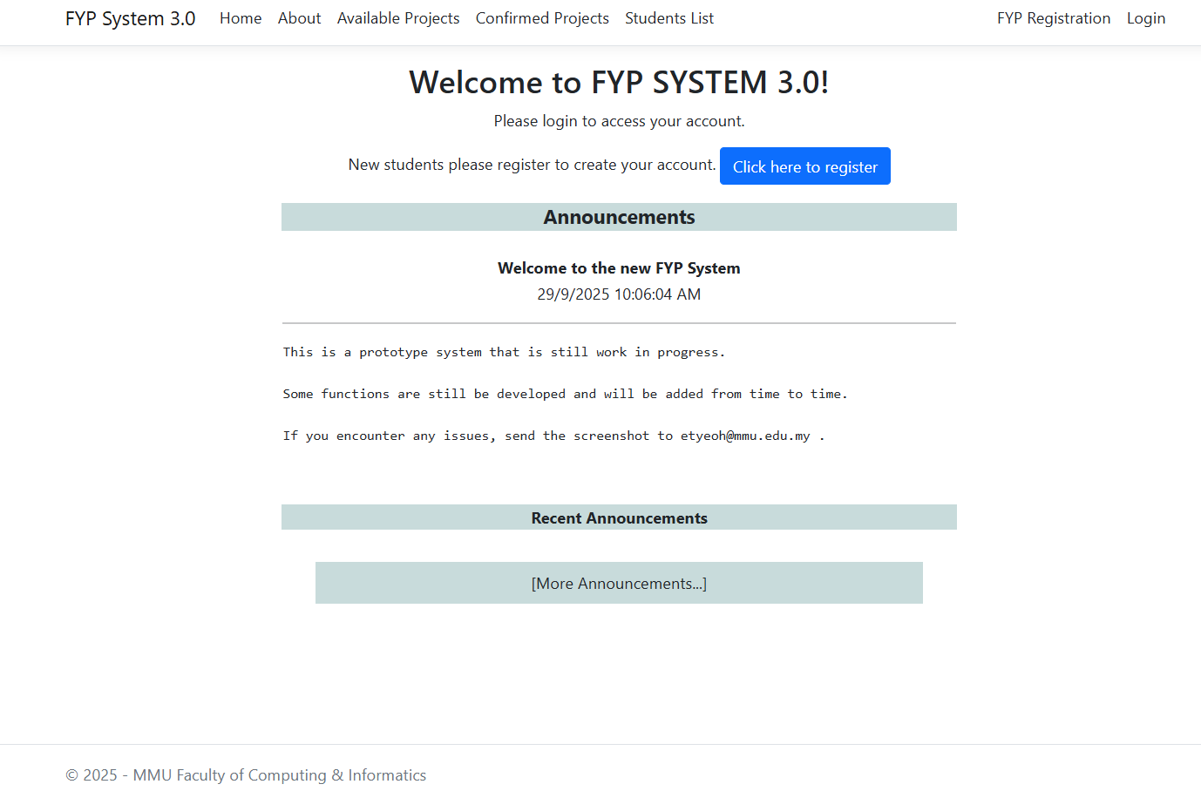
Figure 2.1 MMU FCI FYP System 3.0 – Home Screen

2.1.2 Universiti Malaysia Sarawak (UNIMAS)
The Faculty of Computer Science and Information Technology (FCSIT) Universiti Malaysia Sarawak (UNIMAS) has an online FYP Management System v2.0. The homepage offers fast access to general documents including poster templates, paper formats and user guides as well as specific sections for FYP 1 and FYP 2. Each section includes course outlines, assessment rubrics and report preparation formats. This set up aids standardisation of documentation and gives students easy access to key resources.
One of the most remarkable features in the UNIMAS system is the "Supervisor List by Majoring" section. Supervisors are presented in coloured cards organised by specialisation (e.g. Computational Science). Each card contains the supervisor's name, email address, existing number of supervisees, number of supervision quota and a "Register Now" button. Students can search through this list to find available supervisors in their major and start the registration process from within the system. This user interface makes supervisor availability transparent and reduces guess work when students are looking for a supervisor.
Despite these benefits, information distribution and manual registration are still the focus of the UNIMAS portal. Decisions on the choice of supervisor are still made entirely by students and coordinators, based on reading profiles and quotas. There is no AI-powered recommendation engine that automatically matches the proposals to the supervisors based on their research interest and no visible module for automated analysis of the proposals or integrated analysis of the meeting logs. As such, the UNIMAS system is a good example of a well-structured FYP portal based on manual judgment for decisions on supervision.
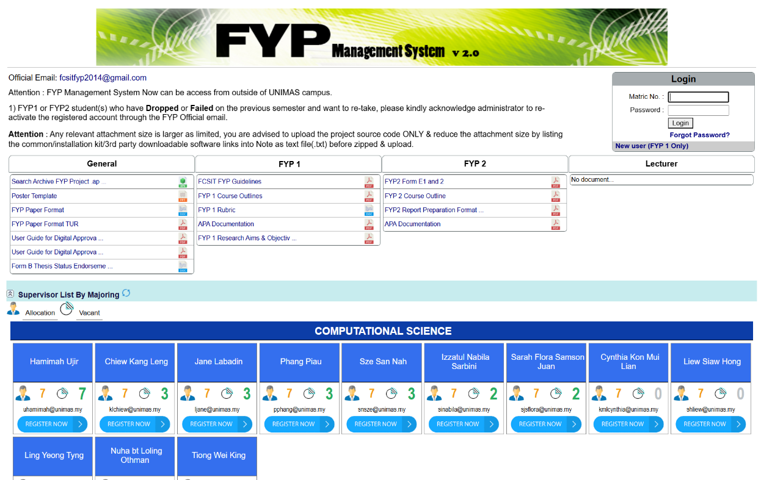
Figure 2.2 UNIMAS FYP Management System v2.0 – Home Screen

2.1.3 Universiti Malaysia Perlis (UniMAP)
Universiti Malaysia Perlis (UniMAP) has faculty-level FYP portals such as the FTKEN FYP System for the Faculty of Electronic Engineering Technology. The system gives role based login to FYP committee, supervisors & students. New users can register for an account and existing users can reset passwords through the same interface. Once logged in, users get access to functions such as project registration, title management and basic reporting.
The UniMAP portals centralise the information about the projects and standardise how the FYP data is captured. They usually give the supervisors the option to suggest titles for projects, the students to choose titles or submit proposals, and coordinators to keep track of the total list of projects in a faculty. This approach lessens the need for paper forms and informal communication and it can ensure that all official titles and assignments are held in one database.
However, like the UNIMAS system, the main functions of the UniMAP portals are data entry/retrieval functions. There is low evidence of such advanced features as intelligent supervisor balancing, automated analysis of proposal content or tools to monitor supervision activity across time. The systems enhance administrative efficiency but currently do not implement the AI or analytics to aid in decision-making in supervision.
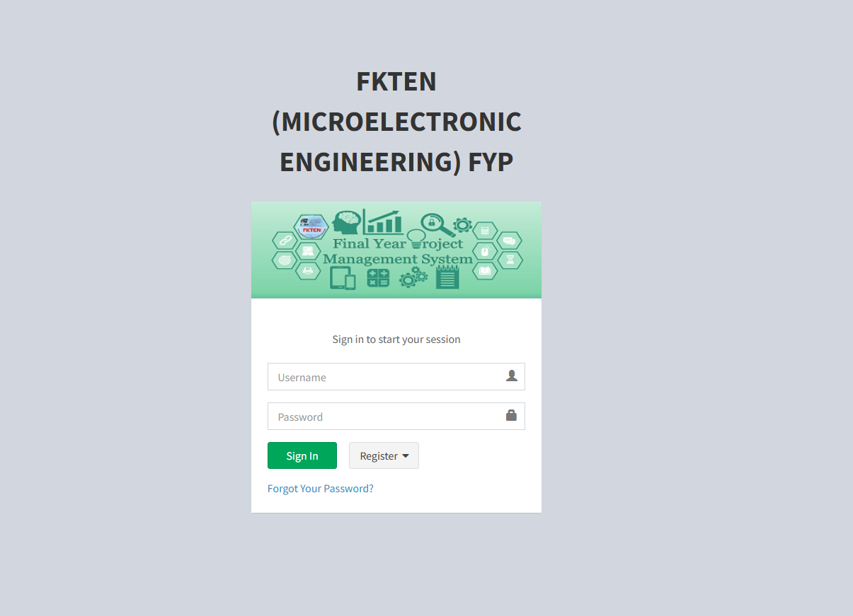
Figure 2.3 UniMAP FTKEN Final Year Project Management System – Registration Screen

2.1.4 Universiti Teknologi MARA (UiTM)
A number of faculties in Universiti Teknologi MARA (UiTM) have developed their own FYP management and assessment systems. One example is a web-based Final Year Project Management System which helps in substituting manual processes and minimising the errors in storing the project information. The system is intended to serve as a central place for students to register projects, students/ supervisors to monitor progress and project coordinators to track FYP activities. Another example is the Final Year Project Assessment System (FYPAS), which uses digitalisation to digitise the evaluation process by enabling evaluators to enter marks online and calculate final scores automatically.
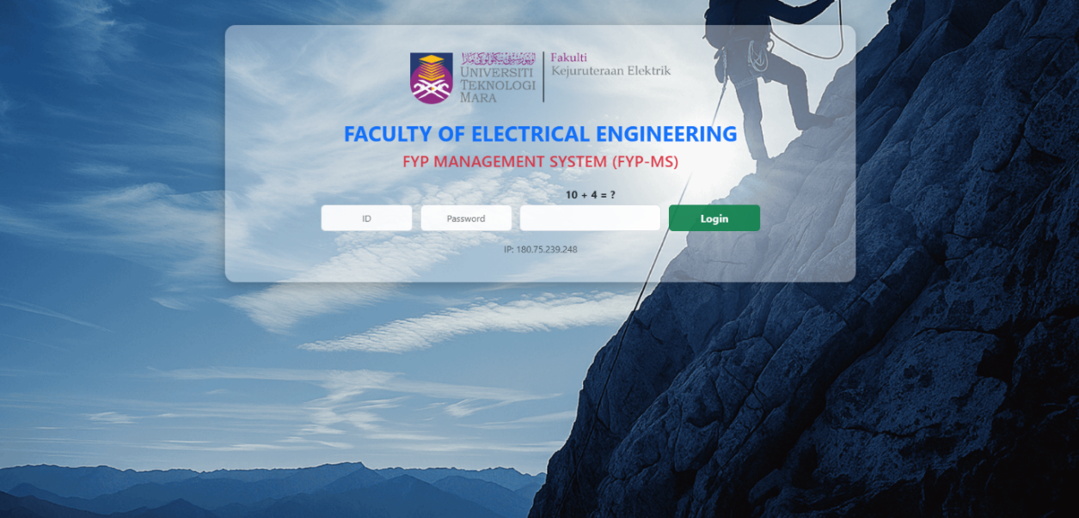
These systems are an example of the benefits of centralised data management and electronic assessment. They minimise paperwork, reduce the processing time and allow better audit trails for evaluations. Nevertheless, their primary focus remains on the automation of workflows and grading rather than on intelligent support for supervision as such. Students still usually search for supervisors manually and proposal quality is still determined by human reviewers without the benefit of automated text analysis. Features such as supervisor recommendation, proposal scoring or chatbot-based guidance have not yet found wide incorporation.
Figure 2.4 Universiti Teknologi MARA (UiTM) FYP Management System – Login Screen

2.1.5 Universiti Teknologi Malaysia (UTM)
Universiti Teknologi Malaysia (UTM) has a comprehensive FYP portal under the name of "My First Thesis". The website offers a well-constructed path for the students through the menu items such as “Start Your FYP”, “Briefing for FYP”, “Logbook”, “Template”, “File Uploading”, “Assessment & Dates”, “FYP Report”, “FYP Seminar” and “Technical Paper”. Students are guided through three stages of first attending briefings, then proposing a topic, keeping a logbook, preparing reports according to official templates and finally submitting the e-report and technical paper via the portal.
For topic registration, the portal provides a Topic Proposal form in which the student can enter some important information like programme, proposed supervisor, title, objectives and scope and then submits the proposal. This ensures that critical information in a standard format is captured and stored digitally from the start of the FYP process. The same portal also provides for online logbook entries and file uploads for various deliverables which provide for a more complete workflow than many older systems.
Even with this rich feature set the UTM portal is still relying on manual decision making. The system collects and stores data but there is no automatic analysis of the content of proposals or recommendation of supervisor based on research interests and capacity. Meeting logs are maintained as logs or uploaded files but there is little evidence for higher-level analytics such as automatic alerts for inactive projects or supervision dashboards. Consequently, the UTM system is a mature embodiment of process digitalisation but it is not yet an AI-enhanced supervision platform.
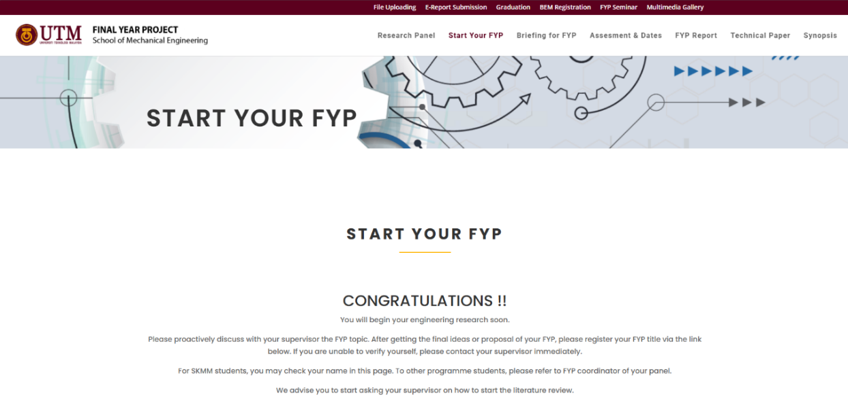
Figure 2.5 Universiti Teknologi Malaysia (UTM) FYP Portal – Home Screen

2.1.6 Learning Management Systems (LMS) with Project Features
Apart from dedicated FYP portals, many universities are using general purpose learning management systems (LMS) such as Moodle and Canvas in teaching and assessment. MMU, for instance, uses eBwise, which has been built on Moodle, to deliver course materials, assignments and quizzes. Lecturers may post resources, build online activities and grades while students may turn in assignments and join forums.
Moodle is an open source LMS which allows educators to build online courses with resources, assignments, quizzes, forums and gradebooks. It supports file submission, feedback, grading and tracking of learner progress and can be access via web browser or mobile app. Because of this flexibility some institutions re-use Moodle course shells to manage FYP deliverables and communication (using the Assignment activity for example to collect proposals and reports, or forums to communicate announcements). Nevertheless, Moodle is built on the basic philosophy of course over one-to-one supervision workflow structures. It does not natively support features such as supervisor load balancing, automatic proposal checks or integrated supervision analytics which may be project specific.
Canvas is another popular LMS created by Instructure. Canvas features, such as modules, online assignments, discussion forums, quizzes and an extensive Gradebook that provides instructors with a clear picture of learner progress and allows them to manage their assignment weightings and marks. Like Moodle, Canvas has the capabilities to host FYP-related activities through setting up a "course" for Final Year Project, assignment slots for interim and final reports, and discussions to communicate. It also integrates with 3rd-party tools, such as AI-assistant grading tools for programming assignments.
Despite all of these capabilities, both Moodle and Canvas are generic teaching platforms. They do not have in-built functions for automatic assignment of supervisor, modelling of supervisor capacity, maintenance of per-project meeting log with approval workflow or NLP analysis of FYP proposals. Any such processes would have to be implemented with the help of custom plug-ins or manual workarounds, often outside of a faculty project alone.
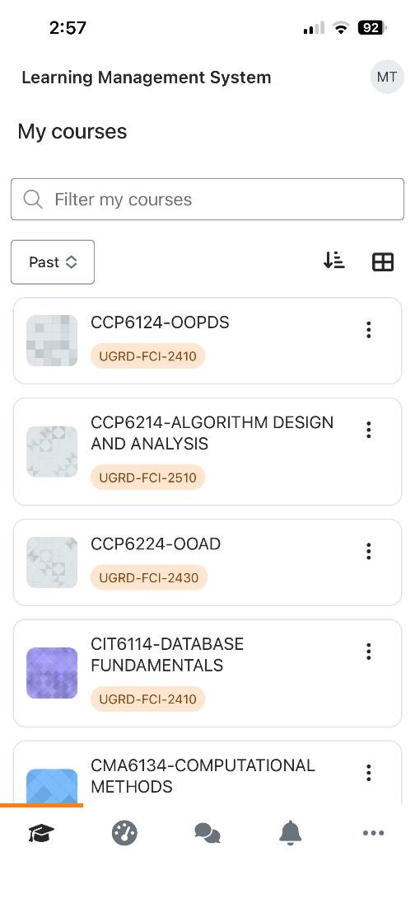

Figure 2.6 MMU Learning Management System (Moodle) – Mobile Course View

2.1.7 Microsoft Teams
Microsoft Teams is a communication and collaboration tool which has become popular in the educational world, particularly during and after the pandemic of Covid 19. Teams for Education allows teachers and students to communicate using chat, video meetings and channels, file sharing, and integrate other applications in Microsoft 365. In the education edition, class teams offer features like assignments, grading and class notebooks, allow teachers to send work out, collect work and feedback in a single interface.
Many universities, including MMU, are using Teams as an additional channel to FYP meetings, online consultation and files sharing. During video calls it is convenient when scheduling video calls, keeping the history of chats and storing shared documents in SharePoint. However, Microsoft Teams is not an FYP management system. It does not maintain structured metadata on projects (titles, objectives or supervisor quotas, for example) and it does not provide specialised tools for project registration, supervisor allocation or evaluation of proposals. Like Moodle and Canvas, it requires a lot of manual configuration and discipline on the part of the users to be an effective supervision platform.
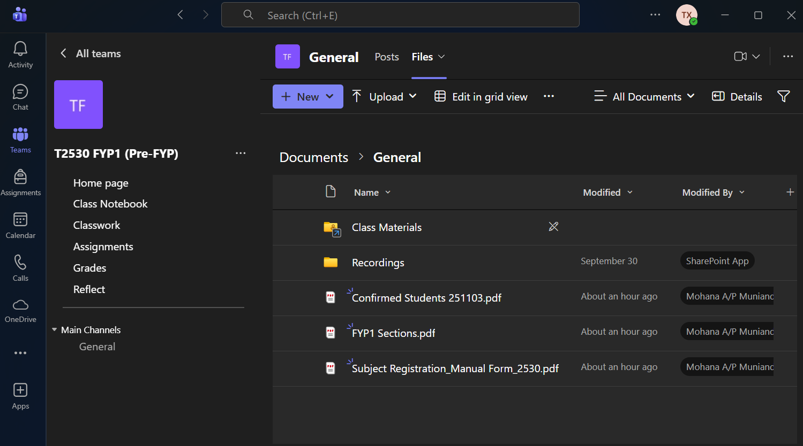
Figure 2.7 Microsoft Teams – T2530 FYP1 (Pre-FYP) General Channel Files

2.1.8 Summary
Overall, the majority of the reviewed FYP systems (MMU FYP System 3.0, UNIMAS FYP Management System, UniMAP faculty portals, UiTM faculty systems, and UTM "My First Thesis") have been effective in digitising most of the essential administrative components such as project listings, templates, project proposal forms, and registration records, and fundamental role-based access. Such general platforms as Moodle and Microsoft Teams also contribute to distributing documents, announcements, assignments, and online meetings, which assists universities to have a baseline structure of the FYP communication and assessment.
But in these systems, there are a number of loopholes that have remained the same. To start with, matching between the supervisors and the students is still very manual as the students have to scroll through the lists and verify the quotas informally and send emails to the supervisor to be sure that they have been matched. Second, the processing of proposals can be document-intensive and human-intensive and have few automated measures to verify that proposals include the necessary sections, or that its quality is up to the minimum standards. Third, the tools (portal, LMS, email, Teams, cloud drives) where supervision activities are carried out are usually fragmented, and it is hard to have a single and full supervision record that would consist of meeting history, action items, feedback and progress status. The availability limitations of the intranet like the dependency by the intranet in the context of MMU also make further impractical the usage of the portal off campus and the temptation to treat the portal as the sole source of truth.
Accordingly, even though the existing solutions enhance the efficiency of the administrative aspect, they do not typically include end-to-end supervision workflow integration, proposal intelligence (automatic completeness or quality controls), data-driven supervisor recommendation, and progress analytics dashboard. The above limitations are the direct reason why the proposed FYP Supervision System is needed, in which the centralisation of registration, proposals, meetings, logs, documents, and announcements into a single platform will be proposed, with AI-assisted modules (supervisor recommendation, proposal analysers, and chatbot support) being implemented to decrease the workload and enhance the quality of supervision.

2.2 Literature Survey
This section is a review of recent literature that is relevant to a web-based FYP supervision system.

2.2.1 FYP Management Systems
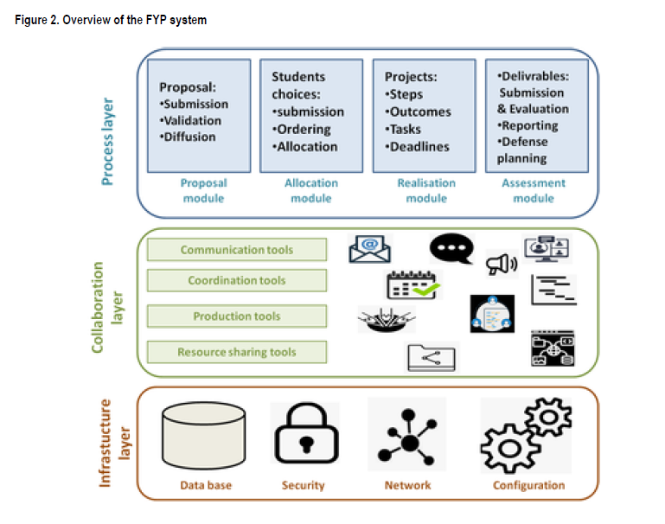
As student cohorts grow, efficient management of final year projects becomes more important. Many institutions have developed specific FYP management systems to attempt to make the supervision, project tracking, and communication process more efficient. Lounas et al (2023) presented an e-collaboration platform that covers the whole FYP lifecycle - from the proposal submission and project allocation to progress tracking and final evaluation. This multi-user system was intended for students, their supervisors, and administrators and provided them with the ability to communicate, coordinate, and share resources, while each user had their own personal workspace. Notably, the platform covered all the collaborative aspects of FYP supervision and the evaluation showed a positive result in terms of increased efficiency of the process with a positive user adoption. These findings highlight the importance of a centralized online system for better coordination and oversight for managing FYP.
Figure 2.8 Overview of the FYP system by Lounas et al. (2023)

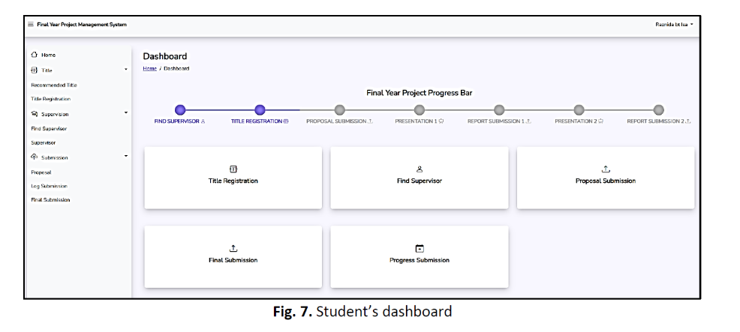
Similarly, Isa et al. (2024) created a prototype of a web-based FYP management system in an effort to improve project monitoring and project supervision. Their dashboard-driven application let students visualize their project timeline and progress, and also enabled lecturers and FYP coordinators to centrally monitor student performance and deadlines. The system helped in efficient three-way communication (student-supervisor-coordinator) and introduced automated alerts to make sure that important milestones were achieved. The expected benefits of this platform were better quality of supervision, less time delay in projects and a more structured FYP process.
Figure 2.9 Student’s dashboard in the FYP Management System by Isa et al. (2024)
In sum, the recent FYP management systems show that a centralized platform has the ability to greatly streamline the supervision process. Key features such as progress dashboards, integrated communication modules, and automated reminders have been shown to increase transparency and efficiency in the management of FYPs. Collectively, these works ensure the need for a dedicated FYP management module in the proposed system, which ensures that all stakeholders of the project (students, supervisors and administrators) are coordinated and informed throughout the project duration

2.2.2 AI in Education
Artificial intelligence has become an increasingly important part of modern education, providing tools that can be used to personalize learning and automate certain tasks. Research in AI in Education (AIED) has grown significantly in the last few years with a wide range of applications including, but not limited to, intelligent tutoring systems and administrative support. For example, a comprehensive review by Wang et al. (2024) outlines major categories of AIED applications including adaptive learning systems and personalized tutoring systems, intelligent assessment and grading systems, student profiling systems and performance prediction systems as well as other emerging AI-driven educational products. These technologies have been proven to improve a number of aspects of learning and management - adaptive systems can adjust instruction to individual student needs, while AI-powered analytics can help educators identify at-risk students using data trends. Importantly, such tools are not limited to classroom learning, but also to educational administration and decision-making, which is relevant for an FYP supervision platform.
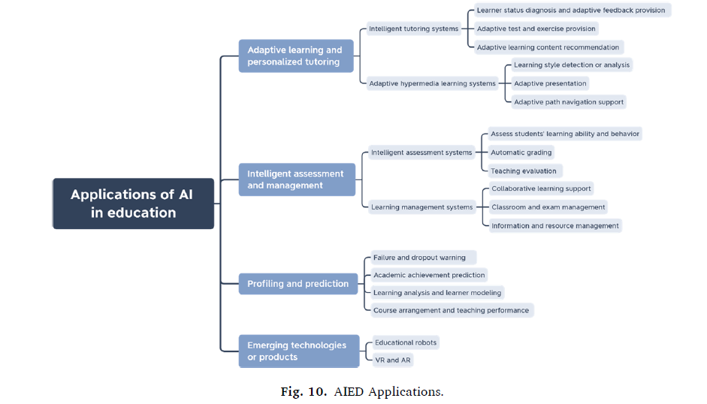
Figure 2.10 AIED Applications (four main categories of AI in Education applications).

Recent literature focuses on the point that integration of AI can have tangible benefits in education when done thoughtfully. A systematic review conducted by Garzon et al. (2025) demonstrated an increase in the amount of AI-education research since 2022 and reported a number of positive results of AI adoption. Notably, the use of AI tools has been linked to better learning outcomes, more personalized instruction, and increased student motivation and engagement. These benefits come from the fact that AI systems can give feedback immediately, be tailored to pace and learners can take more time to learn at their own pace, and instructors can be freed from some of the repetitive work to focus on higher-level mentoring. At the same time, researchers warn of challenges, such as ethical considerations, data privacy and teacher's readiness for AI tools. For example, the implementation of AI in a "smart classroom" environment helped the teachers with classroom management and with hybrid learning, but also created technical complexities and cost issues which need to be addressed by institutions. Similarly, Saputra et al. (2023) mentioned that the use of AI can enhance assessment and administrative processes, although there are challenges that could impact this process, including a lack of pedagogical frameworks and low digital literacy among employees.
In the light of the proposed FYP supervision system, the above insights suggest that exploiting the AI elements could contribute to an important level of additional functionality. By incorporating AI-powered modules the system can help to automate labor-intensive tasks and offer data-informed support to educators. Prior studies confirm that when used properly, AI in education is not only a matter of increased efficiency, but can also maintain or enhance the quality of education by allowing for more personalized and timely support to students. Therefore, the design of our FYP supervision system will include implementation of AI techniques for areas that can be shown to have benefits - for instance, by using machine learning to automatically assess drafts of proposals or match students with suitable supervisors - while keeping in mind ethical and usability considerations mentioned in the literature.

2.2.3 NLP for Proposal Analysis
A core feature of the envisioned system is automated proposal checking, which relies on Natural Language Processing (NLP) to analyze students’ project proposals. Handling numerous proposals manually is time-consuming and prone to inconsistency, especially as project topics grow interdisciplinary. Studies show that NLP can effectively assist in understanding and classifying proposal documents. For example, Chikwarti and Thomas (2023) developed an NLP-driven framework to automate the topic mapping and alignment of research proposals. They highlight that traditional manual classification of proposals is often “error-prone and inconsistent” in large-scale environments, whereas their approach uses transformer-based language models and domain ontologies to extract each proposal’s key thematic elements and categorize it appropriately. In their system, proposals are automatically classified according to scientific domains and even matched with relevant funding agency priorities by computing semantic similarity scores. This resulted in an impressive 89% classification accuracy on a test set of 5,000 proposals, significantly improving the speed and consistency of reviewer assignment and proposal routing compared to manual methods. Such a result demonstrates NLP’s capability to perform complex evaluation tasks (like reading and labeling proposal text) with high reliability and at scale.
Another pertinent study by Knisely and Pavliscsak (2023) applied NLP with semi-supervised machine learning to cluster research proposals by topic area. Through the use of state-of-the-art text embeddings (BERT), and a partial human-in-the-loop clustering approach, they were able to group the documents of a proposal into meaningful groups that matched thematic areas of interest. Notably, their semi-supervised method produced roughly 25% higher topic coherence in clustering results than fully unsupervised techniques, and this suggests that NLP techniques are able to capture the topical structure of proposals in a way that aligns well with expert judgement. These clustered groupings of proposals can be useful in finding trends in proposals or ensuring that similar project ideas are considered in a consistent manner. Other NLP applications in proposal analysis are plagiarism detection and originality checks, automated readability or quality evaluation and extraction of information for decision support. For example, NLP-based plagiarism detection systems are becoming more and more advanced in the ability to compare the text, and detect the overlaps, which could be used to check that student proposals are original.
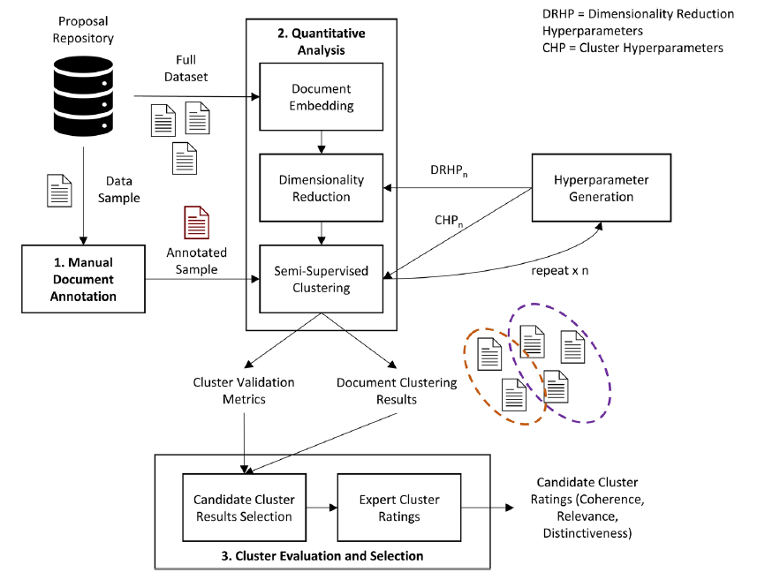
Figure 2.11 Overview of the NLP-based semi-supervised clustering methodology for research proposal categorization
Drawing from these works, the proposed FYP supervision system will incorporate an “automated proposal analysis” component that leverages NLP to support academic staff. Specifically, the system could parse each submitted project proposal, automatically classify its academic field or topic keywords, and flag potential issues. By doing so, the system provides a form of automated preliminary review, helping supervisors and FYP committees handle the growing volume of proposals more efficiently. The literature confirms that NLP techniques are capable of performing such analysis with a high degree of accuracy and consistency. This not only saves time but also contributes to fairness and early feedback for students. In summary, NLP-based proposal analysis, as evidenced by current research, is a viable and valuable addition to a web-based FYP supervision system’s feature set.

2.2.4 Supervisor Recommendation Systems
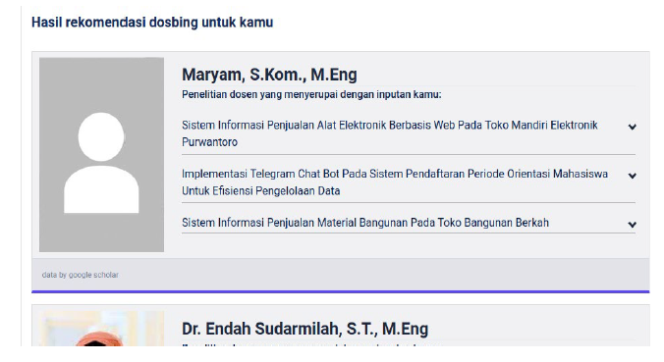
Matching students with the appropriate project supervisor is a critical component of FYP management as a good match can increase student motivation and project success. Traditional allocation on a manual basis is often based on limited information or informal "word-of-mouth" recommendations. Recent research has therefore investigated automated supervisor recommendation systems to optimise this matching process. One of the key findings is that having a student's project topic be of interest to a supervisor's expertise has a significant impact on the FYP's success: students are often more enthusiastic and better guided when working with supervisors who are knowledgeable of the topic of the project. Falah and Suryawan (2022) handled the aforementioned problem by designing a content-based filtering recommender system that recommends appropriate supervisors based on the content of proposals. In their system, a student enters the title, abstract, and keywords of their proposed project and the algorithm calculates the cosine similarity between the student's project proposal and the research profiles of faculty members. The name of those supervisors whose published work has the closest affinity with the topics proposed is then recommended. This approach proved effective - the application was able to find supervisors whose interests and expertise were in line with the students' proposals, thereby validating the premise that text similarity can be used as a proxy to measure research fit. By automating the process of searching and comparing, the system enabled students to find an advisor more in a data-driven way, rather than using a purely ad hoc knowledge.
Figure 2.12 Results page of the supervisor recommendation system (cosine-similarity / content-based filtering output)
Another advanced implementation is the two-way supervisor recommendation system by Dasri et al. (2025). They do not just take the preferences and project topic of the student into account but also consider the preferences or capacity of the supervisors, so there is actually a mutual matching model. Their solution is based on a skyline query algorithm (k-skyband) to deal with multiple criteria for matching and compare a traditional approach (Block Nested Loop, BNL) with a big data optimized approach (MapReduce k-skyband). In testing, the MapReduce based model brought dramatic improvements in scalability - performing 8x faster computation speed than the BNL method, vital for handling large datasets of students and supervisors. The system used a database of 239 research topics entries to make an educated guess on what students are interested in researching, then comparing them with possible supervisors areas. The recommendations were tuned (with an optimal parameter k=16 for the skyband algorithm) to balance between relevance and diversity of recommendations. Feedback on this system was positive: in a user study, students rated the recommended supervisor lists very favorable on relevance (score 3.5/4), topic diversity (3.7), serendipity (3.4) and novelty (3.5). Such evaluations suggest that recommendations from the matches not only were accurate but were introducing students to supervisors whom they might not have considered themselves, but not overloading them with irrelevant options. Furthermore, Dasri et al. note that with a better student-supervisor matching process the system can eventually lead to an improved supervision experience and potentially contribute to the on-time completion rate.
These studies highlight feasibility and the benefits of an intelligent supervisor allocation feature in an FYP system. For the proposed platform, a Supervisor Recommender Module will be designed to automatically propose a list of suitable Supervisors for a given project proposal using techniques from the above works. This module could perhaps combine content based analysis similar to the two way model by Dasri et al. The goal is to insure each student is matched with a faculty supervisor with relevant expertise and interest in the project area, therefore creating a more supportive and productive mentorship. By automating this process, the system can improve fairness and transparency in the allocation of supervisors, as well as be better adapted to changing conditions than static manual allocation. Ultimately, the literature seems to indicate that such recommendation systems can lead to an improvement in student satisfaction and student outcomes of capstone projects, and is well aligned with the goal of improving the FYP supervision process.

2.2.5 Chatbots in Academic Environments
Universities are increasingly using chatbots as virtual assistants to assist students both outside the classroom. These AI-driven conversational agents can assist with various student queries ranging from responding to common questions about administrative procedures to offering guidance on academic issues. A recent review by Peyton et al. (2025) looking at university chatbots for use in student support, identified that although there are many different implementations, the higher education sector is still investigating the full potential of this technology. Campus chatbots can complement student service by being available 24/7 and providing instant responses, to complement the work of the academic and support staff. For example, chatbots have been used to answer questions about course enrollment, deadlines, campus facilities or technical support, which helps to lessen the response load on university offices. Peyton et al. state that many institutions have reported positive results including enhanced student engagement and satisfaction with the entire learning process when routine queries are managed and offered by AI chatbots because students receive timely responses at any given time of the day. They also emphasise observations by previous researchers that chatbots provide "personalisation and 24/7 instantaneous availability" in educational settings which makes them a promising resource to use for student interaction. However, the review also identified challenges: creating a high-quality chatbot for a university often involves bringing together a lot of domain-specific data which can be hard to curate. Additionally, many universities have not yet fully harnessed the capabilities of advanced conversational AI - conversational AI chatbots of the past were often rule-based and limited in scope. The advent of state-of-the-art NLP and generative AI is an opportunity to build more flexible and intelligent academic chatbots. Peyton et al. have suggested that by taking advantage of existing institutional data, combined with newer AI frameworks, universities are able to develop chatbots that go beyond the simple FAQ to support more interactive and context-aware support.
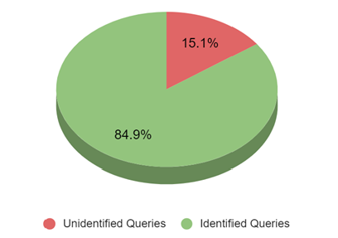
In the context of an FYP supervision system, an integrated chatbot could be a first-line 'help desk' to students, and even supervisors. Such a chatbot can be programmed to provide responses to frequently asked questions around the FYP process, thereby clearing doubts on procedures on the spot. The real-world deployments prove the viability of this approach. For example, Nadir et al. (2025) deployed "SQUbot", an AI-powered chatbot in the Sultan Qaboos University to help students with various academic and administrative queries. Notably, SQUbot was bilingual (English and Arabic), to reflect the linguistic needs of the student population, and used IBM Watson's NLP services for intent recognition and dialogue management. The chatbot could be able to impart general information as well as personalized responses for things like the student's own timetable or the state of their project. During pilot testing, SQUbot had about 84.9% accuracy in the ability to understand student queries i.e. correctly recognized the intent of almost 85% of questions asked. Most of the unanswered queries were as a result of either very colloquial phrasing or questions outside of the scope the chatbot was trained for, which the developers responded to by refining the training data and adding fallbacks. Overall, the implementation was considered to be successful as it greatly relieved the staff from a great deal of routine enquiries and helped students to gain quick assistance on all hours.
Figure 2.13 Identified vs. unidentified student queries in SQUbot pilot testing
For our proposed system, a chatbot component in the FYP portal can be used in a similar way to enhance the user experience by not only immediately addressing FAQs related to FYP supervision. Students could pose questions to the chatbot such as "How do I submit my project draft?" or "What is the rubric for how I can evaluate proposals?" And get the answers immediately and consistently based on the FYP handbook or system database. Supervisors and administrators may also use the chatbot to perform quick queries. By referring to the methods discussed by Peyton et al. and the success of systems such as SQUbot, we would create the chatbot with strong NLP methods and an integration with the knowledge base of the FYP system. The chatbot would work within a defined scope (FYP-related content) in order to keep the accuracy high, but be expandable in scope as new common questions are asked. This is consistent with findings that closed-domain chatbots need to be continually curated but can be a major source of reducing friction in day-to-day academic activities. Ultimately, the inclusion of a chatbot aligns with the aim of a student-friendly, self-service platform: it will enable students to access the support and information they need when they need it, in addition to the support given by human supervisors and FYP coordinators.

2.3 Problems to be solved
Based on the analysis of the existing systems and the related literature, there are several key problems that are not solved in FYP supervision process especially in MMU FCI. First, supervisor-student matching is still highly a manual operation. Whether students have a supervisor with a proposed title or have come up with their own idea, students are expected to identify and approach possible supervisors on their own. Supervisor capacity and research interests need to be checked informally, usually resulting in repeated exchanges by email, competition for popular lecturers and uncertainty for students who have no experience of staff expertise.
Second, MMU's current FYP system is not a fully integrated and online proposal submission and validation system. While other institutions like UNIMAS and UTM are already offering structured forms to provide the topic proposals online, MMU students are generally trading the proposals with documents and email with no automatic validation related to the content. As a consequence there are proposals that are inconsistent in terms of format and fail to include important parts of the proposal, e.g. objectives, scope or methodology, leaving extra work to supervisors and coordinators. This is added to the high volume of repetitive procedural queries. Coordinators and supervisors often get the same questions about deadlines, how to report, how to submit and how to evaluate. Whilst guidelines and announcements are published by existing systems and LMS platforms, students can miss them or misunderstand them and without a self-service, conversational interface, staff have to waste valuable time answering routine enquiries instead of supervising academics.
Third, supervision records are scattered on a number of platforms. Meeting logs, feedback, draft reports and assessment forms are stored separately in eBwise, email, local devices, Turnitin and informal messaging channels. This fragmentation makes it difficult to create a more complete picture of a student's history and trajectory as they are being supervised, and makes it impossible for coordinators to have a consolidated, real-time view of what is happening with a particular project across the faculty. Last but not least, there are limited analytics and early warning mechanisms on existing systems. There are generally no dashboards or automatic indicators to identify students who are falling behind, supervisors that may be overloaded or proposals that could be problematic. Coordinators are required to use manual checks and ad hoc reports that are time consuming and may not pull up issues early enough for meaningful intervention.
These gaps suggest that it is not enough to have digitised forms and file uploads. A smarter and more integrated FYP supervision system is needed to enable data-driven supervisor student matching, structured proposals submission with automatic checks, active student support with self-service tools, and supervisor and coordinator monitoring and analytics.

2.4 Technological Background
This section presents the main technologies that will be used for development of the proposed FYP Supervision System and explains the reasons for the use of these technologies in the proposed project.

2.4.1 Backend and Database
2.4.1.1 Java Spring Boot (backend)
The backend of the system will be developed using Spring Boot, which is a popular Java framework for building web applications and APIs (Rest APIs). Spring Boot is used because:
- it facilitates fast development thanks to auto-configuration;
- it provides built-in support for common features such as dependency injection, validation and security; and
- it works well with relational databases and external services.
In this project, Spring Boot will be used in the authentication of the users, business logic for managing FYP (e.g. project registration and supervision records), and communication with the database and AI modules.

2.4.1.2 MySQL (database)
All persistent data, i.e. user profile, project details, proposals, meetings etc, shall be stored in a MySQL database. The popular open source relational database management system MySQL provides the following features:
- structured storage of data in tables with defined relationships;
- support for standard SQL queries; and
- good performance and reliability for web systems.
Using MySQL allows the system to maintain consistent and structured records of FYP-related information.

2.4.2 Frontend Technology

2.4.2.1 React (Client-Side Interface)
The interface will be created based on React, and it is a JavaScript library of creating interactive web interfaces. React is suitable because:
- it supports the development of single-page applications where the page updates without full reloads;
- it uses reusable components, which helps maintain a consistent look and feel; and
- it can provide a responsive and modern experience for students and lecturers.
Through the React frontend, users will be able to view project information, submit proposals, manage supervision meetings and interact with the chatbot.
2.4.3 AI and NLP Technologies
Python-based tools and libraries will be the primary instruments of the implementation of the AI-related features of the system (proposal analysis, supervisor recommendation and chatbot assistant).
2.4.3.1 Flask Microservices (Python AI Modules)
The AI functions will be packaged into microservices that will be developed on Flask, a simple Python web framework. Every AI-based feature may be launched as a standalone Flask service, for example:
- a proposal analysis service that receives proposal text and returns feedback,
- a supervisor recommendation service that accepts a project description and returns a ranked list of supervisors, and
- a chatbot service answering typical FYP-related questions.
This microservice design ensures that AI logic is not coupled with the primary Java backend and, therefore, a service can be developed, tested and scaled independently. These Flask services will be communicated with the Java backend through the use of REST APIs.
2.4.3.2 TF-IDF and Cosine Similarity
To process text-based matching tasks (e.g. matching proposals to the profiles of supervisors), the system will work with Term Frequency-Inverse Document Frequency (TF-IDF), which will convert documents into numerical vectors. The description of each proposal and supervisor research profile will be shown as a TF-IDF vector.
Cosine similarity will be used to find the similarity between vectors of two pieces of text to measure the similarity. An increased cosine similarity means that more significant terms are shared between the texts and, therefore, they are similar. This method is fast enough computationally and can be effective with sparse text representations and is therefore appropriate to the supervisor recommendation part.
2.4.3.3 spaCy (NLP Library)
The project will adopt the use of the spaCy which is an open-source python library of industrial strength tools of natural language processing. spaCy provides fast and accurate natural language processing tools:
- tokenisation,
- part-of-speech tagging,
- named entity recognition, and
- dependency parsing.
To analyse the proposal, spaCy can assist in the parsing of the document, in the identification of essential phrases or technical terminologies and the examination of the sentence composition. This data may be utilized to verify the presence of critical areas (e.g. problem statement, objectives, methodology), as well as to aid more sophisticated rule-based or statistical tests of the quality of the proposal.
2.4.3.4 Rule-Based NLP Checks
In addition to statistical or machine learning models, the system will use rule-based NLP for straightforward validation tasks. Example rules include:
- verifying that a proposal contains at least one sentence mentioning an “objective” or “aim”,
- checking that the total word count exceeds a minimum threshold, or
- flagging proposals that do not mention a problem context or proposed solution.
These rules act as a checklist to enforce basic requirements that do not necessarily require complex models. They complement TF-IDF and spaCy by providing deterministic constraints on proposal structure and content.

2.4.4 Integration
RESTful APIs will be used to communicate between all components in the system using HTTP and JSON:
- The Spring Boot backend will expose endpoints for the React frontend to perform operations such as login, project registration, proposal submission and meeting management.
- The Flask AI services will have endpoints such as /analyzeProposal, /recommendSupervisor and /chatbotQuery. These endpoints will be called by the backend when there is a need to process the AI.
This design keeps the frontend, backend and AI modules loosely coupled so that each part can be developed and maintained separately.

2.4.5 Summary
To conclude, the system will use Spring boot and MySQL as a stable backend and data layer application, and React as a user-friendly web interface, whereas Python/Flask and Natural Language Processing (NLP) methods like TF-IDF, spaCy and rule-based checks will be utilized to give a system an intelligent support. Such a combination will suit building a modern maintainable FYP supervision system, both normal and AI enhanced functionality.

2.5 Proposed Solution
This project proposes a web-based FYP Supervising System which centralises the entire supervision workflow and introduce the intelligent support features. The system is to be developed using three-tier architecture in which Spring Boot backend will be used to implement business logic and the Restful APIs, MySQL relational database will be used to store all the data related to FYP (Students, Supervisors, Projects, Proposals, Meetings, Documents and Logs) and React web frontend will be used to provide role-based interfaces to the users (Students, Supervisors and Coordinators). User authentication and authorisation will make sure that each role only has access to functions that are relevant to them, while a structured data model takes the place of the current scattered use of emails, spreadsheets and shared folders. By bringing information into a single system, the solution is meant to decrease confusion, duplicated effort and missing records.
To solve individual problems of supervision, several AI modules will be used which are implemented as separate microservices in Python Flask and connected to the main system by using Rest. A Supervisor Recommendation module will use NLP (e.g. TF-IDF and similarity matching) to match a project description left by a student with the supervisor profiles and will offer suitable supervisors based on the interests of the research and on the past projects, which will decrease the amount of work of manual matching and will allow to evenly distribute the supervision load. A Proposal Analyzer module will be able to automatically verify if a submitted proposal contains important sections (problem statement, objectives, scope and methodology, etc.), and highlight sections that are missing or weak so that students can improve their work before their proposal is evaluated formally. In addition, a Chatbot Assistant, powered by retrieval-based NLP over the FYP handbook, briefing slides and FAQs will answer common questions regarding procedures, deadlines and requirements, reducing repetitive enquiries to supervisors and FYP coordinators.
Overall, the complete solution of the proposed problems found in the current supervision process (fragmented communication, manual tracking, difficulties of finding suitable supervisors, heavy administrative workload) is the combination of a modern web application stack (Spring Boot, MySQL, React), with focused AI microservices (supervisor recommendation, proposal analysis and chatbot support). The proposed solution is expected to make the FYP supervision process more organised, transparent and efficient for MMU FCI students, supervisors and administrators.

REFERENCES
Abdul Aziz, M., Kamaruzaman, F. J., & Abu Hashim, A. H. (2018). The development of E-Research Engine System for Final Year Project (FYP).
Ahmad, M. H. (2011). Web-based FSKM Final Year Project Management System [Bachelor’s thesis, Universiti Teknologi MARA]. UiTM Institutional Repository.
Chikwarti, D. K., & Thomas, J. (2023). Automated topic mapping and alignment in research proposals using NLP-driven ontologies. International Journal of Advanced Engineering Technologies and Innovations, 1(5), 23–33.
Dasri, D., Annisa, A., & Haryanto, T. (2025). Two-way thesis supervisor recommendation system using MapReduce k-skyband view queries. International Journal on Informatics Visualization, 9(1), 163–175. https://doi.org/10.62527/joiv.9.1.2800
Falah, Z. F., & Suryawan, F. (2022). Recommendation system to propose final project supervisors using cosine similarity matrix. Khazanah Informatika: Jurnal Ilmu Komputer dan Informatika, 8(2), 1–10. https://doi.org/10.23917/khif.v8i2.16235
Garzón, J., Patiño, E., & Marulanda, C. (2025). Systematic review of artificial intelligence in education: Trends, benefits, and challenges. Multimodal Technologies and Interaction, 9(8), Article 84. https://doi.org/10.3390/mti9080084
Instructure. (n.d.). Canvas LMS: Learning management system. Instructure. https://www.instructure.com/canvas
Isa, R., Othman, S., Ali, A. S., Azizan, N., & Ferguson, J. (2024). Prototype development of final year project management system to monitor student’s performance. Journal of Advanced Research in Applied Sciences and Engineering Technology, 40(1), 164–173.
Kannan, M. (n.d.). Final Year Project Supervisor Management System [Undergraduate project report]. Universiti Malaysia Sarawak (UNIMAS).
Knisely, B. M., & Pavliscsak, H. H. (2023). Research proposal content extraction using natural language processing and semi-supervised clustering: A demonstration and comparative analysis. Scientometrics, 128(6), 3197–3224. https://doi.org/10.1007/s11192-023-04689-3
Lounas, R., Hamzaoui, I., Bouguelmouna, N., & Mokrani, H. (2023). An e-collaboration application for final-year project management. International Journal of e-Collaboration, 19(1), 1–17. https://doi.org/10.4018/IJeC.315787
Microsoft. (n.d.). Microsoft Teams for Education. Microsoft Education. https://www.microsoft.com/en-us/education/products/teams
Moodle. (n.d.). Moodle.org: Home. Moodle Project. https://moodle.org
Multimedia University. (n.d.). eBwise – Moodle user guides. MMU. https://ebwise.mmu.edu.my/guide/
Multimedia University. (n.d.). FYP System 3.0 [Web portal]. Faculty of Computing and Informatics, Multimedia University. https://fci-fyp.mmu.edu.my
Multimedia University. (n.d.). MMU Portal (CLiC and online services). MMU. https://online.mmu.edu.my
Nadir, Z., Al Lawati, H. M., Mohammed, R. A., Al Subhi, M., & Hossen, A. (2025). SQUbot: Enhancing student support through a personalized chatbot system. Technologies, 13(9), Article 416. https://doi.org/10.3390/technologies13090416
Peyton, K., Unnikrishnan, S., & Mulligan, B. (2025). A review of university chatbots for student support: FAQs and beyond. Discover Education, 4, Article 21. https://doi.org/10.1007/s44217-025-00397-7
Universiti Malaysia Perlis. (n.d.). FTKEN FYP System – Electronic Engineering (FKTEN) and Computer Engineering [Web system]. School of Microelectronic / Electronic Engineering Technology, UniMAP. https://ftkenfyp.unimap.edu.my/electronic/index.php and https://ftkenfyp.unimap.edu.my/computer/index.php
Universiti Malaysia Sarawak. (n.d.). FYP Management System [Online service]. Faculty of Computer Science and Information Technology (FCSIT). https://www.fcsit.unimas.my/my-fcsit/student/online-services
Universiti Malaysia Sarawak. (n.d.). FYP Management System v2.0 [Web system]. Faculty of Computer Science and Information Technology (FCSIT), UNIMAS. (Accessed via system interface and related project documentation.)
Universiti Teknologi MARA. (n.d.). FYP Management System (FYP-MS). Faculty of Electrical Engineering, UiTM. https://www.fee-uitm.com/fyp/
Universiti Teknologi Malaysia. (2021). Start your FYP – SKM Final Year Project Portal. School of Mechanical Engineering, UTM. https://mech.utm.my/fyp/start-your-fyp/
Wang, S., Wang, F., Zhu, Z., Wang, J., Tran, T., & Du, Z. (2024). Artificial intelligence in education: A systematic literature review. Expert Systems with Applications, 252, 124167. https://doi.org/10.1016/j.eswa.2024.124167

