Chapter 3: REQUIREMENTS

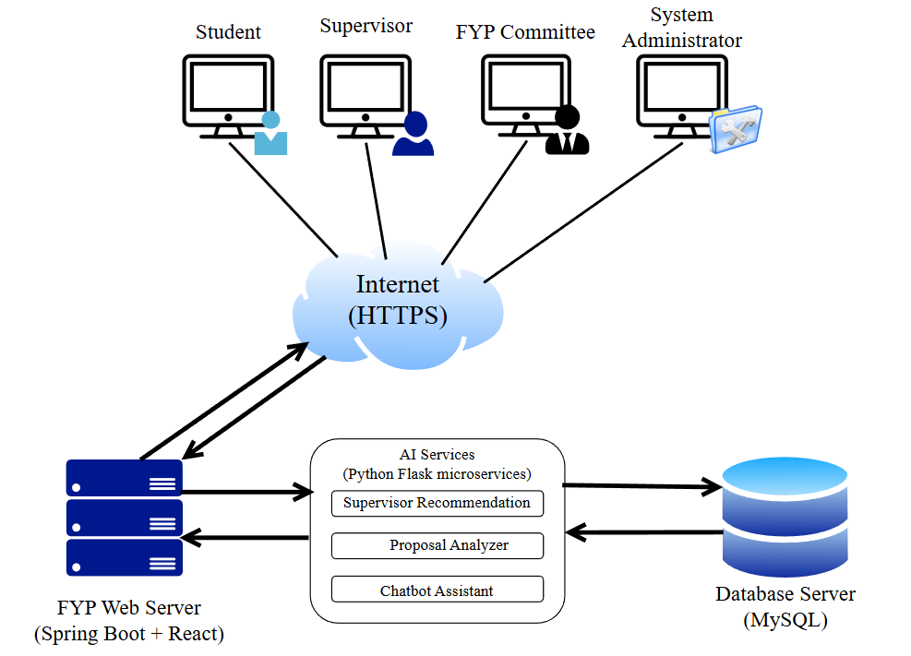
3.1 System Overview
Figure 3.1 System Overview
Figure 3.1 illustrates the overall architecture of the proposed FYP Supervision System. The system is implemented as a web-based client–server application. At the top of the diagram there are four user workstation icons:
- a computer icon labelled Student,
- a computer icon labelled Supervisor,
- a computer icon labelled FYP Committee, and
- a computer icon labelled System Administrator.
Each icon represents a user accessing the system through a web browser on a PC or laptop. In the centre of the diagram, a cloud icon labelled Internet shows that all users connect to the system via the Internet using secure HTTP/HTTPS. Arrows from each user workstation to the Internet cloud indicate these connections.
At the bottom of the diagram is the server layer. On the left, a rack-style server icon labelled FYP Web Server hosts the web application (frontend and backend) and processes all user requests. On the right, a cylindrical icon labelled Database Server (MySQL) represents the central database that stores users, projects, proposals, supervision logs, meetings, evaluation records and uploaded documents. Two-way arrows between the FYP Web Server and the Database Server indicate continuous reading and updating of data.
Next to the web server, a separate box labelled AI Services contains the AI modules used by the system (e.g. Supervisor Recommendation, Proposal Analyzer, Chatbot). A two-way arrow between the FYP Web Server and the AI Services box shows that the main application invokes these components through REST APIs when intelligent support is needed.
All users interact only with the FYP Web Server through the Internet; they do not access the database or AI services directly. This separation of concerns improves security, scalability and maintainability of the system.
The main roles in the system are:
- Student – registers projects, submits proposals and documents, books meetings and views feedback.
- Supervisor – manages supervisees, reviews proposals and documents, records meetings and provides feedback.
- FYP Committee – manages FYP configuration, users, project records, allocations and reporting for the faculty.
- System Administrator – maintains user accounts at system level, manages backups, monitoring and technical configuration.

3.2 System minimum requirements
This section outlines the minimum hardware and software requirements necessary to run the FYP Supervision System effectively. The system is designed as a web-based application using a Spring Boot backend, MySQL database, and optional AI microservices. Therefore, both client-side (student/supervisor devices) and server-side environments must meet the minimum specifications listed below.

3.2.1 Personal Computer (Client Side)
- Processor : Intel Core i3 (2.0 GHz) or equivalent
- Memory : 4 GB RAM or higher
- Storage : At least 10 GB free disk space
- Operating System : Windows 10 / 11, macOS, or Linux
- Web Browser : Latest version of Google Chrome, Microsoft Edge, Mozilla Firefox or equivalent (JavaScript and cookies enabled)
- Network : Stable broadband Internet connection (wired or Wi-Fi)
- Peripherals : Keyboard, mouse/trackpad and monitor with minimum 1366 × 768 resolution
These specifications are sufficient for students, supervisors, FYP Committees and system administrators to access the system via a web browser.

3.2.2 Application Server (Web + Database + AI Services)
For deployment in a small faculty environment (or on a dedicated virtual machine), the following minimum specifications are recommended:
- Processor : Quad-core Intel Core i5 / Xeon or equivalent (2.4 GHz or higher)
- Memory : 8 GB RAM (16 GB recommended for heavier usage)
- Storage :
  - Minimum 200 GB SSD or HDD
  - Separate logical volumes for:
    - Operating system and application files
    - Database data and backups
- Operating System : Windows Server 2019 / 2022, or a modern Linux distribution (e.g. Ubuntu Server LTS)
- Software Stack :
  - Java Development Kit (JDK 17 or above) for Spring Boot
  - Node.js + npm for building the React frontend
  - Python 3.x and Flask for AI microservices
  - MySQL Server 8.x for the relational database
  - Web server / reverse proxy such as Nginx or Apache HTTP Server
- Network :
  - Reliable Internet connection
  - Configured firewall and HTTPS support (TLS certificate)
For development and testing purposes, the client and server components may be hosted on the same physical machine (e.g. the student’s laptop), provided that the above minimum specifications are met.

3.3 Fact-Finding Techniques

3.2.1 Justification
Different stakeholders experience the FYP supervision process in different ways. Students experience the process directly through supervisor selection, proposal submission, meetings and report writing. Supervisors and coordinators interact with internal systems such as FYP System 3.0, eBwise and email. In order to capture these experiences in a systematic way, a combination of quantitative and qualitative techniques is used.
A questionnaire is suitable for collecting feedback from a relatively large number of students within a short time, and for quantifying common problems and preferences. Observation of existing systems allows the researcher to see how current tools actually behave in practice, beyond what is written in documentation. Using multiple techniques improves the validity of the requirements and reduces the risk of overlooking important issues.

3.3.1 Questionnaire Design
The questionnaire was designed and administered using Google Forms. It targeted two main groups of students in the Faculty of Computing and Informatics (FCI):
- Completed FYP students, who had finished their Final Year Project within the last one or two trimesters and therefore experienced the full supervision process from topic selection to final submission; and
- Current FYP students, who were taking FYP 1 or FYP 2 during the current trimester and could provide feedback on ongoing activities such as supervisor selection, proposal handling and supervision meetings.
The questionnaire is divided into several sections:
- Section 1: Background Information
This section collected respondents’ current FYP status (Currently taking FYP 1, Currently taking FYP 2, Completed FYP) and the systems/platforms they used for FYP-related activities. Examples included FCI FYP System 3.0, eBwise/Moodle, Microsoft Teams, Microsoft Outlook, WhatsApp/Telegram and cloud storage services such as Google Drive or OneDrive. Multiple selections were allowed for the systems/platforms item.
- Section 2A – Experience After Completing FYP
This section was displayed only to respondents who indicated that they had completed FYP. Using a 5-point Likert scale (1 = Strongly Disagree, 5 = Strongly Agree), it measured their perceptions of:
- alignment between supervisor’s research area and the FYP topic;
- ease of finding and contacting a supervisor;
- clarity of topic proposal and registration steps;
- satisfaction with proposal submission and revision;
- ease of booking and managing supervision meetings;
- ease of keeping track of meeting records;
- time spent checking multiple systems just to keep track of FYP information;
- clarity of FYP rules, guidelines and deadlines; and
- overall satisfaction with the current FYP supervision process and tools.
A multiple-response question then asked them to select up to three major challenges faced during their FYP (e.g. finding a supervisor, understanding rules and deadlines, managing files across platforms).
- Section 2B – Current FYP Supervision Experience
This section was shown only to students who were currently taking FYP 1 or FYP 2. Using the same 5-point Likert scale, it captured their current experience with:
- finding and contacting a supervisor;
- understanding proposal and registration steps;
- satisfaction with the proposal process so far;
- ease of booking and tracking meetings;
- fragmentation across systems;
- uncertainty about deadlines and formats; and
- perceived effectiveness of existing tools in supporting their FYP work.
They were also asked to indicate the main challenges they were currently facing, again selecting up to three options.
- Section 3 – Interest in Proposed Features
All respondents (Completed FYP and Current FYP) answered this section. A 5-point usefulness scale (1 = Not useful at all, 5 = Very useful) was used to assess their interest in several proposed features for a new FYP supervision system:
- an automatic proposal checker that highlights missing sections or unclear objectives;
- a supervisor recommendation feature based on the student’s proposed topic;
- a 24/7 FYP chatbot that answers common questions; and
- a single integrated platform combining project registration, proposal submission, meeting logs, file uploads and announcements.

3.3.1.1 Analysis of Questionnaire Results
An online questionnaire was conducted from 24 November 2025 to 30 November 2025, and 45 valid responses were collected from FCI students. The detailed question-by-question results, charts, and response distributions are provided in Appendix C.
Among the 45 respondents, 46.7% (21) had completed FYP, 31.1% (14) were currently taking FYP 2, and 22.2% (10) were currently taking FYP 1 (Appendix C). This distribution is useful because it captures both retrospective feedback from completed students and ongoing issues faced by current students.
The results show that FYP activities are not handled in a single platform. Nearly all respondents reported using multiple systems concurrently, including eBwise/Moodle (100%), Microsoft Teams (97.8%), Microsoft Outlook (95.6%), and the FCI FYP System (93.3%) (Appendix C). This confirms that students must switch across platforms to manage proposals, meetings, documents, and announcements, reinforcing the need for a unified supervision platform.
Key pain points in the current supervision process. For both completed and current students, the strongest issues are consistently related to supervisor matching, proposal process clarity, and tracking supervision activities (Appendix C).
- Completed students reported major difficulties in finding and contacting a suitable supervisor, understanding proposal/registration steps, and tracking meeting records, indicating that current processes are not sufficiently structured.
- Current students similarly reported difficulties in finding supervisors, knowing supervisor availability, and managing FYP information across multiple tools, suggesting these problems remain unresolved for ongoing cohorts.
Across both groups, the “top challenge” selections highlight three recurring themes:
- Supervisor selection and matching (finding a supervisor and knowing who is suitable/available)
- Fragmented file and document management across different tools
- Meeting tracking and supervision record-keeping (meeting history, feedback, and action items)
These findings directly inform the proposed system requirements, particularly the need for a searchable supervisor directory, supervisor recommendation support, a structured proposal workflow, and a centralised meeting log module.
Support for the proposed system features. Respondents also showed strong interest in the proposed features of the FYP Supervision System (Appendix C). The most supported enhancements include:
- Automatic proposal checking (all respondents rated it useful/very useful)
- Supervisor recommendation (all respondents rated it useful/very useful)
- A single integrated FYP platform combining key workflows (all respondents rated it useful/very useful)
- A 24/7 FYP chatbot (the majority rated it useful/very useful)
Overall, the questionnaire results provide strong quantitative justification that the current FYP supervision workflow is fragmented and difficult to manage, and that students support an integrated platform with structured supervision features and AI-assisted guidance.

3.3.2 Observation
In addition to the questionnaire, direct observation was carried out on the current FYP supervision process used in MMU FCI. The observation focused on the actual tools and workflows that students and supervisors use in the October/November 2025 trimester. The main environments observed were:
- Microsoft Teams – “T2530 FYP1 (Pre-FYP)” team
- Microsoft Teams – “FYP 1 T2530” team
- eBwise FYP1 course site (Moodle)
- FCI FYP System 3.0 (web portal)
- Email (Microsoft Outlook)
- Supervisor–student pairing and proposal workflow
From the student’s point of view, the supervisor–student pairing process begins with information distributed through Teams. Students are expected to email supervisors individually via Outlook to ask whether the lecturer is willing to supervise their project idea or one of the available project titles.
Once a supervisor has agreed, the proposal is prepared as a Word document and sent to the supervisor. Any revisions are handled through multiple rounds of comments and updated attachments. Importantly, students do not submit the proposal directly into FYP System 3.0. Instead, after the proposal is finalised, the supervisor logs into FYP System 3.0 and uploads the proposal on behalf of the student, following the faculty’s “FYP Student Proposal Submission Process”. Only proposals submitted by supervisors through the portal are reviewed by the FYP Committee, and students are explicitly told that proposals sent directly by email will not be accepted.
- Project registration from the student view
After a supervisor and project title have been confirmed, the student must complete several steps:
- Access FYP System 3.0 via the MMU intranet (or VPN if off-campus).
- Register in the system and link themselves to the selected supervisor and project title.
- Download and upload a signed registration form so that faculty administrators can later enrol the student into the official FYP subject in the central academic system.
From observation, some students have difficulty accessing the FYP System from home and ask in the Teams channel whether the link is working or whether they must use a campus lab PC. This confirms that the intranet-only access and VPN requirement are real constraints for students.
- Supervision and reporting workflow
After registration, the actual supervision is carried out mainly through Microsoft Teams spaces created by individual supervisors for their own supervisees.
In my case, my supervisor created a class team named “FYP 1 T2530” which is used only by him and his FYP students. Within this team:
- The General channel – Files tab stores the FYP 1 report template, the requirements document and the Meeting Log_FYP1_T2530.docx templates.
- A private channel (for example, “P01 FYP Supervision System”) is used to share project-specific files and discussions between the supervisor and me.
- Under Assignments, a series of tasks (“Meeting Log 1” to “Meeting Log 10”) act as submission slots. For every meeting, I download the meeting log template, fill in the details, and upload it back to the corresponding assignment. The supervisor opens each file to review and add comments.
From informal discussion with peers, other supervisors follow a similar pattern, either by creating their own FYP Teams class or by using private channels in an existing class team to manage their supervisees. In all cases, Teams is the primary tool for meeting coordination, file sharing, and weekly meeting-log submission, while the exact team name or structure may differ between supervisors.
In parallel, eBwise is used as the official course shell. It contains the FYP Handbook, interim report templates, rubrics and submission links for interim/final reports. Links to the online Meeting Log Form and weekly plan are also posted there. Therefore, day-to-day supervision (meetings, chat, file sharing) occurs mainly in Teams, while formal documents and assessment-related uploads are handled through eBwise.
Throughout the trimester, email (Outlook) remains an important channel. Students use email to approach supervisors initially, to ask clarification questions, and sometimes to send updated proposals or drafts. Supervisors and coordinators also use email to broadcast important notices to groups of students, in addition to posting messages in Teams and eBwise.
- Overall observation
From these observations, it is clear that managing one FYP currently requires students and supervisors to juggle several tools: FYP System 3.0 for registration and official proposal submission, Microsoft Teams for meetings and weekly logs, eBwise for handbooks and report submissions, and Outlook/OneDrive for email and document sharing. There is no single system that provides an end-to-end supervision workflow.

3.3.2.1 Analysis of Observation Results
The observations above confirm and deepen the issues highlighted by the questionnaire:
- Manual, email-based supervisor–student pairing
  - Students must search a contact list and individually email potential supervisors to ask if they are willing to supervise.
  - There is no central interface that shows supervisor availability, research interests and current load in a structured, searchable way.
  - Multiple back-and-forth emails are required before a match is finalised, and coordinators have limited real-time visibility of which students are still unpaired.
  - This manual process explains why many respondents indicated that finding a suitable supervisor and knowing who is available are among their top challenges.
- Separated proposal handling and student perspective
  - Students draft proposals in Word and exchange versions via email or Teams, but only supervisors can submit proposals into FYP System 3.0.
  - From the student’s point of view, the portal is mainly a registration and record-keeping tool; they cannot see a clear proposal workflow, submission history, or automated checks on content.
  - This separation contributes to confusion about proposal steps and dissatisfaction with the submission and revision process.
- Multi-step project registration with limited transparency
  - After supervisor approval, students must: register in FYP System 3.0, link to the project, upload a signed form, and later ensure they are officially enrolled in the FYP subject.
  - These steps are spread across different systems (FYP portal, manual forms, central academic system) and are not visualised as a single, guided process.
  - Students who miss or misunderstand one of the steps may only discover the issue much later, which aligns with the survey finding that many feel unsure about deadlines and procedures.
- Fragmented tools for supervision and documentation
  - Meetings and weekly logs are handled via Teams assignments using separate Word files for each session; supervision history is therefore split across many individual documents.
  - Report templates, handbooks and rubrics are stored on eBwise, while proposals and drafts may also reside in email threads or OneDrive folders.
  - Because there is no unified dashboard, supervisors and students must manually open and cross-check multiple files and platforms to reconstruct the full supervision story.
- Limited automation and lack of intelligent support
  - None of the observed tools provide automated proposal checking, supervisor matching, or reminders based on supervision activity.
  - Coordinators must rely on manual monitoring of Teams, eBwise and FYP System 3.0 to identify students who are at risk (for example, no recent meeting logs) or supervisors who are overloaded.
  - This confirms that current systems mainly digitise documents but do not actively assist decision-making.
Overall, the observation shows that the existing FYP supervision process at MMU FCI is spread across multiple generic platforms that were never designed as a single supervision system. Supervisor–student pairing is email-driven, proposal submission is indirect from the student’s perspective, project registration involves several disconnected steps, and supervision records are scattered among Teams, eBwise, Outlook and the FYP portal. These findings strongly justify the proposed FYP Supervision System, which will:
- centralise project registration, supervision records and document management,
- provide a structured, student-visible workflow for proposal submission and approval,
- incorporate AI-based supervisor recommendation and proposal analysis, and
- offer dashboards and meeting logs that give students, supervisors and coordinators a clear, up-to-date view of FYP progress.

3.4 Requirements
Based on the background study, questionnaire results and observations, the following actors and requirements for the FYP Supervision System were identified.
System actors
- Student
- Supervisor
- FYP Committee
- System Administrator

3.4.1 Functional Requirements
The Functional requirements define what the system must do to support the FYP supervision workflow. Based on the problem findings and the use cases in Section 3.5, the functional requirements are organised by key modules and main actors (Student, Supervisor, FYP Committee, System Administrator), including AI-supported functions.
To keep the report concise, only a summary of the functional requirement groups is presented in this section. The complete functional requirements list (FR1–FR47) is provided in Appendix D (Table D.1) for reference and traceability.
Table 3.1 summarises the major functional modules and the most important requirement IDs that drive the system design.
Table 3.1: Summary of Functional Requirements (Main Modules)
Module | Key Functional Requirements (FR IDs) | Summary
User access & profile | FR1–FR2, FR41 | Users log in using MMU credentials, maintain profiles, and system admin manages accounts/roles.
Supervisor discovery & matching | FR3–FR8, FR29–FR32 | Students search/filter supervisors and request supervision; supervisors manage availability and respond to requests; AI recommends suitable supervisors.
Proposal submission & AI checking | FR9–FR17, FR12–FR15 | Students submit proposals via form/upload with versioning; AI proposal analyzer checks completeness; supervisors review/comment/approve; project status is visible to students.
Meetings & supervision log | FR18–FR23, FR44–FR46 | Students propose meetings; supervisors confirm/reschedule; meeting logs store summaries & action items; both parties sign and logs are locked after signing; admin verifies minimum logs.
Document & guideline management | FR24–FR27, FR34, FR40 | Students upload documents by phase/type; supervisors upload feedback/supporting files; admin uploads official templates/handbook; system sends deadline/meeting reminders.
Dashboards, reporting & announcements | FR33, FR38–FR39, FR47 | Supervisor dashboard shows supervisee progress; admin dashboard/reporting supports monitoring; announcements can be published for students/supervisees.
Chatbot support | FR28 | Chatbot answers common FYP questions (rules, deadlines, formatting, system usage).
System configuration & integration | FR42–FR43, FR45 | System admin configures FYP cycles/parameters and integration/export; meeting logs are securely locked as official records.

3.4.2 Non-Functional Requirements
The non-functional requirements describe quality attributes that the system must satisfy:
Table 3.2: Non-Functional Requirements (NFR)
ID | Category | Description
NFR1 | Usability | The system shall provide a web-based, responsive user interface that works on modern desktop and laptop browsers.
NFR2 | Usability | The system shall use clear and consistent navigation with menu entries such as Dashboard, Projects, Meetings, Documents and Help.
NFR3 | Usability | All forms shall include validation and user-friendly error messages to reduce data entry mistakes.
NFR4 | Performance | Under normal network conditions, common actions (loading dashboard, opening project details) shall complete within 3 seconds.
NFR5 | Performance | AI services (proposal checker, supervisor recommendation, chatbot) shall return results within 10 seconds for typical proposal sizes.
NFR6 | Scalability | The system architecture shall support multiple FYP batches and future extension to other faculties without major redesign.
NFR7 | Availability | The system shall be available at least 99% of the time during the semester, excluding scheduled maintenance.
NFR8 | Reliability | The system shall perform regular backups of the database to prevent data loss.
NFR9 | Security | All client–server communication shall use HTTPS encryption.
NFR10 | Security | Access to data shall be role-based: students only see their own projects; supervisors only see their supervisees; FYP Committee and System Admin have broader access as required.
NFR11 | Security | FYP documents and personal data shall be stored securely with appropriate access control in the database or storage server.
NFR12 | Maintainability | The system shall be implemented using modular, well-documented code to ease maintenance and enhancement.
NFR13 | Maintainability | Interfaces between the main web application and AI microservices shall be clearly defined and documented.
NFR14 | Compatibility | The system shall be deployable on MMU’s existing infrastructure (e.g. Spring Boot backend, MySQL database, Python AI services).
NFR15 | Portability | The system shall be deployable either on-premise or on a cloud platform with minimal configuration changes.

3.4.3 User Requirements
User requirements capture what each type of user expects to achieve when using the proposed FYP Supervision System. They are written from the user’s perspective and are mapped to the detailed Functional Requirements in Section 3.4.1 to ensure traceability.
To keep the main report concise, this section presents a high-level summary by actor. The complete user requirements list (UR1–UR27) with FR mapping is provided in Appendix E (Table E.1).
Table 3.3: Summary of User Requirements (by Actor)
Actor | User requirement summary (what they expect) | Related UR IDs
Student | Single place to access FYP info; discover available supervisors; request supervision without mass emailing; guided proposal submission with AI checking; track status and deadlines; manage meetings, logs, and documents; ask common questions anytime. | UR1–UR11
Supervisor | Maintain supervision profile/quota; efficiently respond to requests; review proposals online with feedback; schedule meetings and maintain supervision logs; monitor supervisee progress; share documents/feedback; publish announcements to supervisees. | UR12–UR18
FYP Committee | Oversee proposals and approval workflow; monitor project/supervisor allocation; generate administrative reports (e.g., meeting logs compliance); publish faculty-wide announcements; manage official templates/guidelines in one place. | UR19–UR24
System Admin | Securely manage accounts/roles; configure FYP cycles and key parameters (e.g., quota limits); manage integration/export settings when needed. | UR25–UR27

3.5 Use Case Diagram

Table 3.4 Use Cases by Actor
Actor | Use Cases
Student | UC1 – Register and Log In
 | UC2 – Manage Student Profile
 | UC3 – View FYP Dashboard
 | UC4 – Browse and Search Supervisors
 | UC5 – View AI Supervisor Recommendations
 | UC6 – Send Supervisor Request
 | UC7 – Manage Proposal
 | UC8 – View Proposal Status
 | UC9 – View Project Registration Status
 | UC10 – Manage Meeting Schedule
 | UC11 – Manage Supervision Log
 | UC12 – Upload and Manage FYP Documents
 | UC13 – View FYP Guidelines, Rubrics and Deadlines
 | UC14 – View Reminders and Notifications
 | UC15 – Ask Questions Using the FYP Chatbot
Supervisor | UC1 – Register and Log In
 | UC16 – Manage Supervisor Profile
 | UC17 – Review and Respond to Supervisor Requests
 | UC18 – View Supervisee List and Project Details
 | UC19 – Review Student Proposal
 | UC20 – Manage Supervision Meetings
 | UC21 – Review, Comment on and Sign Supervision Log
 | UC22 – View Supervisee Progress Dashboard
 | UC23 – Upload, Download and Review FYP Documents
 | UC24 – Publish FYP Announcements
FYP Committee | UC1 – Register and Log In
 | UC24 – Publish FYP Announcements
 | UC25 – View Proposal Review Queue
 | UC26 – Review Proposal
 | UC27 – Manage General FYP Documents
 | UC28 – View FYP Project and Pairing Overview
 | UC29 – Generate and Export FYP Reports
System Administrator | UC1 – Register and Log In
 | UC30 – Manage User Accounts and Roles
 | UC31 – Configure System Parameters
 | UC32 – Configure Integration and Export Settings
 | UC33 – Perform System Maintenance

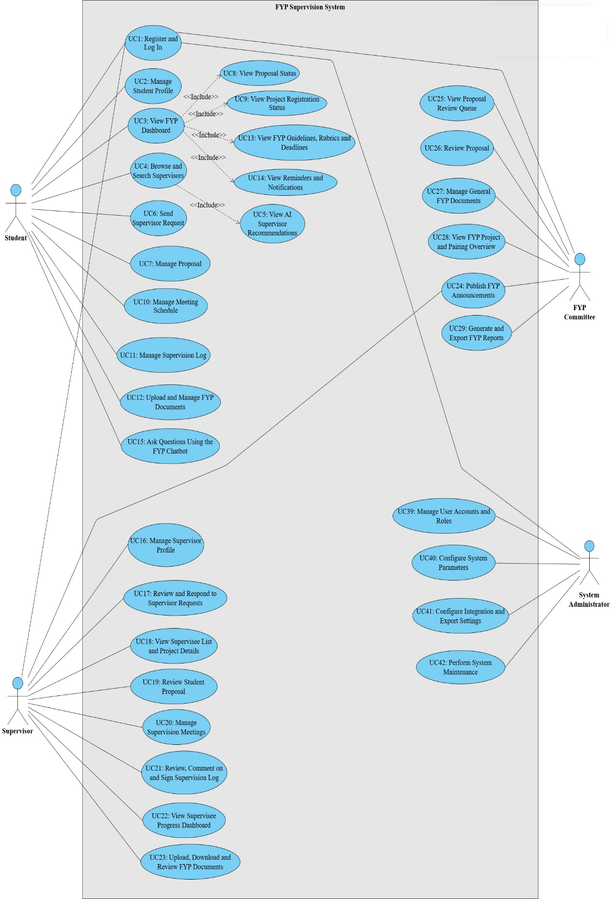
Figure 3.2 Use Case Diagram

3.5.1 Common Use Case Specification
Register use case specification
Table 3.5 UC1: Register and Log In
Field | Details
Use Case ID | UC1
Use Case Name | Register and Log In
Actors | Student, Supervisor, FYP Committee, System Administrator
Description | Allows users to access the system through registration (for eligible users) and login. The system determines the user role and displays the authorised modules and dashboard accordingly.
Pre-condition | System is available. For registration: user has a valid MMU ID and is eligible to self-register (Student or Supervisor). For login: user account exists in the system.
Postcondition | For registration: user account is created with an assigned role. For login: user is authenticated, a session is created, and the role-based dashboard and menus are displayed.
Basic Path | - User opens the system access page (Register or Log In).  - If the user is a Student or Supervisor and does not have an account, the user selects Register.  - User enters required details (MMU ID, full name, email, phone) and accepts the terms.  - System validates details and creates the user account with role Student or Supervisor.  - System redirects the user to the login page.  - User enters MMU ID and password.  - System validates credentials.  - System retrieves the user role (Student, Supervisor, FYP Committee, or System Administrator) and permissions.  - System creates a session and redirects to the corresponding dashboard.
Alternative Path | A1: User account already exists → system directs user to Log In page.  A2: FYP Committee or System Administrator registration attempt → system blocks self-registration and informs that the account must be created by System Administrator.  A3: Invalid registration inputs → system highlights errors and requests correction.  A4: Invalid login credentials → system displays error and allows retry.
Exceptional Path | E1: Duplicate MMU ID or email during registration → system prevents account creation and displays message.  E2: Authentication service unavailable → system displays service unavailable message and logs the incident.  E3: Database/server error → system terminates the process and does not create account or session.

3.5.2 Student Use Case Specifications
Table 3.6 UC2: Manage Student Profile
Field | Details
Use Case ID | UC2
Use Case Name | Manage Student Profile
Actors | Student
Description | Student views and updates personal and academic profile.
Pre-condition | Student is logged in.
Postcondition | Profile is updated and saved.
Basic Path | - Student opens profile page.  - Student edits profile fields.  - System validates inputs.  - System saves profile changes.
Alternative Path | A1: Student cancels changes → system discards edits.
Exceptional Path | E1: Invalid input → system shows validation error messages.
Table 3.7 UC3: View FYP Dashboard
Field | Details
Use Case ID | UC3
Use Case Name | View FYP Dashboard
Actors | Student
Description | Student views project status, deadlines, and notifications.
Pre-condition | Student is logged in.
Postcondition | Dashboard is displayed.
Basic Path | - Student opens dashboard.  - System loads proposal, meetings, logs, and documents summary.  - System displays dashboard cards and alerts.
Alternative Path | A1: Student has no project → system displays next steps and guidance.
Exceptional Path | E1: Data retrieval error → system shows message and logs the error.
Table 3.8 UC4: Browse and Search Supervisors
Field | Details
Use Case ID | UC4
Use Case Name | Browse and Search Supervisors
Actors | Student
Description | Student searches supervisors by research area and availability.
Pre-condition | Student is logged in.
Postcondition | Supervisor list and details are displayed.
Basic Path | - Student opens supervisor directory.  - Student applies filters and keywords.  - System displays matching supervisors.  - Student views supervisor profile.
Alternative Path | A1: No results → system suggests adjusting filters.
Exceptional Path | E1: Directory service failure → system displays error banner.
Table 3.9 UC5: View AI Supervisor Recommendations
Field | Details
Use Case ID | UC5
Use Case Name | View AI Supervisor Recommendations
Actors | Student
Description | Student views recommended supervisors based on topic and profile.
Pre-condition | Student is logged in; topic keywords or draft proposal exists.
Postcondition | Recommendation list is displayed.
Basic Path | - Student opens recommendations page.  - Student inputs topic or selects draft proposal.  - System calls AI service.  - System displays ranked recommendations.
Alternative Path | A1: Missing topic information → system prompts student to enter keywords.
Exceptional Path | E1: AI service timeout → system shows failure and allows retry.
Table 3.10 UC6: Send Supervisor Request
Field | Details
Use Case ID | UC6
Use Case Name | Send Supervisor Request
Actors | Student
Description | Student requests supervision from a supervisor.
Pre-condition | Student is logged in; supervisor is selectable; request rules are satisfied.
Postcondition | Request is created and supervisor is notified.
Basic Path | - Student selects supervisor.  - Student enters message and topic.  - Student submits request.  - System records request as Pending and notifies supervisor.
Alternative Path | A1: Student withdraws pending request → status becomes Withdrawn.
Exceptional Path | E1: Supervisor not accepting students → system blocks request and shows reason.
Table 3.11 UC7: Manage Proposal
Field | Details
Use Case ID | UC7
Use Case Name | Manage Proposal
Actors | Student
Description | Student manages the proposal in a single workflow: create or edit proposal content (via form or file upload), optionally run the AI proposal checker to evaluate completeness/quality, and submit the proposal to the assigned supervisor for review. Version history is maintained for each saved or submitted proposal version.
Pre-condition | Student is logged in.
Postcondition | Draft proposal is saved with version history.
Basic Path | - Student opens the proposal module.  - System displays the latest proposal draft (or an empty draft if none exists).  - Student creates/edits proposal content or uploads a proposal file.  - Student clicks Save Draft.  - System creates a new proposal version and stores content/file.  - Student clicks Run AI Checker.  - System analyses the latest version and displays a score, detected issues, missing sections, and suggested improvements.  - Student improves the proposal based on feedback and saves a new version if needed.  - Student clicks Submit to Supervisor.  - System updates proposal status to Submitted/Under Review, notifies the supervisor, and records the submission action.
Alternative Path | A1: Student skips AI checker → Student saves draft and proceeds to submit directly (Steps 3–5, then Step 9–10).  A2: Student uploads file instead of form input → System extracts/stores file and creates a new version (Steps 3–5).  A3: Student edits after running AI checker → Student saves a new version, then runs AI checker again (repeat Steps 3–8) before submission.  A4: No supervisor assigned yet → System allows submission but routes to committee queue or prevents submission and prompts student to request/confirm supervisor (depends on your rules).
Exceptional Path | E1: Unsupported file type / upload error → System rejects upload and shows accepted formats/size limits.  E2: AI service unavailable / timeout → System shows error, keeps draft saved, and allows retry later.  E3: Missing mandatory proposal fields (e.g., title/objectives) → System blocks submission and highlights required sections.  E4: Duplicate submission attempt (already under review) → System prevents re-submit and instructs student to wait for review or create a new revision version.
Table 3.12 UC8: View Proposal Status
Field | Details
Use Case ID | UC8
Use Case Name | View Proposal Status
Actors | Student
Description | Student tracks proposal status and supervisor feedback.
Pre-condition | Student is logged in.
Postcondition | Proposal status is displayed.
Basic Path | - Student opens proposal status page.  - System displays status timeline and feedback.  - Student views required actions.
Alternative Path | A1: Revision requested → system displays required changes and edit link.
Exceptional Path | E1: Proposal record not found → system displays support message and logs issue.
Table 3.13 UC9: View Project Registration Status
Field | Details
Use Case ID | UC9
Use Case Name | View Project Registration Status
Actors | Student
Description | Student views registration and pairing status for FYP cycle.
Pre-condition | Student is logged in.
Postcondition | Registration status is displayed.
Basic Path | - Student opens registration status.  - System displays FYP stage and pairing info.  - System displays next steps if applicable.
Alternative Path | A1: Not registered → system displays registration guidance.
Exceptional Path | E1: Status inconsistency → system warns user and logs warning.
Table 3.14 UC10: Manage Meeting Schedule
Field | Details
Use Case ID | UC10
Use Case Name | Manage Meeting Schedule
Actors | Student
Description | Student manages supervision meeting scheduling in one module: view upcoming and past meetings, propose new meeting slots with agenda, and update/cancel pending meeting requests before supervisor confirmation.
Pre-condition | Student is logged in; student is paired with a supervisor.
Postcondition | Meeting schedule is displayed, and/or a meeting request is created/updated with status Pending Confirmation and the supervisor is notified.
Basic Path | - Student opens the Meeting Schedule module.  - System displays a calendar/list view of upcoming and past meetings for the student’s project.  - Student clicks Request Meeting.  - Student proposes date/time (start–end), selects platform (e.g., Teams/Zoom/Face-to-face), and enters an agenda.  - Student submits the request.  - System creates the meeting record with status Proposed/Pending Confirmation and notifies the supervisor.  - Student returns to the schedule view and sees the pending meeting request.
Alternative Path | A1: Edit pending request → Student opens a pending request, edits time/agenda/platform, and submits; system updates the meeting and re-notifies the supervisor.  A2: Cancel pending request → Student cancels a pending request; system updates status to Cancelled and notifies the supervisor.  A3: View meeting details → Student opens a meeting item to view full details (agenda, status, confirmed time if available).  A4: Export schedule → Student chooses export; system generates a calendar export file (e.g., .ics) or downloadable schedule output.
Exceptional Path | E1: Proposed time violates policy (outside allowed hours / too short notice / clashes with deadline blackout period) → system blocks submission and displays allowed rules.  E2: Student not paired with supervisor → system disables request action and prompts student to complete supervisor pairing first.  E3: Schedule/notification service error → system shows error message, logs the issue, and keeps the request as unsent or retries based on system design.
Table 3.15 UC11: Manage Supervision Log
Field | Details
Use Case ID | UC11
Use Case Name | Manage Supervision Log
Actors | Student
Description | Student manages supervision logs in one module: view meeting log history, create or upload a meeting log for a meeting session, submit the log for supervisor review, and sign the log once it reaches the signing stage. The log becomes an official supervision record when both student and supervisor have signed and the log is locked.
Pre-condition | Student is logged in; Student has an active project and related meeting record exists.
Postcondition | Logs are displayed.
Basic Path | - Student opens the Supervision Log module.  - System lists supervision logs by meeting (including status and signature progress).  - Student selects a meeting and clicks Create/Upload Log.  - Student fills in the log form (discussion summary, action items, next meeting date) and/or uploads the log file.  - Student saves the log as Draft or submits it as Submitted.  - System stores the log and notifies the supervisor for review/comments (if submitted).  - After the supervisor reviews and signs, the student is notified.  - Student opens the log and clicks Sign Log.  - System records the student signature. If both signatures exist, system locks the log and marks it as an official record.
Alternative Path | A1: View only (history) → Student only views logs and action items; no upload/sign actions taken.  A2: Filter logs → Student filters logs by date range, meeting, or status (Draft/Submitted/Signed/Locked).  A3: Supervisor requests correction → Student receives feedback, edits the log, re-submits, and proceeds to signing after supervisor signs again.  A4: Save as draft → Student saves as Draft and continues editing later before submission.
Exceptional Path | E1: Access to unauthorised log → System denies access and logs the attempt.  E2: Student attempts to edit locked log → System blocks the action and displays “Locked record cannot be edited”.  E3: Upload error / unsupported file type → System rejects upload and shows accepted formats/size limits.  E4: Signing stage not reached (supervisor has not reviewed/signed yet) → System prevents student signing and shows current status and required next step.
Table 3.16 UC12: Upload and Manage FYP Documents
Field | Details
Use Case ID | UC12
Use Case Name | Upload and Manage FYP Documents
Actors | Student
Description | Student uploads reports, slides, and code archives by phase and type.
Pre-condition | Student is logged in.
Postcondition | Document is stored and visible to authorised users.
Basic Path | - Student opens document module.  - Student selects document type and phase.  - Student uploads file.  - System stores file and updates list.
Alternative Path | A1: Replace document → system keeps version history.
Exceptional Path | E1: File exceeds limit or fails scan → system rejects and shows reason.
Table 3.17 UC13: View FYP Guidelines, Rubrics and Deadlines
Field | Detail
Use Case ID | UC13
Use Case Name | View FYP Guidelines, Rubrics and Deadlines
Actors | Student
Description | Student accesses official resources and deadlines.
Pre-condition | Student is logged in.
Postcondition | Resources are displayed and downloadable.
Basic Path | - Student opens guidelines page.  - System displays resources by category.  - Student opens or downloads resource.
Alternative Path | A1: Keyword search across resources.
Exceptional Path | E1: Missing resource file → system shows error and logs incident.
Table 3.18 UC14: View Reminders and Notifications
Field | Details
Use Case ID | UC18
Use Case Name | View Reminders and Notifications
Actors | Student
Description | System notifies student about meetings, deadlines, and announcements.
Pre-condition | Student account exists; notification rules configured.
Postcondition | Notification is delivered and recorded.
Basic Path | - Trigger occurs (deadline, meeting update, announcement).  - System sends notification.  - Student views notification in system.
Alternative Path | A1: Student customises notification preferences.
Exceptional Path | E1: Delivery failure → system retries and logs failure.
Table 3.19 UC15: Ask Questions Using the FYP Chatbot
Field | Details
Use Case ID | UC19
Use Case Name | Ask Questions Using the FYP Chatbot
Actors | Student
Description | Student asks questions and receives chatbot guidance.
Pre-condition | Student is logged in; chatbot service is available.
Postcondition | Answer is displayed; conversation is stored.
Basic Path | - Student opens chatbot.  - Student asks question.  - System returns answer and reference source if available.
Alternative Path | A1: Low confidence → system suggests contacting FYP Committee and creates help request.
Exceptional Path | E1: Chatbot unavailable → system displays fallback contact instructions.

3.5.2 Supervisor Use Case Specifications
Table 3.20 UC16: Manage Supervisor Profile
Field | Details
Use Case ID | UC16
Use Case Name | Manage Supervisor Profile
Actors | Supervisor
Description | Supervisor updates research areas, quota, and availability.
Pre-condition | Supervisor is logged in.
Postcondition | Profile updates are saved and reflected in search and recommendations.
Basic Path | - Supervisor opens profile.  - Supervisor edits fields.  - System validates and saves changes.
Alternative Path | A1: Set temporary unavailability dates.
Exceptional Path | E1: Quota violates policy → system blocks save and shows constraints.
Table 3.21 UC17: Review and Respond to Supervisor Requests
Field | Details
Use Case ID | UC17
Use Case Name | Review and Respond to Supervisor Requests
Actors | Supervisor
Description | Supervisor accepts, rejects, or requests clarification for requests.
Pre-condition | Supervisor logged in; pending requests exist.
Postcondition | Request status updated; student notified.
Basic Path | - Supervisor opens request list.  - Supervisor views request details.  - Supervisor selects accept or reject or clarify.  - System updates status and notifies student.
Alternative Path | A1: Clarification requested → student replies, request remains pending.
Exceptional Path | E1: Acceptance exceeds quota → system blocks acceptance.
Table 3.22 UC18: View Supervisee List and Project Details
Field | Details
Use Case ID | UC18
Use Case Name | View Supervisee List and Project Details
Actors | Supervisor
Description | Supervisor views supervisees and their project information.
Pre-condition | Supervisor is logged in.
Postcondition | Supervisee list and details are displayed.
Basic Path | - Supervisor opens supervisee list.  - System displays supervisees with status.  - Supervisor opens a supervisee’s project details.
Alternative Path | A1: Filter by FYP stage or risk status.
Exceptional Path | E1: Access attempt to non-assigned student → system denies access.
Table 3.23 UC19: Review Student Proposal
Field | Details
Use Case ID | UC19
Use Case Name | Review Student Proposal
Actors | Supervisor
Description | Supervisor reviews the student’s submitted proposal in a single workflow screen. The supervisor can view proposal versions and AI checking results, provide comments, request revisions, or approve the proposal for project registration. All decisions and remarks are recorded for traceability.
Pre-condition | Supervisor logged in; proposal is submitted for review.
Postcondition | Proposal review outcome is recorded. The proposal status is updated to Revision Required or Approved, and the student is notified. If approved, the project registration status is updated accordingly and the supervisor’s supervision load may be updated.
Basic Path | - Supervisor opens the Proposal Review module.  - System lists submitted proposals from supervisees with current status.  - Supervisor selects a proposal to review.  - System displays proposal details, latest proposal version, and version history.  - System displays AI checking results (score, missing sections, suggested improvements) for the selected version (if available).  - Supervisor reviews the content and enters remarks/comments.  - Supervisor chooses an action: Request Revision or Approve.  - System records the review decision and remarks in the review history.  - System updates the proposal status accordingly and sends a notification to the student.  - If Approve, system updates the project registration status (e.g., Registered/Approved) and updates supervisor’s current supervision load if applicable.
Alternative Path | A1: Review an older version → Supervisor selects a previous proposal version to compare changes; system shows the chosen version and its AI result  A2: Request multiple revisions → After student resubmits a new version, supervisor repeats review and requests revision again until acceptable.
Exceptional Path | E1: Proposal not found / already withdrawn → System shows message and refreshes the list.  E2: Supervisor not authorised (proposal not under their supervisee list) → System denies access and logs the attempt.  E3: Missing required fields for decision (e.g., empty remarks when requesting revision if required) → System blocks submission and prompts for required input.  E4: System error during status update/notification → System saves the review record, shows error, and retries notification or logs for admin action.
Table 3.24 UC20: Manage Supervision Meetings
Field | Details
Use Case ID | UC20
Use Case Name | Manage Supervision Meetings
Actors | Supervisor
Description | Supervisor confirms, reschedules, or cancels meeting requests.
Pre-condition | Supervisor logged in; meeting requests exist.
Postcondition | Meeting status updated; student notified.
Basic Path | - Supervisor opens meeting requests.  - Supervisor selects request.  - Supervisor confirms or reschedules or cancels.  - System updates schedule and notifies student.
Alternative Path | A1: Suggest alternative times → student selects a new slot.
Exceptional Path | E1: Time conflict detected → system blocks and suggests available slots.
Table 3.25 UC21: Review, Comment on and Sign Supervision Log
Field | Details
Use Case ID | UC21
Use Case Name | Review, Comment on and Sign Supervision Log
Actors | Supervisor
Description | Supervisor reviews log, adds comments, and signs.
Pre-condition | Supervisor logged in; student submitted meeting log.
Postcondition | Supervisor signature recorded; student prompted to sign; log locked after both signatures.
Basic Path | - Supervisor opens submitted log.  - Supervisor adds comments.  - Supervisor signs log.  - System notifies student to sign.
Alternative Path | A1: Request correction before signing → status becomes Correction Required.
Exceptional Path | E1: Log already locked → system blocks modifications.
Table 3.26 UC22: View Supervisee Progress Dashboard
Field | Details
Use Case ID | UC22
Use Case Name | View Supervisee Progress Dashboard
Actors | Supervisor
Description | Supervisor views progress indicators for meetings, logs, documents, and deadlines.
Pre-condition | Supervisor logged in.
Postcondition | Dashboard is displayed.
Basic Path | - Supervisor opens progress dashboard.  - System aggregates supervisee progress data.  - System displays indicators and alerts.
Alternative Path | A1: Export progress summary report.
Exceptional Path | E1: Metrics service failure → system shows partial results and logs issue.
Table 3.27 UC23: Upload, Download and Review FYP Documents
Field | Details
Use Case ID | UC23
Use Case Name | Upload, Download and Review FYP Documents
Actors | Supervisor
Description | Supervisor reviews student documents and uploads feedback.
Pre-condition | Supervisor logged in; documents exist.
Postcondition | Feedback files stored; student notified.
Basic Path | - Supervisor opens student documents list.  - Supervisor downloads and reviews.  - Supervisor uploads feedback file.  - System notifies student.
Alternative Path | A1: Request resubmission with remarks.
Exceptional Path | E1: Upload fails security scan → system rejects upload.
Table 3.28 UC24: Publish FYP Announcements
Field | Details
Use Case ID | UC24
Use Case Name | Publish FYP Announcements
Actors | Supervisor
Description | Supervisor publishes announcements to supervisees.
Pre-condition | Supervisor logged in; supervisees exist.
Postcondition | Announcement published; recipients notified.
Basic Path | - Supervisor creates announcement.  - Supervisor selects audience (supervisees).  - Supervisor publishes.  - System sends notifications.
Alternative Path | A1: Schedule announcement for a future date.
Exceptional Path | E1: Invalid content (empty) → system blocks publish.

3.5.3 FYP Committee Use Case Specifications
Table 3.29 UC24: Publish FYP Announcements
Field | Details
Use Case ID | UC24
Use Case Name | Publish FYP Announcements
Actors | FYP Committee
Description | Admin publishes faculty-level announcements for selected users and cycles.
Pre-condition | FYP Committee logged in.
Postcondition | Announcement published and logged; recipients notified.
Basic Path | - Admin creates announcement.  - Admin selects audience and cycle.  - Admin publishes.  - System sends notifications.
Alternative Path | A1: Schedule announcement release time.
Exceptional Path | E1: Missing audience selection → system blocks publish.
Table 3.30 UC25: View Proposal Review Queue
Field | Details
Use Case ID | UC25
Use Case Name | View Proposal Review Queue
Actors | FYP Committee
Description | Admin views proposals awaiting committee review.
Pre-condition | FYP Committee is logged in.
Postcondition | Queue list displayed.
Basic Path | - Admin opens queue page.  - System lists proposals with status and filters.  - Admin opens a proposal record.
Alternative Path | A1: Filter by programme or supervisor or status.
Exceptional Path | E1: Permission error → system denies access and logs attempt.
Table 3.31 UC26: Review Proposal
Field | Details
Use Case ID | UC26
Use Case Name | Review Proposal
Actors | FYP Committee
Description | FYP Committee reviews submitted proposals in a single workflow screen. The committee can view proposal versions and AI checking results, record remarks, and make a decision to approve, reject, or request revision. All decisions are stored for traceability and official record keeping.
Pre-condition | FYP Committee logged in; proposal exists in queue.
Postcondition | Committee decision is recorded. Proposal status is updated to Approved, Rejected, or Revision Required, and relevant parties (student and supervisor) are notified. If approved, project registration status is updated accordingly.
Basic Path | - Committee member opens the Proposal Review Queue.  - System displays proposals pending committee action with filtering/sorting options.  - Committee member selects a proposal.  - System displays proposal details, latest version, and version history.  - System displays AI checking results (score, missing sections, suggested improvements) for the selected version (if available).  - Committee member reviews content and enters remarks/comments.  - Committee member selects a decision: Approve, Reject, or Request Revision.  - System records the decision and remarks in the review history.  - System updates proposal status and, if applicable, updates project registration status.  - System notifies the student and supervisor of the outcome.
Alternative Path | A1: Review previous versions → Committee member opens earlier versions to compare changes; system displays selected version and related AI results if available.  A2: Request additional information → Committee member requests clarification and specifies required updates in remarks.  A3: Multiple revision cycles → Student resubmits a new version; proposal returns to the queue until decision is finalised.  A4: Assign to another committee member → Proposal remains in queue but reviewer changes.
Exceptional Path | E1: Proposal not found / already finalised → System shows message and refreshes the queue.  E2: Committee member not authorised → System denies access and logs the attempt.  E3: Missing required remarks for revision/rejection → System blocks submission and prompts for mandatory remarks.  E4: System error during status update/notification → System saves the review record, shows error, and retries notification or logs for admin follow-up.
Table 3.32 UC27: Manage General FYP Documents
Field | Details
Use Case ID | UC27
Use Case Name | Manage General FYP Documents
Actors | FYP Committee
Description | Admin uploads and maintains handbook, templates, rubrics, and forms.
Pre-condition | FYP Committee logged in.
Postcondition | Resources updated and published.
Basic Path | - Admin opens resources module.  - Admin uploads or replaces files.  - Admin assigns category and publish settings.  - System makes resources available to users.
Alternative Path | A1: Archive old version for reference.
Exceptional Path | E1: Invalid file type → system rejects upload.
Table 3.33 UC28: View FYP Project and Pairing Overview
Field | Details
Use Case ID | UC28
Use Case Name | View FYP Project and Pairing Overview
Actors | FYP Committee
Description | FYP Committee monitors FYP projects and supervisor–student pairings across programmes and cycles in a single dashboard. The dashboard summarises project statuses and pairing progress, and highlights unpaired students and overloaded supervisors to support timely administrative actions.
Pre-condition | FYP Committee logged in.
Postcondition | Overview dashboard is displayed with pairing status, project status summaries, and highlighted exceptions (unpaired students / overloaded supervisors).
Basic Path | - Committee member opens the Project & Pairing Overview dashboard.  - System retrieves and aggregates project and pairing data for the selected FYP cycle (default to current cycle).  - System displays overall statistics (e.g., total projects, paired vs unpaired students, supervisor load distribution).  - System lists key items, including: (a) unpaired students, (b) projects pending supervisor assignment, and (c) supervisors approaching/exceeding quota.  - Committee member uses filters (programme, specialisation, supervisor, status) to refine the view.
Alternative Path | A1: Drill down by supervisor → Committee member selects a supervisor to view assigned students/projects and current load.  A2: Drill down by programme/specialisation → Committee member filters by programme/specialisation to view localised pairing progress and exceptions.  A3: Export overview → Committee member exports the list/summary (e.g., CSV/PDF report) for reporting purposes
Exceptional Path | E1: Query timeout / dataset too large → System prompts the user to apply filters (e.g., cycle/programme) and retries with the refined query.  E2: No data available for selected cycle → System displays an empty-state message and suggests selecting another cycle or confirming cycle setup.  E3: Access not authorised → System denies access and logs the attempt.
Table 3.34 UC29: Generate and Export FYP Reports
Field | Details
Use Case ID | UC29
Use Case Name | Generate and Export FYP Reports
Actors | FYP Committee
Description | Admin generates and exports reports such as pairing status and approved projects.
Pre-condition | FYP Committee logged in.
Postcondition | Report generated and downloaded.
Basic Path | - Admin selects report type.  - Admin sets filters.  - System generates report.  - Admin downloads output file.
Alternative Path | A1: Save report configuration for reuse.
Exceptional Path | E1: Export generation failed → system displays error and logs incident.

3.5.4 System Administrator Use Case Specifications
Table 3.35 UC30: Manage User Accounts and Roles
Field | Details
Use Case ID | UC30
Use Case Name | Manage User Accounts and Roles
Actors | System Administrator
Description | System administrator manages accounts, roles, and access rights.
Pre-condition | System Administrator is logged in.
Postcondition | User account and role updates are applied.
Basic Path | - Admin searches user.  - Admin edits role and status.  - System validates and saves changes.
Alternative Path | A1: Disable account for security reasons.
Exceptional Path | E1: Attempt to remove last System Administrator role → system blocks action.
Table 3.36 UC31: Configure System Parameters
Field | Details
Use Case ID | UC31
Use Case Name | Configure System Parameters
Actors | System Administrator
Description | Admin configures FYP cycles, sessions, and policy parameters.
Pre-condition | System Administrator logged in.
Postcondition | Settings saved and applied.
Basic Path | - Admin opens settings.  - Admin updates parameters.  - System validates constraints.  - System saves configuration.
Alternative Path | A1: Preview setting impact before applying.
Exceptional Path | E1: Invalid values → system blocks save and displays constraints.
Table 3.37 UC32: Configure Integration and Export Settings
Field | Details
Use Case ID | UC32
Use Case Name | Configure Integration and Export Settings
Actors | System Administrator
Description | Admin configures integrations and export formats for faculty systems.
Pre-condition | System Administrator logged in; integration info available.
Postcondition | Integration settings stored; connection tested.
Basic Path | - Admin enters endpoints and credentials.  - Admin runs test connection.  - System saves settings.
Alternative Path | A1: Disable integration temporarily.
Exceptional Path | E1: Test connection fails → system blocks or saves as disabled with error note.
Table 3.38 UC33: Perform System Maintenance
Field | Details
Use Case ID | UC33
Use Case Name | Perform System Maintenance
Actors | System Administrator
Description | Admin performs backup, restore, and monitoring tasks.
Pre-condition | System Administrator logged in; maintenance permissions granted.
Postcondition | Maintenance task completed and logged.
Basic Path | - Admin selects maintenance task.  - Admin confirms execution.  - System runs task and logs outcome.
Alternative Path | A1: Schedule automatic backup.
Exceptional Path | E1: Backup fails due to storage issue → system alerts and logs critical error.

3.6 Entity Relationship Diagram
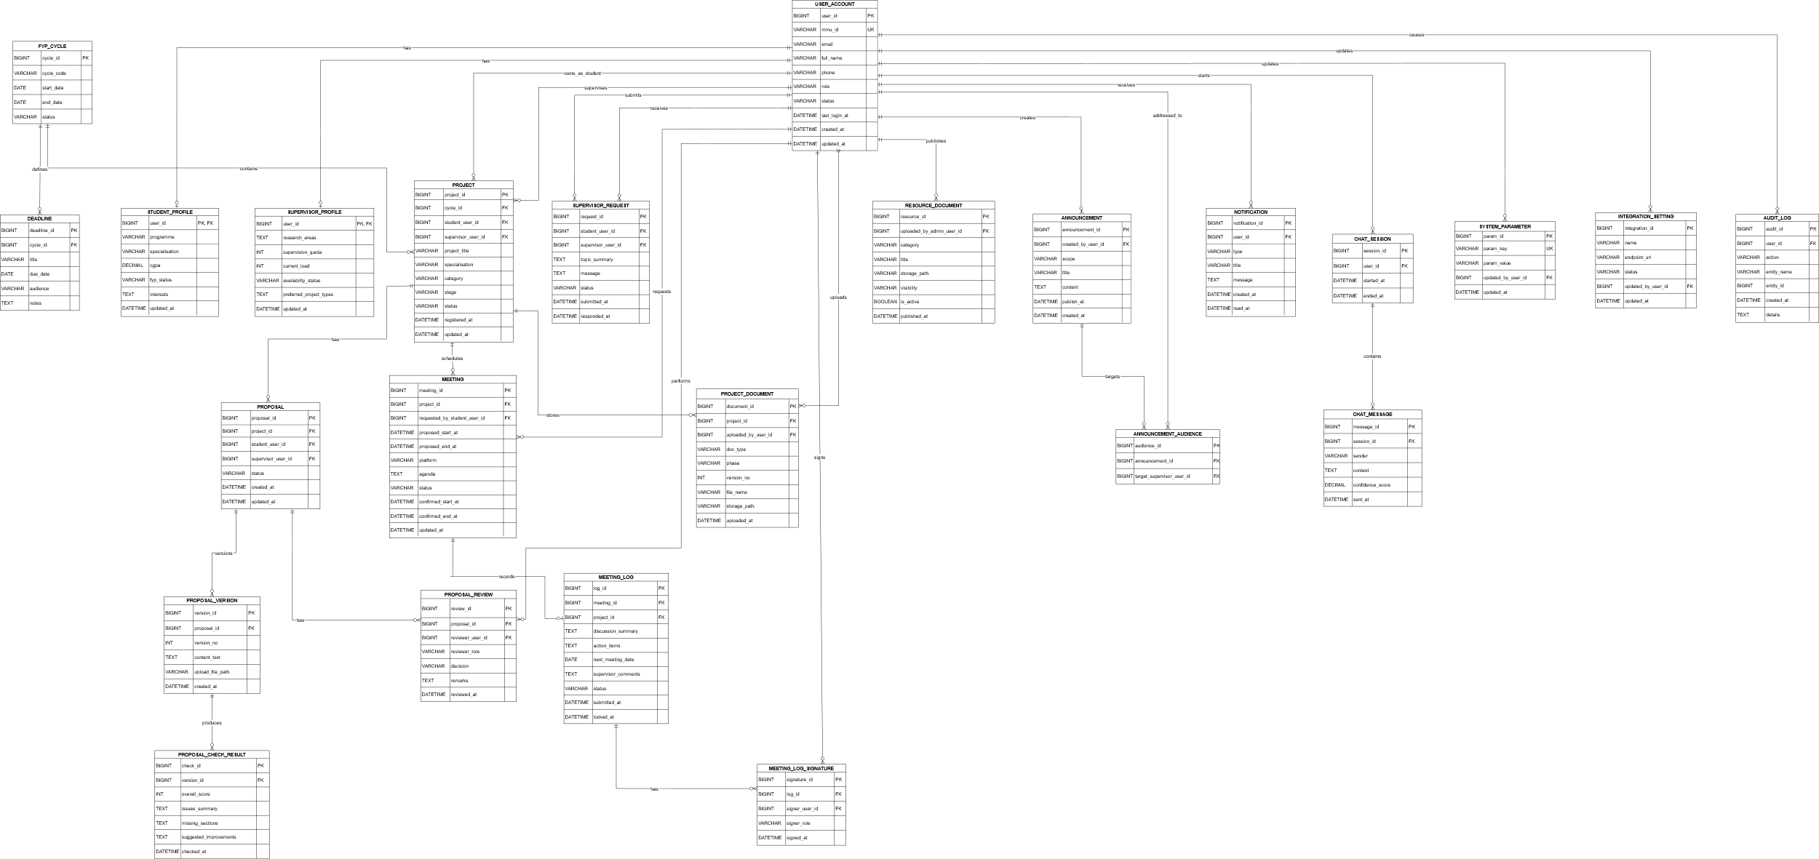
Figure 3.3 Entity Relationship Diagram

3.6.1 ERD Overview
Figure 3.3 presents the Entity Relationship Diagram (ERD) of the FYP Supervision System. The ERD models the core data structure required to support user management, project supervision workflows, proposal handling, meeting management, document storage, system communications, and administrative auditing. The USER_ACCOUNT entity serves as the central identity table for all system roles (student, supervisor, and administrators), while STUDENT_PROFILE and SUPERVISOR_PROFILE store role-specific information using optional one-to-one relationships.
Each FYP_CYCLE contains multiple PROJECT records. A project is owned by a student and may be assigned to a supervisor through foreign keys referencing USER_ACCOUNT. Students may submit SUPERVISOR_REQUEST records to request supervision, supporting the supervisor selection and assignment process.
For proposal handling, each project is associated with PROPOSAL records and maintains revision history through PROPOSAL_VERSION. Automated proposal analysis results are stored in PROPOSAL_CHECK_RESULT, while review decisions and feedback are captured in PROPOSAL_REVIEW to support approval tracking and revision management.
Supervision meetings are managed in MEETING, and each meeting may optionally generate a corresponding MEETING_LOG (0..1). Meeting logs can be verified by both parties via MEETING_LOG_SIGNATURE before being locked as an official supervision record. Project deliverables and uploaded files are stored in PROJECT_DOCUMENT, while shared templates, rubrics, and administrative materials are stored in RESOURCE_DOCUMENT.
Important dates and submissions are tracked using DEADLINE. System communication is supported through ANNOUNCEMENT, targeted audiences in ANNOUNCEMENT_AUDIENCE, and user NOTIFICATION for reminders and alerts. Chatbot interactions are recorded in CHAT_SESSION and CHAT_MESSAGE. Administrative configuration and traceability are supported through SYSTEM_PARAMETER, INTEGRATION_SETTING, and AUDIT_LOG.
The full database table descriptions for all entities shown in Figure 3.3, including attributes, keys, constraints, and field definitions, are provided in Appendix F (ERD Table Dictionary).

3.6.2 Use Case to Database Traceability (CRUD Mapping)
Tables 3.47–3.50 show traceability between use cases and database tables.
Table 3.47: Student Use Cases (UC1–UC19) and Main Database Tables Involved (CRUD)
Use Case | Main Tables Involved (CRUD)
UC1 – Register and Log In | USER_ACCOUNT (C/R/U last_login_at), AUDIT_LOG (C)
UC2 – Manage Student Profile | STUDENT_PROFILE (C/U), USER_ACCOUNT (U), AUDIT_LOG (C)
UC3 – View FYP Dashboard | PROJECT (R), PROPOSAL (R), MEETING (R), DEADLINE (R), NOTIFICATION (R)
UC4 – Browse and Search Supervisors | SUPERVISOR_PROFILE (R), USER_ACCOUNT (R)
UC5 – View AI Supervisor Recommendations | SUPERVISOR_PROFILE (R), USER_ACCOUNT (R), AUDIT_LOG (C)
UC6 – Send Supervisor Request | SUPERVISOR_REQUEST (C), NOTIFICATION (C), AUDIT_LOG (C)
UC7 – Manage Proposal | PROPOSAL (C/U), PROPOSAL_VERSION (C), PROPOSAL_CHECK_RESULT (C), PROPOSAL_REVIEW (R), NOTIFICATION (C), AUDIT_LOG (C)
UC8 – View Proposal Status | PROPOSAL (R), PROPOSAL_VERSION (R), PROPOSAL_REVIEW (R)
UC9 – View Project Registration Status | PROJECT (R), FYP_CYCLE (R)
UC10 – Manage Meeting Schedule | MEETING (C/R/U), NOTIFICATION (C), AUDIT_LOG (C)
UC11 – Manage Supervision Log | MEETING_LOG (C/R/U), MEETING_LOG_SIGNATURE (C/R), MEETING (R), NOTIFICATION (C), AUDIT_LOG (C)
UC12 – Upload and Manage FYP Documents | PROJECT_DOCUMENT (C/R/U/D), AUDIT_LOG (C)
UC13 – View FYP Guidelines, Rubrics and Deadlines | RESOURCE_DOCUMENT (R), DEADLINE (R), ANNOUNCEMENT (R)
UC14 – View Reminders and Notifications | NOTIFICATION (R/U read_at)
UC15 – Ask Questions Using the FYP Chatbot | CHAT_SESSION (C/R), CHAT_MESSAGE (C/R

Table 3.48: Supervisor Use Cases (UC1, UC20–UC30) and Main Database Tables Involved (CRUD)
Use Case | Main Tables Involved (CRUD)
UC1 – Register and Log In | USER_ACCOUNT (C/R/U last_login_at), AUDIT_LOG (C)
UC16 – Manage Supervisor Profile | SUPERVISOR_PROFILE (C/U), USER_ACCOUNT (U), AUDIT_LOG (C)
UC17 – Review and Respond to Supervisor Requests | SUPERVISOR_REQUEST (R/U), PROJECT (U), NOTIFICATION (C), AUDIT_LOG (C)
UC18 – View Supervisee List and Project Details | PROJECT (R), USER_ACCOUNT (R), STUDENT_PROFILE (R)
UC19 – Review Student Proposal | PROPOSAL (R/U), PROPOSAL_VERSION (R), PROPOSAL_CHECK_RESULT (R), PROPOSAL_REVIEW (C), PROJECT (U), SUPERVISOR_PROFILE (U), NOTIFICATION (C), AUDIT_LOG (C)
UC20 – Manage Supervision Meetings | MEETING (C/R/U), NOTIFICATION (C), AUDIT_LOG (C)
UC21 – Review, Comment on and Sign Supervision Log | MEETING_LOG (R/U), MEETING_LOG_SIGNATURE (C), MEETING (R), NOTIFICATION (C), AUDIT_LOG (C)
UC22 – View Supervisee Progress Dashboard | PROJECT (R), PROPOSAL (R), MEETING (R), MEETING_LOG (R), PROJECT_DOCUMENT (R), DEADLINE (R)
UC23 – Upload, Download and Review FYP Documents | PROJECT_DOCUMENT (C/R), AUDIT_LOG (C)
UC24 – Publish FYP Announcements | ANNOUNCEMENT (C/R), ANNOUNCEMENT_AUDIENCE (C/R), NOTIFICATION (C), AUDIT_LOG (C)

Table 3.49: FYP Committee Use Cases (UC1, UC31–UC38) and Main Database Tables Involved (CRUD)
Use Case | Main Tables Involved (CRUD)
UC1 – Register and Log In | USER_ACCOUNT (C/R/U last_login_at), AUDIT_LOG (C)
UC24 – Publish FYP Announcements | ANNOUNCEMENT (C/R), ANNOUNCEMENT_AUDIENCE (C/R), NOTIFICATION (C), AUDIT_LOG (C)
UC25 – View Proposal Review Queue | PROPOSAL (R), PROJECT (R), USER_ACCOUNT (R)
UC26 – Review Proposal | PROPOSAL (R/U), PROPOSAL_VERSION (R), PROPOSAL_CHECK_RESULT (R), PROPOSAL_REVIEW (C), PROJECT (U), NOTIFICATION (C), AUDIT_LOG (C)
UC27 – Manage General FYP Documents | RESOURCE_DOCUMENT (C/R/U/D), AUDIT_LOG (C)
UC28 – View FYP Project and Pairing Overview | PROJECT (R), FYP_CYCLE (R), SUPERVISOR_PROFILE (R), STUDENT_PROFILE (R), SUPERVISOR_REQUEST (R), USER_ACCOUNT (R), AUDIT_LOG (C)
UC29 – Generate and Export FYP Reports | PROJECT (R), PROPOSAL (R), MEETING_LOG (R), PROJECT_DOCUMENT (R), USER_ACCOUNT (R), AUDIT_LOG (C)

Table 3.50: System Administrator Use Cases (UC1, UC39–UC42) and Main Database Tables Involved (CRUD)
Use Case | Main Tables Involved (CRUD)
UC1 – Register and Log In | USER_ACCOUNT (C/R/U last_login_at), AUDIT_LOG (C)
UC30 – Manage User Accounts and Roles | USER_ACCOUNT (C/R/U/D), STUDENT_PROFILE (C/R/U/D), SUPERVISOR_PROFILE (C/R/U/D), AUDIT_LOG (C)
UC31 – Configure System Parameters | SYSTEM_PARAMETER (C/R/U/D), FYP_CYCLE (C/R/U/D), DEADLINE (C/R/U/D), AUDIT_LOG (C)
UC32 – Configure Integration and Export Settings | INTEGRATION_SETTING (C/R/U/D), AUDIT_LOG (C)
UC33 – Perform System Maintenance | AUDIT_LOG (C/R)

3.6.3 Sub-ERDs by Actor
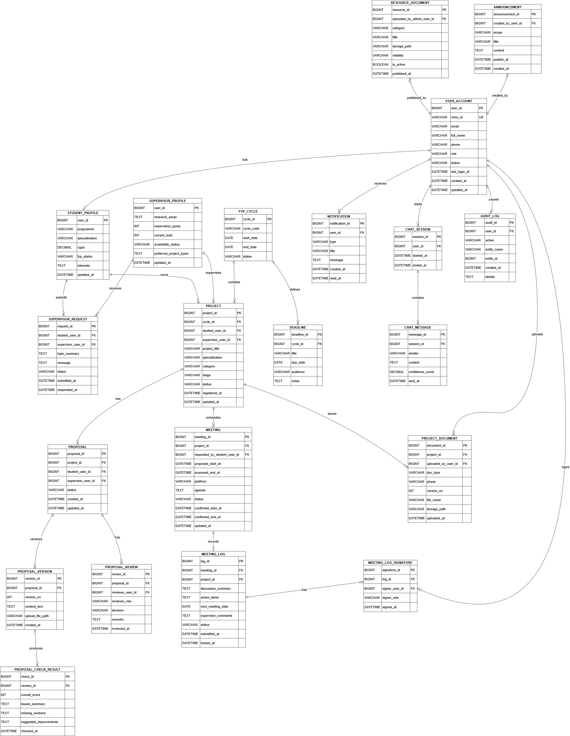
To improve readability of the complete ERD (Figure 3.3), role-based Sub-ERDs are provided to show the main entities involved in each actor’s workflow. Figures 3.4 –3.7 summarise the database entities and key relationships relevant to the Student, Supervisor, FYP Committee, and System Administrator perspectives.
Figure 3.4 Student Sub-ERD
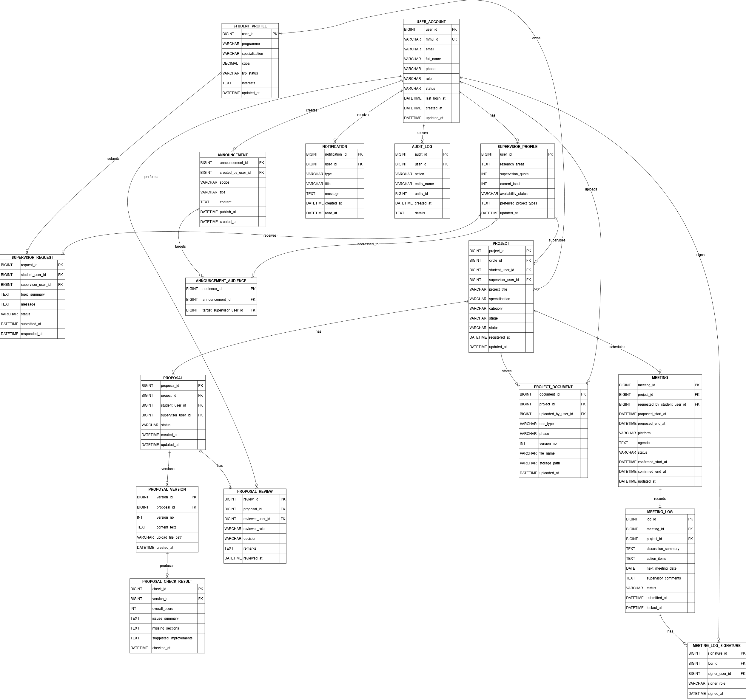
Figure 3.5 Supervisor Sub-ERD

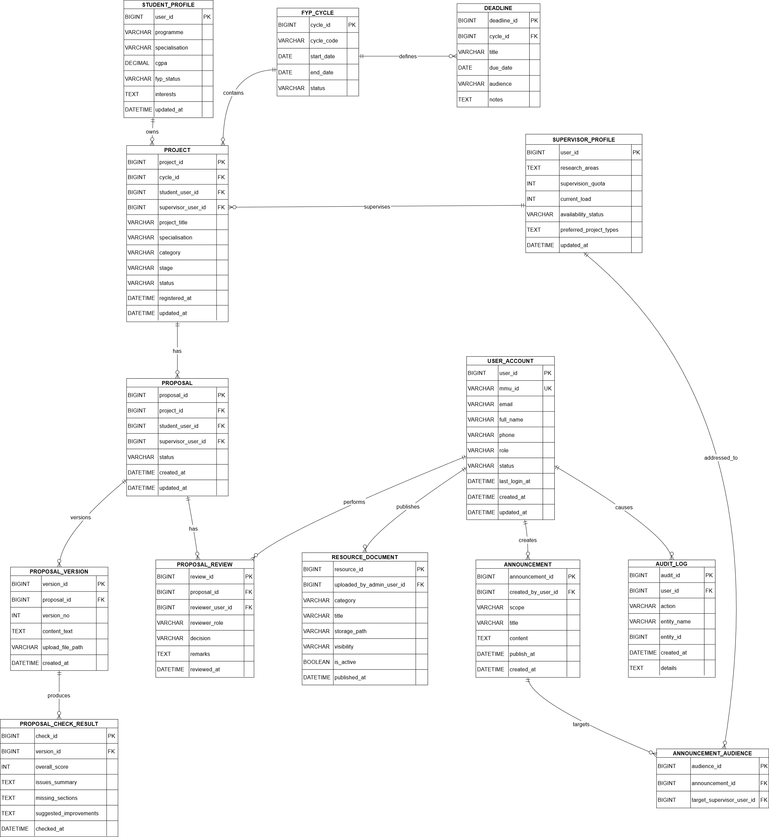
Figure 3.6 Supervisor Sub-ERD
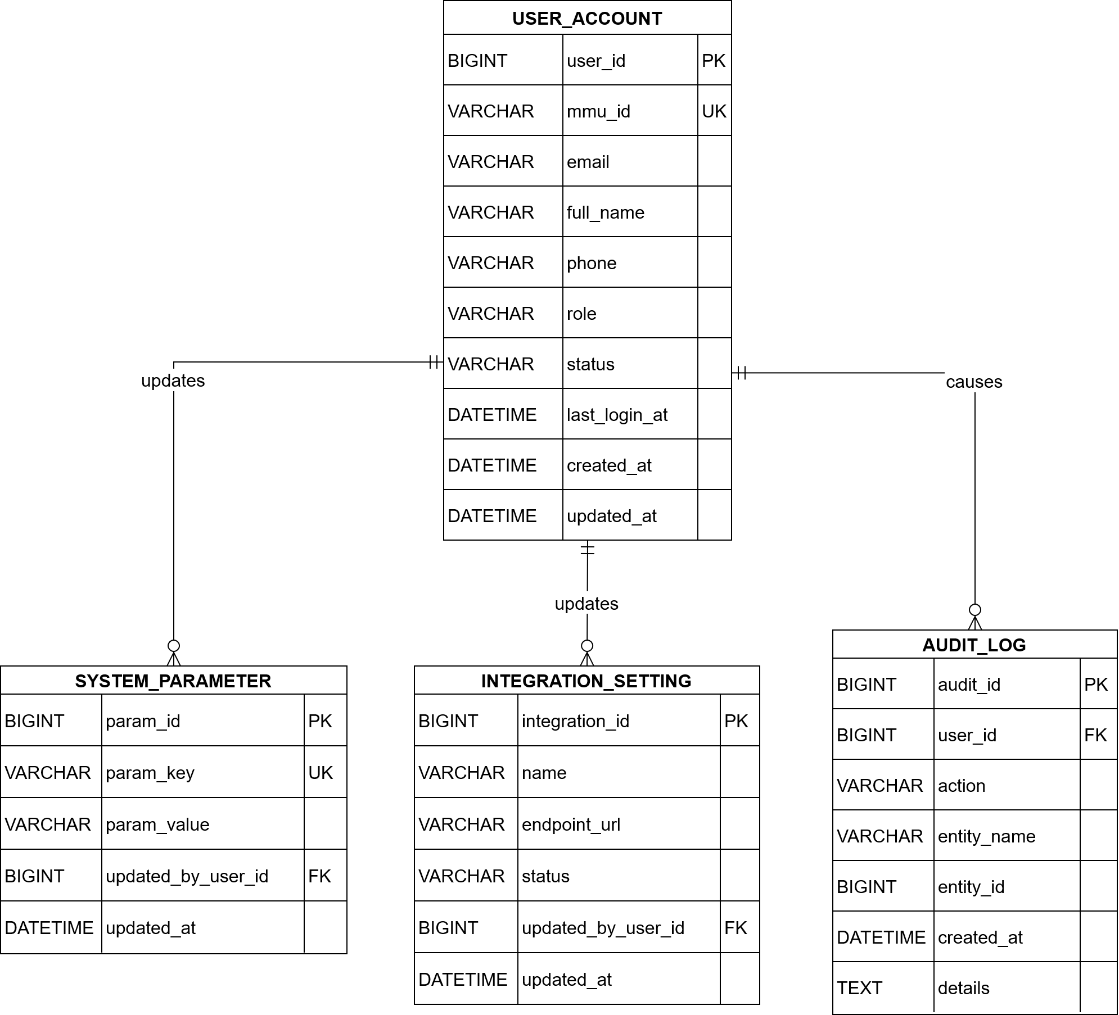
Figure 3.7 Supervisor Sub-ERD

