Chapter 4: DESIGN

4.1 Software Architecture
This section presents the software architecture of the proposed FYP Supervision System. The architecture is documented using two complementary views. The first view describes the system at a UML component or subsystem level to show how the platform is organised by user roles and how access is controlled through a shared authentication component. The second view describes the implementation-level layered architecture to show how the web application, backend services, data storage, and AI microservices communicate in the deployed system.
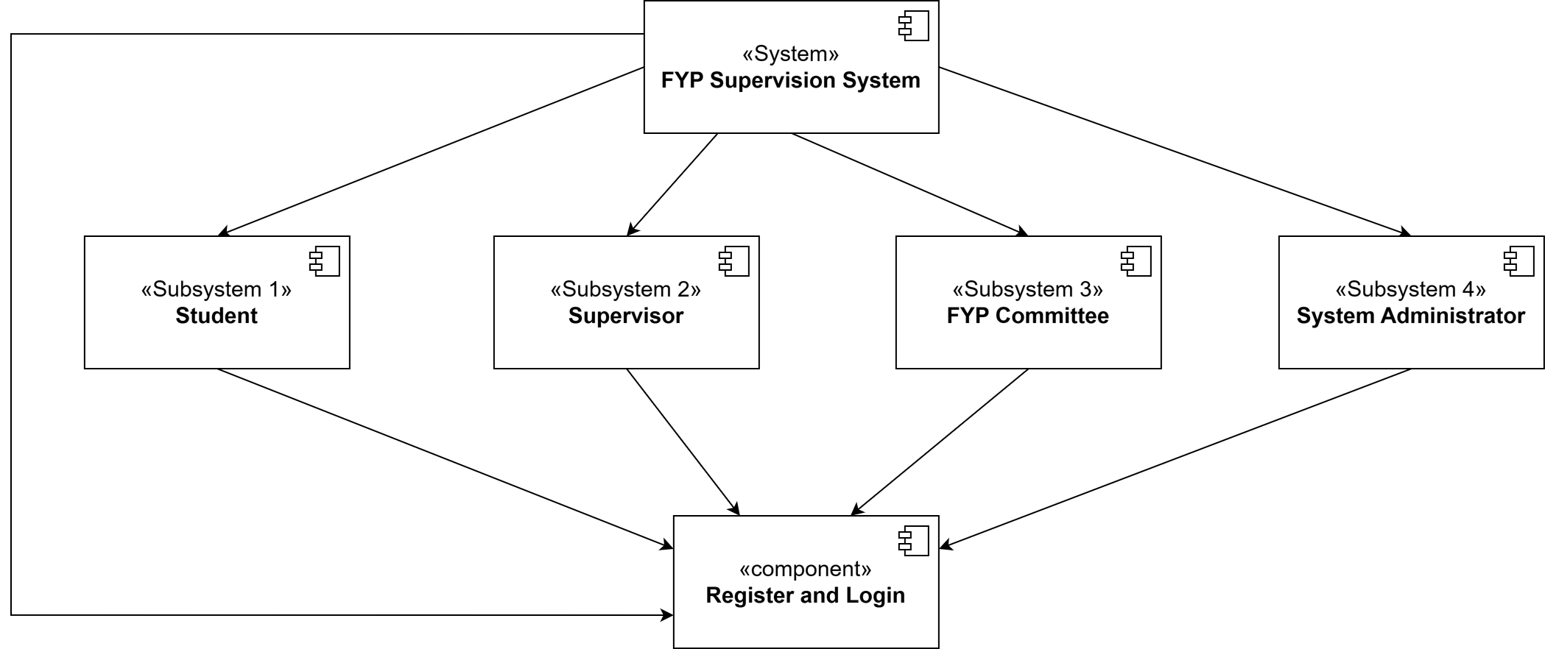
Figure 4.1 Overall Software Architecture (Subsystem and Component View)
Figure 4.1 illustrates the overall structure of the FYP Supervision System as four main subsystems based on system actors: Student, Supervisor, FYP Committee, and System Administrator. Each subsystem contains the features and operations required by the corresponding user role. All subsystems interact with a shared Register and Login component, which acts as the entry point for authentication and role-based access. After a user successfully registers and logs in, the system enables access to the appropriate subsystem according to the user’s role. This design improves modularity by separating responsibilities by user type while maintaining consistent access control through a single authentication component.
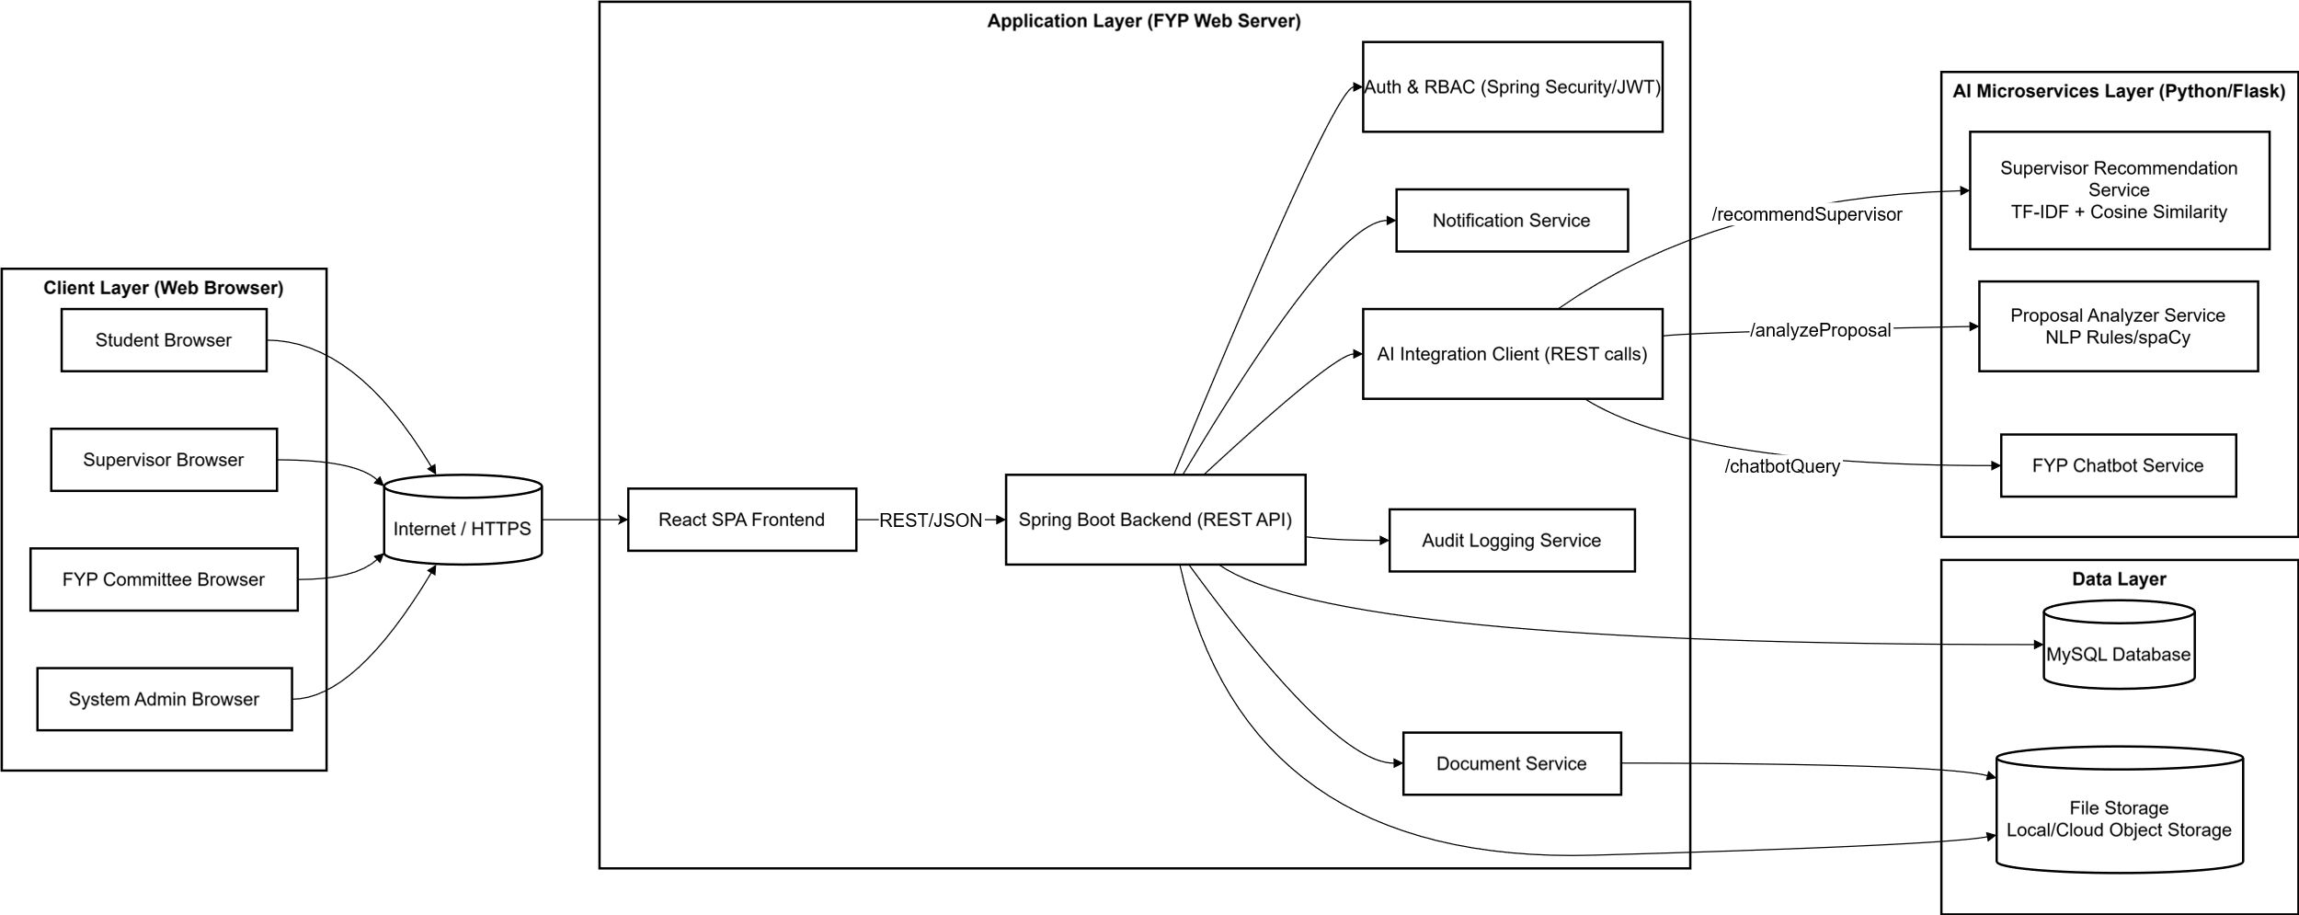
Figure 4.2 Implementation Software Architecture (Layered System View)
Figure 4.2 shows the deployed architecture in a layered structure. The Client Layer consists of web browsers used by students, supervisors, the FYP committee, and system administrators. These clients access the system through the Internet/HTTPS, ensuring secure communication. The React SPA Frontend provides the user interface and interacts with the backend using REST/JSON API calls.
The Application Layer is implemented using a Spring Boot Backend (REST API), which contains the core business logic and system workflows such as proposal management, meeting scheduling, supervision logging, and document handling. Supporting services inside the backend include Auth and RBAC for access control, a Notification Service for reminders and alerts, a Document Service for file operations, and an Audit Logging Service for tracking critical actions and ensuring accountability. For AI functions, the backend communicates through an AI Integration Client, which sends requests to the AI layer and returns AI-generated results to users.
The Data Layer stores structured system data in a MySQL Database, including user profiles, proposals, meeting schedules, supervision logs, and request statuses. Uploaded files such as proposal documents and supporting attachments are stored in a File Storage component, which is accessed through the backend document module.
Finally, the AI Microservices Layer consists of independent Python/Flask services to support intelligent features. These include a Supervisor Recommendation Service for matching students to supervisors, a Proposal Analyzer Service for checking proposal completeness and weaknesses, and an FYP Chatbot Service for answering user questions. Separating the AI services from the main backend improves maintainability and allows AI modules to be updated independently without disrupting the core system.

4.1.1 Subsystem 1 (Student)
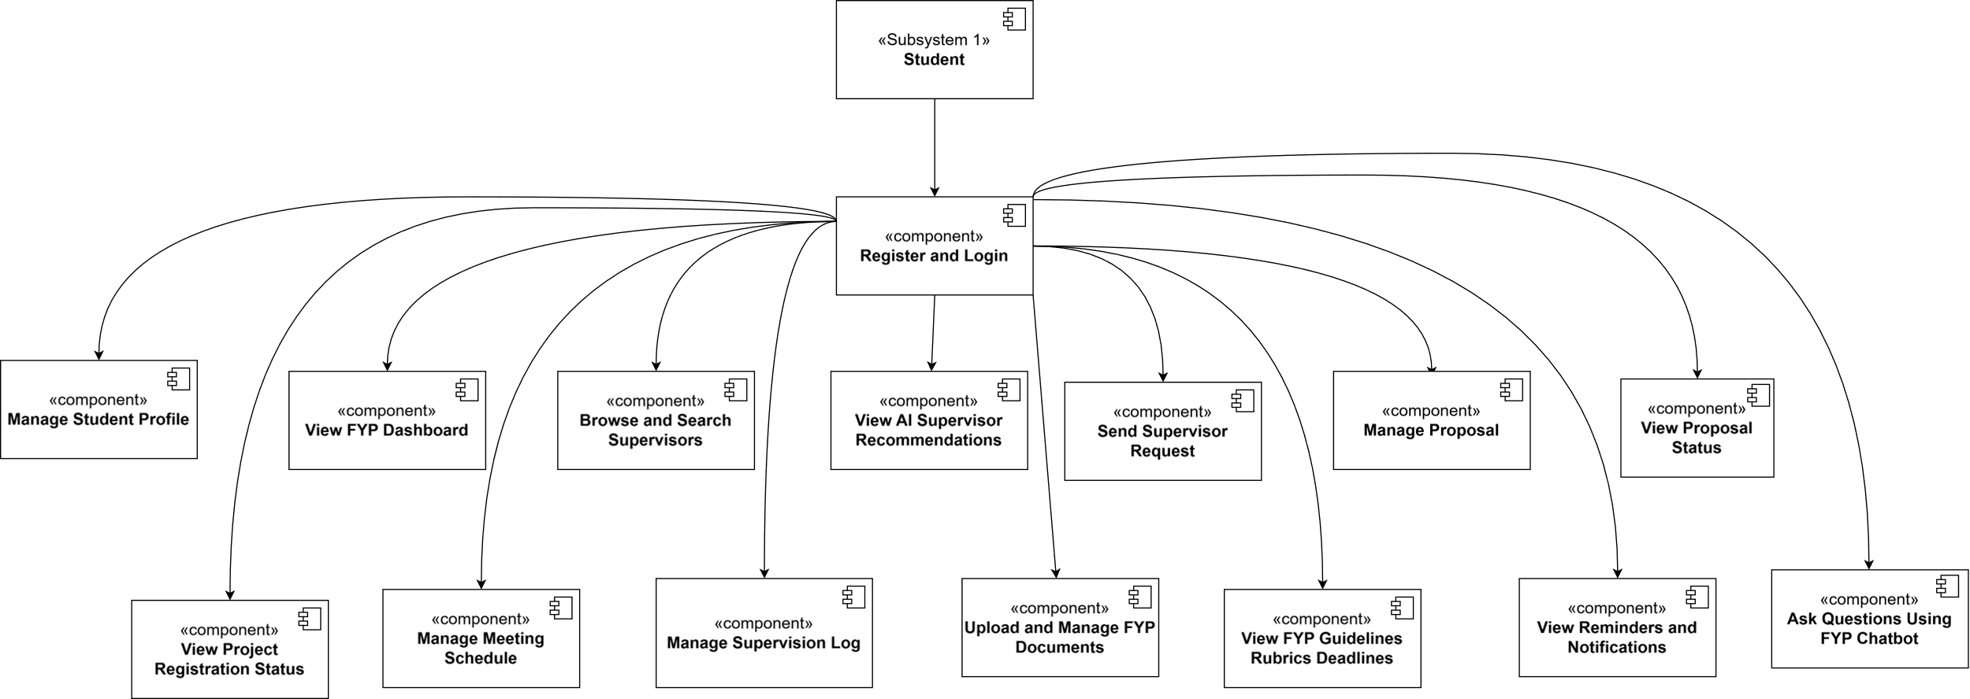
Figure 4.3 Student Subsystem Architecture (Component View)
Figure 4.3 shows the Student subsystem as a set of components accessed through the Register and Login component. After authentication, students can perform the main functions required in the FYP process, including managing profile and dashboard, searching supervisors and viewing AI recommendations, sending supervisor requests, managing proposals and checking status, tracking registration status, scheduling meetings, maintaining supervision logs, uploading FYP documents, viewing guidelines/rubrics/deadlines, receiving reminders/notifications, and asking questions via the chatbot.

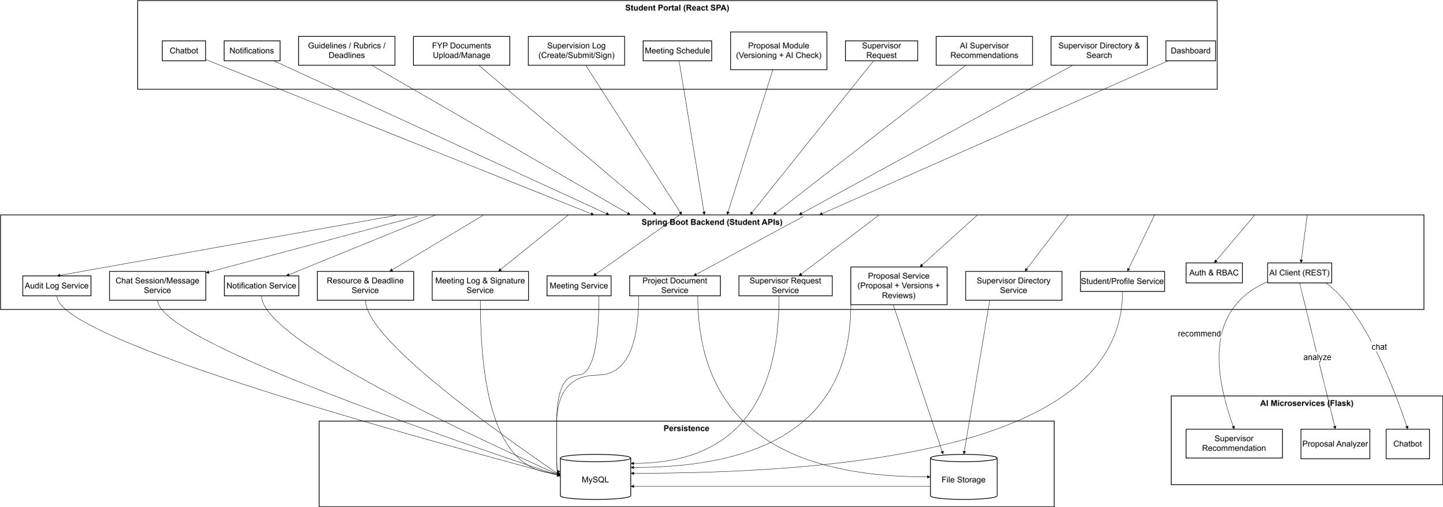
Figure 4.4 Student Subsystem Architecture (Implementation Layer View)
Figure 4.y illustrates the implementation of the Student subsystem where the Student Portal (React SPA) communicates with the Spring Boot Backend (Student APIs) via REST/JSON. The backend enforces access control using Auth and RBAC, stores structured records in MySQL, stores uploaded files in File Storage, and integrates with Flask-based AI microservices (recommendation, proposal analysis, and chatbot) to support intelligent features.

4.1.2 Subsystem 2 (Supervisor)
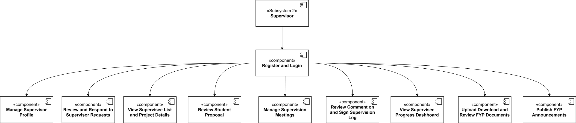
Figure 4.5 Supervisor Subsystem Architecture (Component View)
Figure 4.5 shows the Supervisor subsystem where access is provided through the Register and Login component. After logging in, supervisors can manage their profile, review and respond to supervisor requests, view supervisee lists and project details, review student proposals, manage supervision meetings, review/comment/sign supervision logs, view supervisee progress, upload/download/review FYP documents, and publish announcements.

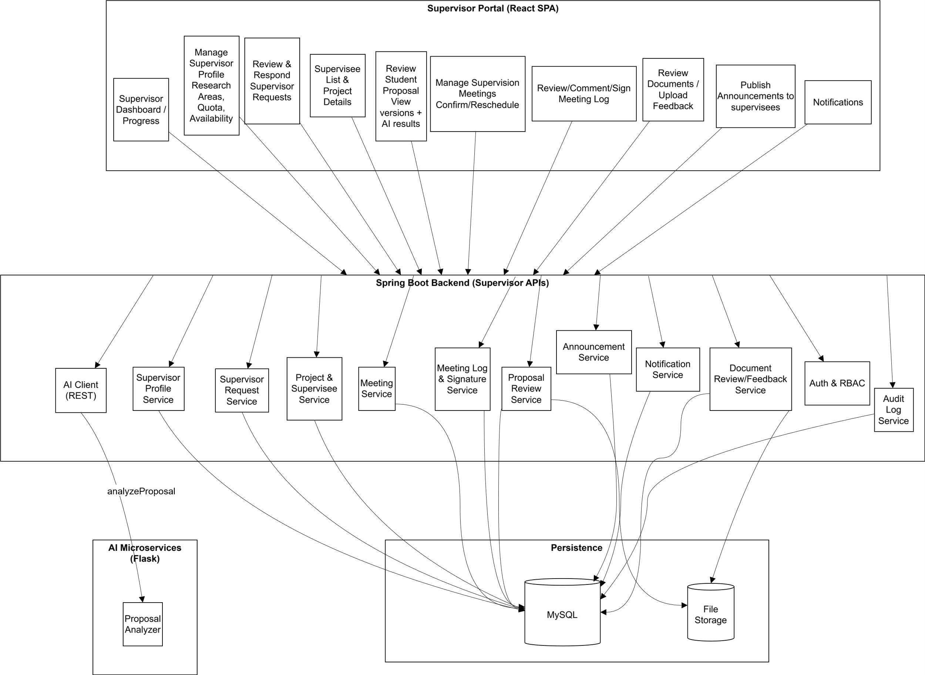
Figure 4.6 Supervisor Subsystem Architecture (Implementation Layer View)
Figure 4.6 illustrates that the Supervisor Portal (React SPA) communicates with the Spring Boot Backend (Supervisor APIs) via REST/JSON. The backend applies Auth and RBAC, stores records in MySQL, stores files in File Storage, and integrates with the Proposal Analyzer AI microservice through the AI client to support proposal review and analysis.

4.1.3 Subsystem 3 (FYP Committee)
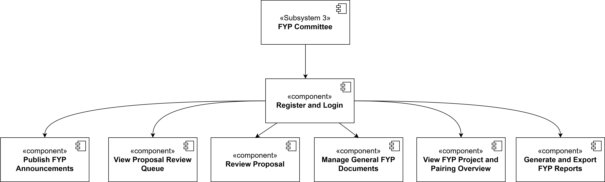
Figure 4.7 FYP Committee Subsystem Architecture (Component View)
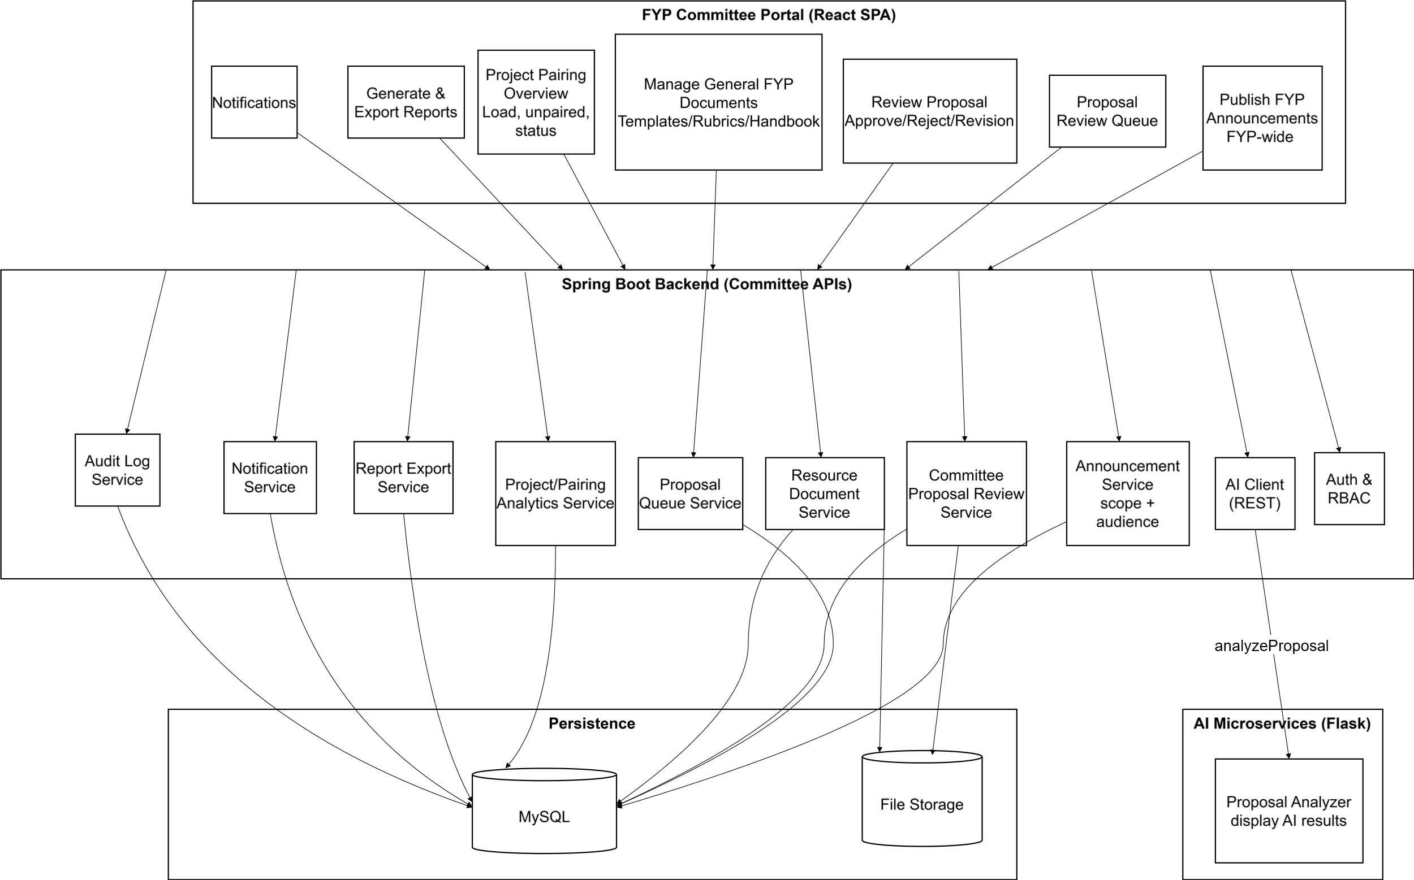
Figure 4.7 shows the FYP Committee subsystem where access is provided through the Register and Login component. After logging in, the committee can publish FYP announcements, view the proposal review queue, review proposals (approve/reject/revision), manage general FYP documents (templates/rubrics/handbook), view FYP project and pairing overview, and generate and export FYP reports.
Figure 4.8 FYP Committee Subsystem Architecture (Implementation Layer View)
Figure 4.8 illustrates that the FYP Committee Portal (React SPA) communicates with the Spring Boot Backend (Committee APIs) via REST/JSON. The backend enforces Auth and RBAC, uses services such as announcement, proposal queue/review, resource document, analytics, report export, notification and audit logging, stores data in MySQL, stores files in File Storage, and can retrieve AI proposal analysis results via the AI client for committee review.

4.1.4 Subsystem 4 (System Admistrator)
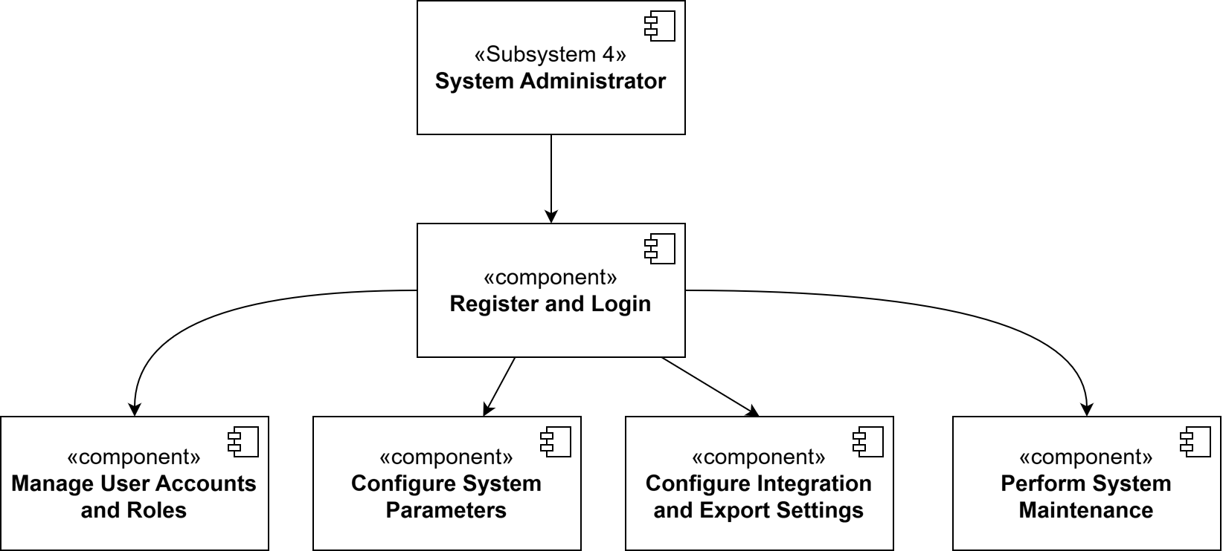
Figure 4.9 System Administrator Subsystem Architecture (Component View)
Figure 4.9 shows the System Administrator subsystem where access is provided through the Register and Login component. After logging in, the administrator can manage user accounts and roles, configure system parameters, configure integration and export settings, and perform system maintenance activities.
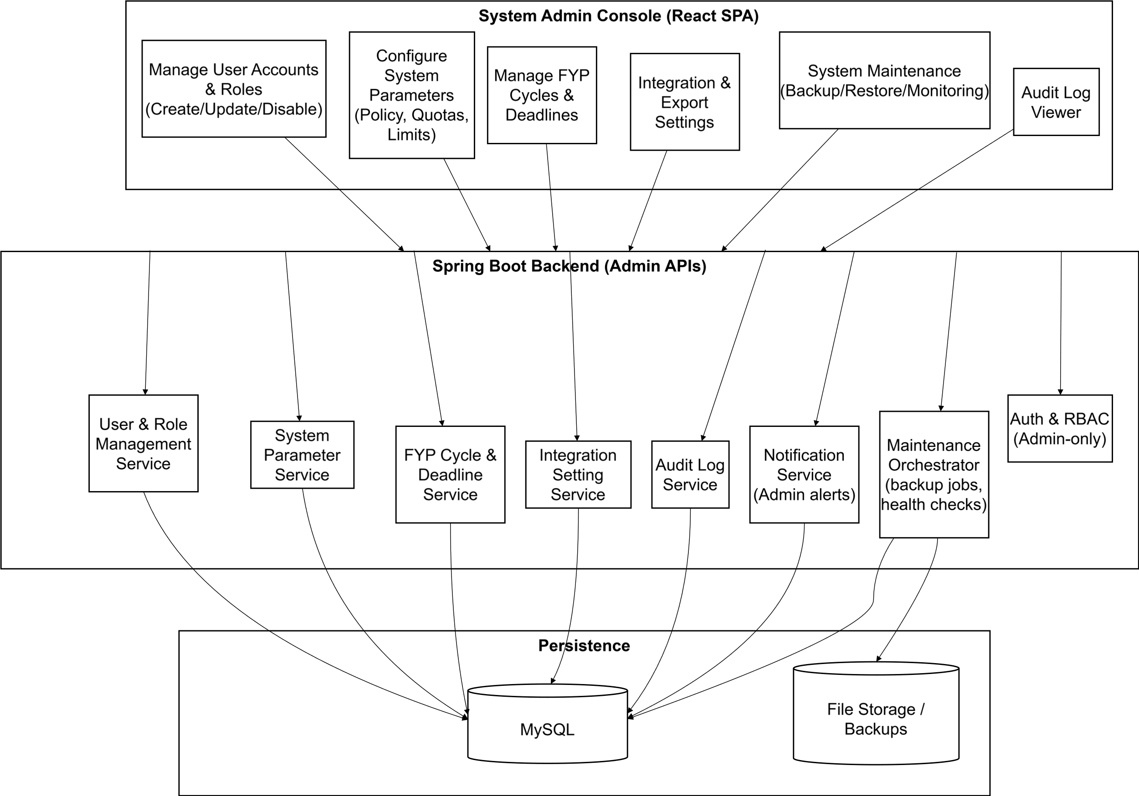
Figure 4.10 System Administrator Subsystem Architecture (Implementation Layer View)
Figure 4.10 illustrates that the System Admin Console (React SPA) communicates with the Spring Boot Backend (Admin APIs) via REST/JSON. The backend enforces Admin-only Auth and RBAC, manages configuration and maintenance through dedicated services, stores system records in MySQL, and stores backup or maintenance files in File Storage/Backups, with audit logs available for monitoring and traceability.

4.2 Sequence Diagrams

4.2.1 UC1 Register and Log In (All Roles)
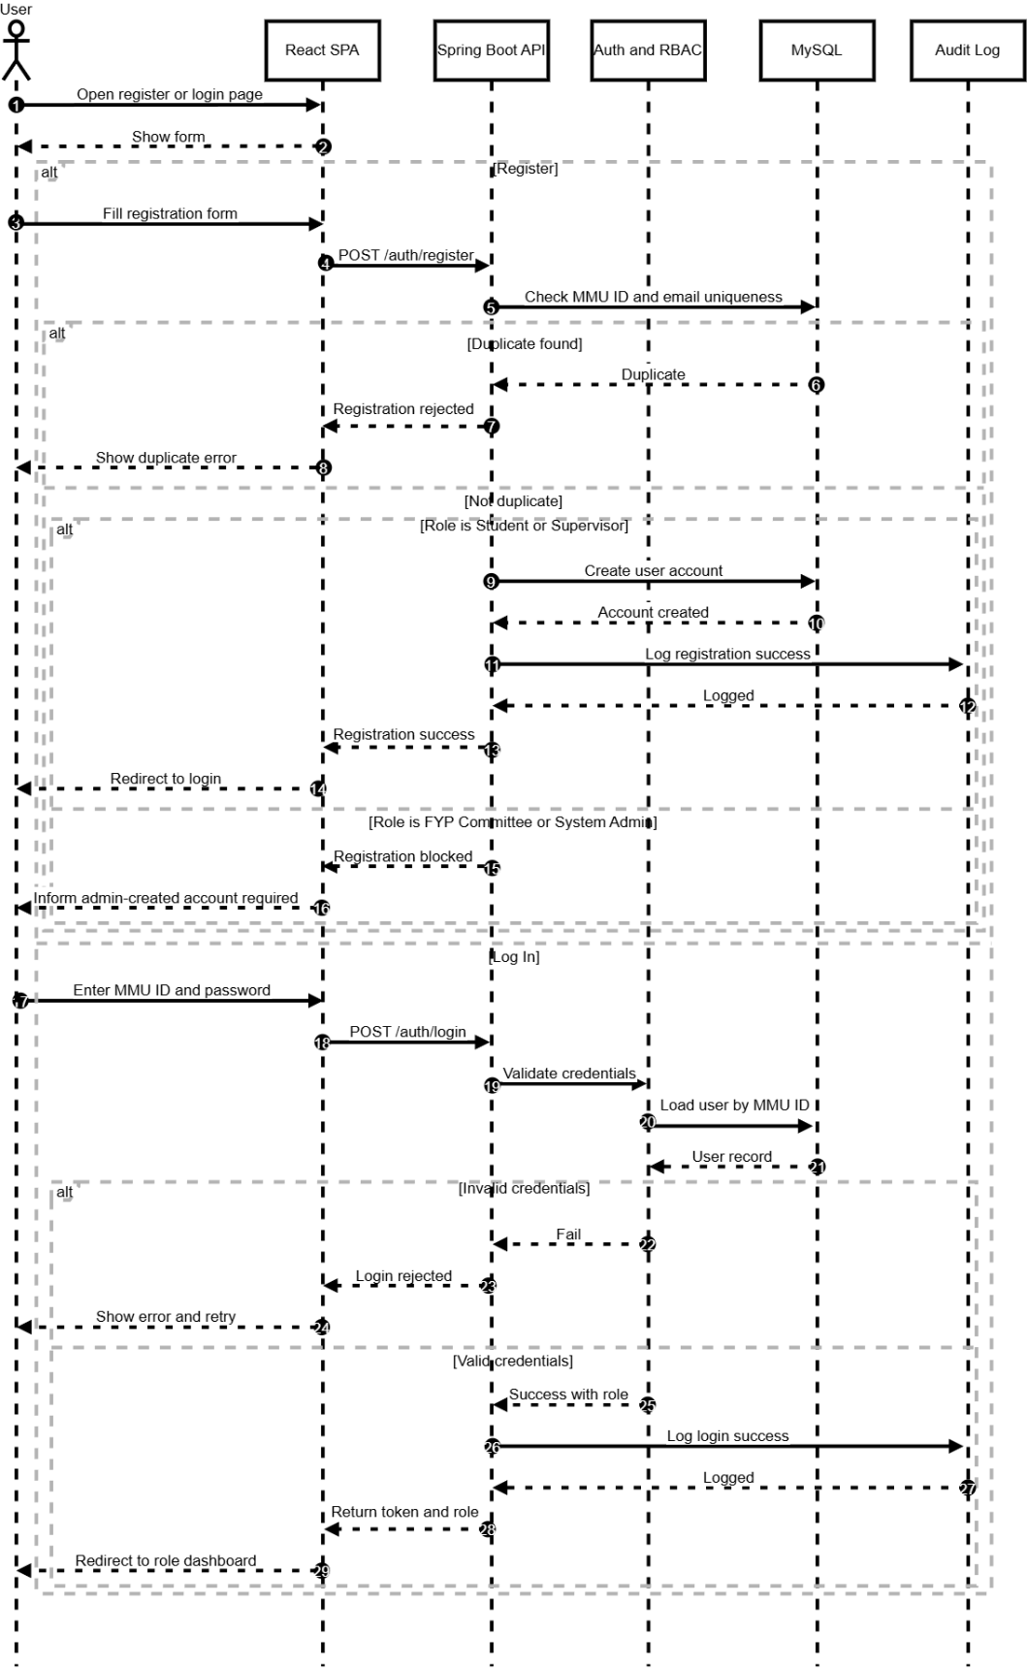
Figure 4.11 UC1 Register and Log In Sequence Diagram
- The user opens the Register/Login page in the React SPA and the form is displayed.
- The user chooses either Register or Log In.
Register flow
- The user fills in the registration form and submits it.
- React SPA sends POST /auth/register to the Spring Boot API.
- Spring Boot checks MMU ID and email uniqueness in the MySQL database.
- If a duplicate is found, the backend rejects the registration and the UI shows a duplicate error.
- If no duplicate is found and the role is Student or Supervisor, the backend creates the user account in MySQL.
- The backend records the registration event in the Audit Log.
- The backend returns registration success and the UI redirects the user to the Log In page.
- If the role is FYP Committee or System Administrator, the backend blocks registration and the UI informs that the account must be admin-created.
Log In flow
- The user enters MMU ID and password and submits.
- React SPA sends POST /auth/login to the Spring Boot API.
- Spring Boot calls the Auth/RBAC module to validate credentials.
- Auth/RBAC loads the user record from MySQL.
- If credentials are invalid, the backend rejects login and the UI shows an error with retry.
- If credentials are valid, Auth/RBAC returns success with role information.
- The backend records the login event in the Audit Log.
- The backend returns a token and role details, and the UI redirects the user to the correct role dashboard.

4.2.2 UC2 Manage Student Profile (Student)
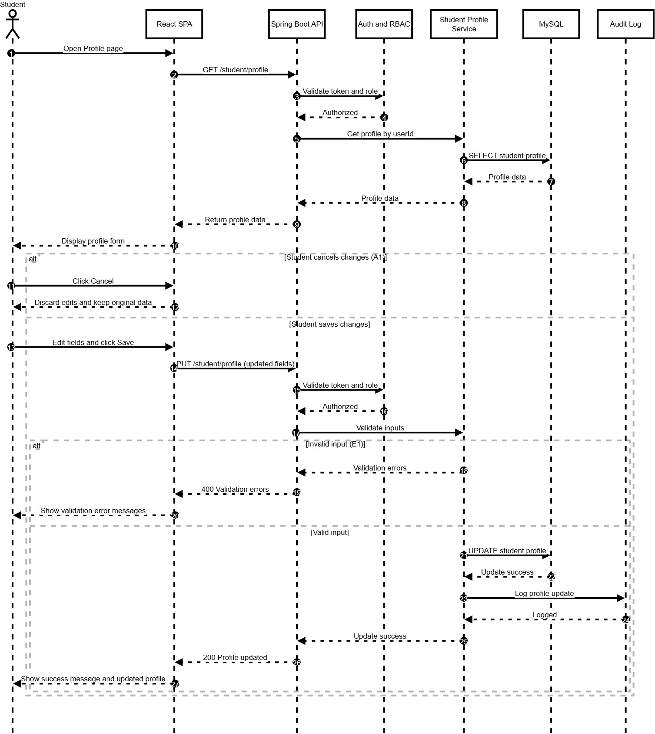
Figure 4.12 UC2 Manage Student Profile Sequence Diagram
- The student opens the Profile page in the React SPA.
- The frontend requests the current profile using GET /student/profile.
- The backend verifies the student session using Auth and RBAC.
- The Student Profile Service retrieves profile data from MySQL and returns it to the frontend for display.
- The student edits the required profile fields (personal and academic details).
- If the student selects Cancel (A1), the system discards the changes and restores the previously loaded profile values.
- If the student selects Save, the frontend submits the updates using PUT /student/profile.
- The backend performs authentication and input validation.
- If validation fails (E1), the system returns error messages and the frontend displays the validation errors.
- If validation succeeds, the system updates the profile in MySQL, records the action in the Audit Log, and returns a success response.
- The frontend displays a success message and shows the updated profile information.

4.2.3 UC3 View FYP Dashboard (Student)
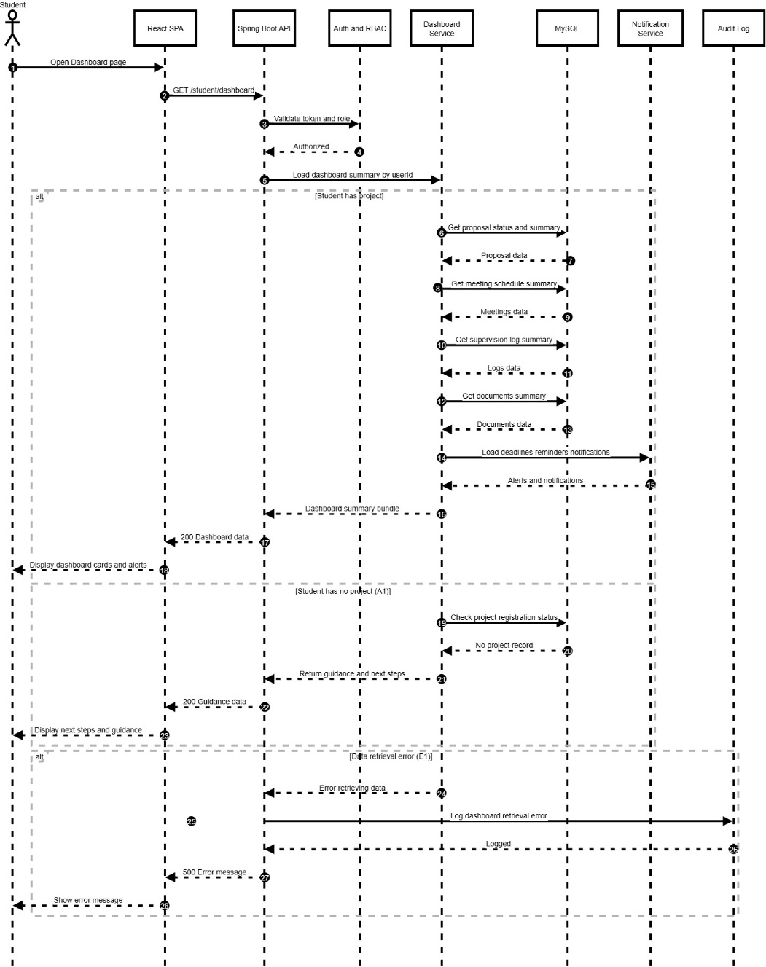
Figure 4.13 UC3 View FYP Dashboard Sequence Diagram
- The student opens the Dashboard page in the React SPA.
- The frontend sends GET /student/dashboard to the Spring Boot API.
- The backend validates the student session using Auth and RBAC.
- The Dashboard Service loads the dashboard summary for the student, including proposal status, meeting schedule, supervision logs, document summary, deadlines, and notifications.
- If the student has an active project, the system returns the summary data and the frontend displays dashboard cards and alerts.
- If the student has no project (A1), the system returns guidance and next steps (e.g., registration/proposal actions) and the frontend displays the guidance.
- If a data retrieval error occurs (E1), the system logs the error in the audit log and displays an error message to the student.

4.2.4 UC4 Browse and Search Supervisors (Student)
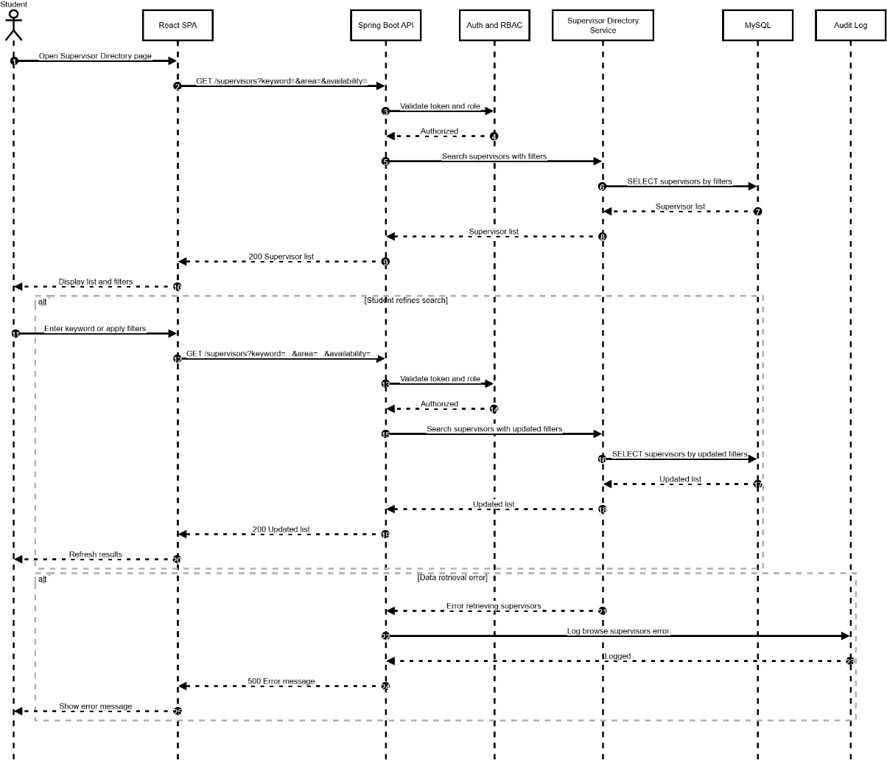
Figure 4.14 UC4 Browse and Search Supervisors Sequence Diagram
- Student opens the Supervisor Directory page.
- Frontend requests supervisors with optional filters via GET /supervisors.
- Backend validates the session using Auth and RBAC.
- Supervisor Directory Service queries MySQL and returns the supervisor list.
- Frontend displays the list and filter controls.
- If the student refines the search, the frontend sends another GET /supervisors with updated filters and refreshes results.
- If retrieval fails, the backend logs the error and the UI shows an error message.

4.2.5 UC5 View AI Supervisor Recommendations (Student)
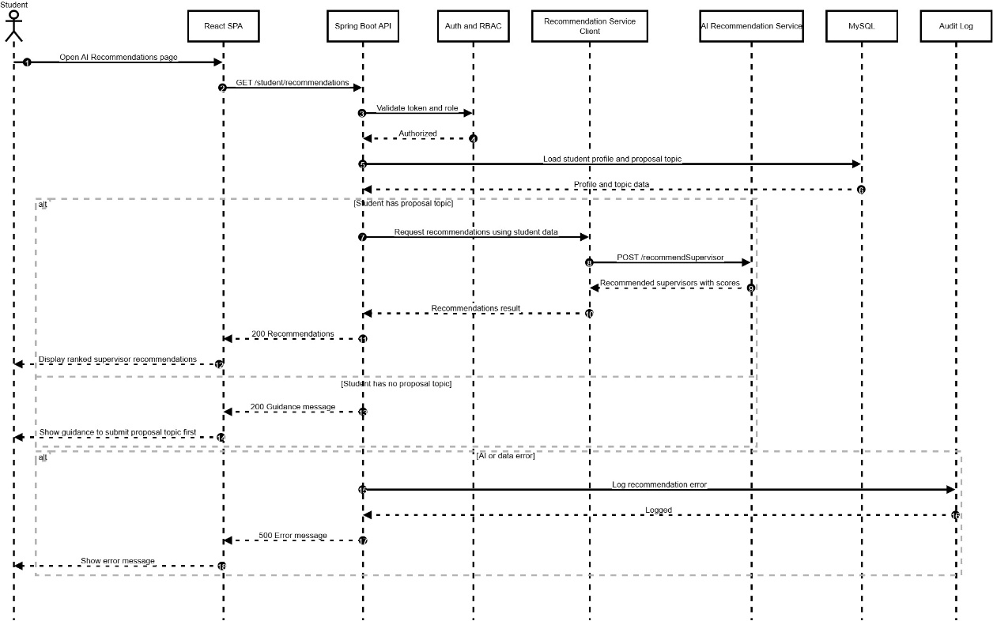
Figure 4.15 UC5 View AI Supervisor Recommendations Sequence Diagram
- Student opens the AI Recommendations page.
- Frontend calls GET /student/recommendations.
- Backend validates the session using Auth and RBAC.
- Backend loads the student profile and proposal topic from MySQL.
- If a proposal topic exists, backend calls the AI recommendation service and receives ranked supervisors with scores.
- Frontend displays the recommended supervisors.
- If no proposal topic exists, the system shows guidance to submit a proposal/topic first.
- If errors occur, the system logs the failure and displays an error message.

4.2.6 UC6 Send Supervisor Request (Student)

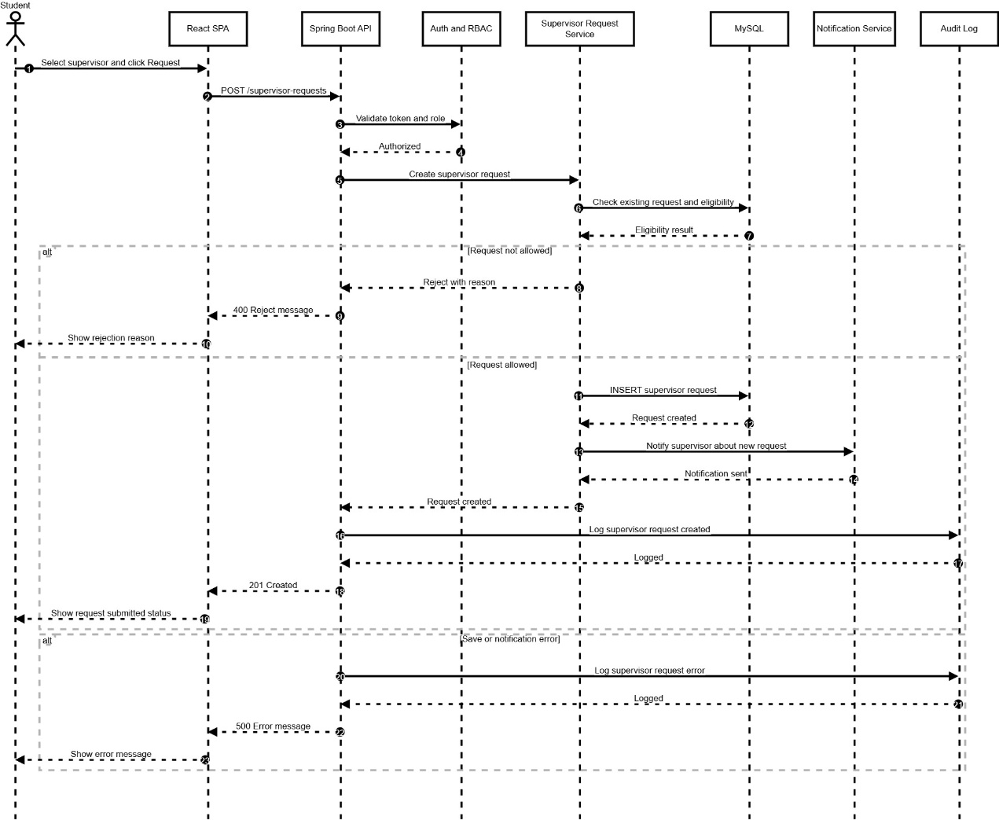
Figure 4.16 UC6 Send Supervisor Request Sequence Diagram
- Student selects a supervisor and submits a request.
- Frontend sends POST /supervisor-requests to the backend.
- Backend validates the student session via Auth and RBAC.
- Supervisor Request Service checks eligibility and whether a request already exists in MySQL.
- If not allowed, the system returns a rejection reason to the student.
- If allowed, the request is saved in MySQL and a notification is sent to the supervisor.
- The action is logged in the audit log and the UI shows the submitted status.
- If any error occurs, the system logs it and shows an error message.

4.2.7 UC7 Manage Proposal (Student)

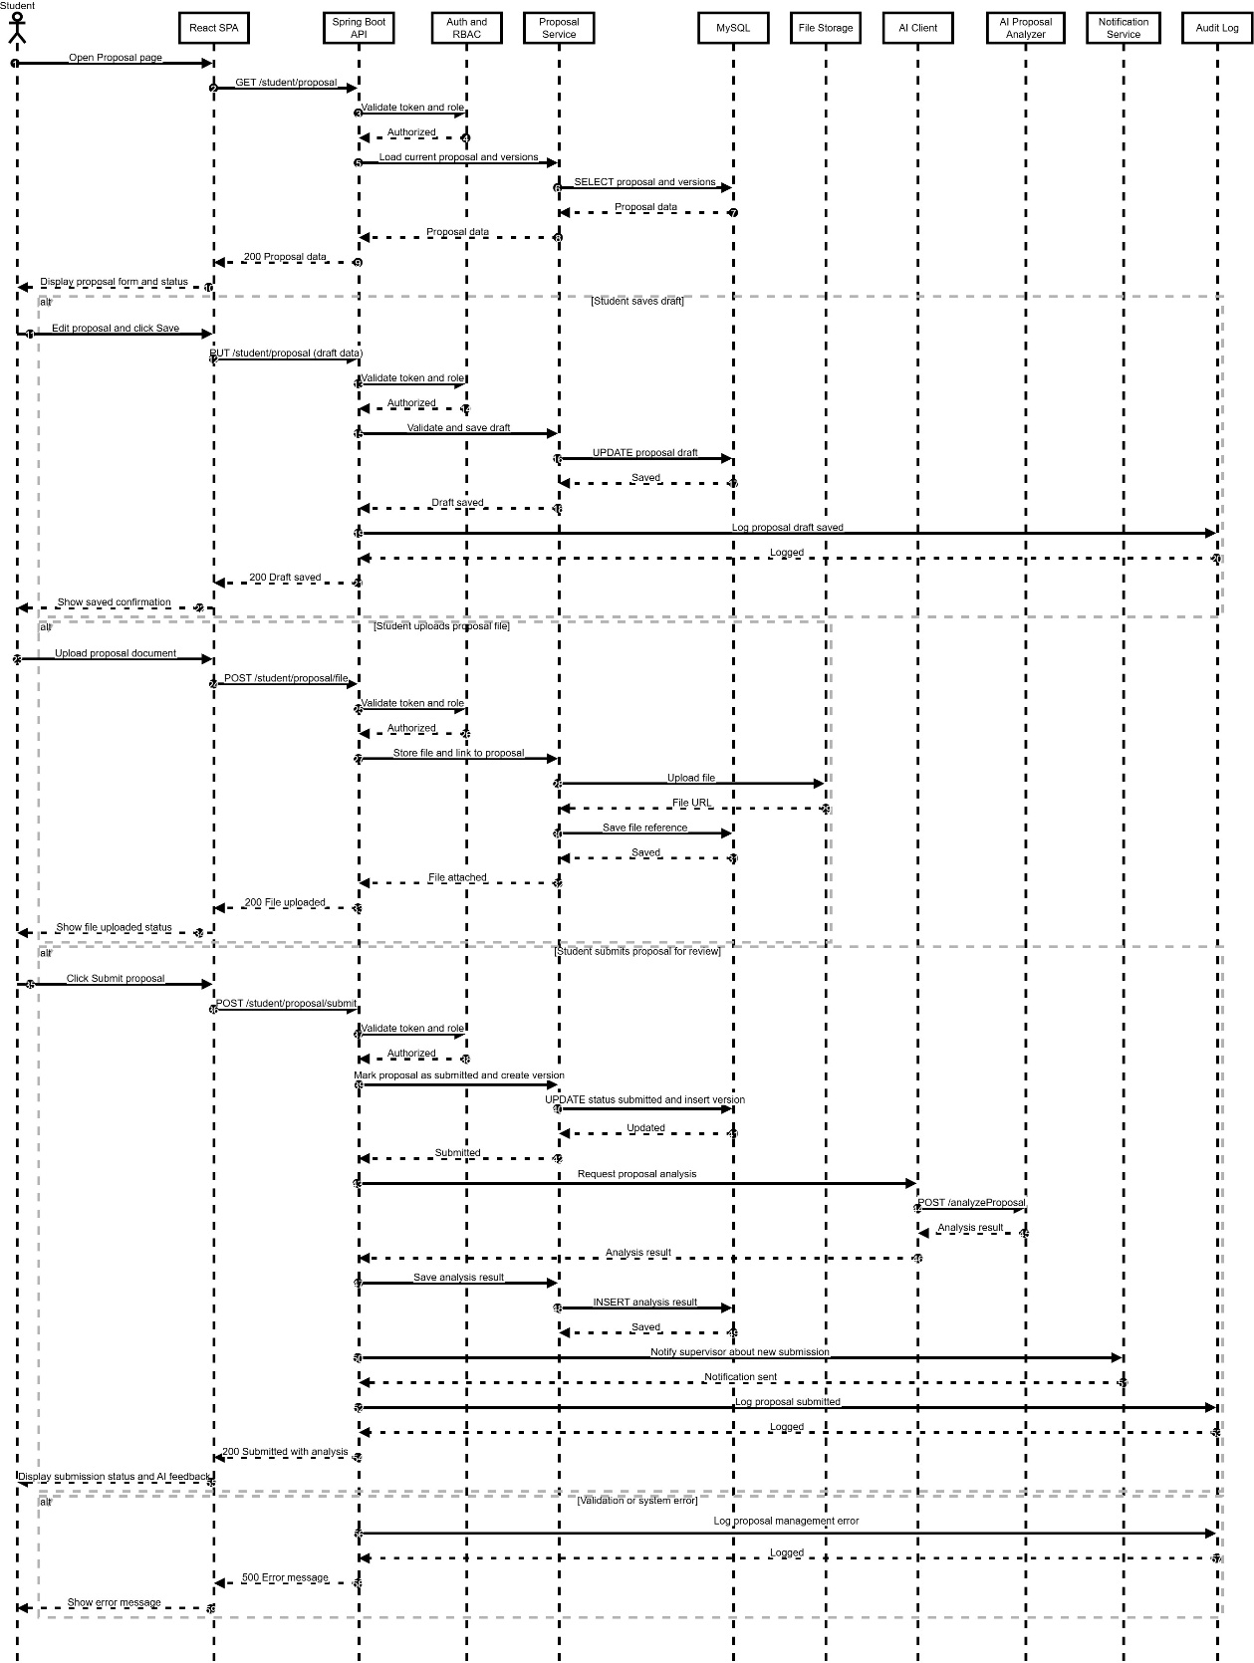
Figure 4.17 UC7 Manage Proposal Sequence Diagram
- Student opens the Proposal page; frontend requests current proposal via GET /student/proposal.
- Backend validates session via Auth and RBAC and loads proposal data from MySQL.
- The proposal form and current status are displayed to the student.
- If the student saves a draft, the frontend sends PUT /student/proposal; the backend validates and updates the draft record in MySQL, then logs the action.
- If the student uploads a proposal file, the frontend sends POST /student/proposal/file; the system stores the file in File Storage and saves its reference in MySQL.
- If the student submits the proposal, the backend updates the proposal status to submitted, creates a new version, and triggers the AI Proposal Analyzer.
- The AI analysis result is saved and returned to the student, and the supervisor is notified about the submission.
- Any validation or system error is logged and an error message is shown to the student.

4.2.8 UC8 View Proposal Status (Student)
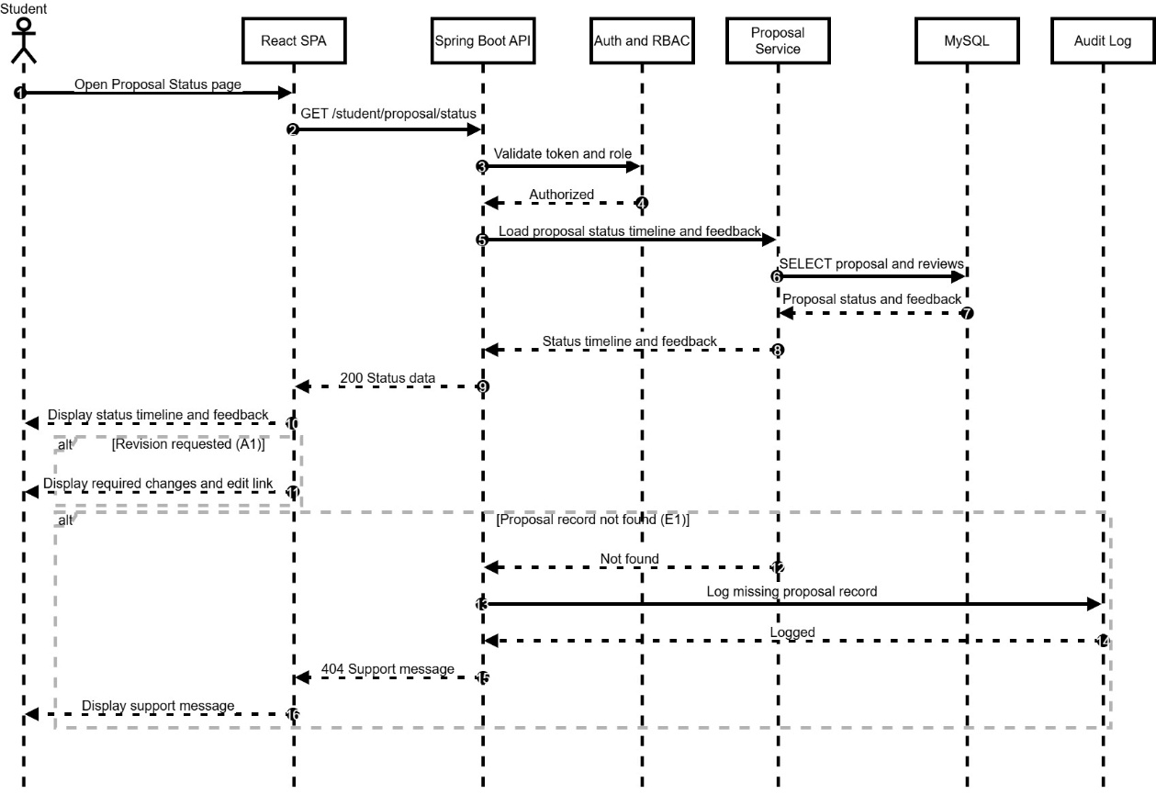
Figure 4.18 UC8 View Proposal Status Sequence Diagram
- Student opens the Proposal Status page.
- Frontend sends GET /student/proposal/status to the backend.
- Backend validates the session using Auth and RBAC.
- Proposal Service retrieves proposal status timeline and supervisor feedback from MySQL.
- System returns the status data and the frontend displays the timeline and feedback.
- If revision is requested (A1), the system highlights required changes and provides an edit link.
- If no proposal record exists (E1), the system logs the issue and displays a support message.

4.2.9 UC9 View Project Registration Status (Student)
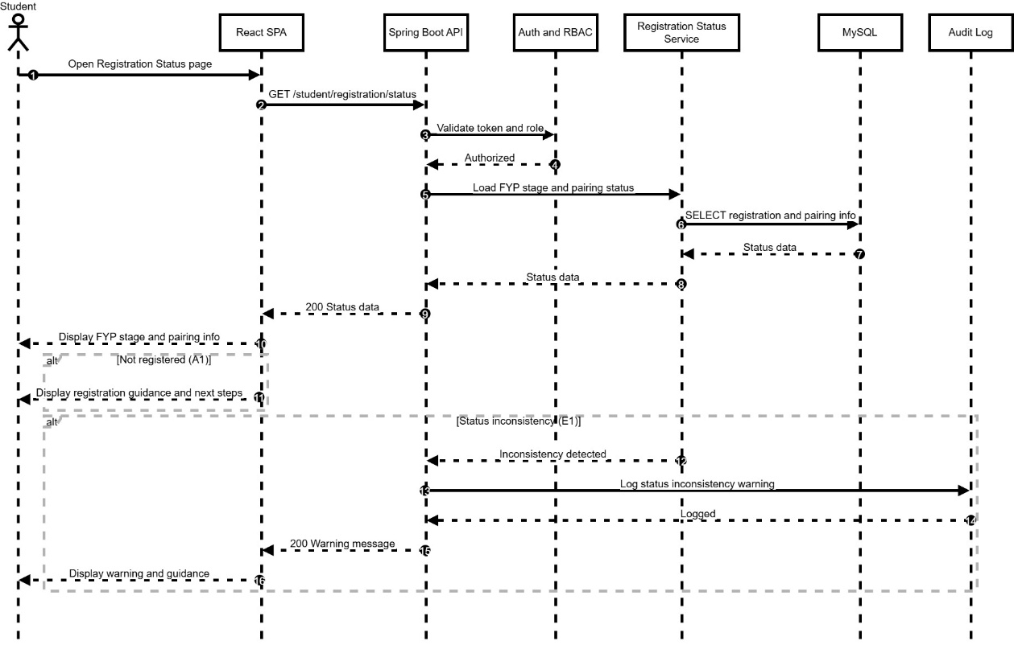
Figure 4.19 UC9 View Project Registration Status Sequence Diagram
- Student opens Registration Status page.
- Frontend calls GET /student/registration/status.
- Backend validates the session using Auth and RBAC.
- Registration Status Service loads FYP stage and pairing status from MySQL.
- Frontend displays the current stage, pairing information, and next steps.
- If the student is not registered (A1), the system shows registration guidance.
- If an inconsistency is detected (E1), the system shows a warning and logs the issue.

4.2.10 UC10 Manage Meeting Schedule (Student)

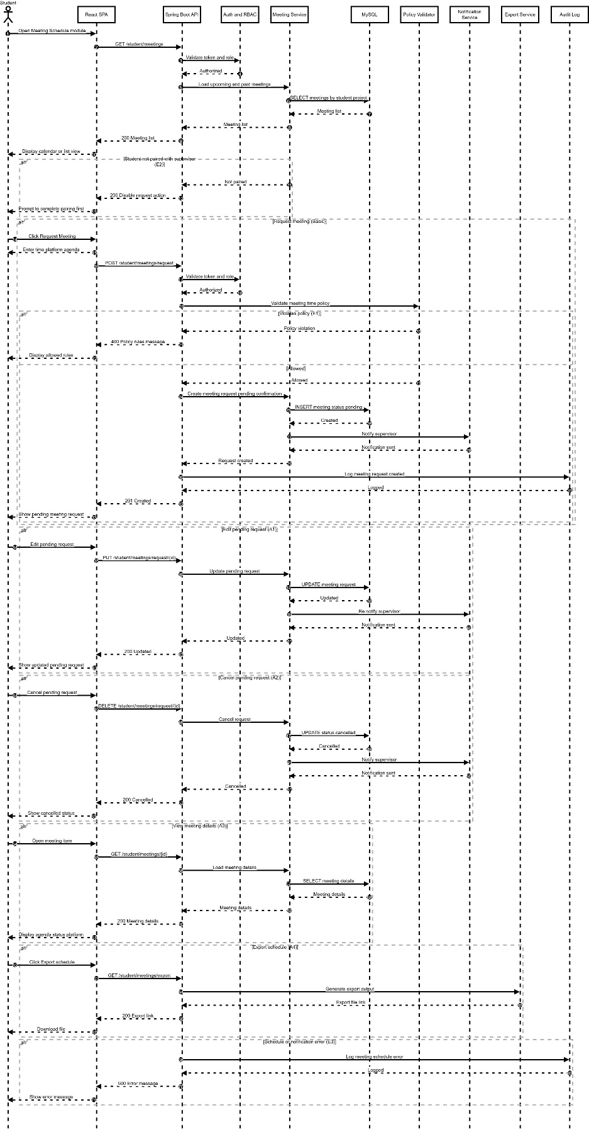
Figure 4.20 UC10 Manage Meeting Schedule Sequence Diagram
- Student opens Meeting Schedule module.
- Frontend requests meeting list via GET /student/meetings.
- Backend validates session and returns upcoming and past meetings from MySQL.
- If student is not paired (E2), the request action is disabled and guidance is shown.
- Student can request a meeting by submitting time, platform, and agenda.
- System validates policy rules; if violated (E1), it blocks submission and shows allowed rules.
- If allowed, system creates a pending request, notifies the supervisor, and shows pending status.
- Student may edit (A1) or cancel (A2) a pending request; system updates status and notifies supervisor.
- Student can view details (A3) and export schedule (A4).
- Any service error (E3) is logged and an error message is displayed.

4.2.11 UC11 Manage Supervision Log (Student)

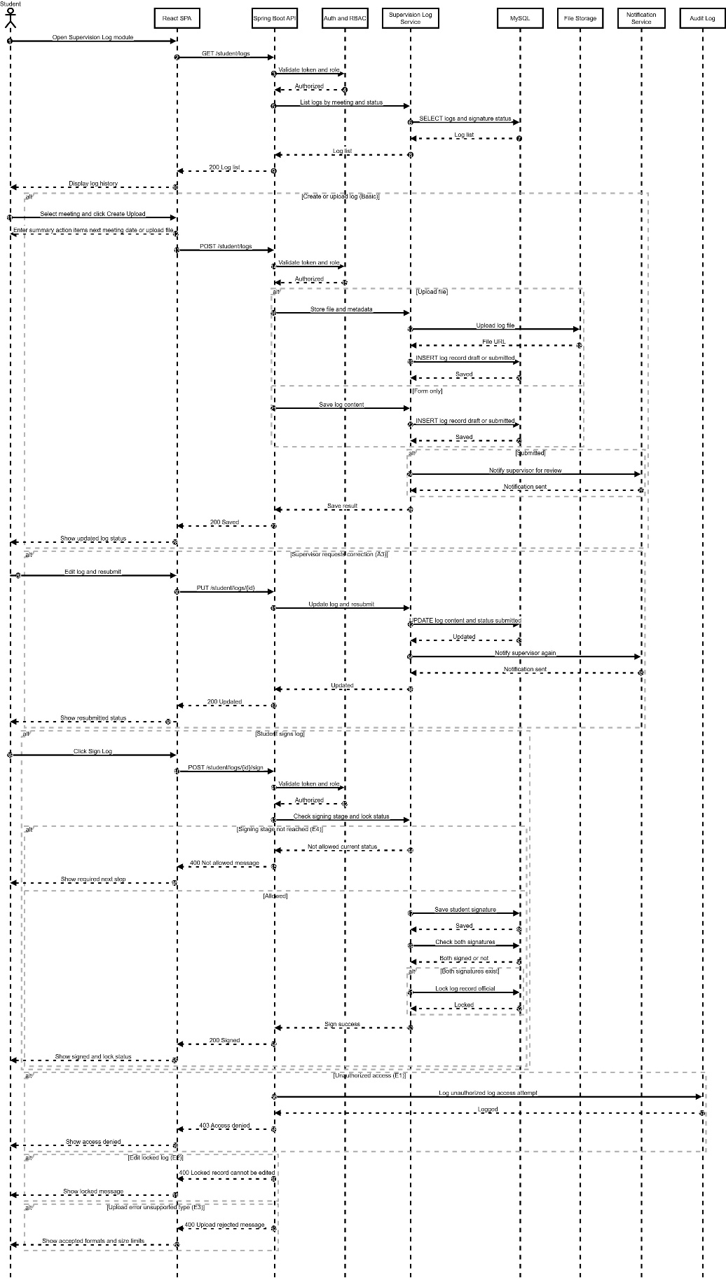
Figure 4.21 UC11 Manage Supervision Log Sequence Diagram
- Student opens Supervision Log module; system lists logs by meeting with status and signatures.
- Student creates or uploads a log; system stores content and optional file, then saves to MySQL and File Storage.
- If submitted, the supervisor is notified for review.
- If correction is requested (A3), student edits and re-submits and the supervisor is notified again.
- When signing is allowed, student signs the log; the system records the signature and locks the log if both signatures exist.
- Unauthorized access, locked-edit attempts, upload errors, or signing too early trigger the relevant error messages and logging.

4.2.12 UC12 Upload and Manage FYP Documents (Student)
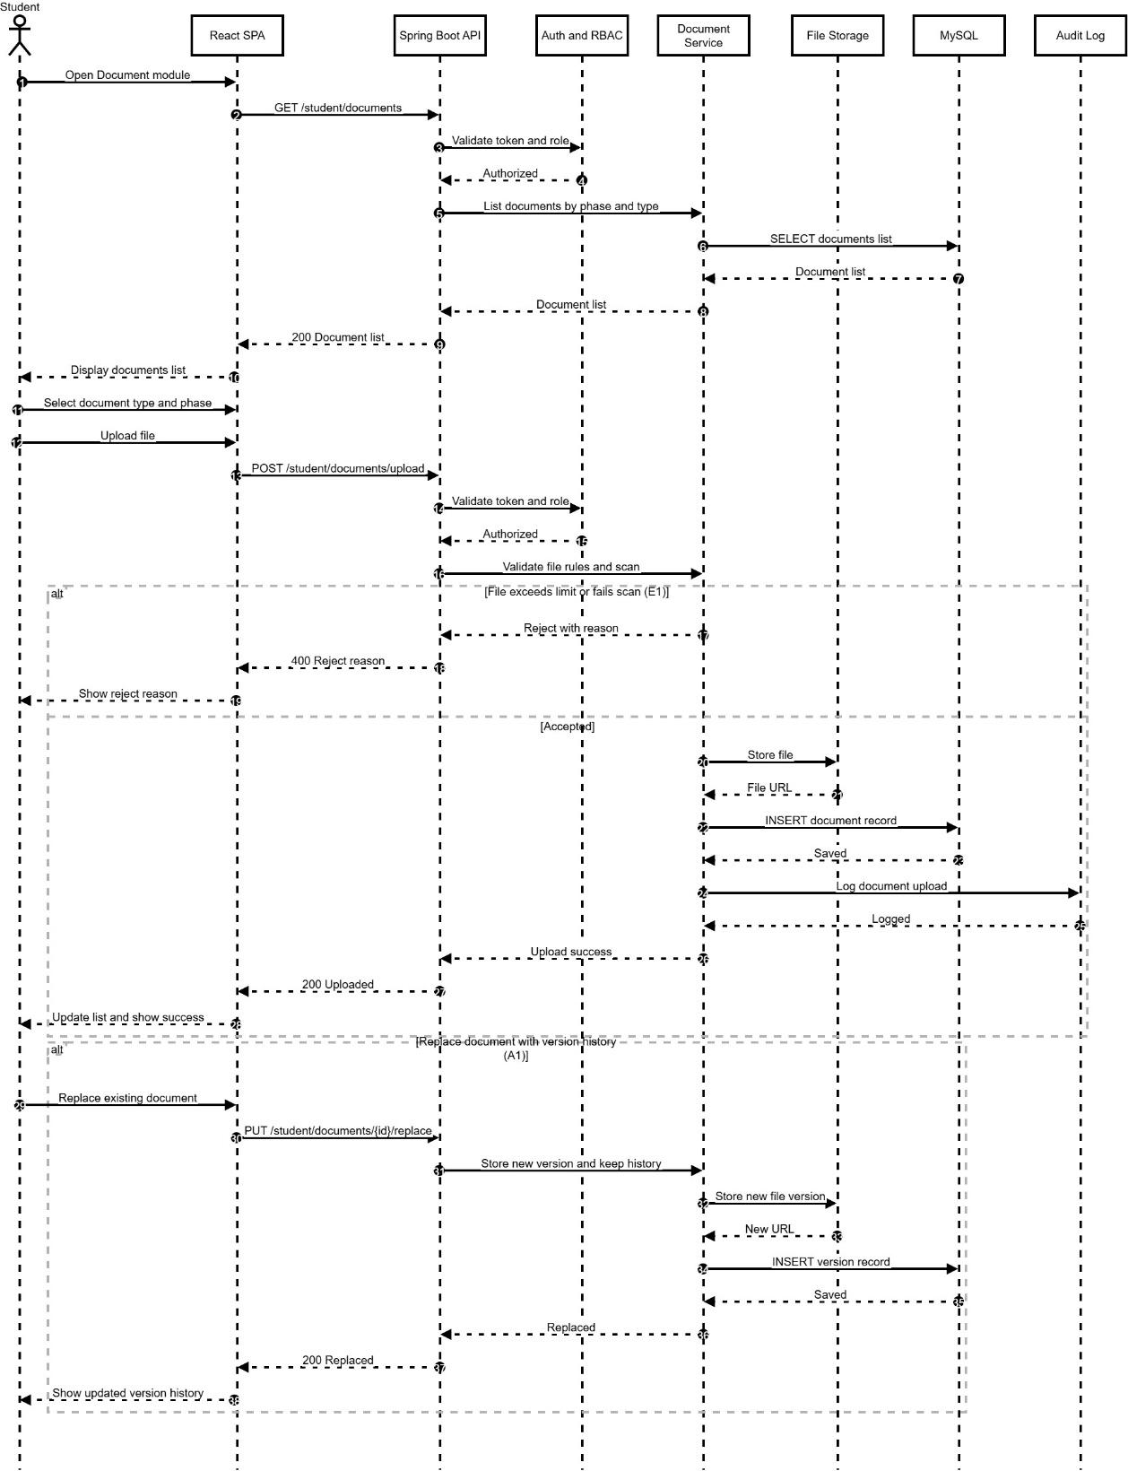
Figure 4.22 UC12 Upload and Manage FYP Documents Sequence Diagram
- Student opens Document module and the system lists existing documents.
- Student selects document phase and type, then uploads a file.
- Backend validates session and checks file constraints and scanning rules.
- If file fails (E1), the system rejects and shows the reason.
- If accepted, the file is stored in File Storage and metadata is saved in MySQL.
- If replacing a document (A1), the system stores a new version and keeps version history.

4.2.13 UC13 View FYP Guidelines, Rubrics and Deadlines (Student)

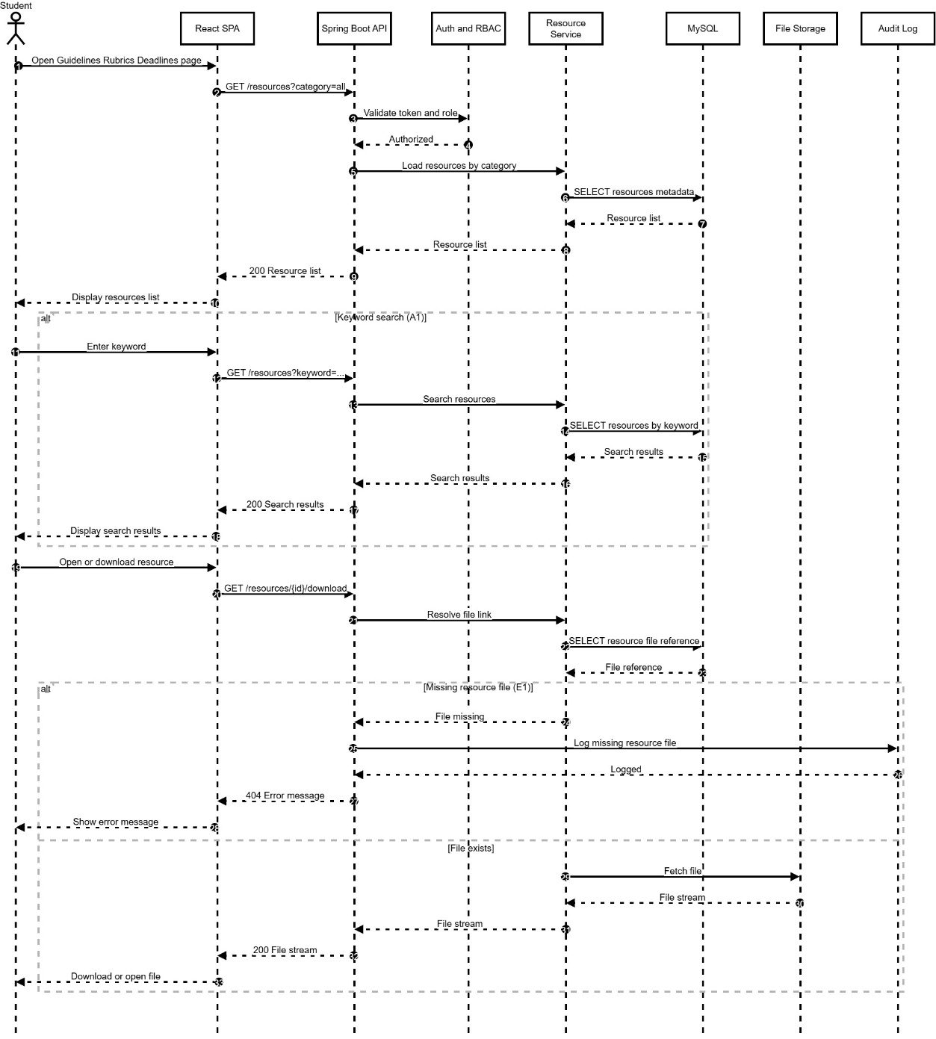
Figure 4.23 UC13 View FYP Guidelines, Rubrics and Deadlines Sequence Diagram
- Student opens Guidelines, Rubrics and Deadlines page.
- System loads resources by category and displays them.
- Student may search by keyword (A1); system returns matching resources.
- Student opens or downloads a resource; system retrieves the file from storage.
- If the file is missing (E1), the system logs the incident and shows an error message.

4.2.14 UC14 View Reminders and Notifications (Student)
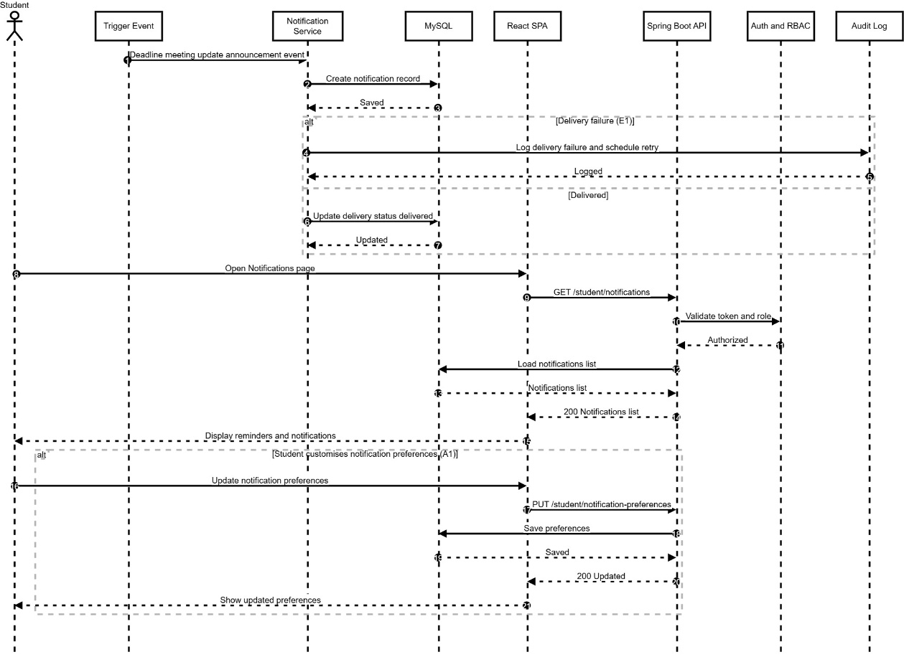

Figure 4.24 UC14 View Reminders and Notifications Sequence Diagram
- A trigger event occurs (deadline, meeting update, or announcement).
- Notification Service creates a notification record in MySQL.
- If delivery fails (E1), the system logs the failure and retries based on rules; otherwise delivery status is updated.
- Student opens the Notifications page; system retrieves and displays notifications.
- Student may update notification preferences (A1); the system saves the updated preferences.

4.2.15 UC15 Ask Questions Using the FYP Chatbot (Student)

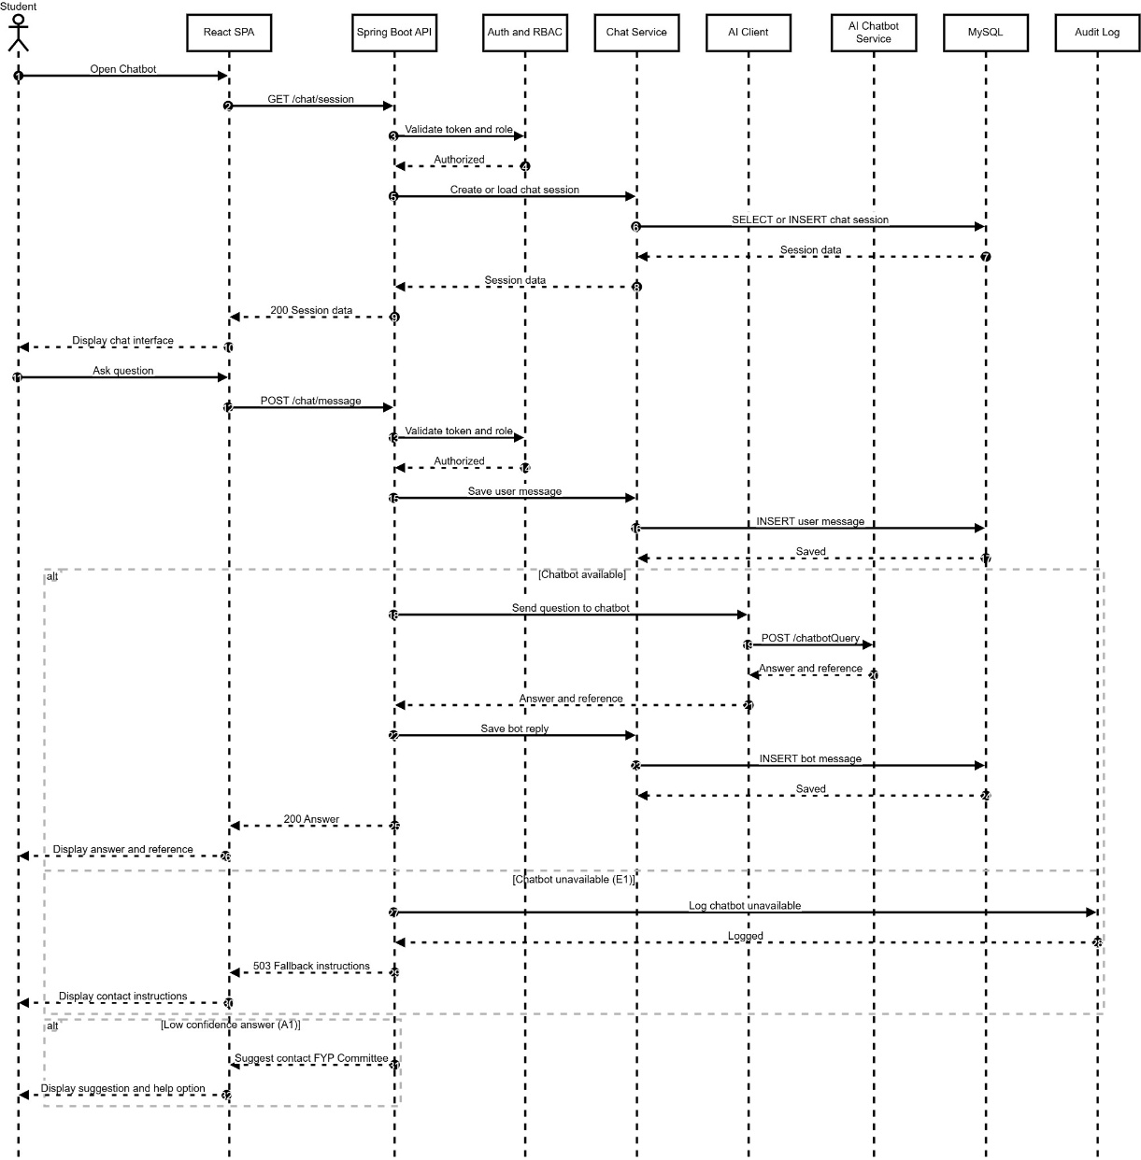
Figure 4.25 UC15 Ask Questions Using the FYP Chatbot Sequence Diagram
- Student opens the chatbot; system creates or loads a chat session.
- Student sends a question; the system stores the user message.
- If chatbot service is available, the backend sends the query to the AI chatbot and returns an answer with references, then stores the bot reply.
- If chatbot is unavailable (E1), the system logs the issue and shows fallback contact instructions.
- If the response confidence is low (A1), the system suggests contacting the FYP Committee and provides a help option.

4.2.16 UC16 Manage Supervisor Profile (Supervisor)
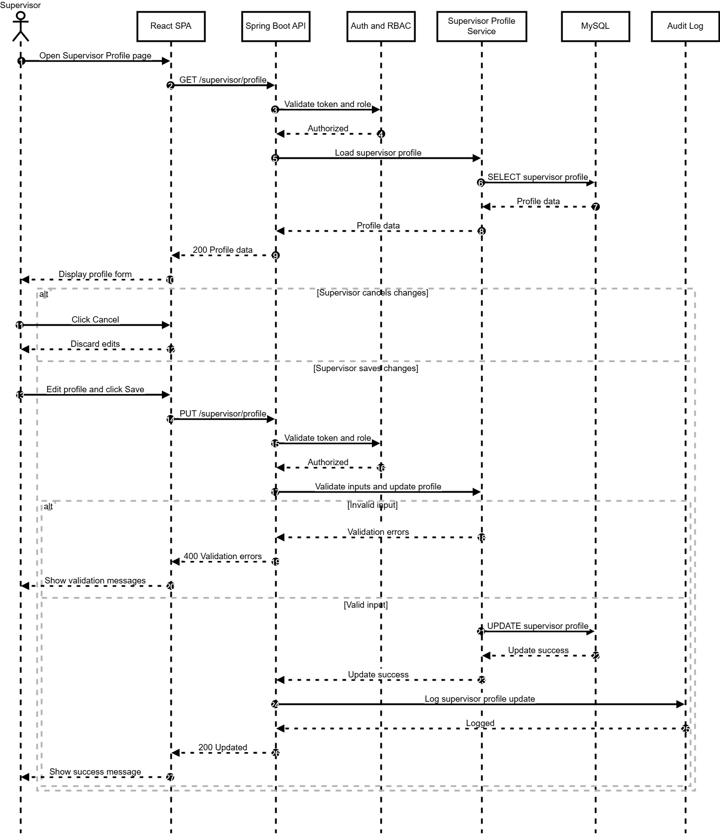
Figure 4.26 UC16 Manage Supervisor Profile Sequence Diagram
- Supervisor opens Profile page; frontend requests current profile.
- Backend validates session and loads supervisor profile from MySQL.
- Supervisor edits profile fields (research areas, quota, availability) or cancels.
- On save, backend validates input and updates the profile in MySQL.
- If validation fails, error messages are shown; otherwise success is returned and logged.

4.2.17 UC17 Review and Respond to Supervisor Requests (Supervisor)
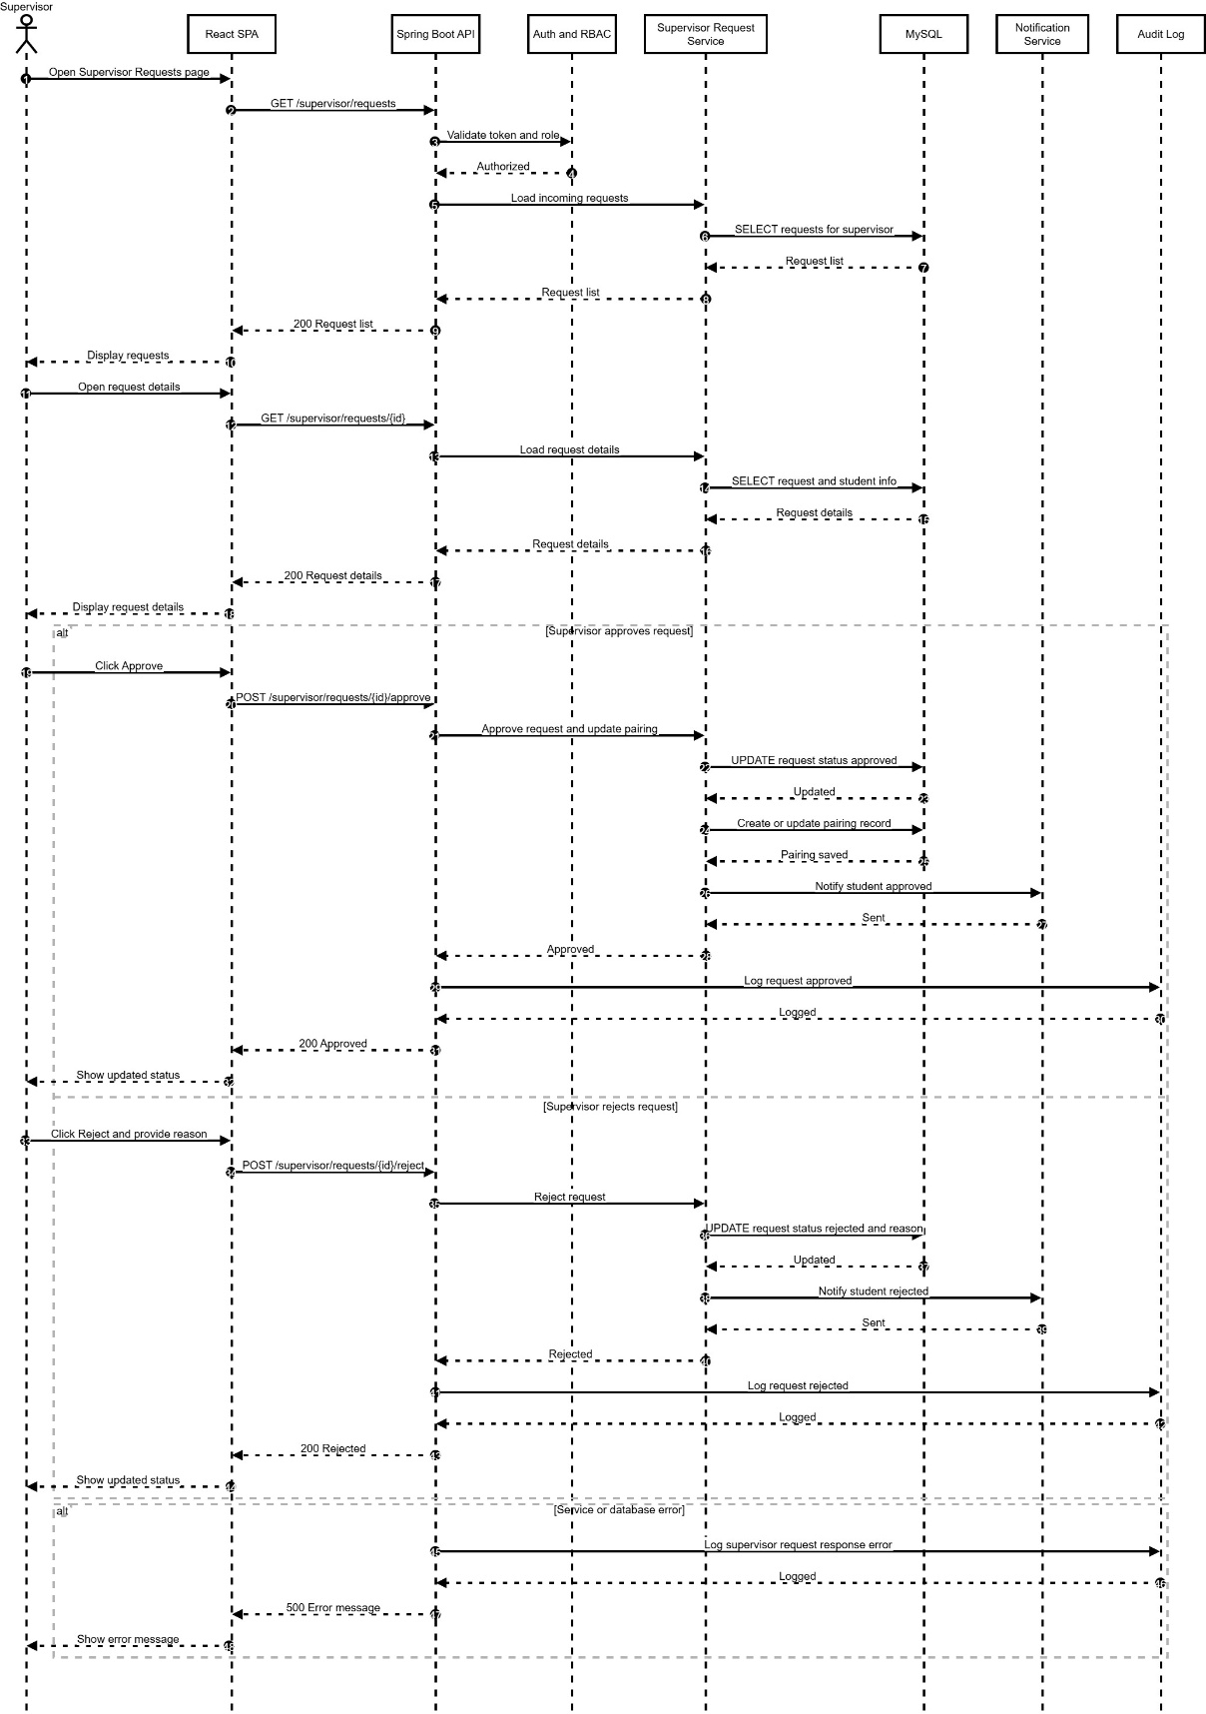
Figure 4.27 UC17 Review and Respond to Supervisor Requests Sequence Diagram
- Supervisor opens Requests module; system loads incoming requests.
- Supervisor views a request and chooses approve or reject.
- On approve, the system updates request status, creates pairing, notifies student, and logs the action.
- On reject, the system updates status with reason, notifies student, and logs the action.
- Errors are logged and shown to the supervisor.

4.2.18 UC18 View Supervisee List and Project Details (Supervisor)
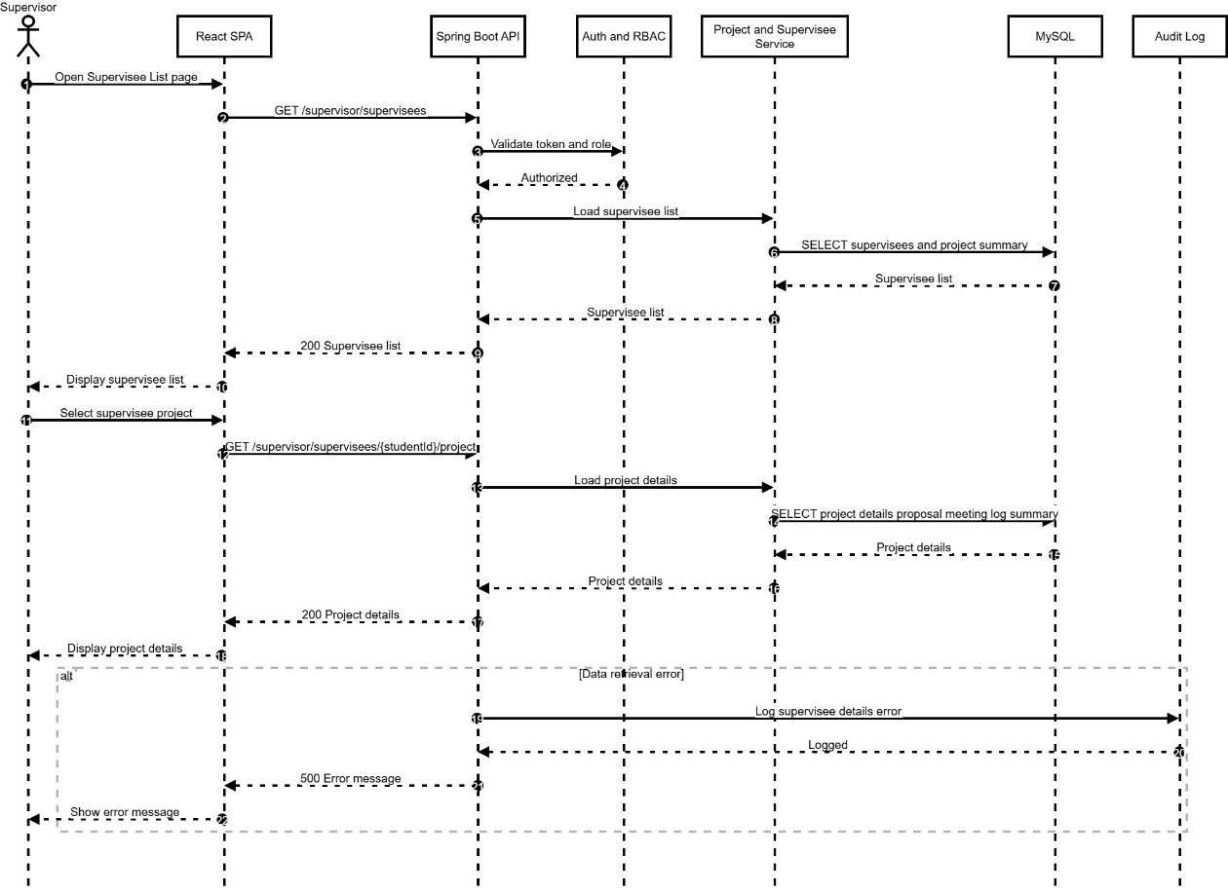
Figure 4.28 UC18 View Supervisee List and Project Details Sequence Diagram
- Supervisor opens Supervisee List; system loads supervisee projects.
- Supervisor selects a supervisee; system loads detailed project information from MySQL.
- Frontend displays supervisee list and selected project details.
- Any retrieval error is logged and displayed.

4.2.19 UC19 Review Student Proposal (Supervisor)
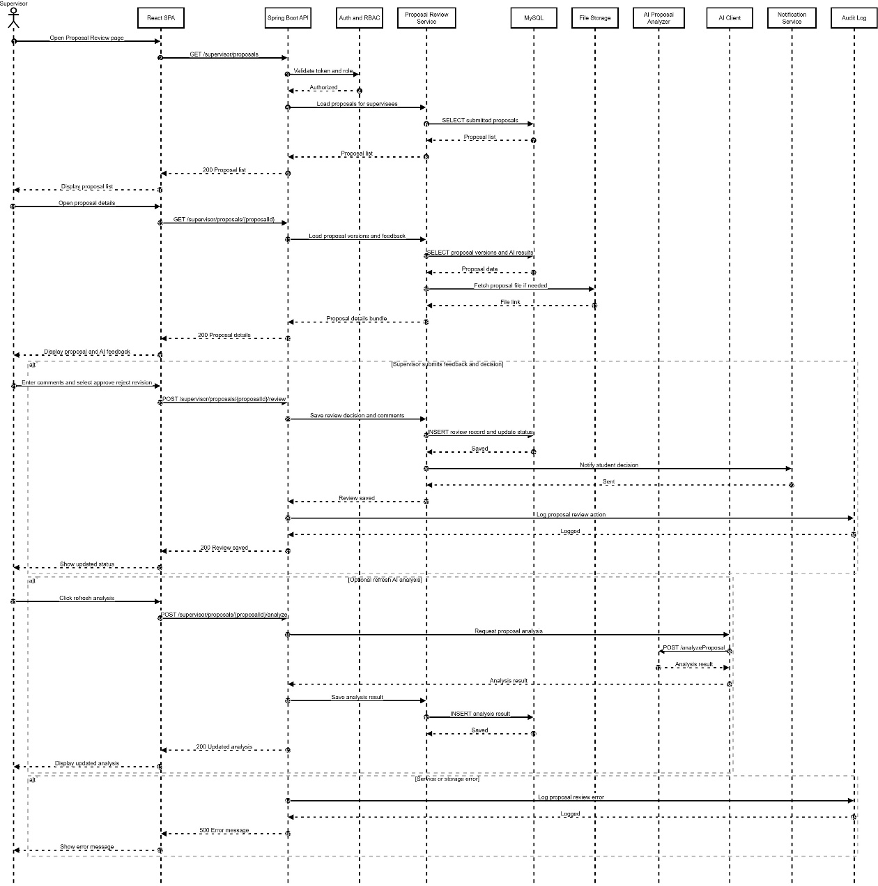
Figure 4.29 UC19 Review Student Proposal Sequence Diagram
- Supervisor opens Proposal Review and loads submitted proposals.
- Supervisor opens a proposal; system loads versions, files, and AI results.
- Supervisor enters comments and submits decision; system updates status, stores feedback, notifies student, and logs the action.
- Supervisor may refresh AI analysis; system calls AI service and stores updated results.
- Errors are logged and shown.

4.2.20 UC20 Manage Supervision Meetings (Supervisor)
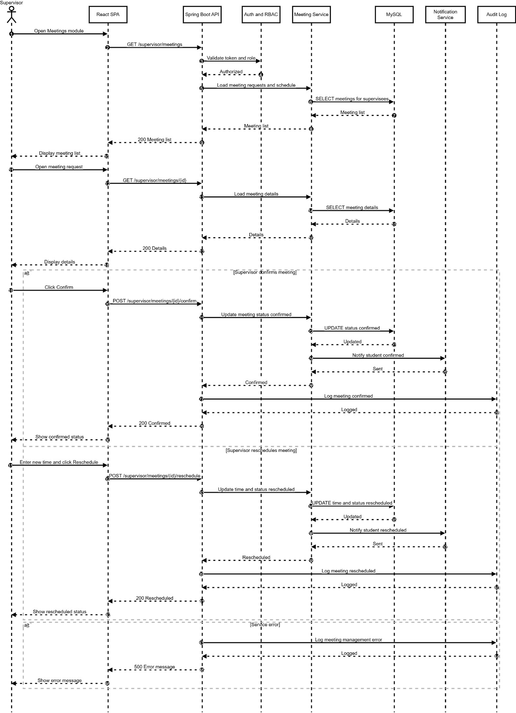
Figure 4.30 UC20 Manage Supervision Meetings Sequence Diagram
- Supervisor opens Meetings module and views meeting requests.
- Supervisor opens a request to view details.
- Supervisor confirms or reschedules; system updates the meeting record, notifies student, and logs the action.
- Errors are logged and shown.

4.2.21 UC21 Review, Comment on and Sign Supervision Log (Supervisor)
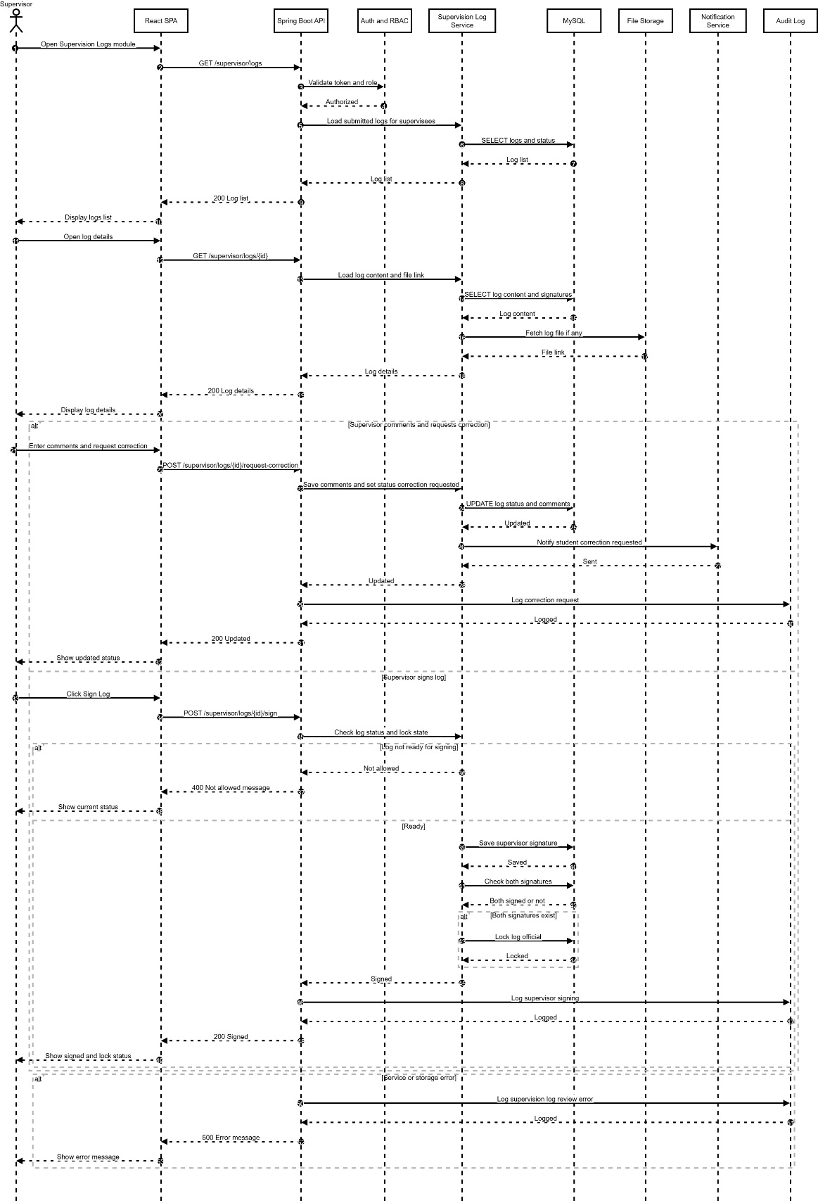
Figure 4.31 UC21 Review, Comment on and Sign Supervision Log Sequence Diagram
- Supervisor opens Logs module and views submitted logs.
- Supervisor opens a log and reviews content and attachments.
- Supervisor may request correction with comments; system updates status and notifies student.
- Supervisor may sign the log; system records the signature and locks the log when both signatures exist.
- Errors are logged and shown.

4.2.22 UC22 View Supervisee Progress Dashboard (Supervisor)
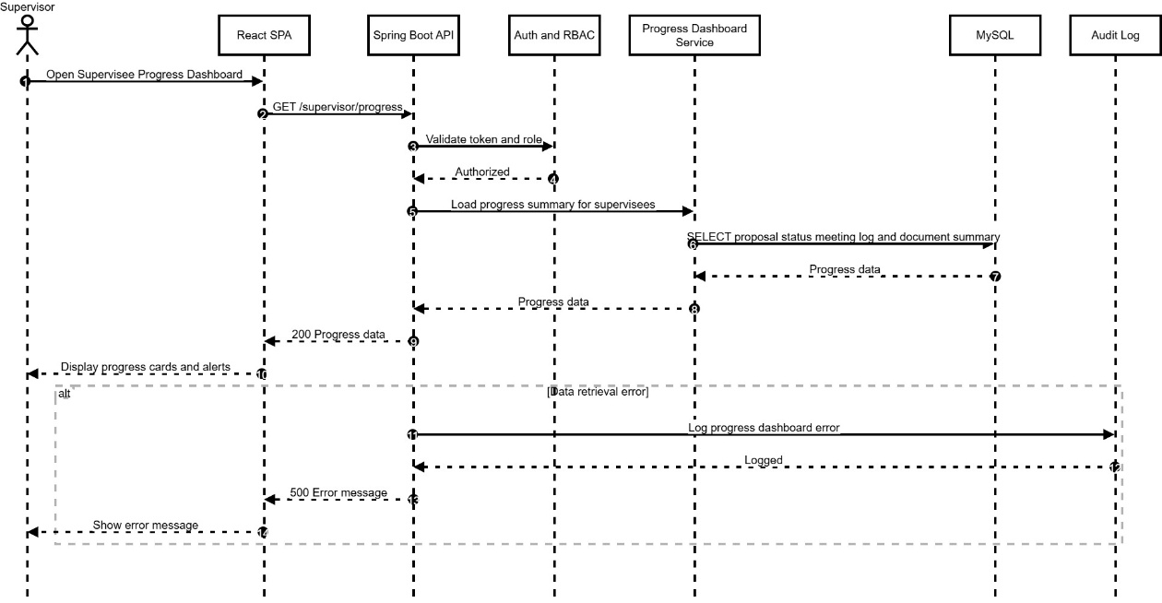
Figure 4.32 UC22 View Supervisee Progress Dashboard Sequence Diagram
- Supervisor opens Progress Dashboard.
- System loads supervisee progress summary from MySQL.
- Frontend displays progress cards and alerts.
- Errors are logged and displayed.

4.2.23 UC23 Upload, Download and Review FYP Documents (Supervisor)
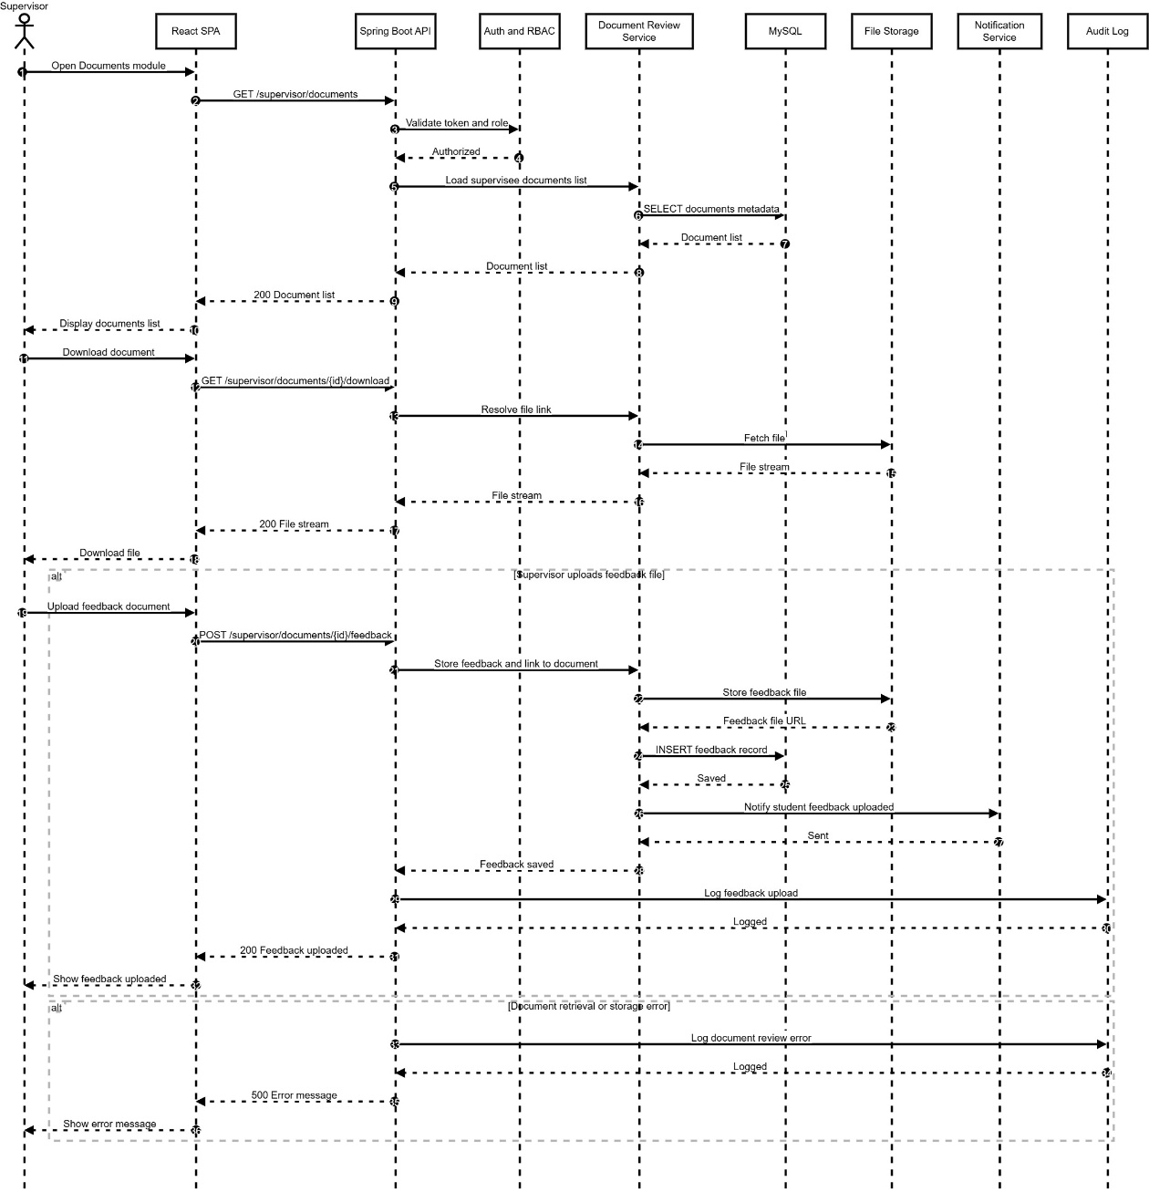
Figure 4.33 UC23 Upload, Download and Review FYP Documents Sequence Diagram
- Supervisor opens Documents module and loads supervisee document list.
- Supervisor downloads a document; the system retrieves the file from storage.
- Supervisor may upload feedback; the system stores the feedback file, records metadata, notifies the student, and logs the action.
- Errors are logged and displayed.

4.2.24 UC24 Publish FYP Announcements (Supervisor, FYP Committee)
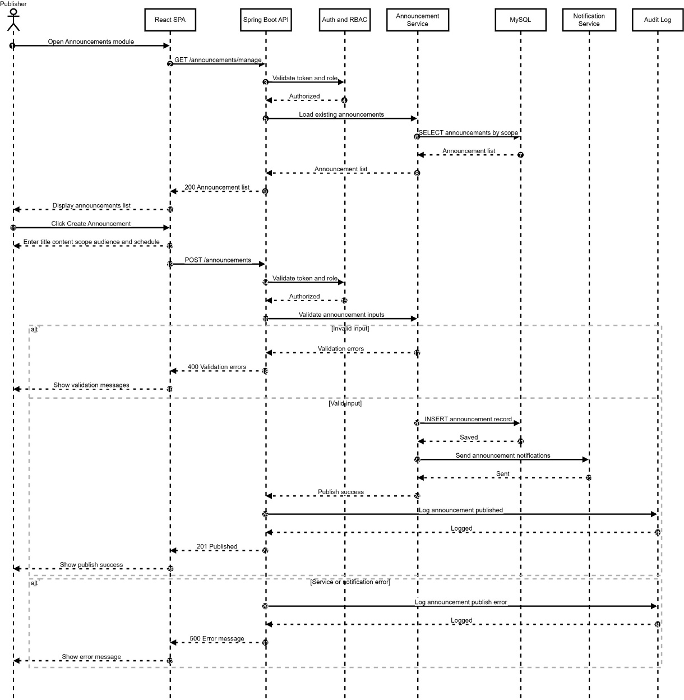
Figure 4.34 UC24 Publish FYP Announcements Sequence Diagram
- Supervisor or FYP Committee opens the Announcements module.
- System loads existing announcements after validating access via Auth and RBAC.
- Publisher creates an announcement by entering title, content, scope, and target audience.
- System validates inputs; if invalid, validation messages are displayed.
- If valid, the announcement is stored in MySQL, notifications are sent, and the action is logged.
- Any error is logged and shown to the publisher.

4.2.25 UC25 View Proposal Review Queue (FYP Committee)
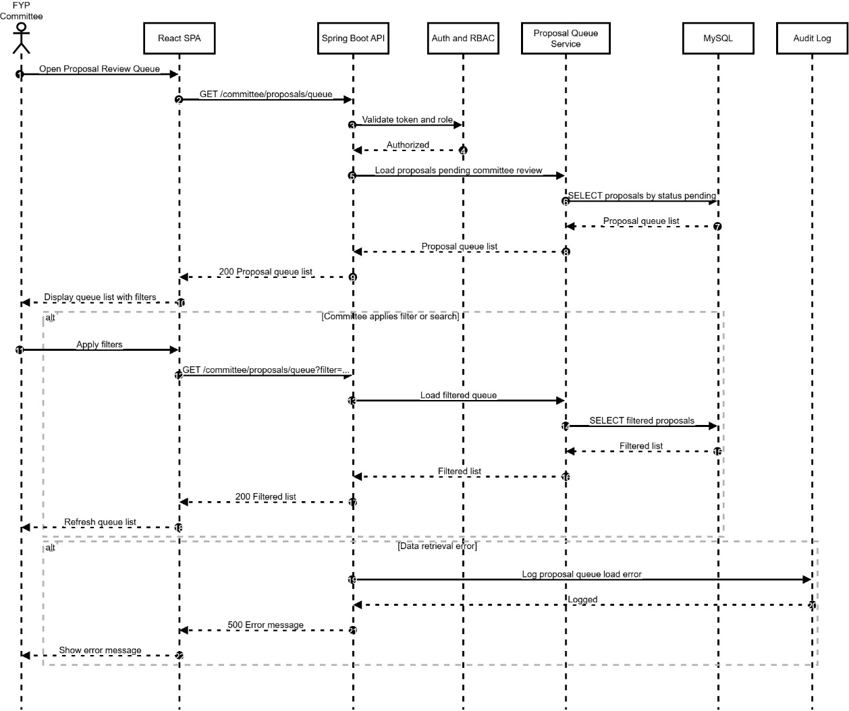
Figure 4.35 UC25 View Proposal Review Queue Sequence Diagram
- FYP Committee opens the Proposal Review Queue.
- Backend validates the committee role and loads proposals pending review from MySQL.
- Frontend displays the queue and supports filtering/searching.
- Errors during retrieval are logged and shown.

4.2.26 UC26 Review Proposal (FYP Committee)
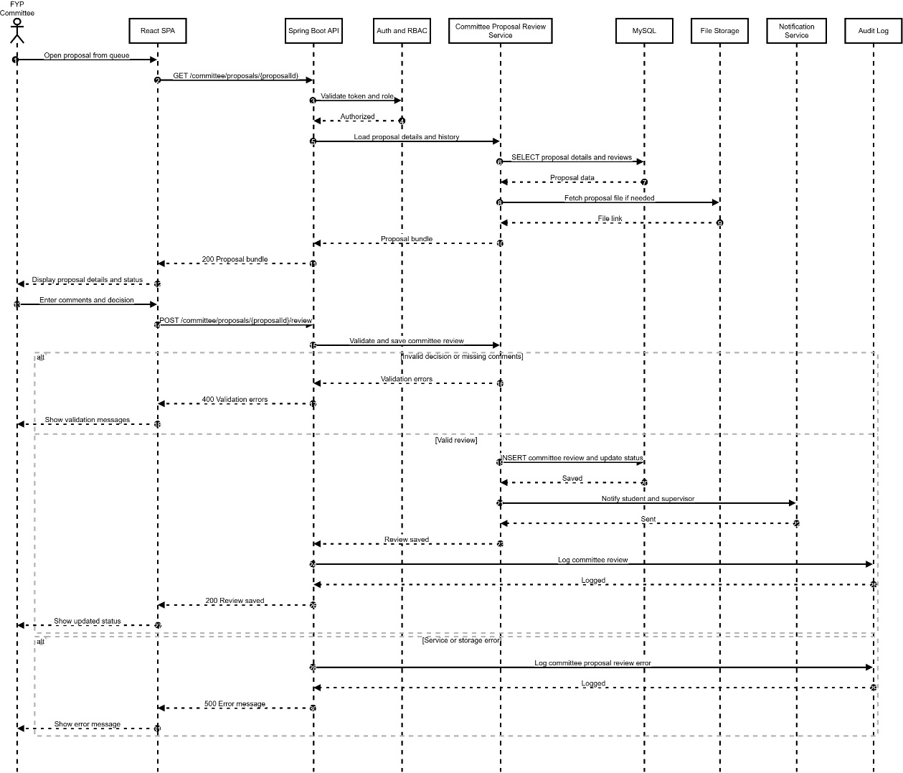
Figure 4.36 UC26 Review Proposal Sequence Diagram
- Committee opens a proposal from the queue.
- System validates access and loads proposal details, history, and file link.
- Committee submits decision and comments.
- System validates the review; if valid, saves decision, updates status, notifies relevant users, and logs the action.
- Errors are logged and shown.

4.2.27 UC27 Manage General FYP Documents (FYP Committee)
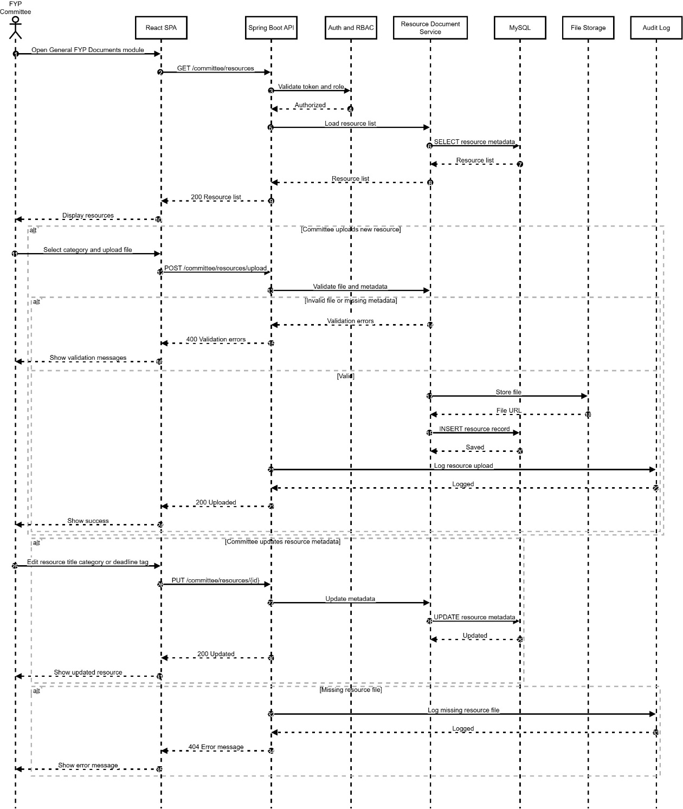
Figure 4.37 UC27 Manage General FYP Documents Sequence Diagram
- Committee opens General FYP Documents and views existing resources.
- Committee may upload a new resource; system validates, stores file, saves metadata, and logs the action.
- Committee may update resource metadata; system updates records in MySQL.
- Missing file incidents are logged and shown.

4.2.28 UC28 View FYP Project and Pairing Overview (FYP Committee)
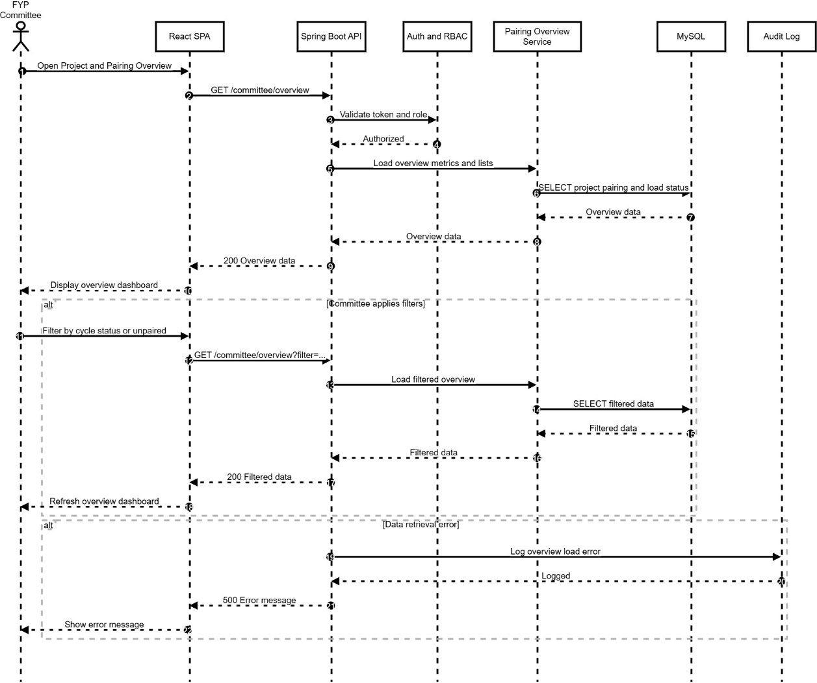
Figure 4.38 UC28 View FYP Project and Pairing Overview Sequence Diagram
- Committee opens the Project and Pairing Overview page.
- System validates access and retrieves pairing, load, and project status metrics from MySQL.
- Committee can apply filters; system refreshes the displayed overview.
- Errors are logged and shown.

4.2.29 UC29 Generate and Export FYP Reports (FYP Committee)
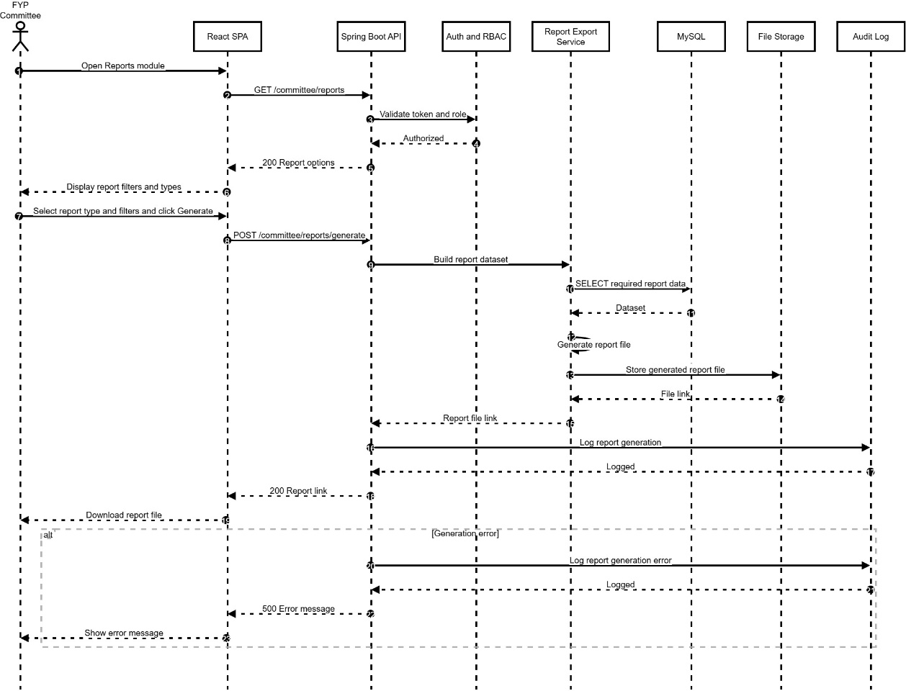
Figure 4.39 UC29 Generate and Export FYP Reports Sequence Diagram
- Committee opens Reports module and views available report types and filters.
- Committee selects report type and parameters, then generates the report.
- Report service retrieves required data from MySQL, generates the report file, and stores it in File Storage.
- System returns a downloadable link and logs the generation activity.
- Any generation error is logged and displayed.

4.2.30 UC30 Manage User Accounts and Roles (System Administrator)
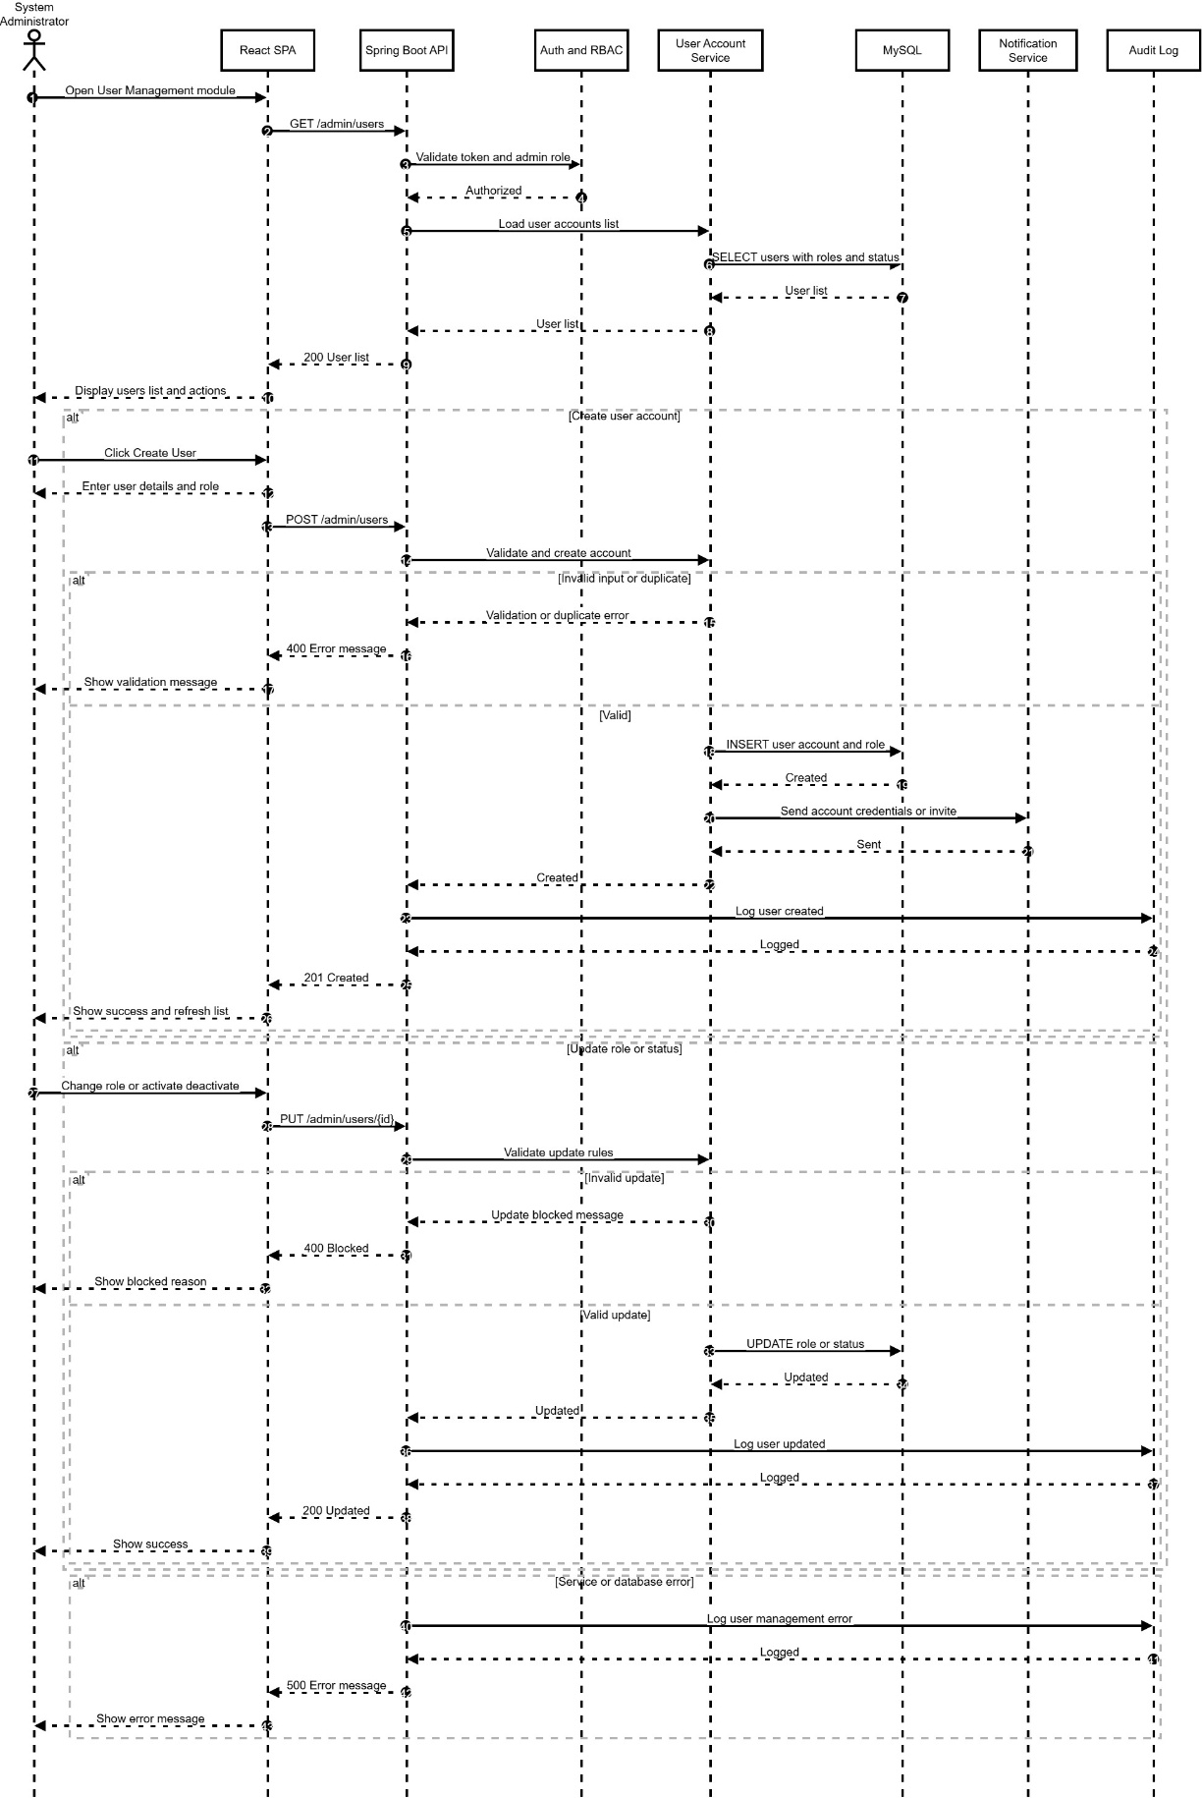
Figure 4.40 UC30 Manage User Accounts and Roles Sequence Diagram
- System Administrator opens User Management and requests the user list.
- Backend validates admin access and loads users, roles, and status from MySQL.
- Admin may create a user by entering details and selecting a role; system validates and checks duplicates.
- If valid, the account is created, notification is sent, and the action is logged.
- Admin may update a user’s role or status; system validates and updates MySQL, then logs the action.
- Errors are logged and displayed.

4.2.31 UC31 Configure System Parameters (System Administrator)

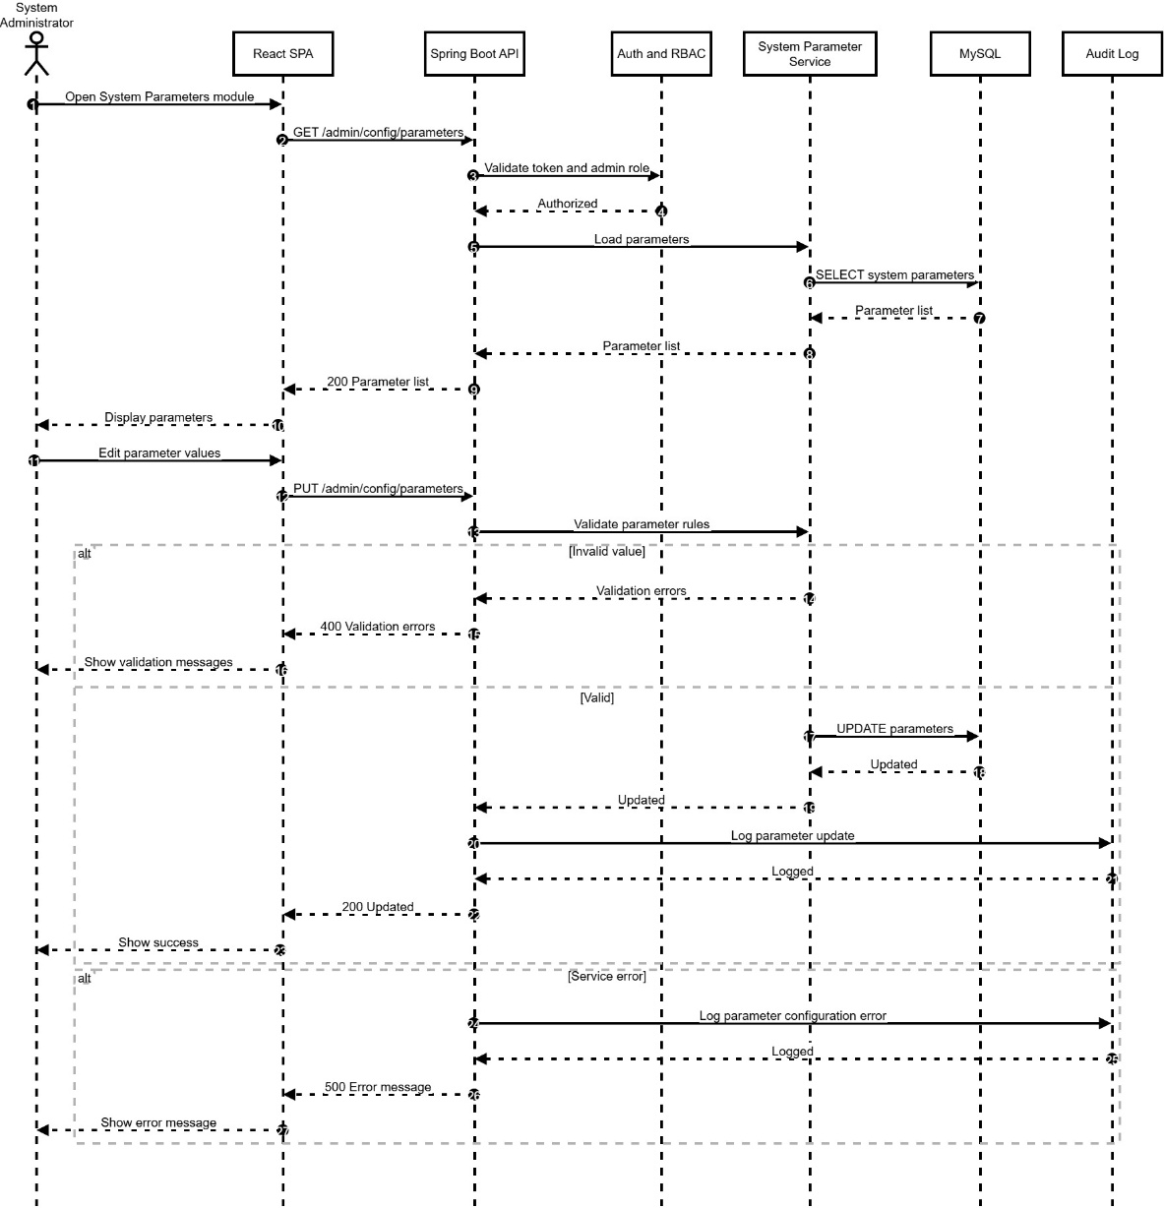
Figure 4.41 UC31 Configure System Parameters Sequence Diagram
- Admin opens System Parameters module and loads current configuration values.
- System validates admin access and retrieves parameters from MySQL.
- Admin updates parameter values; system validates rules and constraints.
- If valid, parameters are updated and the action is logged; otherwise validation errors are displayed.
- Any service error is logged and shown.

4.2.32 UC32 Configure Integration and Export Settings (System Administrator)
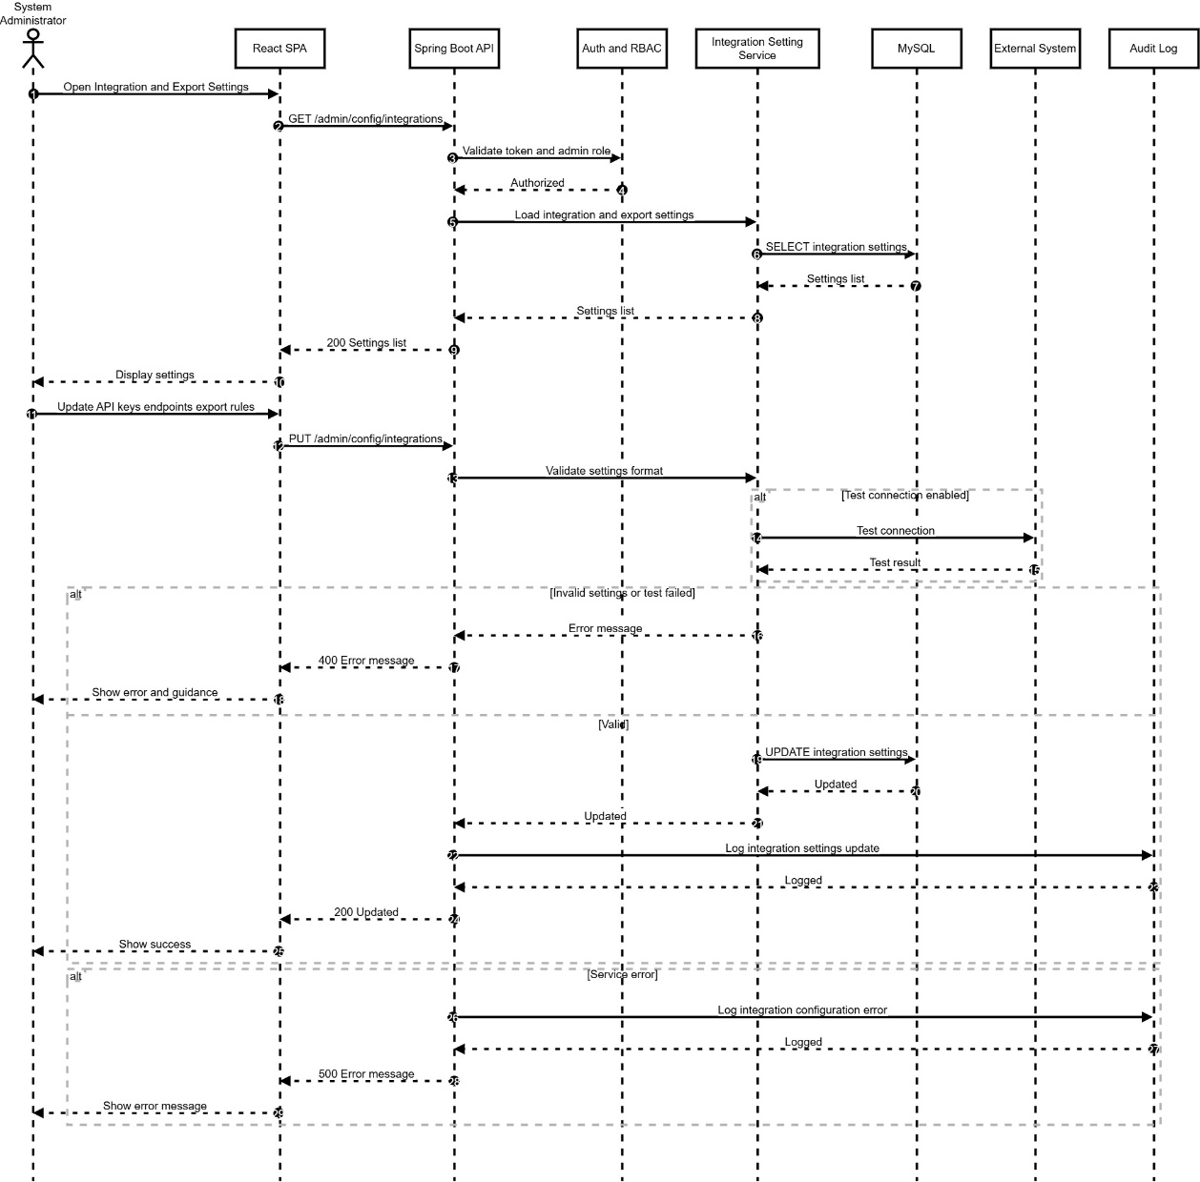
Figure 4.42 UC32 Configure Integration and Export Settings Sequence Diagram
- Admin opens Integration and Export Settings module.
- System validates admin access and loads current settings from MySQL.
- Admin updates endpoints, API keys, and export rules; system validates format and optionally runs a connection test.
- If settings are invalid or test fails, the system shows an error; otherwise settings are saved and logged.
- Errors are logged and displayed.

4.2.33 UC33 Perform System Maintenance (System Administrator)
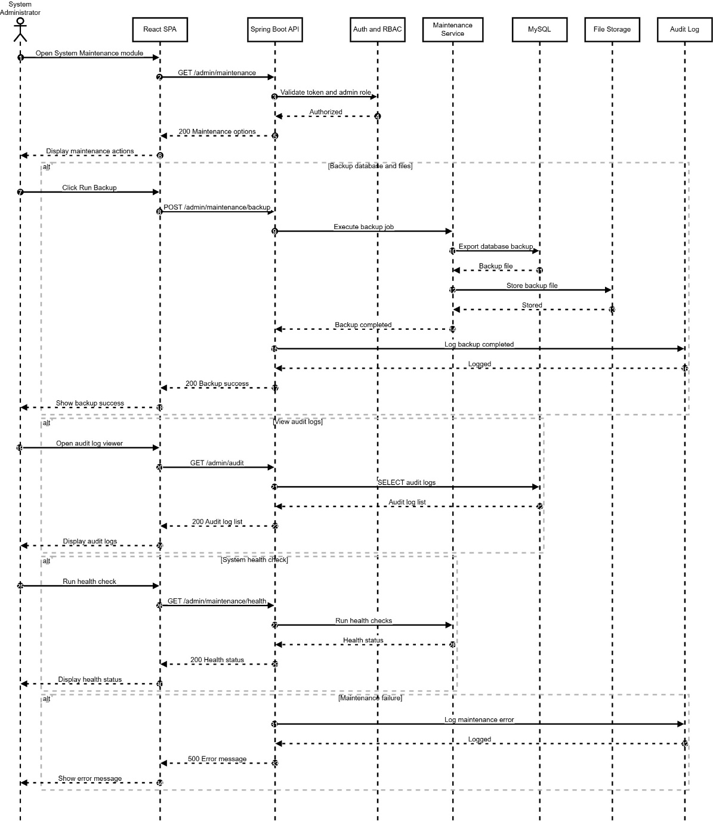
Figure 4.43 UC33 Perform System Maintenance Sequence Diagram
- Admin opens System Maintenance module and views maintenance actions.
- For backup, system executes a backup job, stores backup output, and logs completion.
- Admin may view audit logs, where the system retrieves audit entries from MySQL.
- Admin may run health checks, where the system returns health status results.
- Any maintenance failure is logged and displayed.

