Chapter 1: INTRODUCTION

1.1 Project Overview
At Multimedia University (MMU), it is mandatory that all students undertake a Final Year Project (FYP) at the Faculty of Computing and Informatics (FCI), Bachelor of Computer Science programme. The FYP involves the students applying the knowledge that they have acquired during their studies to a real-life problem including problem identification, solution design, system development as well as formal report writing. Supervision also plays a crucial role in this process since it helps students maintain their progress, deliver the work that is needed within the deadlines, and improve the quality of their final project.
Based on the experiences with the previous FYP batches in FCI, the process of supervision is frequently handled with the help of a number of separate tools. Email, messaging applications, spreadsheets, printed logbooks, and shared folders are prevalent methods of coordinating proposals, consultations, and tracking of progress among students and supervisors. This causes meeting notes, feedback, file versions, and action items to be scattered across different platforms. As a result, it becomes difficult to have a clear history of supervision and keep track of the project progress, which could lead to misunderstanding, missed tasks and the last-minute rush towards submission times.
To address these issues, this project proposes FYP Supervision System that is a web-based system that centralises all the key supervision activities at MMU FCI. The system will enable students to manage their profiles, request supervisors, submit project proposals, schedule consultation sessions, maintain supervision logs, upload project documents and view important guidelines or reminders. Supervisors are able to manage information of supervisees, review proposals and documents, respond to meeting requests, provide feedback, sign supervisee supervision logs, as well as monitor supervisee progress through a structured dashboard.
The system contains also the AI-assisted features to enhance the supervision process. The supervisor recommendation module assists in recommending appropriate supervisors, based on the similarity between proposal topics and supervisors' research interests, as well as supervisor workload. The proposal analysis module applies the Natural Language Processing (NLP) techniques to verify whether the proposals have significant sections like introduction, problem statement, objectives and methodology. It also includes a chatbot assistant that will respond to the most frequently asked questions related to FYP, as well as guide users in the process of using the system.
The system is implemented as a web application based on Java Spring Boot as a back end, and MySQL as the primary database. The AI services are implemented in Python and linked to the main backend with the help of the RESTful APIs. In FYP1, the project was concerned with studying the background, conducting requirements analysis, and designing the system. FYP2 focuses on system implementation, module integration, testing, evaluation and final documentation.
Overall, this project will provide a viable supervision management system to MMU FCI. Replacing the scattered manual practices with a formal online system with AI-based support, the system is expected to assist students in managing their FYP in a more systematic manner.

1.2 Problem Statement
At MMU FCI, FYP supervision is currently handled without any dedicated system. Students and supervisors use whatever tools they have at hand — email for formal communication, messaging apps for quick updates, and shared cloud folders for documents. None of these are linked together. A proposal draft can sit in one inbox while the latest feedback is in chat messages and the meeting summary is in a separate document. Both sides end up unsure of what has been done, what is still pending, and where the project actually stands.
This creates real problems as the semester goes on. A student might miss a revision because the comment was given verbally and never written down, or because the supervisor's reply was buried in a long email thread. Supervisors guiding four or five students at the same time have to remember on their own what each one is working on, without any consolidated view to refer back to. Meeting outcomes are sometimes recorded in detail, but more often only remembered, which makes accountability weak when something is forgotten later. For the FYP coordinator, checking whether students have met the minimum supervision requirements often means asking each supervisor manually.
The early phase of FYP is also poorly supported. When students first look for a supervisor, they have little to go on beyond a list of names and broad research areas, so popular lecturers get flooded with requests while others receive fewer. The proposal stage is similar. Without any automatic check, students sometimes submit proposals that miss basic sections like problem statement, objectives, scope, or methodology, and supervisors only catch this after reading through. A lot of supervisor time then goes into pointing out structure and completeness issues instead of discussing the research itself.
This project develops a web-based FYP Supervision System for MMU FCI to bring the main supervision activities into one platform — supervisor requests, proposal submission and review, meeting scheduling, supervision logs, document management, announcements, and progress tracking. Three AI-assisted features are added on top: a supervisor recommendation module, an automated proposal structure check, and an FYP chatbot. In FYP2, the work goes beyond design. The aim is to build the system, integrate the modules, test it end to end, and evaluate whether it produces a real improvement over the current workflow.

1.3 Project Objectives
This project sets out to build a web-based FYP supervision system for MMU FCI and to check whether it actually works better than how supervision is currently done. The system should serve four groups of users — students, supervisors, the FYP Committee, and system administrators — with each group seeing only the functions that apply to their role.
The objectives are as follows:
- Study how FYP supervision is currently carried out at MMU FCI and gather input from students, supervisors, and coordinators in order to determine the functional and non-functional requirements of the proposed system.
- Design a secure web-based system from the gathered requirements, with role-based access for the four user groups so that each user only sees what is relevant to their role.
- Build the system to cover the main supervision workflows, including supervisor requests, proposal submission and review, meeting scheduling, supervision logs, document submission, feedback, and announcements.
- Add three AI-assisted features into the system, which are a supervisor recommendation module, an automated proposal structure checker, and an FYP chatbot, to support users during the early phase of FYP and reduce repetitive tasks.
- Test the completed system and evaluate, through user feedback and system testing, whether it improves the current supervision workflow in FCI.

1.4 Expected Deliverables
The deliverables produced from this project are listed below.
- The FYP Supervision System itself, deployed as a working web application. It must be able to handle a full supervision cycle: a student requesting a supervisor, the supervisor confirming, proposal going through review, meetings being scheduled, logs being kept, documents getting uploaded, and announcements and reminders reaching the right users.
- A MySQL database built according to the ERD and data dictionary from FYP1. The schema needs to hold user accounts, project records, proposals, meetings, logs, documents, announcements, notifications, and the audit data needed for traceability.
- Three AI-assisted components — supervisor recommendation, proposal structure checking, and an FYP chatbot — running as Python services and connected to the main backend through RESTful APIs.
- Four role-based interfaces, one each for students, supervisors, FYP Committee members, and system administrators. Each role only sees the screens and functions that apply to it.
- Testing artefacts. This includes the test cases that were prepared, the results from running them, and any supporting evidence gathered during validation.
- An evaluation write-up covering functionality, usability, and how well the prototype addresses the supervision problems.
- The final FYP2 report, with implementation details, testing results, evaluation discussion, conclusion, and possible future enhancements.
- A final presentation and live demo that walks through the completed workflow.

1.5 Goals of the Project
What this project is ultimately trying to achieve is a more organised FYP supervision lifecycle, where the scattered manual practices currently used at FCI are replaced with a structured digital platform and supported by intelligent features at the points where they make the biggest difference. The system is built with the following goals in mind:
- Cut down the time that supervisors and the FYP Committee spend on administrative and monitoring work, so that more of their time can go into the actual academic side of supervision.
- Make student progress, supervision records, feedback, and follow-up actions easier to track and verify, so that nothing important slips through the cracks during the semester.
- Push proposal quality higher from the start, by giving students automated structural feedback before their work reaches the supervisor.
- Smooth out the parts of the process that students usually find frustrating — picking a supervisor, getting proposals through, arranging meetings, and keeping in touch with their supervisor.
- End up with something that actually works and can be tested, not just a paper design, so that the project can show in practice how FYP supervision can be run from one system.

1.6 Project Plan

1.6.1 Milestones
Table 1.1 Milestones for Trimester 2
Week | Milestones | Due Date
2 | Project Plan and Updated Requirements Baseline | 19/04/2026
5 | System Design Document (Database, Software Architecture, API Contracts) | 10/05/2026
6 | Core Platform Setup and Foundational Modules (Auth/RBAC, Student Module, Supervisor Module) | 17/05/2026
7 | Remaining Modules, AI Integration and Prototype Review (FYP Committee Module, System Admin Module, AI Services) | 24/05/2026
8 | First Draft of Report | 31/05/2026
10 | Test Plan, Test Cases and Test Data | 14/06/2026
12 | System Completion | 28/06/2026
13 | Testing and Evaluation Complete | 05/07/2026
14 | Final Draft of Report Submission | 12/07/2026
16 | Final Presentation and Project Submission | 26/07/2026

1.6.2 Gantt Chart
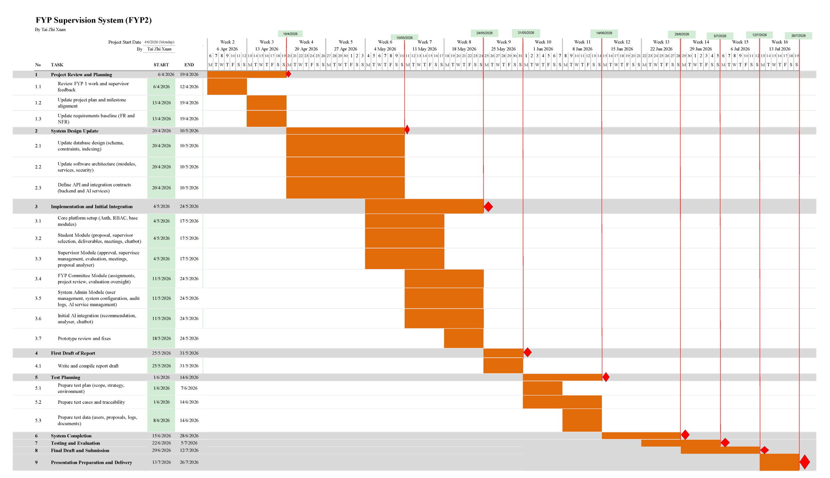
Figure 1.1 Gantt chart for Trimester 2
Figure 1.1 shows the planned schedule for FYP2 from Week 2 to Week 17. The trimester begins with a project review and planning phase, where the FYP1 report, project scope, functional and non-functional requirements, and supervisor feedback are reviewed to identify the improvements and adjustments needed before implementation. The requirements baseline and project plan are then updated to reflect the agreed direction.
Following this, the system design is refined, covering the database schema, software architecture, security model, and the API and integration contracts between the Spring Boot backend and the three Flask AI services (recommendation, proposal analyser, chatbot).
The main development work is carried out from Week 6 to Week 13, organised by actor module so that progress can be tracked clearly. The Core Platform (authentication, role-based access control, and shared services) and the Student and Supervisor modules are delivered first, followed by the FYP Committee and System Admin modules together with the initial AI integration. Each module covers its frontend, backend, database, and AI integration work, and the prototype is iteratively improved into a more complete working system through a prototype review and fix step.
Testing activities are then planned and executed to verify system functions, fix defects, and evaluate the completed modules end to end. Towards the end of the trimester, the report is finalised, followed by final submission and preparation for the presentation and demonstration. Overall, the Gantt chart ensures that requirements review, design, module-level implementation, AI integration, testing, documentation, and presentation preparation are completed in a structured and traceable sequence.

CTable 4.13 MEETING_LOG_SIGNATURE Table
Table | Field Name | Data Type | Data Format | Field Size | Description | Example
MEETING_LOG_SIGNATURE | signature_id | BIGINT | Numeric | 20 | Unique signature identifier (PK) | 11001
MEETING_LOG_SIGNATURE | log_id | BIGINT | Numeric | 20 | Meeting log being signed (FK) | 10001
MEETING_LOG_SIGNATURE | signer_user_id | BIGINT | Numeric | 20 | User who signed (FK) | 1001
MEETING_LOG_SIGNATURE | signer_role | VARCHAR | Enumeration | 15 | Role of signer | STUDENT, SUPERVISOR
MEETING_LOG_SIGNATURE | signed_at | DATETIME | YYYY-MM-DD HH:MM:SS | - | Signature timestamp | 2025-02-01 16:30:00

