Chapter 4: DESIGN

4.1 Software Architecture
This section presents the software architecture of the proposed FYP Supervision System. The architecture is documented using two complementary views. The first view describes the system at a UML component or subsystem level to show how the platform is organised by user roles and how access is controlled through a shared authentication component. The second view describes the implementation-level layered architecture to show how the web application, backend services, data storage, and AI microservices communicate in the deployed system.
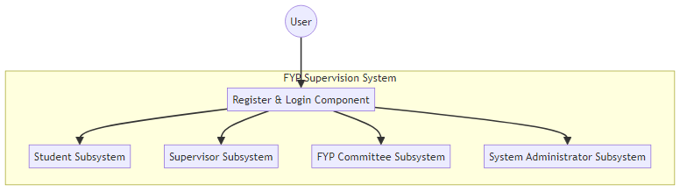
Figure 4.1 Overall Software Architecture (Subsystem and Component View)
Figure 4.1 illustrates the overall structure of the FYP Supervision System as four main subsystems based on system actors: Student, Supervisor, FYP Committee, and System Administrator. Each subsystem contains the features and operations required by the corresponding user role. All subsystems interact with a shared Register and Login component, which acts as the entry point for authentication and role-based access. After a user successfully registers and logs in, the system enables access to the appropriate subsystem according to the user’s role. This design improves modularity by separating responsibilities by user type while maintaining consistent access control through a single authentication component.
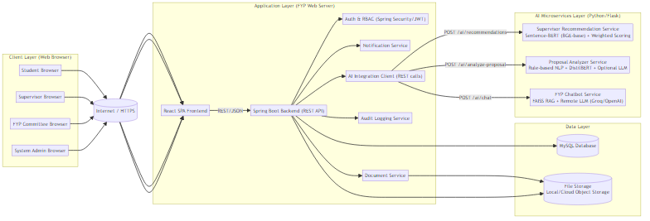
Figure 4.2 Implementation Software Architecture (Layered System View)
Figure 4.2 shows the deployed architecture in a layered structure. The Client Layer consists of web browsers used by students, supervisors, the FYP committee, and system administrators. These clients access the system through the Internet/HTTPS, ensuring secure communication. The React SPA Frontend provides the user interface and interacts with the backend using REST/JSON API calls.
The Application Layer is implemented using a Spring Boot Backend (REST API), which contains the core business logic and system workflows such as proposal management, meeting scheduling, supervision logging, and document handling. Supporting services inside the backend include Auth and RBAC for access control, a Notification Service for reminders and alerts, a Document Service for file operations, and an Audit Logging Service for tracking critical actions and ensuring accountability. For AI functions, the backend communicates through an AI Integration Client, which sends requests to the AI layer and returns AI-generated results to users.
The Data Layer stores structured system data in a MySQL Database, including user profiles, proposals, meeting schedules, supervision logs, and request statuses. Uploaded files such as proposal documents and supporting attachments are stored in a File Storage component, which is accessed through the backend document module.
Finally, the AI Microservices Layer consists of independent Python/Flask services to support intelligent features. These include a Supervisor Recommendation Service for matching students to supervisors, a Proposal Analyzer Service for checking proposal completeness and weaknesses, and an FYP Chatbot Service for answering user questions. Separating the AI services from the main backend improves maintainability and allows AI modules to be updated independently without disrupting the core system.

4.1.1 Subsystem 1 (Student)
Figure 4.3 Student Subsystem Architecture (Component View)
Figure 4.3 shows the Student subsystem as a set of components accessed through the Register and Login component. After authentication, students can perform the main functions required in the FYP process, including managing profile and dashboard, searching supervisors and viewing AI recommendations, sending supervisor requests, managing proposals and checking status, tracking registration status, scheduling meetings, maintaining supervision logs, uploading FYP documents, viewing guidelines/rubrics/deadlines, receiving reminders/notifications, and asking questions via the chatbot.
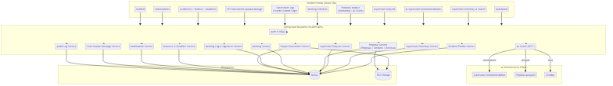
Figure 4.4 Student Subsystem Architecture (Implementation Layer View)
Figure 4.y illustrates the implementation of the Student subsystem where the Student Portal (React SPA) communicates with the Spring Boot Backend (Student APIs) via REST/JSON. The backend enforces access control using Auth and RBAC, stores structured records in MySQL, stores uploaded files in File Storage, and integrates with Flask-based AI microservices (recommendation, proposal analysis, and chatbot) to support intelligent features.

4.1.2 Subsystem 2 (Supervisor)
Figure 4.5 Supervisor Subsystem Architecture (Component View)
Figure 4.5 shows the Supervisor subsystem where access is provided through the Register and Login component. After logging in, supervisors can manage their profile, review and respond to supervisor requests, view supervisee lists and project details, review student proposals, manage supervision meetings, review/comment/sign supervision logs, view supervisee progress, upload/download/review FYP documents, and publish announcements.
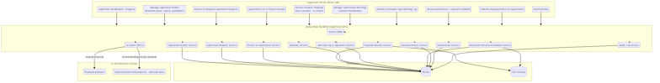
Figure 4.6 Supervisor Subsystem Architecture (Implementation Layer View)
Figure 4.6 illustrates that the Supervisor Portal (React SPA) communicates with the Spring Boot Backend (Supervisor APIs) via REST/JSON. The backend applies Auth and RBAC, stores records in MySQL, stores files in File Storage, and integrates with the Proposal Analyzer AI microservice through the AI client to support proposal review and analysis.

4.1.3 Subsystem 3 (FYP Committee)
Figure 4.7 FYP Committee Subsystem Architecture (Component View)
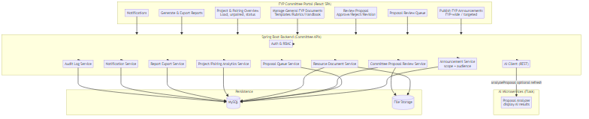
Figure 4.7 shows the FYP Committee subsystem where access is provided through the Register and Login component. After logging in, the committee can publish FYP announcements, view the proposal review queue, review proposals (approve/reject/revision), manage general FYP documents (templates/rubrics/handbook), view FYP project and pairing overview, and generate and export FYP reports.
Figure 4.8 FYP Committee Subsystem Architecture (Implementation Layer View)
Figure 4.8 illustrates that the FYP Committee Portal (React SPA) communicates with the Spring Boot Backend (Committee APIs) via REST/JSON. The backend enforces Auth and RBAC, uses services such as announcement, proposal queue/review, resource document, analytics, report export, notification and audit logging, stores data in MySQL, stores files in File Storage, and can retrieve AI proposal analysis results via the AI client for committee review.

4.1.4 Subsystem 4 (System Admistrator)
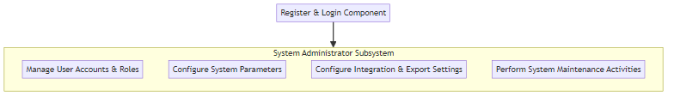
Figure 4.9 System Administrator Subsystem Architecture (Component View)
Figure 4.9 shows the System Administrator subsystem where access is provided through the Register and Login component. After logging in, the administrator can manage user accounts and roles, configure system parameters, configure integration and export settings, and perform system maintenance activities.
/
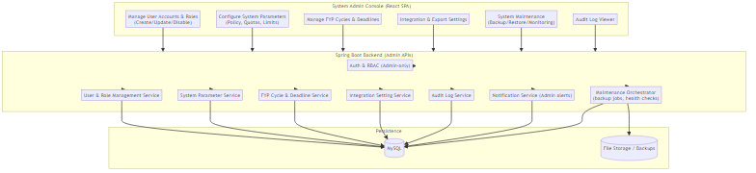
Figure 4.10 System Administrator Subsystem Architecture (Implementation Layer View)
Figure 4.10 illustrates that the System Admin Console (React SPA) communicates with the Spring Boot Backend (Admin APIs) via REST/JSON. The backend enforces Admin-only Auth and RBAC, manages configuration and maintenance through dedicated services, stores system records in MySQL, and stores backup or maintenance files in File Storage/Backups, with audit logs available for monitoring and traceability.

4.2 Sequence Diagrams
Refer to Project-info/reports/Sequence Diagram.md

4.4 Data Dictionary
Refer to Project-info/reports/Data-Dictionary-Report.md

