**How to deploy Project Asgn5!**

The library was authored by Garry Guerrier and AJ Crowetz , hopeful software developers.

Below is a set of instructions for our application EJB client and the application library.

1. Download 1 zip files.
   1. Crowetz1_Guerrier2asg5 (Solution)
2. Unzip all the projects using a tool such as 7-zip or winrar.
   1. Crowetz1_Guerrier2asg5
   2. GuerrierGarryasg4
3. Open Crowetz1_Guerrier2asg5 in desired IDE – For this example we will use Visual Studio(VS)
   1. 
4. After opening the project – add a reference to the library via external link.
   * 1. How to add external Libraries
        1. Select the desired project, navigate to references

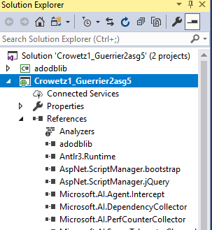

* + - 1. Right click on References and click Add Reference
      2. Add dll Folder – Navigate to the desired project.

1. Once they are unpacked into the VS – Build Each Project.
   1. Select Project and Right Click
      1. Build

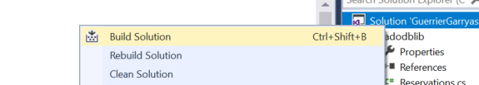

1. Set Run Property to the client (Solution)
   1. Right the solution and select property
2. Select Single Startup Project and select asg4client.
3. Run the project



1. Confirm

