1. Which bus is ADC1 on?
→ The ADCs are mapped on the AHB bus to allow fast data handling
→ which RCC register to enable clock

2. What is the ADC input voltage reference?
→ VREF+ determines the max input voltage
→ Input, analog reference positive. The higher/positive reference voltage for the
ADC.

3. What register starts a conversion?
→ look for ADSTART bit
→ in ADC_CR, Bit 2 ADSTART: ADC start of regular conversion
0: No ADC regular conversion is ongoing.
1: Write 1 to start regular conversions. Read 1 means that the ADC is operating and eventually
converting a regular channel.

4. What register holds the result?
→ look for ADC_DR (data register)
In ADC_DR register Bits 31:0 RDATA[31:0]: Regular Data converted
These bits are read-only. They contain the conversion result from the last converted regular channel.
The data are left- or right-aligned

5. How do you know conversion is complete?
→ look for EOC flag (End Of Conversion)
→ Bit 2 in ADC_ISR, End of Conversion Flag.
This bit is set by hardware at the end of each regular conversion of a channel when a new data is available in the ADC_DR register. It is cleared by software writing 1 to it or by reading the ADC_DR register 0: Regular channel conversion not complete (or the flag event was already acknowledged and cleared by software) 1: Regular channel conversion complete

6. What is the ADC_CR register?
→ find ADEN bit (ADC enable)
Bit 0 ADEN: ADC enable control
This bit is set by software to enable the ADC. The ADC will be effectively ready to operate once the
flag ADRDY has been set.
It is cleared by hardware when the ADC is disabled, after the execution of the ADDIS command.
0: ADC is disabled (OFF state)
1: Write 1 to enable the ADC.
→ find ADCAL bit (calibration)
Bit 31 ADCAL: ADC calibration
This bit is set by software to start the calibration of the ADC. Program first the bit ADCALDIF to
determine if this calibration applies for single-ended or differential inputs mode.
It is cleared by hardware after calibration is complete.
0: Calibration complete
1: Write 1 to calibrate the ADC. Read at 1 means that a calibration in progress.

7. What is sampling time?
→ why does it matter for accuracy
Before starting a conversion, the ADC must establish a direct connection between the
voltage source under measurement and the embedded sampling capacitor of the ADC. This
sampling time must be enough for the input voltage source to charge the embedded
capacitor to the input voltage level.
The total conversion time is calculated as follows:
TCONV = Sampling time + 7.5 ADC clock cycles

8. Which register configures the input channel?
→ look for ADC_SQR1 (sequence register)

The result of the ADC is stored in a left-aligned or right-aligned 32-bit data register.
The ADCs are mapped on the AHB bus to allow fast data handling.
ADC conversion time is independent from the AHB bus clock frequency
ADC input range: VREF– ≤ VIN ≤ VREF+
adc_ker_ck_input → ADC kernel clock input from RCC, which is independent and asynchronous with the AHB clock. CKMODE[1:0] bits of the ADCx_CCR register must be reset.
ADEN=1 enables the ADC. The flag ADRDY will be set once the ADC is ready for operation.
ADDIS=1 disables the ADC. ADEN and ADDIS are then automatically cleared by hardware as soon as the analog ADC is effectively disabled.
Regular conversion can then start either by setting ADSTART=1.

Software procedure to enable the ADC

1. Clear the ADRDY bit in the ADC_ISR register by writing ‘1’.
2. Set ADEN=1.
3. Wait until ADRDY=1 (ADRDY is set after the ADC startup time). This can be done
using the associated interrupt (setting ADRDYIE=1).
4. Clear the ADRDY bit in the ADC_ISR register by writing ‘1’ (optional).

Software procedure to disable the ADC

1. Check that both ADSTART=0 and JADSTART=0 to ensure that no conversion is
ongoing. If required, stop any regular and injected conversion ongoing by setting
ADSTP=1 and JADSTP=1 and then wait until ADSTP=0 and JADSTP=0.
2. Set ADDIS=1.
3. If required by the application, wait until ADEN=0, until the analog ADC is effectively
disabled (ADDIS will automatically be reset once ADEN=0).

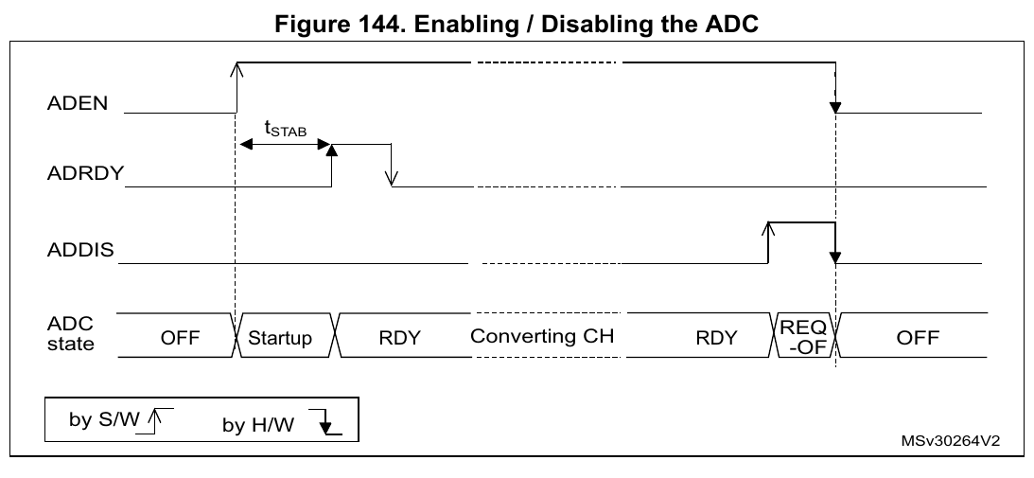

* If ADC is disabled, then the following bits can be written:
1. RCC control bits to configure and enable the ADC clock
2. the control bits DIFSEL in the ADC_DIFSEL register,
3. ADCx_CCR register and the control bits ADCAL and ADEN in the ADC_CR register

* If ADC is enabled, then the following bits are allowed to written:
ADSTART, JADSTART, and ADDIS

Startup Sequence for implementing ADC in STm32:

Step1: Exit deep power down

By default, the ADC is in deep-power-down mode where its supply is internally switched off to reduce the leakage currents (the reset state of bit DEEPPWD is 1 in the ADC_CR register). To start ADC operations, it is first needed to exit deep-power-down mode by clearing bit DEEPPWD=0.

Then, it is mandatory to enable the ADC internal voltage regulator by setting the bit ADVREGEN=1 into ADC_CR register. The software must wait for the startup time of the ADC voltage regulator (TADCVREG_STUP) before launching a calibration or enabling the ADC.

ADC1→CR &= ~ADC_CR_DEEPPWD
ADC1→CR |= ADC_CR_ADVREGEN
delay_us(10) // TADCVREG_SETUP
Step 2: Calibration
The calibration is preliminary to any ADC operation. It removes the systematic errors which may vary from chip to chip and allows to compensate offset and linearity deviation. The calibration is then initiated by software by setting bit ADCAL=1. It can be initiated only when the ADC is disabled (when ADEN=0).
It is recommended to recalibrate when VREF+ voltage changed more than 10%.

Software procedure to calibrate the ADC:
1.Ensure DEEPPWD=0, ADVREGEN=1 and verify that the ADC voltage regulator startup time has elapsed by checking the LDORDY bit in ADC_ISR.
2. Ensure that ADEN=0.
3. Select the input mode for this calibration by setting ADCALDIF=0 (Single-ended input) or ADCALDIF=1 (Differential input). Select if Linearity calibration enable or not by ADCALLIN=1(enabled) or ADCALLIN=0(disabled).
4. Set ADCAL=1.
5. Wait until ADCAL=0.
6. The offset calibration factor can be read from ADC_CALFACT register.
7. The linearity calibration factor can be read from ADC_CALFACT2 register, following the procedure described in Section : Linearity calibration reading procedure (ADEN must be set to 1 prior to accessing ADC_CALFACT2 register).

Codes:
// Step 2 — Calibration // ADEN must be 0 (default after reset, so we are fine) // Single-ended mode → ADCALDIF = 0 (already 0 by default) ADC1->CR &= ADC_CR_ADCALDIF; // single-ended calibration ADC1->CR |= ADC_CR_ADCAL; // start calibration // Wait for hardware to clear ADCAL
while (ADC1->CR & ADC_CR_ADCAL);

Step 3: Enable ADC (ADEN)
Software procedure to enable the ADC:
1. Clear the ADRDY bit in the ADC_ISR register by writing ‘1’.
2. Set ADEN=1.
3. Wait until ADRDY=1 (ADRDY is set after the ADC startup time). This can be done using the associated interrupt (setting ADRDYIE=1).
4. Clear the ADRDY bit in the ADC_ISR register by writing ‘1’ (optional).

Code:
// Step 3 — Enable ADC
ADC1->CR |= ADC_CR_ADEN;
// Wait until ADC is ready
while (!(ADC1->ISR & ADC_ISR_ADRDY));
// Clear ADRDY flag by writing 1 to it
ADC1->ISR |= ADC_ISR_ADRDY;
Step 4: Configure Channel and sampling time
Before starting a conversion, the ADC must establish a direct connection between the voltage source under measurement and the embedded sampling capacitor of the ADC. This sampling time must be enough for the input voltage source to charge the embedded capacitor to the input voltage level.
Codes:
// Step 4 — Configure channel and sampling time
// SQR1: 1 conversion, channel 15 first
ADC1->SQR1 = (15 << 6);
// SMPR2: 64.5 cycles for channel 15 (bits 17:15)
ADC1->SMPR2 = (0b011 << 15);
Step 5: Start Conversion (ADSTART)
Step 6: Poll EOC, read ADC_DR

