|  |
| --- |
| Kreative |
| Terms of Reference |
| Foundation Degree in iMedia |

|  |
| --- |
| 2nd October 2014 |

Contents

Company Description 1

Team Name 1

Team Brand 1

Product/Service 1

Wireframes 1

Target Groups & Markets 1

Hardware 1

Software 1

Design Requirements 1

Additional Requirements 1

Production Schedule 1

Budget Plan 1

Cost of design 1

Cost of print 1

Travel expenses 1

Total 1

# Management Summary

We have been tasked to create a website for our client Umit Shah who would like a professional job searchers website. Umit currently lives in London and so will not be available for face to face meetings but we shall be in touch with his representative Dominic Devlin.Team Kreative is happy to take up this challenge. The team consists of;

* **Alec** - Meets with client representative and obtains any information the team has about the project. Set up the project schedule and the product/service evaluation using information from the client.
* **Taj** - Is our in-house designer who designed our logo after researching other agency logos. He also wrote up the company description and design requirements for the client.
* **Lauren** -Wrote all out hardware and software requirements needed for our project. She also created our budget plan so that we don’t over spend on our project.
* **Declan** - In charge of researching competitor websites and keeping notes on our group meetings.

We shall be creating this website using Wordpress as it will allow the client to easily manage their site and keep it up-to-date without our constant help. We were asked to research potential competitors and see what kind of design and layout we should do for our client’s site. After researching we are to come up with some ideas about what this site might look like when we finished. If we have time we shall also create a prototype wireframe using the information give.

# Company Description

## Team Name

Before we started our project we needed a short and easy to remember name. The name of our agency will have tremendous impact on how our potential clients view us, so it’s very important to decide on our name carefully.

We got a pen and paper and started jotting down whatever came to mind. We had a few good ideas, but in the end we went with ‘Kreative’, which we thought was simple, clear and potential clients will instantly understand that we are a creative design agency.

## Team Brand

We started out by doing some research on agency logos using inspiration sites such as [www.awwwards.com](http://www.awwwards.com) and [www.logopond.com](http://www.logopond.com) and found that most agencies use a simplistic type logo. We decided to do the same, but also accompany our type logo with a logo graphic that we could use if we needed to.



The use of lowercase letters reflects the logos informal and friendly nature, but at the same time the boldness makes the logo seem strong. We also decided to include a red full stop at the end to show the supreme confidence of our agency; conveying a message along the lines of: 'This is the agency for you - period.'

  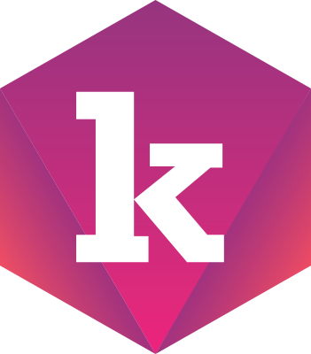 

The above logo icons were created to accompany the logotype. Each team has been assigned their own colour. These icons can be used on our own personal websites or documents as way of signing something off.

• Alec = Red

• Declan = Green

• Lauren = Pink

• Tajdid = Blue

# Product/Service

We have been in touch with the client and he has given me a small amount of information regarding the project. From the information gathered our team knows that the client would like a website which works as a jobs board. We have researched several different jobs boards’ websites and have taken into account different features in each different site. Using this knowledge and the information provided by the client some of the features that we shall include in our website will be;

* CV Search facility - This would be used by Employers looking for Employees. It would contain any submitted CV’s and allow the Employer to search for potential candidates using different search options to allow the employer to narrow down their search for candidates of their choosing
* Job Listings- The employer would have the option to advertise different types of vacant positions that they are looking for e.g. part-time, full-time, holiday period, etc. He would like this to be a single page on the website. This page will simply contain a form that the employer can fill in with the above listings. This form is then sent to administration for checking. If approved the job will then be posted on the jobs page for public viewing. This will also require the employer to register their details with the website before being allowed to post jobs.
* ~~Latest post- will allow users to view recently posted items on the blog.~~ Client has decided to remove this feature as he feels it is an unnecessary addition to the website.
* Jobs page- This page will contain all current up-to-date job listings that have been approved. It will have a search option similar to the CV search facility. Any outdated or expired job listings will need to be deleted from the system.
* News- This page will contain up-to-date news regarding any new job postings, etc. It will take the information from any recently accepted job listing and display them. This is simply a box located on the home page which will link to the jobs page.
* CV writing Service- This will allow users to create and submit CV’s. This will be done just like the job listing page except that the form will be sent to the search CV’s page.
* Newsletter email sign-up- This option will allow users to sign-up for the websites newsletter. This means that any new job listings that happen to fall within the users designated area will be emailed to the user.
* Other- the client has said that he would like other features in his website however at the present moment in time he has no current ideas and so will think about other possibilities for now.

# Wireframes

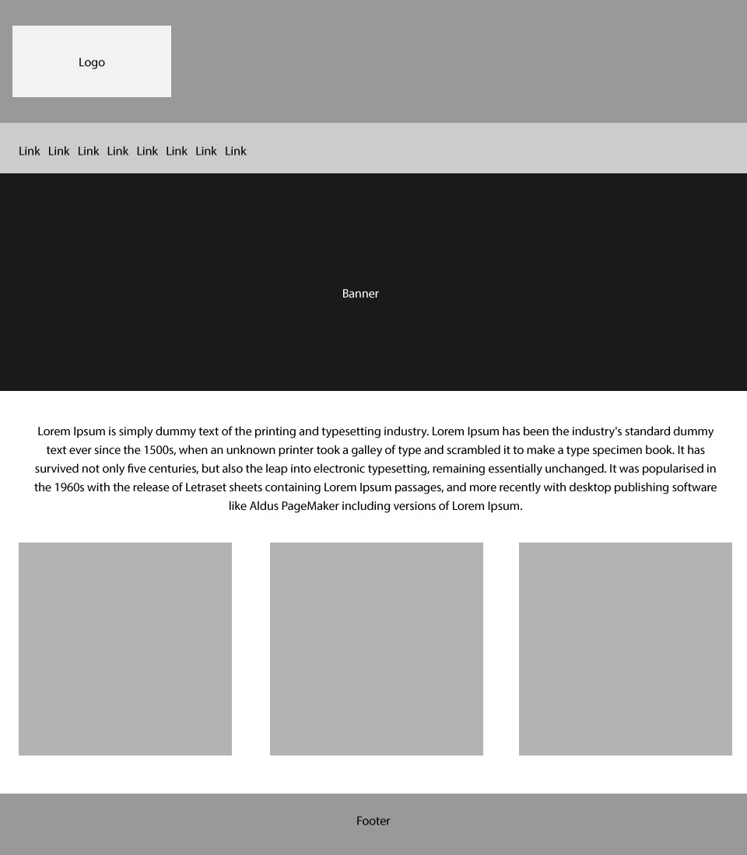

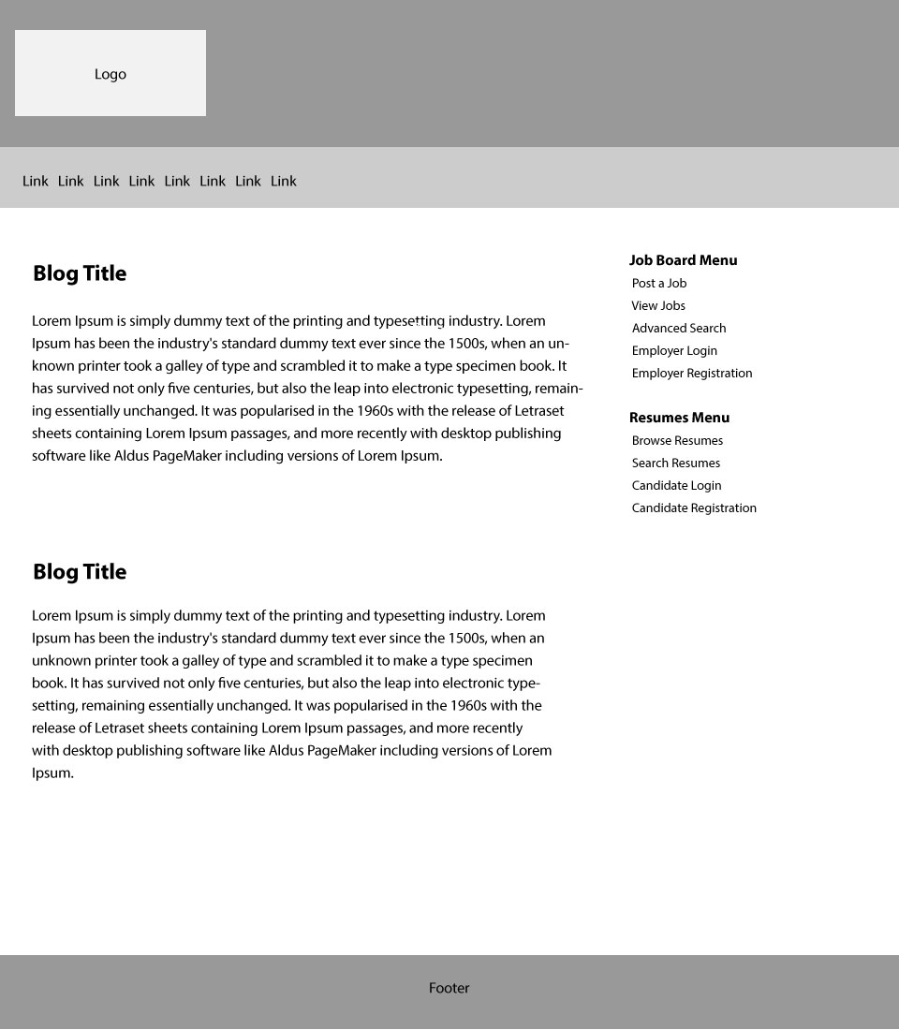

# Target Groups & Markets

**Target Market**

As we are creating a website that advertises open job positions our target market is people looking for jobs online. This means we have to create a website that is simple and easy to navigate through with the information being clear and easy to read on the page. To achieve this we need to take into consideration the font, layout, colour and images we use.

**Competitors Websites**

Before creating a website for our client, we first need to search online and view what their competitor’s websites look like. It is important to pay special attention to the font, layout, colour and images used, as these make up the look and feel of the website and control the message that you are trying to convey to the customer.

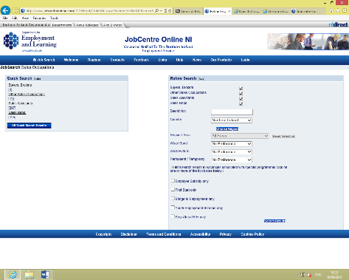Job Centre Online

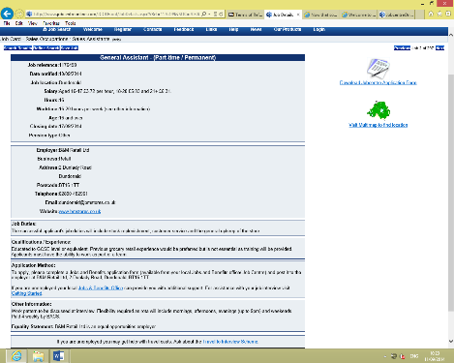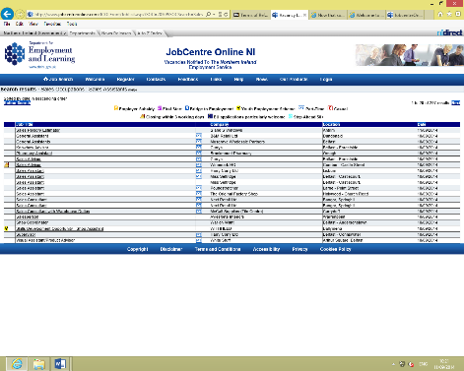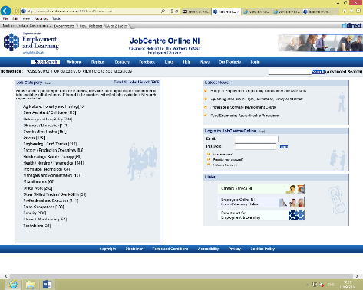

**Colour**

This website uses a monochromatic colour scheme using only light blue throughout the whole website. This light blue and the clever use of white space makes the information very clear and easy to read, giving the reader quick access to information.

**Layout**

This webpage has a very simple navigation process. There is a light blue box on the left side of the screen that numerous job categories in it that allows you to select the job category you are searching for. Once you have selected your category it brings you to a page that has the same layout and allows you to refine your search of the location and the job title.

Once you have selected your job title it then brings you to a list of available jobs to apply for and gives you the company name, location and date. If you see a job that you would like to apply for you can click on the link and it will give you all the details of that position, for example, salary, hours you work a week and the closing date to apply. Also there is a link on the page that allows you to apply for the job.

**Font**

Throughout this website the designer has decided to use a San Serif font, this gives the text a strong and clear display which makes it easy for the user to read. This was the right choice for the website as the user would want access to information fast.

**Images**

There is only one image used on this website. It is places in the top right hand corner and depicts a happy working atmosphere. I believe the websites works with minimal images as the majority of the space is given to text which gets the information across.

**Total Jobs**

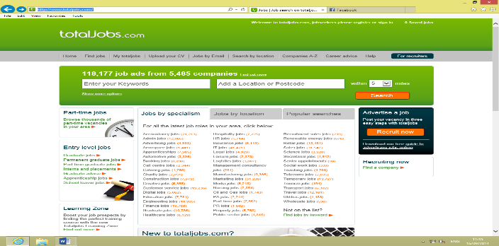

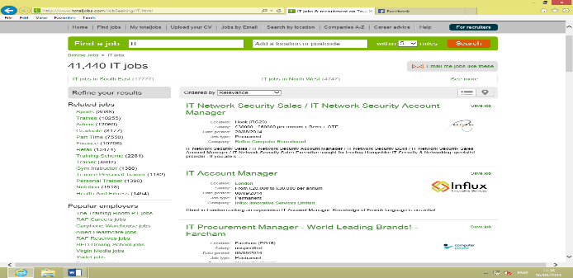

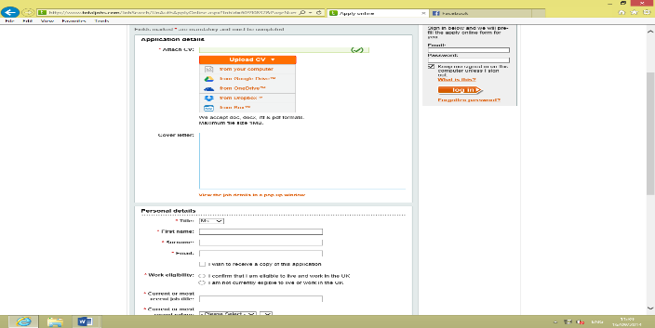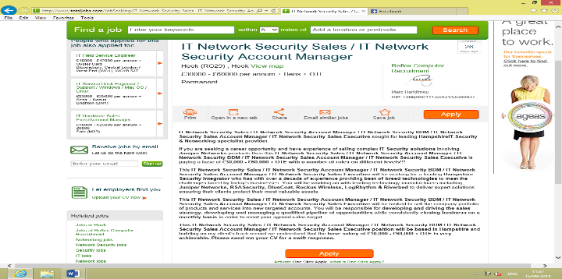

**Colour**

Again, this website also uses a monochromatic colour scheme using a vibrant green and white space to leave the information clear and easy to read. The vibrate green is useful as it draws the eye of the user to the banner, which has the name of the website, and the search bar, which allows you to search for a job or jobs in a certain location.

**Layout**

This website uses a similar layout to the last website I looked at. The index page gives you a list of job categories to refine your job search, or if you already know the job you are searching for you can simply type in in the search bar and search for it directly. They have decided to use borders in order to separate the information being displayed to make it easier to read.

Once you have decided on the job category that you want to search you click on the link and it brings you to a new page with a list of available jobs within that category. The information is separated with a line under each new job listing, leaving the information clear and easy to read. When you have seen a job that interests you, you can click on the link of that website and it will bring up all the information on that job and also gives you the option to apply for that job.

**Font**

Throughout the webpage the designer has decided to use the San Serif typeface Arial. This makes the text easy to read for the user as the text is clear and crisp. I believe this was a good choice by the designer as the users are using the webpage to gain quick access to information. Therefore, the information needs to clear and easy to read.

**Images**

On the left hand side of the index page there are three images used in order to give a visual aid to the information being displayed, for example, in the part time job section there is an image of a clock. For the mobile section, there is a mobile phone displayed. This gives a bit of life to the webpage and does not leave the reader constantly staring at text.

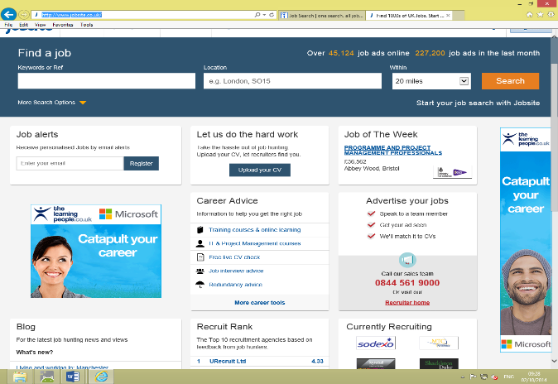**Job Site** 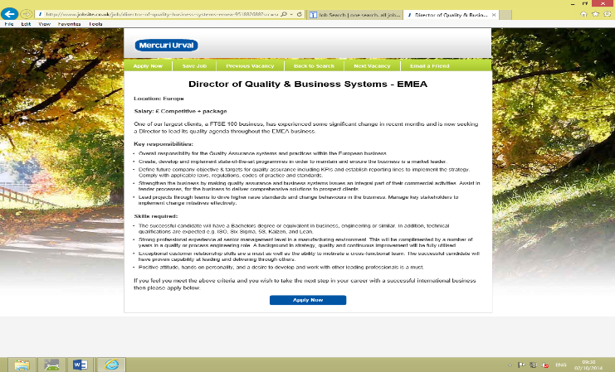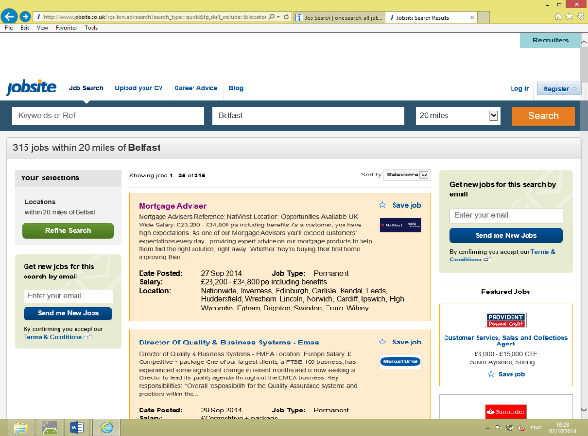

**Colour**

This website decided to use a complementary colour scheme with the use of Blue and Orange throughout the website. The primary colour used within this website is Blue. This is used as the header of the page. It is cleverly located behind the search bars which allows them to jump of the page for the user. Orange is used for the search button at the top of the page, this stands out well against the Blue. Also, it is also the colour for some of the borders that are advertising the jobs, this separated the information well and leaves it easy to read.

There is not a lot of colour used on this webpage, a lot of it was left with white space. This was done in order for the information to stand out and be quick and easy to read.

**Layout**

On the index page of this website there is a search bar at the top of the page that allows you to search specifically for a job or to search for one by location. Above this there is also a navigation bar that allows you to refine your search by “Sector”, “Location” or “Title”. Also, on the main body of the index page there is relevant information separated with borders leaving the page uncluttered with information. These borders create lists of relevant information, for example, “Career Advice”, “Recruitment Rank” and “Job of the Week”. This is useful for the user as it lets them know who the best recruiters on this specific webpage are. Once you have selected your specific job or location, you are shown a page with a list of jobs depending on what you have searched. These jobs are surrounded with borders in order to keep the information clear. I believe this was a clever use of borders as keeps the webpage neat and tidy. Once you have seen a job you like you can click on it and it gives you all the relevant information on that job and the option to apply for it.

**Font**

Like the other websites I have looked at, this site has decided to use the Sans Serif typeface Arial. It is clear that Arial was used to leave the individual letters more distinctive and easier for our brains to recognise quickly.

**Images**

On the main page the designer has decided to use basically the same image twice, with the only difference being that in one image they use a man and in the other there is a woman. Both of them are looking up at the text “Catapult Your Career” while smiling. This gives the audience the impression that using this website you could catapult your career and be happy about it.

# Hardware

The Kreative team already have use of suitable hardware which is required. These are simple computers which are able to run the software which is required. However, I feel in order to run the software at a quicker pace a fast run computer is required as this will decrease the time that is needed to run the assigned task. I also feel that a computer with a better screen quality would be suitable as therefore the Kreative team would see their designs and ideas at a higher quality. Through research I have discovered that a price range of £400 - £550 should be suitable to buy the hardware that is required.

After carrying out research on many different computers and considering the price range along with the efficiency and screen quality I found a computer that suits our needs.

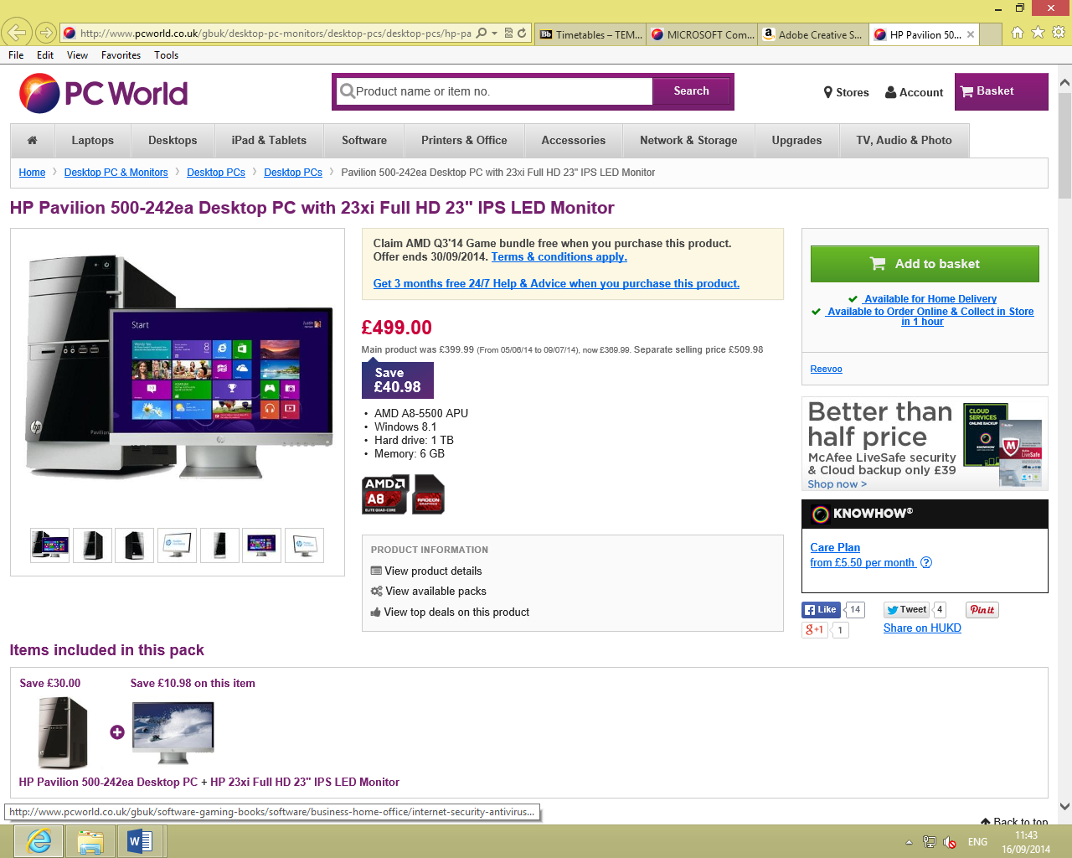**HP Pavilion 500-242ea Desktop PC with 23xi Full HD 23" IPS LED Monitor**

* AMD A8-5500 APU
* Windows 8.1
* Hard drive: 1 TB
* Memory: 6 GB

<http://www.pcworld.co.uk/gbuk/desktop-pc-monitors/desktop-pcs/desktop-pcs/hp-pavilion-500-242ea-desktop-pc-with-23xi-full-hd-23-ips-led-monitor-21907270-pdt.html>

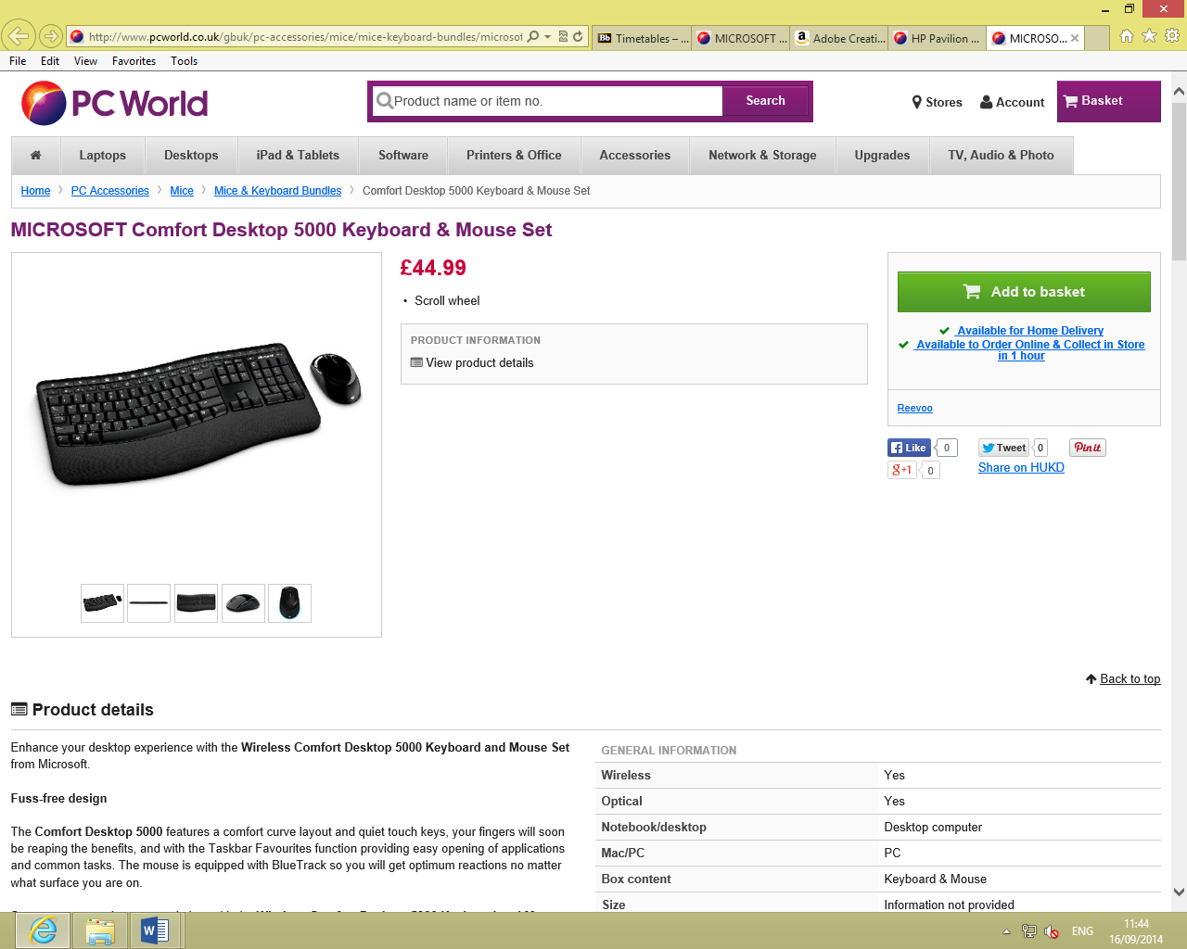This computer works out at a reasonable price of £499.00 from “www.pcworld.co.uk” and it would be great for each member of the team as it features an integrated graphics card which will produce crisp graphics and an excellent processing power. As there are four members of our team, four of these computers will be need which will cost a subtotal of £1,996 and as students we are entitled to 20% student discount in PC world we therefore would get the four computers for a total of £1,596.80. As there is no keyboard and mouse included within the desktop package we therefore need to purchase a keyboard and mouse combo which is priced at £44.99 and as four is needed it’s a subtotal of £179.96 and with the 20% student discount the total would therefore be £143.97. This is the best price I could find as it is compatible with windows 8.

<http://www.pcworld.co.uk/gbuk/pc-accessories/mice/mice-keyboard-bundles/microsoft-comfort-desktop-5000-keyboard-mouse-set-03635659-pdt.html?intcmpid=display~RR~Home+%3e+PC+Accessories+%3e+Mice+%3e+Mice+%26+Keyboard+Bundles~03635659>

# Software

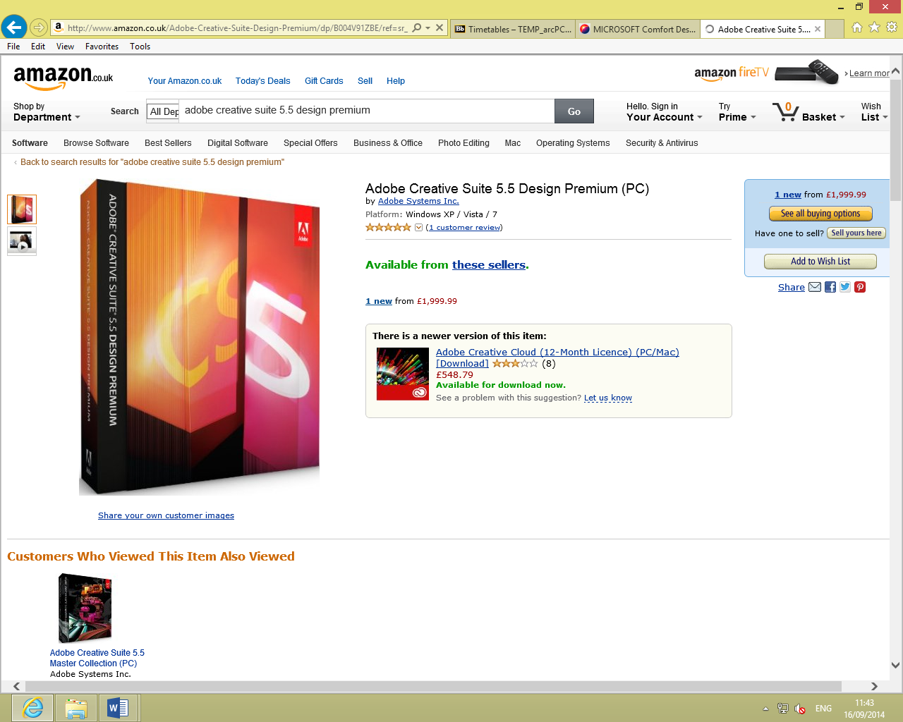The Kreative team have decided to find our own software package that suits the needs of the team members and also our client. We decided that an Adobe package would be best suited to us as it has everything included in it which as designers we need. The best package available to us as designers would be “Adobe Creative Suite CS5.5 Design Premium” as it includes many different Adobe programmes which will enable us to create things such as brochures to websites. The best deal I found for this particular software was on [www.amazon.co.uk](http://www.amazon.co.uk) which gives us as students discount and therefore instead of this software costing £1,380 for one subscription we can get one subscription for £322. As this software is needed on all four computers it will cost us a total of £1,288.

# Design Requirements

Umit Shah wants a clean, professional and easy to use website that users can employ as a key job finding tool. Our client approached us to help realise their idea and find the right way of presenting the content, consolidating information, and ultimately making it happen with a clean site design that the client can later manage them self.

As the client has not provided us with any material to work with, we will need to develop a comprehensive brand style guideline that will inform everything from the tone to the visual look and feel of the site and all of its creative assets, including the logo.

One of the main objectives of the website is to make it modern and accessible to users. To do this we will employ a responsive design, and rely on clear visuals and typography to reduce unnecessary content, making the overall experience much more visual and much less complex.

For job seekers, our client wants;

* a simple job search process
* users to easily browse through thousands of job listings or target specific keywords
* users to create a custom profile with a picture and upload their resume
* Get notified when your profile is viewed by a hiring manager so no more guessing if a company has seen your application

For employers, our client wants;

* an easy to use interface where employers can login and post a job opening
* syndication for job listing on sites like Indeed, SimplyHired, and Juju to increase the number and range of applicants to each listing
* to keep in touch with applicants, with features such as job alerts, job feeds, and email notifications

## Additional Requirements

#### Accessibility

In the United Kingdom the Disability Discrimination Act (DDA) requires that reasonable effort is taken to ensure that any service that is provided is accessible to disabled people. From October 2004 the DDA started including websites as services. Taking that into mind, the client’s site must comply with W3C WAI (World Wide Web Consortium Web Accessibility Initiative) level A Guidelines.

#### Code Validation

We will be using high standard HTML and CSS coding that will validate to W3C (World Wide Web Consortium) specifications.

# Production Schedule

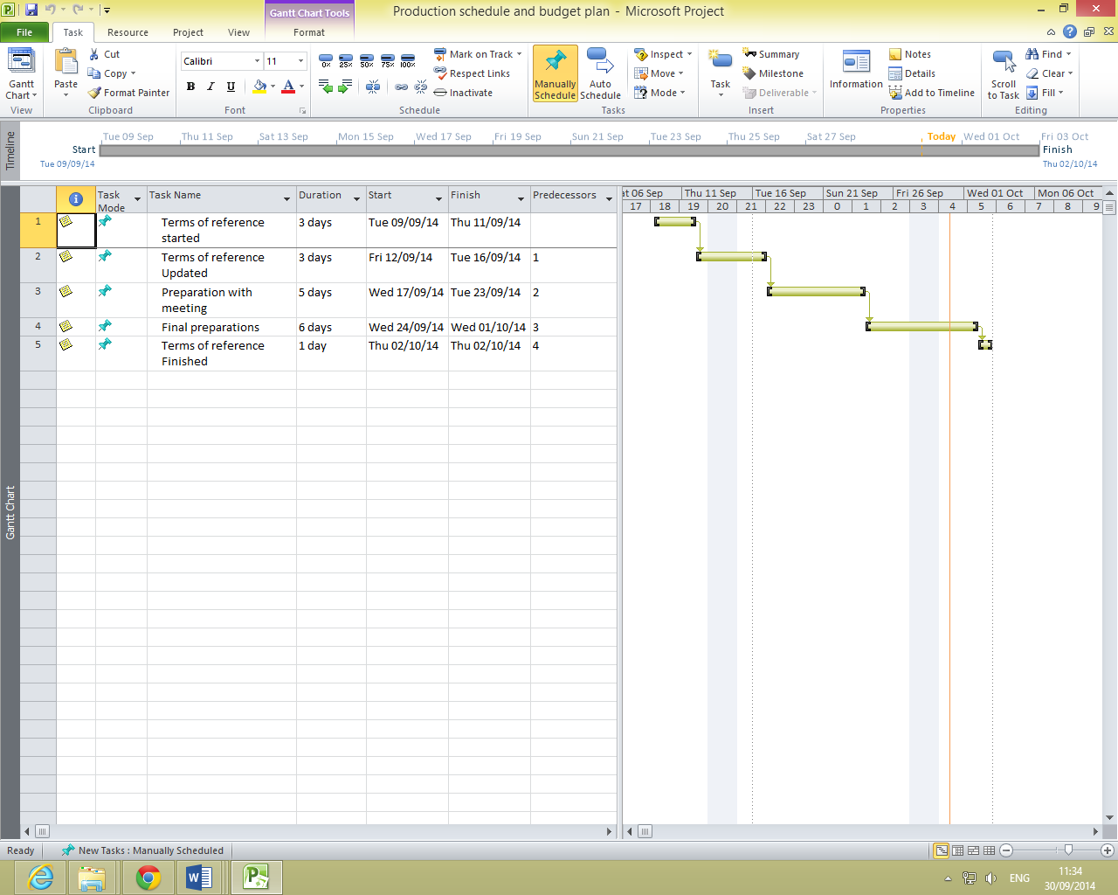

The notes on the project schedule has been attached as a separate file.

# Budget Plan

## Cost of design

The general layout of the website will be kept consistent throughout with perhaps some slight changes depending on what looks best on certain pages. For the cost of this it should be just be set depending on how long it takes to create the website as different elements which take up time could be included within certain areas. The client has suggested a theme that they would like used therefore when I looked into the theme the client has suggested it already comes with a layout and I feel that this layout should be followed.

On the main page we have decided to create a banner to bring life and colour to the webpage. Therefore it will take some time on deciding the design of the banner including content, colour and layout. However, once the design is decided on it shouldn’t take too long for it to be created.

A navigation bar will be included at the top of each page throughout the website to allow the user to navigate freely and with ease. It just needs to be designed and created one of then it can be copied to each page within the website.

For the content of the website the client has suggested a plug-in that should be included which allows for CV search and upload, post vacancies and for the candidates to post work. The plug-in is known as “wpjobboard.net” and when I looked into this I realised it will cost £122.00. This plug-in will therefore be used as the main page content, however other sub-pages will contain different content. Therefore to fill each page with content an hourly rate would be best set.

Photos will need to be included to show the company of the job that is being advertised. These images can be found online and therefore won’t cost anything or take up a huge amount of time to locate these kind of images.

The client has yet to fully decide on whether they want cards and posters created to advertise their business. If the client decides they do want advertising methods created this will therefore be charged on an hourly rate as the implementation of each and creation of each will take a considerable amount of time.

## Cost of print

The only elements of the design that will need printed ­will be the business cards and posters if the client decides they are wanted for their business. I therefore looked at the prices for the business cards which are £24.99 for 250. The posters won’t cost much to print as 3/4 will only need to be printed. If the client does decide they want cards and posters; we have informed them that they will need to cover the cost of print themselves as our team are only used for the design and creation of these.

## Travel expenses

The only travel expenses which are totally necessary and should be included within our budget should be the cost to meet the client which enables us to keep them up-to-date on our progression. The best type of transport would be public transport which is available to all four members of our team. A day ticket costs roughly £2.00 and as there are four members in the team it will cost £8 per meeting which the client has agreed to cover.

**Total**

Looking at all the above I have been able to come up with a rough budget estimate for the client.

**Hardware** - £1,740.77 (supplied by team) – As a team we have decided even though we are supplying the hardware, the client will therefore need to cover the cost for us to use it to produce what they need. The client will cover the cost of the software over the space of a year. The client will pay us the money weekly which works out around £31.00 per week and this will therefore cover the total cost for the use of the hardware.

**Software** - £1,288.00 – The client will pay for the software over the space of a year. The client will pay us the money weekly which works out around £25.00 per week; this will therefore cover the total cost of the software needed.

**Design** – £19,162.50 per annum (7 hours per day for 365 days at £7.50 per hour)

Expenses such as the business cards, posters and travel expenses when meeting the client will be covered by the client as stated previously.

The overall fee which will be presented to the client will be around the sum of £5,000.

|  |  |  |  |
| --- | --- | --- | --- |
|  | Rough cost | Rough total cost | Grand total |
| Equipment | £399 | £1596 | £1596 |
| Software | £322 | £1288 | £1288 |
| Design | £7.50 per hour | 7 hours per day for 365 days | £19,162.50 |
| Print | £25 | Covered by client |  |
| Travel | £8 when meeting client | Covered by client |  |
|  |  |  | £22,046.50 (per annum) |

# References

PC World, n.d., HP Pavilion 500-242ea Desktop PC with 23xi Full HD 23 [PC World | Laptops, Tablets, iPads, Desktop PCs, Printers & More ], [online]. Available: http://www.pcworld.co.uk/gbuk/desktop-pc-monitors/desktop-pcs/desktop-pcs/hp-pavilion-500-242ea-desktop-pc-with-23xi-full-hd-23-ips-led-monitor-21907270-pdt.html [23/09/2014].

PC World, n.d., MICROSOFT Comfort Desktop 5000 Keyboard & Mouse Set Deals | Pcworld [PC World | Laptops, Tablets, iPads, Desktop PCs, Printers & More ], [online]. Available: [http://www.pcworld.co.uk/gbuk/pc-accessories/mice/mice-keyboard-bundles/microsoft-comfort-desktop-5000-keyboard-mouse-set-03635659-pdt.html?intcmpid=display~RR~Home > PC Accessories > Mice > Mice & Keyboard Bundles~03635659 ](http://www.pcworld.co.uk/gbuk/pc-accessories/mice/mice-keyboard-bundles/microsoft-comfort-desktop-5000-keyboard-mouse-set-03635659-pdt.html?intcmpid=display~RR~Home > PC Accessories > Mice > Mice & Keyboard Bundles~03635659 ) [23/09/2014].

Nidirect.gov.uk, (2014). *The Disability Discrimination Act (DDA) | nidirect*. [online] Available at: http://www.nidirect.gov.uk/the-disability-discrimination-act-dda [Accessed 23 Sep. 2014].

W3.org, (2014). *Designing for Inclusion*. [online] Available at: http://www.w3.org/WAI/users/Overview.html [Accessed 23 Sep. 2014].

**Job Centre Online NI** (<http://www.jobcentreonline.com/JCOLFront/Home.aspx>

[**http://www.totaljobs.com/**](http://www.totaljobs.com/)

**<http://www.jobsite.co.uk/>**

*We also used the client’s written notes*