login -> erlkgoerkpoer$2y$10$NCslR7gefhjgsuefiuh8882UqQfHbYV1bgxzeUYv3EdqP2Wce2hBVD7luUu/OTPXLwZGkrejireokope
password -> 0586$2y$10$DtVQQzD.qsLg3AaleRRiuO9zua5Ux/IyIWgW0Jomto561s1evG136568822kkssrkjfioerfjeopfpe89815fekjfjeifpoepf[s[fplkdsfokpsioefjeiofjpokrgler[pij

https://rohkhat.tj/api/ref/auth/login
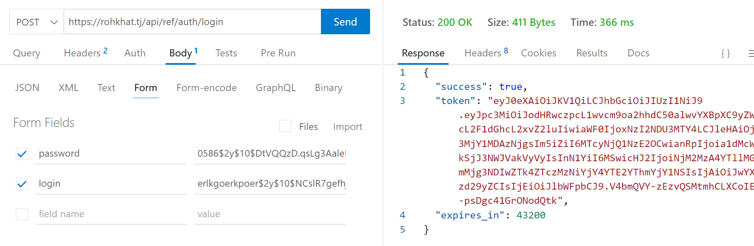
"expires_in": 43200 // в секундах

Недействительные данные для входа
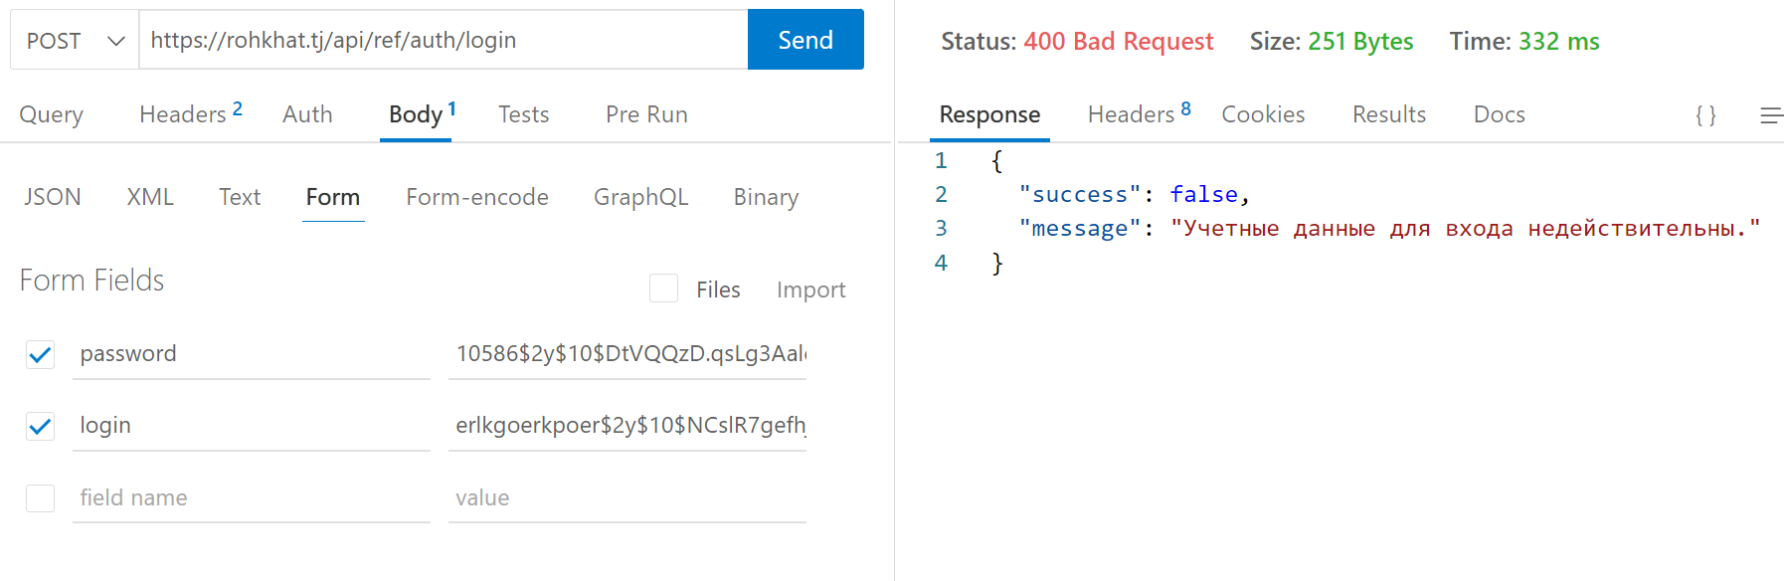

https://rohkhat.tj/api/ref/auth/refresh
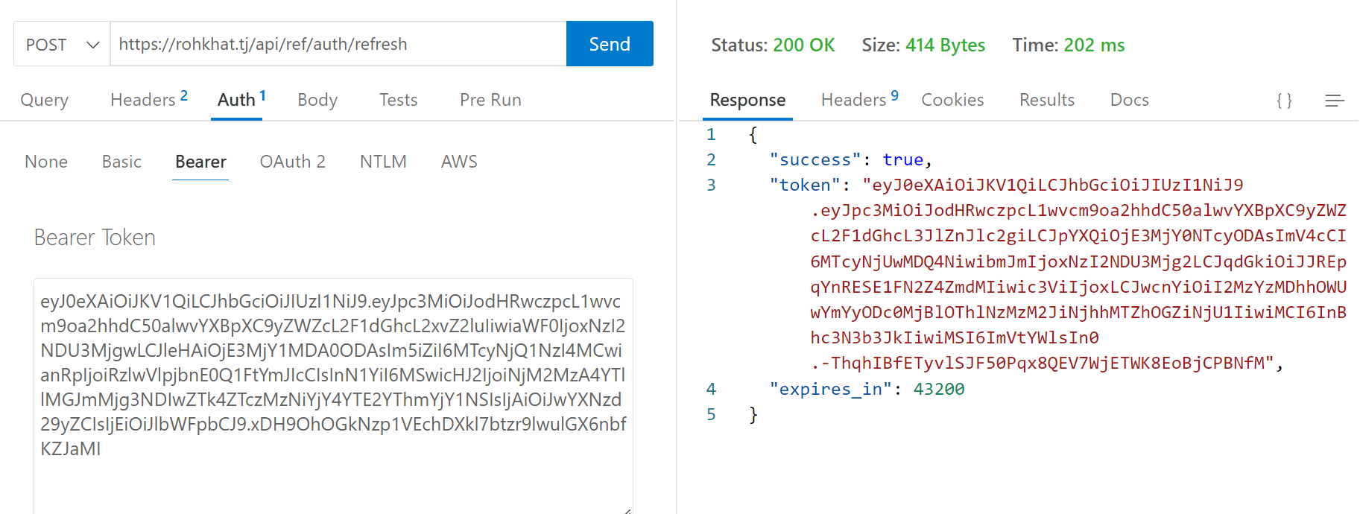

Недействительный токен
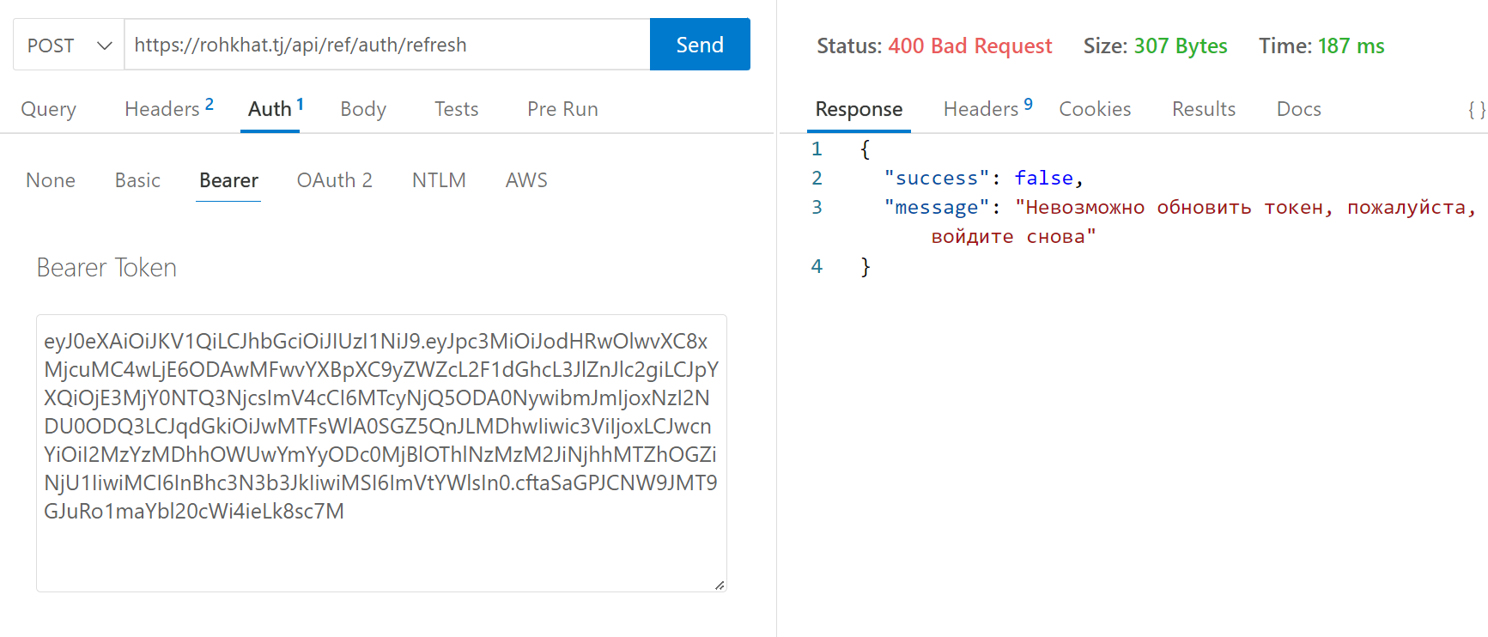

https://rohkhat.tj/api/ref/auth/logout

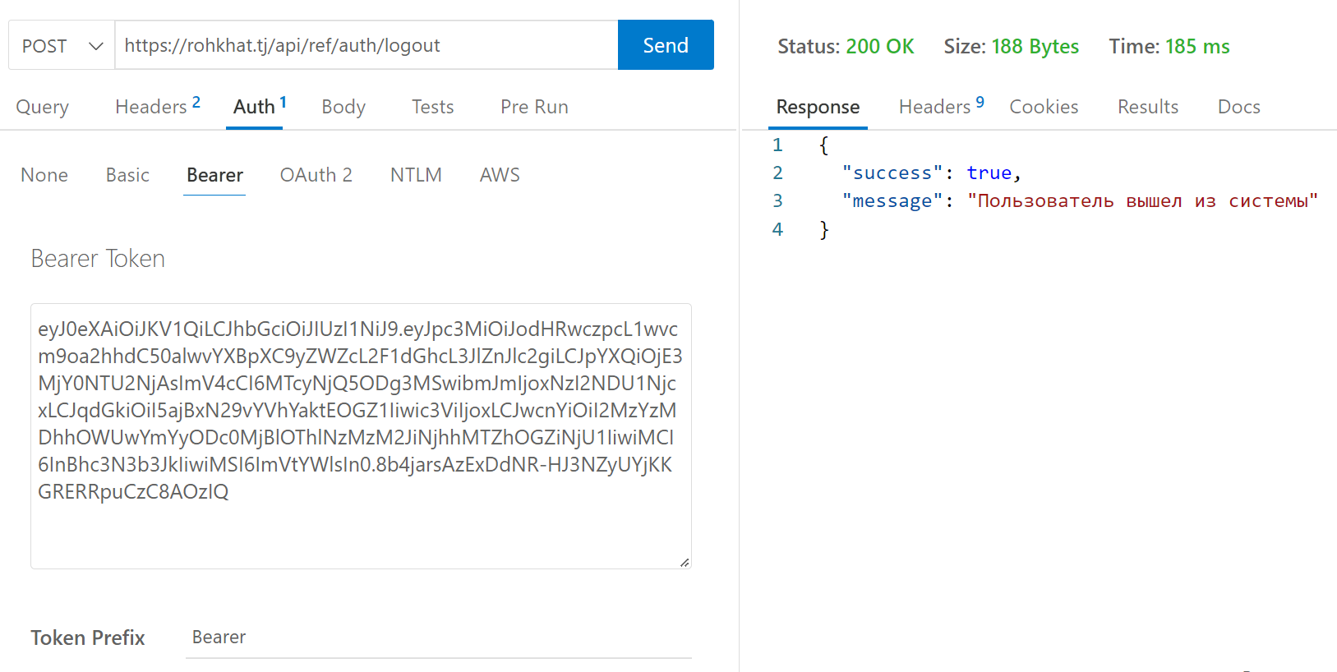

https://rohkhat.tj/api/ref/companies?page=1&updated_after=09.09.2022

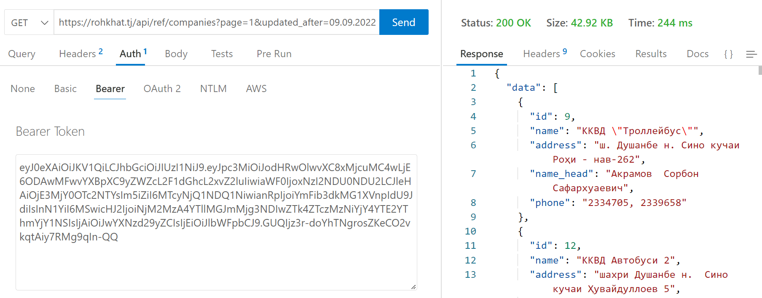
{
"data": [
{
},
],
"meta": {
"current_page": 1,
"last_page":,
"per_page":,
"total":
}
}
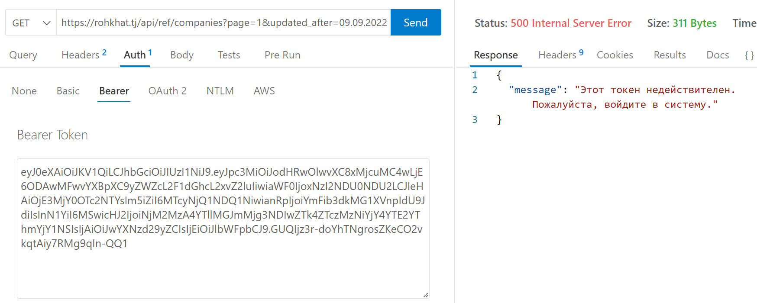

https://rohkhat.tj/api/ref/transports?page=1&updated_after=09.09.2022
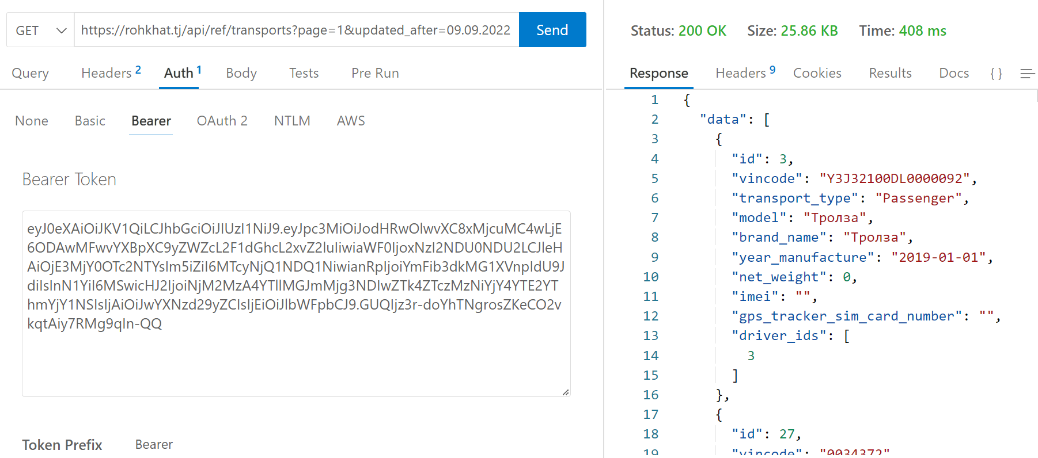
{
"data": [
{
},
],
"meta": {
"current_page": 1,
"last_page":,
"per_page":,
"total":
}
}

https://rohkhat.tj/api/ref/drivers?page=1&updated_after=09.09.2022

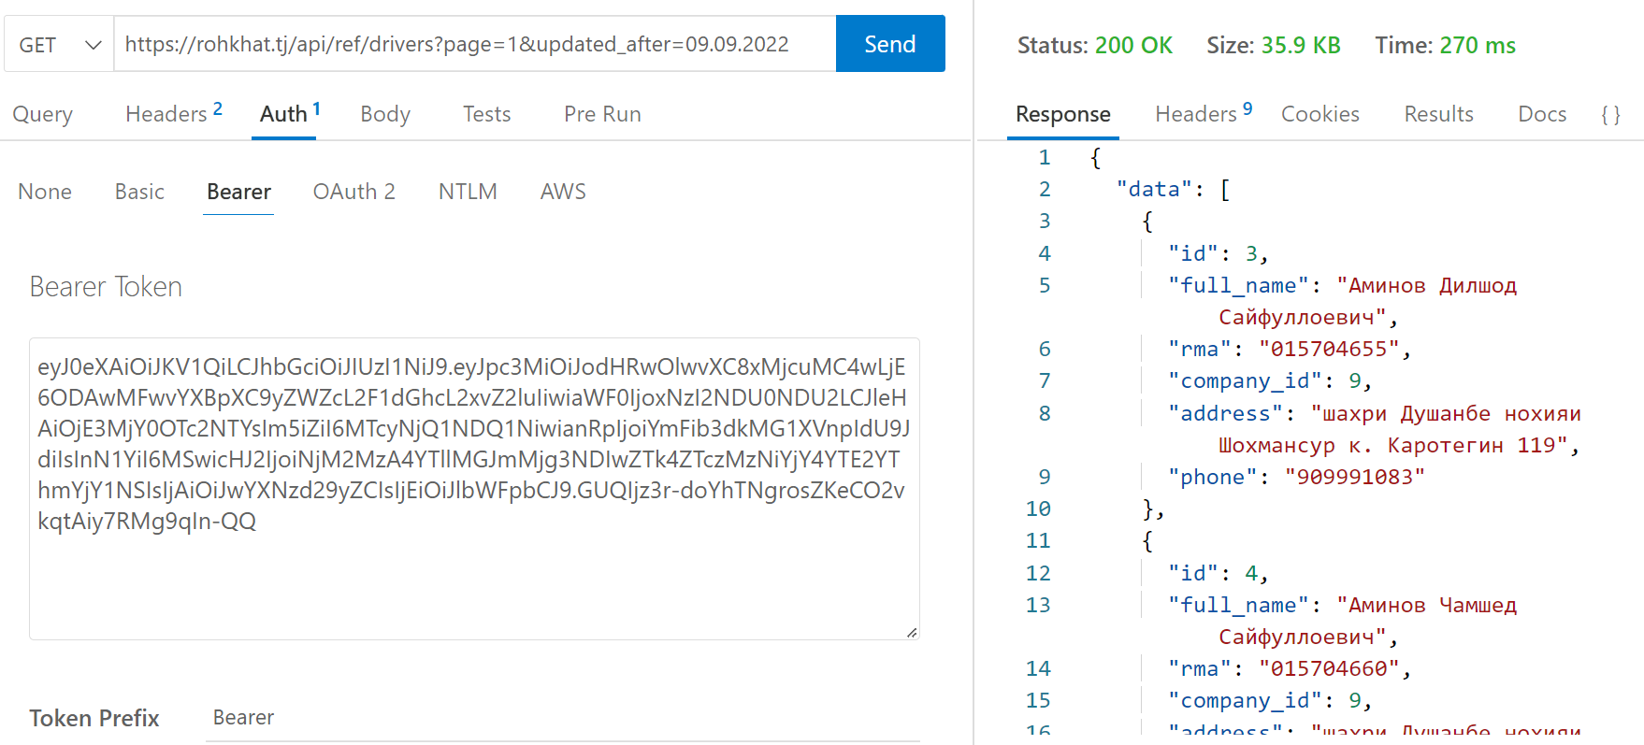
{
"data": [
{
},
],
"meta": {
"current_page": 1,
"last_page":,
"per_page":,
"total":
} }

{
"error": "api аз соати 05:00 то 23:00 ғайрифаъол мегардад."
}

