***WHAT IS A SERVICE LEVEL AGREEMENT (SLA)?***

A **service level agreement (SLA)** is a contract between a service provider (either internal or external) and the end user that defines the level of service expected from the service provider. SLAs are output-based in that their purpose is specifically to define what the customer will receive. SLAs do not define how the service itself is provided or delivered. The SLA an Internet Service Provider (ISP) will provide its customers is a basic example of an SLA from an external service provider. The metrics that define levels of service for an ISP should aim to guarantee:

* **A description of the service being provided**– maintenance of areas such as network connectivity, domain name servers, dynamic host configuration protocol servers
* **Reliability** – when the service is available (percentage uptime) and the limits outages can be expected to stay within
* **Responsiveness** – the punctuality of services to be performed in response to requests and scheduled service dates
* **Procedure for reporting problems** – who can be contacted, how problems will be reported, procedure for escalation, and what other steps are taken to resolve the problem efficiently
* **Monitoring and reporting service level** – who will monitor performance, what data will be collected and how often as well as how much access the customer is given to performance statistics
* **Consequences for not meeting service obligations** – may include credit or reimbursement to customers, or enabling the customer to terminate the relationship.
* **Escape clauses or constraints** – circumstances under which the level of service promised does not apply. An example could be an exemption from meeting uptime requirements in circumstance that floods, fires or other hazardous situations damage the ISP’s equipment.

Though the exact metrics for each SLA vary depending on the service provider, the areas covered are uniform: volume and quality of work (including precision and accuracy), speed, responsiveness, and efficiency. In covering these areas, the document aims to establish a mutual understanding of services, areas prioritized, responsibilities, guarantees, and warranties provided by the service provider.

The level of service definitions should be specific and measureable in each area. This allows the quality of service to be benchmarked and, if stipulated by the agreement, rewarded or penalized accordingly. An SLA will commonly use technical definitions that quantify the level of service such as mean time between failures (MTBF) or mean time to recovery, response, or resolution (MTTR), which specifies a “target” (average) or “minimum” value for service level performance.

https://www.paloaltonetworks.com/cyberpedia/what-is-a-service-level-agreement-sla

SLAs are also very popular among internal departments in larger organizations. For example, the use of a SLA by an IT helpdesk with other departments (the customer) allows their performance to be defined and benchmarked. The use of SLAs is also common in outsourcing, cloud computing, and other areas where the responsibility of an organization is transferred out to another supplier.

Overview[[edit](https://en.wikipedia.org/w/index.php?title=Service-level_agreement&action=edit&section=1" \o "Edit section: Overview)]

A service-level agreement is an agreement between two or more parties, where one is the customer and the others are service providers. This can be a legally binding formal or an informal "contract" (for example, internal department relationships). The agreement may involve separate organizations, or different teams within one organization. Contracts between the service provider and other third parties are often (incorrectly) called SLAs – because the level of service has been set by the (principal) customer, there can be no "agreement" between third parties; these agreements are simply "contracts." [Operational-level agreements](https://en.wikipedia.org/wiki/Operational-level_agreement) or OLAs, however, may be used by internal groups to support SLAs. If some aspect of a service has not been agreed with the customer, it is not an "SLA".

SLAs commonly include many components, from a definition of services to the termination of agreement.[[2]](https://en.wikipedia.org/wiki/Service-level_agreement#cite_note-SLAZone-2) To ensure that SLAs are consistently met, these agreements are often designed with specific lines of [demarcation](https://en.wiktionary.org/wiki/demarcation) and the parties involved are required to meet regularly to create an open forum for communication. Rewards and penalties applying to the provider are often specified. Most SLAs also leave room for periodic (annual) revisitation to make changes.[[3]](https://en.wikipedia.org/wiki/Service-level_agreement#cite_note-ShacklettFive11-3)

Since late 1980s SLA's have been used by fixed line telecom operators. SLAs are so widely used these days that larger organizations have many different SLAs existing within the company itself. Two different units in an organization script a SLA with one unit being the customer and another being the service provider. This practice helps to maintain the same quality of service amongst different units in the organization and also across multiple locations of the organization. This internal scripting of SLA also helps to compare the quality of service between an in-house department and an external service provider.[[4]](https://en.wikipedia.org/wiki/Service-level_agreement#cite_note-4)

The output received by the customer as a result of the service provided is the main focus of the service level agreement.

Service level agreements are also defined at different levels:

* **Customer-based SLA**: An agreement with an individual customer group, covering all the services they use. For example, an SLA between a supplier (IT service provider) and the finance department of a large organization for the services such as finance system, payroll system, billing system, procurement/purchase system, etc.
* **Service-based SLA**: An agreement for all customers using the services being delivered by the service provider**.** For example:
  + A mobile service provider offers a routine service to all the customers and offers certain maintenance as a part of an offer with the universal charging.
  + An email system for the entire organization. There are chances of difficulties arising in this type of SLA as level of the services being offered may vary for different customers (for example, head office staff may use high-speed [LAN](https://en.wikipedia.org/wiki/Local_area_network) connections while local offices may have to use a lower speed leased line).
* **Multilevel SLA**: The SLA is split into the different levels, each addressing different set of customers for the same services, in the same SLA.
  + **Corporate-level SLA**: Covering all the generic [service level management](https://en.wikipedia.org/wiki/Service_level_management#Service_level_management) (often abbreviated as SLM) issues appropriate to every customer throughout the organization. These issues are likely to be less volatile and so updates (SLA reviews) are less frequently required.
  + **Customer-level SLA**: covering all SLM issues relevant to the particular customer group, regardless of the services being used.
  + **Service-level SLA**: covering all SLM issue relevant to the specific services, in relation to this specific customer group.

Components[[edit](https://en.wikipedia.org/w/index.php?title=Service-level_agreement&action=edit&section=2" \o "Edit section: Components)]

A well defined and typical SLA will contain the following components:[[5]](https://en.wikipedia.org/wiki/Service-level_agreement" \l "cite_note-5)

* **Type of service to be provided**: It specifies the type of service and any additional details of type of service to be provided. In case of an IP network connectivity, type of service will describe functions such as operation and maintenance of networking equipment, connection bandwidth to be provided, etc.
* **The service's desired performance level, especially its reliability and responsiveness**: A reliable service will be the one which suffers minimum disruptions in a specific amount of time and is available at almost all times. A service with good responsiveness will perform the desired action promptly after the customer requests for it.
* **Monitoring process and service level reporting:** This component describes how the performance levels are supervised and monitored. This process involves gathering of different type of statistics, how frequently this statistics will be collected and how this statistics will be accessed by the customers.
* **The steps for reporting issues with the service**: This component will specify the contact details to report the problem to and the order in which details about the issue have to be reported. The contract will also include a time range in which the problem will be looked upon and also till when the issue will be resolved.
* **Response and issue resolution time-frame**: Response time-frame is the time period by which the service provider will start the investigation of the issue. Issue resolution time-frame is the time period by which the current service issue will be resolved and fixed.
* **Repercussions for service provider not meeting its commitment**: If the provider is not able to meet the requirements as stated in SLA then service provider will have to face consequences for the same. These consequences may include customer's right to terminate the contract or ask for a refund for losses incurred by the customer due to failure of service.

Common metrics[[edit](https://en.wikipedia.org/w/index.php?title=Service-level_agreement&action=edit&section=3" \o "Edit section: Common metrics)]

Service-level agreements can contain numerous service-[performance metrics](https://en.wikipedia.org/wiki/Performance_metrics) with corresponding [service-level objectives](https://en.wikipedia.org/wiki/Service-level_objective). A common case in [IT-service management](https://en.wikipedia.org/wiki/IT_Service_Management) is a [call center](https://en.wikipedia.org/wiki/Call_center)or [service desk](https://en.wikipedia.org/wiki/Service_Desk_(ITSM)). Metrics commonly agreed to in these cases include:

* **Abandonment Rate**: Percentage of calls abandoned while waiting to be answered.
* **ASA** (Average Speed to Answer): Average time (usually in seconds) it takes for a call to be answered by the service desk.
* **TSF** (Time Service Factor): Percentage of calls answered within a definite [timeframe](https://en.wikipedia.org/wiki/Timeframe), e.g., 80% in 20 seconds.
* **FCR** (First-Call Resolution): Percentage of incoming calls that can be resolved without the use of a callback or without having the caller call back the helpdesk to finish resolving the case.[[6]](https://en.wikipedia.org/wiki/Service-level_agreement#cite_note-6)
* **TAT** ([Turn-Around Time](https://en.wikipedia.org/wiki/Turnaround_time)): Time taken to complete a certain task.
* **MTTR** ([Mean Time To Recover](https://en.wikipedia.org/wiki/Mean_time_to_recovery)): Time taken to recover after an outage of service.

[**Uptime**](https://en.wikipedia.org/wiki/Uptime) is also a common metric, often used for data services such as [shared hosting](https://en.wikipedia.org/wiki/Shared_hosting), [virtual private servers](https://en.wikipedia.org/wiki/Virtual_private_server) and [dedicated servers](https://en.wikipedia.org/wiki/Dedicated_servers). Common agreements include percentage of network uptime, power uptime, number of scheduled [maintenance windows](https://en.wikipedia.org/wiki/Maintenance_window), etc.

Many SLAs track to the [Information Technology Infrastructure Library](https://en.wikipedia.org/wiki/Information_Technology_Infrastructure_Library) specifications when applied to IT services.

Specific examples[[edit](https://en.wikipedia.org/w/index.php?title=Service-level_agreement&action=edit&section=4" \o "Edit section: Specific examples)]

**Backbone Internet providers**[[edit](https://en.wikipedia.org/w/index.php?title=Service-level_agreement&action=edit&section=5" \o "Edit section: Backbone Internet providers)]

It is not uncommon for an internet backbone service provider (or [network service provider](https://en.wikipedia.org/wiki/Network_service_provider)) to explicitly state its own SLA on its website.[[7]](https://en.wikipedia.org/wiki/Service-level_agreement#cite_note-NTT_SLA-7)[[8]](https://en.wikipedia.org/wiki/Service-level_agreement#cite_note-VerizonSLA-8)[[9]](https://en.wikipedia.org/wiki/Service-level_agreement#cite_note-AT&T_SLA-9) The U.S. [Telecommunications Act of 1996](https://en.wikipedia.org/wiki/Telecommunications_Act_of_1996) does not expressly mandate that companies have SLAs, but it does provide a framework for firms to do so in Sections 251 and 252.[[10]](https://en.wikipedia.org/wiki/Service-level_agreement#cite_note-10) Section 252(c)(1) for example ("Duty to Negotiate") requires [Incumbent local exchange carriers](https://en.wikipedia.org/wiki/Incumbent_local_exchange_carrier) (ILECs) to negotiate in good faith about matters such as resale and access to rights of way.

**WSLA**[[edit](https://en.wikipedia.org/w/index.php?title=Service-level_agreement&action=edit&section=6" \o "Edit section: WSLA)]

A **web service level agreement** (**WSLA**) is a standard for service level agreement compliance monitoring of [web services](https://en.wikipedia.org/wiki/Web_service). It allows authors to specify the performance metrics associated with a web service application, desired performance targets, and actions that should be performed when performance is not met.

[WSLA Language Specification, version 1.0](http://www.research.ibm.com/people/a/akeller/Data/WSLASpecV1-20030128.pdf) was published by IBM on January 28, 2001.

**Cloud computing**[[edit](https://en.wikipedia.org/w/index.php?title=Service-level_agreement&action=edit&section=7" \o "Edit section: Cloud computing)]

The underlying benefit of [cloud computing](https://en.wikipedia.org/wiki/Cloud_computing) is shared resources, which is supported by the underlying nature of a shared infrastructure environment. Thus, SLAs span across the cloud and are offered by service providers as a service-based agreement rather than a customer-based agreement. Measuring, monitoring and reporting on cloud performance is based on the end UX or their ability to consume resources. The downside of cloud computing relative to SLAs is the difficulty in determining the root cause of service interruptions due to the complex nature of the environment.

As applications are moved from dedicated hardware into the [cloud](https://en.wikipedia.org/wiki/Cloud_computing), they need to achieve the same or even more demanding levels of service than classical installations. SLAs for cloud services focus on characteristics of the data center and more recently include characteristics of the network (see [carrier cloud](https://en.wikipedia.org/wiki/Carrier_Cloud)) to support end-to-end SLAs.[[11]](https://en.wikipedia.org/wiki/Service-level_agreement#cite_note-RuedaTheServ11-11)

Any SLA management strategy considers two well-differentiated phases: negotiating the contract and monitoring its fulfilment in real time. Thus, SLA management encompasses the SLA contract definition: the basic schema with the [QoS](https://en.wikipedia.org/wiki/Quality_of_service" \o "Quality of service) parameters; SLA negotiation; SLA monitoring; SLA violation detection; and SLA enforcement—according to defined policies.

The main point is to build a new layer upon the grid, cloud, or [SOA](https://en.wikipedia.org/wiki/Service-oriented_architecture) middleware able to create a negotiation mechanism between the providers and consumers of services. An example is the EU–funded Framework 7 research project, SLA@SOI,[[12]](https://en.wikipedia.org/wiki/Service-level_agreement#cite_note-ButlerMotiv11-12) which is researching aspects of multi-level, multi-provider SLAs within service-oriented infrastructure and cloud computing, while another EU-funded project, VISION Cloud,[[13]](https://en.wikipedia.org/wiki/Service-level_agreement#cite_note-VillariHowTo12-13) has provided results with respect to content-oriented SLAs.

FP7 IRMOS also investigated aspects of translating application-level SLA terms to resource-based attributes in an effort to bridge the gap between client-side expectations and cloud-provider resource-management mechanisms.[[14]](https://en.wikipedia.org/wiki/Service-level_agreement#cite_note-BonifacePlat10-14)[[15]](https://en.wikipedia.org/wiki/Service-level_agreement#cite_note-CuomoAnSLA13-15) A summary of the results of various research projects in the area of SLAs (ranging from specifications to monitoring, management and enforcement) has been provided by the European Commission.[[16]](https://en.wikipedia.org/wiki/Service-level_agreement#cite_note-KyriazisCloud13-16)

**Outsourcing**[[edit](https://en.wikipedia.org/w/index.php?title=Service-level_agreement&action=edit&section=8" \o "Edit section: Outsourcing)]

[Outsourcing](https://en.wikipedia.org/wiki/Outsourcing) involves the transfer of responsibility from an organization to a supplier. This new arrangement is managed through a contract that may include one or more SLAs. The contract may involve financial penalties and the right to terminate if any of the SLAs metrics are consistently missed. Setting, tracking and managing SLAs is an important part of the [outsourcing relationship management](https://en.wikipedia.org/wiki/Outsourcing_relationship_management) (ORM) discipline. Specific SLAs are typically negotiated up front as part of the outsourcing contract and used as one of the primary tools of outsourcing governance.

In software development, specific SLAs can apply to application outsourcing contracts in line with standards in [software quality](https://en.wikipedia.org/wiki/Software_quality), as well as recommendations provided by neutral organizations like [CISQ](https://en.wikipedia.org/wiki/CISQ), which has published numerous papers on the topic (such as *Using Software Measurement in SLAs*[[17]](https://en.wikipedia.org/wiki/Service-level_agreement#cite_note-CurtisUsing15-17)) that are available to the public.

<https://en.wikipedia.org/wiki/Service-level_agreement>

## Service Level Agreements

You might have a service level agreement to set expectations with a vendor providing supplies or services to your business. Or you might have a service level agreement to document the expectations for your contribution to your clients or business partners. Your SLA could set the standards for timelines, quality levels or the amount of service you expect a business deal to include.

## Key Performance Indicators

Which key performance indicators will serve you best can vary by the size of your business and the type of market you’re in. Your KPIs might include some combination of web traffic, social media engagement and net profit on the products or services you offer. The performance measurements for a restaurant will likely be very different from the KPIs for a computer repair shop or an online retailer.

## Using SLA and KPI

Service level agreements and key performance indicators are closely related, but clearly different. An SLA is forward-looking, while KPIs focus on past performance. Your SLA will set benchmarks ahead of time for you to measure performance in the near future. The KPIs you choose will measure the performance of your business against those benchmarks as time passes. Your SLA could even specify which performance indicators will be used.

## Making Adjustments

Using an SLA and performance indicators together allows you to monitor your business as you progress through a business agreement. Trends will develop and you can find opportunities to recalibrate your role in the partnership. If you’re under-performing against the expectations set in the SLA, performance measurements will show how much improvement is needed. If you identify an ability to perform beyond the parameters of the service agreement, you’ll see an opportunity improve your timelines or increase the volume of your business.

<https://yourbusiness.azcentral.com/sla-vs-kpi-16559.html>

# Pricing Models

Pricing your products or services accurately is one of the greatest challenges you are going to face as a business owner or manager. The importance of pricing is obvious, as it has a direct correlation to the amount of money you bring into your company. If you price your products and services too high, you are going to risk driving customers into the arms of your competitors. On the other hand, prices that are too low will leave you with small margins, even if you are able to make plenty of sales. In the end, only companies who are able to find the ‘sweet spot’ for pricing will be able to thrive well into the future.

For that reason, it is a good idea to use advanced pricing models to settle on a price point that makes sense for your market and your products. It doesn’t really matter what you would like to sell your products for – it only matters what customers are willing to pay.

[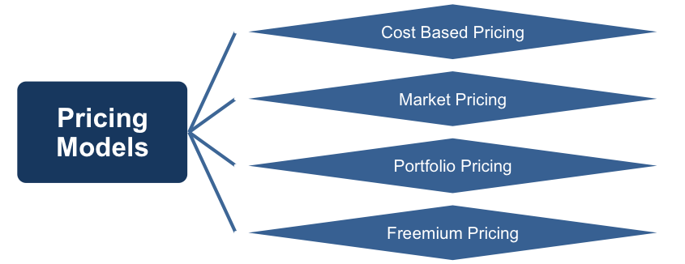](http://www.free-management-ebooks.com/news/wp-content/uploads/2017/02/price1.png)

Finding that number is a complicated task in many cases, which is why we have compiled the list of pricing models below. Review these options and use the ones that are going to help you find the perfect number to attach to everything you sell.

## Cost-based Pricing

This is perhaps the most-common way to price the products that you take to market. With this model, you are going to use the cost of production as the basis for the final price that consumers see when they make a purchase. The multiple that you use to price your goods is going to depend on the industry in which you are working. Some industries see multiples around 2-3 times the cost of production, while other industries are around 5 times or higher.

[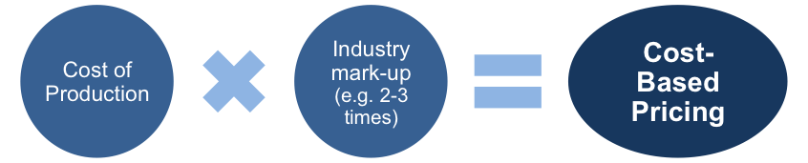](http://www.free-management-ebooks.com/news/wp-content/uploads/2017/02/price2.png)

For example, imagine you are in an industry which tends to sell products for around 3 times the cost of production. If you have determined that your average cost on one unit is $10, you will naturally look to sell the item for around $30 (if using a cost-based model). Multiplying your cost by three is a great way to get in the right ‘neighborhood’ for your pricing, but you can then tweak the final number until you hit a spot that you feel is a winner. For instance, if you see that many of your competitors already sell for $30, you may decide to move down to $27 or $28 just to have a slight edge on price. Or, if you think your product is of a superior quality to the competition, you could set your price at $35.

## Market Pricing

As the name would indicate, this pricing model is all about the market conditions that you find around you. Fortunately, in the internet age, it is relatively easy to determine market pricing for just about any product or service. A quick internet search should lead you to the prices of your competitors, and you can then react appropriately. Trying to sell a product that falls well outside the market norms for pricing is always going to be an uphill battle, so the market pricing model is a smart one to use.

[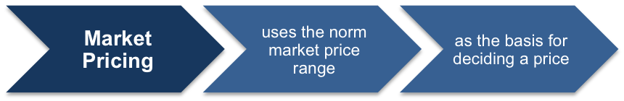](http://www.free-management-ebooks.com/news/wp-content/uploads/2017/02/price3.png)

It is worth noting that using a market pricing model doesn’t mean you always have to be the lowest priced product available. In fact, you might intentionally decide that you want to be the most expensive version of a specific type of good. The price that you choose relative to the rest of the market should match up with the marketing strategy you are using to reach your customers. If you are marketing your product as high-quality, it would make sense to have a higher price. On the other hand, if you talk about great value and affordability in your adverts, you better come in on the low end of the spectrum.

## Portfolio Pricing

This is a great model to use if you are offering a service – or, more specifically, a selection of services. In the portfolio pricing model you are going to set up a pricing structure that makes sense throughout your product or service line. For instance, if you run an accounting agency, you may offer basic tax preparation services for a certain rate. Then from there, your more advanced accounting services move up the pricing scale. It makes sense to price out all of your services in this way so that each of your customers feels they are getting a good deal.

[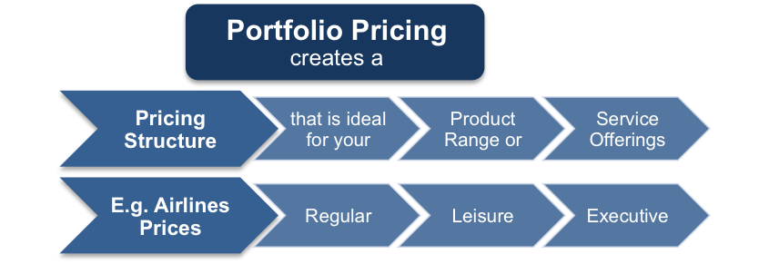](http://www.free-management-ebooks.com/news/wp-content/uploads/2017/02/price4.png)

Providing more service for less money would never make sense to your audience, so keep the portfolio pricing model in mind when structuring your overall price strategy.

## Freemium Pricing

The last model on our list is one that will only work for a specific segment of the market. In freemium pricing, you give away your base service or product for free, in the hopes that satisfied customers will decide to pay for more advanced features.

[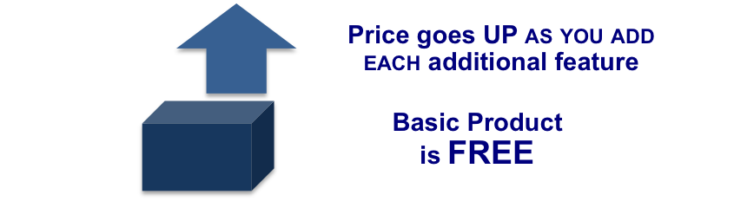](http://www.free-management-ebooks.com/news/wp-content/uploads/2017/02/price5.png)

This is a pricing model that is commonly used in the software world. A basic version of a piece of software may be made available to everyone for no charge, while an advanced version can be purchased for a flat rate (or a monthly subscription). Obviously you can’t use this model if you are in the business of selling sandwiches or something similar, but the freemium plan can work perfectly for some industries.

There will always be a feeling of nervousness when you take a new product, with a new price, out to market. Even with the use of great pricing models you can never be quite sure how consumers are going to react. To give yourself the best possible chance at success with your pricing decisions, be sure to consider the use of some of the models listed above. Also, remember one key thing with regard to pricing – your prices can always be changed. If your first decision was not spot on, feel free to adjust as you go until you settle on a price that strikes a balance between affordability and profit margin. As you gain experience with setting prices, and as you learn more and more about your market, you should become highly accurate with most of your pricing choices.

You can read more about Pricing Models in our free eBook ‘[**Top 5 Marketing Models**](http://www.free-management-ebooks.com/dldebk/dlmk-5models.htm)’. Download it now for your PC, Mac, laptop, tablet, Kindle, eBook reader or Smartphone.

http://www.free-management-ebooks.com/news/pricing-models/

# 7 pricing models – and which you should choose

**01. Hourly pricing**

Hourly pricing is one of the two most simple models. The key things you need for successful hourly pricing is discipline, documentation and communication. It requires greater scrutiny of the process, which often doesn't foster client trust. Hourly pricing only works when you have good data. You must meticulously track your time and expenses, and consistently check in with your client.

This approach is ideal for freelancers who aren't directly working with the client – for example, a freelancer for an ad agency. It's also ideal for any work involving sophisticated technology such as app development, where things often go wrong. However, it isn't a long-term solution for most creatives unless you choose to remain freelance. You will only become more profitable by raising your rates, which has a ceiling.

To summarise, hourly pricing is a good option if:

* You're working regularly with the same client, on similar work
* The project's deliverables are unclear
* Project scope changed several times when meeting with the client
* You're doing complex technical work

**02. Project-based pricing**

The second of these simple models is project-based pricing, which can be used in tandem with the hourly model.

Project-based or 'flat-fee' pricing is the most common model. Someone asks you how much a website costs, you tell them $4,000, and you charge them $4,000 regardless of the time or cost involved. However, with this method we often underestimate the effort required, and end up with excessive changes or unexpected problems. This means a loss in profit or an awkward request for a budget increase.

Project-based pricing can be profitable, and it's a step toward value-based pricing and higher profit levels. If you do similar work for similar clients routinely (e.g. WordPress websites for restaurants), you can cut costs and increase profit with this approach. It can also work well if you're good at time estimates, but most of us aren't.

You want to use this approach if:

* The client asks about money a lot up-front
* It's clear you can get the project done faster than the client's estimate

**03. Retainer pricing**

A retainer is the closest thing to a regular paycheck; it's a pre-set and pre-billed fee for a time period or volume of work. This can be based on time – for example the client agrees to buy 100 hours per month at $100 per hour, for a total of $10,000. Alternatively, it can be based on value. In this case the client might specify the features or deliverables they need, and pay $10,000 per month for this work, regardless of exactly how long it takes.

There are two types of time-based retainers: rolling and use-it-or-lose-it. In a rolling retainer, clients roll over any unused hours to the next month. In a use-it-or-lose-it retainer, any unused time is lost and the balance resets the next month. Don't offer rolling retainers; you'll end up doing meaningless work just so your client can burn through the hours.

You will find a maximum hourly rate a client is willing to pay. Value-based retainers enable you to scale your skills instead of your time, which means you can increase your profit. If you can reduce the time it takes to produce a chunk of code, you are no longer penalised for the increased efficiency. You are paid the same amount regardless of how long the job takes.

**04. Value-based pricing**

Value-based pricing calls for a less traditional client relationship. At Nine Labs we call it growth-driven design and our clients love it

The crux of value-based pricing is ensuring the client is satisfied they paid for what they received. Two clients may pay a different price for the same work. But they aren't paying you for your time; they're paying you for solutions. And those solutions are worth more to some clients than others. It's driven by customer demand and their willingness to pay. The strategy is based on three components, which we'll look at now.

**What your market will bear**

Consider the limits of both your local market (where you do business) and your horizontal market (what you do). You can get granular and define your market as 'custom logo designs for consumer brands'. You need to find out what your competition is charging for similar work with clients of similar size. So how do you do this?

* **Ask**: You'll be shocked at how many people will tell you
* **Go where the clients are**: Instead of networking with other creatives, go to client events and trade shows and ask them what they paid
* **Get involved**: Go to conferences, join trade associations, and sit in round tables and talk about pricing
* **Monitor**: Set up alerts for freelance pricing guides and pricing surveys

Advertisement

**Your track record**

Your past experience will affect how much you can charge. If you have extensive experience with a particular type of client, technology or style of design, then you fall into the 'expert' category. Experts can charge more for their services. Clients see that hiring you means that they're more likely to get desirable results.

**Perceived value**

Often you'll be called upon to detail how your work is 'worth more' to the client than the work of others. There are ways to quantify value, but the mentality has to change from what the client values to the client valuing you and your expertise. This means you have to demonstrate expertise, competence, and the ability to quickly understand their problems.

**05. Package pricing**

Package pricing can get a business up and running, but it can also result in your services being viewed as a commodity. Putting your prices out front before you've analysed the client's problem puts your needs (money) above theirs (effective solutions).

You've removed the ability to find pain points and address them directly because you have fit their problem into your process. If your package pricing includes discovery and analysis, that won't be as big an issue.

Here are some examples of different package pricing options:

* **Brand package**: A logo, website and business cards at one fixed price
* **Template customisation**: Customised website themes for WordPress
* **Consulting workshops and day rates**: Aimed at public or private audiences
* **Analysis or reviews**: Analysis of existing projects at a fixed cost, including a report
* **Photoshoots and videos**: A certain number of shots or amount of time

You can also offer price ranges (for example, 'CMS-based websites range from $5,000 to $20,000'), or consider minimum project costs. 'Projects start at $10,000' indicates you will not accept projects that are less than $10,000.

**06. Performance-based pricing**

Performance-based pricing means to base your fee on the performance of your work. You must affect a measurable outcome for your client, such as higher revenue or increased efficiency. It's often tied to analytics, so it's common with web or application design, and with ad agencies and SEO experts that can measure media impressions.

You must have a bulletproof contract with clear metrics and clear terms – if you don't have legal support, don't use this model. It can result in powerful working relationships that closely align the buyer's goals and the seller's goals, creating the ultimate bond between you and your client. It's near-impossible to under-price yourself, as long as your metrics line up.

## 07. Equity pricing

Advertisement

You may be offered a stake in a business in exchange for your work, either in lieu of any cash payment or as a mix of equity and a reduced cash payment. This approach is good for side projects or small engagements, but not if you're giving up a large number of cash bookings or clients and you need the money now.

Success depends on where the company is at the time you get involved. If it hasn't received any outside funding, your ownership could be diluted once it does. If it has, you're going to be offered little equity, probably less than 5 per cent. If the company is funded but can't offer you partial cash, it's not worth it unless you plan to go and work there full-time.

## Summary

Money can be messy, but it doesn't have to be. The key is to avoid getting emotional about pricing. No two projects or clients are the same, and there has to be a method to the madness. The sooner you get control of your pricing strategy, the sooner you'll find profitability.

https://www.creativebloq.com/advice/7-pricing-models-and-which-you-should-choose