Project Proposal

Title: MANAGE FUNDS IN A SMART WAY

Submitted to

The training program of “Web app development (php)”, batch-63

Basis Institute of Technology & Management (BITM)

Submitted By

**Team HackSlash**

**Summary**

The project titled “Manage funds in a smart way” will be a complete web-based management system. This will be a great platform for charitable organizations & donors can somewhat directly supervise their donations as well as communicate with the respective organization through our system. Even startups, which are in need of fund to implement their dream, can demonstrate their ideas to fetch attention of the relevant investors. It will suitable for other fund management workings. User can add category of funding and collection areas for that funding. Then the system will show the total fund and daily raising as well as. It will show the results in graph. It will be user friendly for the various banking systems like mobile banking, credit cards, online banking etc. User can trust this system as the payment will reach the correct destination in a secure way.

**Goals and Objectives**

The motive behind it is to build a common platform for all the charitable organizations & to ease their efforts for raising funds for any respective issue. Besides, there will be all the issues at one places that are in need for some money. Not only charity but also startups & young entrepreneurs can use the system to uphold their ideas & plans through presentations & information. Relevant investors & donors can check this site to communicate with the respective fund-craver. It will be also suitable in business purpose.

**Benefits**

* There will be a universal payment gateway.
* There will be less turmoil for charitable organizations to reach people for their humanitarian activities which thrive on money.
* People can be sure of the authenticity of the fundraisers, as there will be a verification system for every account holder in this site.
* The payment gateway system will be secured & hassle-free.
* Payment system via various banking systems like mobile banking, credit cards, online banking etc. will be available.
* It will be also suitable in business purpose as like the money collection from the business partners.
* The system will be secure, trusted and user friendly.

**Methodology**

We will complete our project by our group with Agile software development process.

**System Overview With UML diagram**

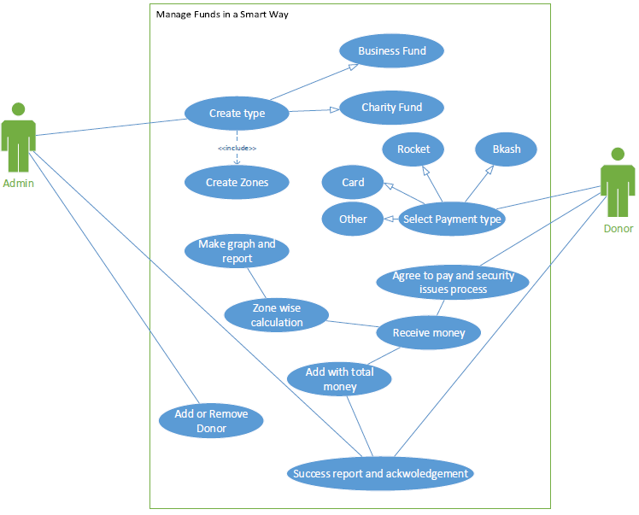

**Technical Issues**

Our programming platform will be php in back-end.

In front-end we will design our web-based project with html and bootstrap.

In Database we will use mysql.

**Pages in our Project**

1. Home page
2. Create type
3. Create zone to collect funding
4. Total funding result view page
5. Zone wise collected view page
6. Result with Fund graph
7. FAQ and info page

**Stuffing**

* Tajim Md. Niamat Ullah Akhund
* Imran Hoshain
* Raju Sheikh
* Shouvik Sarkar
* Momin Ahmed