Erie Insurance Agents’ Handbook

Requirements Document

Prepared by: Tajmilur Rahman, PhD, Asst. Professor @ Gannon University

December 10th, 2023

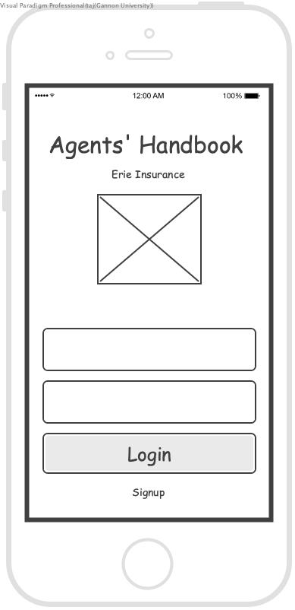

## 

## Entities

Erie Insurance, Branch, Agency (Primary Agent), Sales Team, Producer, CSR, Account

## Project Background

* Erie Insurance is the primary entity. It has many branches. Each branch is located in different locations.
* Agency is another entity that works with a branch. Many agencies work with one branch.
* An agency has a primary agent, and many other agents who sell insurance products individually or as a “Sales” team. Within a sales team an agent can be a “Producer”, or a “CSR”.
* An agency is typically identified by the primary agent. Each agent including primary, individual, and agents working within a sales team has an unique ID and they are identified by this ID.
* The unique ID of an agent has the following format: AANNNN
  + In this format, A - represents Alphabet, N - represents Number
  + The first two letters: “AA” represents the state
* Agent has the following attributes:
  + Agent ID
  + First Name
  + Middle Name
  + Last Name
  + Preferred Name
  + Account / Location / Address
* Sales Team is a collection of:
  + Producers (composed of agents)
  + CSR (composed of agents)
* Product is another entity which is sold by the agencies, or individual agents (sales, producers, CSRs) within an agency.

## Project Description

Erie Insurance has 18 branches as of today. Each branch organizes their annual board meeting events where they celebrate their performance of the past year and distributes awards to the best performing agents or agencies. Thousands (2200) of agents/agencies (principal agents / executives) may participate in the Annual Board Meeting (ABM) of a branch. Currently the agency's information is shared via pdf or text documents where it takes a lot of manual effort to find out someone in particular in the document.

Erie Insurance needs a mobile application where all the agencies/agents will be accessible by a robust search functionality. The search functionality is the primary feature of this application where a person (agent) can be found by typing any text in the search text-field.

Besides agent search, Erie Insurance also wants their users of this application to be able to browse and navigate to an event, browse and navigate to an agent manually through branches.

**Figure 1 (a)** shows the landing frame of the iOS mobile application where there will be a search bar and two navigator panels i) events, ii) branches. The search bar will be a universal search element throughout the application. Users should be able use the search bar to search for an agent any time while using the app. When users tap on the Events panel, the panel will be expanded listing up all the events. When users tap on the Branches panel, the panel will be expanded listing up all the branches of Erie Insurance.

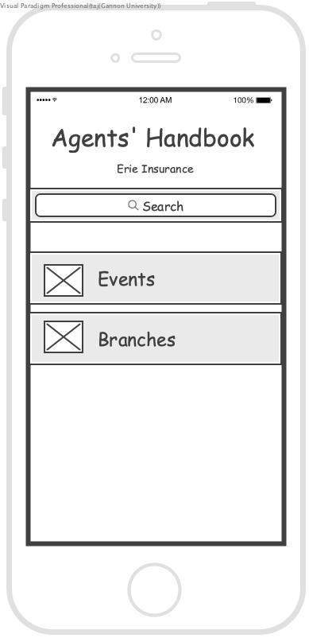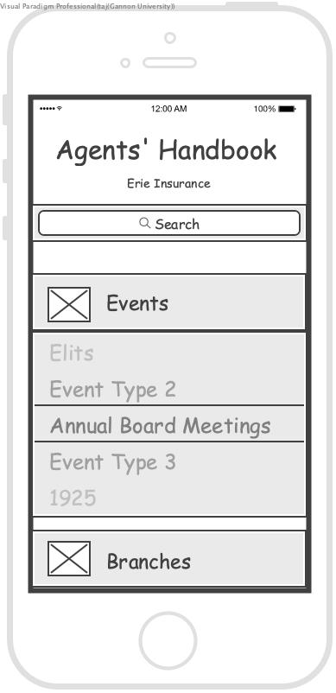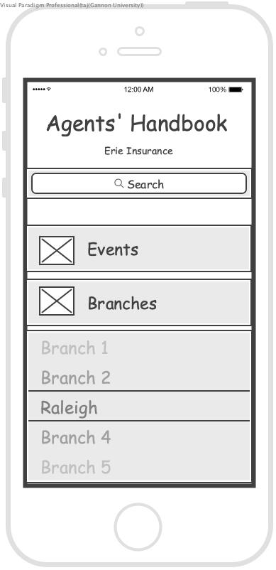

a b c

**Figure 1:** a) Landing Frame b) Tap on Events c) Tap on Branches

## Project Specifications

* Erie Insurance wants an iOS mobile application for V1.0 (MVP) and later on an Android version too.
* Agent search is the primary feature of this application.
* The search keywords from the search text-field will be looked into the Agent’s Name, Location, Phone Number, Email Address, Description (short bio), and all other information associated with an agent.
* All users of the mobile app will have similar access levels and can perform the same functionalities.
* Users should be able to browse events or branches from the landing frame.
* Users must login to the app. The Landing Frame in Figure 2 will be launched once the user is successfully logged in.
* Each user will have a basic profile page containing a profile picture and other basic details such as affiliation, designation, ID number, location (city, state), fun-fact, hobbies, short bio.

# EI Agents’ Handout - Minimum Viable Product (MVP) Requirements

## Functional Requirements

* **Full-text Search:** Users would like to type in any fragment of an agent’s name, designation, company, city, description/bio, hobbies, fun-facts, or anything else associated with the user. Search results will appear as a dropdown suggestions list.
* **Login:** Users must login to the app before he/she can do anything in the app.
  + If not registered in the app, a link/button will allow users to quickly signup in the app.
  + Login authentication has to be implemented via two-steps variations technique by sending a text/email to the user.
  + Once login is successful, the user will be taken to the landing screen (Figure 2 (a)).
* Registration: Users must signup before using the app.
  + Users can create a user account in the app using his/her Agent ID, email address, and password.
  + During app signup uploading a profile picture and providing other details is not mandatory.
  + Once signup is completed the user will be taken to the login screen.
* Search
  + Search must be wildcard and full text.
  + Search results must be linked to **user profiles**.
  + Users will be able to type anything in the search text field.
  + The search keyword will be looked up into the following data in the following order:
    - First Name
    - Last Name
    - Middle Name
    - Preferred Name
    - Agency (affiliation)
    - Designation
    - Biography or description
    - Address
    - Fun-fact
  + For example: If a keyword typed in is “Thoma” then all agents having their first names starting with “Thoma” will appear first. After that if any agent has their last name starting with “Thoma” will be added in the search result. And so on for middle name, preferred name, agency name, designation, bio, address, and fun-fact.
  + **Figure 2 (a)** shows a search UI mockup.
* Profile Page of Agent:
  + Once a user taps on an agent listed in the search result drop-down list, the user will go to the profile page of the corresponding agent as shown in **Figure 3 (b)**.
* Navigate through Events: The landing page contains two panels, i) events and ii) branches. Users can navigate through the events. Once the user taps on the “Event” panel, the user will see the list of different types of events. This is just an expansion of the panel instead of going to a new frame/screen. Similarly, once a user taps on the “Branches” panel, users will see the list of branches.
  + If a user taps on an event type, for example “Annual Board Meeting”, then the user will be taken to the list of all ABMs sorted by date earliest first. From this screen the user will be able to tap on a particular ABM of a branch. User will then be taken to another screen where the following details will be accessible:
    - Event Details
      * Branch Info
      * Award Info
      * Reports
  + **Figure 3** shows the event navigation screens.
* Navigate through Branches (up to primary agent level): On the other hand, if the user taps on a Branch from the list of branches, for example “Raleigh” then the user will be taken to a screen where details of the Raleigh branch is accessible.
  + Branches
    - Agencies
      * Primary Agent
      * ID
      * Account/Location

# 

a b

**Figure 2:** a) Agent Search b) User profile navigating from the search result

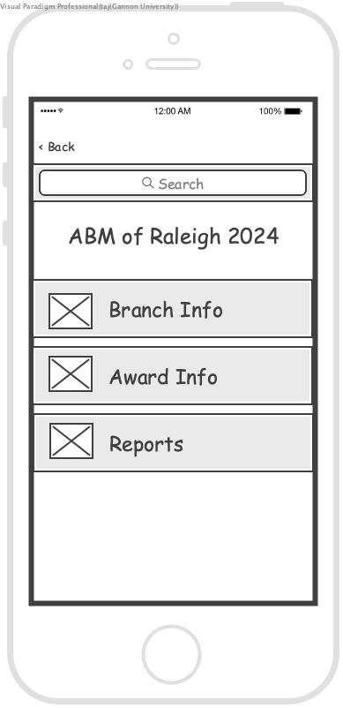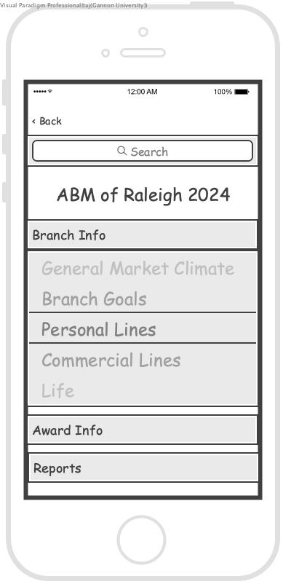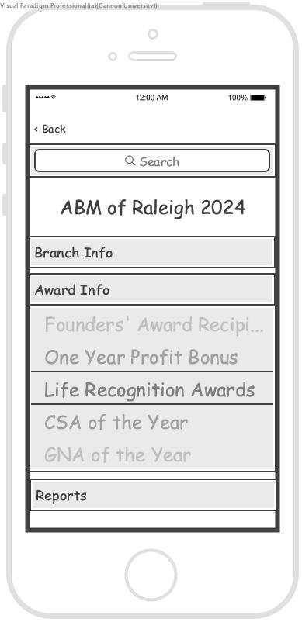

a b c

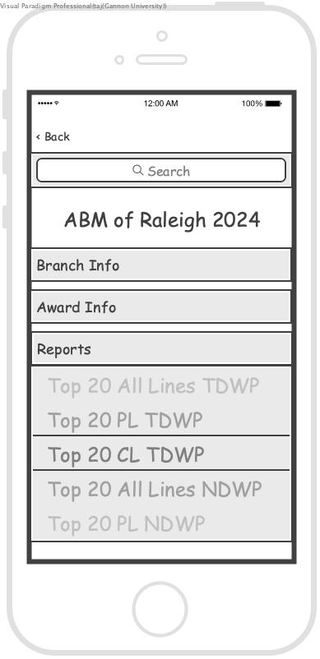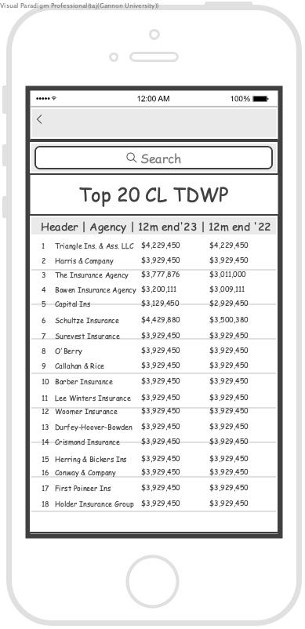

d e

**Figure 3:** Event navigation screens starting from ***a*** to ***e***.

## Non-functional Requirements

Not discussed

## Deadlines

UAT & Training: March 1st, 2024

* User Acceptance Testing
* Data:

V1.0 Release Date: April 10th, 2024

## Success Criteria

– MVP v1.0 before April 2024’s (April 11) ABM event.

– At least the following features are completed

o Basic search capability – Full-text search

– MVP users are senior leaders

# Post-MVP Requirements

Discussed but not confirmed

Mobile App

* Connect (may be later)
* Social media (may be later)
* Gamification (may be later)
  + Badges
  + Milestones
* Social networking (may be later)
* Push notifications (may be later)

Web App / Admin Panel

* Features
* Users
* Data operator
* Super user
* Use Case
* Data Source

Server Infrastructure

* Database
* Web Server