Grazioso Salvare Animal Rescue Dashboard
Tajudeen Tijani
CS 340 – Project Two
Southern New Hampshire University
Tenario Powell
August 16th, 2026

1. Project Overview
For Project Two, I completed an interactive dashboard for Grazioso Salvare. The purpose of the dashboard is to make it easier to review animal shelter records and identify dogs that may be appropriate for different types of search-and-rescue training. The dashboard uses the Austin Animal Center Outcomes dataset. The data is stored in MongoDB, and I use the Python CRUD module from Project One to retrieve the information needed by the dashboard. I used Dash to create the web interface and connect the database results to the tables and visualizations. The completed dataset contains 10,002 records and 16 columns. The information includes animal type, breed, age, outcome information, sex, date information, and geographic coordinates.
The dashboard allows the user to select different rescue categories. After a category is selected, the dashboard updates the data table and visualizations, so the user can focus on the records that match the selected category.
2. Required Project Functionality
The main requirement of this project was to create a working MongoDB dashboard that allows Grazioso Salvare to interact with the Austin Animal Center data.
My dashboard includes the required components:
- Interactive filtering controls
- Interactive data table
- Geolocation visualization
- Second data visualization
- Grazioso Salvare logo
- Unique student identifier
- Water Rescue filtering
- Mountain or Wilderness Rescue filtering
- Disaster or Individual Tracking filtering
- Reset functionality
The required filters are used to identify records associated with different types of rescue work.
Dashboard Option | Purpose
Water Rescue | Filters the records using the criteria for water rescue
Mountain or Wilderness Rescue | Filters the records using the criteria for mountain or wilderness rescue
Disaster or Individual Tracking | Filters the records using the criteria for disaster or individual tracking
Reset | Returns the dashboard to its original unfiltered state
The filter selection controls the other dashboard components. This means the user does not have to search through the entire dataset manually.

3. Tools and Technologies

I used several technologies to complete the project.
Technology | How I Used It
Python | Used to write the application and database interaction logic
MongoDB | Used to store and query the animal records
PyMongo | Used to connect Python to MongoDB
CRUD Python Module | Used to perform database operations and retrieve records for the dashboard
Dash | Used to create the interactive dashboard and connect dashboard components through callbacks
Plotly | Used to create the dashboard visualizations
Jupyter Notebook | Used to develop and run the dashboard code
Codio | Used as the development environment for the project
Each tool had a different purpose. MongoDB handled the data storage, Python handled the application and database logic, and Dash provided the interface the user interacts with.

4. Why MongoDB Was Used
MongoDB was used as the database component of the application. The animal records are stored as documents in MongoDB, enabling retrieval based on the fields needed by the dashboard.
One reason MongoDB works well for this project is that the data can be stored as documents containing the information for each animal. The dataset includes fields such as breed, animal type, outcome type, sex, age, latitude, and longitude.
MongoDB also works with Python through PyMongo. This allowed my Python CRUD module to connect to the database and perform database operations.
For this project, MongoDB serves as the model portion of the application. The dashboard does not need to store the animal information itself because it can request the information from the database when it needs it.

5. Python CRUD Module
I used the CRUD Python module that was developed during Project One.
CRUD stands for:
- Create
- Read
- Update
- Delete
The CRUD module provides the database access used by the dashboard. The Read functionality is especially important in this project because the dashboard needs to retrieve the animal records from MongoDB.
The dashboard uses the records retrieved through the CRUD module to populate the interactive data table and visualizations.
Keeping the database operations in the CRUD module also helps separate the database code from the dashboard interface. This makes the application easier to understand and maintain.

6. Dash Framework
I used the Dash framework to create the web-based dashboard.
Dash was useful for this project because it provides components for creating interactive web applications with Python. It also provides callback functionality, which allows one dashboard component to respond when another component changes.
For example, when the user selects Water Rescue, the dashboard receives that selection and updates the information displayed in the table and charts.
The application can be viewed using the following basic structure:
User
|
v
Dashboard Filter
|
v
Dash Callback / Python Logic
|
v
CRUD Module
|
v
MongoDB
|
v
Filtered Records
|
+----> Data Table
|
+----> Geolocation Chart
|
+----> Second Chart

This structure follows the MVC idea described in the project instructions.

Model
MongoDB is the model because it stores the animal records.

Controller
The Python CRUD module and Dash callback logic handle the requests and determine which information should be displayed.

View
The Dash dashboard is the view. It includes the filter controls, table, map, and second chart that the user sees.

7. Database and Dataset
The Austin Animal Center Outcomes dataset was used for this project.
After loading and checking the dataset, the collection contained:

10,002 documents
and the data contained:

16 columns
The fields include:
rec_num
age_upon_outcome
animal_id
animal_type
breed
color
date_of_birth
datetime
monthyear
name
outcome_subtype
outcome_type
sex_upon_outcome
location_lat
location_long
age_upon_outcome_in_weeks
The latitude and longitude fields are important because they provide the geographic information used by the geolocation visualization.

8. Dashboard Development
I developed the dashboard in stages.
First, I made sure that the MongoDB database and CRUD module were working correctly. I then used the CRUD functionality to retrieve the animal records.
Next, I created the data table so that the dashboard could display the animal information.
After the table was working, I added the rescue filtering controls. The filtering logic was then connected to the dashboard so that selecting a rescue category changes the data displayed by the dashboard.
I also connected the filtering results to the geolocation visualization and the second chart.
Finally, I added the Grazioso Salvare logo and my unique identifier to the dashboard.

9. Interactive Filtering
The dashboard provides four options that the user can select.

Water Rescue
The Water Rescue option applies the database filtering criteria for dogs that may be appropriate for water rescue.
After the selection is made, the dashboard updates the displayed records and visualizations.

Water Rescue screenshot

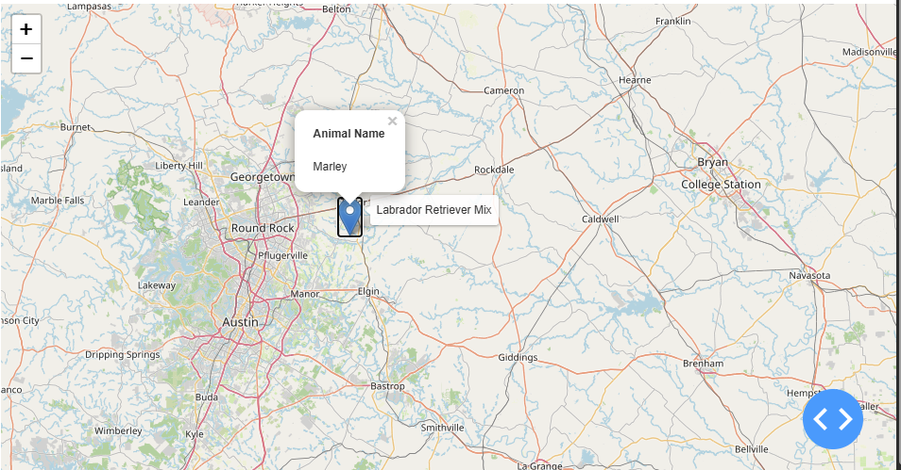

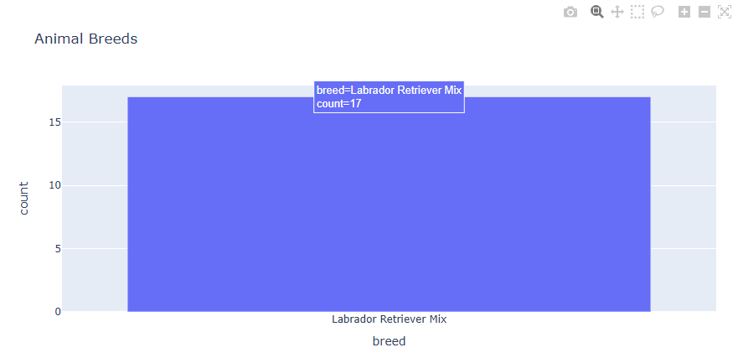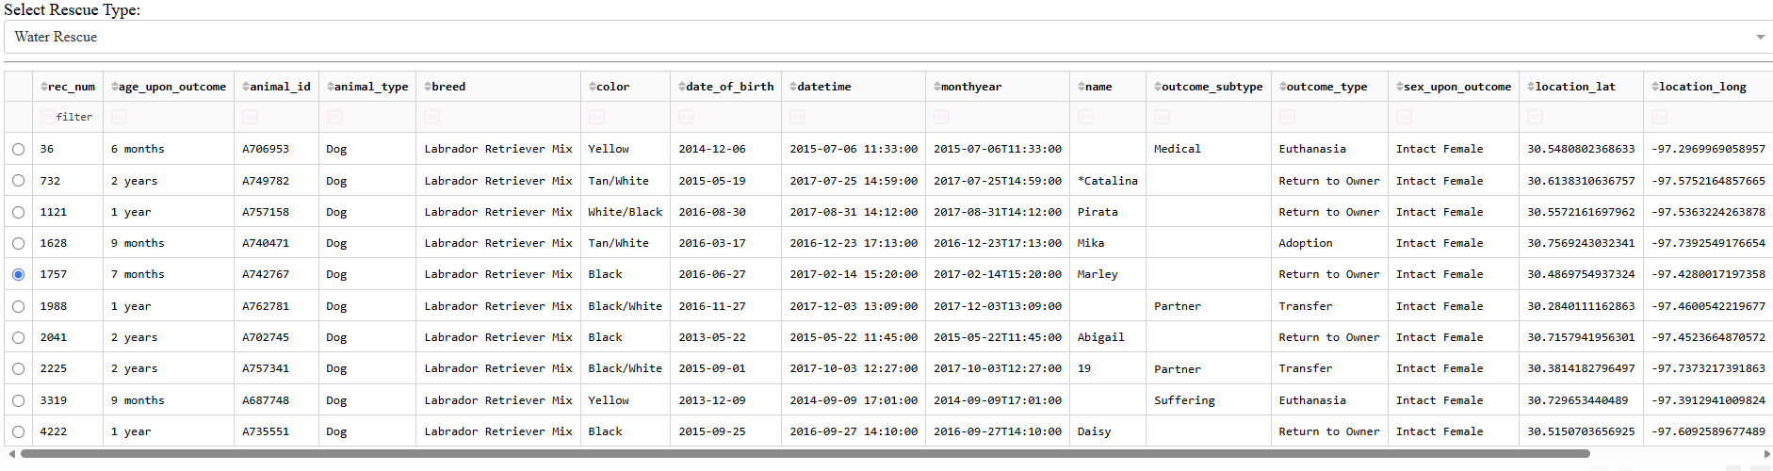
Figure 1. Water Rescue filter
This screenshot shows the dashboard after the Water Rescue option has been selected.

Mountain or Wilderness Rescue
The Mountain or Wilderness Rescue option applies the filtering criteria for dogs that may be appropriate for mountain or wilderness rescue.
The data table and visualizations update after the selection is made.
Mountain/Wilderness screenshot
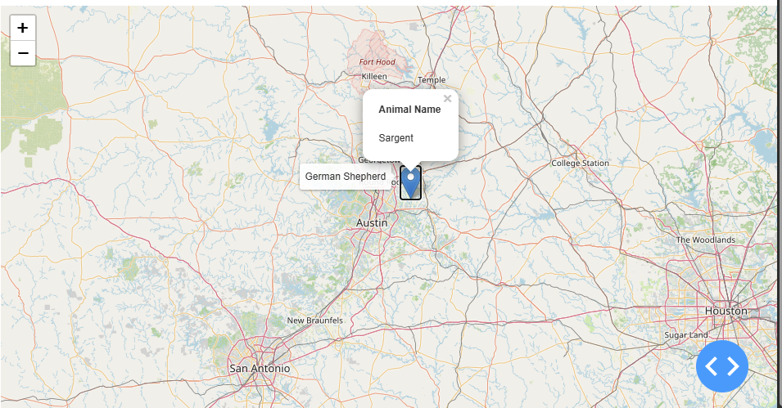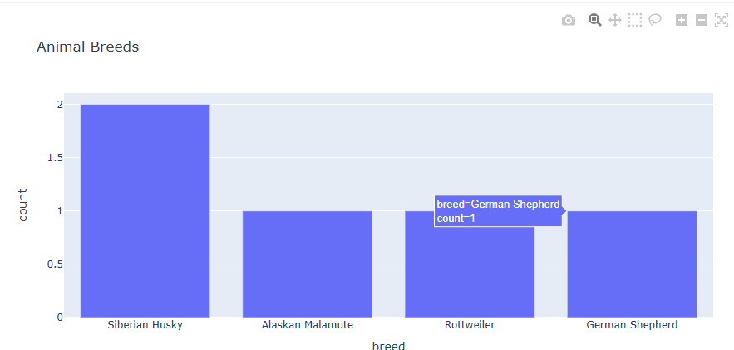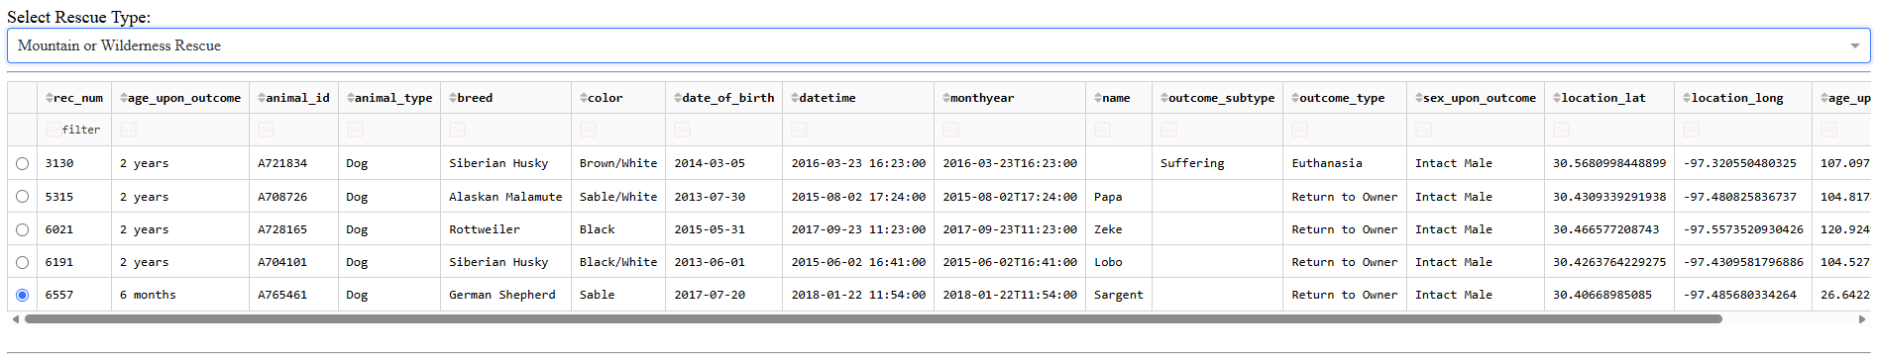
Figure 2. Mountain or Wilderness Rescue filter
This screenshot shows the dashboard after the Mountain or Wilderness Rescue option has been selected.

Disaster or Individual Tracking
The Disaster or Individual Tracking option applies the filtering criteria for dogs that may be appropriate for disaster or individual tracking.
The dashboard updates the displayed records and visualizations based on the selected option.

Disaster/Individual Tracking screenshot

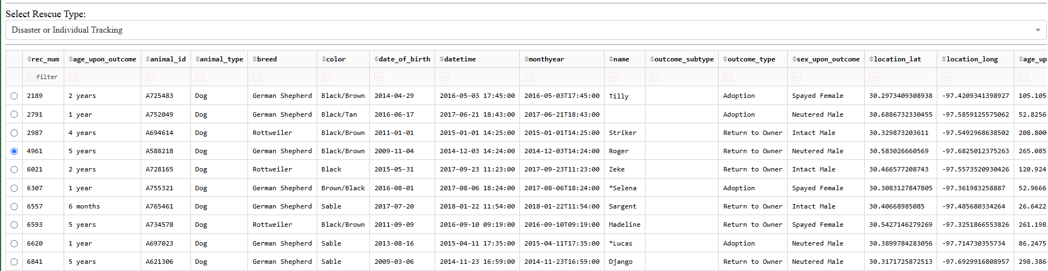

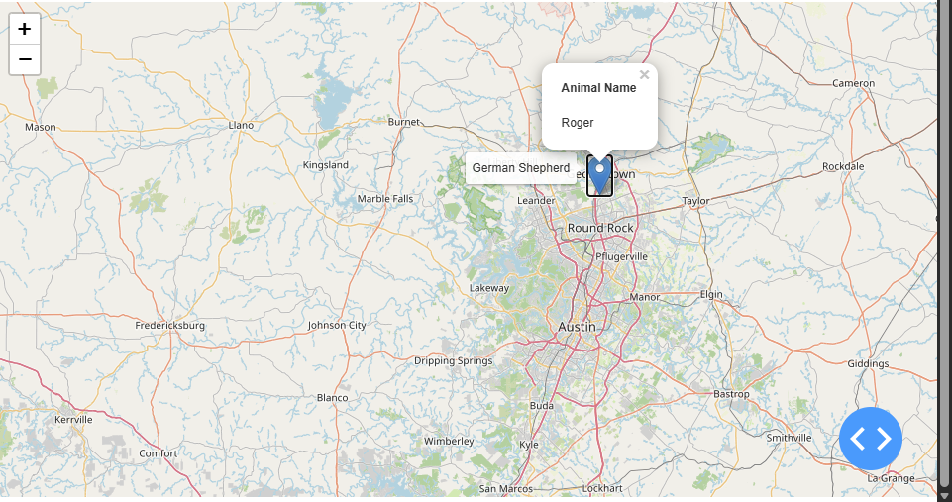

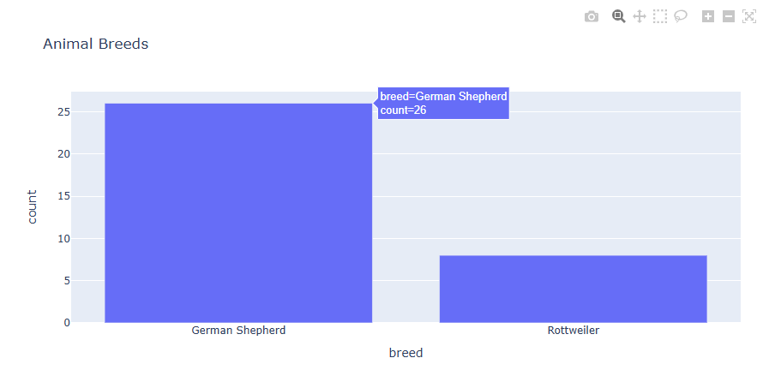
Figure 3. Disaster or Individual Tracking filter
This screenshot shows the dashboard after the Disaster or Individual Tracking option has been selected.

Reset
The Reset option returns the dashboard to the original unfiltered state.
This gives the user a simple way to clear the current selection and return to the complete dataset.
Reset screenshot
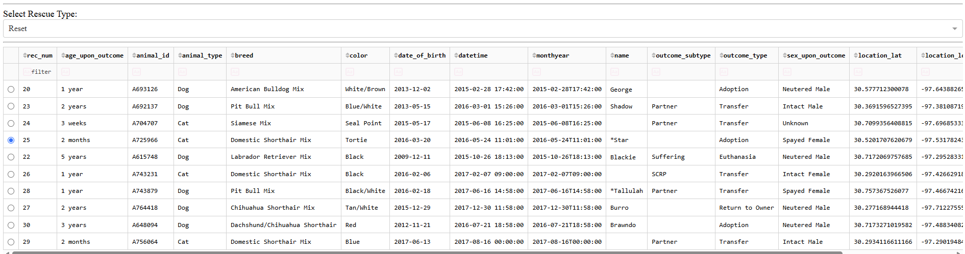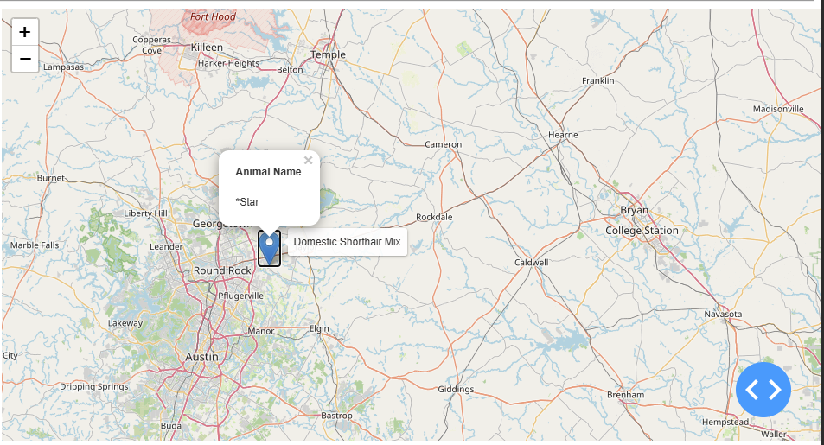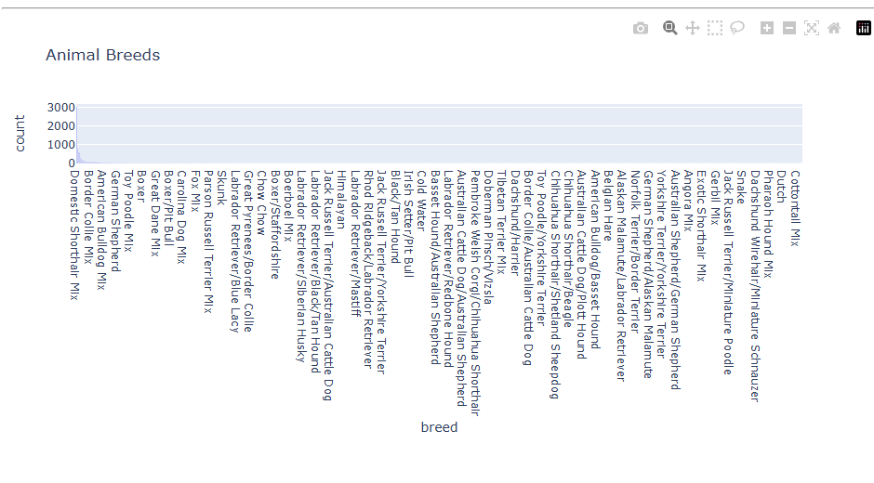
Figure 4. Reset
This screenshot shows the dashboard after the Reset option has been selected.

10. Interactive Data Table
The data table is one of the main components of the dashboard.
When the dashboard first opens, the table displays the unfiltered animal records.
The table then responds to the rescue filtering controls. When a user selects one of the rescue categories, the table updates to show the records associated with that selection.
This makes the information easier to review because the user can narrow the results instead of manually searching through all the animal records.
The table also allows the user to view the individual records returned by the database.

11. Geolocation Visualization
The dashboard includes a geolocation visualization based on the geographic information in the dataset.
The two fields used for the geographic coordinates are:
location_lat
location_long
These values allow the dashboard to display animal locations geographically.
The geolocation visualization is also connected to the dashboard filtering functionality. When the user changes the rescue category, the visualization updates to correspond to the filtered results.
This gives the user another way to examine the data in addition to the table.
Second Visualization
The dashboard includes a bar chart titled “Animal Breeds.” The chart displays the number of animals for each breed in the data currently displayed by the dashboard. The breed is shown on the horizontal axis, and the number of animals is shown on the vertical axis. The chart is connected to the interactive data table through a Dash callback. When the data displayed in the table changes, the chart receives the updated records and redraws the breed counts. This allows the user to see the breed distribution for the selected rescue category.

Grazioso Salvare Logo and Unique Identifier

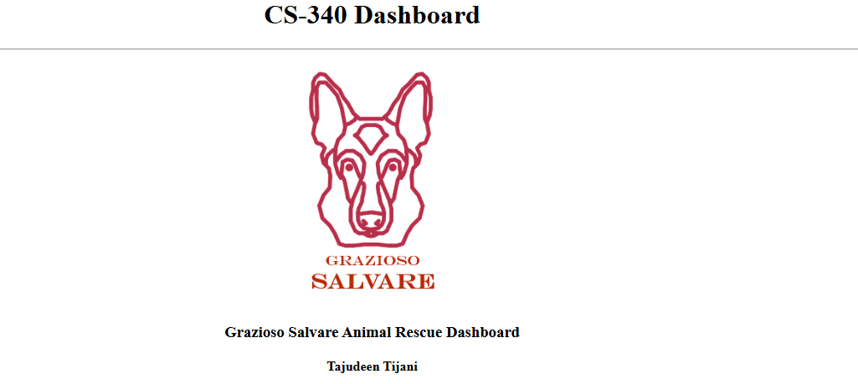
The Grazioso Salvare logo was added to the dashboard to meet the branding requirement provided in the project instructions.
I also included my unique identifier on the dashboard.
The logo and identifier are visible in the screenshots used to document the dashboard testing.
This makes the screenshots easier to associate with the completed project.

Testing and Deployment
After completing the dashboard, I tested the application in the Codio environment.
The Dash application successfully started and was accessible through the Codio Dash application URL.
I tested the dashboard in the following order:
- Starting unfiltered state
- Water Rescue
- Mountain or Wilderness Rescue
- Disaster or Individual Tracking
- Reset
For each filter, I checked the data table and visualizations to make sure they responded to the selection.
I also checked the Reset option to make sure the dashboard returned to the original state.
The screenshots in the next section provide evidence of these tests.

Dashboard Testing Screenshots

Starting State

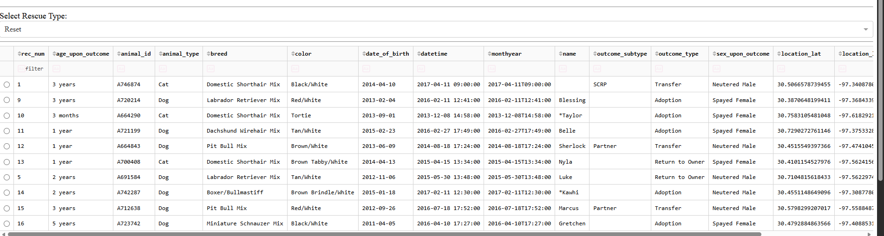

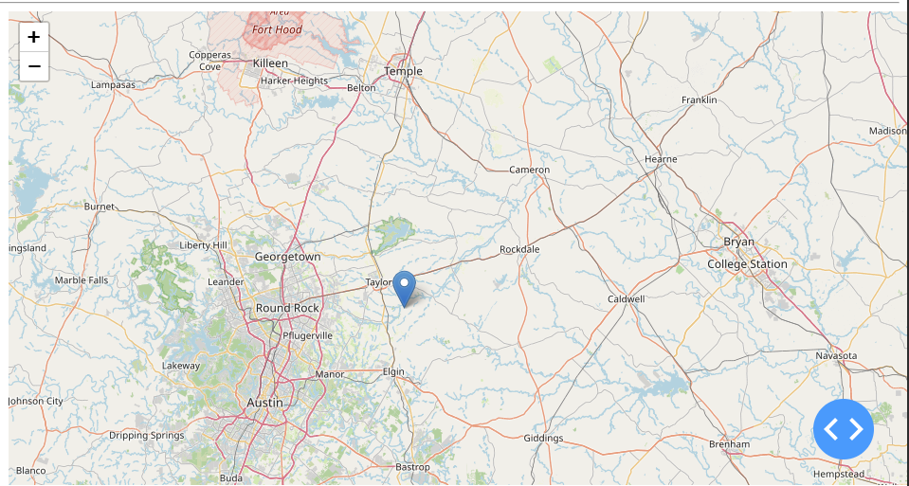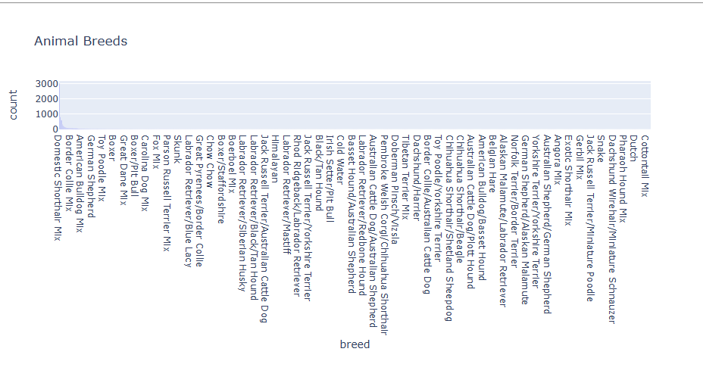Figure 5. Starting dashboard
The starting-state screenshot shows the dashboard before a rescue filter is selected. The dashboard contains the filtering controls, data table, visualizations, Grazioso Salvare logo, and unique identifier.

Water Rescue

Figure 6. Water Rescue
The Water Rescue screenshot shows the dashboard after the Water Rescue filter has been selected. The table and visualizations show the results associated with the selected filter.

Mountain or Wilderness Rescue


Figure 7. Mountain or Wilderness Rescue
This screenshot shows the dashboard after the Mountain or Wilderness Rescue filter has been selected. The dashboard components respond to the selected filtering option.

Disaster or Individual Tracking
Figure 8. Disaster or Individual Tracking
This screenshot shows the dashboard after the Disaster or Individual Tracking filter has been selected. The table and visualizations display the corresponding filtered results.

Reset
Figure 9. Reset
This screenshot shows the dashboard after Reset has been selected. The dashboard returns to the original unfiltered state.

Reproduction Instructions
The following steps explain how the project can be reproduced in the development environment.

Step 1: Prepare the Environment
Open the Codio environment used for the project.
Make sure Python, MongoDB, Jupyter Notebook/JupyterLab, and the required Python packages are available.
The project uses packages for MongoDB access, Dash, and data visualization.

Step 2: Start MongoDB
Start the MongoDB server in the development environment.
Verify that the server is running before attempting to connect to the database.

Step 3: Load the Dataset
Load the Austin Animal Center Outcomes dataset into the MongoDB database and collection used by the CRUD module.
Verify that the records were imported successfully.
The completed dataset used by this project contains 10,002 records.

Step 4: Place the Project Files in the Working Directory
The dashboard files should be available in the project directory.
The project contains:
ProjectTwoDashboard.ipynb
CRUD.py
Grazioso Salvare Logo.png
Screenshots/
The logo should be located where the dashboard code expects to find it.

Step 5: Open the Notebook
Open:
ProjectTwoDashboard.ipynb
in Jupyter Notebook or JupyterLab.

Step 6: Run the Notebook
Run the notebook cells in order.
The notebook should establish the database connection, load the necessary data, create the dashboard components, and start the Dash application.
If the notebook is restarted, the cells should be run again in the appropriate order so that all variables and components are defined.

Step 7: Open the Dashboard
After the Dash application starts, open the URL provided by the Codio environment.
Verify that the dashboard loads correctly.
The dashboard should display the Grazioso Salvare logo, unique identifier, filtering controls, table, and charts.

Step 8: Test the Filters
Select each of the required filtering options:
- Water Rescue
- Mountain or Wilderness Rescue
- Disaster or Individual Tracking
After each selection, verify that the data table and visualizations update.

Step 9: Test Reset
Select Reset.
Verify that the dashboard returns to the original unfiltered state.
Project Challenges and Solutions
One challenge during development was making sure that the different Dash components were structured correctly. Some of the dashboard code produced syntax or component errors while I was developing the application.
I worked through these problems by checking the affected sections of the notebook, correcting the code, and running the notebook again to verify the changes.
Another part that required testing was the geolocation visualization. The map needed to use the latitude and longitude information correctly so that the animal locations could be displayed. I tested the map and corrected the component setup until the locations were displayed correctly.
I also had to test the filtering functionality carefully because changing a filter needs to affect more than just the table. The visualizations also need to respond to the selected option. I tested the required rescue categories individually and checked the results after each selection.
The Reset function was tested separately to make sure that selecting it returned the dashboard to its original state.
Project Files
The final dashboard package contains the following files:
CS340_ProjectTwo_Final/
│
├── ProjectTwoDashboard.ipynb
├── CRUD.py
├── Grazioso Salvare Logo.png
│
└── Screenshots/
├── 01_Start_Unfiltered.png
├── 02_Water_Rescue.png
├── 03_Mountain_Wilderness_Rescue.png
├── 04_Disaster_Individual_Tracking.png
└── 05_Reset.png

ProjectTwoDashboard.ipynb
Contains the Python code used to create and run the dashboard.

CRUD.py
Contains the Python CRUD functionality used to communicate with MongoDB.

Grazioso Salvare Logo.png
Contains the Grazioso Salvare logo used for dashboard branding.

Screenshots
Contains the five screenshots documenting the required dashboard states.
Resources
The following resources were used or provided as part of the course project:
SNHU CS 340 Dashboard Specifications Document
The Dashboard Specifications Document was used to understand the required dashboard layout, filtering categories, and visualization requirements.
Austin Animal Center Outcomes Dataset
The Austin Animal Center Outcomes dataset was used as the source of the animal records displayed by the application.
Python PEP 8 Style Guide
The Python style guide was used as a reference for writing readable and organized Python code.
MongoDB
MongoDB was used as the database system for storing and querying the animal records.
Dash
Dash was used to create the interactive web dashboard.
Plotly
Plotly was used for the dashboard visualizations.
Conclusion
This project resulted in a working dashboard that allows Grazioso Salvare to interact with the Austin Animal Center animal records. The application uses MongoDB for data storage, the Python CRUD module for database access, and Dash for the client-facing dashboard.
The dashboard includes the required rescue filters, interactive data table, geolocation visualization, second visualization, Grazioso Salvare logo, and unique identifier.
I tested the dashboard using each of the required rescue categories and the Reset option. The testing screenshots included in this document provide evidence of the different dashboard states.
The completed project demonstrates how a database, Python application logic, and an interactive web interface can be combined to create a client/server application that makes stored data easier for users to access and understand.

