

**Spring 2021**

Assignment on

**“**Fantastic Gardens**”**

Course title: Database Management System

Assignment title: Fantastic Gardens

**Submitted to:**

***Nayeema Rahman***

Department of CIS

Daffodil international university

**Submitted by:**

**Tajil Islam Rifat**

ID : 192-16-447

6th batch, Spring-2021

**TASK1:**

1. Produce normalized Entity Relationship Diagram for the proposed database system

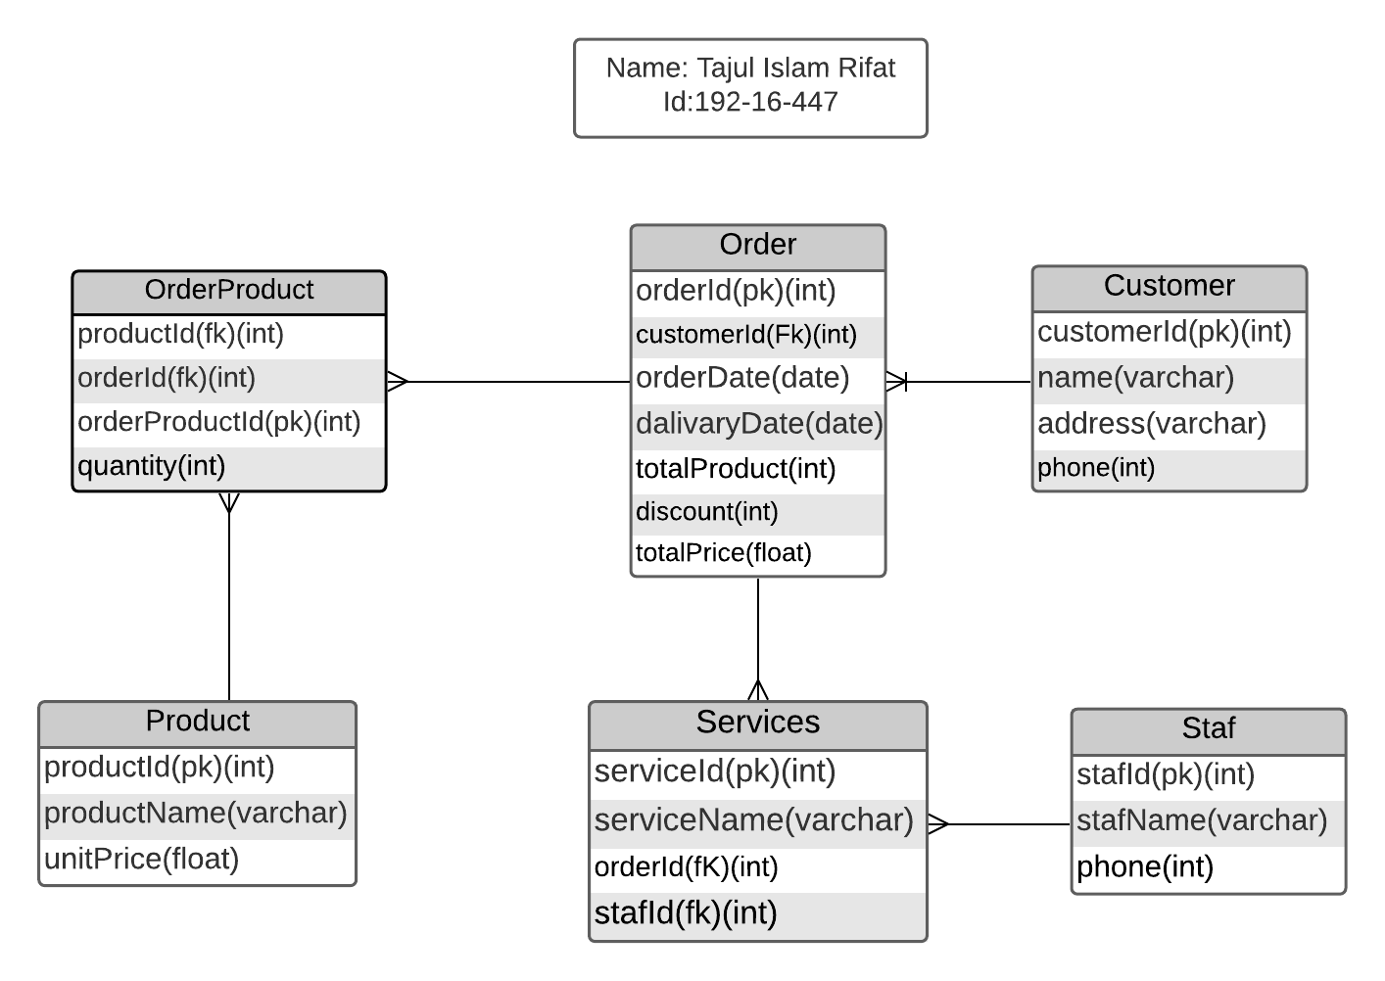

1. Design a data dictionary for the entity relationship model showing all attributes

1. Customer

|  |  |  |  |  |  |
| --- | --- | --- | --- | --- | --- |
| Attribute | Data Type | Length | Primary Key | Foreign Key | References Table |
| customerId | int | 11 | yes |  |  |
| name | varchar | 50 |  |  |  |
| address | varchar | 100 |  |  |  |
| phone | int | 12 |  |  |  |

1. Product

|  |  |  |  |  |  |
| --- | --- | --- | --- | --- | --- |
| Attribute | Data Type | Length | Primary Key | Foreign Key | References Table |
| productId | int | 6 | yes |  |  |
| productName | varchar | 100 |  |  |  |
| unitePrice | float | 10 |  |  |  |

1. Staf

|  |  |  |  |  |  |
| --- | --- | --- | --- | --- | --- |
| Attribute | Data Type | Length | Primary Key | Foreign Key | References Table |
| stafId | int | 4 | yes |  |  |
| stafName | varchar | 50 |  |  |  |
| phone | int | 12 |  |  |  |

1. Orders

|  |  |  |  |  |  |
| --- | --- | --- | --- | --- | --- |
| Attribute | Data Type | Length | Primary Key | Foreign Key | References Table |
| orderId | int | 100 | yes |  |  |
| customerId | int | 11 |  | yes | Coustomer |
| orderDate | Date |  |  |  |  |
| dalivaryDate | Date |  |  |  |  |
| totalProducts | int | 4 |  |  |  |
| discount | int | 4 |  |  |  |
| totalPrice | float | 20 |  |  |  |

5)Order Product

|  |  |  |  |  |  |
| --- | --- | --- | --- | --- | --- |
| Attribute | Data Type | Length | Primary Key | Foreign Key | References Table |
| productId | int | 6 |  | yes | Product |
| orderId | int | 100 |  | yes | Orders |
| orderProductId | int | 100 | yes |  |  |
| quantity | int | 4 |  |  |  |

1. Service

|  |  |  |  |  |  |
| --- | --- | --- | --- | --- | --- |
| Attribute | Data Type | Length | Primary Key | Foreign Key | References Table |
| serviceId | int | 4 | yes |  |  |
| serviceName | varchar | 100 |  |  |  |
| orderId | int | 100 |  | yes | Orders |
| stafId | int | 4 |  | yes | Staf |

**TASK 2:**

1. Create all the tables using SQL
2. Customer Table

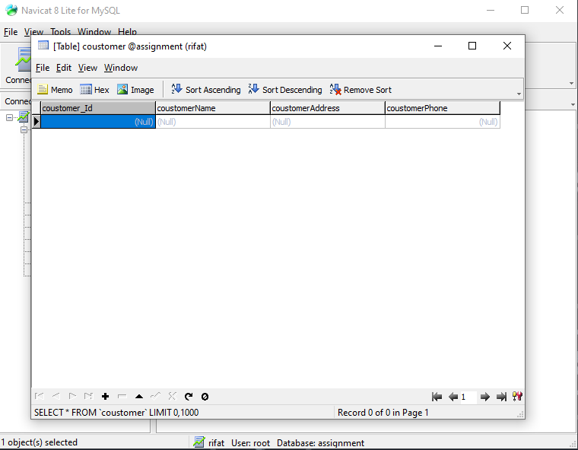

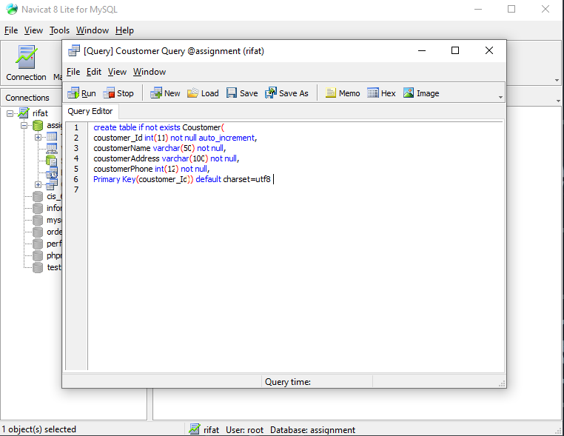

1. Orders table

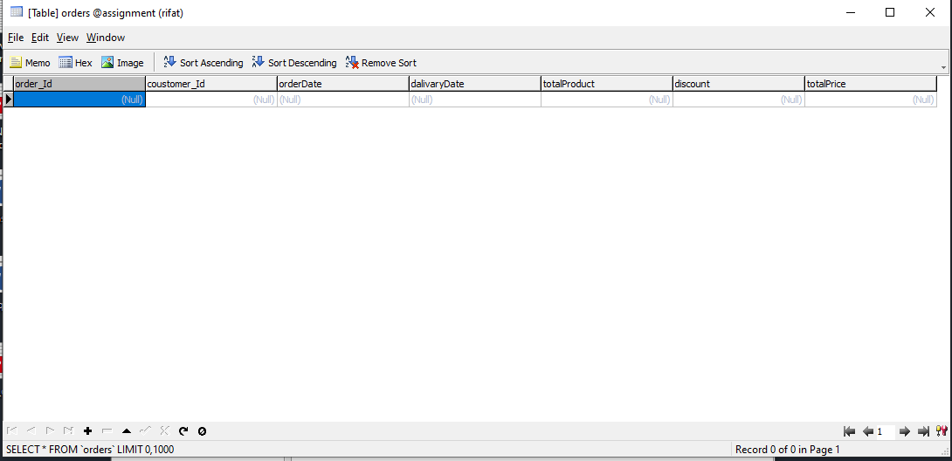

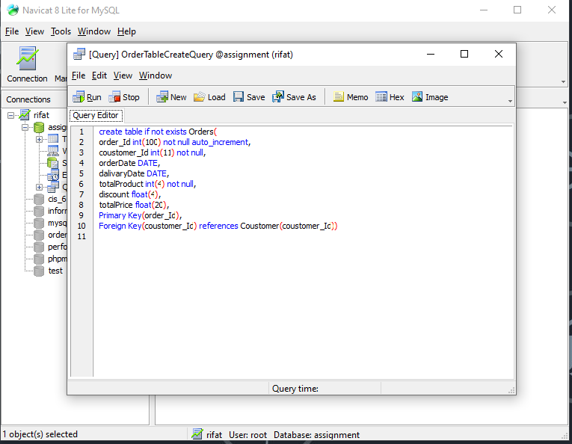

1. Order Product Table

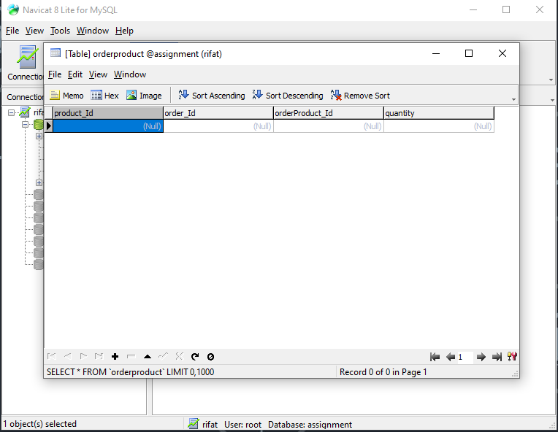

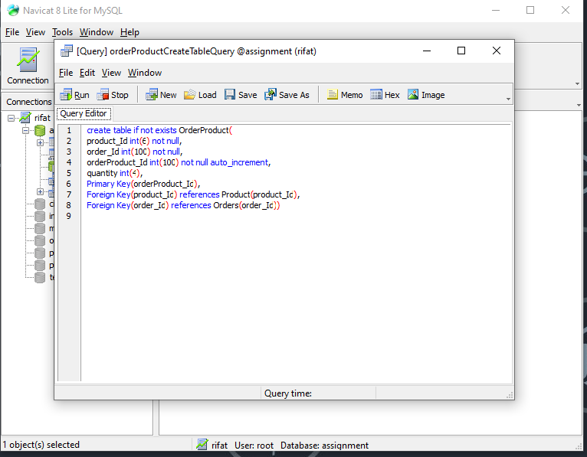

1. Product Table

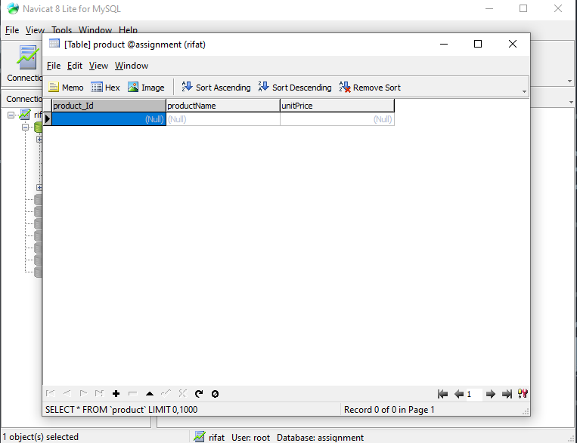

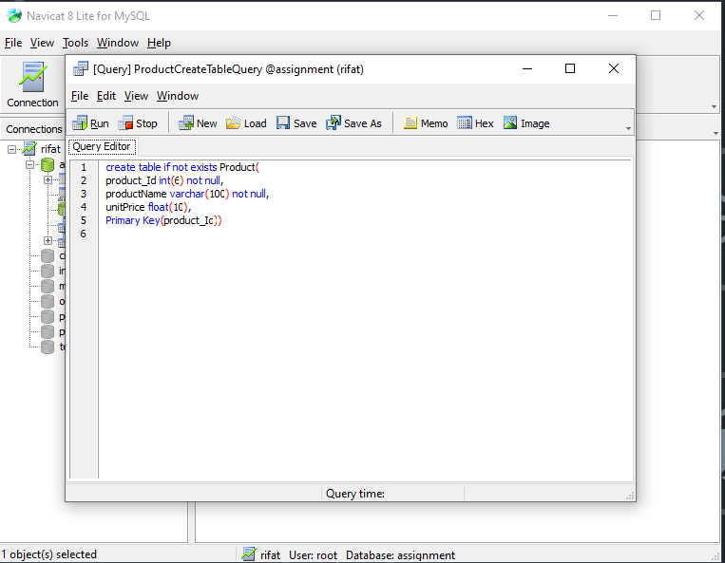

1. Service Table

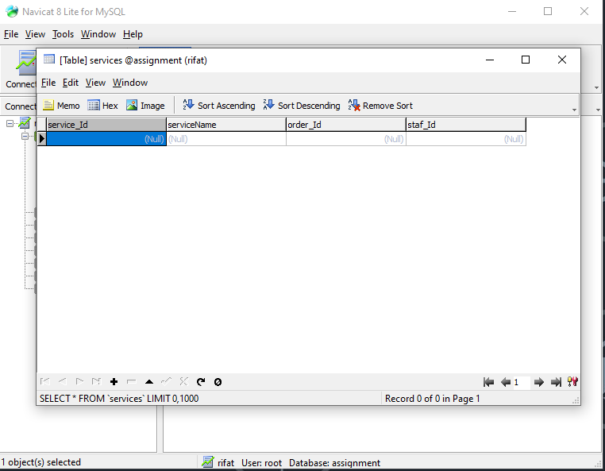

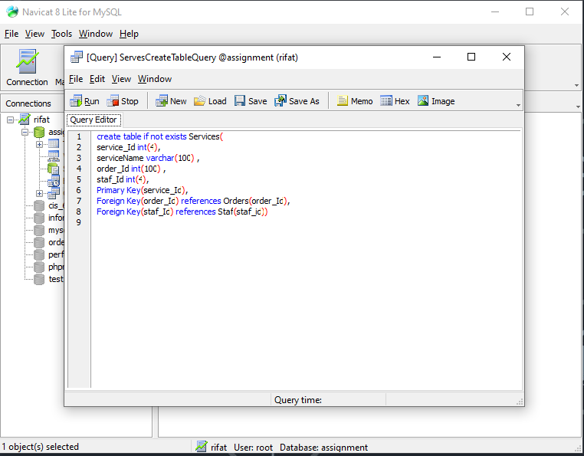

1. Staf Table

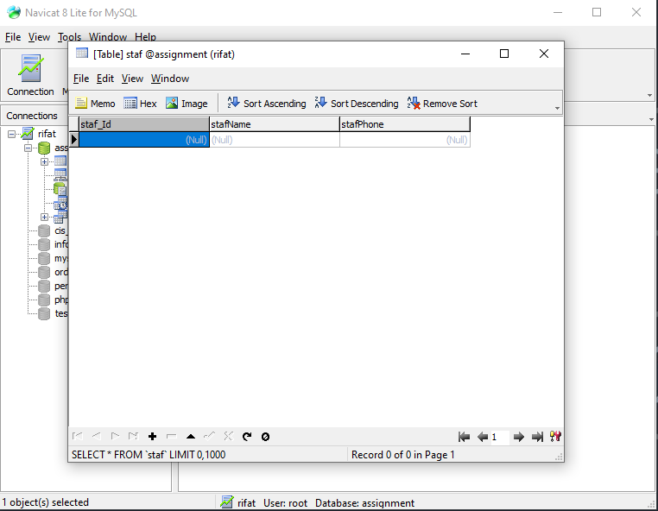

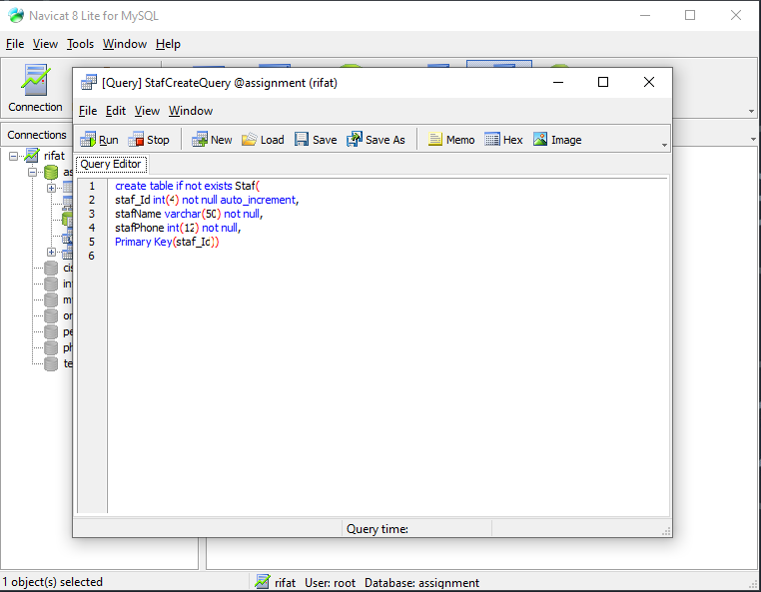

1. Enter all the data from the scenario into the tables
2. Customer Table

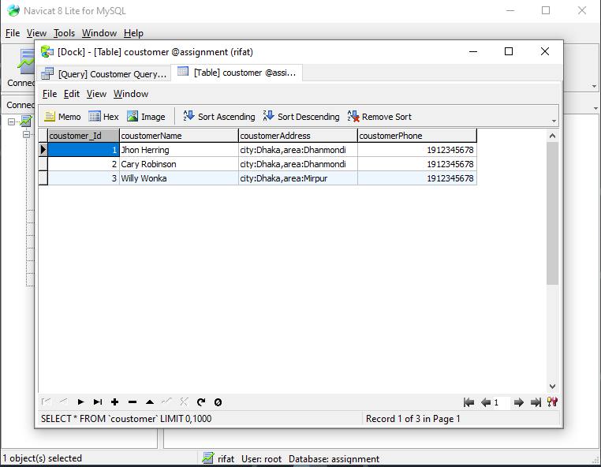

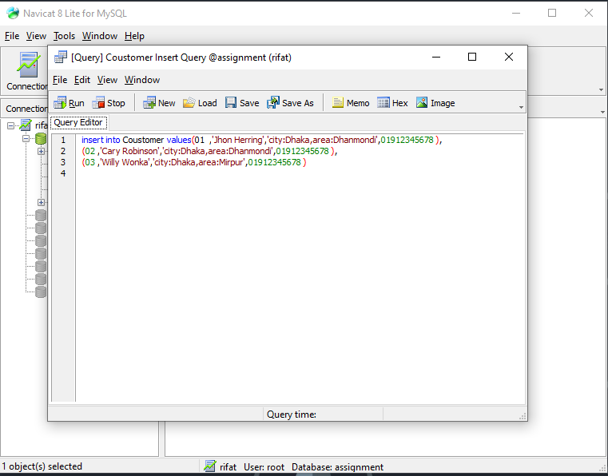

1. Orders Table

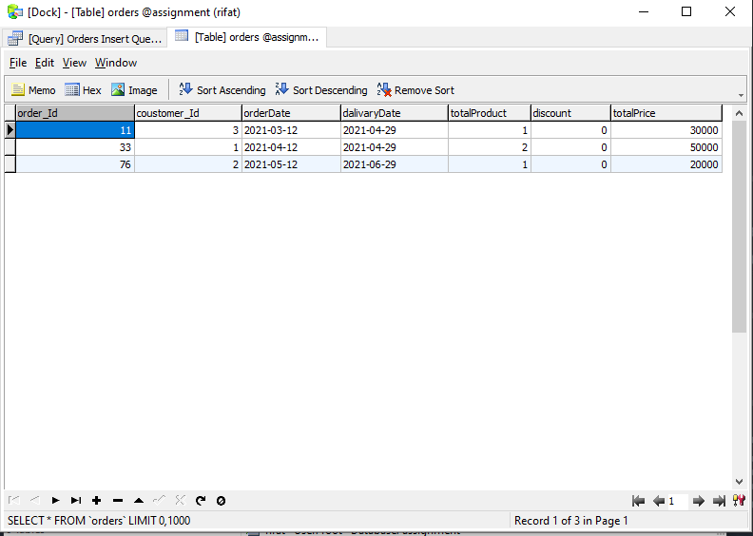

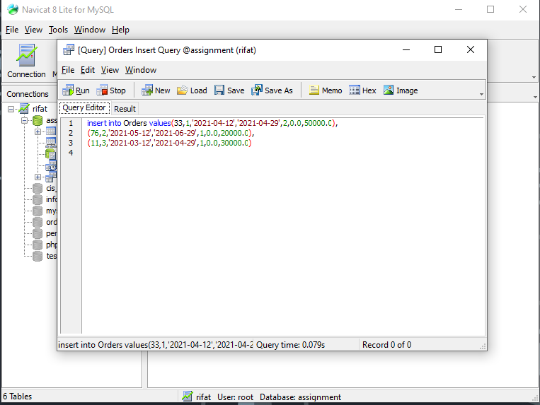

1. Order Product Table

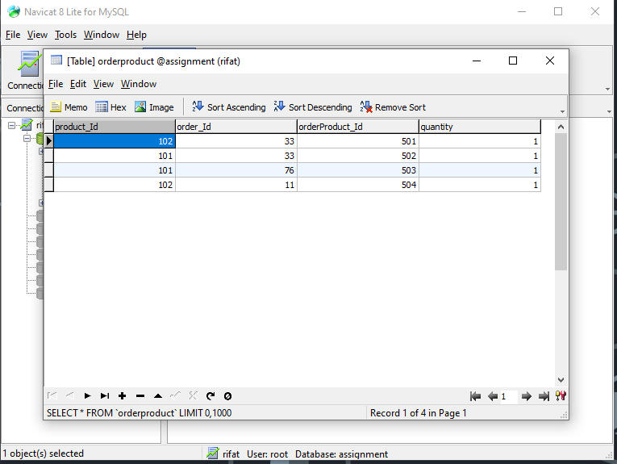

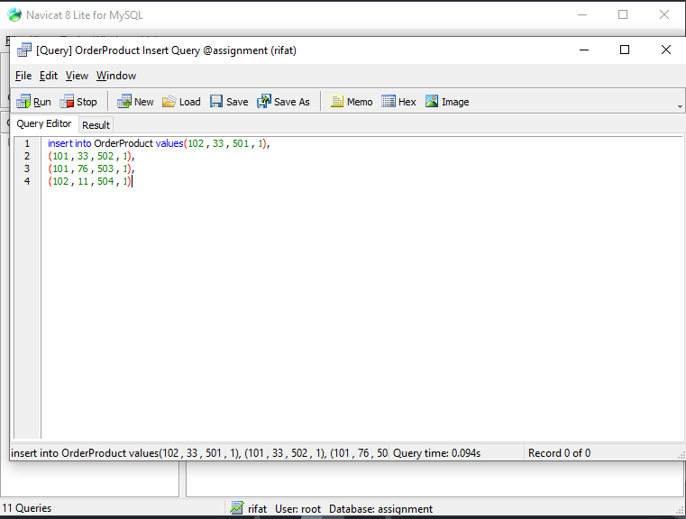

1. Product Table

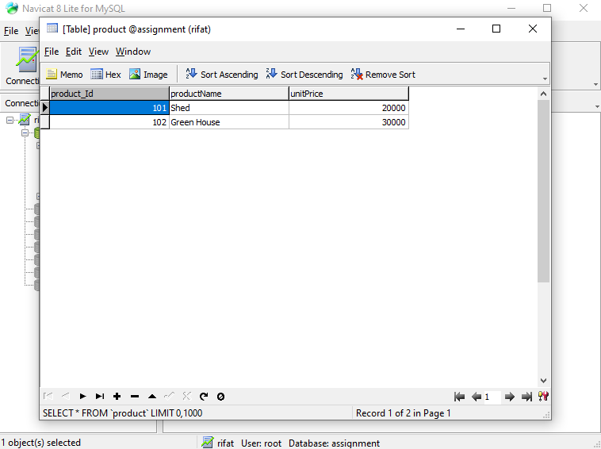

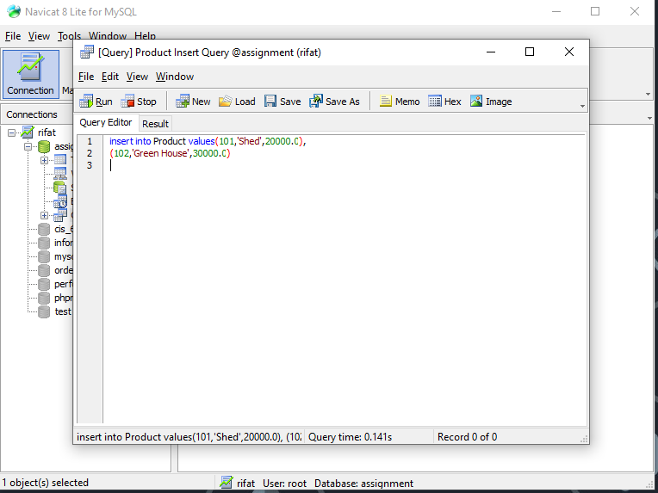

1. Services Table

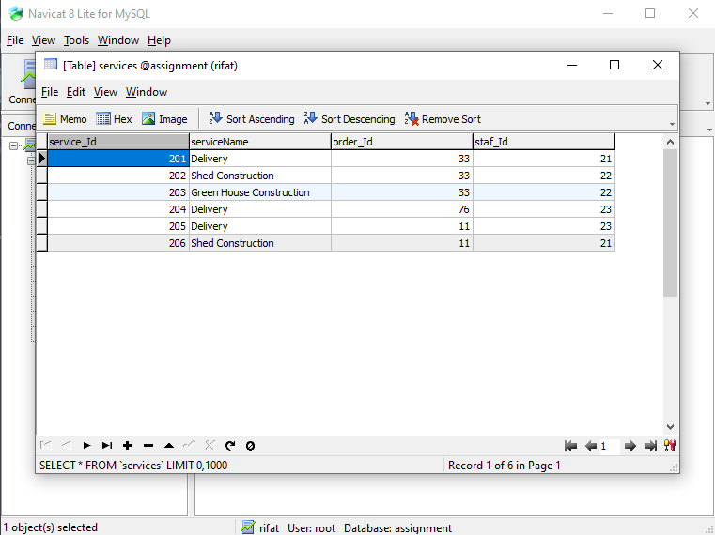

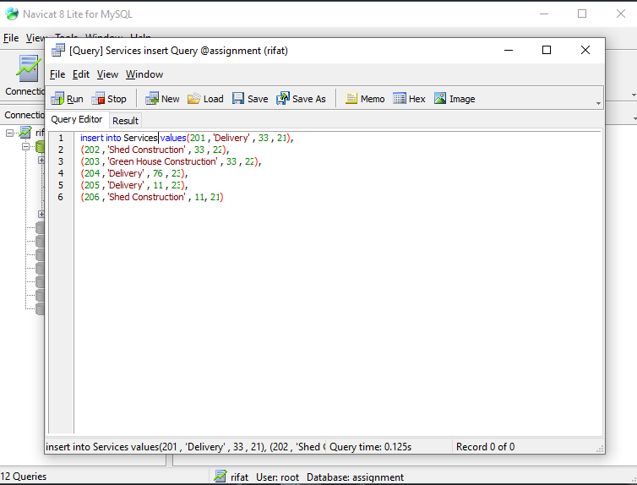

1. Staf Table

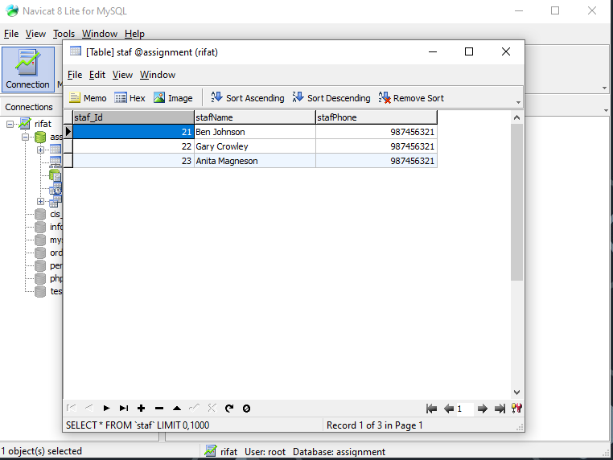

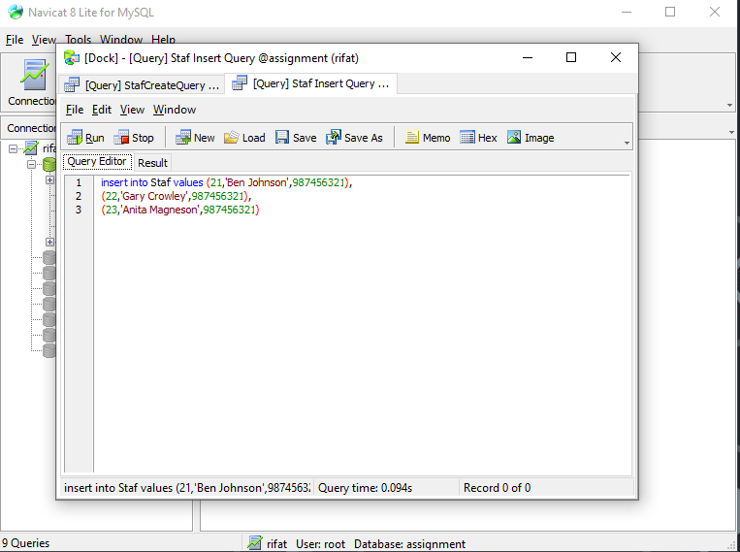

1. Update the record of staff ‘Ben Johnson’ to ‘Ben Roberts’:

* Before Update



* After Update

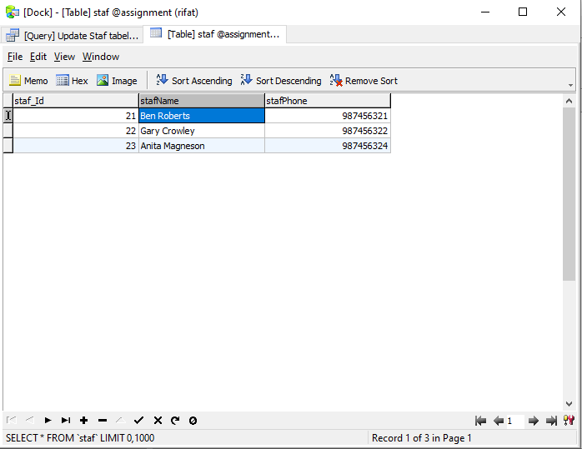

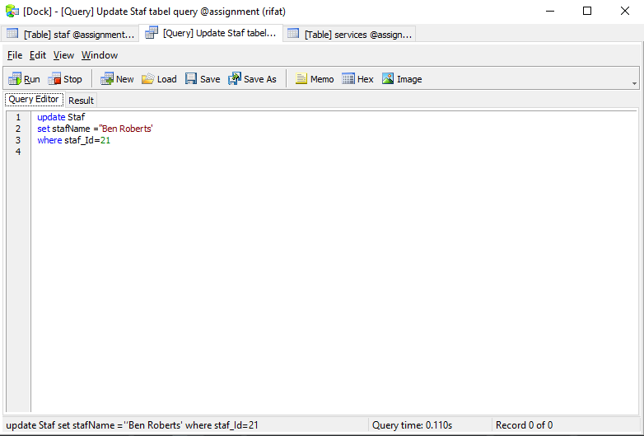

1. A query that selects all the orders of the customers

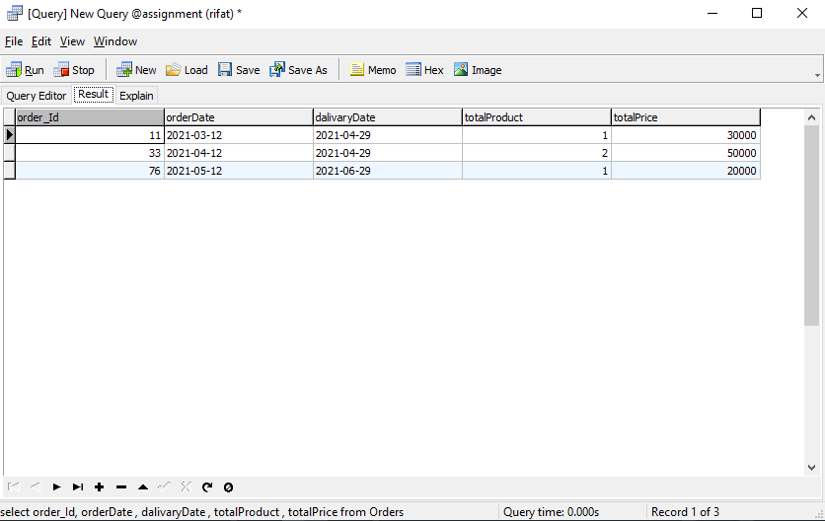

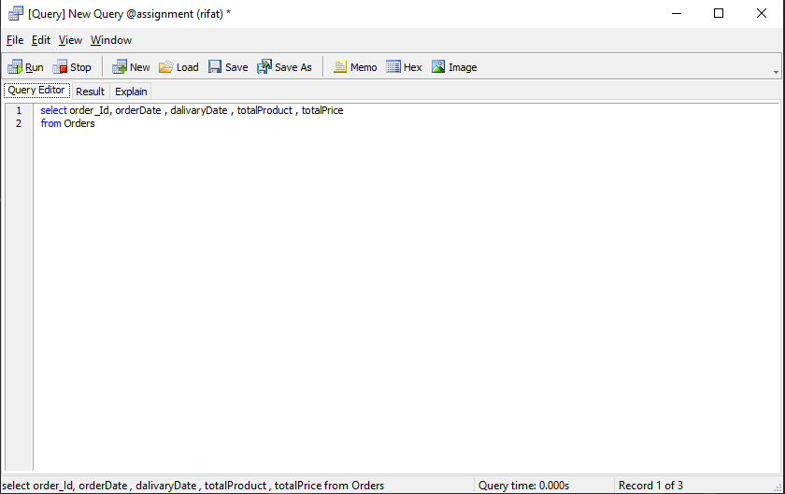

1. Selects all the services for a particular order:

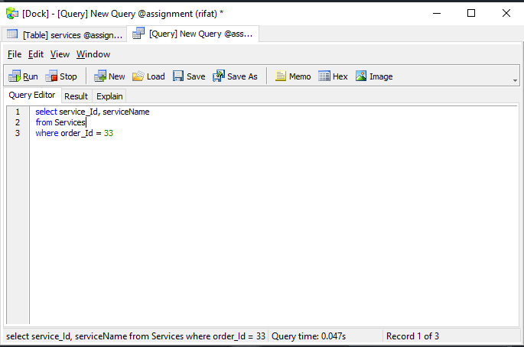

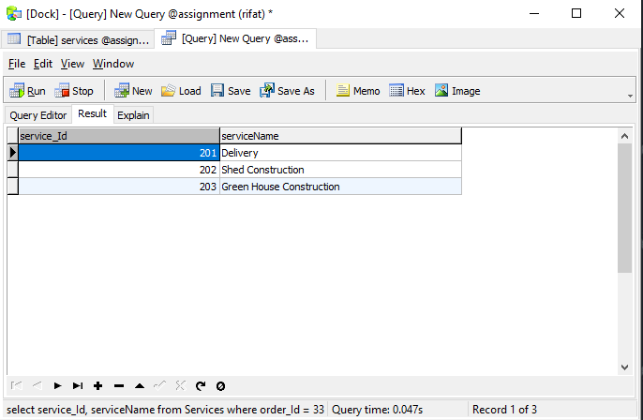

1. shows products purchased for a particular order

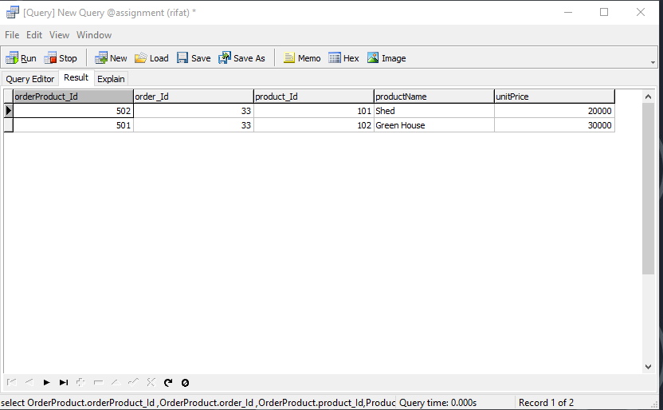

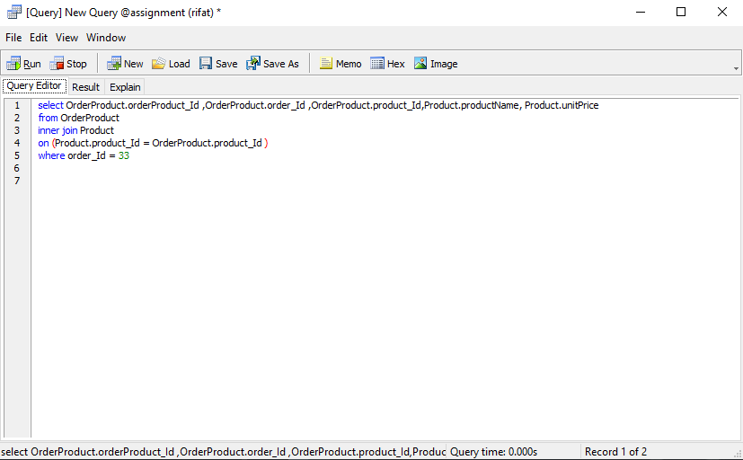

**Task 3:** Fantastic Gardens is a medium sized garden construction company. My task is to design a database for this company. There are so many information about this company and I need to use them for designing database.

In the Task one I find out all the possible entity. After that I make a relationships between them and finally I draw a ERD Diagram for the proposed database system of Fantastic Gardens.

In the second part I design a data dictionary for the entity relationship model showing all attributes, with data types and identifying primary and foreign keys this is help me when I am create table and insert data into table.

In Task two I am using SQL for creating table for Fantastic Gardens database system. Insert all the data from the scenario into the tables.

Update Staf table record of staff Ben Johnson to Ben Roberts. Then I will write some query like selects all the orders of the customers, selects all the services for a particular order and selects all the services for a particular order.

When I am try to create table for any entity. There are so many things I need to assumption made to meet the requirements. In every table need a key to be unique that is called Primary Key so I am assumption this key. There are so many attributes like customer name, customer address, order date, product price I am assuming for create a perfect database.

In future improvement we need to put some data for better experience like product price, total price, staf info , customer info. This data gives us proper information about the order , customer and staf.