- (8 points) Given the following UML Diagram:

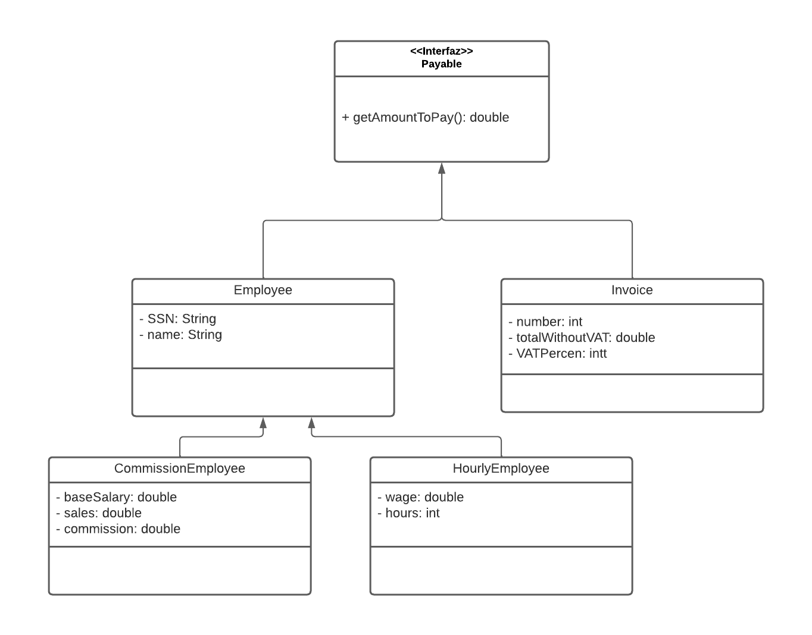

- (2 points) Implement all the classes and the interface represented in the UML diagram. Generate all the getters, setters and toStrings.
- (2 points) In another class (PlayableTester.java), create a static method with this signature.

public static double totalToPay(LinkedList <Payable> l)

the method has to add the total to pay of all the invoices (total including VAT) and salaries of all the employees. Use an Iterator to do this part.

- (2 points) In the same class create a static method with the following signature:

public static void incrementBaseSalaryOfCommissionEmployee(LinkedList <Payable> l, double percent)

this method has to increment the base salary of the commission employees in the percent that receives as a parameter

IMPORTANT: when accessing to the objects of the LinkedList, downcast only if it is necessary!!!

- (2 points) Code a main method (in PlayableTester.java) that performs the following actions:
  - creates an LinkedList of Payable type.
  - adds 10 elements to it (don’t ask for the information, insert them with literals). Insert 3 employees of each type and 4 invoices.
  - Use a ListIterator to display the contents of the List in backward direction
  - Call the two methods of parts b and c

2. (2 points) Write a program that asks some numbers (until the user types a 0) and shows these numbers the other way around (al revés) as they were introduced. Use a Stack to do this action.

