- (8 points) Given the following UML Diagram:

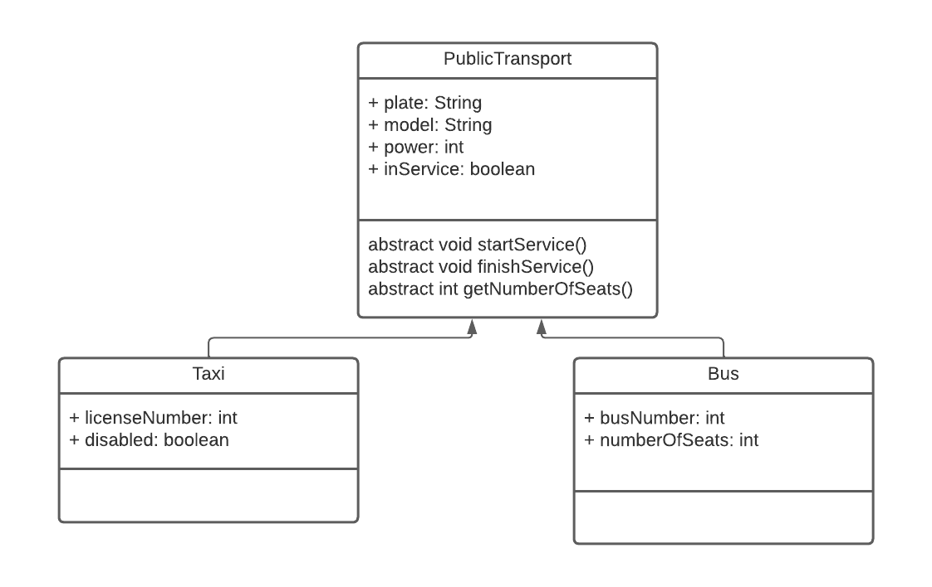
- (2 points) Implement all the classes represented in the UML diagram. The method startService has to put the atribute inService to true and display a message in the console like this “Taxi with license XXX in service now” or “Bus number XXX in service now”. And the stopService has to put the same atribute to false and show “Taxi with license XXX has finished its service” or “Bus number XXX has finished its service. The method getNumberOfSeats will return 4 in case of taxi and the atribute in case of bus.
- (2 points) In another class (PublicTransportTester), create a static method with this signature.

public static double howManySeatsInService(ArrayList <PublicTransport>l)

the method has to return the total number of seats available (in service) in the public transport.

- (2 points) In the tester class create a static method that displays the numbers of license of the taxis that are prepared for disabled people (disable to true). The header would be:

public static void taxisForDisabledPeople(ArrayList <PublicTransport>l)

IMPORTANT: when accessing to the objects of the ArrayList, downcast only if it is necessary!!!

- (2 points) Code a main method that creates an ArrayList of PublicTransport and adds 10 elements to it (don’t ask for the information, insert them with literals). Insert some Taxis and some Buses). Call the methods created in parts b and c, with that ArrayList and show total of seats in service (method b)

2. (2 points) Input 10 words and after inputing all of them, display them in the opposite order. Use an ArrayList of Strings to do it (traverse it with a ListIterator in backward direction)

