Task 15. Inheritance.

*** All the exercises MUST include a tester

- Create the class Point3D (that inherits from Point) that we did in class. Create Point3D tester

- Create the following three classes:
- Class Square (parent), that has an attribute, side and a method area.
- Class Rectangle (that inherits from Square). It adds another side and overrides the method area.
- Class Cube (that inherits from Square). It doesn’t add any attribute and it overrides the method area too.

In the tester program create an object of each class and call every method. To know which method is being run, you have to show a message at the beginning of each method area like this System.out.println(“I am the method area of the class...”).
Change the name of the method area of the class rectangle and call the method area of the object rectangle to check what method is being run.

3. Code the following UML diagram:
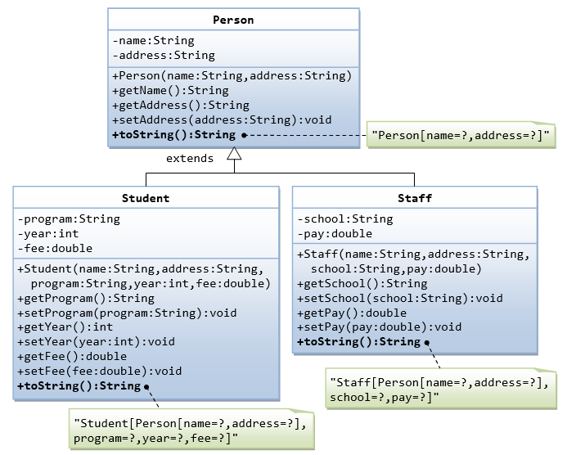

4. A better tester class for exercise 3. Create a static method that receives an ArrayList of Persons and a program:
public static int countStudentsInAProgram(ArrayList <Person> l, String program)

This method has to count the students that are in that program in the ArrayList.
5. Code this UML diagram:

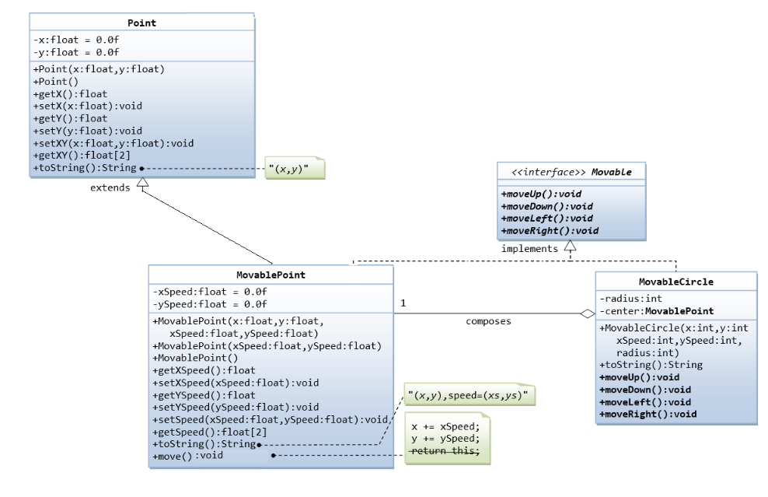

6. Abstract classes exercise
a. Write an abstract class Shape
– Data members: numSides
– Constructor: initialize numSides
– Concrete method: get method for numSides
– Abstract methods: getArea(), getPerimeter()
b. Write a concrete subclass Rectangle
– Data members: width, height
c. Write a concrete subclass Triangle
– Data members: width, height
d. In another class, write a main method to define a Rectangle and a Triangle.

7. Interfaces exercise

a. Write an interface Resizable
– Has a method void resize(double x) that resizes a Shape’s dimensions by factor x
b. Make Rectangle implement Resizable
c. Write a main method to:
- Define a Rectangle (width = 2, height = 3)
- Print the Rectangle‟s area & perimeter
- Resize the Rectangle by factor of 2
- Re-print the Rectangle‟s area & perimeter

Resizable r= new Rectangle(3,4);
Rectangle r= new Rectangle(3,4);

8. Program the following UML diagram.

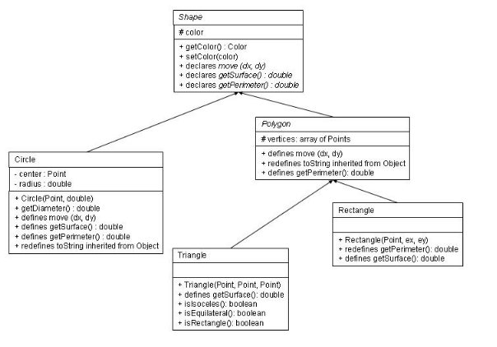

9. Given the following UML Diagram:

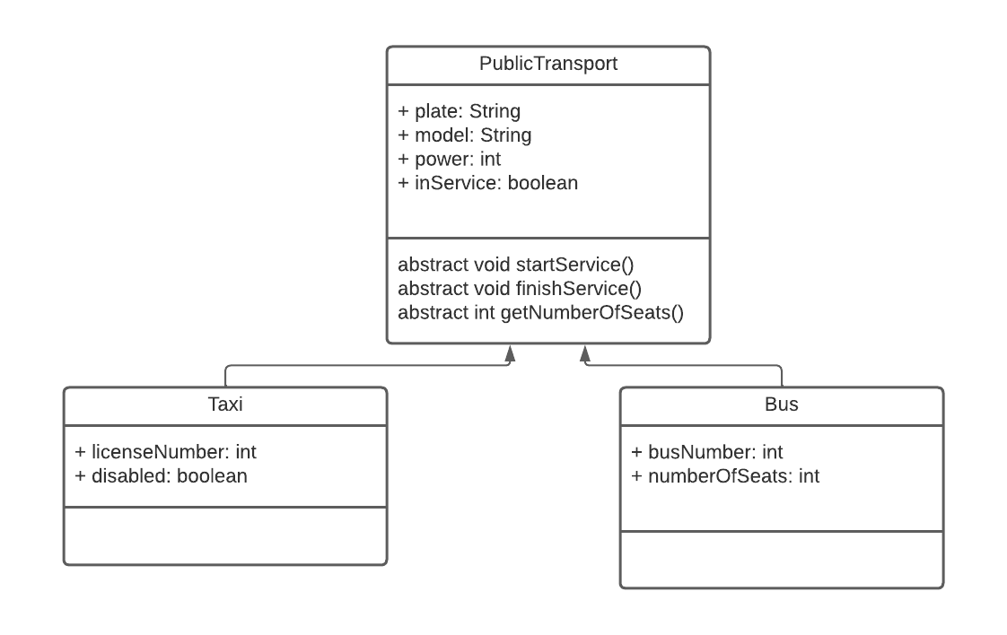
- (2 points) Implement all the classes represented in the UML diagram. The method startService has to put the atribute inService to true and display a message in the console like this “Taxi with license XXX in service now” or “Bus number XXX in service now”. And the stopService has to put the same atribute to false and show “Taxi with license XXX has finished its service” or “Bus number XXX has finished its service. The method getNumberOfSeats will return 4 in case of taxi and the atribute in case of bus.
- (2 points) In another class (PublicTransportTester), create a static method with this signature.

public static double howManySeatsInService(ArrayList <PublicTransport>l)

the method has to return the total number of seats available (in service) in the public transport.

- (2 points) In the tester class create a static method that displays the numbers of license of the taxis that are prepared for disabled people (disable to true). The header would be:

public static void taxisForDisabledPeople(ArrayList <PublicTransport>l)

IMPORTANT: when accessing to the objects of the ArrayList, downcast only if it is necessary!!!

- (2 points) Code a main method that creates an ArrayList of PublicTransport and adds 10 elements to it (don’t ask for the information, insert them with literals). Insert some Taxis and some Buses). Call the methods created in parts b and c, with that ArrayList and show total of seats in service (method b)
10, Given the following UML Diagram:

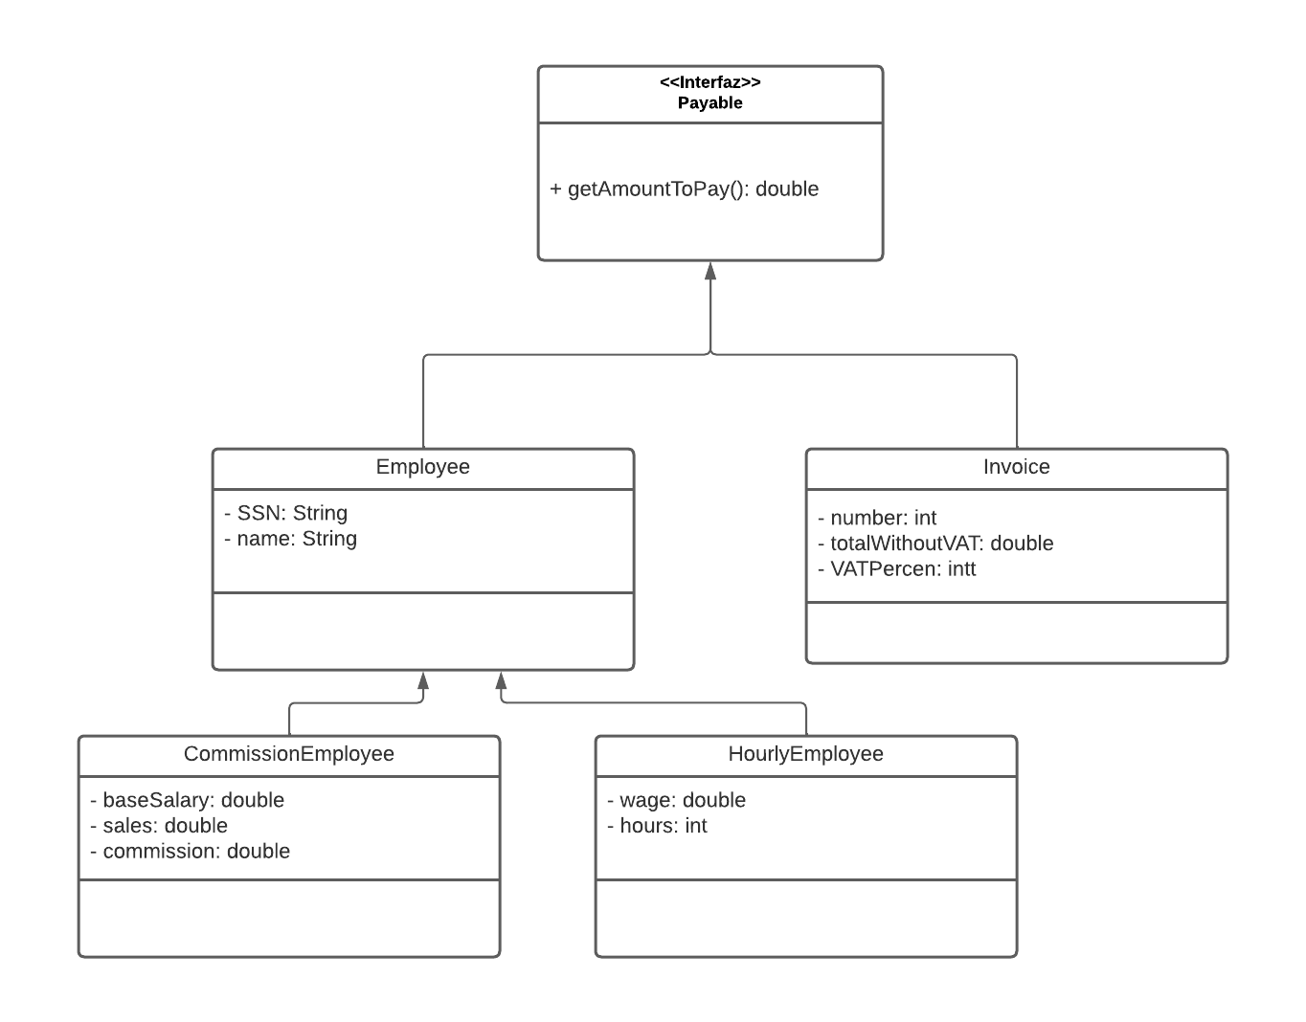

- (2 points) Implement all the classes and the interface represented in the UML diagram. Generate all the getters, setters and toStrings.
- (2 points) In another class (PlayableTester.java), create a static method with this signature.

public static double totalToPay(LinkedList <Payable> l)

the method has to add the total to pay of all the invoices (total including VAT) and salaries of all the employees. Use an Iterator to do this part.

- (2 points) In the same class create a static method with the following signature:

public static void incrementBaseSalaryOfCommissionEmployee(LinkedList <Payable> l, double percent)

this method has to increment the base salary of the commission employees in the percent that receives as a parameter

IMPORTANT: when accessing to the objects of the LinkedList, downcast only if it is necessary!!!

- (2 points) Code a main method (in PlayableTester.java) that performs the following actions:
  - creates an LinkedList of Payable type.
  - adds 10 elements to it (don’t ask for the information, insert them with literals). Insert 3 employees of each type and 4 invoices.
  - Use a ListIterator to display the contents of the List in backward direction
  - Call the two methods of parts b and c

