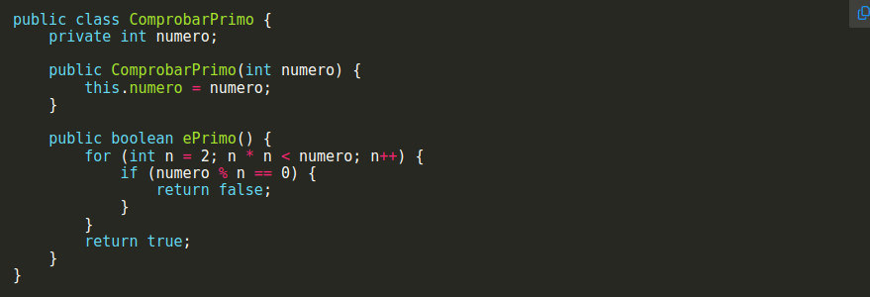
1.)
1(Default)+1(for)+1(if)

2)
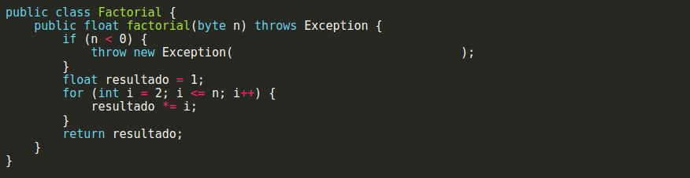
1(Default)+1(if)+1(for)

3)
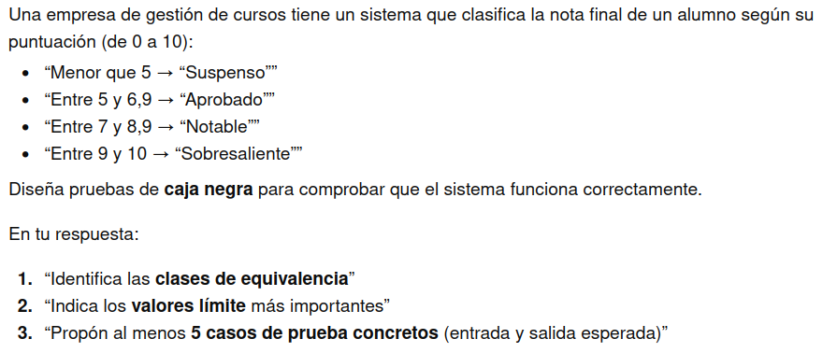
1. [0, 5)[5, 6.9][7, 8.9][9, 10]

2.
(4.9 , 5) – Fail-to-Pass limit
(6.9 , 7) – Pass-to-Notable limite
(8.9 , 9) – Notable-to-Sobresaliente limite
(0 , 10) – Edgecases

3.
2,5 – To test Fail
5 – Pass edge
6.9 – Pass-Before-Notable edge
7.5 – Notable case
10 – Sobresaliente-top-edge
-1 , 11 – Error edges
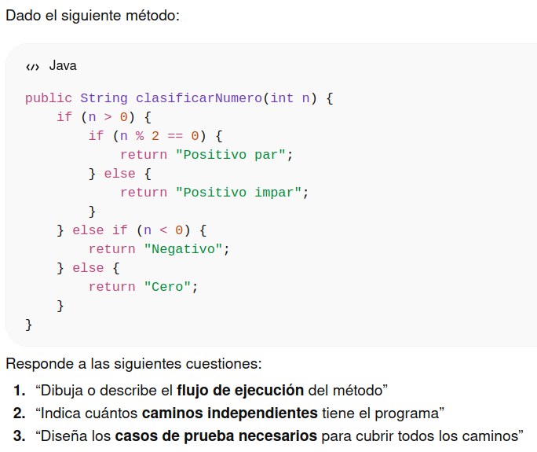
1)
1. Checks if n is higher than 0 (positive){
1.1 Checks if n is pair
}
2. Checks if n is lower than 0 (negative)

2)
Tiene 3 caminos independientes (1st IF, IF inside the 1st IF, ELSE IF)

3)
n = 0
n = 2
n = 3
n = -1

