- (4 points) We want to implement the following UML diagram:

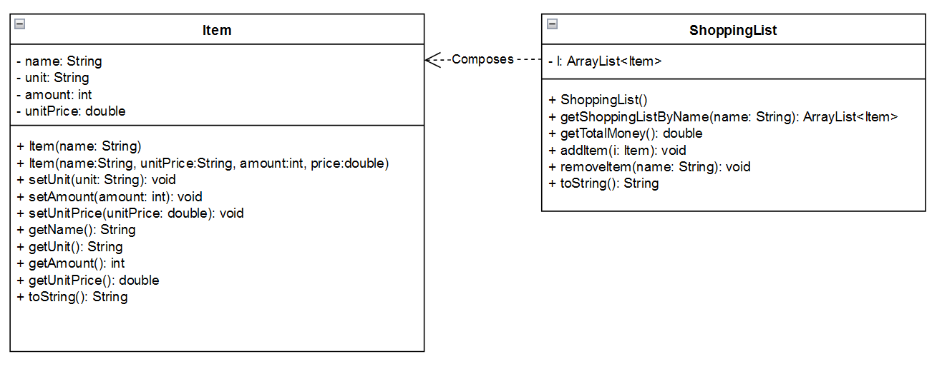
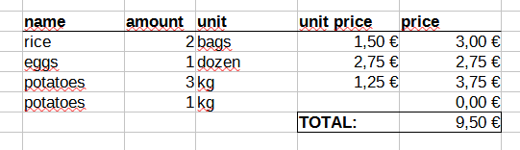

  - Item: to keep every item to be included in the ShoppingList. To create an item, the name is compulsory.
    - Item(name:String): this constructor keeps the name of the item, assigns 1 to the unit and “unit” to the attribute unit.
  - ShoppingList:
- Method getShoppingListByName(name:String): returns an ArrayList with the items in the list that have the name equal to the name received as a parameter.
- Method getTotalMoney(): returns the budget for the list, that is the total money of all the items.
- Method addItem(i: Item): adds the item that receives as a parameter.
- Method removeItem(name:String): removes the item or items (if any) that have exactly the same name that is received as a parameter.
  - ShoppingListTester: You have to test all the methods in bold (in part b of this exercise)

- (2 points) Given two variables, one of type long and another one of type Long, write one statement for each part, to do the following actions:
long num = -3568;
Long numO;
- Assign the value of variable num to variable numO by using Autoboxing or Unboxing (and say which one)
- Assign the value of variable numO to variable num by using Autoboxing or Unboxing (and say which one)
- Assign the value of variable num to variable numO without Autoboxing/Unboxing, by calling a constructor.
- Assign the value of variable num to variable numO without Autoboxing/Unboxing, by calling another method.

- Define a variable of type String called numS
- Assign the value of variable num to numS
- Assign the value of variable numO to numS

- (1,5 points) Given the following class:

class StudentSchool {
private String name;
private int rollNo;
private static String schoolName;
// static counter to set unique roll no
private static int counter = 0;

public StudentSchool(String name){
this.name = name;
this.rollNo = ++counter;
}

public static void setSchool(String name) {
schoolName = name; }

public void printStudentInfo() {
System.out.println("name : " + this.name);
System.out.println("rollNo : " + this.rollNo);
System.out.println("schoolName : " + schoolName);
}
}
class StudentSchoolTester{
public static void main(String args[]){

}
}

Implement the main method so that you create two objects of class StudentSchool, one with your name, and the other one with the name of one relative of you (mother, father, sibling…). Set the name of the school to the name of your primary school. And finally, print the info of the two students by calling the method printStudentInfo()

- (1,5 points) Write a Java method that receives a String and converts it into a charArray. Then, it has to test if it is a safe password or not. A safe password must have:
  - at least, two digits,
  - at least, one lowercase letter,
  - at least, two uppercase letters,
And it must have, at least 10 characters.

Definition isAStrongPassword(String password):boolean

You also have to write a main method to test the method, with examples that don’t fulfil the conditions and one example that it does.

- (1 point) Fill in the gaps in the text below with the most suitable term about OOP/Wrapper classes/ArrayLists. You can use the terms in the text box. There are more terms than needed.

A Wrapper class wraps (encloses) around a data type and gives it an object appearance. Wrapper classes are final and immutable. Two concepts are there in the wrapper classes namely autoboxing and unboxing.
Autoboxing is a procedure of converting a primitive value into an object of the corresponding wrapper class. For example, converting int to Integer class. The Java compiler applies autoboxing when a primitive value is:
- Passed as a parameter to a method that expects an object of the corresponding wrapper class.
- Assigned to a variable of the corresponding wrapper class.
Unboxing is a procedure of converting an object of a wrapper type to its corresponding primitive value. For example conversion of Integer to int

Encapsulation
Wrapper class
Autoboxing
ArrayList
Unboxing
int
Attribute
Method

