 | UNIVERSITI MALAYSIA SARAWAK  Faculty of Computer Science and Information Technology

Assignment/Report Cover Sheet

Student Name | Student ID Number | Group No | Signature
Mirza Muhammad Bin Munshee | 82669 | G02 | 
Robbie Samir Anak Bruno | 85556 | G02 | 
Javier Miguel Abeng | 84110 | G02 | 
Azeleen Jane Romanus | 83340 | G02 | 
Christine Yong Sze Teng | 82491 | G02 | 

Subject Code: TMA3084 |  | Subject Name : Software Engineering Lab
Assignment Title : | Software Design Specification (SDS) |  | Lecturer: | Ts. Nurfauza Jali
Due Date : 9th January 2025 |  |  | Date Submitted: 9th January 2025

This cover sheet must be completed, signed and firmly attached to the front of the submission. All work must be submitted by the due date. If an extension of work is granted, an assignment extension acknowledgement slip must be signed by the lecturer/tutor and attached to assignment. Please note that is your responsibility to retain copies of your assignment.

Plagiarism and Collusion are methods of cheating that falls under Peraturan Akademik Universiti Malaysia Sarawak para 11: Etika Akademik

Plagiarism
Plagiarism is the presentation of work which has been copied in whole or in part from another person’s work, or from any other source such as the internet, published books or periodicals without due acknowledgement given in the text.

Collusion
Collusion is the presentation of work that is the result in whole or in part of unauthorized collaboration with another person or persons.

Where there are reasonable grounds for believing that cheating has occurred, the only action that may be taken when plagiarism or collusion is detected is for the staff member not to mark the item of work and to report or refer the matter to the Dean. This may result in work being disallowed and given a fail grade or if the circumstances warrant, the matter may be referred to a Committee of inquiry for investigation. Such investigation may result in the matter being referred to the University Discipline Committee, which has the power to exclude a student.

Upon placing signature above, I certify that I have not plagiarized the work of others or participated in unauthorized collusion when preparing this assignment.

I also certify that I have taken proper case in safeguarding my work and have made all reasonable efforts to ensure that may work not be able to be copied.

MARK :
Software Design Specification
for

Wedding2U
Version <1.0>

Prepared by
Group Name: Nerds
Mirza Muhammad Bin Munshee | 82669 | 82669@siswa.unimas.my
Robbie Samir Anak Bruno | 85556 | 85556@siswa.unimas.my
Javier Miguel Abeng | 84110 | 84110@siswa.unimas.my
Azeleen Jane Romanus | 83340 | 83340@siswa.unimas.my
Christine Yong Sze Teng | 82491 | 82491@siswa.unimas.my

Instructor: | Mdm. Nurfauza bt Jali
Course: | TMA3084 Software Engineering Lab
Lab Section: | Group 2
Teaching Assistant: | Mdm. Nurfauza bt Jali
Date: | 9th January 2025

Contents
Assignment/Report Cover Sheet 1
1. Introduction 1
1.1 Purpose 1
1.2 System Overview 1
1.3 Definitions, Acronyms and Abbreviations 2
1.4 Supporting Materials 2
1.5 Document Overview 2
2. Architecture 3
2.1 Overview 3
2.2 System Component 4
2.2.1 General Interface 4
2.2.2 Client Interface 5
2.2.3 Guest Interface 5
2.2.4 Vendor Interface 5
2.2.5 Admin Interface 5
2.2.6 Sign Up 5
2.2.7 Sign In 5
2.2.8 Continue as guest 5
2.2.9 User Profile 6
2.2.10 Venue Catalog 6
2.2.11 Venue Booking 6
2.2.12 Wedding Plan 6
2.2.13 Vendor Catalog 6
2.2.14 Client Posts and Reviews 6
2.2.15 Wedding2U Database 7
3. High Level Design 8
3.1 View / Model Component 1..n 9
Appendix A – Group Log 17

Revisions
Version | Primary Author(s) | Description of Version | Date Completed

Introduction

1.1 Purpose
The purpose of this document is to outline the design specifications for the Wedding2U mobile application. Building upon the requirements identified in the Software Requirements Specification (SRS), this document provides a detailed description of the system architecture, components and design considerations to guide the development process and ensure alignment with the client’s needs and expectations.

1.2 System Overview
Below is the diagram illustrating the 3-tier architecture of the Wedding2U mobile application:
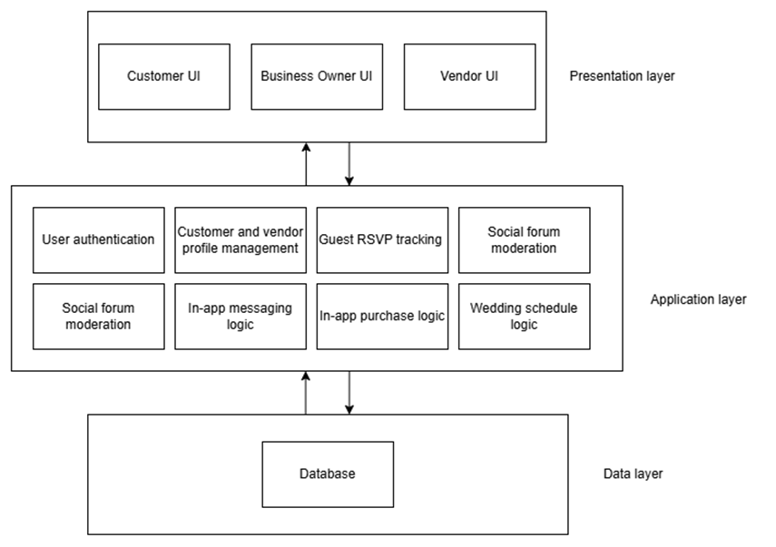
Figure 1: Wedding2U 3-Tier Architecture
The system is structured using a 3-tier architecture to ensure modularity, scalability, and security. The Presentation Layer acts as the user interface, tailored for different user roles (customers, vendors, and administrators) with features such as the venue catalog, guest RSVP, and in-app messaging. The Application Layer contains the core business logic, managing functionalities like user authentication, vendor management and real-time RSVP tracking. The Data Later securely stores essential data, including user profiles, wedding schedules, and vendor portfolios, ensuring efficient retrieval and updates.
This architecture promotes ease of development and maintenance by separating responsibilities into distinct layers. It enables the integration of new features, secure handling of sensitive information, and iterative development, supporting the Agile methodology adopted for the project.

1.3 Definitions, Acronyms and Abbreviations
Acronyms and Abbreviation
- · HLD – High-Level Design

1.4 Supporting Materials
In general, this document follows the IEEE formatting requirement. Formatting requirements involves the document to be in Arial Font to be in size 11, singled spaced and 1” margins at all sides. Bold letters indicate the main topic and the subtopic for ease of readability of topics desired. All the diagrams and figures included in this document are numbered accordingly in order and a short description is provided where necessary.

1.5 Document Overview
This Software Design Specification (SDS) pertains specifically to the design process of the Wedding2U mobile application. The document is organized into four sections: Introduction, System Overview, Design Details, and Appendix.
- The Introduction provides a concise overview of the SDS, outlining its purpose and the rationale for creating the document.
- The System Overview section outlines the top-level design of the application, including the system’s architecture and a general explanation of its functionality.
- The Design Details section elaborates on the elements covered in the System Overview, including component design, data design, and interface design, offering in-depth descriptions of key modules like the venue catalog, in-app messaging, and customizable wedding schedules.
- The Appendix includes meeting minutes, task allocation records, and other supporting materials that reflect the team’s collaborative efforts during the design process.
While we recommend reading the SDS in its entirety for a comprehensive understanding, we suggest that stakeholders focus on the Introduction, System Overview, and Design Details sections to gain a clear understanding of the application’s design and functionality.

Architecture
This section provides the top-level design view of the system and serves as a foundation for the more detailed design work. A high level overview of the Wedding2U application is represented by the Component Diagram, which illustrates the key system components, their interactions, and how they collaborate to achieve the system’s overall functionality. The subsequent section will detail the Component Diagram and provide description for each system component and their roles in the system.
The Wedding2U system follows the 3-tier architecture, which consists of the presentation, application and data layer. Hence, the system components are categorised based on the layer to which it belongs in the architecture. This ensures a clear separation of concerns, improving maintainability and scalability.

2.1 Overview
Figure 2 shows the component diagram for the Wedding2U application:
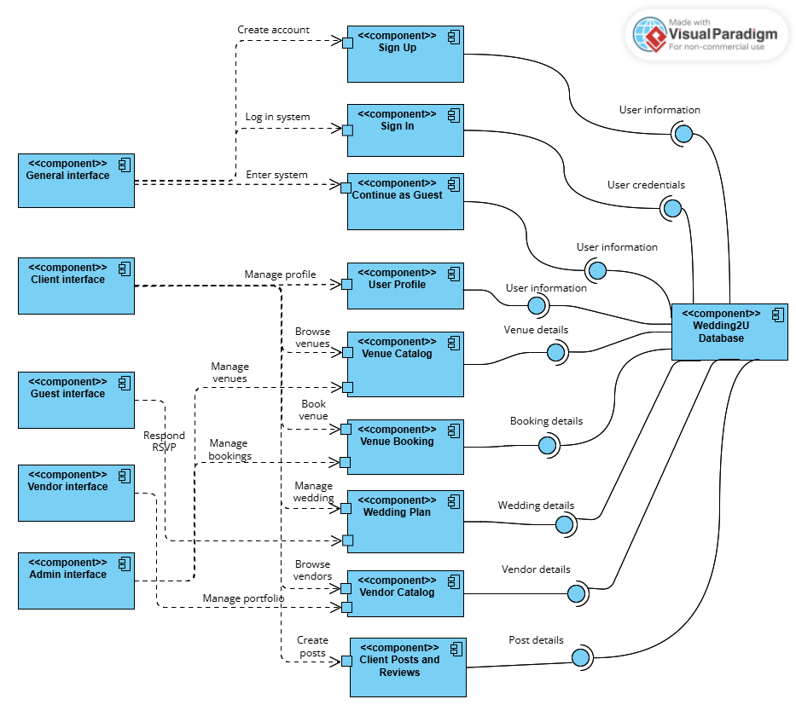
Figure 2: Component Diagram for Wedding2U Application
As observed in Figure 2, the system components are arranged based on the architecture layer it belongs to. The left side of the component diagram consists of the system components from the presentation layer, which includes the general, client, guest, vendor and admin interface. This layer is implemented using Flutter SDK. The middle part of the diagram consists of system components from the application layer, which includes sign up, sign in, continue as guest, user profile, venue catalog, venue booking, wedding plan, vendor catalog and client posts and reviews. This layer is implemented using the Dart language. Lastly, the right side of the diagram consists of the system component from the data layer, which is the Wedding2U database. The database used is Firebase Firestore for handling system data and Firebase authentication for handling the app’s user authentication.

Table 1 below shows a summary of the components of Wedding2U Application based on their architecture layer:
Column | Architecture layer | Component
Left | Presentation | - General interface  - Client interface  - Guest interface  - Vendor interface  - Admin interface
Middle | Application | - Sign up  - Sign in  - Continue as guest  - User profile  - Venue catalog  - Venue booking  - Wedding plan  - Vendor catalog  - Client posts and reviews
Right | Data | - Wedding2U database

Table 1: Components of the Wedding2U Application

2.2 System Component

2.2.1 General Interface
The general interface allows all users to access the sign up, sign in and continue as guest feature. Upon signing in successfully into the system, the user will enter their specific interface such as the client, guest, vendor and admin interface according to their role to ensure they can only access role-specific features.

2.2.2 Client Interface
The client interface is accessible by client users. It contains client features such as browse venue catalog, book venues, manage wedding plan and browse vendor catalog.

2.2.3 Guest Interface
The guest interface is accessible by guest users. It requires the user to enter their phone number and the correct wedding invitation code that they received from the client user. If the phone number entered exists in the guest list of the client’s wedding plan and the wedding invitation code entered belongs to the client’s wedding plan, the guest is granted access to respond to their wedding RSVP and view the wedding details, including the wedding tentative, wedding countdown, and guest list.

2.2.4 Vendor Interface
The vendor interface is accessible by vendor users. It contains vendor features such as managing their portfolio.

2.2.5 Admin Interface
The admin interface is accessible by admin users. It contains admin features such as managing venue catalog and venue bookings.

2.2.6 Sign Up
The sign-up feature allows users to create role-specific accounts such as client and vendor accounts. To register for an account, users are required to provide their name, email address, phone number, and password.

2.2.7 Sign In
Users can sign in and enter the system by providing the correct email and password as their user credentials. The system will ensure security by validating the user credentials and only authorise entry into the system for correct credentials entered.

2.2.8 Continue as guest
Guest users can proceed to enter the system without creating an account in the system, but will have to provide their phone number and the correct wedding invitation code that they received from the client in order to respond to the wedding RSVP and access the wedding plan of the client.

2.2.9 User Profile
Clients can manage their profile by updating their profile information, such as their phone number, location, and their social media links.

2.2.10 Venue Catalog
Clients can browse a catalog of wedding venues with detailed descriptions and images. They can also use the search functionality to look for a specific venue. For administrators, they are able to manage the venue listings via adding new venues, editing existing venue details and deleting venues.

2.2.11 Venue Booking
The venue booking feature enables clients to book venues directly through the app, receiving confirmation notifications upon successful booking. Meanwhile, administrators are able to manage the client’s venue booking by approving or declining the bookings.

2.2.12 Wedding Plan
The Wedding Plan feature enables clients to manage their wedding event through customisable wedding tentative, wedding countdown, guest list and RSVP management and checklist feature. Inside the guest list and RSVP management, clients are able to share their invitation code to guests to invite them into their wedding plan. For guests, they are able to respond to RSVP invitations directly through the app, indicating their attendance status. After accepting the RSVP, they can view the details of the client’s wedding plan.

2.2.13 Vendor Catalog
Clients can explore vendor portfolios, according to the type of service provided by the vendor. They can view the service description, ratings and reviews, and directly contact vendors for services. This streamlined process facilitates informed decision-making. Clients can also use the search functionality to search for a specific vendor. For vendors, they are able to manage their portfolio by adding and editing their portfolio details such as their service description.

2.2.14 Client Posts and Reviews
Clients can share posts about their wedding experiences and leave reviews for vendors and venues. These reviews contribute to the system’s credibility and provide valuable feedback to service providers.

2.2.15 Wedding2U Database
The Wedding2U database is the core data repository that will store and manage all application data. Firebase Firestore, a cloud NoSQL database, is used for handling system data. Meanwhile, Firebase authentication is used for user authentication and storing user credentials securely.

High Level Design
High-Level Design (HLD) aims to give what is needed in-depth description in order to represent an appropriate model. It can be used as a reference guide to understand how the different parts work together and is intended to assist with operational requirements. Furthermore, HLD is a technical visual representation of the information flow between assets or components and the functional requirements. The Wedding2U mobile application system flow will be summarised using a Statechart diagram.

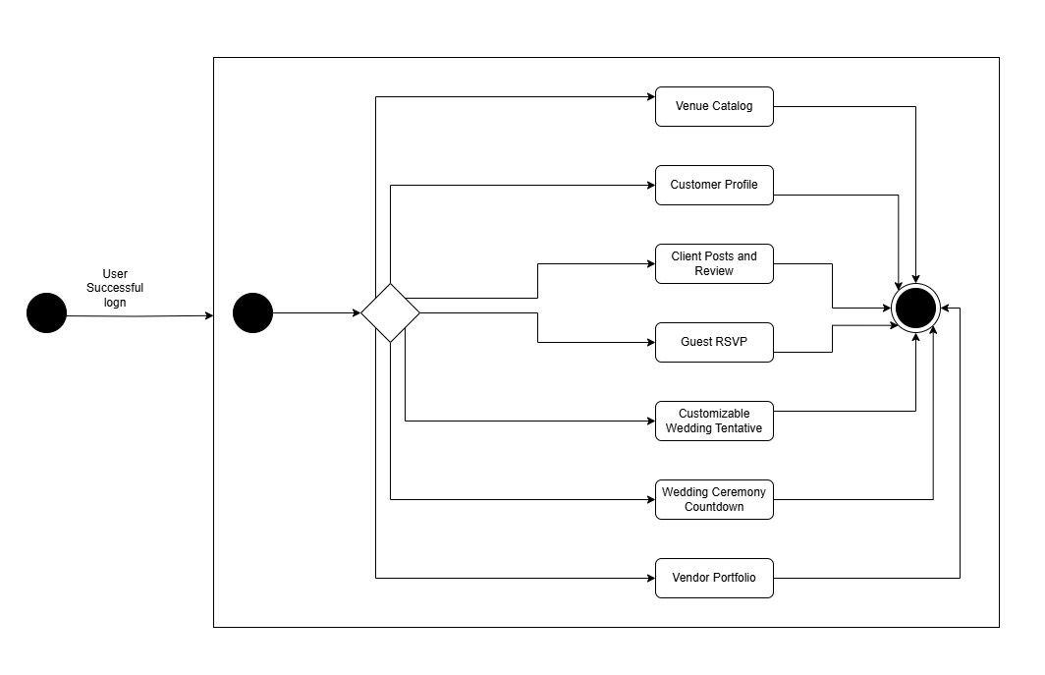
Figure 3: State Chart overview
When user has successfully login into the Wedding2U mobile application, users are able to make decision:

1. Users can view venue catalog and booking.
2. Users can manage the customer profile.
3. Users can view and manage client posts and reviews.
4. Users can manage guest RSVP.
5. Users can manage customizable wedding tentative.
6. Users can manage wedding ceremony countdown.
7. Users can view vendor portfolio.

3.1 View / Model Component 1..n
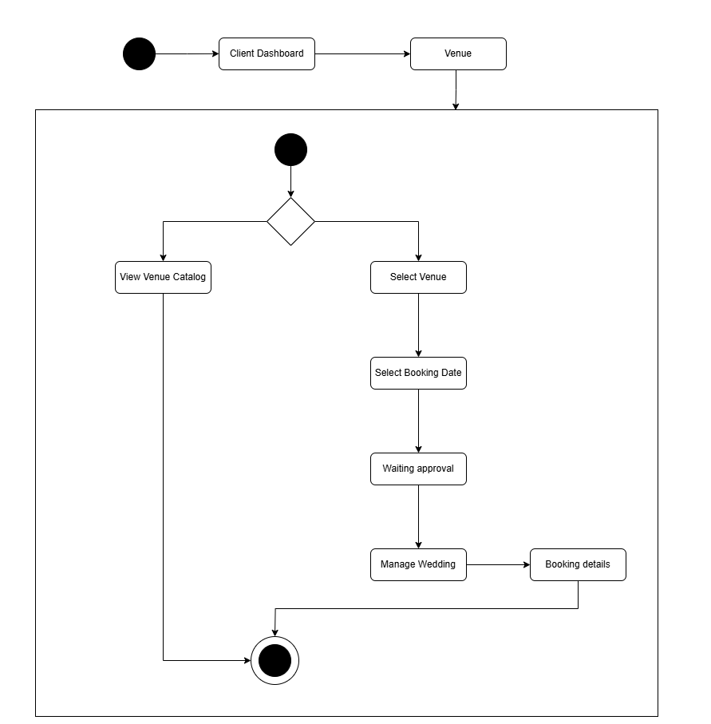
Figure 4: State Chart Diagram for Venue Catalog and Booking

In the event of a client successfully accessing the system’s dashboard, the client can select the venue and browse for the venue catalog and proceed to booking. That are a few events can be triggered:
1. Client can browse venue catalog and select venue.
2. Once a client has selected the venue, they can select the booking date for the actual day.
3. After selecting the booking date, the system will show the booking is sent and notify the admin for booking approval.
4. Client can view the booking details on the manage wedding section.

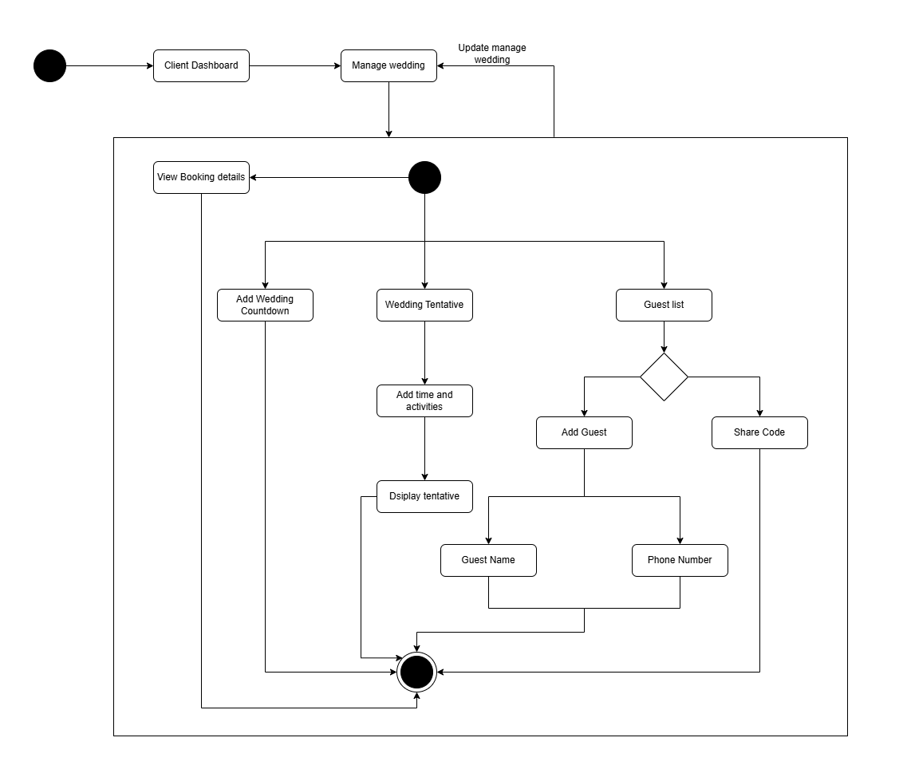
Figure 5: State Chart Diagram for Manage Wedding

In the event of a client successfully accessing the system’s dashboard, the client can the manage wedding to meet their requirements. That are a few events can be triggered:
1. Clients can view booking details to see the approval from the admin.
2. Clients can add the wedding countdown.
3. Clients can update the wedding tentative by entering the time and activities.
4. Clients can manage the guest lists.
5. Clients can add guests by entering the guest name and phone number.
6. Client can share codes to the guests.

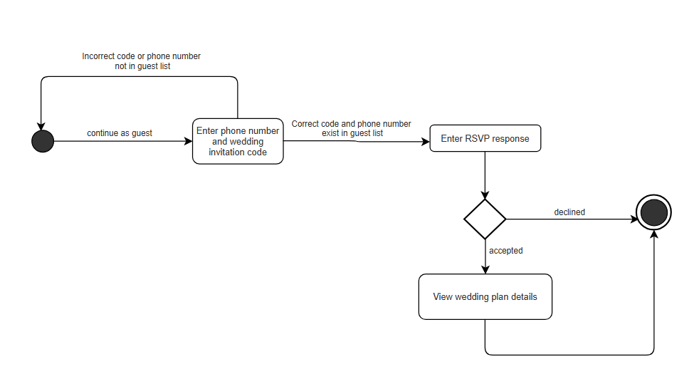
Figure 6: State Chart Diagram for Guest RSVP
When a guest interacts with the Guest RSVP system, they are able to make decisions:
- Guests can enter their phone number and wedding invitation code to verify their details.
- Guests with incorrect phone numbers or invitation codes are prompted to re-enter correct information.
- Guests with valid details can proceed to respond to the RSVP by accepting or declining the invitation.
- Guests who accept the RSVP can view wedding plan details.
- Guests who decline will exit the system.

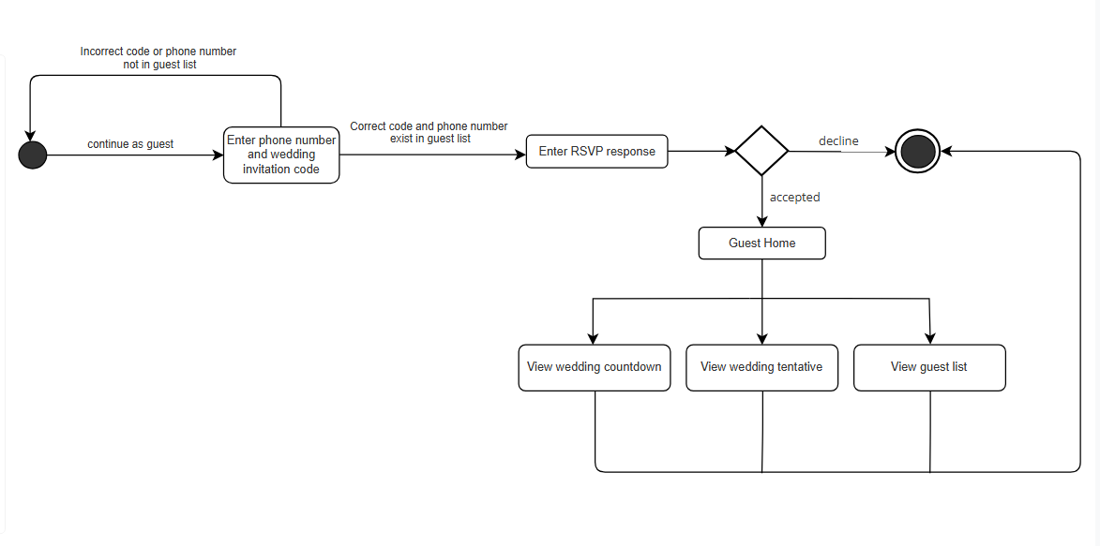Figure 7: State Chart Diagram for Guest View Wedding Plan Details
When a guest accepts a wedding invitation and successfully accesses the Guest Home, the guest can interact with the wedding details. There are a few events that can be triggered:
- View Wedding Countdown
Guests can view a countdown timer to the wedding day to keep track of the remaining time.
- View Wedding Tentative
Guests can access the detailed wedding itinerary, including schedules and planned activities for the event.
- View Guest List
Guests can browse the list of other attendees invited to the wedding.
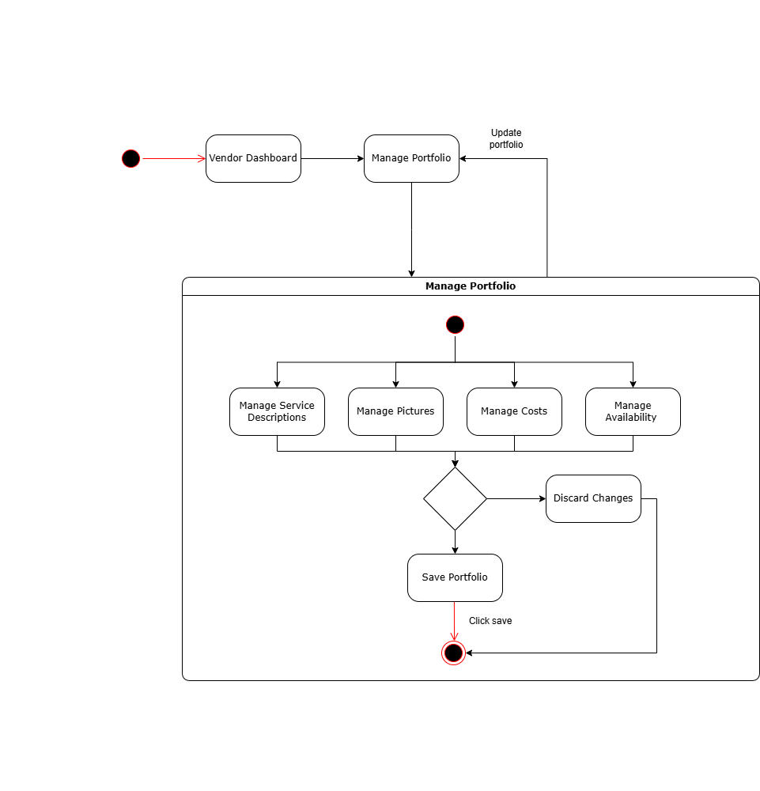
Figure 8: State Chart Diagram for Vendor Edit Portfolio
When a vendor interacts with the Vendor Portfolio system:
- Vendors login and navigate to the "Manage Portfolio" section.
- Within the portfolio management process, vendors can manage service descriptions, upload pictures, update costs, and set availability.
- Vendors can choose to save their updates or discard changes.
- Once saved, the portfolio becomes accessible for clients to browse.
- Clients can view vendor profiles, bookmark them, or directly contact the vendors.

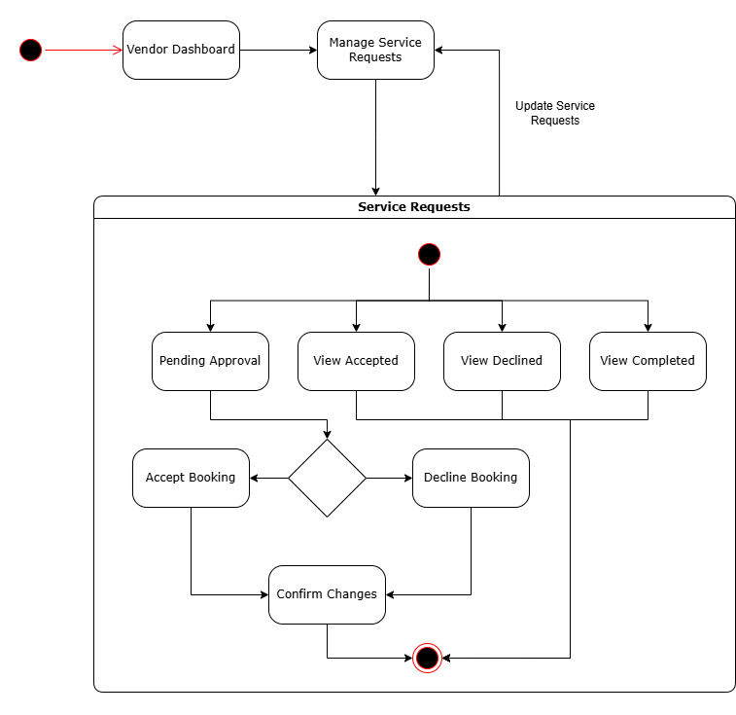
Figure 9: State Chart Diagram for Vendor Manage Service Requests
1. Vendor logs into the app and accesses the Vendor Dashboard.
2. From the dashboard, vendors can navigate to the Manage Service Requests section.
3. In the Service Requests container, vendors can:
- View pending approval requests
- View accepted requests
- View declined requests
- View completed requests
4. For each service request, vendors can:
- Accept the booking which moves it to accepted state
- Decline the booking which moves it to declined state
5. Both accept and decline actions require confirmation of changes
6. After confirming changes, the service requests list gets updated
7. Vendors can continuously monitor and update service requests through this flow

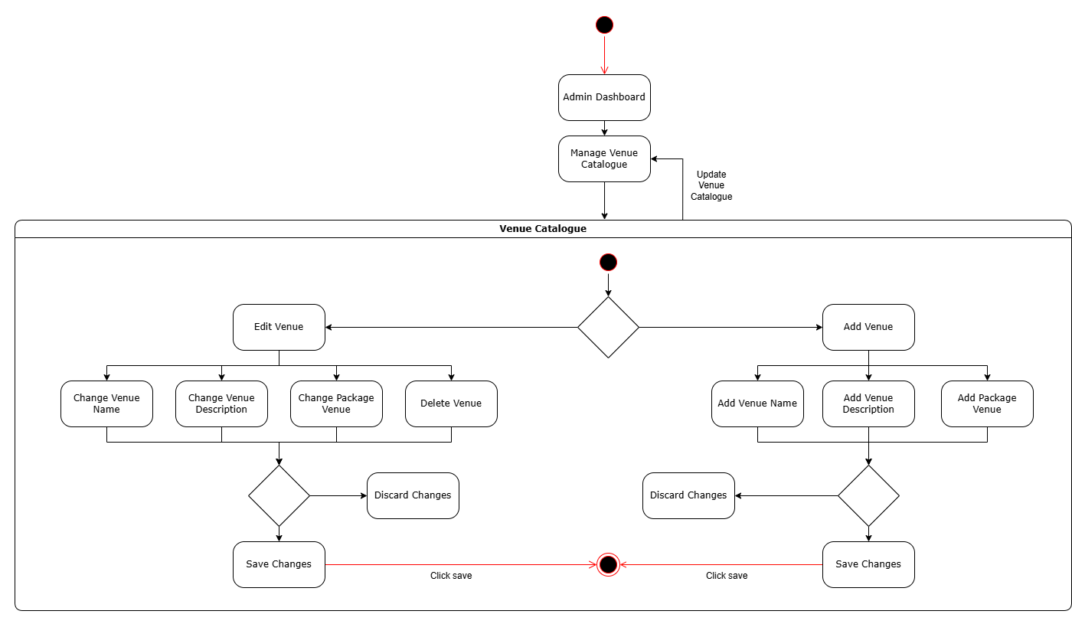
Figure 10: State Chart Diagram for Admin Manage Venue Catalogue
- The process starts at the Admin Dashboard, where admins can navigate to “Manage Venue Catalogue”
- In the “Manage Venue Catalogue”, admins can choose to edit venue or add a new venue
- When admins choose to edit details of a venue, they can see the venue name, venue description and also the package of the venue. They can also decide to delete the venue if wanted to
- If admins choose to add a venue, they have to enter the new venue name, description and also package venue.
- Admins have to press “Save changes” to make sure the new changes have been saved to the database.

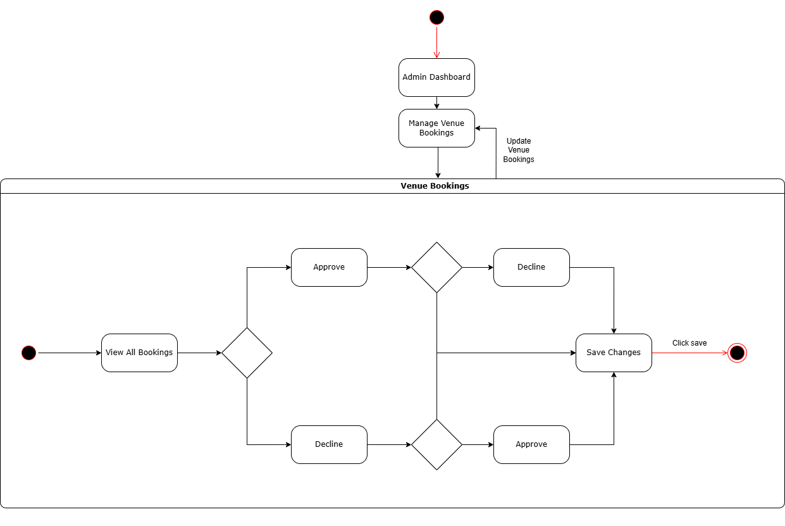
Figure 11: State Chart Diagram for Admin Manage Venue Catalogue
- The process starts at the Admin Dashboard, where admins can navigate to “Manage Venue Bookings”
- In the “Manage Venue Bookings”, all the clients’ bookings are displayed to the admin in the pending and all section
- Admins can choose whether to approve or decline a client’s booking
- Once the booking has been declined or approved, it will be moved into their own respective section
- Admins can decline an approved booking or vice versa by going into their own section and declining/approving it

Appendix A – Group Log
Nerds
Meeting Minutes

Platform: WhatsApp (Online)
Date: 5th December 2024.
Time: 2:00 PM
Attendees: Mirza Muhammad bin Munshee, Azeleen Jane Romanus, Javier Miguel Abeng, Christine Yong Sze Teng, Robbie Samir Anak Bruno
Absent: None.
Meeting Objective: To distribute tasks for the mobile app Figma prototype

Agenda Item #1
Discussion: | Mirza and Javier will work together on creating and implementing the admin account feature.
Discussion: | Azeleen and Christine will collaborate on designing and adding the vendor account functionality.
Discussion: | Mirza will focus on implementing the guest view section of the prototype
Discussion: | Robbie will be responsible for correcting and refining the diagrams in the prototype to improve clarity and flow.
Decision: | Task distribution for the Figma prototype has been finalized.
Meeting Adjournment: | The meeting was adjourned at 2:45 PM, with each member assigned specific tasks. The team agreed to check progress on the prototype by the next meeting.

Nerds
Meeting Minutes

Platform: WhatsApp (Online)
Date: 13th December 2024.
Time: 1:00 PM
Attendees: Mirza Muhammad bin Munshee, Azeleen Jane Romanus, Javier Miguel Abeng, Christine Yong Sze Teng, Robbie Samir Anak Bruno
Absent: None.
Meeting Objective: Distribute tasks for the mobile app front end and backend features.

Agenda Item #1
Discussion: | Discussed the implementation features for the mobile app.
Discussion: | Javier will work on the design and implementation of features that cater to the guest experience.
Discussion: | Robbie will handle the design and development of the wedding management features on the front end.
Discussion: | Azeleen will manage the design and development of the vendor catalogue and portfolio sections.
Discussion: | Mirza will handle the design and implementation of client posts and reviews features.
Discussion: | Christine will be responsible for handling the app's backend functionalities and integration.
Decision: | Task distribution for front end and app backend features has been finalized.
Meeting Adjournment: | The meeting was adjourned at 2:00 PM, with each member assigned specific tasks.

Nerds
Meeting Minutes

Platform: WhatsApp (Online)
Date: 2 January 2025
Time: 3:00 PM
Attendees: Mirza Muhammad bin Munshee, Azeleen Jane Romanus, Javier Miguel Abeng, Christine Yong Sze Teng, Robbie Samir Anak Bruno
Absent: None.
Meeting Objective: Distribute tasks for the Software Design Specification (SDS) document.
Agenda Item #1
Discussion: | Part 1: Introduction - Robbie will be responsible for completing this section.
Discussion: | Part 2: Architecture - Christine and Robbie will collaborate on the Architecture section.  - Christine will handle the Overview and Component Diagram.  - Robbie will document the System Components.
Discussion: | Part 3: High-Level Design - Robbie, Azeleen, Javier, and Mirza will handle various state chart diagrams:  - Robbie: State Chart Diagram for Venue Catalog and Booking and Manage Wedding.  - Azeleen: State Chart Diagram for Guest RSVP and View Wedding Details.  - Javier: State Chart Diagram for Vendor Edit Portfolio and Vendor Manage Service Requests.  - Mirza: State Chart Diagram for Admin Manage Venue Catalogue.
Discussion: | Meeting Minutes - Azeleen will be responsible for recording and preparing the minutes for this and future meetings.
Decision: | Task distribution for the SDS document has been finalized.
Meeting Adjournment: | The meeting was adjourned at 4:00 PM

