Software Requirements Specification

for

Wedding2U
Version 1.0

Prepared by
Group Name: The Nerds
Mirza Muhammad Bin Munshee | 82669 | 82669@siswa.unimas.my
Robbie Samir Anak Bruno | 85556 | 85556@siswa.unimas.my
Javier Miguel Abeng | 84110 | 84110@siswa.unimas.my
Azeleen Jane Romanus | 83340 | 83340@siswa.unimas.my
Christine Yong Sze Teng | 82491 | 82491@siswa.unimas.my

Instructor: | Mdm. Nurfauza bt Jali
Course: | TMA3084/TMA3083: Software Engineering Lab
Lecture Group: | Group 2
Teaching Assistant: | Mdm. Nurfauza bt Jali

Date: | 2nd December 2024
Contents

Revisions iii
1 Introduction 1
1.1 Document Purpose 1
1.2 Product Scope 1
1.3 Intended Audience and Document Overview 1
1.4 Definitions, Acronyms and Abbreviations 1
1.5 Document Conventions 2
1.6 References and Acknowledgments 3
2 Overall Description 3
2.1 Product Perspective 3
2.2 Product Functionality 3
2.3 Users and Characteristics 4
2.4 Operating Environment 4
2.5 Design and Implementation Constraints 5
2.6 User Documentation 5
2.7 Assumptions and Dependencies 5
3 Specific Requirements 6
3.1 External Interface Requirements 6
3.2 Functional Requirements 7
3.3 Behaviour Requirements 10
4 Other Non-functional Requirements 18
4.1 Performance Requirements 18
4.2 Safety and Security Requirements 18
4.3 Software Quality Attributes 19
5 Other Requirements 21
Appendix A – Data Dictionary 22
Appendix B - Group Log 23

Revisions
Version | Primary Author(s) | Description of Version | Date Completed

Introduction
This document outlines the software requirements for the Wedding2U mobile application developed by The Nerds. Wedding2U is designed to streamline the wedding planning process by offering a comprehensive digital platform for couples and vendors. It addresses the limitations of traditional wedding planning methods, such as manual scheduling and communication inefficiencies, by integrating modern technology and personalization. The app serves as a tool for managing appointments, coordinating vendor services, and customizing wedding plans, enhancing the user experience for both clients and vendors.

Document Purpose
This Software Requirements Specification (SRS) describes the functional and non-functional requirements of the Wedding2U mobile application. The document serves as a foundation for all subsequent stages of development, including design, testing, and deployment. By defining the scope, audience, and system requirements, this SRS aims to align the expectations of all stakeholders, including developers, testers, and the client, Madam Eina of Wedding Project.

Product Scope
Wedding2U is a mobile application tailored for the wedding planning industry in Sarawak. It offers tools for couples and vendors to manage event details, track guest RSVPs, and communicate effectively through in-app messaging. Key features include a venue catalog, customizable checklists, wedding-day schedules, and a countdown timer. By integrating these functionalities, Wedding2U aims to minimize scheduling conflicts, improve vendor coordination, and elevate customer satisfaction, setting a new standard for wedding planning services in Sarawak.

Intended Audience and Document Overview
This document is intended for the development team, project managers, clients, and quality assurance teams involved in the Wedding2U project. It includes a detailed description of the system, its functionalities, and the requirements to ensure successful implementation. The document is organized into sections, starting with the system overview, followed by specific and non-functional requirements, and concludes with a discussion of assumptions and constraints.

Definitions, Acronyms and Abbreviations
API: Application Programming Interface
RSVP: Répondez S'il Vous Plaît (Respond if you please)
UI: User Interface
HTTPS: Hypertext Transfer Protocol Secure

Document Conventions
Several formatting conventions have been followed throughout the entire document:

Font Style Conventions

Bold: Used to emphasize section titles and important terms.

Italics: Used for emphasis on specific concepts or to indicate terms being defined.

Underlined: Used sparingly for additional emphasis or cross-references.

Numbering and Bullets

Numbered lists are used for ordered sequences.

Bullet points are used for unordered lists or summaries.

Figures and Tables

Figures are labeled as "Figure X," with a brief caption below the diagram or image.

Tables are labeled as "Table X," with a title placed above the table.

References and Citations

All references are included at the end of the document, following APA or MLA formatting standards.

Page Layout

Each page contains a header with the project title and a footer with the page number and document version.

References and Acknowledgments
The following standards apply:

J-STD-016-1995 | IEEE/EIA Standard for Information Technology, Software Lifecycle  Processes, Software Development, Acquirer-Supplier Agreement
IEEE-STD-P1063 | IEEE Standard for Software User Documentation

Overall Description

2.1 Product Perspective
Wedding2U represents a transformative approach to wedding planning by integrating technology into traditional practices. It is a new, standalone application designed to address inefficiencies in manual scheduling and vendor coordination. The app operates within a 3-tier architecture comprising the presentation layer for user interaction, the application layer for business logic, and the data layer for storing essential information. Figure 1 illustrates this architecture, showcasing the seamless interaction between users, vendors, and backend services.
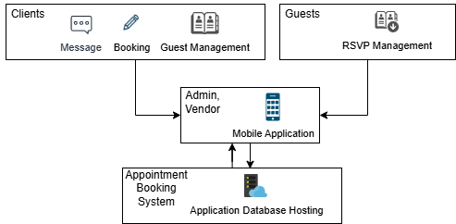

Figure 1: Wedding2U Mobile Application Architecture

2.2 Product Functionality
The primary functionalities of Wedding2U include:

- Venue Catalog: Displays detailed information about potential wedding venues.
- Guest RSVP Management: Tracks live responses from invited guests.
- Customizable Wedding Tentative: Allows couples to create and share personalized wedding schedules.
- In-App Messaging: Facilitates direct communication between clients and vendors.
- Checklist Management: Allow clients to purchase service through app, where they can monitor progress through interactive task lists.
- Vendor Portfolio: Provides a platform for vendors to showcase their services.
- Wedding Countdown: Adds excitement by displaying the time remaining until the event.
- Client Posts and Review: Client may post reviews on vendors whose serviced they have used for their wedding.

2.3 Users and Characteristics
Clients: Couples planning their weddings. They require intuitive navigation and tools for event customization.
Admin: Manages the backend, ensuring system security, maintenance, and support.
Vendors: Service providers showcasing portfolios and managing client interactions.
Guests: Individuals responding to RSVPs and accessing wedding schedules.

2.4 Operating Environment
Wedding2U is designed for mobile devices running Android (version 9 or above) and iOS (version 12 or above). The backend services will be hosted on cloud platforms like Firebase, ensuring reliability and scalability.

2.5 Design and Implementation Constraints
Key constraints include:

- The app must support cross-platform compatibility using Flutter.
- Secure data handling and privacy compliance are mandatory.
- The backend architecture must ensure minimal latency and high availability.
- Vendor profiles should dynamically update based on client interactions.
- The app must function offline for core features, syncing data when connectivity is restored.

2.6 User Documentation
A comprehensive user manual will be provided, including tutorials, FAQs, and troubleshooting guides. The documentation will be available online and as a downloadable PDF.

2.7 Assumptions and Dependencies
The assumptions that can be included are:

- Stable internet connectivity for real-time features.
- Access to third-party APIs for messaging and payment processing.
- Timely updates from vendors to maintain accurate catalog data.

Specific Requirements

3.1 External Interface Requirements

3.1.1 User Interfaces
Sign In

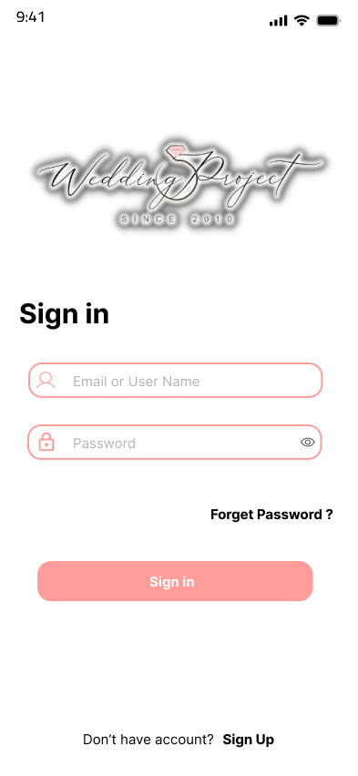

Sign Up

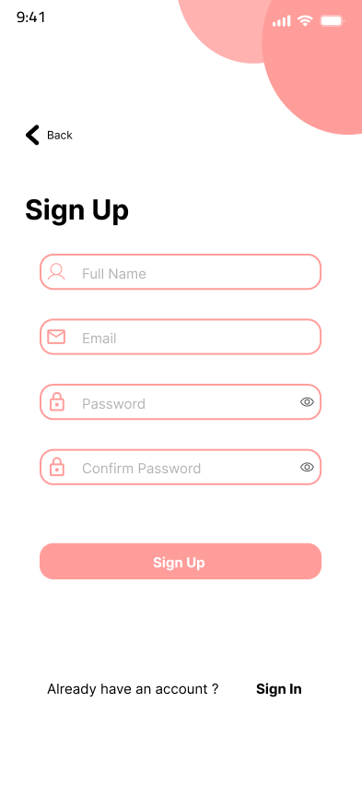

Main

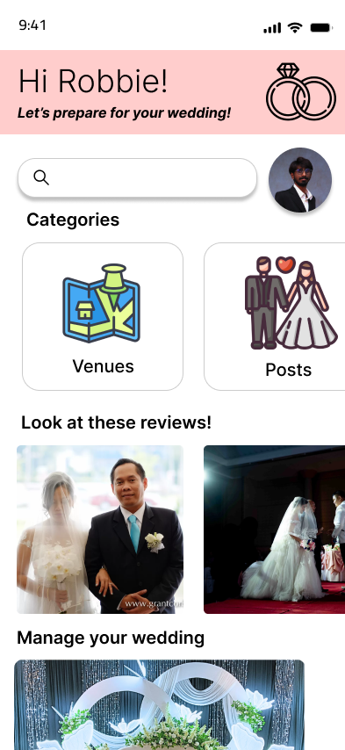

Venue

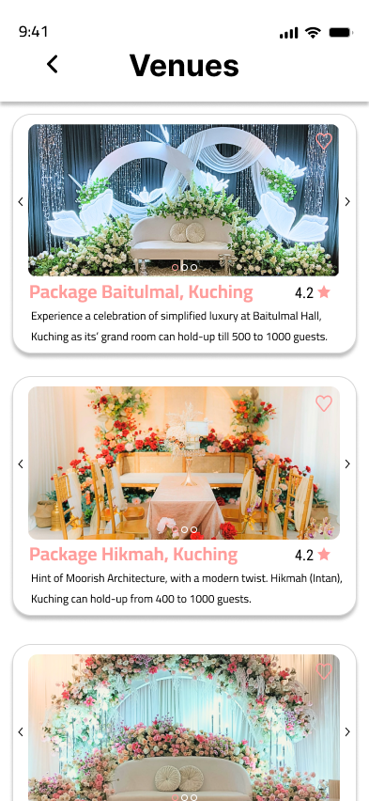

Booking

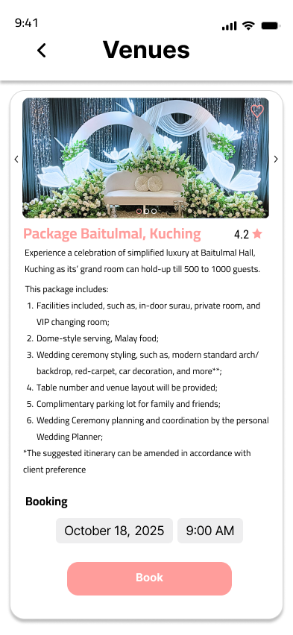

Checklist

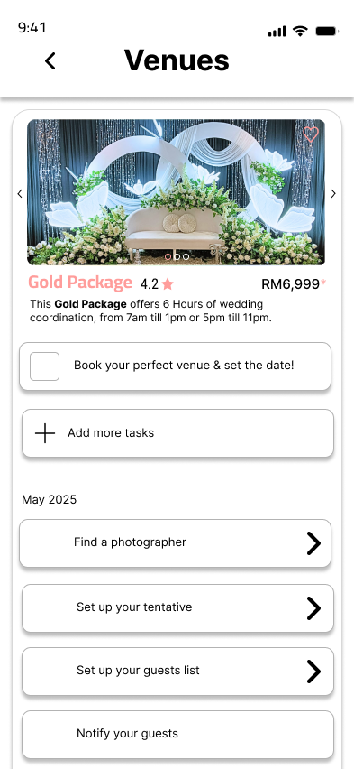

Guest RSVP

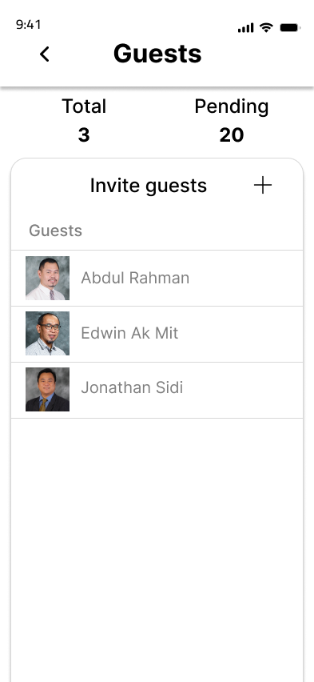

Customisable Wedding Tentative

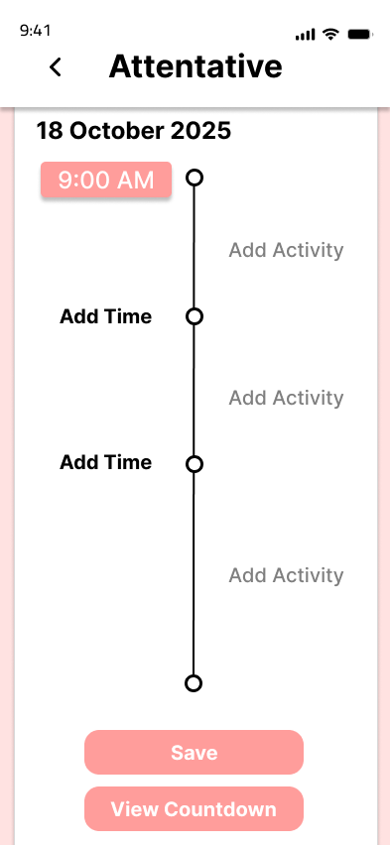

In-App Messaging

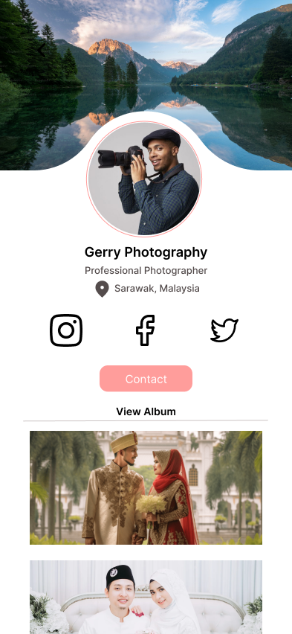
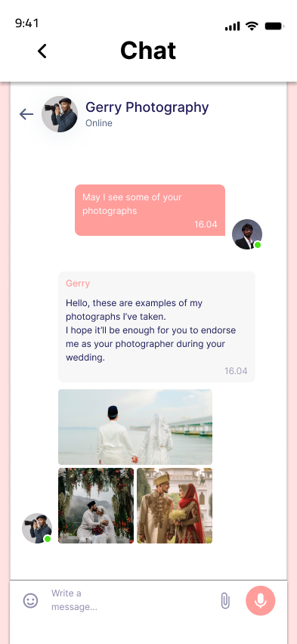

Vendor Portfolio

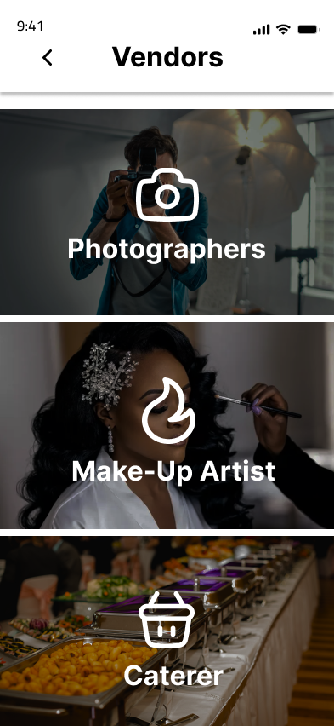

Wedding Countdown

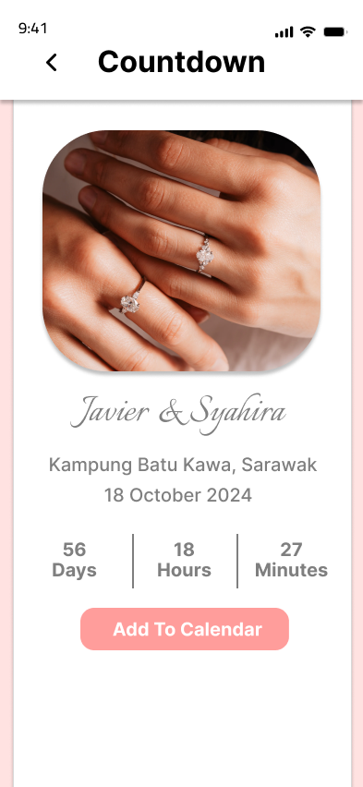

Client Post and Reviews

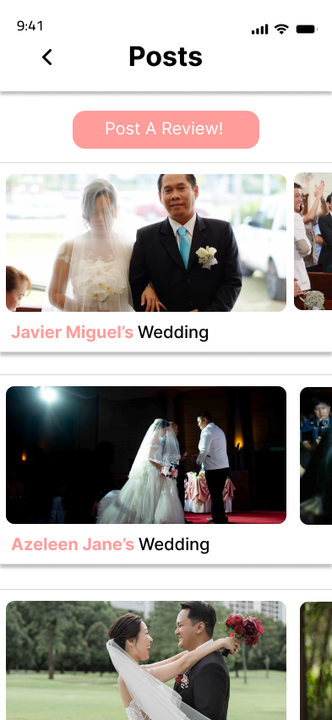

3.1.2 Hardware Interfaces
The application must support Android and iOS devices. The minimum requirements for the mobile devices are as follows:
- Android: Version 9.0 or above
- iOS: Version 12.0 or above

3.1.3 Software Interfaces
For the backend operations, the app will connect to Firebase as a cloud database for user authentication, messaging services, data storage, retrieval and real-time updates. The application will also integrate with other external services including social media APIs and payment gateways for in-app purchases.

3.1.4 Communications Interfaces
The application will use secure and reliable communication protocols such as HTTPS for data exchanges between the app and backend API services, to provide data encryption and protect sensitive information.

3.2 Functional Requirements

3.2.1 Registration and login

- The app must allow new users (Customers, vendors, admins) to register by providing their name, valid email address or phone number.
- The app must require new users to select their role (Customer or vendor) during registration.
- The app must require new users to create a strong password before they can successfully register for an account.
- Users must provide the correct email and password before they are granted access to log in the system.
- The system must provide a password recovery option by sending OTP to the registered email of the user.
- The app must differentiate between user types (customer, vendor, admin) and grant access to features based on their roles.

3.2.2 Venue catalog and booking

- The app should display a list of available wedding venue packages with detailed descriptions, images, and availability.
- The app should provide a search and filter functionality for the wedding venue.
- The app should display the ratings and reviews for all the wedding venue.
- The app should allow customers to rate and add reviews to the wedding packages.
- The app should have a bookmark option where customers can save their preferred wedding venue.
- The app should allow customers to book available wedding venue.
- The app should send push notifications for any status updates on their booking request.
- The customers should be able to check their booking status in their profile page.

3.2.3 Customer profile management
- Customers should be able to edit their profile information, including name, contact details and social media account.
- The app should allow customers to view and manage their booked services, upcoming weddings and payment history.

3.2.4 Customers post and reviews

- Customers should be able to share posts about their wedding experiences.
- The app should allow customers to add reactions and comments on the posts.

3.2.5 In-app purchases for checklists
- Customers should be able to make in-app purchases for service checklists.
- Customers should be able to track the completion of each service in their checklist.

3.2.6 Guest List and RSVP Management

- The system shall allow customers to create and manage a guest list.
- The app shall allow customers to send digital RSVP invitations to their guests.
- The invited guests should be able to reply to the RSVP invitations directly via the app, by selecting their status as “Confirmed”, “Declined”, or “Pending”.
- The app should notify the customer regarding the status of their RSVP invitations via push notifications.
- The system must monitor RSVP replies in real time and display a categorised list of attendees based on their responses.

3.2.7 Customisable wedding tentative

- The app should allow customers to add event details in the wedding tentative, by indicating the event’s name, starting time, venue, and additional notes.
- The app should display the wedding schedule to the customers and involved vendors.

3.2.8 Wedding ceremony countdown

- The app should provide the customers (clients and guests) a countdown to their wedding day.
- The countdown should count in days, hours and minutes.
- The app should send push notification to customers for reminders prior to their wedding day.

3.2.9 Vendor listings and in-app messaging with vendors

- The app should display a list of verified vendors and their portfolios.
- The vendors should be categorised by their service types (e.g. photographers, makeup artists)
- Customers should be able to view the ratings and reviews of the vendors.
- Customers should be able to rate and add reviews to the vendors.
- The app should provide in-app messaging for communication between customers and vendors for service inquiries.

3.2.10 Vendor portfolio management

- Vendors should be able to update their portfolio by adding and editing their service description, images, pricing choices and biographies.

3.2.11 User management for administrator

- The app should enable the administrator to view and manage all registered user accounts.
- The app should offer a search and filter functionality for user accounts.
- The app should categorise user accounts based on user roles, namely customers and vendors.

3.2.12 Venue catalog management for administrator

- The app should allow the administrator to add, edit and delete wedding venue packages.
- The app should allow the administrator to add and edit the description of the wedding venue packages.

3.2.13 Booking management for administrator

- The admin should be able to view the lists of all booking requests made by customers, and their details such as venue name, booking date and time, customer details and status of the booking (e.g., Pending, Confirmed, Cancelled).
- The app should allow the administrator to search for bookings using keywords such as customer name or venue.
- The app should allow the administrator to filter the bookings by venue and booking status.
- The admin should be able to update the customers’ booking details such as changing the booking status or editing booking dates or venue details upon customer requests.
- The app should send notifications to customers regarding their booking confirmations, modifications or cancellations.
- The app should allow the administrator to view and monitor payments associated with the booking and services, such as their payment status.

3.3 Behaviour Requirements

3.3.1 Use Case View
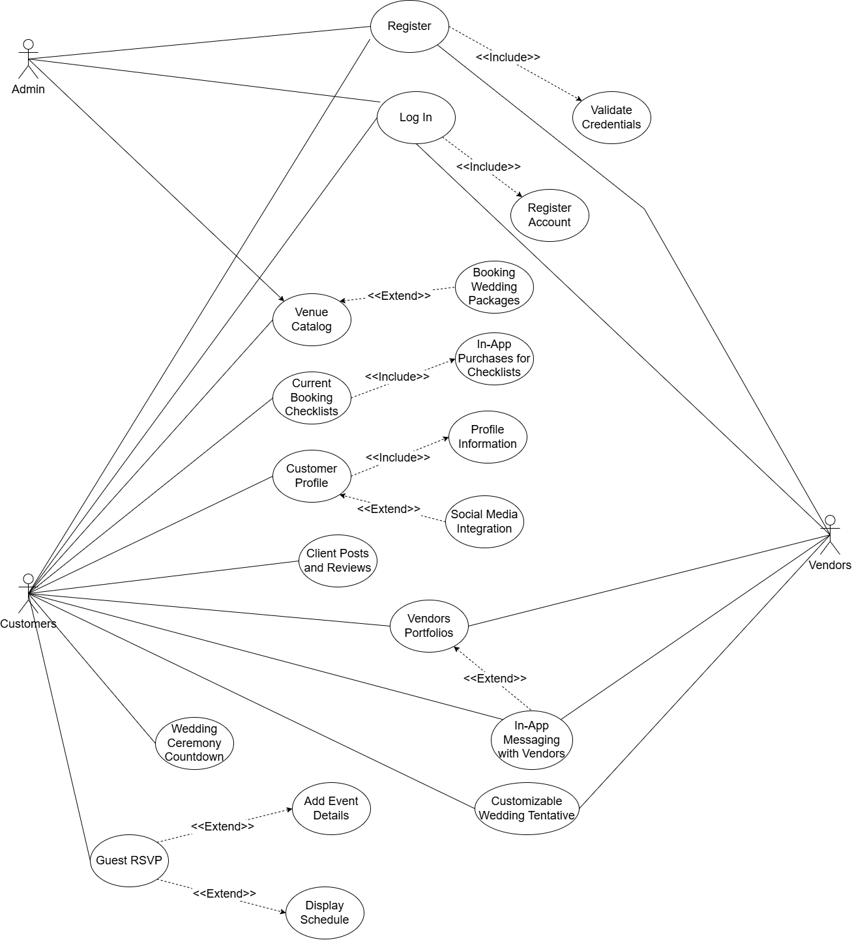

Figure 2: Use case diagram for Wedding2U application

- Registration

Use Case | Registration
Short Description | Enables a new user (client or vendor) to register by entering the required information, which includes their name, email address, phone number, and password.
Actor(s) | Customer, Vendor, Admin
Pre-condition(s) | - The user has downloaded the Wedding2u app.  - The connected device of the user is having the internet connectivity.  - The user has not been registered in the application before.
Post-condition(s) | - The creation of a new user account is completed.  - From this stage, the user can use the registered entry detail to log into the application.
Main flow | - The Wedding2U app is launched by the user.  - The Welcome Page with Log In and Sign Up choices is displayed by the app.  - The user selects Sign Up.  - The user is prompted by the app to provide their registration information.  - The Register button is tapped by the user.  - The entered details are verified by the system.  - The new account information is saved to the database by the system.  - The Log In page is displayed to the user.
Alternative Flow(s) | - The user leaves the registration screen by tapping Cancel.  - The user is sent to the Welcome Page without creating an account.
Exception Flow(s) | - The system notifies the user to update their input and try again if they enter incorrect or incomplete information (such as a weak password or a wrong email format).  - The system notifies the user to use a different email address or go to the login page if the email address they entered is already linked to an existing account.

Requirement | Description
REQ-1 | A Sign-Up page with input boxes for name, phone number, email, and password must be included in the app.
REQ-2 | If an email address is already registered, the app should notify the user.
REQ-3 | After a successful registration, the app must show success notifications.

- Log in
Use Case | Log In
Short Description | Enables an existing user to access the app by entering their password and email address.
Actor(s) | Customer, Vendor, Admin
Pre-condition(s) | - The user’s account registration was completed successfully.  - The user’s internet connection is operational.
Post-condition(s) | - After successfully logging in, the user is directed to the Main Page of the application.
Main flow | - The Wedding2U is launched by the user.  - The Welcome Page with Log In and Sign Up choices are displayed by the app.  - The user selects Log In.  - The application asks the user to input he Email Address and Password.  - The Log In button is tapped by the user.  - The email and password are checked against the database by the system.  - If credentials are valid, the app redirects the user to Main Page.
Alternative Flow(s) | - The user leaves the login screen by tapping Cancel.
Exception Flow(s) | - The system will ask the user to re-enter their credentials if they input an invalid email address or password.  - If the email provided is not registered, the system guidance message appears that the user needs to sign up.  - The user is informed and told to try again later if there is a technical problem preventing the system from veriftying the credentials.

Requirement | Description
REQ-1 | A Log In page with email and password input forms must be included in the application.
REQ-2 | Credentials must be verified by the app against the database.
REQ-3 | When credentials are invalid, the application must display error notifications.

3. Venue Catalog
Use Case | Venue Catalog
Short Description | Enables customers to browse and book wedding locations offered by business owner via the catalogue.
Actor(s) | Customer, Admin
Pre-condition(s) | - User is logged in.  - The information regarding the venue by the admin is available in the system.
Post-condition(s) | - The user chooses the venue and books it after viewing the venue’s details.  - The booking is sent to the administrator for administrator for the confirmation.
Main flow | - Client goes to the “Venue Catalog”.  - System contains list of venues having pictures and simple description about the venue.  - If the user is interested, they proceed to start the booking process for the venue.  - The user’s booking information are gathered by the system.  - The system notifies the administrator of the new booking request and validates the reservation.  - The user is notified that their reservation request was submitted.
Alternative Flow(s) | - The user refines search results by filtering venues by price range, size, or location. (KIV)
Exception Flow(s) | - The system shows an error notice and tells the user to try again later if venue data cannot be loaded.  - If a technical problem causes the booking process to fail, the system notifies the user and tells the user to try again or contact support.

Requirement | Description
REQ-1 | Users should be able to access detailed information about venues using the system.
REQ-2 | Users must be able to direct book venues using the system.
REQ-3 | The admin should receive a booking notification from the system.
REQ-4 | To make choosing a venue easier, the system must provide search and filtering capabilities -KIV

4. Customer Profile
Use Case | Customer Profile
Short Description | It allows the management of some of the user’s information and the connection of social networking profiles.
Actor(s) | Customer
Pre-condition(s) | - User is logged in.
Post-condition(s) | - Changes in profile information are stored.
Main flow | - The client selects “Profile” section.  - The client modifies contact information, name and other details.  - The system verifies updates and saves modifications.  - The client goes to the part with links to social media.  - The client chooses a platform (like Facebook or Instagram) and gives authorisation.  - The social networking account is successfully linked by the system.
Alternative Flow(s) | - The system stores the profile even if the user leaves some optional fields empty.  - When the user ends the connecting procedure, the system keeps the data from before.
Exception Flow(s) | - If any of the required sections are left empty, the system will prompt the user to fill them up.  - The system alerts the client and offers troubleshooting instructions in the scenario that connecting fails.

Requirement | Description
REQ-1 | The system must enable the creation and updating of profiles.
REQ-2 | Social media account connection and unlinking must be supported by the system.
REQ-3 | System needs to ensure that during next profile updates, all necessary fields are passed through the validation step.

5. Client Posts and Reviews
Use Case | Client Posts and Reviews
Short Description | Enables clients to create posts, review venues or vendors, and interact with others.
Actor(s) | Customer
Pre-condition(s) | - User logged in.  - A venue or vendor has relevant date stored in the system
Post-condition(s) | - Posts and reviews are stored and can be seen by other people.
Main flow | - Client goes to the “Posts and Reviews”.  - Client makes a new post with text and may post one or more images.  - The post is saved by the system and appears on the forum.  - Client chooses a location or vendor page.  - Client interacts with the website by writing a review or reading other reviews.  - After the review has been entered by the user, system retains and shows the entered review.
Alternative Flow(s) | - Instead of posting the post, the user can decide to store it as a draft.  - A user modifies or removes a review that has already been submitted.
Exception Flow(s) | - If the post does not save, the system shows an error message.

Requirement | Description
REQ-1 | System must support creating, editing, and deleting posts.
REQ-2 | A system must enable the clients to read and post comments.

6. In-App Purchases for Checklist
Use Case | In-App Purchases for Checklist
Short Description | Allows clients to buy and use wedding planning checklists that may be customised.
Actor(s) | Customer
Pre-condition(s) | - User is logged in.  - The payment gateway is working.
Post-condition(s) | - Progress is monitored and the purchased checklist is unlocked.
Main flow | - Client chooses a checklist and makes purchase.  - The payment is processed by the system.  - Client’s account is updated with unlocked checklist.  - In the checklist, the client marks tasks as completed.  - Progress is saved and updated in real time by the system.
Alternative Flow(s) | N/A
Exception Flow(s) | - When a payment fails, the user is prompted to attempt again by the system.

Requirement | Description
REQ-1 | Secure checklist payments must be supported by the system.
REQ-2 | System must include functionality to enable users mark tasks as complete.
REQ-3 | Progress must be graphically displayed by the system.

7. Guest RSVP
Use Case | Guest RSVP
Short Description | Allows clients to track lists of guests and send out invitations for acceptance.
Actor(s) | Customer
Pre-condition(s) | User is logged in.
Post-condition(s) | Guests are added, and RSVP responses are recorded.
Main flow | - Client goes to the “Guest RSVP”.  - Client inputs the details of the event such as date, time and location of the event.  - System shows a confirmation and stores the information.  - System sends digital invitations to guest.  - Guest responds to the invitation.  - System records RSVP responses and updates the guest list.
Alternative Flow(s) | - The system is updated when guests modify their RSVP status.
Exception Flow(s) | - The user is prompted by the system if any necessary event fields are missing.

Requirement | Description
REQ-1 | RSVP invitations must be sent by the system.
REQ-2 | Guest responses must be recorded and kept up to date by the system.

8. Customizable Wedding Tentative
Use Case | Customizable Wedding Tentative
Short Description | Enable clients to make and show guests the wedding tentative.
Actor(s) | Customer, Vendor
Pre-condition(s) | - User is logged in.  - Vendors associated with the wedding have provided details of their services (if applicable).
Post-condition(s) | - Tentative for wedding with customization is created and saved.  - Guests and vendors might be given access to the draft.
Main flow | - Client selects the “Wedding Tentative” feature.  - The app shows a default tentative template.  - The finalised tentative is saved by the app.
Alternative Flow(s) | N/A
Exception Flow(s) | - The system shows error message if there is a technical problem getting the tentative.  - The only action that is available to the user is to try and reload the page.

Requirement | Description
REQ-1 | The wedding tentative must be shown in the app as a timeline with event titles, times, locations and descriptions.
REQ-2 | The finalized tentative must be retrieved and shown by the app from the database.
REQ-3 | If the tentative is not available, the user must be informed via the app.
REQ-4 | In the event of a retrieval failure, the application must manage and show errors.

9. Wedding Ceremony Countdown
Use Case | Wedding Ceremony Countdown
Short Description | Features a wedding day counter to enable the users to remain informed of the remaining time.
Actor(s) | Customer
Pre-condition(s) | - User is logged in.
Post-condition(s) | - The countdown timer is shown on the dashboard.
Main flow | - The user logs into the app.  - If the wedding date has not been inputted yet, it asks for it when setting up the app.  - The system shows the countdown to the wedding day in days, hours and minutes.  - The user dashboard clearly displays the countdown timer.  - As time goes on, the timer is updated dynamically.
Alternative Flow(s) | N/A
Exception Flow(s) | - The app asks the user to enter the wedding date if they have not already.

Requirement | Description
REQ-1 | Users must be able to enter or modify the wedding date within the app.
REQ-2 | A countdown clock to the wedding day must be calculated and shown by the app.
REQ-3 | The countdown timer has to be updated dynamically by the app.
REQ-4 | If an invalid or past date is entered, the app must handle it and ask for valid date.

10. In-App Messaging with Vendors
Use Case | In-App Messaging with Vendors
Short Description | Enables customers to ask simple enquiries about weddings via a chatbot. If the customer needs further help, the chatbot can direct them to use the app to get in touch with vendors directly.
Actor(s) | Customer, Vendors
Pre-condition(s) | - The user is logged into the app.  - Vendors have profiles in the system.  - The chatbot has pre-programmed replies to frequently asked questions.
Post-condition(s) | - The client’s basic questions are answered by the chatbot.  - The client has the option to contact with a vendor directly if needed.
Main flow | - The client opens the Chatbot feature in the app.  - The client can enter the basic questions to chatbot.  - After analysing the question, the chatbot responds appropriately.  - The chatbot also provides the opportunity to get in touch with a relevant vendor directly if question cannot be answered.  - After choosing a vendor, client enters a message.  - The app sends the message to the vendor, and the conversation start.
Alternative Flow(s) | - The conversation is over if the chatbot is able to respond to the client’s question.  - Without getting in touch with a vendor, the client leaves the chatbot.
Exception Flow(s) | - The question is fails to process by the chatbot.  - The client either rephrases the question or contact directly with vendors.  - The client either leaves the discussion or attempts sending the message again.

Requirement | Description
REQ-1 | A chatbot that can analyse simple questions and respond to pre-established FAQs must be included in the app.
REQ-2 | If the chatbot is unable to answer a question, it must provide the option to contact vendors.
REQ-3 | Users must be informed via the app if messages are unsuccessful or if the chatbot is unable to handle the question.

11. Vendor’s Portfolio
Use Case | Vendor’s Portfolio
Short Description | It makes it easier for the vendors to display their services while clients get the opportunity to preview, evaluate, and save the vendors they prefer.
Actor(s) | Vendors, Customers
Pre-condition(s) | - Vendors have uploaded their service data and created profiles.  - Client is logged in.
Post-condition(s) | - Clients may see vendor profiles successfully.  - Clients can contact suppliers or bookmark them depending on their portfolio.
Main flow | - Vendors log into the app and go to Portfolio section.  - Details like service descriptions, costs, pictures, and availability are uploaded by vendors.  - The portfolio details are saved by the system.  - The Vendor Portfolio feature allows clients to browse vendor profiles.  - Clients can use their accounts to bookmark or contact directly to vendors.
Alternative Flow(s) | - Clients applies filters (e.g., category, price range, location). -KIV  - The system updates and displays the filtered results. -KIV
Exception Flow(s) | - If an upload fails, the system alerts the vendors and asks them to try again.  - The client has option to reset search or modify the filters. -KIV

Requirement | Description
REQ-1 | The system must have the functionality that enables vendors to create and edit portfolio with descriptions, prices, and media.
REQ-2 | Clients must be able to browse and see vendor profiles in an orderly manner on the app.

4.0 Other Non-functional Requirements

4.1 Performance Requirements
- The system must respond to user interactions such as navigating pages and clicking buttons within 2 seconds.
- Ensures a smooth and responsive experience, reducing frustration and improving user retention.
- The system must process a booking request and display a confirmation message within 5 seconds.
- Maintains efficiency during critical operations, ensuring user satisfaction.
- The system must handle up to 10,000 concurrent users without noticeable performance degradation.
- Ensures stability during peak usage periods, such as major wedding seasons.
- Retrieving user profiles or vendor information should take no more than 3 seconds.
- Facilitates quick access to essential data, enhancing operational efficiency.
- All financial transactions must be processed within 10 seconds.
- Ensures timely and secure payment processing, building user trust.

4.2 Safety and Security Requirements

4.2.1 Safety Requirements

1. The system must show a confirmation message before performing critical actions, such as submitting a booking or deleting data.
- Prevents accidental actions and data loss by allowing users to confirm their decisions.

2. The system must disable the submit button after the user clicks it to prevent multiple submissions of the same form.
- Prevents accidental duplicate bookings or data entries, which could cause confusion or errors in the system.

- The system must provide clear feedback messages after users perform actions like submitting a form or completing a booking.
- Helps users understand whether their actions were successful or if an error occurred, reducing confusion.

4. All input fields must be checked to ensure data is complete and correct before submission.
- Prevents users from submitting incorrect or incomplete data, which could lead to errors or system issues.

4.2.2 Security Requirements
The system is designed to meet a high security standard, ensuring that user data is always protected. Key measures include enforcing strong passwords, encrypting sensitive data, and restricting access through Role-Based Access Control (RBAC).
- The system must require strong passwords (at least 8 characters with a mix of letters, numbers, and symbols) for all user accounts.
- This ensures user accounts are protected from simple password attacks.

- All sensitive data must be encrypted during storage and transmission.
- Prevents data theft and ensures information remains confidential.

- Access to sensitive features and data must be restricted based on user roles (admin, vendor, client) using Role-Based Access Control (RBAC)
- This ensures that only authorized users can access specific functions or information.

4.3 Software Quality Attributes
4.3.1 Usability
The app must have a user-friendly design that is intuitive and easy to navigate.
- Focus on creating a clean and simple user interface (UI) with clear menus, simple icons, and easy-to-read labels. User experience (UX) will be a priority, and the design will undergo multiple iterations based on feedback from user testing to ensure it meets the needs of both first-time and experienced users.

4.3.2 Robustness
The app must handle unexpected user input or errors without crashing.
- Input validation will be implemented to ensure the system processes only valid data.

4.3.3 Portability
The app must function properly on both Android (version 9 or above) and iOS (version 12 or above).
- The system will be built using a cross-platform framework like Flutter, which will allow us to maintain one codebase for both platforms. This approach will simplify updates and ensure that the app performs consistently across both operating systems.

4.3.4 Testability
The system’s code must be tested to make sure it works properly.
- Testing will ensure that each component works correctly individually and that all components function properly together

Other Requirements

Availability
The app should be operational and available 99.9% of the time, excluding scheduled maintenance.

Legal
The app must comply with data protection regulations, such as the Malaysian Personal Data Protection Act 2010 (PDPA).

Appendix A – Data Dictionary

<Data dictionary is used to track all the different variables, states and functional requirements that you described in your document. Make sure to include the complete list of all constants, state variables (and their possible states), inputs and outputs in a table. In the table, include the description of these items as well as all related operations and requirements.>

Appendix B - Group Log
Nerds
Meeting Minutes

Location: SIR Room, FCSIT, UNIMAS.

Date: 10th October 2024.

Time: 2:00 PM

Attendees: Mirza Muhammad bin Munshee, Azeleen Jane Romanus, Javier Miguel Abeng, Christine Yong Sze Teng, Robbie Samir Anak Bruno

Absent: None.

Meeting Objective: To plan on the type of client to have a collaboration with.

Agenda Item #1
Discussion: | Mirza began the discussion by inquiring about the team members' preferred client standards.
Discussion: | Azeleen and Christine suggested finding a client based on providing student necessities services within universities.
Discussion: | Robbie suggested finding a client with a known connection.
Discussion: | Javier and Mirza advised finding a client who owns a simple business.
Discussion: | Azeleen suggested finding a client from the university who needs a website.
Discussion: | Everyone on the team agrees and begins finding companies.
Decision: | Everyone on the team agreed on a known client who owns a company and needs to build a web or mobile application for any of their service.
Meeting Adjournment: | Meeting adjourned at 3:00 PM

Nerds
Meeting Minutes

Location: SIR Room, FCSIT, UNIMAS.

Date: 15th October 2024.

Time: 2:30 PM

Attendees: Mirza Muhammad bin Munshee, Azeleen Jane Romanus, Javier Miguel Abeng, Christine Yong Sze Teng, Robbie Samir Anak Bruno

Absent: None.

Meeting Objective: Confirmation of Client.

Agenda Item #1
Discussion: | Mirza informed the group after a consultation with our lecturer, Madam Nurfauza, the confirmation of our client, with the contact details given by Madam herself.
Discussion: | Mirza then provided a brief overview of the client's name, business background, and location of operation.
Discussion: | Robbie suggested meeting the client physically as soon as possible.
Discussion: | All team members agreed on Robbie’s idea.
Discussion: | Mirza proceeded to contact the client on the soonest meeting date.
Decision: | Nerds have agreed that Wedding2U will be Nerd’s client for the Software Engineering Laboratory Project.
Meeting Adjournment: | Meeting adjourned at 3:00 PM

Nerds
Meeting Minutes

Location: SIR Room, FCSIT, UNIMAS.

Date: 21th October 204.

Time: 2:00 PM

Attendees: Mirza Muhammad bin Munshee, Azeleen Jane Romanus, Javier Miguel Abeng, Christine Yong Sze Teng, Robbie Samir Anak Bruno

Absent: None.

Meeting Objective: To discuss and assign tasks and roles throughout the project phase.
Agenda Item #1
Discussion: | Mirza started the meeting mentioning that all team members will be required to take roles for the purpose of the project.
Discussion: | Mirza mentioned that she will be taking the Project Manager.
Discussion: | Javier will be the Planning Manager.
Discussion: | Christine mentioned that she will be taking Lead Developer.
Discussion: | Robbie mentioned she will be taking over Quality Manager.
Discussion: | Azeleen stated that she will be Support Manager.
Discussion: | All decided to take on their duties, responsibly and do their job appropriate and effectively.
Decision: | Task and roles for the project has been determined.
Meeting Adjournment: | Meeting adjourned at 3.00PM

Nerds
Meeting Minutes

Location: Lorong Pustaka 2D, Petra Jaya, Kuching

Date: 26th October 2024.

Time: 4:00 PM

Attendees: Mirza Muhammad bin Munshee, Javier Miguel Abeng, Robbie Samir Anak Bruno

Absent: Christine Yong Sze Teng, Azeleen Jane Romanus

Meeting Objective: Gathering requirements from client

Agenda Item #1
Discussion:  Greeting and Introduction | The Nerds greeted Madam Sarina Ahmad, the manager of the Wedding Project, and expressed their gratitude for her time and cooperation. Each team member introduced themselves, and Madam Sarina provided a brief overview of her company’s background and operations.

Agenda Item #2
Discussion:  Gathering necessary requirements for the project from the client. | Our team presented a preliminary project proposal, suggesting the development of a mobile application for Madam Sarina’s wedding project business. Madam Sarina expressed strong interest in the idea and confirmed her support for the project throughout the development process.
 | Madam Sarina shared her vision for the app’s functionality and design, ensuring the team captured all essential requirements. The meeting concluded with a group photo session.
Meeting Adjournment: | Meeting adjourned at 5:30 PM

Nerds
Meeting Minutes

Location: Online Meeting, Whatsapp Application

Date: 27th October 2024.

Time: 7:00 PM

Attendees: Mirza Muhammad bin Munshee, Christine Yong Sze Teng, Javier Miguel Abeng, Robbie Samir Anak Bruno, Azeleen Jane Romanus

Absent: None.

Meeting Objective: To plan on task distribution for the project proposal.

Agenda Item #1
Discussion: | Mirza began with discussion by outlining the main tasks that must be completed for the Wedding2U Project Proposal.
Discussion: | Javier stated that he will be handling the section on Introduction and abstract.
Discussion: | Azeleen mentioned that she will be doing the Software Methodology and team goals section.
Discussion: | Christine mentioned that she would be working on the problem statement and the part on the expected result and deliverables.
Discussion: | Robbie mentioned that he will be doing the project objectives and expected result/ deliverables section.
Discussion: | Mirza mentioned that he will be doing the project perspective and Gantt chart section.
Discussion: | Robbie mentioned that he will be doing the project scope and task allocation and contribution section.
Discussion: | Everyone agreed to do their part in the task allocation and to deliver the project proposal on time.
Decision | Task allocation has been agreed for the proposal for the project.
Meeting Adjournment: | Meeting adjourned at 8:00 PM

The Nerds
Meeting Minutes

Location: Student Interaction Room, FCSIT

Date: 27th November 2024.

Time: 1:00 PM

Attendees: Mirza Muhammad bin Munshee, Javier Miguel Abeng, Robbie Samir Anak Bruno, Christine Yong Sze Teng, Azeleen Jane Romanus

Absent: None.

Meeting Objective: To plan on task distribution for the Software Requirements Specification (SRS) document.

Agenda Item #1: Task distribution for SRS
Discussion: | Mirza started the meeting by highlighting the major topics that need to be done for the Software Requirements Specification  documentation.
Discussion: | Javier mentioned that he will be doing the Introduction and Overall Description.
Discussion: | Mirza mentioned that he will be doing the Overall Description with Javier, and the User Interface.
Discussion: | Christine mentioned that she will be doing the Hardware, Software and Communication Interface, Functional Requirements and Other Requirements.
Discussion: | Azeleen mentioned that she will be doing the Non-Functional Requirements.
Discussion: | Robbie mentioned that he will be doing the Behavioural Requirements and Activity Diagram.
Discussion: | The team have set a deadline for completing the tasks to review the SRS.
Discussion: | Everyone agreed to do their parts responsibly,  and efficiently and to deliver the SRS on the given  time.
Decision: | Task distribution for the SRS documentation  has been decided.
Meeting Adjournment: | Meeting adjourned at 3.00 PM

Appendix C – Activity Diagram
