Notes:

This will show all the image attachments that are associated to an object. The browser is used to render the images, so you should limit the image types to gif, jpg and png files. Others may work, but these will work with all modern browsers. If you have other attachments (like PDF or Word docs), these will not be shown.

You can make the HTML I use in the VisualForce page a lot “prettier”, but that is left for you to do. I am no graphic artist!

Post Install Instructions:

You will need to clone the ShowImageAttachments VisualForce page for each type of object you want to use it with. I would name them ShowImageAttachCase when it is for cases, ShowImageAttachAccount when it is accounts, and ShowImageAttachHoliday when it is for the custom object holiday__c.

After you have cloned it, change the standardController attribute on the apex:page tag to the appropriate object name; case, account or holiday__c using the examples above. See below for the part of the VisualForce page to update.

.
.
.
<apex:page standardController="Case" extensions="ImageViewController"...
.
.
.

You will then need to add a new section to the appropriate page layout, make it one column and call it Attachments (you may want to change its height and add a scrollbar as well).

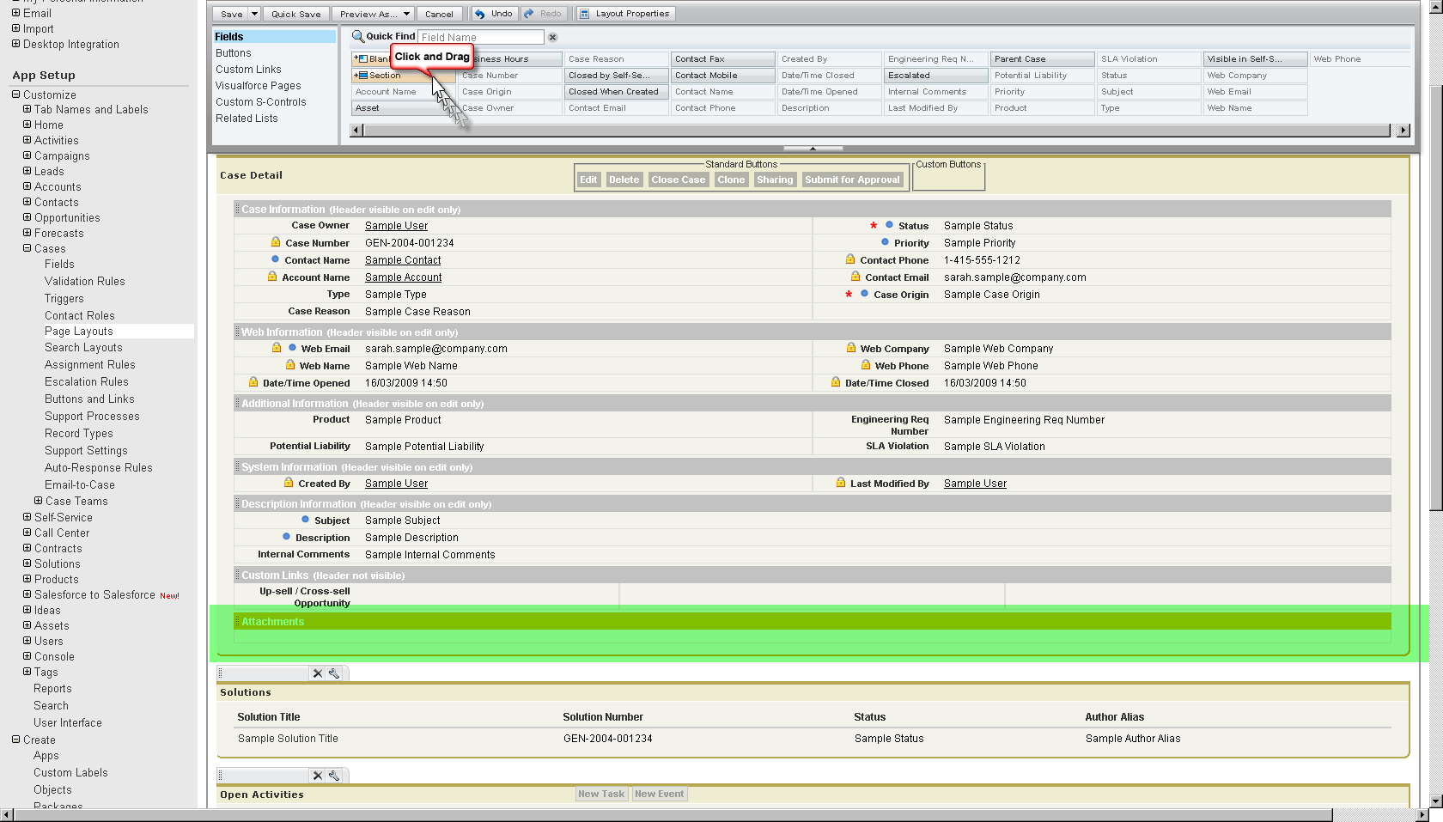

Then choose “VisualForce Pages” and drag the ShowImageAttachCase (or whatever you called it) page into the new section. If the “VisualForce Pages” list is not shown, you have not cloned the VisulaForce page and changed the standardController attribute – this is used by the system to filter which VisualForce pages can be inserted into the current page layouts.

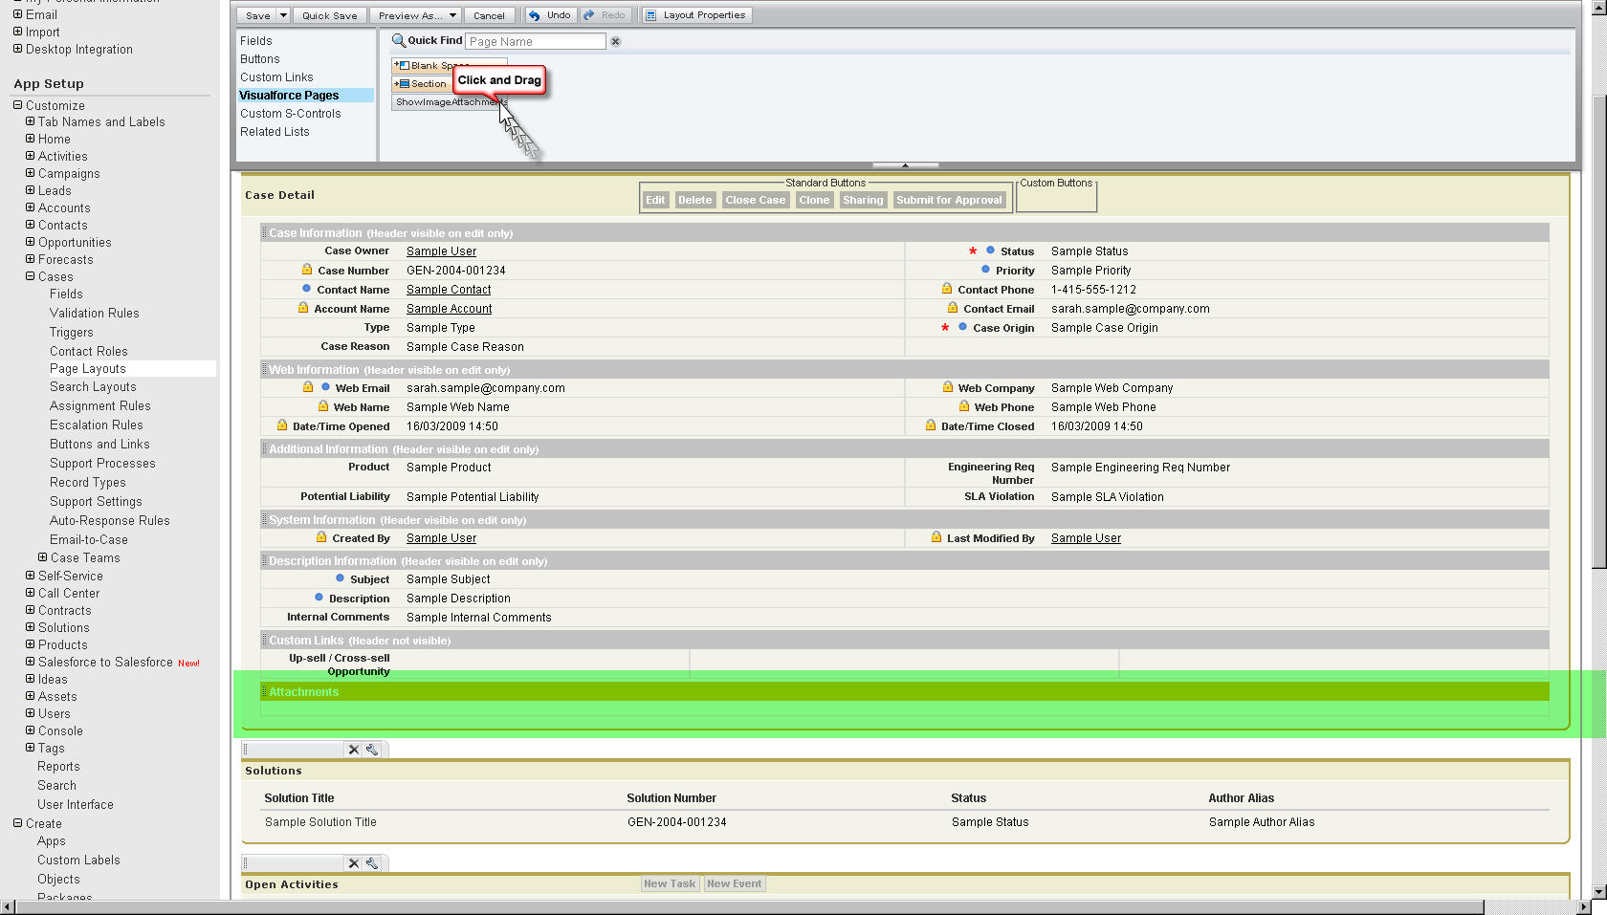

and voila – a working display.

