**GSG1: Introduction to R and R-shiny as Tools for Building Interactive Geospatial Dashboards**   
July 14-15 (8:00am - 9:30am EST)

**Supplementary Information on How to Publish Your App through RStudio Connect**

* Open wb_spatial_training.Rproj in RStudio.

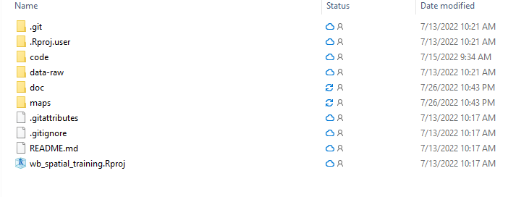

* Open 2.dashboard_exercise.R.

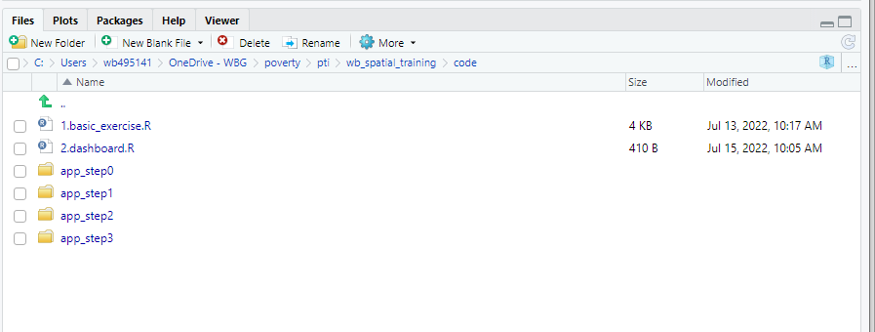

* Run Line 1 and Line 10 in 2.dashboard_exercise.R.

pacman::p_load(shiny,here,tidyr)

shiny::runApp(here::here("code/app_step3"))

* Click on the “Publish” icon at the top right corner.

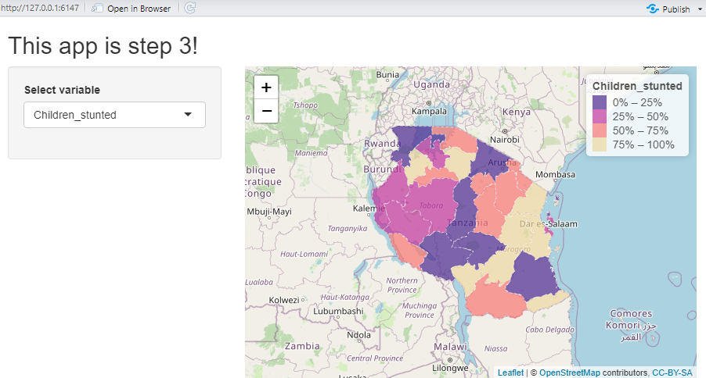

* Click on “Next”.

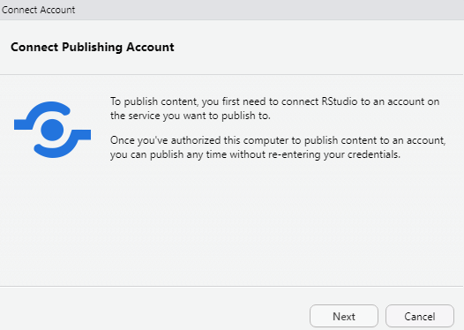

* Select RStudio Connect.

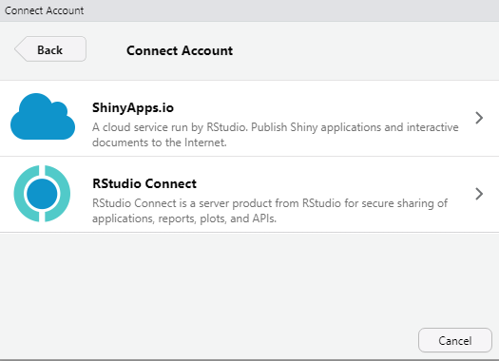

* Now choose a server link to deploy the app. Copy and paste <http://w0lxprconn01.worldbank.org:3939> to publish the app only for Bank staff or<http://w0lxopshyprd1b.worldbank.org:3939> to make the app accessible to anybody who has the link to the app. For this demo, I use the public server URL (<http://w0lxopshyprd1b.worldbank.org:3939>).

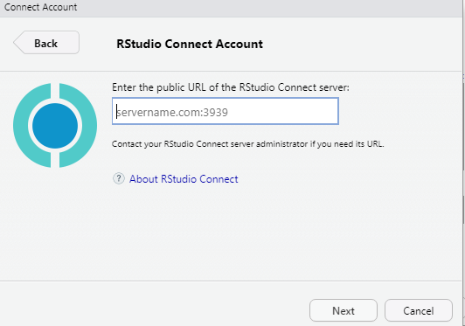

* Confirm your account on RStudio Server. You will be prompted to log in with your user ID and password.

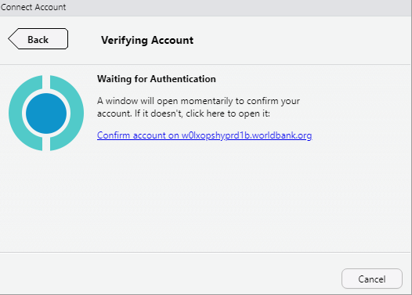

* After you successfully log in, you will see that the “Connect Account” icon show up in RStudio. Click on it.

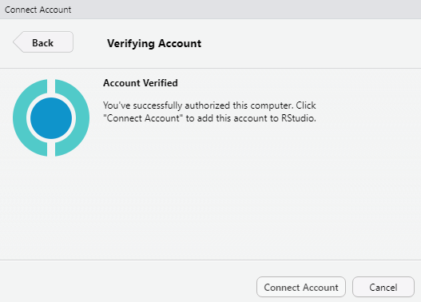

* Now you see your account show up under “Publish From Account:”. Now click on “Publish.”

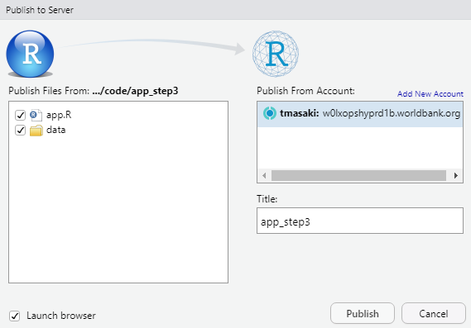

* If successful, it will open a new browser with your app launched on RStudio Connect server.

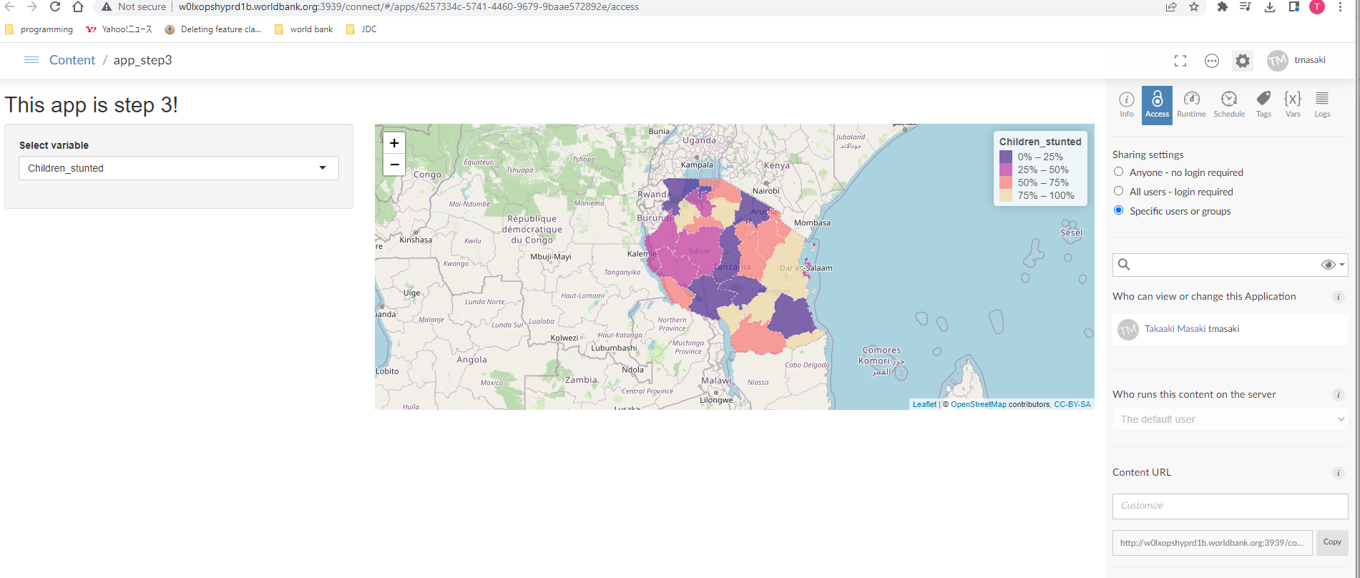

* Finally, you can change sharing settings from “Specific users or groups” to “Anyone – no login required” to share the appYou can click on “Copy” under “Content URL” to copy the link to the app, which can then be shared with anybody who wants to use the link to access the app. If you would like, you can also customize URL. Here I put in /wb_spatial_training_example/ under “Content URL” and now the link to the app becomes: <http://w0lxopshyprd1b.worldbank.org:3939/wb_spatial_training_example/>. If the internal server URL (<http://w0lxprconn01.worldbank.org:3939>) is used to deploy the app, only people who are on Bank VPN can access the app.

