Installation Guide

**How to install R and RStudio**

*For Bank laptop users*

* Go to Software Center

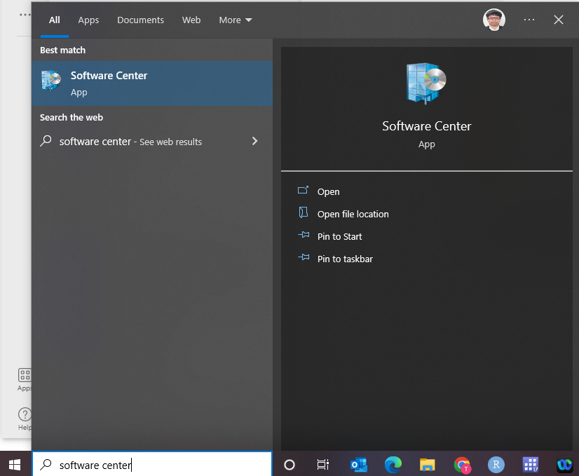

* Install R (RforWindows) and RStudio

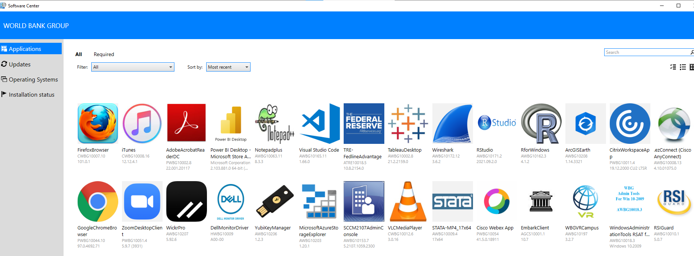

*For non-Bank computer users*

R (4.1.2 or higher) and RStudio

*R*

R is freely available at https://cran.r-project.org/bin/windows/base/ for Windows and https://cran.r-project.org/bin/macosx/ for Mac.

*RStudio*

RStudio is also freely available at <https://www.rstudio.com/products/rstudio/download/#download> for Windows and Mac.

**Install Packages**

Once you have R and RStudio installed, install packages that are used for the training. To install these packages, take the following steps:

1. Open RStudio

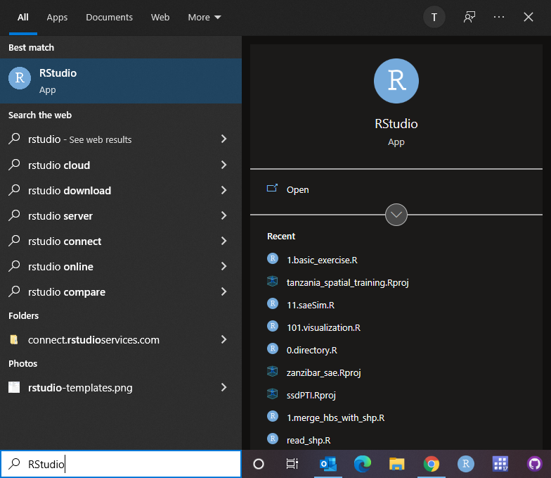

1. Copy and paste the following scripts to the console in RStudio

# How to install packages -------------------------------------------------

# Let's install pacman first

if(!require(pacman)){

install.packages("pacman")

library(pacman)

}

# use pacman::p_load to load packages in one line

pacman::p_load(sf,raster,

tidyverse,tmap,

exactextractr,geosphere,

GISTools,ggplot2,

spdplyr,sfheaders,

smoothr,raster,

paletteer,leaflet,

here,shiny)

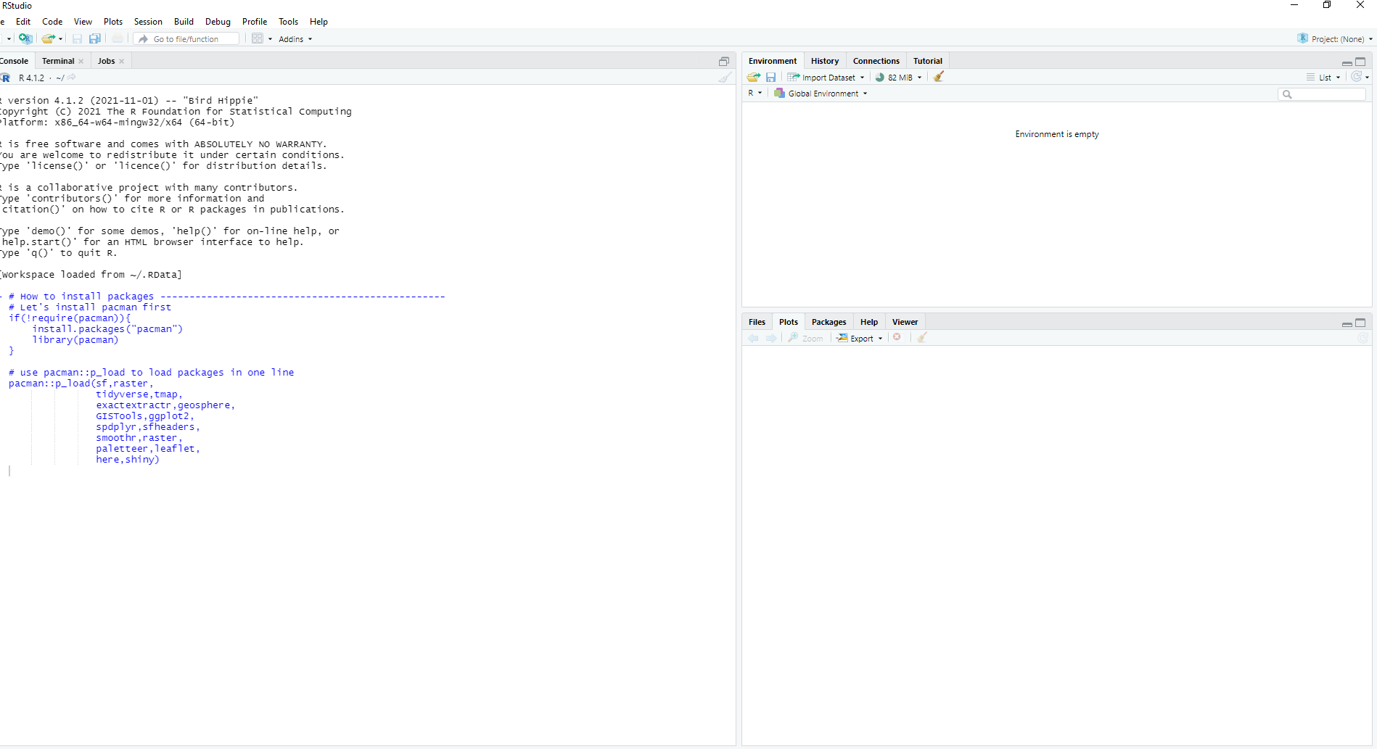

Then hit “Enter.” It will start downloading packages on your computer. Once downloads are complete, please go ahead to close your RStudio by clicking on x at the top right corner of the window. It will say “Save workspace image to ~/.RData?”. You can just click on “Don’t Save.” That’s it!

