# Project: Analyzing a Market Test

## Step 1: Plan Your Analysis

1. What is the performance metric you’ll use to evaluate the results of your test?

The unit for the analysis is roaster. The performance metric is the growth in weekly gross margin per roaster. The percent improvement in gross margin is the criterion to decide whether the new menu and the TV Ad campaign should be launched for all the roasters.

1. What is the test period?

The test period is 12 weeks.

1. At what level (day, week, month, etc.) should the data be aggregated?

The data should be aggregated weekly basis because the test period is defined in the number of weeks.

## Step 2: Clean Up Your Data

*In this step, you should prepare the data for steps 3 and 4. You should aggregate the transaction data to the appropriate level and filter on the appropriate data ranges. You can assume that there is no missing, incomplete, duplicate, or dirty data. You’re ready to move on to the next step when you have weekly transaction data for all stores.*

## Step 3: Match Treatment and Control Units

Apart from trend and seasonality, region, square footage (Sq_Ft), and monthly average sales (AvgMonthSales) have been considered to match control roasters to a treatment roaster. Trend, seasonality, and the monthly average sales are important parameters to consider because the performance of the units should be comparable prior to a test. Region parameter often reflects the demography and the culture of the customers. Including the square footage of the unit makes sense because the number of the customers the roaster can seat is impacted by the size of the roaster.

As it is shown in the table below, the square footage and the average monthly sales variables have a low correlation with each other. The region variable is a categorical variable, therefore, could not be analyzed using correlation.

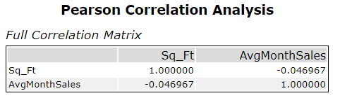**Table 1:** Pearson Correlation Analysis for the control variables (the Square footage of the roaster and the Average Monthly Sales).

The treatment and the control roasters pairs are shown in the table below:

|  |  |  |
| --- | --- | --- |
| Treatment Store | Control Store 1 | Control Store 2 |
| 1664 | 7162 | 7484 |
| 1675 | 1580 | 7584 |
| 1696 | 7334 | 7534 |
| 1700 | 1508 | 1630 |
| 1712 | 7434 | 7284 |
| 2288 | 8817 | 9081 |
| 2293 | 12219 | 9639 |
| 2301 | 3102 | 11668 |
| 2322 | 2409 | 3002 |
| 2341 | 2333 | 2383 |

**Table 2:** The Treatment and the Control Roasters Pairs

## Step 4: Analysis and Writeup

West:

The list is 42.6% with 99.7% statistical significance. The expected impact is $589.6 gross margin increase per week per roaster.

Central:

The lift is 40.1% with 99.3% statistical significance. The expected impact is $754.8 gross margin increase per week per roaster.

Overall:

The list is 41.4% with 100% statistical significance (Fig.1)

The company should roll out the updated menu to all stores. The treatment group consistently outperformed the control group during the test overall (Fig.2 and Fig.3). The AB test supports the case for introducing the updated menu with the expected percent sales increase of 41.4% overall.

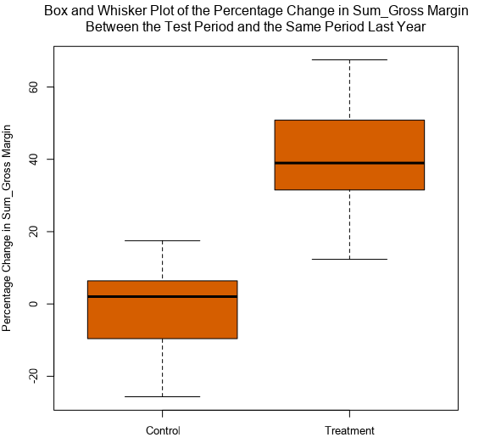

**Fig.1:** Box and Whisker Plot of the Percentage Change in Sum_Gross Margin Between the Test Period and the Same Period Last Year

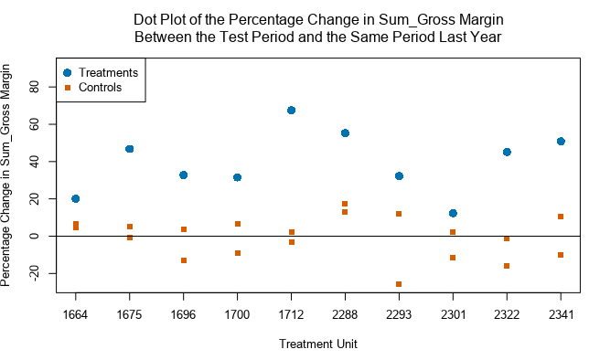

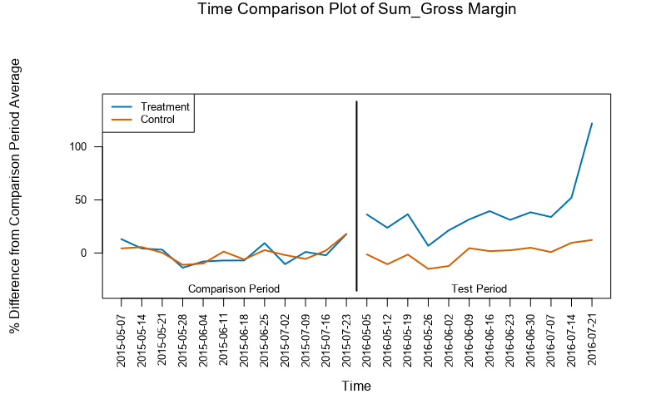**Fig. 2:** Dot Plot of the Percentage Change in Sum_Gross Margin Between the Test Period and the Same Period Last Year compared between treatment roaster and the corresponding control roasters.

**Fig. 3:** Time Comparison Plot of Sum_Gross Margin for all treatment and control roasters.