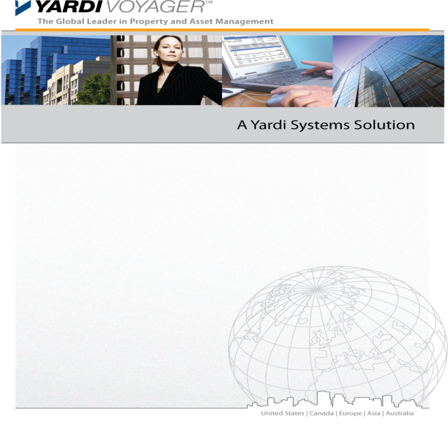

Business Process Requirements
Procure to Pay

Version Control

Version | Date | Author | Remarks
1.0 | {{DATE}} | {{CONSULTANT_NAME}} | First Version

Sign Off

Sign Off | Signatory Name | Date | Signature

Copyright Notice
This document: (1) contains confidential and proprietary information; (2) is protected by copyright and other intellectual property laws; and (3) is intended solely for Yardi Systems, Inc. licensees in connection with their use of Yardi software. Use of this document is subject to the terms and conditions of a Yardi Systems, Inc. software license agreement including, but not limited to, restrictions on its use and disclosure.

Table of Contents
Version Control 2
Copyright Notice 2
Overview 4
Procure to Pay Process 5
Credit Notes 9
Tenant Refund 9
Petty Cash Process 9
Any Additional Comments 10

Overview

The purpose of this document is to provide insight to the {{CLIENT_NAME}} business processes and system requirements. Yardi will use these responses to prepare a list of further interview questions and discussion sessions.

Procure to Pay Process

Yardi Reference | Topic | Requirement
 | Explain the current procure to pay process followed by {{CLIENT_NAME}} | Current Procure to Pay Process:  Purchase Requisition:  - Purchase Requisition is raised by FM Manager or Property Admins.  - If PR value is above 3000 AED landlord approval is needed.  - PRs are sent to Property Managers for review and approval  Purchase Order  - Requestor raises the PO and send for GM manager review  - GM Reviews and send for Finance review  - Finance review and send to the requestor to release the PO  - Requestor approve PO  - PO available to Vendor in Vendor Café.  - Vendor Delivers Material/Service (uploads Delivery note and other compliance documents in PO in VC)  - Requestor will perform GRN for the Materials/Services delivered  - Vendor uploads Invoice in VC for PO / Finance creates Invoice in Yardi for PO  Invoicing and Payment  - Option 1 – AP Accountant creates Invoice for PO  - Option 2 – Vendor Creates Invoice from Vendor Café  - Option 3 – Requestor creates the invoice after GRN  - AP accountant will complete the workflow and post  Commit Payment – performed by AP Accountant  Process Payment - performed by AP Accountant  GL Disbursement – Chief Accountant then GM (DOA in RFI)  RFI
 | Describe the current P2P team structure and responsibilities:  a. Who creates the PO?  b. Who receives the goods and creates GRNs?  c. Who receives and books the invoices?  d. Who processes the payments for invoices? | - FM Manager  - Property Admin  - Property Manager – Residential  - Property Manager – Commercial  - General Manager  - Finance Manager  - AP Accountant
 | Share the list of Expense Types to be configured | Expense Types drive following functionality:  - Different approval workflows by expense type for example: Marketing may have different hierarchy than FM purchasing approvals  - Expense Types can be used to control access to GL Accounts  - Expense types are used for PO/AP categorization and reporting purposes  To be filled in RFI sheet
 | Please share the DOA/workflow for PR/PO approval.  - If, the workflow based on amount of POs- share threshold limits for each approver.  - If, there are different approvers for each of the departments (expense types)- share the hierarchy for each department. | To be filled in RFI sheet
 | List of attachments to be uploaded on PO | To be filled in RFI sheet
 | Who will enter AP Invoice? | Role Purpose  AP accountant Elevate - All invoices  Vendor Vendor Café  FM Manager Person doing GRN
 | Do all the invoices need PO? What type of invoices are created without PO? | Yes, all invoices need PO except for Govt, Dewa.  - Direct invoice should be allowed for the below:  - Cash Purchases  - Utilities  - Legal expenses  - Dubai Civil defence  - AMC Invoices
 | Invoice processing across properties? One AP Invoice from Vendor for Multiple Properties? | - Invoicing to be allowed across multiple properties under the same Legal entity
 | Please share the DOA/workflow for Invoice approval.  - If, the workflow based on amount of Invoices- share threshold limits for each approver.  - If, there are different approvers for each of the departments (expense types)- share the hierarchy for each department. | To be filled in RFI sheet
 | List of attachments to be uploaded on Invoice | To be filled in RFI sheet
 | Do you book direct AP invoices? If yes, please give examples? | Direct invoice should be allowed for the below:  - Cash Purchases  - Utilities  - Legal expenses  - Dubai Civil defence  - AMC Invoices
 | Do you receive and book any invoices from foreign currency? If yes, please provide currencies? | - No  - All Transactions are in AED
 | List of attachments to be uploaded on direct invoices (Payables) | To be filled in RFI sheet
 | Payment methods required for making invoice payments.  Available payment methods:  - Cheque- would it be a pre-printed cheque?  - Electronic Fund Transfer (EFT)- share the bank details to be captured for enabling EFT  - Do you process EFT payments to more than one bank accounts for a single vendor?  - Which bank account is used to process vendor EFT payments? Details to be captured for said bank account? | To be filled in RFI sheet
 | Please share the DOA/workflow for Payment approval.  - If, the workflow based on amount of Payments- share threshold limits for each approver. | To be filled in RFI sheet
 | List of attachments to be uploaded on payments | To be filled in RFI sheet
 | Do you make advance payments to the vendor? Provide us with business scenarios where Advance payment is released to Vendor. Provide an overview of advance payment to the vendor and how you adjust it against invoice | - In most cases (95%), client receives a tax invoice for the advances paid. Therefore, those will be booked under the expense account.  - For the remaining cases (5%), Proforma invoices are received exclusive of VAT. For those cases, an AP control account will be used to track Vendor Advances. (2 payables will be created to record vendor advances routed through a clearing advance account)  The steps and entries are summarized below:  # Transactions Account Dr. Cr.  1 Advance Payable Advance Clearing 5,000.00  AP 5,000.00  2 Advance Credit Vendor Advance 5,000.00  Advance Clearing 5,000.00  3 Advance Payment AP 5,000.00  Bank 5,000.00  Once the tax invoice is submitted by the vendor, the advance credit will be used to settle the advance with the outgoing payment for the tax invoice.
 | PO Accrual? | - Yes  - Open PO with GRN but not invoiced  - Open PO with partial GRN and not invoiced  - For AMCs, PO accrual will be run for all eligible POs irrespective of GRN

Credit Notes

Yardi Reference | Topic | Requirement
 | Do you process credit notes? Provide some examples. | - Credit notes are raised by Vendor in Vendor Café or by Finance directly in Yardi for damages or missing items.
 | Do you adjust credit notes against the outstanding vendor payments? | - Yes

Tenant Refund

Yardi Reference | Topic | Requirement
 | Do you use EFT transfers for tenant refunds. If yes, then share the list of information required to be captured for tenant bank account to process EFT. | Bank Transfer is the only method for tenant refunds.  To be filled in RFI sheet

Petty Cash Process

Yardi Reference | Topic | Requirement
 | Please explain the current petty cash process followed. | AP Accountant Float  - Petty Cash is maintained by Imkan for all its companies including Asseto  - If any petty cash purchase is required, Imkan will directly pay for it, hence to fixed float is kept with Asseto.  Petty Cash Expenses  - When a petty cash purchase is done, the payment will be done from “Asseto-petty cash” bank account  - This account will be negated by a manual journal entry with “Due to Imkan”

Service Contract Process

Yardi Reference | Topic | Requirement
 | Who creates the Service Contract? | - FM Manager
 | Do we need approval for the Service contract? | - Yes  To be filled in RFI sheet
 | Service Contract Attachments | To be filled in RFI sheet
 | How many types of service contracts? | To be filled in RFI sheet
 | What is the renewal process | A new Service contract will be created in the system for the new contractual terms.
 | Service contract additional requirements

Any Additional Comments

Sr.No. | Point Raised | Raised by | Yardi Response
1
2

RFI Items: Refer RFI document on sharepoint.

