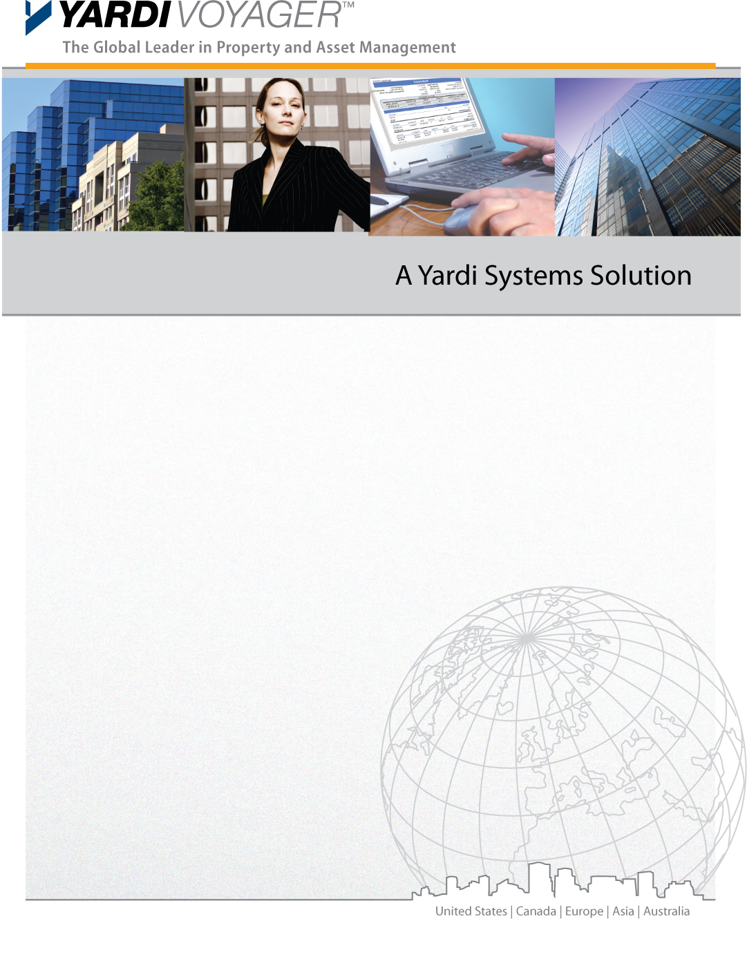

Business Process Requirements
Fixed Assets

Version Control

Version | Date | Author | Reviewer
1.0 | {{DATE}} | {{CONSULTANT_NAME}} | First Version

Sign Off

Sign Off | Signatory Name | Date | Signature

Copyright Notice
This document: (1) contains confidential and proprietary information; (2) is protected by copyright and other intellectual property laws; and (3) is intended solely for Yardi Systems, Inc. licensees about their use of Yardi software. Use of this document is subject to the terms and conditions of a Yardi Systems, Inc. software license agreement including, but not limited to, restrictions on its use and disclosure.

Table of Contents

Version Control 2
Sign Off 2
Copyright Notice 2
Table of Contents 3
Overview 4
Fixed Assets 5
Fixed Assets 5
Additional Open Items :- 9

Overview

The purpose of this document is to provide insight to the {{CLIENT_NAME}} Business Processes and System requirements for Fixed Assets. Yardi will use these responses to prepare a list of further interview questions and discussion sessions.

Yardi Reference | Questions | Requirement/Response
 | Number of Assets held and tracked. | Estate property: ~10 Assets
 | How are assets currently tracked | - No asset tracking for the meantime for LL properties  - For estate property it is tracked in Oracle
 | Asset Groups | To be filled in the RFI sheet
 | Asset Types | To be filled in the RFI sheet
 | Which Depreciation Conventions and Methods? | - Method: Straight line  - Convention: Daily Calculation  - Posting: Monthly
 | How Asset are created including who will create them | Existing Assets  Existing assets will be imported as part of data migration.  New Assets  - Procurement flow:  - PR Approved/PO Approved  - Vendor delivers Asset  - PO GRN done by Warehouse manager  Finance will create Asset by capitalizing the Payable transactions. Finance will enter Asset type, provide Asset information (like Dates, Asset manuals. Asset warranty information, Asset Life etc. ).and validate Accounting information (Asset type/Asset depreciation etc.) and update Asset status to Approved  Approved Assets will be available for Asset transactions (Depreciation, impairment etc.) and Reactive/Preventive maintenance  Facility management will upload warranty information in the Assets  - Direct Asset Creation: (FM)  FM creates Asset in the system, FM will select Asset type, provide Asset information (like Dates, Asset manuals. Asset warranty information, Asset Life etc. ). FM will keep Asset status as Pending.  - Finance will review all Assets with status – Pending, validate Accounting information (Asset type/Asset depreciation etc.) and update Asset status to Approved  Approved Assets will be available for Asset transactions (Depreciation, impairment etc.) and Reactive/Preventive maintenance  - Bulk upload of Assets using Standard Yardi ETL templates:  - Finance/FM can upload Assets in the system using standard ETL templates.  - Assets will be uploaded with Status – Pending  - Finance will review all Assets uploaded, review asset details and Financial information and update status to Approved
 | Do you revalue assets up/down? | - Done by the landlord for revaluation, then it is shared with Asseto to modify the asset book value.
 | How often is depreciation calculated? | - Daily Calculation  - Monthly Posting
 | Disposition and Sale of Assets? | - Not for the meantime as all the of the assets are for the Landlord assets  - For estate property, this might apply in the future
 | What are the different transactions which are processed during life of assets? Please explain in details. | - Purchase  - Depreciation  - Asset Transfer  - Transfer Asset to new Property  - Transfer value to new Asset (Asset Replacement)  - Sale  - Replacement  - Impairment  - Reclassify  - Derecognition  - Split  - Merge
 | Do you maintain Asset Warranty? | - Yes
 | Asset Auto Code. Prefix for each asset type | - Yes  - Based on Asset Type selected in the Asset, the prefix and sequence of asset for that type is decided. For example, the asset code for following Asset is decided as shown:  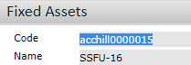  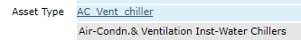  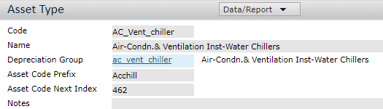
 | Asset Barcode | Asset barcode to be added to each asset for tracking.

Additional Open Items :-

Sr.No. | Point Raised | Raised by | Yardi Response
1

