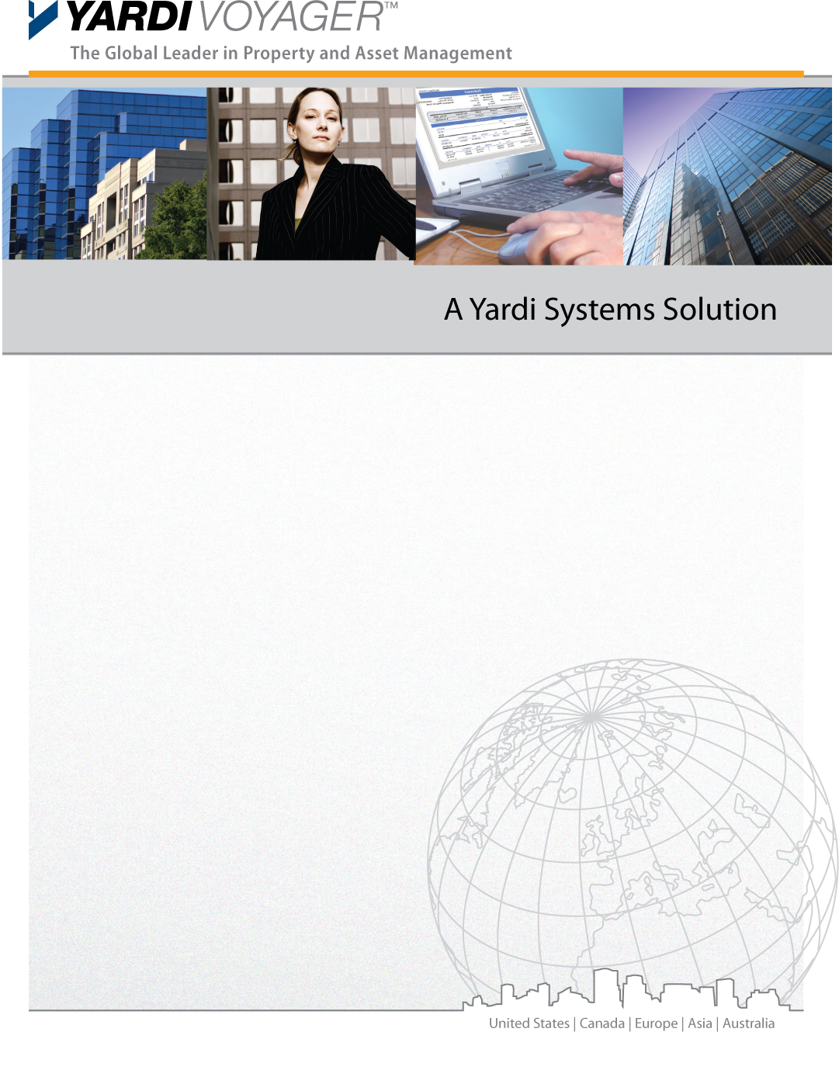

Business Process Requirements
Facilities Management – Inspection and PPM

Version Control

Version | Date | Author | Comments
1.0 | {{DATE}} | {{CONSULTANT_NAME}} | First Version
2.0

Sign Off

Sign Off | Signatory Name | Date | Signature

Copyright Notice
This document: (1) contains confidential and proprietary information; (2) is protected by copyright and other intellectual property laws; and (3) is intended solely for Yardi Systems, Inc. licensees about their use of Yardi software. Use of this document is subject to the terms and conditions of a Yardi Systems, Inc. software license agreement including, but not limited to, restrictions on its use and disclosure.

Table of Contents

Version Control 2
Sign Off 2
Copyright Notice 2
Table of Contents 3
Overview 4
Facilities Management 5
Inspection 5
Planned Preventive Maintenance (PPM) 8

Overview

The purpose of this document is to provide insight to {{CLIENT_NAME}} Business Processes and System requirements for Facilities Management – Inspection and PPM. Yardi will use these responses to prepare a list of further interview questions and discussion sessions.

Facilities Management

Inspection

Yardi Reference | Topic | Requirement
 | High level overview of Inspection process | One Time Setup  - Inspection Templates Setup  Inspection types:  - Patient Move-Out Process  - Incident Recording Process  - Utility Inspection  - Adhoc Inspections  Inspection Process  - Adhoc (Patient Move-Out & Incident Recording)  - Recurring (Utility)
 | Inspection Objects | - Property  - Building  - Common areas
 | Different types of Inspections | Examples for types of Inspections:  Adhoc Inspections:  - Patient Move-Out Process  - Incident Recording Process  - Utility Inspection  - General
 | List of Different Departments Involved in Inspection Activities | Examples of Departments:  - GRO
 | Inspection working hours for: | Inspection scheduling hours in Morning –  E.g. 08h00 to 13h00  Maximum inspections in this slot: 50  Inspection scheduling hours in Afternoon  E.g. 13h00 to 18h00  Maximum inspections in this slot:50
 | Who is Responsible to fix when some item is failed in inspection? | Who is responsible to fix failures:  - Maintenance Contractor (In-case of AMC)
 | Inspection related setups | To be filled in RFI sheet
 | Inspection Statuses | To be filled in RFI sheet  - Inspection Primary Statuses –  - Fail (standard)  - Cancel (standard)  - Needs Approval (standard)  - In Progress  - Completed  - On Hold
 | Inspection Templates | To be filled in the ETLs

Planned Preventive Maintenance (PPM)

Yardi Reference | Topic | Requirement
 | PPM Objects | - Equipments
 | High level overview of PPM process:  Finalize responsibilities-  - Who will create PPM Checklists?  - Who will do one time setup of PPM Task Group and Templates?  - Who will plan and link Assets PPM?  - Who will do monthly PPM Posting and assignment?  - What about recurring common area inspections?  - Who will perform PPM? | Typical Yardi PPM Process:  - PPMs are posted as per the PPM Frequency  - PPMs can be posted for Service Contracts or Assets (common Areas)  - 2 Types of PPMs to be configured:  - PPM Inspections (Performed by Vendors as per schedule). Posted for Service Contracts  - PPM Verification Inspections (Performed by In-House Inspectors). Can be posted for all or Selected equipments. Operationally Vendor Service contract payments can be processed after snags from PPM Verification inspections are rectified  On Going Process  - Posts PPM  - Assign and schedule auto created PPM Inspections  - Execute PMs (verify PPM checklists/templates)  - Work Orders for failed items will be created by system. Reference to the PPM  WO process to be followed till closure
 | List of Different Department Involved in PPM Activities | - AMC Vedors
 | PPM Types and Setup | To be filled in the ETLs

Additional Points discussed during the session
Sr. | Requirement Details
1
2

