Title of Paper Goes Here: First Letter of Each Word Should be Capitalized

Richard K. SMITH^{1*}, Taro SUZUKI^{1,2}, and Hiro SATOH^{2,3}

¹Department of Physics, Cavendish Laboratory, University of Cambridge, Cambridge CB3 0HE, U. K.
²National Institute for Materials Science, Tsukuba 305-0047, Japan
³Institute of Materials Research, Tohoku University, Katahira, Aoba-ku, Sendai 980-8577, Japan

*E-mail: xxxxx
(Received Month dd, year)

Abstract should state briefly the general aspects of the subject and the main conclusions. It should not contain equations. It is not part of the text and should be complete in itself: no table numbers, figure numbers or references should be given. Keywords below should be chosen as they best describe the contents of the paper. Each keyword, except proper nouns and acronyms, should be typed in lower-case letters and followed by a comma.
KEYWORDS: A4-size (210mm x 297mm), US Letter-size (8.5inch x 11 inch), Times New Roman (or Times Roman) font, 12pt-font-size (for main text), 10pt-font-size (for abstract), 17pt-font-size (for title)

1. Introduction

The Physical Society of Japan launched a new open access journal, JPS Conference Proceedings (abbreviation: JPS Conf. Proc.) in 2014. It provides a fast publication of proceedings of an international conference, workshop, summer school or symposium, consisting of peer-reviewed articles.

2. Tables and Figures
2.1 Format
This template is compatible with both A4-size and Letter-size paper. Therefore, please do not change any margin of this file. JPS Conf. Proc. Editorial Office will insert a heading and a footer for each article so please do not add a heading and a footer. Please note that the twocolumn option is not available.

2.2 Main text
Main text should be started with Introduction. Footnotes can be made only for author's present addresses. Any literature, comments, or remarks should be listed in references [1,2,3]. Physical quantities must be typed in italic. Roman type should be used for the following items: units, chemical symbols, mathematical symbols (d(differential), sin, cos, log, lim, etc.).

2.3 Tables
Tables should be numbered consecutively in the order of their appearance in Roman numerals (i.e., I, II, III…). Caption should be typed above the table.
Table I. The following expressions should be used.

At the beginning of a sentence | Within a sentence
Section 1 | §1
Section 2 and 3 | §2 and 3
Equation (1) | eq. (1)
Equations (2) and (3) | eqs. (2) and (3)
Equations (4) - (10) | eqs. (4) - (10)
Table I | Table I
Tables I and II | Tables I and II
Tables II- VI | Tables II- VI
Figure 1 | Fig. 1
Figures 1(a) and 1(b) | Figs. 1(a) and 1(b)
Figures 2-5 | Figs. 2-5

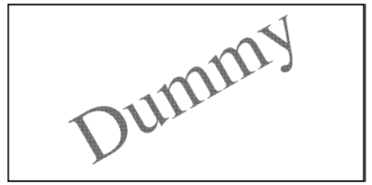
Fig. 1. Figures are printed in black and white in the printed version, unless your Conference organizer allows you to use color. Lines in figures should be more than 0.3pt(0.1mm). Thinner lines than 0.3 pt (0.1 mm) may disappear in the printed version.
2.4 Figures
Figures should be numbered consecutively in Arabic numerals (i.e., 1, 2, 3…). Caption should be typed below the figure.

2.5 Equations
Word Equation Editor must be used as below.
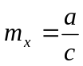. (1)

3. Conclusion

The main text should be ended with Conclusion or Summary.

Acknowledgment

Acknowledgment follows the main text of the paper. No section numbers should be given.

Appendix

If necessary, Appendixes can be written after the acknowledgment. If there are two or more appendixes, they should be labeled Appendix A, Appendix B, etc.

References

- R. Suzuki, K. Beni, P. M. Crozier and T. Miyanaga: J. Phys. Soc. Jpn. 12, 571 (1957).
- E. Freedman and G. Yamada: Plasma Acceleration (MacGraw-Hill, New York, 1982 ) 2nd ed., Vol. 1, Chap. 2, p. 70.
- T. Sawada: Proc. 1987 INS-RIKEN Int. Symp. Heavy and Physics, Tokyo, 1987; T. Sawada: J. Phys. Soc. Jpn. 26 [Suppl. B], 201 (1988).
- Any comments or remarks should be listed in references.
- Each reference number should correspond to one reference. Different papers by the same authors are recommended to be listed separately in the reference list under different number.

