Ongoing Housing stress and cognitive functions
Takashi Iida

Introduction
Housing is a recognized driver of health disparities (1). In the World Health Organization’s 2010 framework, housing was classified as an intermediary determinant of health—downstream from structural forces yet directly shaping health outcomes (2). Its three key elements; affordability, suitability, and security (3), when unmet, expose residents to homelessness, housing instability, and foreclosure. Housing insecurity in the United States is widespread and growing: more than one third of community-living older Americans report at least one form of it, including poor affordability, poor quality, or poor neighborhood conditions (4). In 2024, more than 700,000 people experienced homelessness—the highest count since 2007 (5). Older adults face particular vulnerability, and the population aged 65 and older is projected to grow rapidly in coming decades (6). Housing problems also harm communities: rising foreclosure rates erode local property tax revenues (7), and neighborhood eviction is linked to higher crime rates (8).
Housing problems generate chronic psychological stress (9–11), which contributes to several adverse health outcomes. Housing disadvantage is associated with poor mental health (10), depression (12), and—for those who perceive a risk of eviction—anxiety and related medication use (13). Housing instability also predicts adverse cardiometabolic outcomes (14).
Emerging evidence further suggests that housing stress may accelerate memory decline: foreclosure, for example, has been associated with faster cognitive decline among older adults (15,16). Biologically, chronic stress may impair memory through dysregulation of the hypothalamic-pituitary-adrenal axis and prolonged cortisol exposure. (17) This process has been linked to hippocampal atrophy and poorer hippocampus-dependent memory. (18) Cognitive decline in midlife and late life increases the risk of dementia and Alzheimer’s disease (19,20), making it important to identify modifiable contributing factors. Cognitive decline varies by domain; two domains especially relevant to Alzheimer’s disease are episodic memory and working memory. Episodic memory, assessed through immediate and delayed word recall, is an early cognitive marker with high diagnostic accuracy for Alzheimer’s disease (21). Working memory, which reflects attentional control and central executive function, is also commonly impaired in Alzheimer’s disease (22,23). Studying these domains clarifies whether housing-related stressors contribute to dementia-relevant cognitive change.
The cognitive effects of housing stress may also differ by sex. Women score higher on immediate and delayed word recall in older age (24) yet decline faster in global cognition and executive function than men (25). On the other hand, perceived stress may cause faster cognitive decline for men than women. (26), suggesting that sex may modify the cognitive effects of stress.
Prior research links housing conditions to cognitive health. Better housing quality predicts higher executive function (27), and housing distress is associated with increased cognitive impairment risk (28). However, whether housing stress causally contributes to cognitive decline remains unclear (29). Few studies assess episodic and working memory separately, and sex differences in these effects remain poorly characterized. Using a longitudinal trajectory approach, this study examines the domain-specific effects of ongoing housing stress on episodic memory and working memory separately among U.S. adults aged 50 and older. We also examine whether sex modifies this association, given evidence that women and men differ in both cognitive trajectories and stress sensitivity. We hypothesize that greater housing stress accelerates cognitive decline in both domains, with stronger effects among women than men.

Method

Data Collection
The Health and Retirement Study (HRS) is a nationally representative cohort of U.S. adults aged 50 and older, following approximately 20,000 participants across the United States over time. (30) The initial HRS cohort included individuals born between 1931 and 1941, who were first interviewed in 1992 (wave 1). (31) HRS has conducted core interviews with trained interviewers every two years since 1992. (32) Before 2004, HRS conducted follow-up interviews primarily by telephone, with face-to-face interviews for respondents over the age of 80. (30) Beginning in 2006, HRS assigned half of the cohort to an enhanced face-to-face interview that included physical and biological measures and a psychosocial questionnaire, such that all participants received enhanced face-to-face interviews every four years. (32) The HRS uses a multi-stage national probability sampling and adds a new cohort of individuals aged 51–56 every six years (e.g., in 1998, 2004, 2010, 2016). (32–34)

Analytic Sample
We used wave 8 (2006) as the baseline because the HRS began collecting ongoing housing stress data in that year. (35) Of the 45,234 participants across all waves, 18,469 were wave 8 respondents after excluding non-wave-8 respondents (n=26,765). We further excluded respondents with a doctor-diagnosed memory-related disease at baseline (n=978), leaving 17,491 eligible participants. We then excluded those lacking ongoing housing stress data at wave 8 (n=10,304), yielding 7,187 participants. An additional 90 participants were excluded due to missing cognitive data at wave 8, resulting in a final analytic sample of 7,097. We included only respondents and excluded spouses/partners to avoid within-household clustering, since couples share the same housing environment and may have correlated exposures. Participants were followed for eight years across waves 8, 10, and 12. Wave 14 data were not included because non-missing exposure data at that wave represented only 2,800 observations, reflecting 62% missingness relative to the wave 8 sample. Figure 1 summarizes the flow of study participants.

Exposure
In HRS data, there are items evaluating respondent’s exposure to and perception of common chronic stressors. (35) As one of these stressors, we used ongoing housing stress as an exposure variable. Responses indicate whether a housing problem has lasted at least twelve months and how upsetting it has been, using four categories: “1 = No, didn’t happen,” “2 = Yes, but not upsetting,” “3 = Yes, somewhat upsetting,” and “4 = Yes, very upsetting.” We dichotomized responses into “yes” (categories 2–4) versus “no” (category 1). We assessed the exposure at each wave (waves 8, 10, and 12) through self-report. We handled ongoing housing stress as a single item, consistent with the HRS Psychosocial and Lifestyle Questionnaire user guide. (35)

Outcomes
As outcome variables, we used two domains in cognitive functions: episodic memory and working memory. We assessed episodic memory using total word recall, which was the sum of immediate and delayed word recall scores. For immediate word recall, the interviewer read a randomly assigned list of 10 nouns from four non-overlapping lists and asked the respondent to recall as many words as possible in any order. The scores ranged from 0 to 10, which equaled the number of words correctly recalled. (36) Across waves, each respondent received a different list, and household partners were assigned lists so they would not receive the same list in the same or adjacent waves. Delayed word recall was assessed approximately five minutes after the immediate recall task, when respondents were asked to recall the previously presented nouns. The scores also ranged from 0 to 10. (36) We assessed working memory using the serial 7’s score. In serial 7’s task, the interviewer asked the respondent to subtract 7 from 100 five times consecutively; scores ranged from 0 to 5. (36) Each subtraction was scored independently. For example, if a respondent answered the first item incorrectly (e.g. 92) but correctly subtracted 7 from their own answer for the remaining four trials (e.g. 85, 78, 71, 64), the person would receive a score of 4. The interviewer did not repeat the respondent’s responses during the task. Because total word recall and serial 7’s are on different scales, we standardized both into z-scores, consistent with prior longitudinal cognitive research. (37–39)

Confounders
We selected and operationalized covariates based on HRS documentation. (31) We calculated age in years by dividing the number of months between the respondent’s birth date and interview date by 12. We treated sex (male or female) as an effect measure modifier. We combined race and ethnicity into five categories: Non-Hispanic White, Non-Hispanic Black, Hispanic, Non-Hispanic Other, and Other. We grouped education into five categories: less than high school diploma, General Educational Development (GED), high school diploma, some college (less than a bachelor’s degree), and college and above. Total household income was used in nominal dollars. We coded current smoking status as yes or no. We constructed an eight-condition comorbidity index in which we coded each condition as 1 if the respondent ever reported a physician diagnosis in the current or any prior wave, and 0 otherwise. The eight conditions were hypertension, diabetes or high blood sugar, cancer or malignant tumor (excluding skin cancer), chronic lung disease (excluding asthma), heart disease (including heart attack, coronary heart disease, angina, congestive heart failure, or other heart problems), stroke or transient ischemic attack, emotional, nervous, or psychiatric problems, and arthritis or rheumatism. (40) The summed index ranged from 0 to 8, with higher scores indicating greater disease burden. We used baseline values for sex, race and ethnicity, and education. We treated age, total household income, smoking status, and comorbidity index as time-varying covariates measured at each wave.

Statistical Analysis
We summarized baseline characteristics of the analytic sample using means (SD) or medians (IQR) for continuous variables and counts (percentages) for categorical variables. For the main analysis, we used individual fixed-effects models to estimate standardized mean differences (coefficients) with 95% confidence intervals (CIs). Model 1 was an unadjusted (crude) model, and Model 2 was adjusted for age, total household income, and comorbidity index. Sex and education were not included as covariates because fixed-effects models control for observed and unobserved time-invariant characteristics by exploiting within-person variation. (41,42) For the subgroup analysis, we stratified data by sex to examine effect measure modification and applied crude and adjusted models separately to male and female subsamples. For missing cognitive scores, we used the imputed cognition data provided by HRS. (36) Missing values, refusals, and not-applicable responses were imputed using a multivariate, regression-based procedure conducted with Imputation and Variance Estimation (IVEware) software, drawing on a set of relevant demographic, health, and economic variables along with cognitive scores from the prior and current waves. “Don’t know” responses were treated as incorrect and were not imputed. Household income was used as reported in the RAND HRS dataset, where missing values were imputed by RAND using the unfolding brackets methodology. (31) We handled remaining missing data in the dataset using multiple imputation (m = 20) with results pooled via Rubin’s rules. As a sensitivity analysis, we reran the primary models treating ongoing housing stress as an ordinal variable (1–4) to assess whether collapsing the “not upsetting” and “very upsetting” response categories affected the magnitude or direction of estimates. All analyses were conducted in R 4.5.1.

Results
Table 1 shows characteristics of participants by housing stress status at baseline. The final analytic sample included 7,097 participants: 732 reported ongoing housing stress and 6,365 did not. At baseline, participants had a mean age of 67 years (SD 11) and were predominantly female (59%). Compared with those without ongoing housing stress, participants with ongoing housing stress were younger (mean age 65 vs 68 years) and more often female (62% vs 59%). In the ongoing housing stress group, less-than-high-school education was more common (28% vs 16%), college or above was less common (13% vs 23%), median household income was lower ($25,050 [IQR $12,526–$47,050] vs $42,540 [IQR $22,896–$80,520]), current smoking was more prevalent (23% vs 12%), and comorbidity burden was higher (mean 2.26 vs 1.86). Baseline cognitive performance was lower in the ongoing housing stress group across all three cognitive test scores: immediate word recall (mean 5.23 vs 5.57), delayed word recall (4.05 vs 4.46), and Serial 7’s (3.08 vs 3.70).

Figures
Figure 1. Participant Flow Diagram
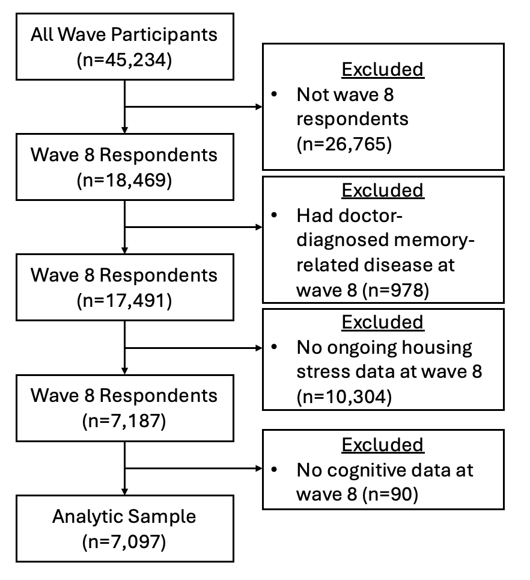
Figure 1: Participant flow diagram showing derivation of the analytic sample from the Health and Retirement Study (HRS). Wave 8 = 2006, Wave 10 = 2010, Wave 12 = 2012.

Figure 2. Directed Acyclic Graph (DAG) for Confounder Selection
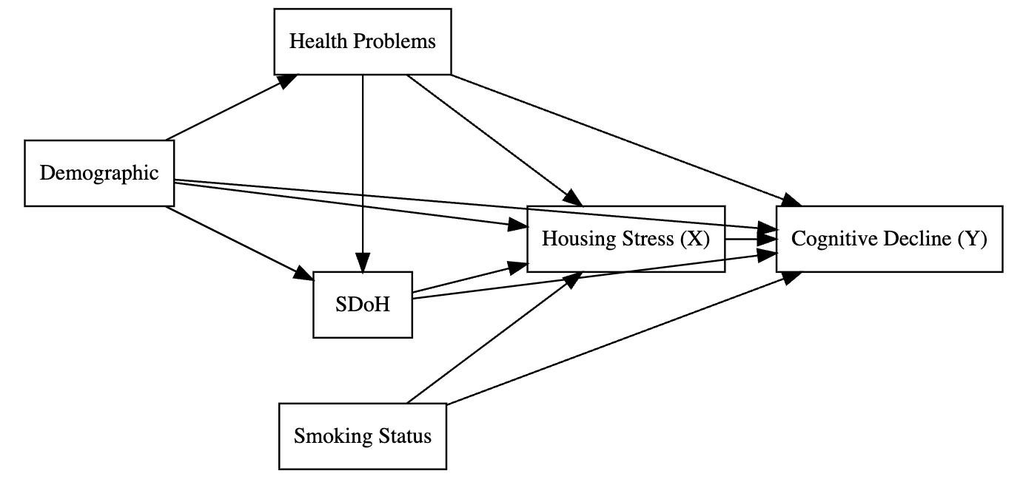
Figure 2: Directed acyclic graph depicting the assumed causal structure used for confounder selection. This DAG illustrates the hypothesized relationship between housing stress (exposure) and cognitive decline (outcome). Demographic characteristics, health problems, social determinants of health (SDoH), and smoking status are included as covariates. Demographic characteristics are age, sex, and race and ethnicity. SDoH are education and household incomes. Health problems include hypertension, diabetes or high blood sugar, cancer or malignant tumor (excluding skin cancer), chronic lung disease (excluding asthma), heart disease (including heart attack, coronary heart disease, angina, congestive heart failure, or other heart problems), stroke or transient ischemic attack, emotional, nervous, or psychiatric problems, and arthritis or rheumatism.

Table 1. Characteristics of Participants in the Health and Retirement Study by Ongoing Housing Stress Status at baseline (Wave 8, 2006) (N=7,097)
Characteristic | Overall  (n = 7097)¹ | Ongoing Housing Stress (n = 732)¹ | No Ongoing Housing Stress (n = 6365)¹
Age, mean (SD) (years) | 67 (11) | 65 (11) | 68 (11)
Sex, n (%)
Male | 2,899 (41%) | 276 (38%) | 2,623 (41%)
Female | 4,198 (59%) | 456 (62%) | 3,742 (59%)
Race and ethnicity, n (%)
Non-Hispanic White | 5,558 (78%) | 437 (60%) | 5,121 (80%)
Non-Hispanic Black | 879 (12%) | 182 (25%) | 697 (11%)
Hispanic | 514 (7.2%) | 77 (11%) | 437 (6.9%)
Non-Hispanic Other | 146 (2.1%) | 36 (4.9%) | 110 (1.7%)
Education, n (%)
Less than high school | 1,244 (18%) | 204 (28%) | 1,040 (16%)
General Educational Diploma | 340 (4.8%) | 49 (6.7%) | 291 (4.6%)
High school diplomas | 2,281 (32%) | 225 (31%) | 2,056 (32%)
Some college | 1,646 (23%) | 156 (21%) | 1,490 (23%)
College and above | 1,586 (22%) | 98 (13%) | 1,488 (23%)
Household income, median (IQR) ($) | 40,500 (21,000, 77,200) | 25,050 (12,526, 47,050) | 42,540 (22,896, 80,520)
Current smoker,  n (%) | 947 (13%) | 167 (23%) | 780 (12%)
Comorbidity index (0–8), mean (SD) | 1.90 (1.40) | 2.26 (1.57) | 1.86 (1.37)
Immediate word recall (0–10),  mean (SD) | 5.54 (1.59) | 5.23 (1.58) | 5.57 (1.59)
Delayed word recall (0–10), mean (SD) | 4.41 (1.93) | 4.05 (1.95) | 4.46 (1.92)
Serial 7's (0–5), mean (SD) | 3.64 (1.64) | 3.08 (1.84) | 3.70 (1.61)
¹Mean (SD); n (%); Median (Q1, Q3)

References
1. Carolyn B Swope, Diana Hernández. Housing as a determinant of health equity: A conceptual model. Soc Sci Med. 2019 Dec;243(112571):112571.
2. Orielle Solar, Alec Irwin. A conceptual framework for action on the social determinants of health. Geneva: World Health Organization; 2010. Report: 2.
3. Adelle Mansour, Rebecca Bentley, Emma Baker, Ang Li, Erika Martino, Amy Clair, Lyrian Daniel, Shiva Raj Mishra, Natasha J Howard, Peter Phibbs, David E Jacobs, Andrew Beer, Tony Blakely, Philippa Howden-Chapman. Housing and health: An updated glossary. J Epidemiol Community Health. 2022 Sep;76(9):833–8.
4. Lucero G Paredes, Yi Wang, Danya E Keene, Thomas M Gill, Robert D Becher. Population-based estimates of major forms of housing insecurity among community-living older americans. J Am Geriatr Soc. 2024 Dec;72(12):3773–83.
5. Tanya de Sousa, Meghan Henry. 2024 annual homelessness assessment report (ahar) to congress. U.S. Department of Housing; Urban Development; 2024.
6. Dennis Culhane, Kelly Doran, Dan Treglia, Eileen Johns, Thomas Byrne, Maryanne Schretzman, Stephen Metraux, Randall Kuhn. The emerging crisis of aged homelessness: Could housing solutions be funded by avoidance of excess shelter, hospital, and nursing home costs? [PhD thesis]. New York University.
7. William C Apgar, Mark Duda, Rochelle Nawrocki Gorey. The municipal cost of foreclosures: A chicago case study. Minneapolis: Homeownership Preservation Foundation; 2005. Report: 2005-1.
8. Gabriel L Schwartz, Kathryn M Leifheit, Mariana C Arcaya, Danya Keene. Eviction as a community health exposure. Soc Sci Med. 2024 Jan;340(116496):116496.
9. Mira Talmatzky, Laura Nohr, Christine Knaevelsrud, Helen Niemeyer. Exploring the association between housing insecurity and mental health among renters: A systematic review of quantitative primary and secondary studies. PLoS One. 2026 Jan;21(1):e0294222.
10. Ankur Singh, Lyrian Daniel, Emma Baker, Rebecca Bentley. Housing disadvantage and poor mental health: A systematic review. Am J Prev Med. 2019 Aug;57(2):262–72.
11. Kate Dotsikas, David Osborn, Kate Walters, Jennifer Dykxhoorn. Trajectories of housing affordability and mental health problems: A population-based cohort study. Soc Psychiatry Psychiatr Epidemiol. 2023 May;58(5):769–78.
12. Ann M Kingsbury, Maria Plotnikova, Alexandra Clavarino, Abullah Mamun, Jake M Najman. Social adversity in pregnancy and trajectories of women’s depressive symptoms: A longitudinal study. Women Birth. 2018 Feb;31(1):52–8.
13. Binod Acharya, Dependra Bhatta, Chandra Dhakal. The risk of eviction and the mental health outcomes among the US adults. Prev Med Rep. 2022 Oct;29(101981):101981.
14. Kristine D Gu, Katherine C Faulkner, Anne N Thorndike. Housing instability and cardiometabolic health in the united states: A narrative review of the literature. BMC Public Health. 2023 May;23(1):931.
15. Min Hee Kim, Gabriel L Schwartz. Foreclosure, memory decline, and dementia probability: A longitudinal cohort study. Alzheimers Dement. 2024 Sep;20(9):6517–26.
16. Esther M Friedman, Jason N Houle, Kathleen A Cagney, Mary E Slaughter, Regina A Shih. The foreclosure crisis, community change, and the cognitive health of older adults. J Gerontol B Psychol Sci Soc Sci. 2021 Apr;76(5):956–67.
17. S J Lupien, M de Leon, S de Santi, A Convit, C Tarshish, N P Nair, M Thakur, B S McEwen, R L Hauger, M J Meaney. Cortisol levels during human aging predict hippocampal atrophy and memory deficits. Nat Neurosci. 1998 May;1(1):69–73.
18. R M Sapolsky. Glucocorticoids and hippocampal atrophy in neuropsychiatric disorders. Arch Gen Psychiatry. 2000 Oct;57(10):925–35.
19. Klodian Dhana, Robert S Wilson, Todd Beck, Denis A Evans, Kumar B Rajan. Cognitive activity from early to late life and the risk of AD dementia: A life-course study. Neurol Open Access. 2025 Mar;1(1):e0002.
20. Sylvie Belleville, Céline Fouquet, Carol Hudon, Hervé Tchala Vignon Zomahoun, Jordie Croteau, Consortium for the Early Identification of Alzheimer’s disease-Quebec. Neuropsychological measures that predict progression from mild cognitive impairment to alzheimer’s type dementia in older adults: A systematic review and meta-analysis. Neuropsychol Rev. 2017 Dec;27(4):328–53.
21. Gali H Weissberger, Jessica V Strong, Kayla B Stefanidis, Mathew J Summers, Mark W Bondi, Nikki H Stricker. Diagnostic accuracy of memory measures in alzheimer’s dementia and mild cognitive impairment: A systematic review and meta-analysis. Neuropsychol Rev. 2017 Dec;27(4):354–88.
22. Anna-Mariya Kirova, Rebecca B Bays, Sarita Lagalwar. Working memory and executive function decline across normal aging, mild cognitive impairment, and alzheimer’s disease. Biomed Res Int. 2015 Oct;2015:748212.
23. Cheryl L Stopford, Jennifer C Thompson, David Neary, Anna M T Richardson, Julie S Snowden. Working memory, attention, and executive function in alzheimer’s disease and frontotemporal dementia. Cortex. 2012 Apr;48(4):429–46.
24. Johannes Golchert, Susanne Roehr, Tobias Luck, Michael Wagner, Angela Fuchs, Birgitt Wiese, Hendrik van den Bussche, Christian Brettschneider, Jochen Werle, Horst Bickel, Michael Pentzek, Anke Oey, Marion Eisele, Hans-Helmut König, Siegfried Weyerer, Edelgard Mösch, Wolfgang Maier, Martin Scherer, Kathrin Heser, Steffi G Riedel-Heller. Women outperform men in verbal episodic memory even in oldest-old age: 13-year longitudinal results of the AgeCoDe/AgeQualiDe study. J Alzheimers Dis. 2019 May;69(3):857–69.
25. Deborah A Levine, Alden L Gross, Emily M Briceño, Nicholas Tilton, Bruno J Giordani, Jeremy B Sussman, Rodney A Hayward, James F Burke, Stephanie Hingtgen, Mitchell S V Elkind, Jennifer J Manly, Rebecca F Gottesman, Darrell J Gaskin, Stephen Sidney, Ralph L Sacco, Sarah E Tom, Clinton B Wright, Kristine Yaffe, Andrzej T Galecki. Sex differences in cognitive decline among US adults. JAMA Netw Open. 2021 Feb;4(2):e210169.
26. Emily W Paolillo, Michelle You, Eva Gontrum, Rowan Saloner, Leslie S Gaynor, Joel H Kramer, Kaitlin B Casaletto. Sex differences in the relationship between perceived stress and cognitive trajectories. Am J Geriatr Psychiatry. 2023 Jun;31(6):401–10.
27. Uchita Vaid. Cognitive health costs of poor housing for women: Exploring executive function and housing stress in urban slums in india. Int J Environ Res Public Health. 2024 Dec;21(12):1710.
28. Renae Wilkinson, Julia S Nakamura, Richard G Cowden, Katelyn N G Long, Howard K Koh, Thomas H Byrne, Jennifer H Molinsky, Eric S Kim, Tyler J VanderWeele, Jack Tsai. Housing distress and subsequent health and well-being among older adults: An outcome-wide longitudinal approach. SSM Popul Health. 2026 Mar;33(101900):101900.
29. Sebastian Walsh, Matthias Klee, Esther K Hui, Usman Saeed, Sheena Waters, Isla Kuhn, Joyce Siette, Vasiliki Orgeta, Jean Stafford, Laura J Smith, Stefano Tamburin, Daria E A Jensen, Elisa Mantovani, Avinash Chandra, Sarah-Naomi James, Eugene Y H Tang, David J Llewellyn, Isabelle F Foote, Scott T Chiesa, Anouk F J Geraets, DEMON SDOH International Research Group. Social determinants of dementia: A scoping review. Alzheimers Dement. 2025 Jul;21(7):e70524.
30. Amanda Sonnega, Jessica D Faul, Mary Beth Ofstedal, Kenneth M Langa, John W R Phillips, David R Weir. Cohort profile: The health and retirement study (HRS). Int J Epidemiol. 2014 Apr;43(2):576–85.
31. Delia Bugliari, Danya Birnbaum, Joanna Carroll, Jessica Hayes, Brooke Hollister, Michael D Hurd, Stephen Lee, Regan Main, Erik Meijer, Philip Pantoja, Susann Rohwedder. RAND HRS longitudinal file 2022 (V1) documentation. Santa Monica: RAND Corporation; 2025.
32. Gwenith G Fisher, Lindsay H Ryan. Overview of the health and retirement study and introduction to the special issue. Work Aging Retire. 2018 Jan;4(1):1–9.
33. F Thomas Juster, Richard Suzman. An overview of the health and retirement study. J Hum Resour. 1995;30:S7.
34. Robert J Willis. Theory confronts data: How the HRS is shaped by the economics of aging and how the economics of aging will be shaped by the HRS. Labour Econ. 1999 Jun;6(2):119–45.
35. Jacqui Smith, Lindsay Ryan, Marina Larkina, Amanda Sonnega, David Weir. Psychosocial and lifestyle questionnaire 2006 - 2022. Ann Arbor, Michigan: University of Michigan; 2023.
36. Ryan J McCammon, Gwenith G Fisher, Halimah Hassan, Jessica D Faul, Willard L Rodgers, David R Weir. Imputation of cognitive functioning measures: 1992 – 2020. Ann Arbor, MI: University of Michigan; 2023.
37. Chittaranjan Andrade. Z scores, standard scores, and composite test scores explained. Indian J Psychol Med. 2021 Nov;43(6):555–7.
38. Suhang Song, Meng Hsuan Sung, Diana Diaz, Zhuofan Lin, Allan D Tate, Zhuo Chen, Janani Rajbhandari-Thapa, Grace Bagwell Adams, M Mahmud Khan, Ye Shen, Lisa M Renzi-Hammond, Yinzi Jin. Long-term cumulative physical activity associated with less cognitive decline: Evidence from a 16-year cohort study. J Prev Alzheimers Dis. 2025 Jun;12(6):100194.
39. Elizabeth A Hahn, Margie E Lachman. Everyday experiences of memory problems and control: The adaptive role of selective optimization with compensation in the context of memory decline. Neuropsychol Dev Cogn B Aging Neuropsychol Cogn. 2015;22(1):25–41.
40. Liulu Pan, Bin Gao, Junpeng Zhu, Jing Guo. Negative wealth shock and cognitive decline and dementia in middle-aged and older US adults. JAMA Netw Open. 2023 Dec;6(12):e2349258.
41. Paul D Allison. Fixed effects regression methods for longitudinal data using SAS. SAS Publishing; 2005.
42. Rafael Quintana. Thinking within-persons: Using unit fixed-effects models to describe causal mechanisms. Meth Psychol. 2021 Dec;5(100076):100076.

