
Software Requirements Specification
for
Elderly Care Management System
Prepared By
Farzana Sadia Takee
2211175
Course Code: CSE309
Course Title: Web Application and Internet
Section: 05
Autumn 2025
Submitted to
MS. Shanjita Akter Prome
Adjunct Faculty
Independent University Bangladesh

Table of Contents
Abstract ................................................. 4
Introduction ......................................... 5
1.1 Background ............................. 5
1.2 Motivation ............................. 6
1.3 Problem Statement ............... 7
1.4 Objective ............................... 8
System Overview ................................... 10
2.1 System Users ......................... 10
2.2 System Architecture ........... 12
2.3 System Modules ..................... 13
2.4 Security and Verification .......... 15
2.5 Software Development Tools .......... 16
2.6 Advantages of Using The System .......... 17
System Life Cycle ............................... 18
3.1 Software Development Life Cycle .......... 18
3.1.1 SDLC Phases ............... 18
Requirement Engineering ................... 20
4.1 Requirement Elicitation .......... 20
4.2 Requirement Analysis .......... 20
4.2.1 Feasibility Study .......... 20
4.2.2 Requirement Classification .......... 21
4.2.3 Conflict and Redundancy Resolution .......... 21
4.3 Requirement Documentation .......... 22
Functional requirements ................... 23
5.1 Feature List with Description .......... 23
5.2 Feature Table ....................... 25
System Specification Diagrams .......... 28
6.1 Entity Relationship Diagram .......... 28
6.3 Data Flow Diagram ............... 29
6.4 Use Case Diagram ................. 30
6.4.1 User Management Subsystem .......... 30
6.4.2 Medication Management Subsystem .......... 31
6.4.3 Appointment Management Subsystem .......... 31
6.4.4 Daily Care & Emergency SOS Subsystem .......... 32
6.5 Use Case Narration Table .......... 33
6.5.1 User Management Subsystem .......... 33
6.5.2 Medication Management Subsystem .......... 37
6.5.3 Appointment Management Subsystem .......... 40
6.5.4 Daily Care & Emergency SOS Subsystem .......... 43
6.6 CRUD Matrix ........................... 46
6.7 Activity Table ..................... 47
6.8 Gantt chart ........................... 48
Non-Functional Requirements ........... 49
7.1 Feature List with Description .......... 49
Result Analysis ................................... 51
8.1 SWOT Analysis ....................... 51
8.2 Risk Matrix ........................... 51
Conclusion ............................................. 52
References ............................................. 53

Abstract
The Elderly Care Management System is a Web-based application that automates, streamlines, and centralizes daily eldercare operations and healthcare supervision. Traditionally, elderly care activities—such as medication administration tracking, doctor appointment scheduling, vital sign monitoring, and caregiver shift handoffs—have been managed manually using handwritten paper logs, physical pillboxes, and fragmented telephone communications. Consequently, families and eldercare institutions face significant inefficiencies, frequent medication errors, missed clinical appointments, and potentially fatal delays during sudden medical emergencies.
The Elderly Care Management System directly resolves these critical vulnerabilities by introducing a unified, multi-role digital ecosystem connecting elderly citizens, family guardians, visiting or residential caregivers, and medical practitioners. By offering real-time medication reminders, single-tap adherence logging, digital prescription archives, structured activities of daily living (ADL) checklists, and instantaneous emergency SOS panic alerting with live GPS broadcast, the platform eliminates human error and provides round-the-clock peace of mind for family guardians.
Developed using an accessible frontend architecture and a robust, secure relational backend, the system adheres strictly to health data privacy protocols, role-based access control (RBAC), and universal accessibility standards (WCAG 2.1 AA) tailored for senior citizens. This comprehensive Software Requirements Specification (SRS) report establishes the architectural foundation, functional and non-functional specifications, UML behavioral models, relational database schemas, and verification frameworks governing the development and deployment of the platform.

Introduction
The purpose of the Elderly Care Management System is to automate, digitize, and coordinate home care and health supervision routines for aging seniors. In modern society, shifting socio-demographic structures, the rapid growth of nuclear families, and demanding professional obligations make it increasingly difficult for adult children and family guardians to administer continuous, error-free care for their aging parents manually. The Elderly Care Management System provides an integrated, methodical, web-enabled solution to this pervasive challenge, establishing a consistent and transparent channel for managing geriatric health routines while enhancing safety, speed, accuracy, and overall quality of life.

1.1 Background
Global demographic transitions indicate an unprecedented increase in the senior citizen population. Concurrently, a substantial portion of the elderly demographic experiences chronic conditions such as hypertension, diabetes mellitus, cardiovascular ailments, arthritis, and mild cognitive impairments. Managing these multi-morbidities necessitates complex polypharmacy regimens, regular clinical checkups, continuous physiological vital sign tracking, and assistance with activities of daily living (ADLs).
In traditional domestic and institutional care environments, care coordination depends on memory, handwritten paper diaries, and manual telephone inquiries. When family members leave for work or reside in distant cities, they remain in a persistent state of anxiety, unable to verify whether their senior relatives took their critical morning cardiovascular medication, consumed balanced meals, or attended their scheduled clinical consultations. Furthermore, professional caregivers working rotating shifts lack standardized handoff documentation, creating hazardous blind spots in patient history. A centralized web application addresses these challenges by consolidating health data into an auditable, real-time platform accessible from any standard web browser.

1.2 Motivation
Several critical real-world factors motivated the conception and development of the Elderly Care Management System:
- 1. Growing Geriatric Demographic: As life expectancy expands and nuclear family arrangements become the predominant societal norm, the reliance on structured digital care management systems has grown exponentially.
- 2. Eradication of Medication Errors: Polypharmacy omissions, dosage duplications, and adverse drug interactions represent leading causes of preventable emergency geriatric hospital admissions.
- 3. Caregiver Handoff Continuity: Visiting caregivers and relatives frequently fail to communicate vital observations during shift changes. A centralized digital handoff log ensures seamless continuity of care.
- 4. Rapid Emergency Crisis Intervention: In acute episodes like falls or cardiovascular crises, seniors cannot dial numbers. A dedicated, one-touch SOS mechanism dispatching GPS coordinates and medical briefs is vital.
- 5. Actionable Clinical Data for Doctors: Physicians routinely encounter patients who cannot recall their past adherence history. Objective longitudinal records improve diagnosis and therapeutic outcomes.

1.3 Problem Statement
Manual systems, physical paper organizers, and informal verbal communications are still the standard methods employed by families and care aides to manage eldercare routines. These outdated administrative workflows result in severe operational challenges, safety risks, and emotional stress, including:
- 1. Medication Mismanagement: Elderly individuals frequently forget daily prescription doses. Physical pillboxes offer no verification mechanism, leading to dangerous under-dosing or double-dosing.
- 2. Lack of Real-Time Visibility: Working guardians lack real-time visibility into the daily wellbeing of their elderly relatives, causing constant anxiety.
- 3. Unaccountable Shift Handoffs: Caregivers document care on arbitrary paper notebooks or convey them verbally, creating hazardous blind spots.
- 4. Misplaced Records & Appointments: Prescriptions and appointment slips are easily misplaced, causing missed consultations.
- 5. Delayed Crisis Response: When a senior falls, delayed emergency response can cause permanent disability or fatality.
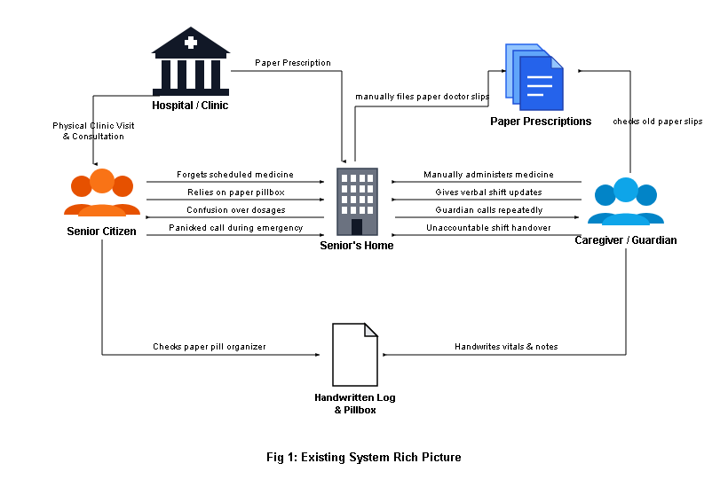
Fig 1: Existing System Rich Picture

1.4 Objective
The primary objectives of the Elderly Care Management System are:
- 1. Centralize Senior Health Baseline: Provide a unified electronic repository of chronic conditions, blood type, drug allergies, primary physicians, and emergency contacts.
- 2. Automate Medication Schedules & Adherence Tracking: Eliminate missed or duplicated medications through schedule alerts and single-click logging.
- 3. Streamline Healthcare Provider Consultations: Maintain scheduled appointments, clinic locations, and digital prescription archives accessible across family members.
- 4. Standardize Daily Care Routines (ADLs): Enable structured task checklists (meals, hydration, physical mobility, vital signs) with timestamped records.
- 5. Instant Emergency SOS Alerting: Deliver a single-touch panic button that dispatches real-time distress alerts, GPS location, and medical briefs to guardians and paramedics.
- 6. Health Data Privacy and Role-Based Protection: Protect personal medical records through encrypted storage, hashed authentication, and strict privilege segregation.
- 7. Deliver Longitudinal Wellness Analytics: Produce downloadable analytical charts and summaries for family peace of mind and clinical consultations.
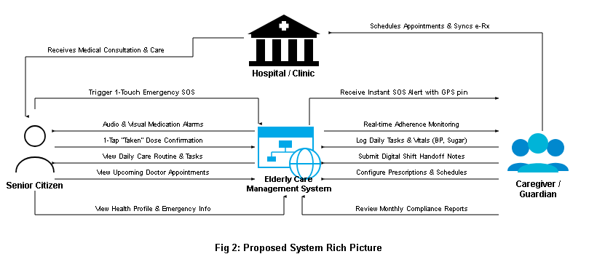
Fig 2: Proposed System Rich Picture

System Overview
The Elderly Care Management System allows families, caregivers, and healthcare professionals to coordinate, monitor, and safeguard geriatric health routines efficiently. In the past, eldercare required heavy manual effort, physical paper record-keeping, and disjointed phone calls that introduced dangerous communication gaps. As a result, critical tasks were frequently overlooked, and emergencies escalated unchecked. The Elderly Care Management System addresses these issues by offering an integrated web application that standardizes schedules, logs daily care, and dispatches instant alerts.

2.1 System Users
The system supports five distinct user classes, each with tailored interfaces and granular operational privileges:
- 1. Elderly Senior Citizen: Interacts through a high-contrast, large-font interface optimized for seniors. Can view daily medication alarms, tap single-click dose confirmations, and trigger the prominent Emergency SOS button.
- 2. Family Member / Primary Guardian: The administrative overseer of the care plan. Registers senior profiles, configures medication regimens, schedules doctor consultations, reviews caregiver shift notes, and receives distress SMS alerts.
- 3. Professional Caregiver: Certified home nurses or visiting aides. Uses a mobile-optimized shift dashboard to record completed ADL tasks, log measured physiological vitals, and compile digital shift handover reports.
- 4. Healthcare Provider / Doctor: Medical specialists and clinic physicians. Securely reviews longitudinal adherence records, vital trends, enters clinical visit notes, and formulates electronic prescriptions.
- 5. First Responder / Paramedic: Emergency medical personnel responding to distress alerts. Receives read-only access to vital baseline data: blood group, drug allergies, chronic conditions, and guardian phone.
- 6. System Administrator: Technical personnel responsible for maintaining platform integrity, managing credentials, database performance, and security policies.

2.2 System Architecture
The Elderly Care Management System is designed following a modern 3-Tier Layered Architecture, ensuring high maintainability, robust security, scalability, and clean separation of concerns:
- 1. Presentation Layer (Client Tier): The top-level interface through which users interact with the system via web browsers on desktop computers, tablets, or smartphones. Built using HTML5, CSS3, and JavaScript, delivering responsive dashboards with senior-accessible typography and high-contrast themes.
- 2. Application / Business Logic Layer (Server Tier): The middle tier executing core business logic, application routing, and security policies. Developed using PHP 8.2 on an MVC structure, coordinating authentication, scheduling algorithms, caregiver handoffs, and notification dispatching.
- 3. Data & Storage Layer (Database Tier): The persistence layer consisting of a relational MySQL 8.0 database engine. Stores user accounts, senior clinical baselines, medication master lists, scheduled dose logs, doctor appointments, daily care checklists, and emergency SOS audit logs.
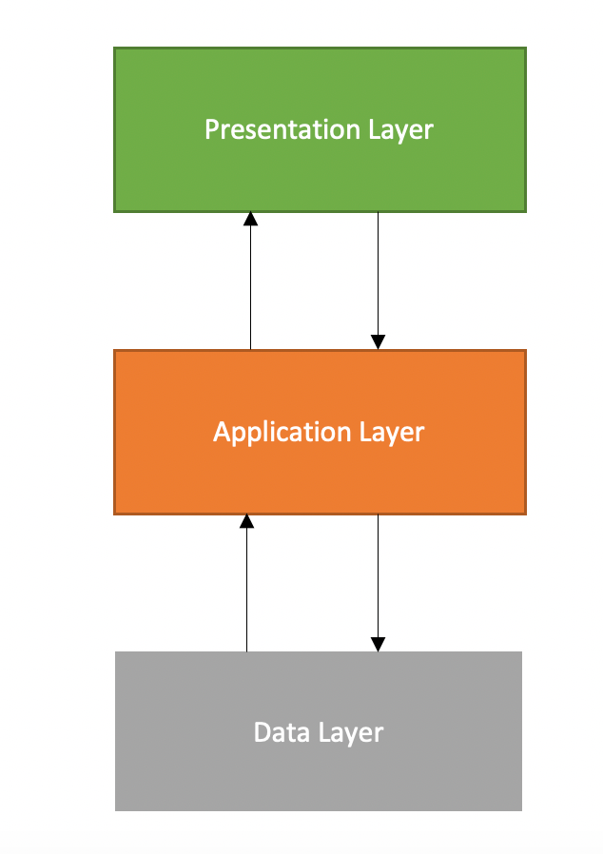
Fig 3: System Architecture [5]

2.3 System Modules
- Module 1: User & Role-Based Authentication: Manages account provisioning, login authentication, password reset, and role assignment (Senior, Guardian, Caregiver, Doctor, Admin).
- Module 2: Elderly Profile & Health Baseline: Maintains comprehensive digital profiles for seniors, documenting full names, birth dates, blood types, home addresses, chronic ailments, and drug allergy flags.
- Module 3: Medication Management & Adherence Tracker: Enables guardians and doctors to configure medication regimens, specify dosage units, set daily timings, and attach instructions. Generates visual reminders and allows single-click adherence logging.
- Module 4: Doctor Appointment & Clinical History: Streamlines the booking, rescheduling, and tracking of specialist consultations and diagnostic tests. Features digital document uploads for doctor prescriptions and laboratory reports.
- Module 5: Daily Care Tasks & ADL Routine: Coordinates non-pharmacological activities of daily living (ADLs) including hygiene, meals, hydration, and mobility, while recording physiological vitals.
- Module 6: Caregiver Shift Handoff & Care Notes: Standardizes the transition between outgoing and incoming care aides with mandatory handover reports documenting completed tasks, vital trends, and patient mood.
- Module 7: Emergency SOS Alert & Notification: Dispatches loud browser alarms, SMS messages, and emails with live GPS coordinates and emergency clinical briefs to guardians and paramedics upon panic button activation.
- Module 8: Family Oversight Dashboard & Reports: Aggregates care data into visual charts, tracking monthly medication compliance percentages, vital sign stability, and daily task completion.

2.4 Security and Verification
Given that the Elderly Care Management System processes sensitive personal and clinical data, security is an essential non-negotiable requirement. The system incorporates multi-layered defensive controls:
- 1. Authentication: Passwords encrypted using one-way cryptographic hashing via Argon2id / Bcrypt with dynamic salting. Passwords are never stored in plain text.
- 2. Authorization & RBAC: Granular Role-Based Access Control ensures that users can only access endpoints and data authorized for their role.
- 3. Session Management: Authenticated sessions use cryptographically random 128-bit session tokens stored with HttpOnly, SameSite=Strict, and Secure flags.
- 4. Input Validation & SQLi Prevention: All database interactions utilize PHP Data Objects (PDO) with parameterized prepared statements, preventing SQL injection.
- 5. Data Protection & Audit Trail: All communications operate over encrypted HTTPS/TLS 1.3 channels. Critical events are logged in an immutable audit table.

2.5 Software Development Tools
Category | Tools/Technology | Description
Frontend | HTML5, CSS3, JavaScript (ES6+) | Constructs responsive semantic markup, senior-accessible visual styling (WCAG AA), audio alerts, and interactive DOM manipulation.
Backend | PHP 8.2 | Implements MVC architecture, RESTful routing, domain business logic, cryptographic hashing, and database communication.
Database | MySQL 8.0 | Provides ACID-compliant relational data storage, foreign key enforcement, indexing, and transactional data integrity.
Server | Apache / XAMPP | Hosts local and staging application servers, managing virtual hosts and HTTP request lifecycles.
Design & Modeling | Draw.io / Lucidchart | Used for designing system architecture, ER diagrams, DFD data pipelines, and UML Use Case diagrams.
Version Control | Git & GitHub | Maintains source code versioning, branch management, collaborative tracking, and milestone releases.
Testing Tools | PHPUnit, Chrome DevTools | Executes backend unit testing, API endpoint validation, accessibility checks, and frontend performance profiling.
Notification Service | Twilio SMS API / SMTP | Dispatches real-time SMS distress messages and email alerts for emergency SOS and medication notifications.

2.6 Advantages of Using The System
- 1. Elimination of Paperwork: Eliminates physical prescription slips, paper notebooks, and unstructured medication logs.
- 2. Reduction in Medication Errors: Synchronized dosage schedules, loud audio-visual reminders, and single-click confirmations eliminate missed doses.
- 3. Transparency for Working Guardians: Enables family members to view real-time adherence logs and care activities from their workplace or mobile phones.
- 4. Caregiver Accountability: Digital shift handoffs and mandatory vital sign logging ensure visiting staff are held accountable.
- 5. Rapid Emergency Crisis Intervention: One-touch SOS button bypasses complicated smartphone navigation, broadcasting GPS locations and medical briefs within seconds.
- 6. Empirical Data for Consultations: Provides visiting physicians with verified, longitudinal adherence records and physiological trends.

System Life Cycle

3.1 Software Development Life Cycle
The development of the Elderly Care Management System adheres to a structured Waterfall / Iterative SDLC methodology. Because healthcare software directly impacts patient wellbeing and life safety, a systematic, phased engineering approach is required to guarantee clinical accuracy, requirement stability, and rigorous testing before production deployment.

3.1.1 SDLC Phases
- 1. Requirement Analysis: User requirements elicited through geriatric literature review, family guardian interviews, and clinical safety guidelines.
- 2. System Design: Translates verified requirements into 3-tier architecture, normalized relational schemas (ERD), data flows (DFD), and accessible wireframes.
- 3. Implementation (Coding): Modular construction of frontend interfaces (HTML5/CSS3/JS) and backend domain controllers (PHP 8.2, MySQL) following PSR-12 conventions.
- 4. Testing & Quality Assurance: Unit tests, integration tests across database boundaries, usability testing with senior personas, security audits, and SOS latency simulations.
- 5. Deployment & Release: Deploying the verified application onto a production cloud server configured with HTTPS/TLS certificates and automated backup cron jobs.
- 6. Maintenance & Evolution: Post-release monitoring, server performance tuning, periodic security patch installation, and ongoing feature refinements.
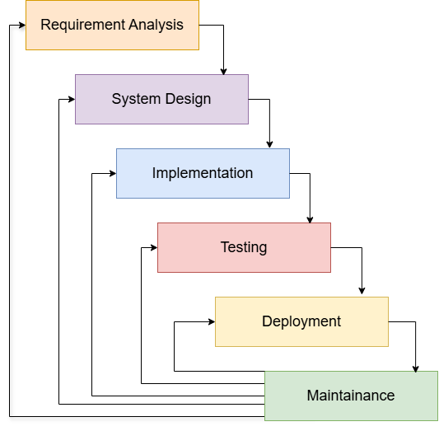
Fig 4: SDLC Process Diagram

Requirement Engineering

4.1 Requirement Elicitation
Requirement elicitation employed structured interviews with family guardians, clinical documentation reviews of paper charts, and direct observational studies of senior daily routines.

4.2 Requirement Analysis & Feasibility Study
- Technical Feasibility: Open-source LAMP stack (PHP, MySQL, Apache) is mature, reliable, and capable of sub-second response times without proprietary hardware.
- Economic Feasibility: Minimal licensing and infrastructure costs with high return on investment (ROI) in preventable hospitalization reduction.
- Operational Feasibility: Senior-friendly high-contrast UI and intuitive single-click interactions ensure rapid adoption.
- Schedule Feasibility: Structured into modular sprints delivering all functional milestones within the 12-week academic semester.

Functional requirements

5.1 Feature List with Description
- FR-01: User Account Registration: Allows family guardians, caregivers, and medical practitioners to create new accounts with email verification and role allocation.
- FR-02: Role-Based Authentication: Authenticates registered users based on their assigned role, generating secure session tokens and role-tailored dashboards.
- FR-03: Senior Profile Management: Enables guardians to maintain comprehensive digital profiles including DOB, blood group, drug allergies, primary physician, and home GPS coordinates.
- FR-04: Medication Scheduling: Allows guardians and doctors to configure prescribed medications, dosage amounts, daily timings, and meal instructions.
- FR-05: Real-Time Dose Logging: Provides intuitive controls for seniors or caregivers to mark doses as 'Taken', 'Missed', or 'Skipped' with mandatory omission notes.
- FR-06: Audio-Visual Reminders: Displays prominent visual banners and plays audio chimes 15 minutes prior to scheduled medication times.
- FR-07: Doctor Appointments: Facilitates booking specialist consultations, laboratory tests, and hospital follow-ups with calendar reminders.
- FR-08: Prescription Archive: Provides encrypted cloud storage for uploading scanned doctor prescriptions, blood test results, and discharge summaries.
- FR-09: Daily ADL Checklist: Establishes a daily routine checklist tracking essential non-medical tasks including bathing, oral hygiene, meals, and mobility.
- FR-10: Vitals Recording: Allows caregivers to record blood pressure, pulse rate, blood glucose, and body temperature, flagging abnormal readings in red.
- FR-11: Shift Handoff Notes: Mandates outgoing caregivers to submit an electronic shift handover summary documenting completed tasks, vital trends, and patient mood.
- FR-12: Emergency SOS Trigger: Prominent one-touch panic button that instantly dispatches browser alarms, SMS messages, and emails with live GPS coordinates and clinical briefs.
- FR-13: Family Live Dashboard: Consolidates daily adherence rates, vital trends, and caregiver logs into intuitive visual graphs for working family members.
- FR-14: Audit Trail Logging: Enforces strict input validation and writes immutable audit logs for all data mutations and emergency dispatches.

5.2 Feature Table
Feature ID | Feature Name | Description | Precondition | Role
FR-01 | User Registration | Register new user accounts with role selection | Valid email & phone | All Users
FR-02 | Login Authentication | Verify credentials and initiate secure session | Active account | All Users
FR-03 | Senior Profile Setup | Create and manage senior clinical baseline | Guardian logged in | Guardian
FR-04 | Medication Scheduling | Configure dosage, timing, and meal rules | Senior profile exists | Guardian, Doctor
FR-05 | Dose Adherence Logging | Log dose as Taken, Missed, or Skipped | Scheduled dose exists | Senior, Caregiver
FR-06 | Dosage Audio Reminders | Audio chimes and visual alert banners | Upcoming dosage time | System, Senior
FR-07 | Appointment Scheduling | Book and track doctor clinical consultations | Senior profile exists | Guardian, Doctor
FR-08 | Prescription Archive | Upload and view digital prescription scans | Appointment / Visit | Doctor, Guardian
FR-09 | Daily ADL Checklist | Structure and track meals, hygiene, mobility | Active care plan | Caregiver, Senior
FR-10 | Vitals Logging | Record BP, pulse, glucose with anomaly flags | Caregiver on duty | Caregiver
FR-11 | Shift Handoff Notes | Outgoing caregiver logs shift summary | End of care shift | Caregiver, Guardian
FR-12 | Emergency SOS Trigger | One-touch panic button for medical crises | Any system screen | Senior, Caregiver
FR-13 | Multichannel SOS Alert | Broadcast SMS, email, and GPS coordinates | SOS triggered | System
FR-14 | Family Live Dashboard | Central monitoring of vitals and adherence | Guardian logged in | Guardian
FR-15 | PDF Compliance Export | Export monthly health and adherence report | Adherence data exists | Guardian, Doctor
FR-16 | System Audit Logging | Log all user operations and mutations | Action performed | System, Admin

System Specification Diagrams

6.1 Entity Relationship Diagram
The Entity Relationship Diagram (ERD) defines the relational database architecture supporting the Elderly Care Management System. The schema is fully normalized to Third Normal Form (3NF), ensuring data integrity, elimination of update anomalies, and efficient indexing across primary and foreign key constraints.
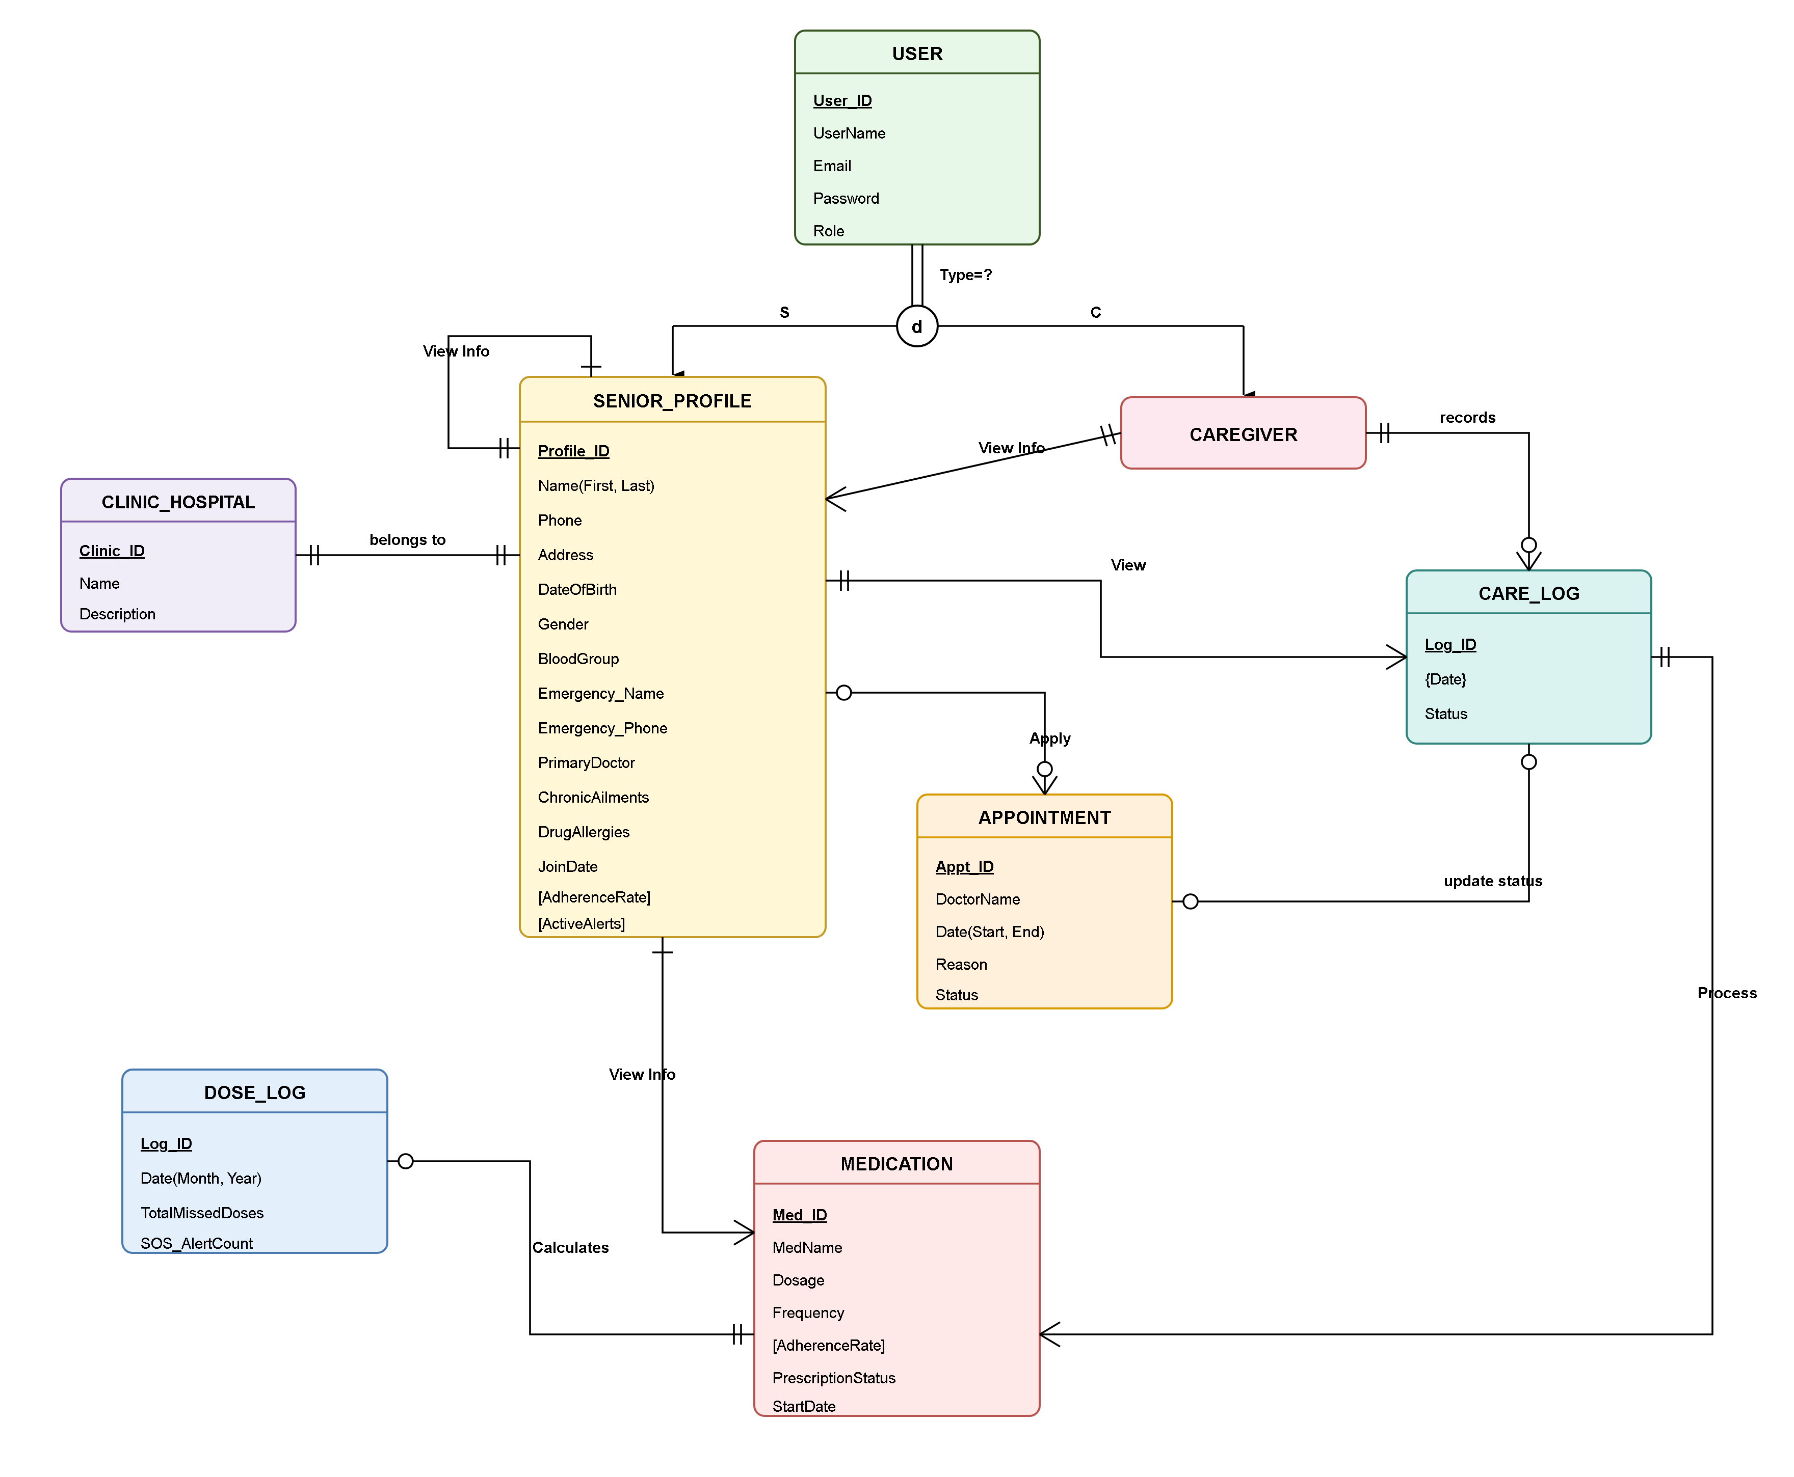
Fig 5: ER Diagram

6.2 Context Diagram (Level 0 DFD)
The Context Diagram (Level 0 DFD) defines the conceptual boundary of the Elderly Care Management System (ECMS) and illustrates the high-level information exchanges between the central application engine and external components: Administrator, Guardian, Caregiver, Doctor, Senior Resident, Twilio SMS Gateway, and SMTP Email Server.
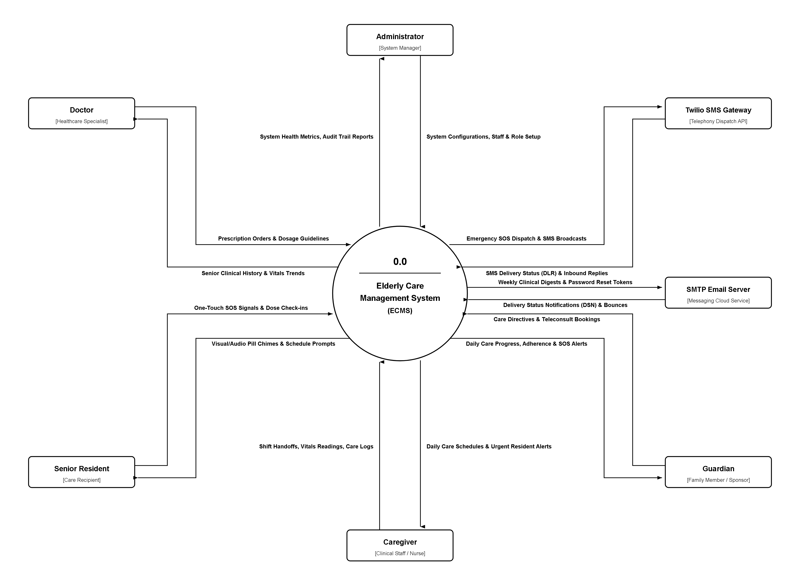
Fig 6a: Context Diagram (Level 0 DFD)

6.3 Data Flow Diagram
The Data Flow Diagram illustrates how information flows through the system, transitioning from external entities (Senior, Guardian, Caregiver, Doctor, Paramedics) through central application processes and into persistent relational data stores.
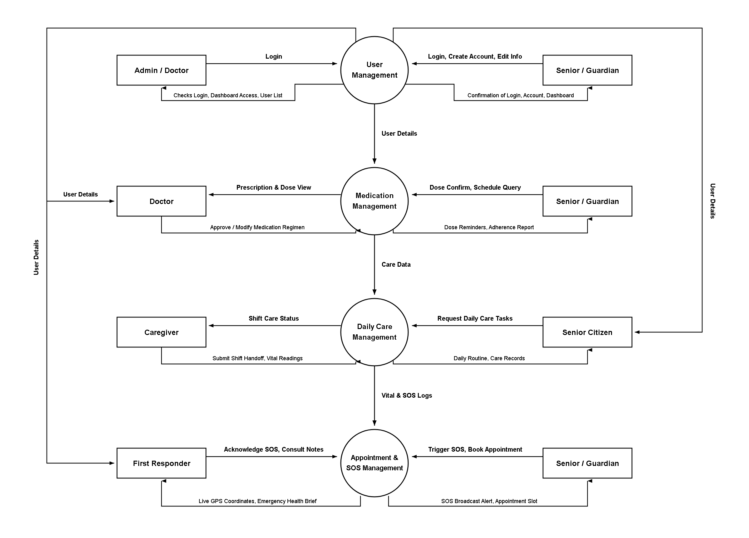
Fig 6b: Level 1 Data Flow Diagram

6.4 Use Case Diagram

6.4.1 User Management Subsystem
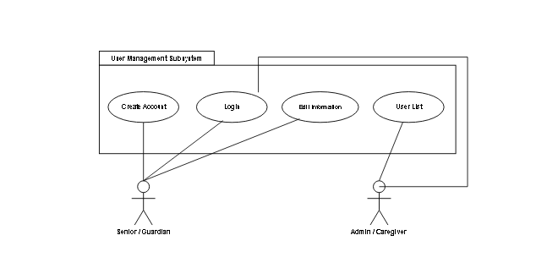
Fig 7: User Management Subsystem Use Case Diagram

6.4.2 Medication Management Subsystem
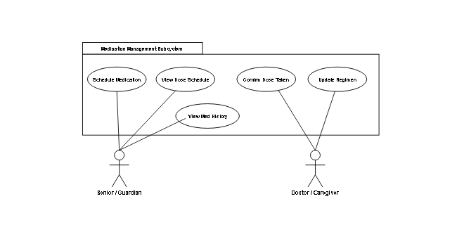
Fig 8: Medication Management Subsystem Use Case Diagram

6.4.3 Appointment Scheduling Subsystem
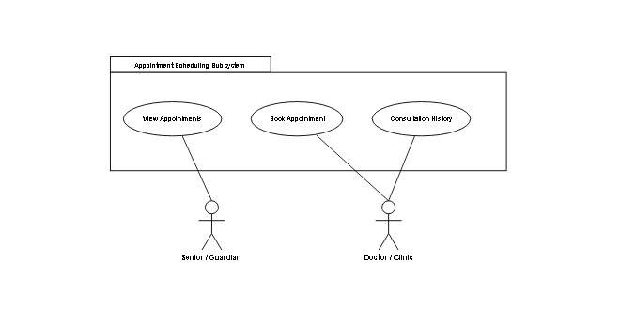
Fig 9: Appointment Scheduling Subsystem Use Case Diagram

6.4.4 Daily Care & Emergency SOS Subsystem
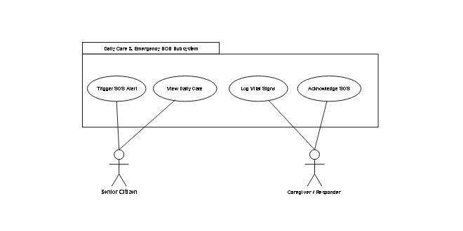
Fig 10: Daily Care & Emergency SOS Subsystem Use Case Diagram

6.5 Use Case Narration Table

6.5.1 User Management Subsystem Use Case Narration Table
Use Case Name | Create Account
Actors | Family Guardian, Caregiver, Doctor
Description | Users register a new account on the Elderly Care Management System by providing identification and credentials.
Precondition | User must not have an existing active account with the provided email. User must provide valid registration data.
Typical course of events | Actors Events | System Response  • User: User navigates to Registration page and inputs full name, email, phone number, role, and password.  System: System validates input formats, password strength, and verifies email uniqueness.  • User: User clicks 'Create Account' button.  System: System hashes password with Argon2id, creates database record, and displays success confirmation.  Alternative Flows:  Alt 02: System displays error 'Email is already registered. Please login.'  Alt 04: System highlights invalid phone number or weak password and prompts correction.
Post Condition | New user account is created in the database and the user can log in to their dashboard.

Use Case Name | Login
Actors | Senior, Family Guardian, Caregiver, Doctor, Admin
Description | Users authenticate into the system to access role-specific caregiving and oversight features.
Precondition | A valid registered user account must exist.
Typical course of events | Actors Events | System Response  • User: User enters registered email/phone and password on login screen.  System: System verifies credentials against stored cryptographic hash.  • User: User clicks 'Login' button.  System: System creates authenticated session and loads role-tailored dashboard.  Alternative Flows:  Alt 02: System displays 'Invalid email or password' and increments failed attempts counter.  Alt 04: Account locked temporarily after 5 consecutive failed attempts.
Post Condition | User is granted an active session and access to authorized features based on their assigned role.

Use Case Name | Edit Profile & Medical Baseline
Actors | Family Guardian
Description | Family Guardian updates senior personal details, home address, emergency contacts, blood group, and chronic conditions.
Precondition | Guardian must be logged in. A senior profile must exist under the guardian's management.
Typical course of events | Actors Events | System Response  • User: Guardian navigates to 'Senior Profile' and clicks 'Edit Baseline'.  System: System loads current profile fields in editable form.  • User: Guardian updates emergency phone, address, or chronic ailments and clicks 'Save Changes'.  System: System validates inputs, updates database, and displays 'Profile updated successfully'.  Alternative Flows:  Alt 04: If mandatory emergency phone number is blank, system displays validation warning and prevents submission.
Post Condition | Updated senior baseline and emergency contact details are committed to the database and immediately visible to caregivers.

6.5.2 Medication Management Subsystem Use Case Narration Table
Use Case Name | Add Medication & Dosage Schedule
Actors | Family Guardian, Healthcare Provider / Doctor
Description | Guardian or Doctor inputs a new prescription regimen, specifying medication name, dosage amount, timing, and meal relation.
Precondition | User must be logged in as Guardian or Doctor. Senior profile must exist.
Typical course of events | Actors Events | System Response  • User: User opens 'Add Medication' screen.  System: System displays prescription configuration form.  • User: User enters drug name (e.g., Amlodipine), dose (5mg), schedule times (08:00 AM, 08:00 PM), meal rule, and clicks 'Save Schedule'.  System: System validates entries, creates dosage schedule records in database, and initializes daily reminder alarms.  Alternative Flows:  Alt 04: If dose timing is unselected, system highlights missing required timing and prompts completion.
Post Condition | New medication schedule is saved and scheduled reminder alarms appear on senior and caregiver dashboards.

Use Case Name | Log Dose Taken / Missed
Actors | Elderly Senior, Professional Caregiver
Description | Senior or Caregiver records whether a scheduled medication dose was consumed, missed, or skipped.
Precondition | A scheduled medication dose event must exist for the current date and time.
Typical course of events | Actors Events | System Response  • User: When reminder triggers, user clicks large green 'Taken' button (or 'Missed/Skipped').  System: System prompts for optional note (mandatory reason if Skipped).  • User: User confirms action.  System: System writes timestamped dose log to database, updates adherence stats, and silences reminder alarm.  Alternative Flows:  Alt 01: If dose remains unconfirmed 30 minutes after scheduled time, system marks status as 'Pending Warning' and alerts Guardian.
Post Condition | Dose status is permanently recorded in the adherence log and updated in the Guardian's live feed.

6.5.3 Appointment Scheduling Subsystem Use Case Narration Table
Use Case Name | Schedule Doctor Appointment
Actors | Family Guardian, Healthcare Provider / Doctor
Description | Guardian books a medical consultation, diagnostic test, or hospital follow-up for the senior.
Precondition | Senior profile must exist. Guardian or Doctor must be logged in.
Typical course of events | Actors Events | System Response  • User: Guardian clicks 'Book Doctor Appointment'.  System: System displays appointment entry form.  • User: Guardian inputs doctor name, clinic address, appointment date, time, and reason for visit.  System: System validates date, saves appointment record, and sets automated reminder notifications.  Alternative Flows:  Alt 04: If selected date is in the past, system rejects entry with error 'Appointment date must be in the future.'
Post Condition | Appointment is confirmed, listed on the family calendar, and scheduled reminders are queued.

6.5.4 Daily Care & Emergency SOS Subsystem Use Case Narration Table
Use Case Name | Log Daily Care Tasks & Vitals
Actors | Professional Caregiver, Senior
Description | Caregiver records completion of non-medical daily tasks (hygiene, meals, walk) and enters measured vital signs.
Precondition | Caregiver must be logged in and assigned to the senior. Daily routine checklist must exist.
Typical course of events | Actors Events | System Response  • User: Caregiver opens 'Daily Care Checklist' screen.  System: System displays scheduled tasks (Breakfast, Bathing, Physical Mobility).  • User: Caregiver checks off completed tasks and inputs measured Blood Pressure (120/80) and Glucose (6.2).  System: System validates numerical ranges, stores logs in database, and updates Guardian's live feed.  Alternative Flows:  Alt 04: If entered blood pressure exceeds safety threshold (>150 systolic), system flags reading in bright red and notifies Guardian.
Post Condition | Daily care tasks and vitals are logged with timestamps, establishing an accountable audit trail.

Use Case Name | Trigger Emergency SOS Alert
Actors | Elderly Senior, Caregiver, Family Guardian
Description | Senior or Caregiver activates the prominent emergency panic button during acute medical crises or domestic falls.
Precondition | System is active on senior tablet, mobile phone, or caregiver terminal.
Typical course of events | Actors Events | System Response  • User: Senior presses the large red 'EMERGENCY SOS' button.  System: System captures live GPS coordinates and sounds local visual/audio distress alarm.  • User: System immediately dispatches emergency SMS and emails to Guardian and ambulance dispatch.  System: Emergency broadcast includes senior name, home address, GPS link, blood group, and drug allergies.  Alternative Flows:  Alt 01: 10-second cancellation window provided in case of accidental tap, allowing immediate disarm with PIN.
Post Condition | Emergency alert is permanently logged in audit table; all guardians and emergency personnel receive distress dispatch.

6.6 CRUD Matrix
The CRUD Matrix establishes data access privileges across the primary relational entities, defining which user roles have permission to Create (C), Read (R), Update (U), or Delete (D) specific database records.
Process / Entity | Senior | Guardian | Caregiver | Doctor | Admin
User Account | R | CRU | CRU | CRU | CRUD
Senior Profile Baseline | R | CRUD | R | RU | RD
Medication Schedule | R | CRUD | R | CRUD | RD
Dose Adherence Log | CR | RU | CRU | R | RD
Doctor Appointments | R | CRUD | R | CRUD | RD
Prescription Documents | R | CRUD | R | CRUD | RD
Daily Care Tasks (ADL) | R | CRUD | CRU | R | RD
Shift Handoff Notes | R | RU | CRU | R | RD
Emergency SOS Alerts | CR | CRU | CRU | R | RD
System Audit Trail | - | R | - | - | CRD

6.7 Activity Table
SL | Activity Code | Activity Name | Duration (Days) | Dependency
1 | A | Project Topic Selection & Scope Definition | 1 | -
2 | B | Requirement Elicitation & Feature Selection | 2 | A
3 | C | System Architecture & Database Schema Design | 2 | B
4 | D | User Authentication & RBAC Engine | 2 | C
5 | E | Senior Health Baseline & Profile Module | 3 | D
6 | F | Medication Master & Dosage Scheduling Module | 3 | E
7 | G | Real-Time Dose Adherence Logging & Reminders | 2 | F
8 | H | Doctor Appointment & Calendar Module | 3 | E
9 | I | Digital Prescription & Clinical Archive | 2 | H
10 | J | Daily Care Checklist & ADL Routine Module | 2 | E
11 | K | Caregiver Shift Handoff & Care Notes Module | 2 | J
12 | L | Instant Emergency SOS Panic & SMS Broadcast | 2 | E
13 | M | Family Guardian Oversight Live Dashboard | 2 | G, K, L
14 | N | Compliance Analytics & PDF Reporting | 2 | M
15 | O | End-to-End System Testing & Quality Assurance | 4 | All
16 | P | Comprehensive SRS Documentation Compilation | 3 | O
17 | Q | Cloud Deployment, Live Demonstration & Release | 1 | P

6.8 Gantt chart
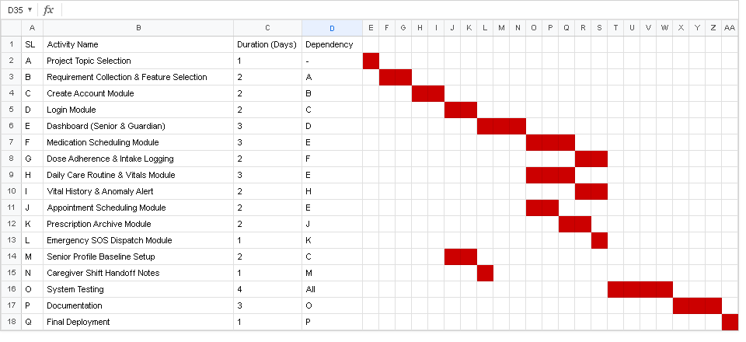
Fig 11: Gantt Chart

Non-Functional Requirements

7.1 Feature List with Description
- 1. Performance & Latency: Page loads render in under 2.0s over standard 4G/WiFi; query latency <200ms; Emergency SOS executes in <1.0s.
- 2. Reliability & Availability: 99.9% scheduled uptime with automated nightly offsite database backups and failover protection.
- 3. Security & Confidentiality: Full TLS 1.3 encryption, Argon2id password hashing, and AES-256 encryption at rest for sensitive health baselines.
- 4. Usability & Senior Accessibility: WCAG 2.1 AA compliant with high-contrast themes, 18px+ font options, and large 48px touch targets for seniors.
- 5. Scalability: Stateless PHP backend horizontally scalable to 10,000+ active care plans without locking contention.
- 6. Portability: Responsive HTML5/CSS3 cross-browser compatibility across Chrome, Firefox, Safari, and Edge.
- 7. Maintainability: Strict PSR-12 coding guidelines, modular MVC architecture, and comprehensive docstring comments.

Result Analysis

8.1 SWOT Analysis
Strength | Weakness
• Eliminates manual eldercare paperwork.  • Real-time medication adherence tracking.  • Instant 1-touch SOS with GPS location.  • Seamless caregiver shift continuity.  • Multi-role integration (Senior, Family, Doctor). | • Dependent on stable internet connectivity.  • Requires initial technical onboarding for seniors.  • Relies on caregiver integrity for accurate vital inputs.
Opportunities  • Integration with wearable IoT health monitors.  • Automated AI predictive fall detection.  • Telemedicine video consultation expansion.  • Automated pharmacy prescription refilling. | Threats  • Cybersecurity and health data breach risks.  • Cloud server downtime during emergency crises.  • Resistance to technology adoption by seniors.

8.2 Risk Matrix
Risk Factor | Likelihood | Impact | Solution / Mitigation Strategy
Database Loss / Corruption | Low | High | Automated daily offsite cloud backups & InnoDB transaction logs.
Unauthorized Health Access | Low | High | Argon2id hashing, TLS 1.3 encryption, and strict RBAC verification.
Network Failure during SOS | Medium | High | Local audio-visual alarm activates immediately; SMS dispatched asynchronously.
Caregiver Handoff Neglect | Medium | Medium | Mandatory digital shift sign-off before clock-out is permitted.

Conclusion
This Software Requirements Specification proposes a comprehensive, methodical, and human-centric approach to modernizing and automating geriatric care routines. Traditional eldercare systems—heavily reliant on physical pillboxes, handwritten notebooks, and fragmented phone communications—expose aging seniors to preventable medication omissions, shift communication breakdowns, and fatal emergency response delays.
The proposed Elderly Care Management System addresses these vulnerabilities through an integrated, multi-role web platform. By synchronizing medication schedules with real-time adherence logging, streamlining doctor consultations and digital prescription archives, standardizing daily living (ADL) routines, enforcing caregiver shift handoff accountability, and providing an instantaneous one-touch Emergency SOS broadcast with GPS coordinates and medical briefs, the platform establishes an unbroken circle of care around the senior.
The architectural design, relational schema, UML behavioral models, and verification frameworks articulated throughout this report demonstrate that the system is technically, economically, and operationally feasible. Built upon an accessible frontend and a secure relational backend, the Elderly Care Management System delivers profound socio-technological value: eliminating dangerous medication errors, fostering professional accountability, and granting working family members 24/7 peace of mind while preserving the independence and dignity of aging senior citizens.

References
[1] IEEE Computer Society, 'IEEE Recommended Practice for Software Requirements Specifications,' IEEE Std 830-1998, Institute of Electrical and Electronics Engineers, New York, 1998.
[2] ISO/IEC/IEEE, 'Systems and software engineering — Life cycle processes — Requirements engineering,' ISO/IEC/IEEE 29148:2018, Geneva, Switzerland, 2018.
[3] World Health Organization (WHO), 'Medication Safety in Polypharmacy: Technical Report,' WHO Patient Safety Global Action, World Health Organization, Geneva, 2019.
[4] World Health Organization (WHO), 'World Report on Ageing and Health,' WHO Press, Geneva, 2015.
[5] B. Bryan, 'Software Architecture Patterns: Layered Architecture Patterns,' Medium Software Engineering Publication, Available: https://yapbryan6.medium.com/software-architecture-patterns-layered-architecture-patterns-975ff2abec6f, [Accessed: Oct. 2025].
[6] World Wide Web Consortium (W3C), 'Web Content Accessibility Guidelines (WCAG) 2.1,' W3C Recommendation, Available: https://www.w3.org/TR/WCAG21/, 2018.
[7] Open Web Application Security Project (OWASP), 'OWASP Top 10: The Ten Most Critical Web Application Security Risks,' OWASP Foundation, 2021.
[8] R. S. Pressman and B. R. Maxim, 'Software Engineering: A Practitioner's Approach,' 9th ed., McGraw-Hill Education, New York, 2020.

