Keep Title Less than 120 Characters

First Author¹, Second Author², Third Author³

¹Monash University, School of Business and Economics,
McMahons Road, Frankston 3199, Australia
author1@email.com

²School of Computer Science and Engineering, Chung-Ang University,
221, Heukseok-dong, Dongjak-gu, Seoul 156-756, Korea
author2@email.com

³Monash University, Department of Management,
McMahons Road, Frankston 3199, Austria
author3@email.com

Abstract: These instructions provide you guidelines for preparing papers for Journal of Innovation and Social Science Research. Use this document as a template and as an instruction set.

Keywords: about four key words separated by commas.

Introduction

When you submit your paper print it in two-column format, including figures and tables [1]. In addition, designate one author as the “corresponding author”. This is the author to whom proofs of the paper will be sent. Proofs are sent to the corresponding author only [2].

Page Size and Layout

Set your page as A4, width 210, height 297 and margins as follows [3]:

- Left Margin 17.8 mm (0.67")
- Right Margin 14.3 mm (0.56)
- Top Margin – 17.8 mm (0.7")
- Bottom Margin – 17.8 mm (0.7")

You should use Times Roman of size 10 for all fonts in the paper. Format the page as two columns:

- Column Width 86.8 mm (3.42")
- Column Height – 271.4 mm (10.69")
- Space/Gap between Columns - 5.0 mm (0.2").

Title, Authors, Body Paragraphs, Sections Headings and References

Title and authors

The title of the paper is centered 17.8 mm (0.67") below the top of the page in 24 point font. Right below the title (separated by single line spacing) are the names of the authors. The font size for the authors is 11pt. Author affiliations shall be in 9 pt.

Body paragraphs

The main text for your paragraphs should be 10pt font. All body paragraphs (except the beginning of a section/sub-section) should have the first line indented about 3.6 mm (0.14").

Figures and Tables

Place illustrations (figures, tables, drawings, and photographs) throughout the paper at the places where they are first discussed in the text, rather than at the end of the paper. Number illustrations sequentially (but number tables separately). Place the illustration numbers and caption under the illustration in 10 pt font. Do not allow illustrations to extend into the margins or the gap between columns (except 2-column illustrations may cross the gap). If your figure has two parts, include the labels “(a)” and “(b)”.

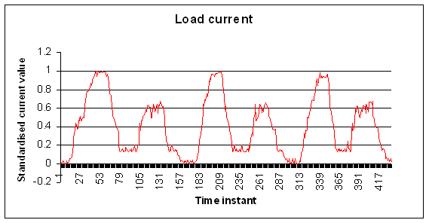
Figure 1: Testing data- load current (amperes)

Tables

Place table titles above the tables.
Table 1: Margin specifications
Margin | A4 Paper | US Letter Paper
Left | 18.5 mm | 14.5 mm (0.58 in)
Right | 18mm | 13 mm (0.51 in)

Sections headings

Section headings come in several varieties:
- first level headings: 1. Heading 1
- second level: 1.2. Heading 2
- third level: 1.2.3 Heading 3
- forth level: (a) Heading 4
- fifth level: (1) Heading 5

References

Number citations consecutively in square brackets [1]. The sentence punctuation follows the brackets [2]. Multiple references [2], [3] are each numbered with separate brackets [1]–[3]. Please note that the references at the end of this document are in the preferred referencing style. Please ensure that the provided references are complete with all the details and also cited inside the manuscript (example: page numbers, year of publication, publisher’s name etc.).

Equations

If you are using Word, use either the Microsoft Equation Editor or the MathType add-on (http://www.mathtype.com) for equations in your paper (Insert | Object | Create New | Microsoft Equation or MathType Equation). “Float over text” should not be selected.

Number equations consecutively with equation numbers in parentheses flush with the right margin, as in (1). First use the equation editor to create the equation. Then select the “Equation” markup style. Press the tab key and write the equation number in parentheses.

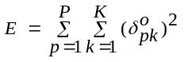 (1)

Other recommendations

Equalize the length of your columns on the last page. If you are using Word, proceed as follows: Insert/Break/Continuous.

References

- A. Bonnaccorsi, “On the Relationship between Firm Size and Export Intensity,” Journal of International Business Studies, XXIII (4), pp. 605-635, 1992. (journal style)
- R. Caves, Multinational Enterprise and Economic Analysis, Cambridge University Press, Cambridge, 1982. (book style)
- M. Clerc, “The Swarm and the Queen: Towards a Deterministic and Adaptive Particle Swarm Optimization,” In Proceedings of the IEEE Congress on Evolutionary Computation (CEC), pp. 1951-1957, 1999. (conference style)
- H.H. Crokell, “Specialization and International Competitiveness,” in Managing the Multinational Subsidiary, H. Etemad and L. S, Sulude (eds.), Croom-Helm, London, 1986. (book chapter style)
- K. Deb, S. Agrawal, A. Pratab, T. Meyarivan, “A Fast Elitist Non-dominated Sorting Genetic Algorithms for Multiobjective Optimization: NSGA II,” KanGAL report 200001, Indian Institute of Technology, Kanpur, India, 2000. (technical report style)
- J. Geralds, "Sega Ends Production of Dreamcast," vnunet.com, para. 2, Jan. 31, 2001. [Online]. Available: http://nl1.vnunet.com/news/1116995. [Accessed: Sept. 12, 2004]. (General Internet site)

Author Profile

<Author Photo>
Taro Denshi received the B.S. and M.S. degrees in Electrical Engineering from Shibaura Institute of Technology in 1997 and 1999, respectively. During 1997-1999, he stayed in Communications Research Laboratory (CRL), Ministry of Posts and Telecommunications of Japan to study digital beam forming antennas, mobile satellite communication systems, and wireless access network using stratospheric platforms. He now with DDI Tokyo Pocket Telephone, Inc.

