PC Build Manual

T. A. Kelley

# INTRODUCTION

B

uilding your own personal computer (PC) can be a highly educational and rewarding experience. This guide intends to provide an easy reference for prospective system builders. This guide is targeted for a popular audience -- all technical jargon is introduced before being used. Industry-standard best-practices will be followed, though the author will also provide some of his own personal input based on these practices.

# Workspace preparation

## Grounding

## Choose a clean, flat, non-conductive surface for your work environment, preferably a table at waist height you can stand over comfortably. Ground yourself from electrostatic discharge (ESD) by touching something conductive or wearing an anti-static wristband. Touching the frame of your case is a common practice for grounding recommended by the author.

Practicing good ESD-safety is generally considered a best practice, although anecdotal evidence may suggest there is no real risk of human-generated static electricity damaging components [1]. Despite this, ESD-safety is recommended by standards bodies like the IEEE, so it will be recommended here [2].

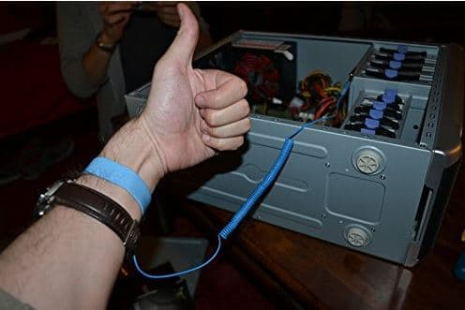

Figure 1. Demonstration of proper anti-static wrist band usage [11].

## Recommended Tools

These tools are considered mandatory for nearly all consumer PC build projects, since many components are fastened by

screws.

- Medium-sized phillips and flat-head screwdrivers

- Small phillips and flat-head screwdrivers

- Anti-static wristband

## Optional Tools

These tools are not absolutely necessary and are only useful in the rare case of dead-on-arrival (DOA) components -- and even then, most dead components can be deduced through simple troubleshooting, without the aid of (possibly expensive) dedicated component testers. If such components are not on-hand, they will also add considerable expense to the project. To this extent, the author considers them useful, but ultimately optional luxuries for most novice builders.

- Multimeter

- Various component testers

# Installation of components

## Motherboard

The motherboard is the backbone if the computer system. Its function is to link all the components together. Motherboards will determine the chipset, processor socket, processor vendor, RAM capacity, RAM speed, rear IO, storage architecture, and expansion options of your PC, among other things [3].

* Motherboards (also called mainboards or logic boards) are sold in a handful of form-factors [3].
  + ATX (305 x 244mm) - The most common motherboard form-factor for consumer PCs. This size will be used in the build demonstrated in this guide.
  + mATX (244 x 244mm) - A slightly shorter, square motherboard form-factor for smaller consumer PCs. Has fewer expansion slots than ATX boards but is equal in most other respects.
  + mini-ITX (170mm x 170mm) - A small form-factor for highly compact builds. Many boards are sold with an integrated CPU to reduce the need for a mounting bracket, allowing more components to be fitted onto the board.
  + E-ATX (305 x 330mm) - Used in high-end enthusiast builds or rackmount server hardware. This size is typically required for four-way SLI or CrossFire for increased gaming performance, as most ATX boards cannot fit four double-wide 16x PCI-e slots.

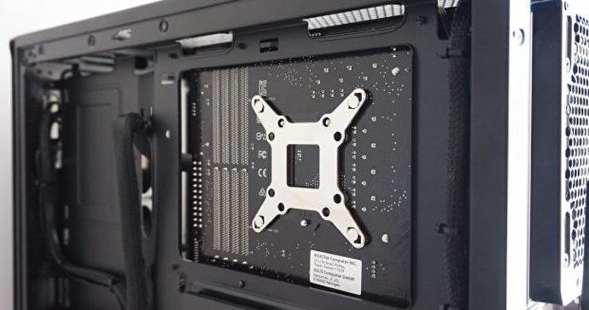

Figure 3. Motherboard with aftermarket CPU cooler backplate. This particular case has a cut-out for easy access to the backplate [4].

It is generally recommended by the author to assemble the computer outside of its case first, in order to ensure all the components are functional. If a component is DOA, it will be much easier to remove it and obtain a replacement if it has not already been installed in the case. This will add time to the build project, but will save far more time in the event of component failure. Additionally, if you suspect component failure once the computer has been installed in its case, you will know it will most likely be the result of user error since you have already tested everything beforehand. This guide will assume you have done this already and are ready to install the components in the case.

For the build demonstrated in this guide, we will be using an Intel-based LGA1166 ATX motherboard, the most powerful motherboard available to us on the shelf.

Remove the motherboard from its packaging and place it on its included anti-static packaging. If no anti-static packaging is available, you can place the board on the cardboard box it was shipped in, to reduce the risk of ESD damage.

Open the right-hand side-panel of your case and lay it flat on its left side. Locate the motherboard stand-off mounting holes in the main compartment of your case. Screw in, by hand, the motherboard standoffs into your case corresponding to the mounting holes located on your motherboard. This is to prevent the stand-offs from being over-tightened.

Figure 2. Case with right side panel removed. Note the grid-like location of the motherboard stand-offs, corresponding to the mounting holes on the motherboard [10].

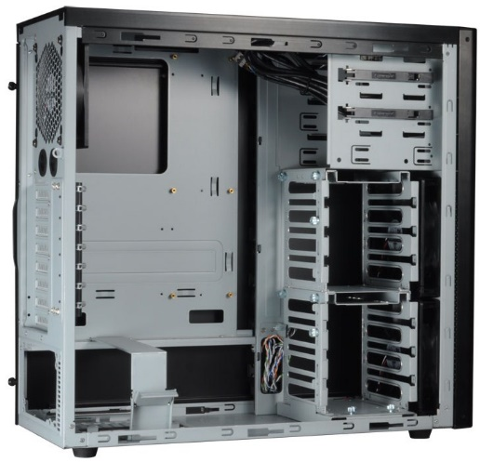

If you’ve purchased an aftermarket CPU cooler, you may need to install a backplate onto the rear of your motherboard in order to mount the cooler. If this is the case, consult the manual for your third-party cooling solution and install the CPU with its cooler before mounting the motherboard into the case, as the rear may be inaccessible once the motherboard has been installed [4]. For CPU installation instructions, see section C.

Pick up your motherboard by its edges (to reduce physical damage) and gently place it into the case, resting it on the motherboard stand-offs. The stand-offs should align nearly perfectly with the holes in your motherboard. If you find your motherboard resting on a standoff that is not near one of the mounting holes in your motherboard, relocate it. The board should be oriented such that the PCI-e expansion slots are facing downwards, located near the power supply. The memory slots should be near the top-left of the motherboard when mounted in the case, depending on your motherboard’s layout [4].

Locate the mounting screws that came with the motherboard stand-offs and screw them into the motherboard stand-offs, securing your motherboard to the case. Be very careful not to over-tighten these screws, as they could damage the delicate composite material of the circuit board. The motherboard should be mounted firmly and should not wiggle, but if you hear any sharp cracking sounds while you’re tightening the screws, you’ve tightened too much.

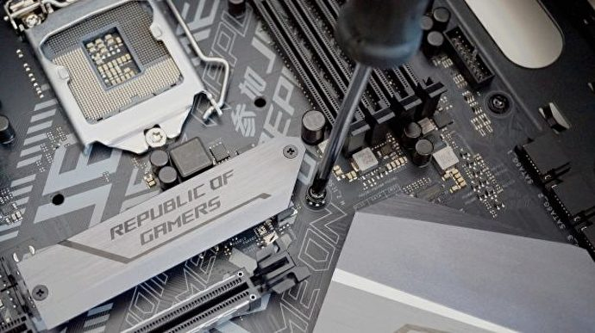

Figure 4. Tightening motherboard stand-off screws [4].

## Power Supply

The power supply (PSU) converts the 115v/230v AC power from your wall outlet to 3V, 5V or 12V DC power that your PC components can use. It is responsible for maintaining system stability and determining how efficient your PC is. A PSU that isn’t powerful enough for the other components of your PC can result in inconsistent performance, random shutdowns, or brown-outs. A variety of PSU calculators are available online to help determine the correct wattage PSU for your components.

A common standard used to measure PSU efficiency is the 80-plus specification. 80-plus-certified PSUs are at least 80% efficient at various loads. More information on 80-plus can be found at <https://www.tomshardware.com/news/what-80-plus-levels-mean,36721.html>.

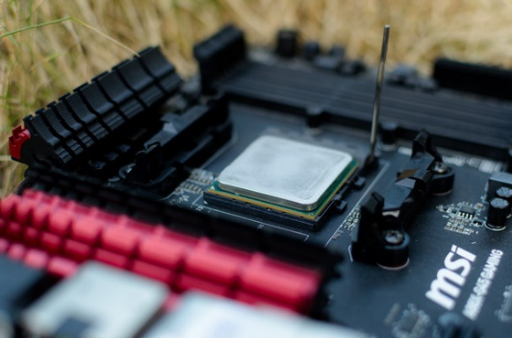

Figure 6. CPU with retaining latch lifted [7].

Many modern PSUs are modular, allowing the user to add and remove power cables as needed for the components available. This helps reduce cable clutter, which can improve airflow throughout the system. Modular PSUs are slightly more expensive than their equivalent counterparts, though the price difference is minimal and typically worth it [5].

For this build, we’ll be using a 750W PSUs to ensure a stable system and allow room for further expansion, such as additional drives or PCI-e cards.

Unpack the PSU from its packaging and place it in the bottom of your case. The side with the 3-prong male power plug should be facing the rear of your case and pressed up against the square cutout for the power supply. The rear of the PSU should align with a few screw holes around the PSU cutout.

Locate the screws that came with your case and screw them through the cutout and into the PSU, securing it to the rear of your case.

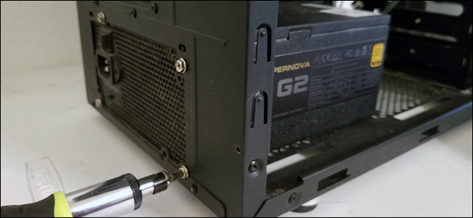

Figure 5. Securing the PSU to the rear chassis of the case [12].

Locate the voltage toggle-switch on the rear of your PSU, near the power plug. Switch it to the voltage according to your country. Yours will likely be 115V since this guide is intended for US-distribution only.

Leave the on/off switch on the rear of the PSU in the “off” position for now, for safety reasons.

## CPU

The central processing unit (CPU) is the brains of your computer, controlling all input and output operations of the PC. It is an extremely delicate piece of engineering, though perhaps the most reliable component in any system once installed. Depending on your video card, it will also be one of the most expensive components.

Different CPU manufacturers and product lines have different mounting methods to affix the CPU to the motherboard. As such, the CPU’s socket must be matched with the socket supported by the motherboard. For this build, we will be using an older Intel i7-975 LGA1366 CPU, released in Q2 2009 [6].

Carefully examine the corners of your CPU. One of them should have a small triangle printed on it. This triangle corresponds to a matching triangle on the CPU mounting socket on the motherboard, indicating the correct orientation of the CPU [7].

Lift the retaining latch of the CPU socket on the motherboard and gently set the CPU down in its correct orientation. It should drop snugly into place without any pushing or forcing necessary. If you feel like you have to push on the CPU, make sure you have the correct orientation.

Slowly bring down the retaining latch of the CPU socket until it locks into place. This should require some force but should be smooth, without any clicking or cracking noises.

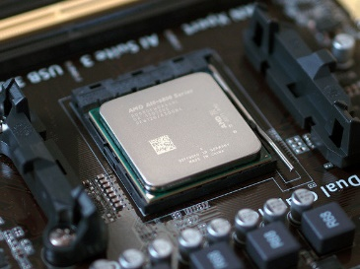

Figure 7. CPU with retaining latch properly secured [7].

If you’re planning on using the CPU cooler that came with your CPU (which is not recommended), you won’t have to apply any thermal paste to the CPU’s integrated heat spreader (IHS). If this is the case, consult the mounting instructions included with your CPU. Recent coolers included with Intel-manufactured CPU coolers typically use a tool-less snap-mounting system [6].

It is highly recommended to purchase an aftermarket CPU cooling solution, most of which are under $50 USD. This will allow your CPU to perform to its full potential and increase its operational lifespan.

If you’re using a third-party CPU cooling solution, consult its included manual for the proper mounting instructions. NEVER MOUNT A CPU COOLER WITHOUT THERMAL PASTE! [7]

* + There are a variety of methods for properly applying thermal paste to your CPU’s HIS in order to achieve the lowest operating temperatures. This guide recommends a small dot in the center of the IHS, slightly smaller than a pea. Be very careful not to over-apply thermal paste to the IHS, as too much thermal paste can actually have an insulating effect and counter-intuitively reduce thermal performance of the CPU, along with reducing its lifespan.
  + Some guides recommend smoothing out the dot of paste such that it is evenly spread throughout the entire surface of your IHS. Opinions differ on this, but this guide suggests simply leaving the dot in the center and allowing the mounting pressure of the CPU cooler to naturally disperse the thermal paste over the surface of the IHS.

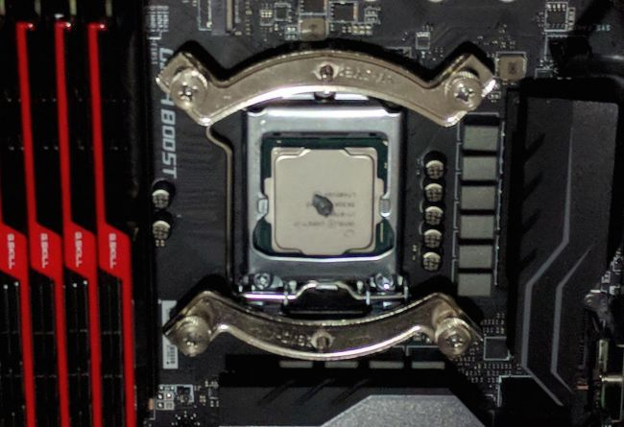Once thermal paste has been applied, carefully mount the third-party cooling solution to the CPU socket, according to its instructions.

Figure . The proper use of the “dot method” for applying thermal paste to the CPU’s IHS. Note the presence of a third-party mounting solution for a CPU cooler [13].

## RAM

Random-access memory (RAM) is similar to a human’s working memory. It allows the CPU to temporarily store data for easy and fast retrieval. The quantity of RAM will determine, in part, how many programs you can have running simultaneously on your PC. RAM speed should not be considered when purchasing RAM unless you are using an integrated graphics solution for your PC. This guide will be using discrete graphics, so RAM speed will be ignored. A separate metric of RAM, CAS latency, is far more meaningful to RAM performance [8]. This, however, is beyond the scope of this guide.

RAM sticks (called dual in-line memory modules, or DIMMs) are generational and correspond to what your motherboard supports. The motherboard used in this guide, for example, uses non-ECC DDR3*. More recent motherboards use DDR4. Each DDR generation is physically incompatible with all other generations, so it is impossible to install DDR4 into a DDR3 motherboard. As such, all motherboards will only support a single DDR generation. Newer DDR generations support newer features and faster speeds, though the speed difference in practice will likely be unnoticed, if meaningful at all.

*ECC refers to error-correcting memory, which is used in data-critical server applications. Most consumer-grade motherboards do not support ECC memory, so make sure the RAM you purchase for your build is non-ECC.

For the build in this guide, we will be using the maximum quantity of RAM our motherboard supports: six 2GB DIMMs for a total of 12GB RAM, allowing us to take advantage of the triple-channel speed advantage provided by populating every DIMM slot. If you intend to obtain better gaming performance from channeled RAM, however, you may be disappointed. Channeled RAM is not noticeably faster than non-channeled RAM in games, if at all [9]. If you are not using the maximum number of DIMMs supported by your motherboard, consult your motherboard manual for which slots to place your DIMMs in.

Open the retaining clips on each DIMM slot you wish to populate by gently pressing down on each one.

All RAM DIMMs are keyed -- they can only be inserted in a particular orientation. Examine the strip of gold along the bottom edge of each DIMM and you’ll notice a notch, offset from the geometric center of each DIMM by a few millimeters. Now observe the DIMM slots on your motherboard, to the right of the CPU and cooler. You will notice a similar notch in each slot, such that one half is slightly longer than the other half.

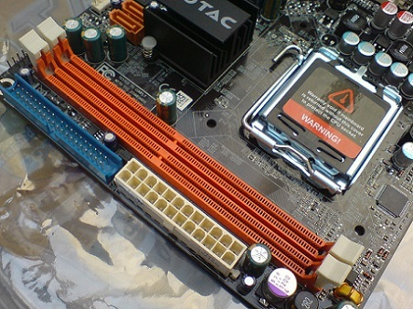

Figure 8. Detail image of DIMM slots. Note the notches slightly off-center. All four retaining clips are in the closed position [3].

Orient the first DIMM to align with the corresponding notch in the desired DIMM slot on the motherboard and insert the DIMM. It should be readily apparent if your DIMM is in the correct orientation as it will not fit into the DIMM slot, allowing you to quickly flip the DIMM around if it’s backwards.

Press down firmly on the top half of the DIMM until it becomes seated in its slot and the top retaining clip snaps upwards, indicating it has properly secured that half of the DIMM. Press down again on the lower half of the DIMM until the lower retaining clip snaps into place.

# References

|  |  |
| --- | --- |
| [1] | Tech YES City, "Can Static Electricity Damage Computer Parts? Do You Really Need an Anti-Static Wrist Band?," YouTube, 29 May 2015. [Online]. Available: https://www.youtube.com/watch?v=1la0a8RQ7kI. [Accessed 8 September 2019]. |
| [2] | J. Vinson and J. Liou, "Electrostatic discharge in semiconductor devices: an overview," *Proceedings of the IEEE,* vol. 86, no. 2, pp. 399-420, 1998. |
| [3] | T. Vartanian, "How a Motherboard Works," 18 February 2018. [Online]. Available: https://www.maketecheasier.com/how-motherboard-works/. [Accessed 09 September 2019]. |
| [4] | K. Castle, "How to install your motherboard," 27 June 2018. [Online]. Available: https://www.rockpapershotgun.com/2018/06/27/how-to-build-a-pc-2018-how-to-install-motherboard/. [Accessed 09 September 2019]. |
| [5] | A. Campbell, "What you need to know about power supplies," 20 July 2016. [Online]. Available: https://www.pcgamer.com/what-you-need-to-know-about-power-supplies/2/#targetText=Simply%20put%2C%20a%20modular%20PSU,attached%20permanently%20to%20the%20PSU.&targetText=The%20downside%20to%20having%20removable,use%20proprietary%20arrangements%20and%20conn. [Accessed 09 September 2019]. |
| [6] | Intel, "Intel® Core™ i7-975 Processor Extreme Edition," [Online]. Available: https://ark.intel.com/content/www/us/en/ark/products/37153/intel-core-i7-975-processor-extreme-edition-8m-cache-3-33-ghz-6-40-gt-s-intel-qpi.html. [Accessed 09 September 2019]. |
| [7] | T. Ryan, "How to install an Intel or AMD CPU in your computer," 24 August 2015. [Online]. Available: https://www.pcworld.com/article/2957260/how-to-install-an-intel-or-amd-cpu-in-your-computer.html#targetText=Start%20with%20your%20motherboard%20outside,LGA%20socket%20in%20the%20motherboard.&targetText=Now%20you%20can%20insert%20your,the%20edge%20of%20you. [Accessed 09 September 2019]. |
| [8] | L. Sebastian, "Does RAM speed REALLY matter?," Linux Tech Tips, 20 April 2017. [Online]. Available: https://www.youtube.com/watch?v=D_Yt4vSZKVk. [Accessed 09 September 2019]. |
| [9] | B. Hale, "Single Channel vs. Dual Channel vs. Quad Channel Memory," 13 September 2018. [Online]. Available: https://techguided.com/single-channel-vs-dual-channel-vs-quad-channel/#targetText=Dual%20Channels%20for%20Aesthetic%20Purposes,yet%2C%20four%20sticks%20of%20RAM.. [Accessed 09 September 2019]. |
| [10] | B. Tarunr, "Lancool Introduces PC-K9 Mid-Tower PC Case," 30 August 2011. [Online]. Available: https://www.techpowerup.com/151323/lancool-introduces-pc-k9-mid-tower-pc-case. [Accessed 09 September 2019]. |
| [11] | J. A. Padilla, "How to use Anti Static Wrist Strap / Wristband?," 29 May 2019. [Online]. Available: https://www.wepc.com/how-to/properly-use-anti-static-wrist-strap/. [Accessed 09 September 2019]. |
| [12] | M. Crider, "How To Upgrade and Install a New Power Supply for Your PC," 9 Aptril 2018. [Online]. Available: https://www.howtogeek.com/348257/how-to-upgrade-and-install-a-new-power-supply-for-your-pc/. [Accessed 09 September 2019]. |
| [13] | R. Fisher, "How do I apply thermal paste?," 24 January 2018. [Online]. Available: https://www.pcgamer.com/how-do-i-apply-thermal-paste/#targetText=Apply%20a%20thin%20line%20of,doesn't%20spread%20out%20evenly.. [Accessed 09 September 2019]. |