Prediction of drug permeation through microneedled skin by machine learning

Supplementary information (SI) 3

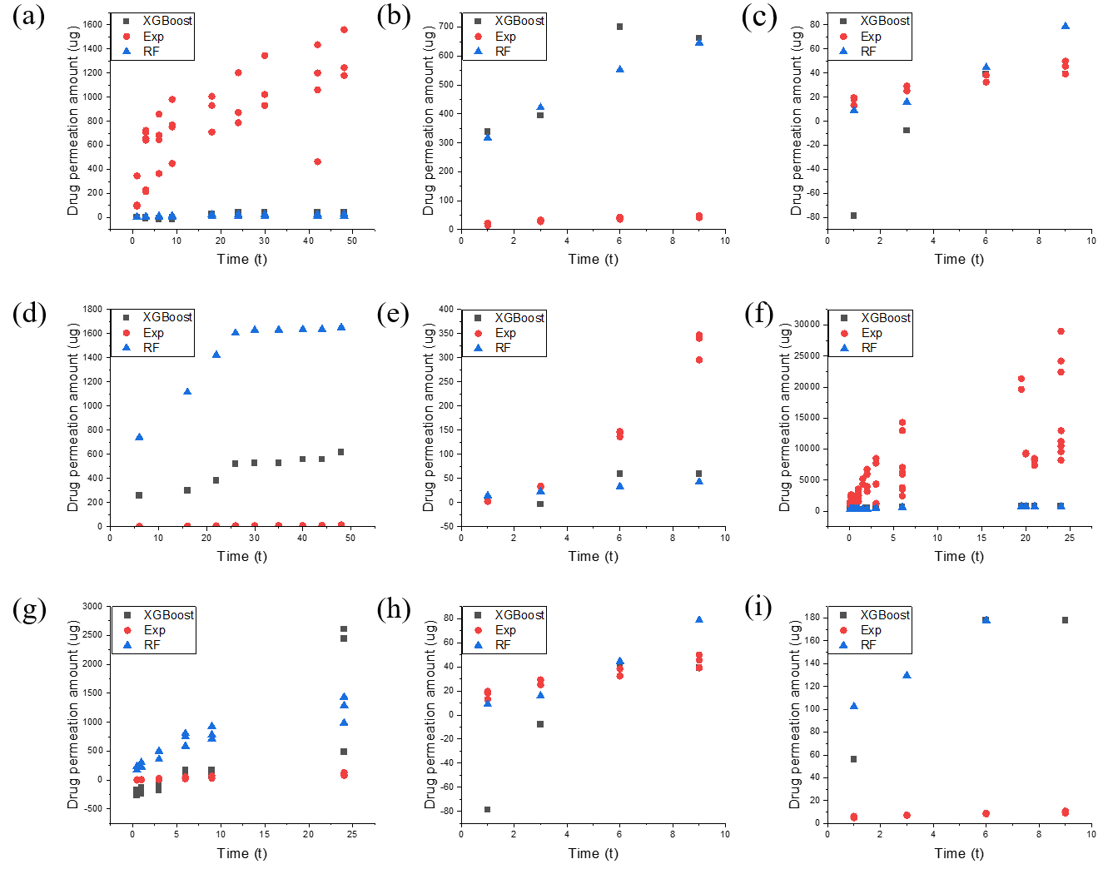

Figure S1. New drug permeation amount prediction: (a) BSA; (b) GHK(H); (c) GHK(R) (d) Rhodamine B(R); (e) Lidocaine(H); (f) Lidocaine(R); (g) Caffeine(H); (h) Cu(R); and (i) Cu(H). (R: in vitro rat skin permeation experiments, H: in vitro human skin permeation experiments

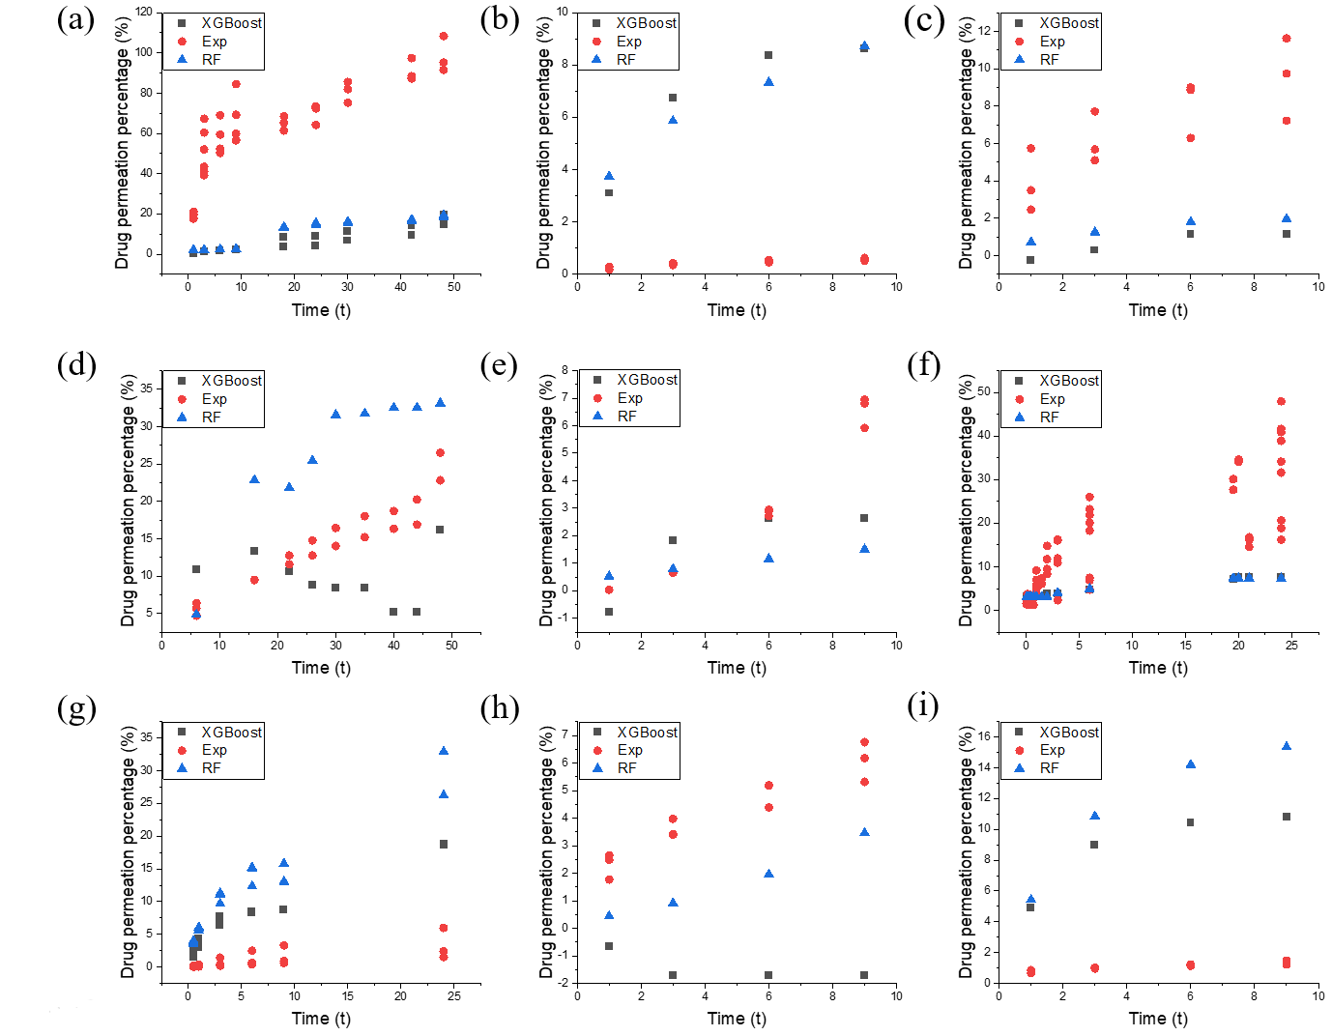
Figure S2. New drug permeation percentage prediction: (a) BSA; (b) GHK(H); (c) GHK(R) (d) Rhodamine B(R); (e) Lidocaine(H); (f) Lidocaine(R); (g) Caffeine(H); (h) Cu(R); and (i) Cu(H). (R: in vitro rat skin permeation experiments, H: in vitro human skin permeation experiments

