Leo Rauthause

CECS 451

Professor Moon

May 5, 2021

Assignment 13

1. 50 + 50 = $\sum_{n=1}^{100}{\left(γ^{n}\right)}$ + $\sum_{n=1}^{100}{\left(γ^{n}\right)}$

100 = 2 $\sum_{n=1}^{100}{\left(γ^{n}\right)}$

$\sum_{n=1}^{100}{\left(γ^n\right)}$\*

= 50

γ = 0.9844

A.) When γ > 0.9844 the agent will choose the down direction. When γ < 0.9844 the agent will choose the up direction

B.)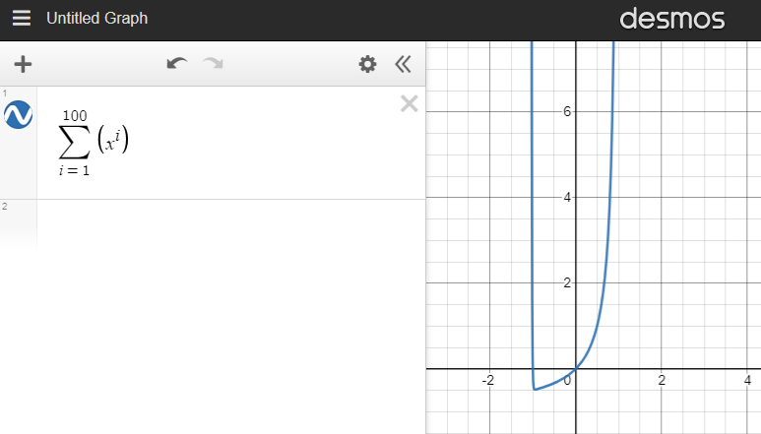

C.) For γ = ½ the agent will choose up since ½ < 0.9844

1. H(γ) = -0.6log2(0.6) – 0.4log2(0.4) = 0.97

H(A1) = 0.8 \* (-0.5log2(0.5) – 0.5log2(0.5)) = 0.8

H(A2) = 0.4(-log2(1)) + 0.6(-0.333log2(0.333) – 0.666log2(0.666)) = 0.55

H(A3) = 0.4(-0.5log2(0.5) – 0.5log2(0.5)) + 0.6(-0.333log2(0.333) – 0.666log2(2/3)) = 0.95

A.) Gain(A1) = 0.97 – 0.8 = 0.17

B.) Gain(A2) = 0.97 – 0.55 = 0.42

C.) Gain(A3) = 0.97 – 0.95 = 0.02

