- Figures

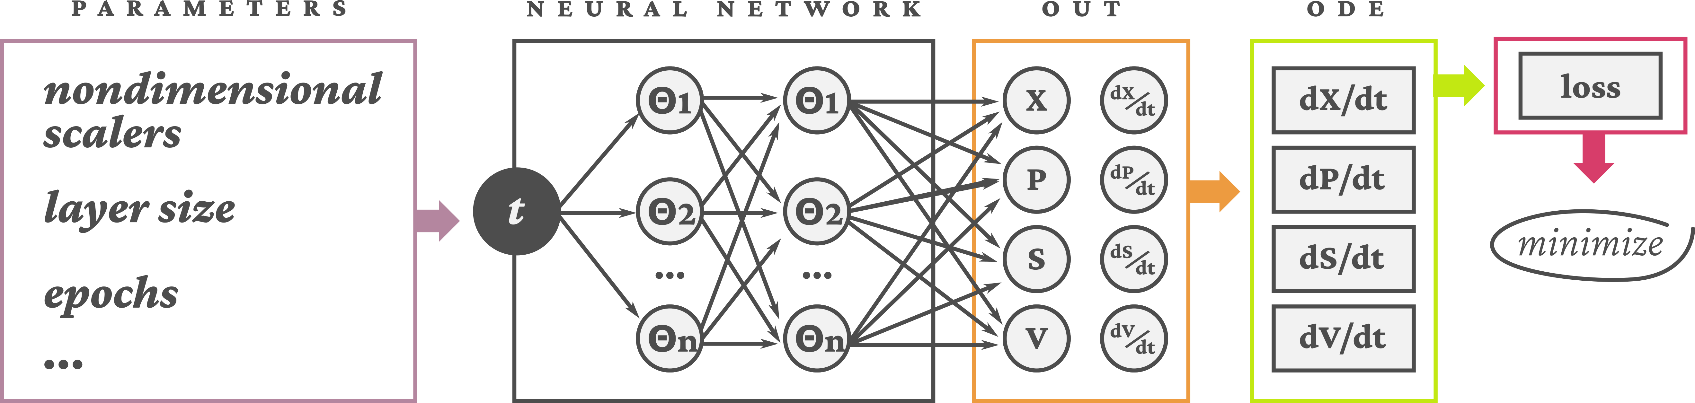Figure 1: Schematic of the PINN model
Figure 2: Nondimensional test, layer test and comparison between experimental data and PINN results
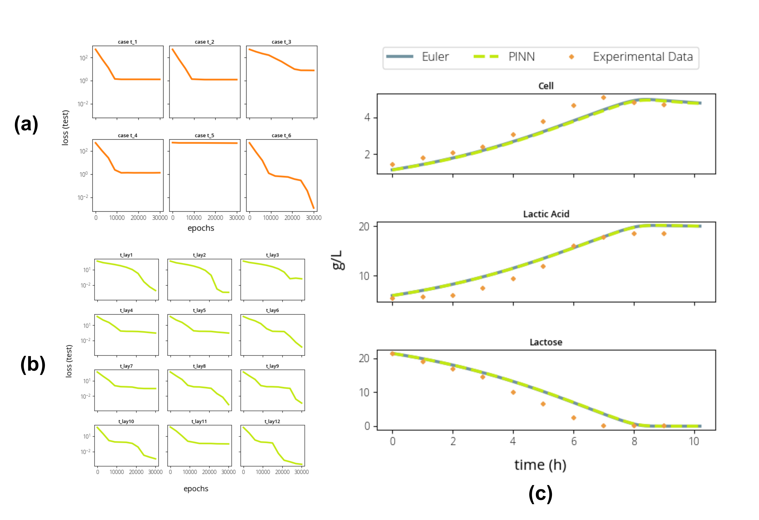

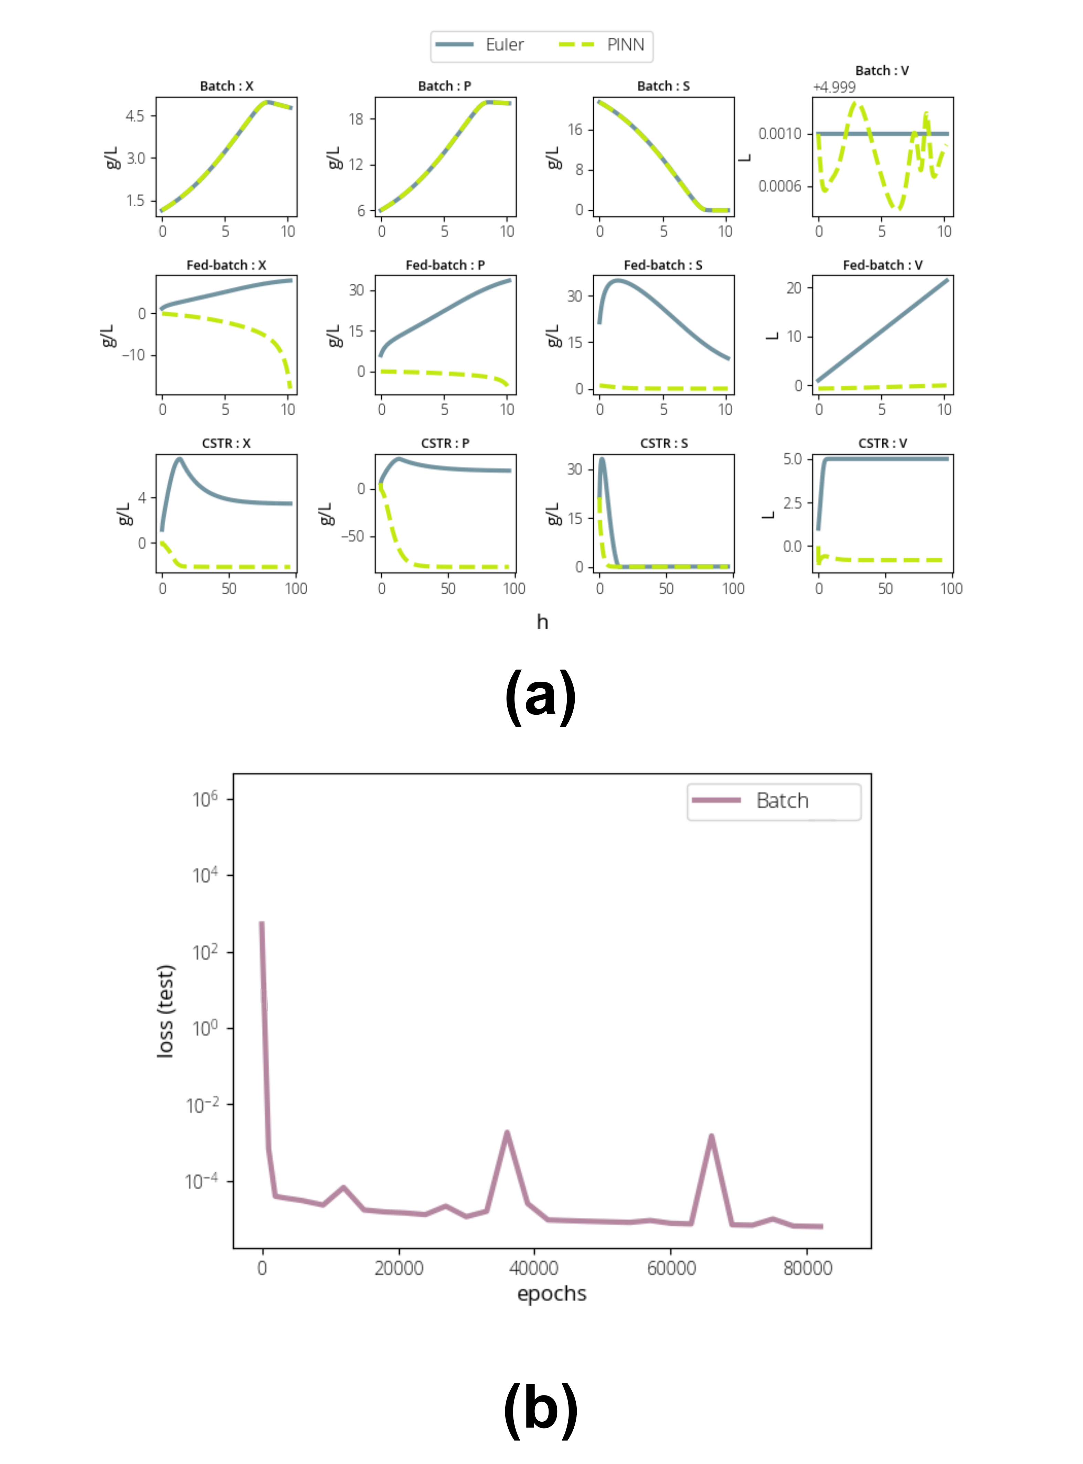Figure 3: PINN results comparison for Bacth, Fed-batch and CSTR reactors

