1. Figures

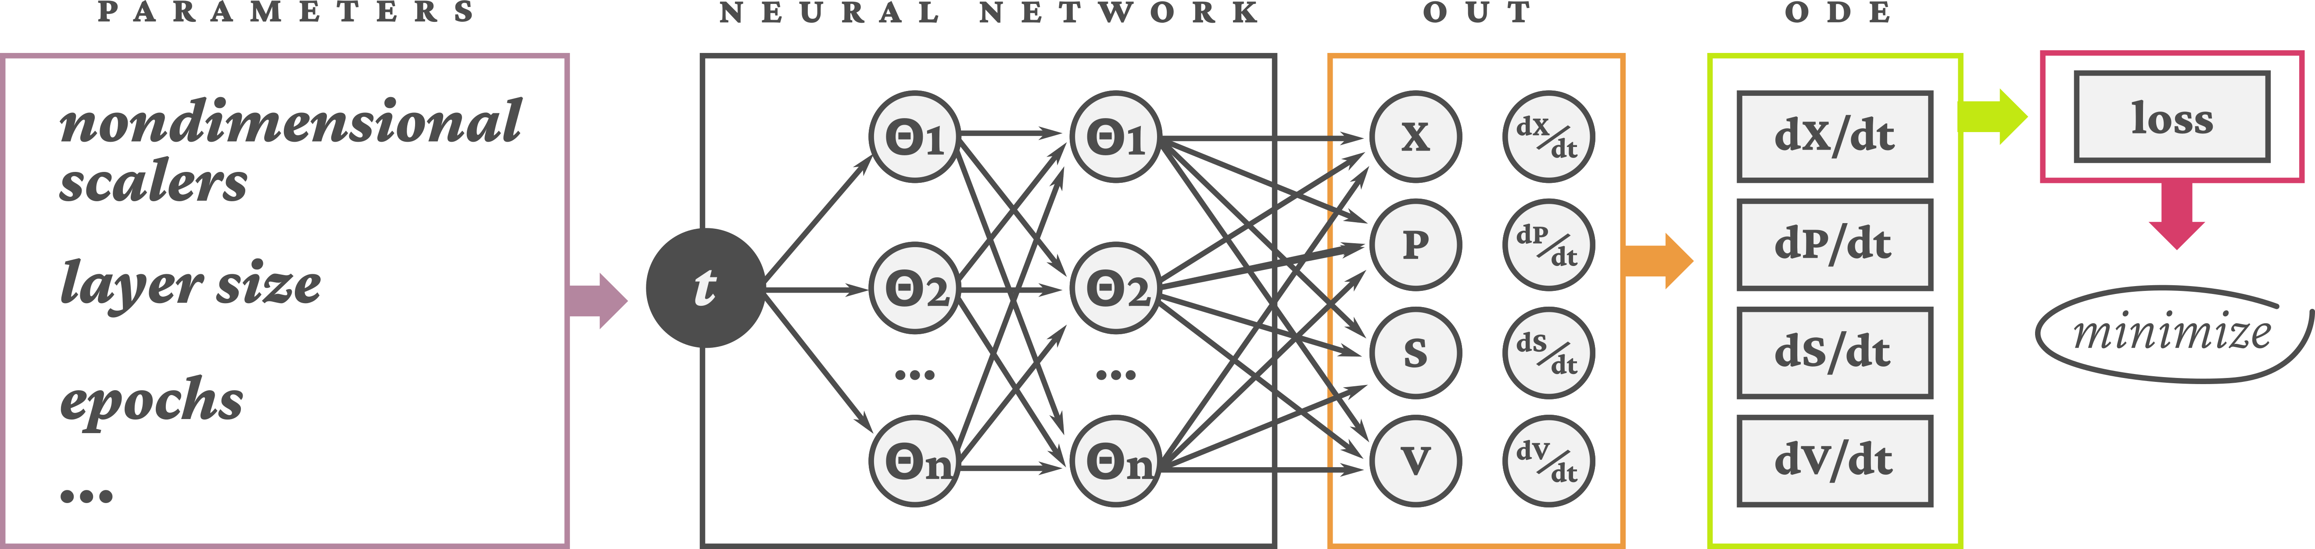Figure 1: Schematic of the PINN model

Figure 2: Nondimensional test, layer test and comparison between experimental data and PINN results

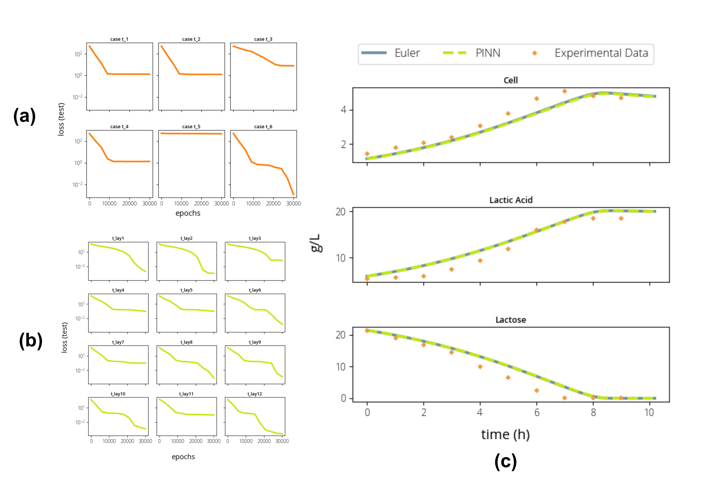

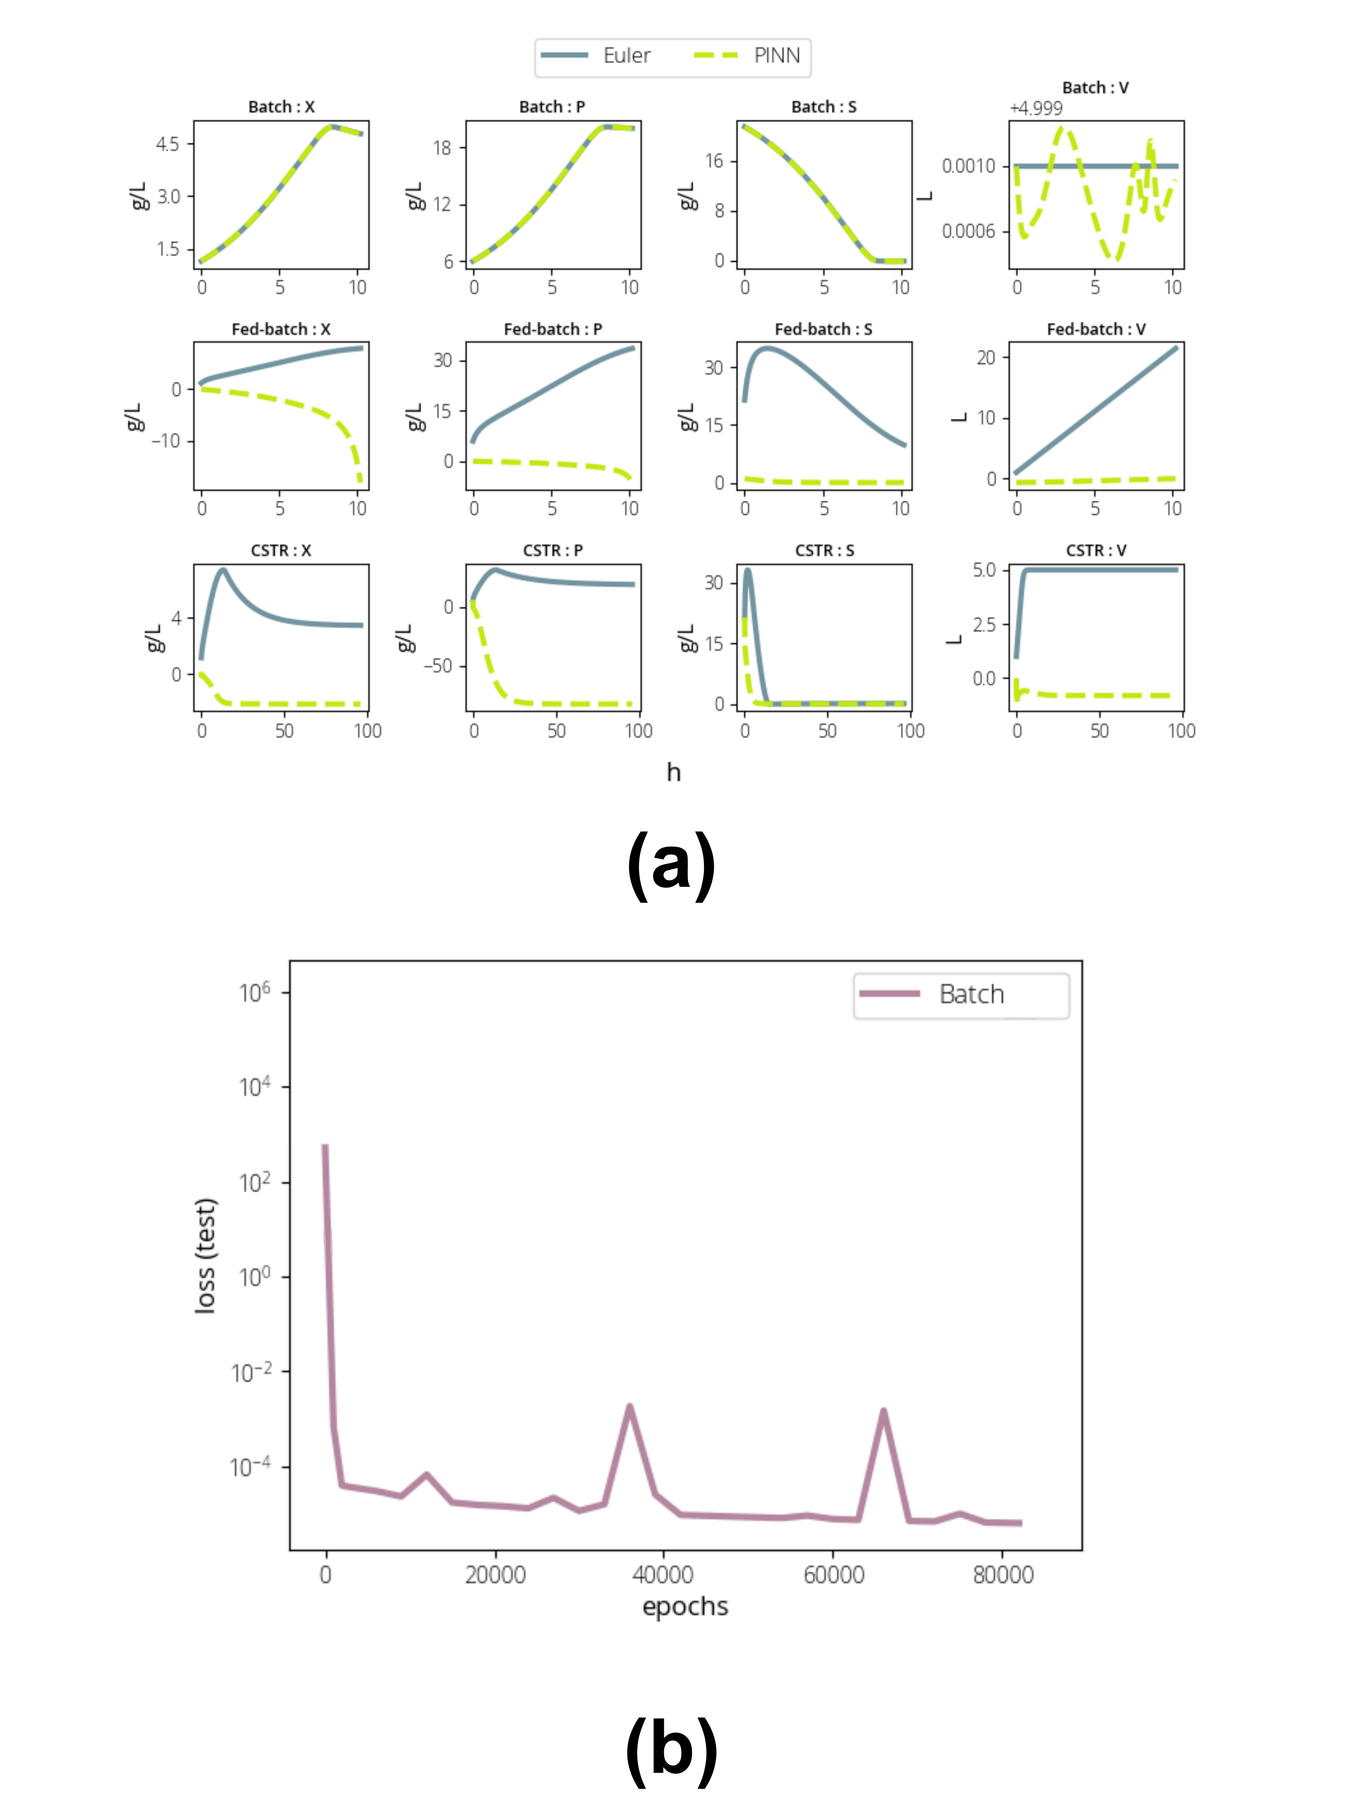Figure 3: PINN results comparison for Bacth, Fed-batch and CSTR reactors