A5100

F222353366

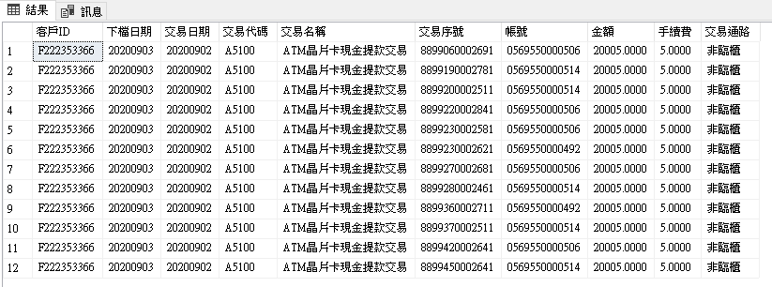

A124018069

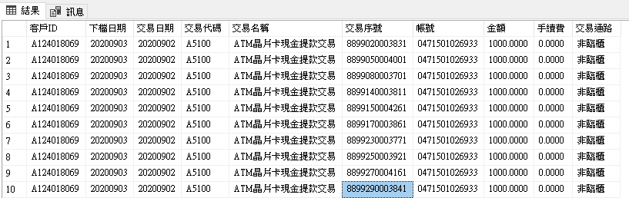

A129761930

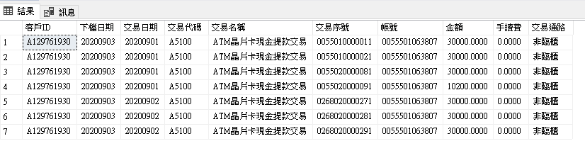

A222261493

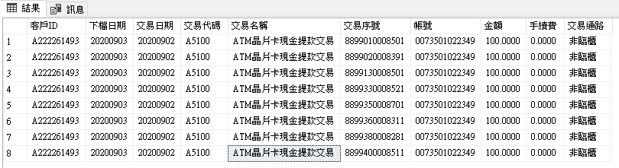

A100068049

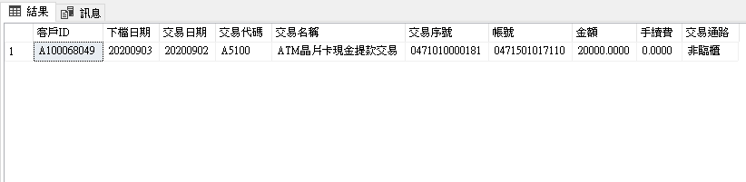

A5111

C220324579

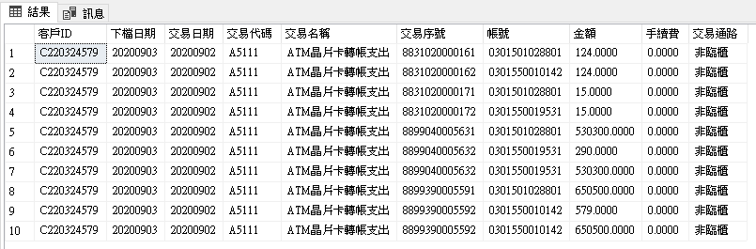

C290020433

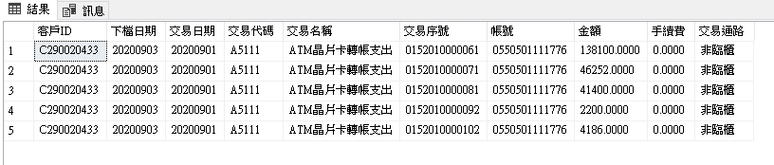

F125029749

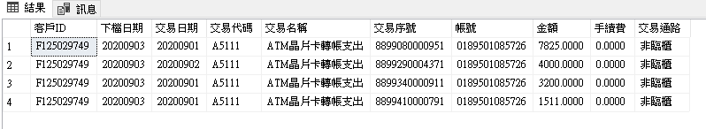

F125724847

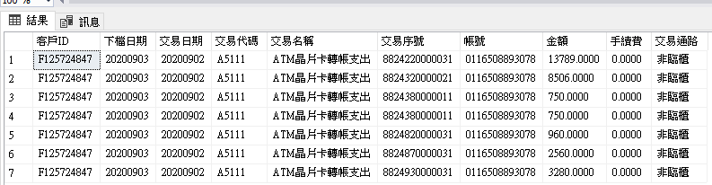

A100218325

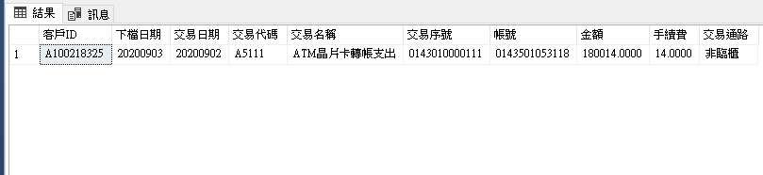

W1150

A227834601

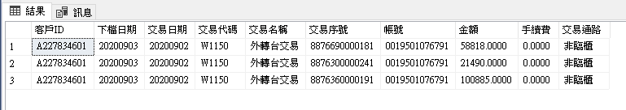

A101138737

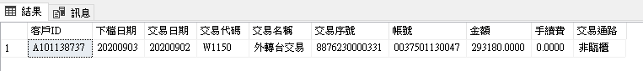

A120218607

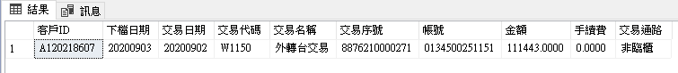

A125586404

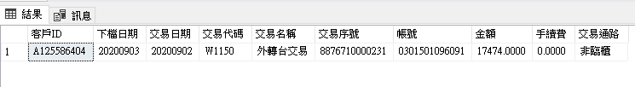

A126248234

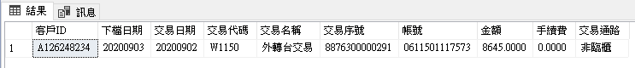

W1150(加碼)

A227834601



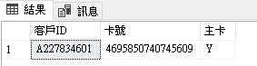

D101251023

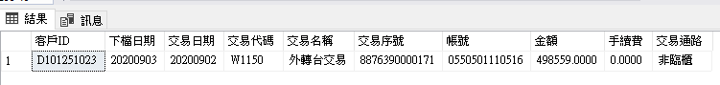

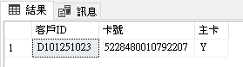

E120603780

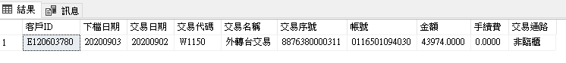

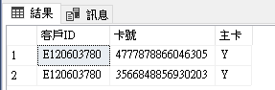

F128832793

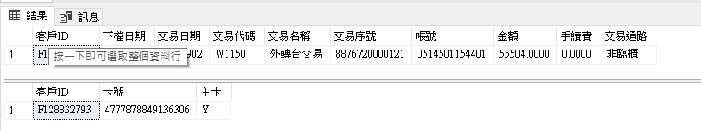

L221466831

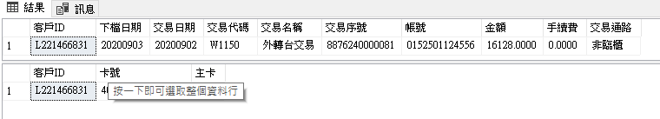

W1190

F222219538

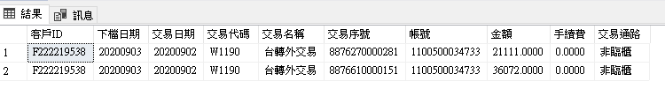

N225315364

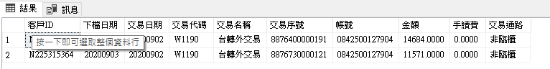

Q221674551

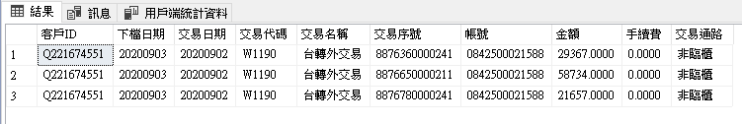

A100354219

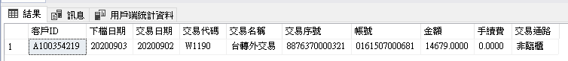

A104249237



W1190(加碼)

K221614051

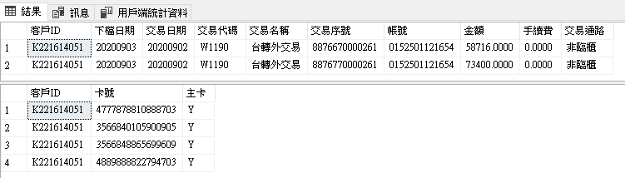

N225315364

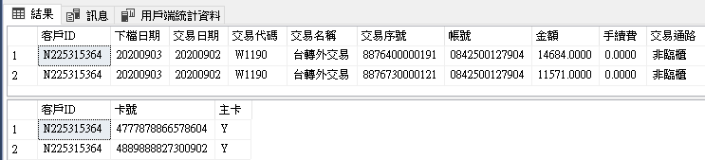

Q221674551

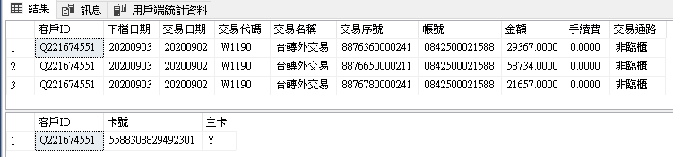

A123717741

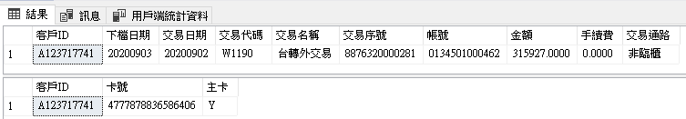

A124556788

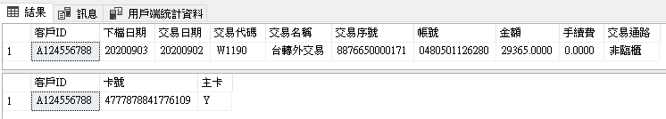

B4

A100203593

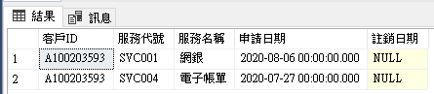

A100454563

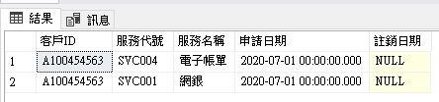

A100456441

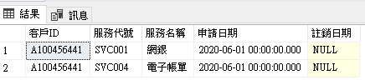

A101112948

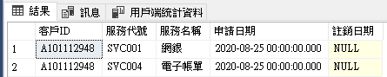

A101346015

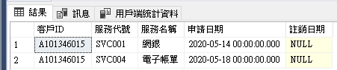

A111240093

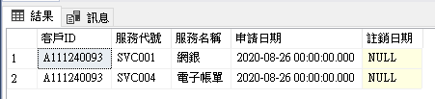

A111280177

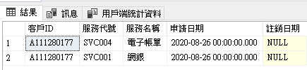

A120002430

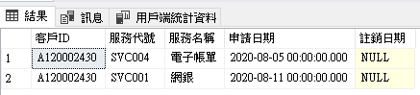

A120027544

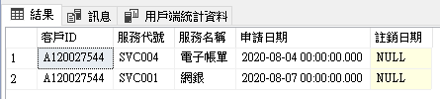

A120027866

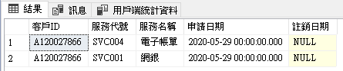

B4(加碼)

A101850158

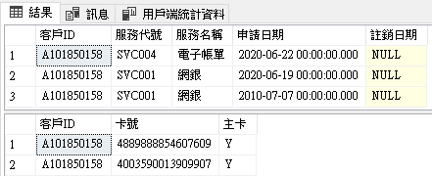

A102232663

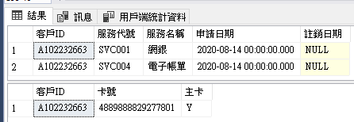

A103725176

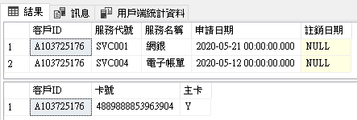

A127224934

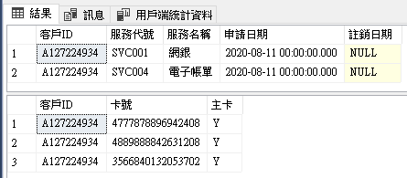

A127299851

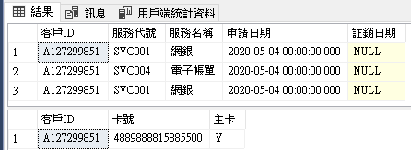

A127310453

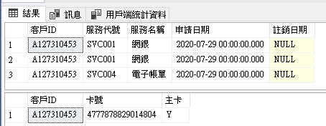

A127312153

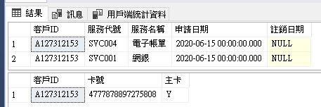

A127384828

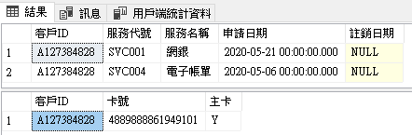

B5

Q120323535

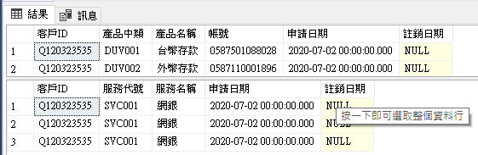

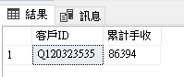

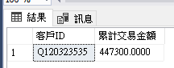

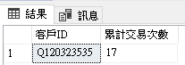

D120025598

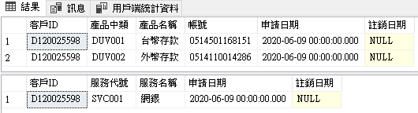

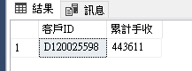

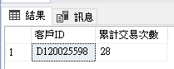

F128105817

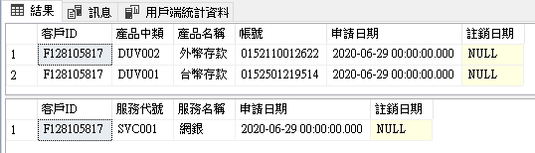

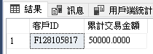

A125072692

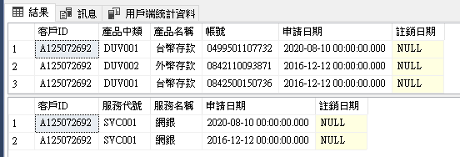

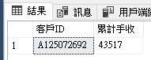

G120141063

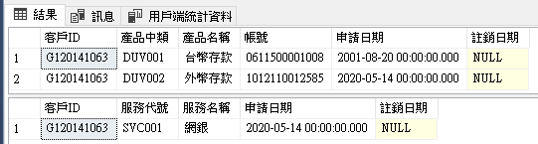

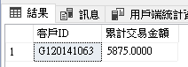

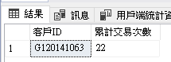

A222926346

