右键菜单

为控件A设置右键菜单1，先给窗体拉取ContextMenuStrip控件，然后设置控件A的属性ContextMenuStrip是该右键菜单。

点击主窗体的控件衍生出来的所有窗体，在关闭主窗体的时候会全部同时关闭。Application.Run()里面的窗体就是唯一的主窗体。

怎样在衍生窗体中关闭主窗体（关闭程序）？获取主窗体的引用即可；定义一个静态变量，在主窗体的加载load事件中，用this初始化该静态变量，那么主窗体的引用在任何地方都可以随时接触，关闭应用程序。

如何获取窗体的宽度和高度？

this.ClientSize.Width this.ClientSize.Height

如何设置TextBox多行和自动换行？

MultiLine（多行显示） 和 WordWrap（不会一行无限长不换行）

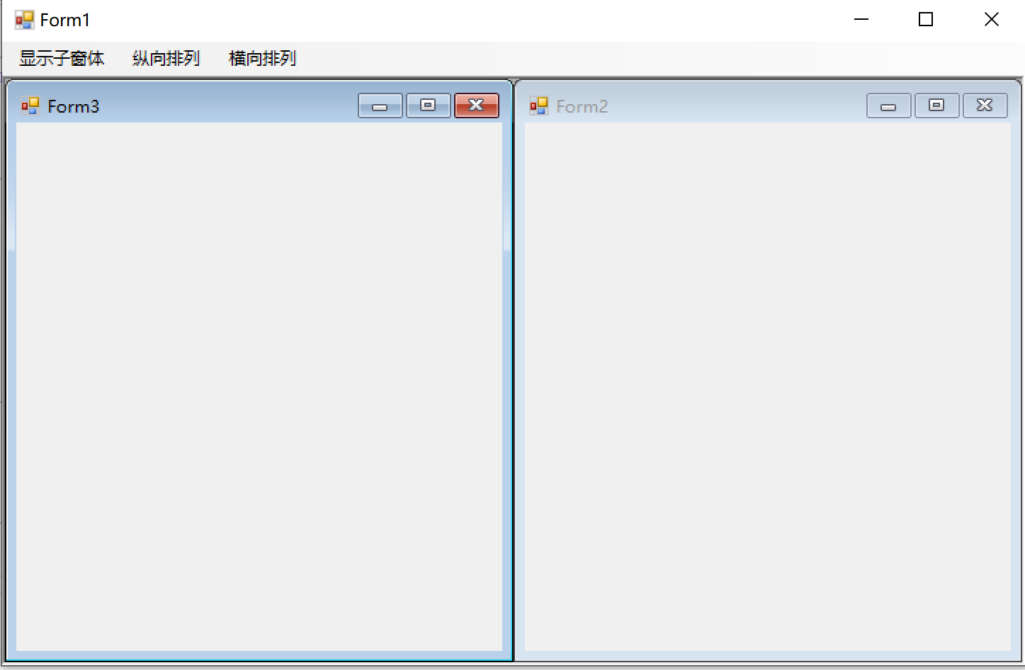

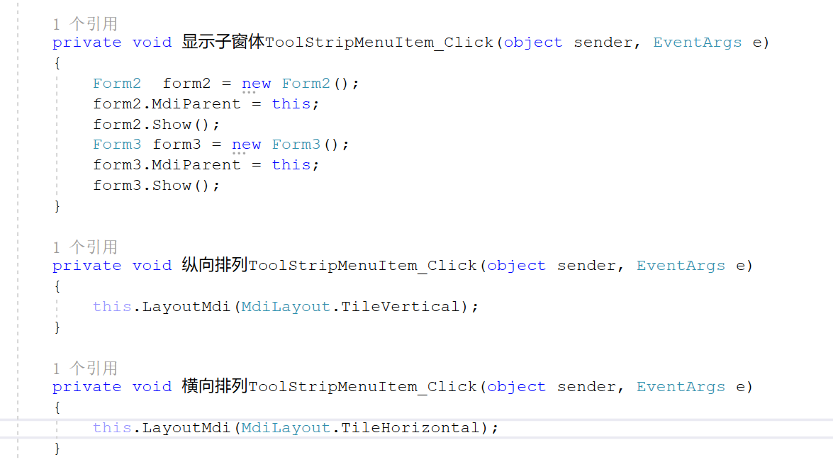

1. 设置父窗体的IsMdiContains属性是true；
2. 设置子窗体的MdiParent属性是父窗体；
3. public partial class Form1 : Form
4. {
5. //获取指定目录下所有文件的名称（包括路径）
6. public string[] path = Directory.GetFiles(@"C:\Users\soft\Desktop\Pictures");
7. int index = 0;
8. public Form1()
9. {
10. InitializeComponent();
11. }
12. private void Form1_Load(object sender, EventArgs e)
13. {
14. pictureBox1.SizeMode = PictureBoxSizeMode.Zoom;
15. pictureBox1.Image = Image.FromFile(path[index]);
16. }
17. //下一张
18. private void button2_Click(object sender, EventArgs e)
19. {
21. if(index < path.Length-1)
22. {
23. index++;
24. pictureBox1.Image = Image.FromFile(path[index]);
25. }
26. }
27. //上一张
28. private void button1_Click(object sender, EventArgs e)
29. {
30. if (index > 0)
31. {
32. index--;
33. pictureBox1.Image = Image.FromFile(path[index]);
34. }
35. }
36. }

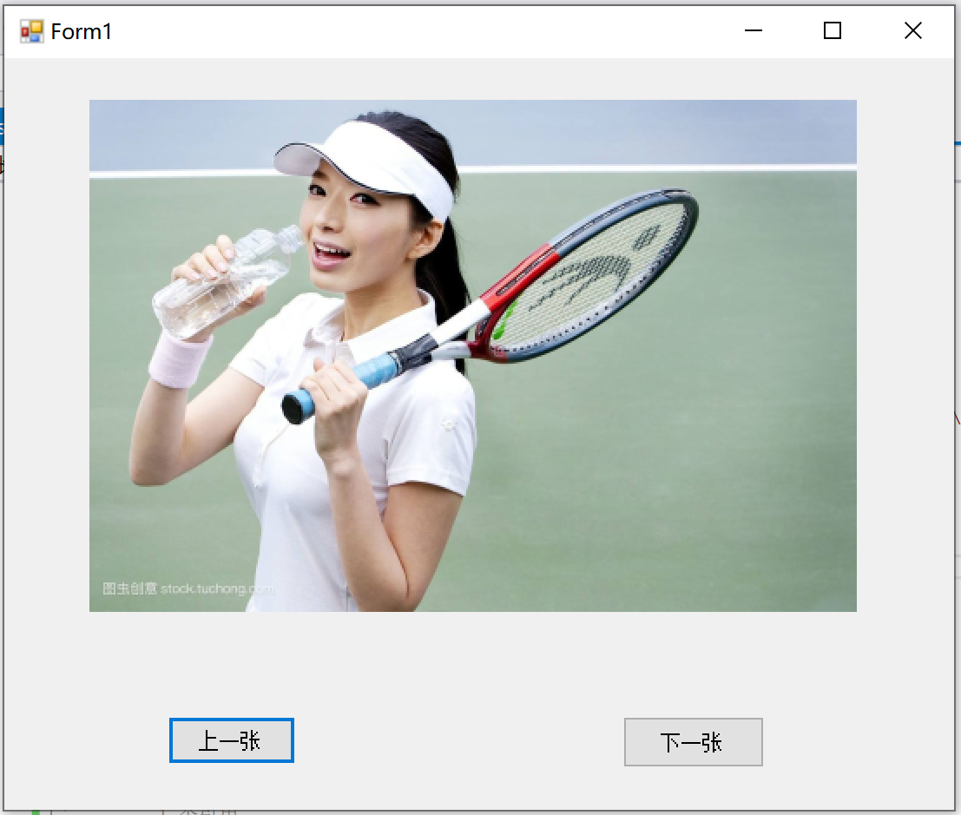

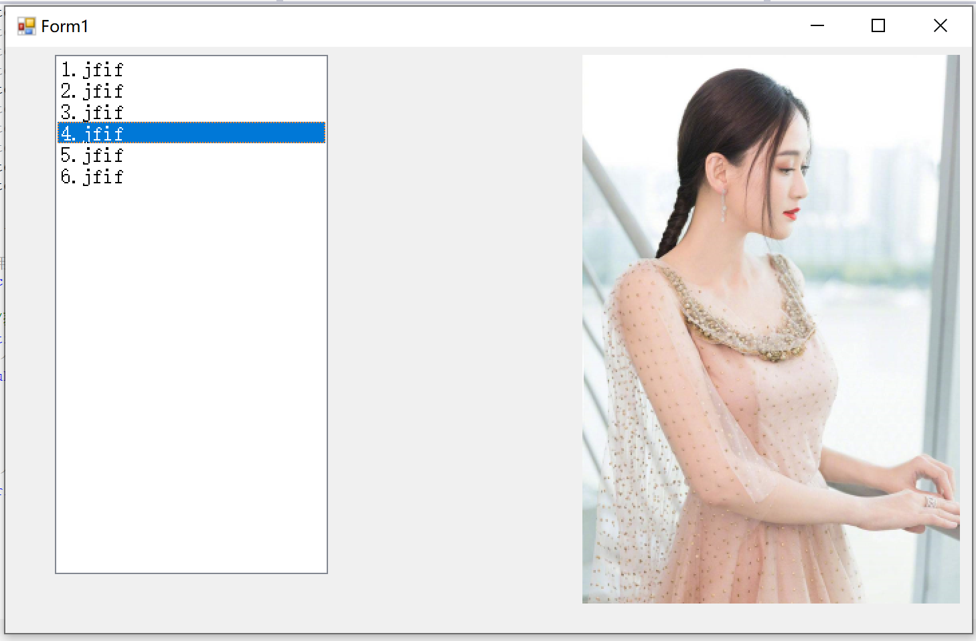

namespace listBox播放图片

{

public partial class Form1 : Form

{

//获取指定目录下所有特定后缀名文件的绝对路径+文件名

string[] path = Directory.GetFiles(@"C:\Users\soft\Desktop\C# Study\Pictures", "*.jfif");

public Form1()

{

InitializeComponent();

}

private void Form1_Load(object sender, EventArgs e)

{

//设置pictureBox的图片的格式

this.pictureBox1.SizeMode = PictureBoxSizeMode.Zoom;

//为listbox添加项

foreach (var item in path)

{

string fileName = Path.GetFileName(item);

this.listBox1.Items.Add(fileName);

}

}

private void listBox1_DoubleClick(object sender, EventArgs e)

{

//双击listbox的某一项，显示图片

this.pictureBox1.Image = Image.FromFile(path[this.listBox1.SelectedIndex]);

}

}

}

打开文件对话框

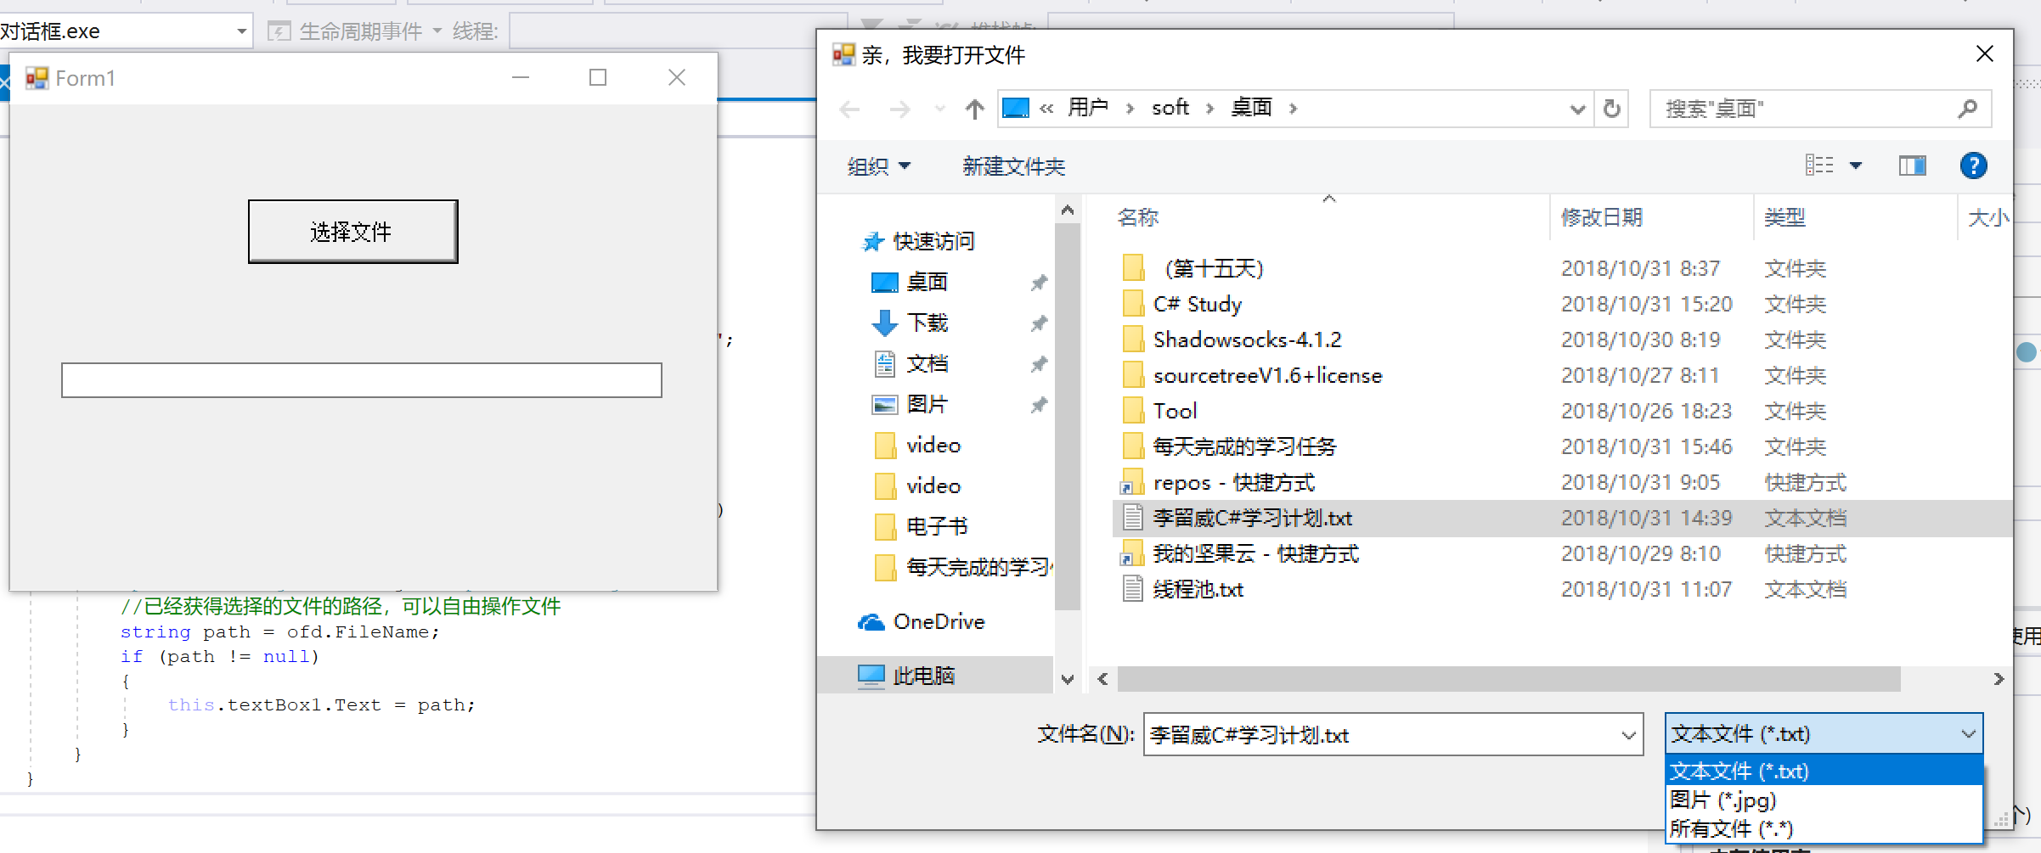

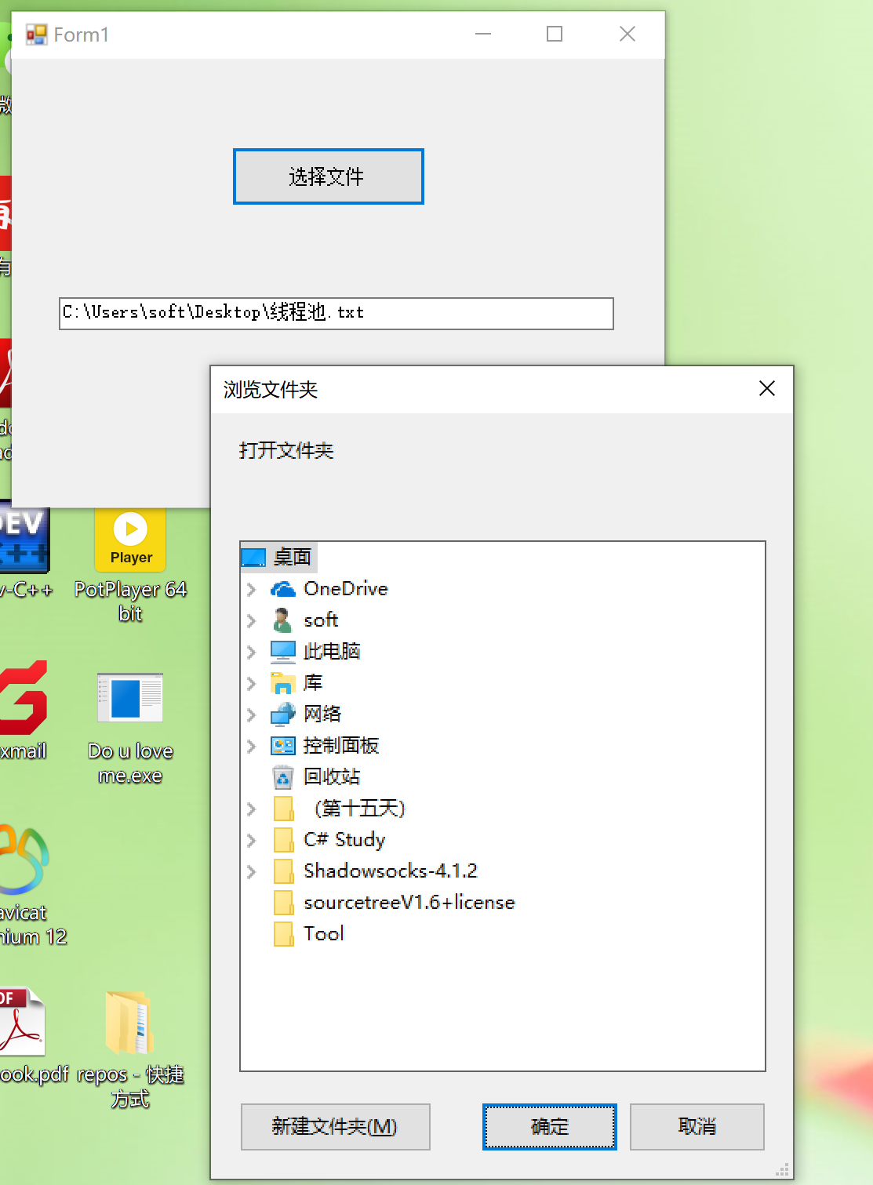

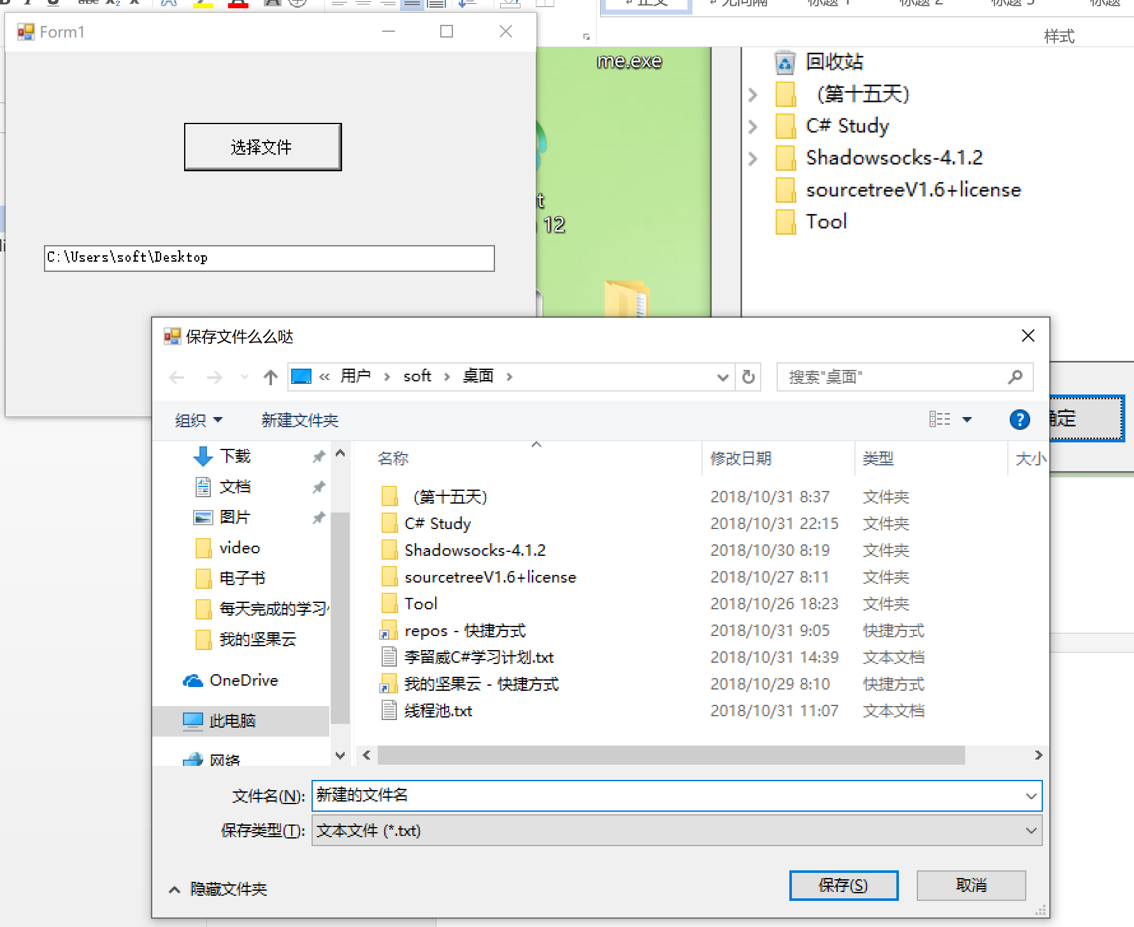

namespace 对话框

{

public partial class Form1 : Form

{

public Form1()

{

InitializeComponent();

}

private void button1_Click(object sender, EventArgs e)

{

//FileDialog是抽象类，不能New，是所有对话框的抽象基类

//FileDialog fd = new FileDialog();

//创建打开文件对话框

OpenFileDialog ofd = new OpenFileDialog();

//设置对话框的标题

ofd.Title = "亲，我要打开文件";

//设置对话框的默认文件夹

ofd.InitialDirectory = @"C:\Users\soft\Desktop";

//设置对话框能够多选

ofd.Multiselect = true;

//设置对话框能打开的文件的类型

ofd.Filter = @"文本文件|*.txt|图片|*.jpg|所有文件|*.*";

if (ofd.ShowDialog() == DialogResult.OK)

{

//FileName选择的文件路径，FileNames多选的文件名数组，没有选择都为null

this.textBox1.Text = ofd.FileName;

//可以根据FileName对选中的文件进行操作

}

//文件夹选择对话框

FolderBrowserDialog fbd = new FolderBrowserDialog();

fbd.Description = "打开文件夹";

fbd.ShowNewFolderButton = true;//允许新建文件夹

if (fbd.ShowDialog() == DialogResult.OK)

{

this.textBox1.Text = fbd.SelectedPath;//获取选择的文件夹路径

}

//保存文件对话框 | 需要输入即将保存的文件名

SaveFileDialog sfd = new SaveFileDialog();

sfd.Title = "保存文件么么哒";

sfd.Filter = "文本文件|*.txt";

if(sfd.ShowDialog() == DialogResult.OK)

{

if(sfd.FileName == null)

{

return;

}

//FileName是选择要保存的路径和用户输入的文件名的字符串

this.textBox1.Text = sfd.FileName;

}

}

//点击对话框“打开”按钮的触发事件

private void FileOkEventHandler(object obj,EventArgs e)

{

//获取选择的文件的路径

OpenFileDialog ofd = obj as OpenFileDialog;

//已经获得选择的文件的路径，可以自由操作文件

string path = ofd.FileName;

if (path != null)

{

this.textBox1.Text = path;

}

}

}

}

[**C# 用 openfiledialog 文件和 savefileDialog 打开和保存文件**](https://www.cnblogs.com/vaevvaev/p/6912253.html)

一、打开文件

Stream myStream = null;  
            OpenFileDialog openFileDialog1 = new OpenFileDialog();  
            openFileDialog1.InitialDirectory = "d:\\";  
            openFileDialog1.Filter = "ext files (*.txt)|*.txt|All files(*.*)|*>**";  
            openFileDialog1.FilterIndex = 2;  
            openFileDialog1.RestoreDirectory = true;  
            if (openFileDialog1.ShowDialog() == DialogResult.OK)  
            {  
                try  
                {  
                    if ((myStream = openFileDialog1.OpenFile()) != null)  
                    {  
                        StreamReader st = new StreamReader(openFileDialog1.FileName, Encoding.GetEncoding("gb2312"));  
                        string str = st.ReadLine();  
                        while (str != null)  
                        {  
                            richTextBox1.AppendText(str);  
                            richTextBox1.AppendText("\n");  
                            str = st.ReadLine();  
                        }  
                    }

                }catch(Exception ex){  
                    MessageBox.Show("打开文件出错："+ex.Message);  
                }

二、保存文件

SaveFileDialog saveFileDialog1 = new SaveFileDialog();  
            saveFileDialog1.InitialDirectory = "d:\\";  
            saveFileDialog1.Filter = "ext files (*.txt)|*.txt|All files(*.*)|*>**";  
            saveFileDialog1.FilterIndex = 2;  
            saveFileDialog1.RestoreDirectory = true;  
            DialogResult dr = saveFileDialog1.ShowDialog();  
            if (dr == DialogResult.OK && saveFileDialog1.FileName.Length> 0)  
            {  
                richTextBox1.SaveFile(saveFileDialog1.FileName,RichTextBoxStreamType.PlainText);  
                MessageBox.Show("存储文件成功！","保存文件");  
            }

三、颜色对话框

 ColorDialog colorDialog1 = new ColorDialog();  
            colorDialog1.AllowFullOpen = false;  
            colorDialog1.Color = richTextBox1.ForeColor;  
            colorDialog1.ShowHelp = true;  
            if(colorDialog1.ShowDialog()==DialogResult.OK)  
            {  
                richTextBox1.ForeColor = colorDialog1.Color;

             }

四、字体对话框

 FontDialog fontDialog = new FontDialog();  
            fontDialog.Font = richTextBox1.Font;  
            fontDialog.Color = richTextBox1.ForeColor;  
            if (fontDialog.ShowDialog() != DialogResult.Cancel)  
            {  
                richTextBox1.Font = fontDialog.Font;  
                richTextBox1.ForeColor = fontDialog.Color;  
            }

对话框：打开文件对话框，保存文件对话框，打开文件夹对话框，字体对话框，颜色对话框