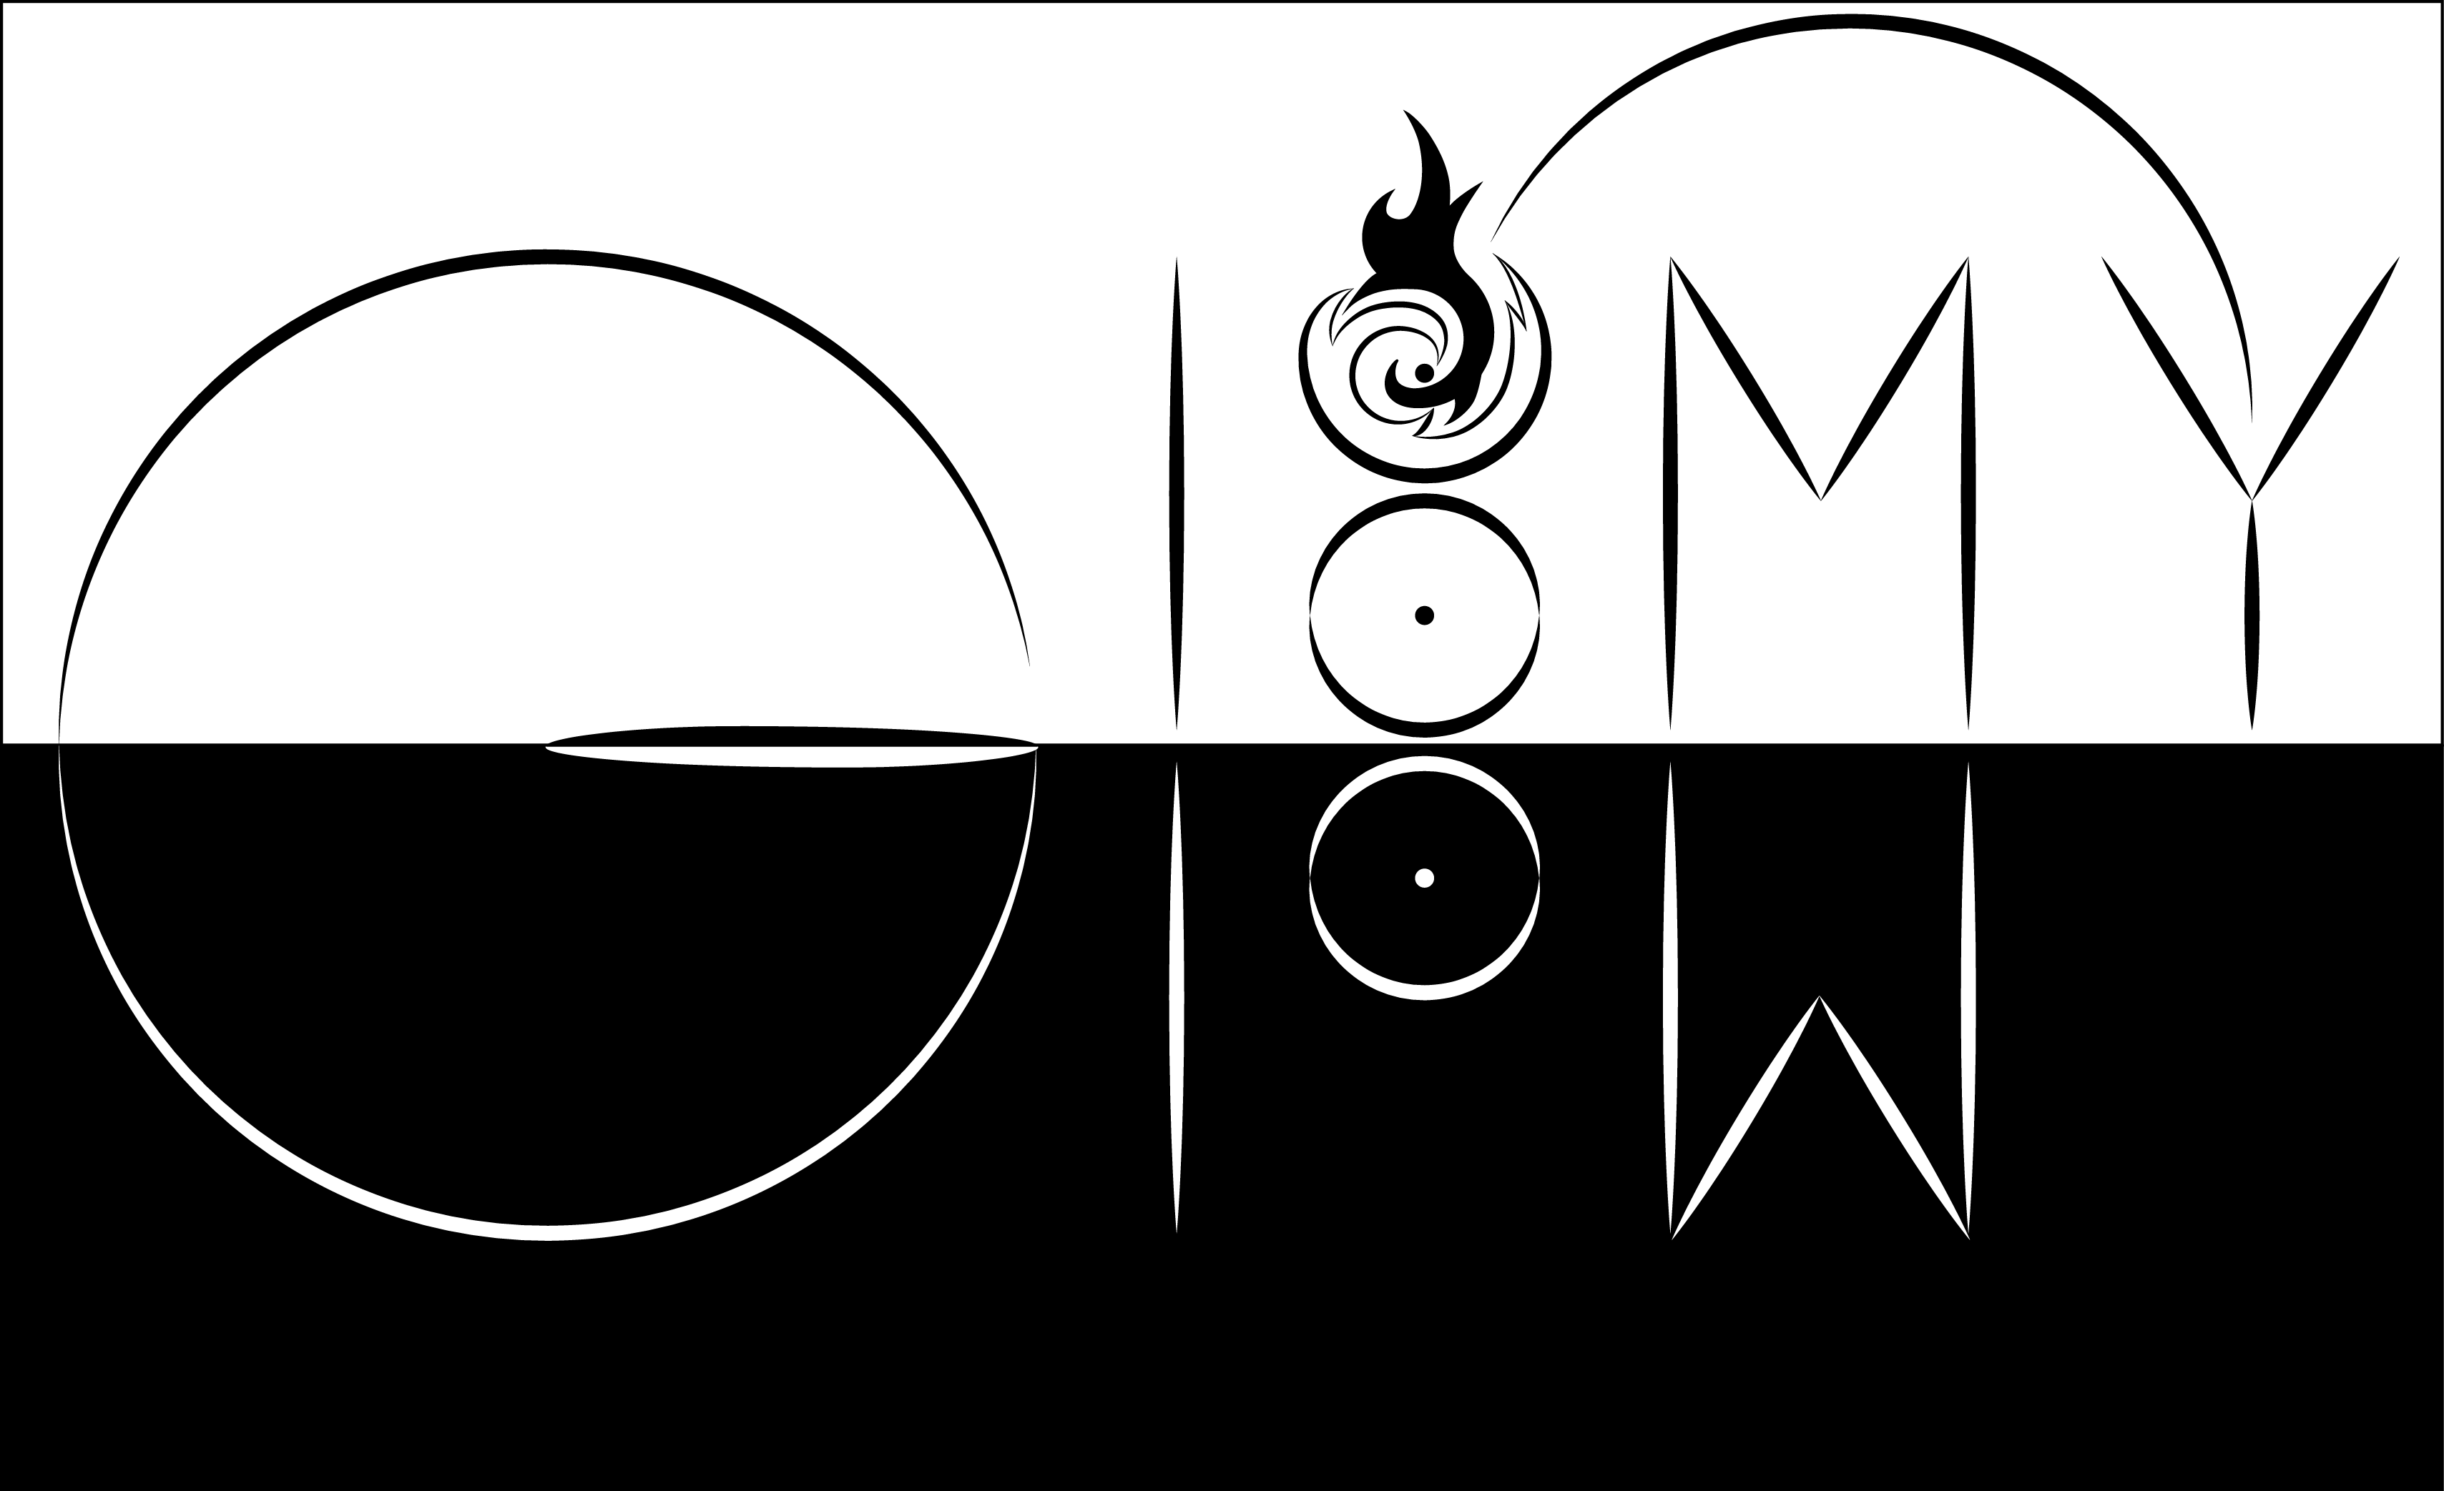

By Kayuzo

Gloomy Glow Studio

|  |  |  |
| --- | --- | --- |
|  |  |  |
|  |  |  |
|  |  |  |

Contents

Introduction 1

Description 2

Script 4

# Introduction



Hi, I'm a young developer whose the pseudo is Kayuzo. I have been working with Unity for 4 years. I have worked on many projects, and I’m embarking on a personal project. For this purpose, and to share my passion, I will put at the disposal the tools, scripts and other asset that I would have created for my video game "**Gloomy Glow**".

This first tools is “**Shadow Detect**”. This is a easy way to detect that your character enters on a shadow. This script use the raycasting system of Unity. This script is used to call event when a character enters (or exit) in a shadow, or detect the object which makes this shadow.

You can modify the “**Shadow Detect**” easily to evolve it. I’ll try to improve this script according to your comment. Do not hesitate if you have some questions or to give me some advices.

# Description

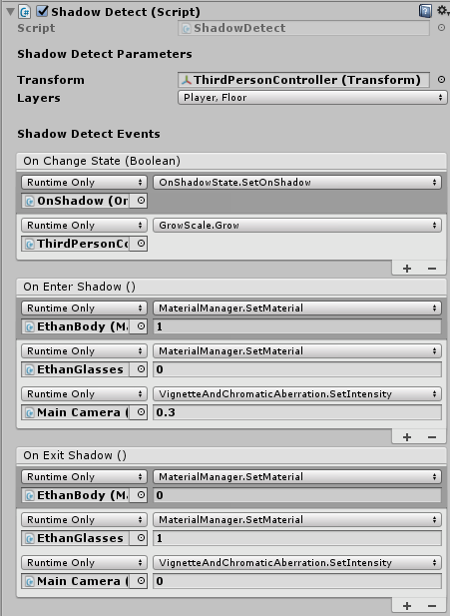

**Transform** : This is the “Transform” of object which is detected in the shadow. It’s better to use the transform of the bottom side of your character, like the foots of a humanoid character.

**Layers** : Choose the layers of GameObject which won’t hit by Raycast. It’s better to choose the layer of your character and the floor.

**On Change Event** : All function call when the GameObject enters or exits the shadow.

**On Enter Shadow** : All function call when the GameObject enters in the shadow.

**On Exit Shadow** : All function call when the GameObject exits the shadow.

# Script

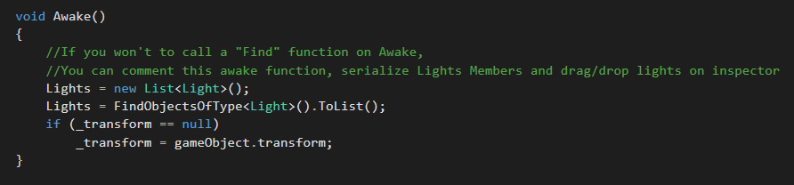

On awake, the script finds all light. You can also “comment” this part and set the member “Lights” public to set value of different light in inspector of Unity.

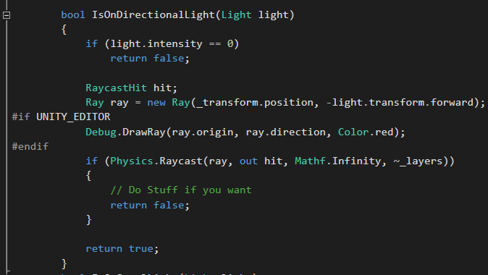

This function detects if a directional light hits your GameObject. You can modifiy this function on “if(Physics.Raycast…)” to know the object which makes the shadow.