|  |
| --- |
|  |
| The Documentation |
| [Type the document subtitle] |
|  |
| **[Your Name]** |
| **[Pick the date]** |

[Type the abstract of the document here. The abstract is typically a short summary of the contents of the document. Type the abstract of the document here. The abstract is typically a short summary of the contents of the document.]

Table of Contents

[To update the table of contents, right click the message below and select Update Field (F9 on PC, ⌥⌘U on Mac).]

**No table of contents entries found.**

1. Pages
   1. Page Tree

Admin Console  
 User Access Management  
 User List  
 Edit User  
 User Confirm  
 Function List  
 Edit Function  
 Group List  
 Edit Group  
 User Works  
 User Mapping  
 User Mapping 2  
 Customer Maintenance  
 Customer Maintenance 2

* 1. Admin Console
     1. User Interface

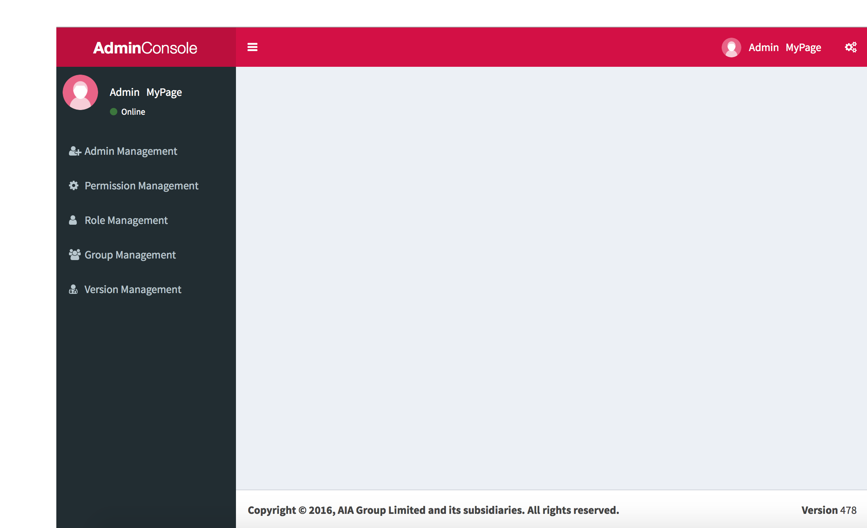

* 1. User Access Management
  2. User List
     1. User Interface

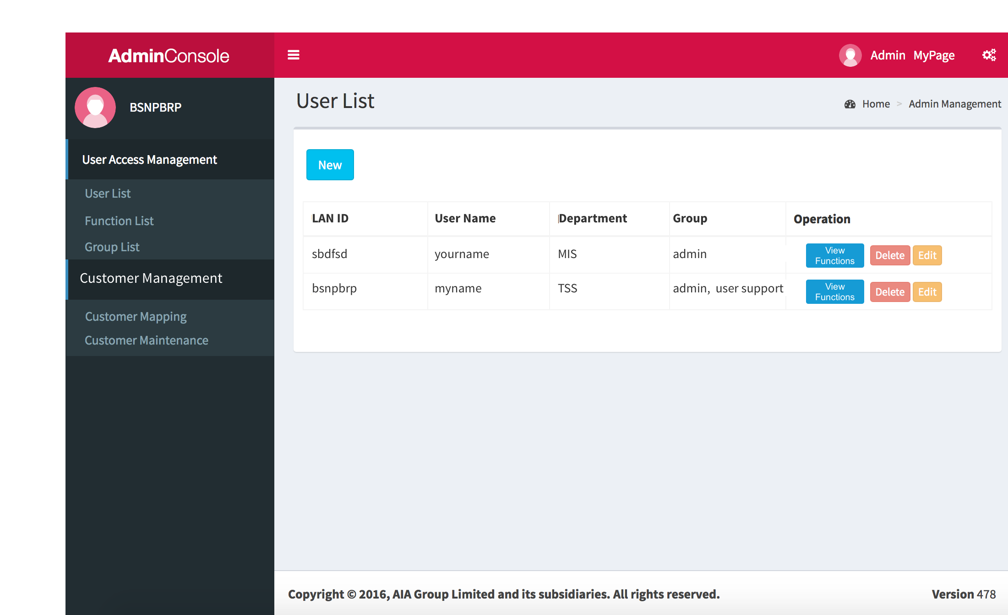

* 1. Edit User
     1. User Interface

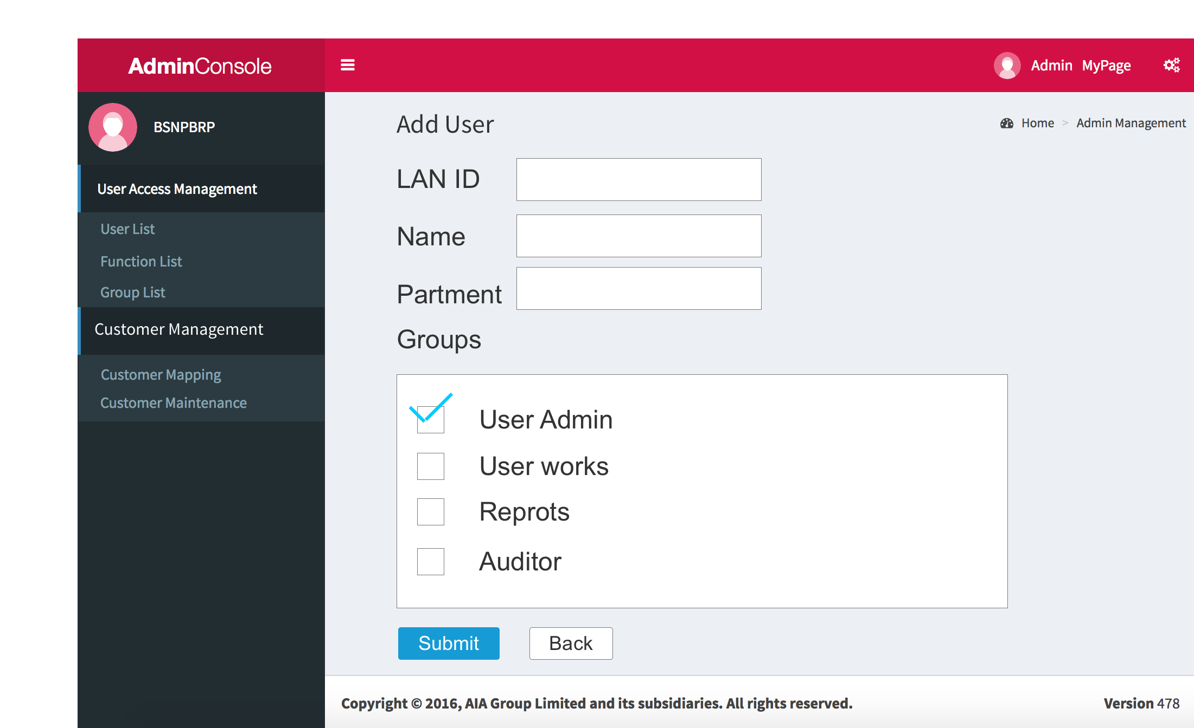

* 1. User Confirm
  2. Function List
     1. User Interface

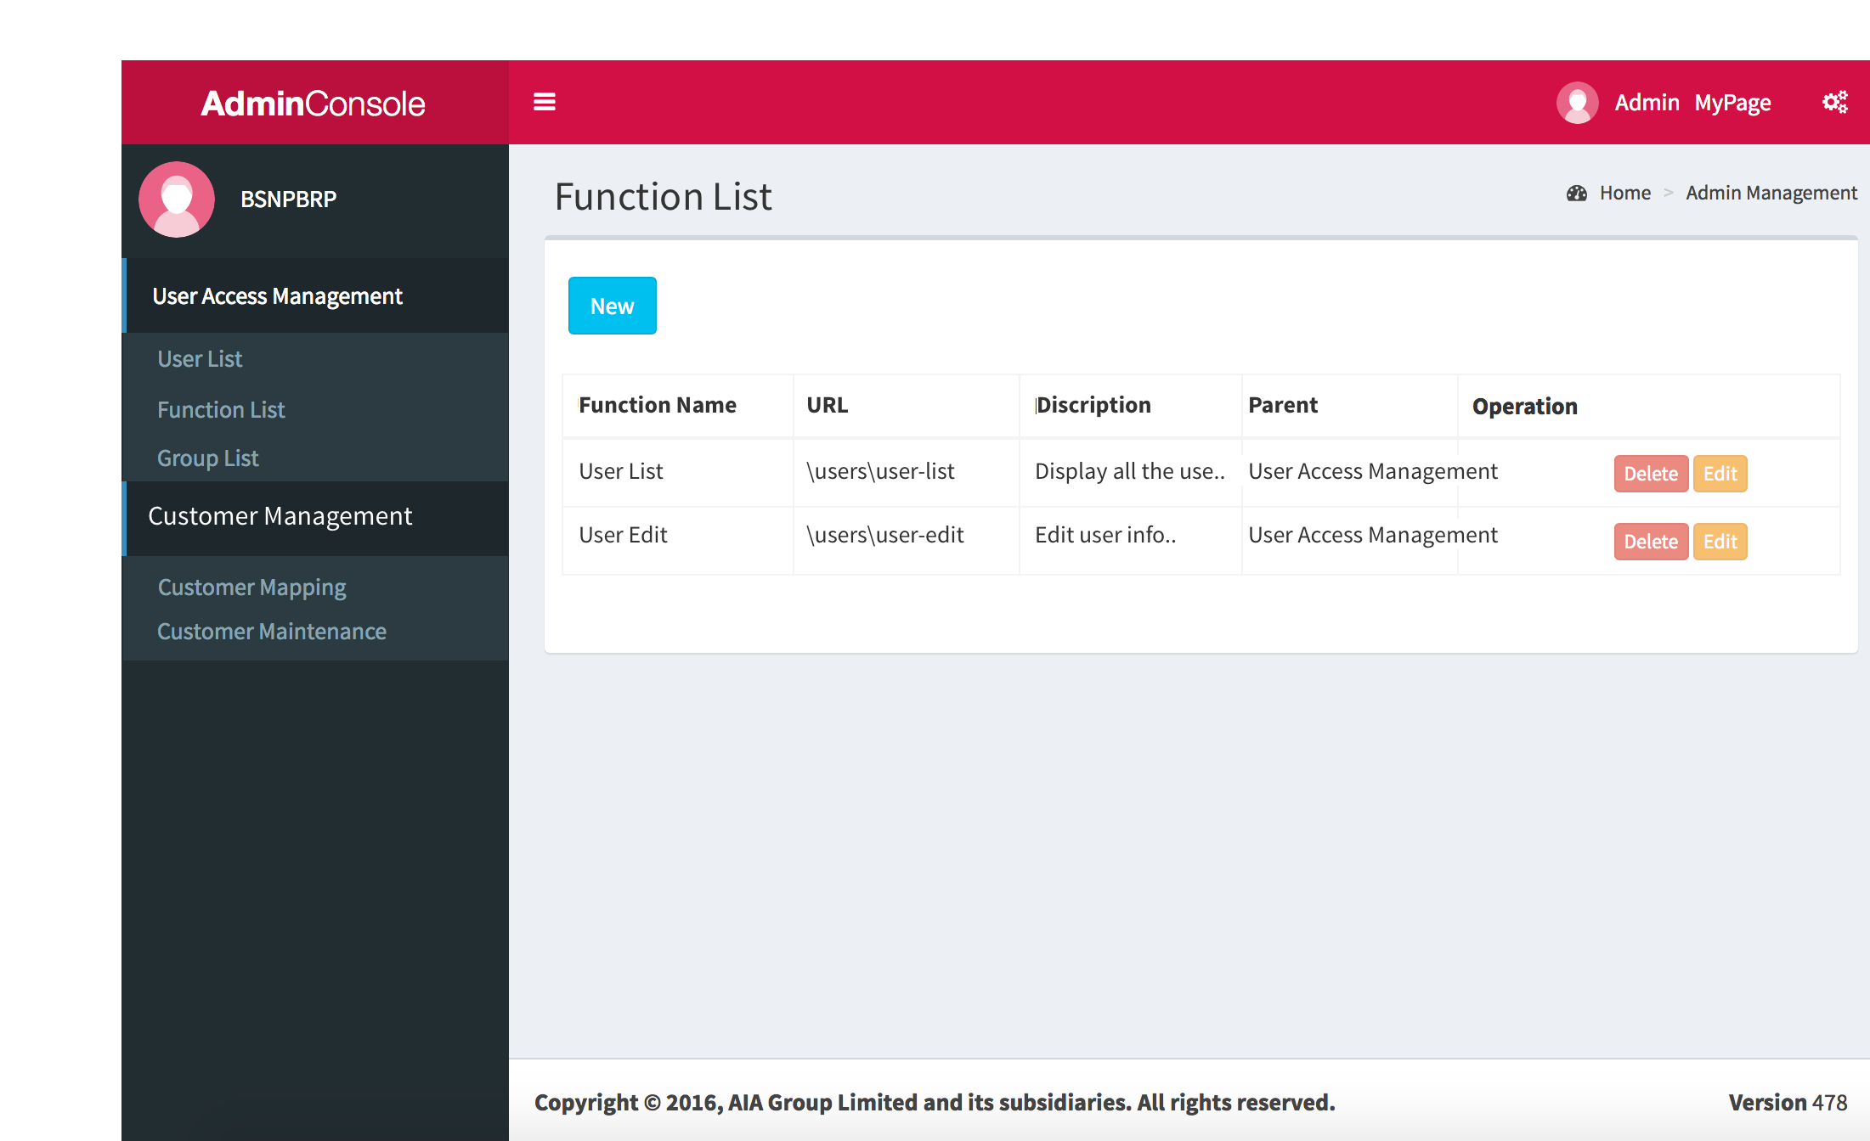

* 1. Edit Function
     1. User Interface

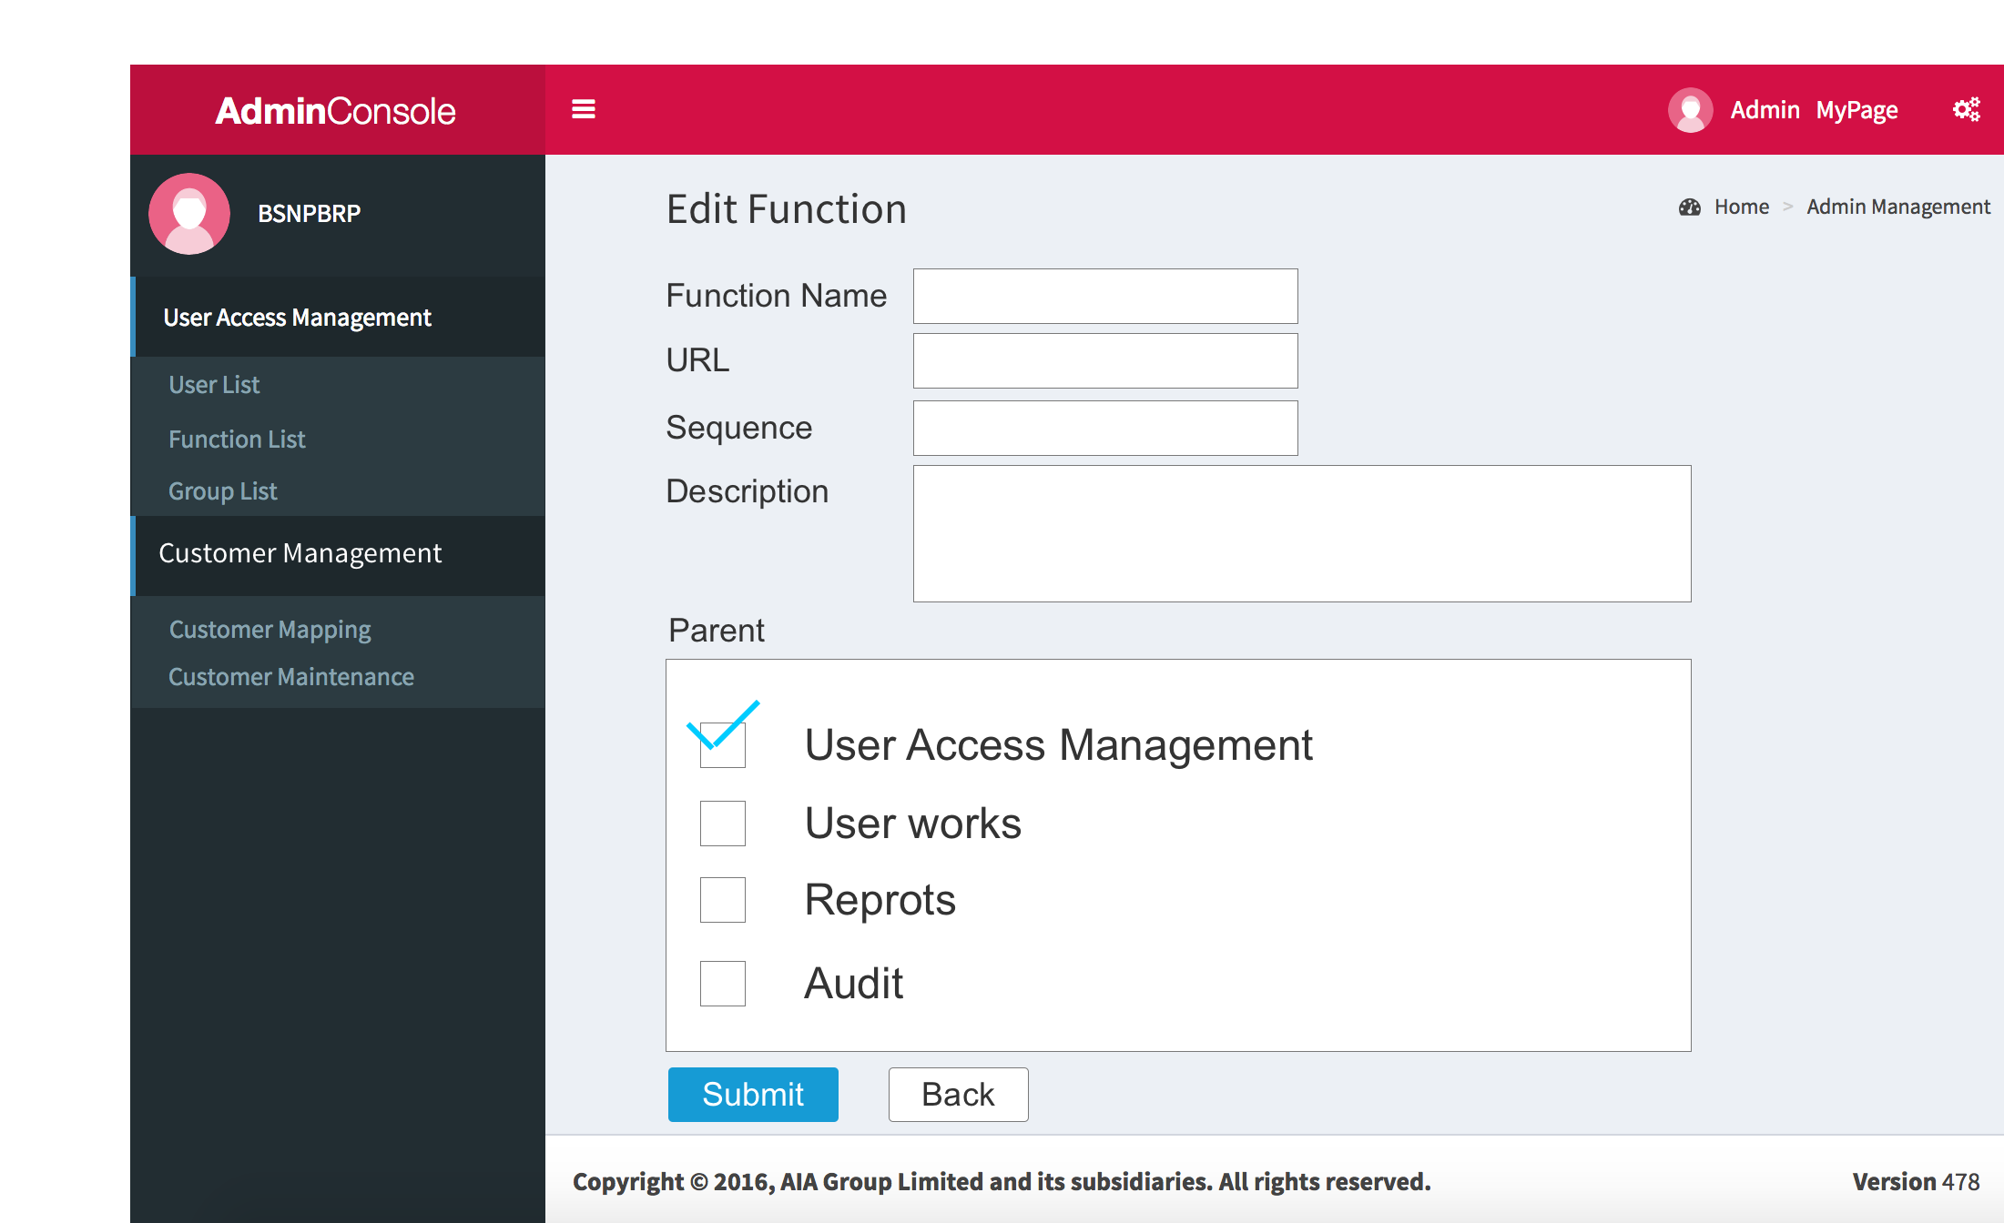

* 1. Group List
     1. User Interface

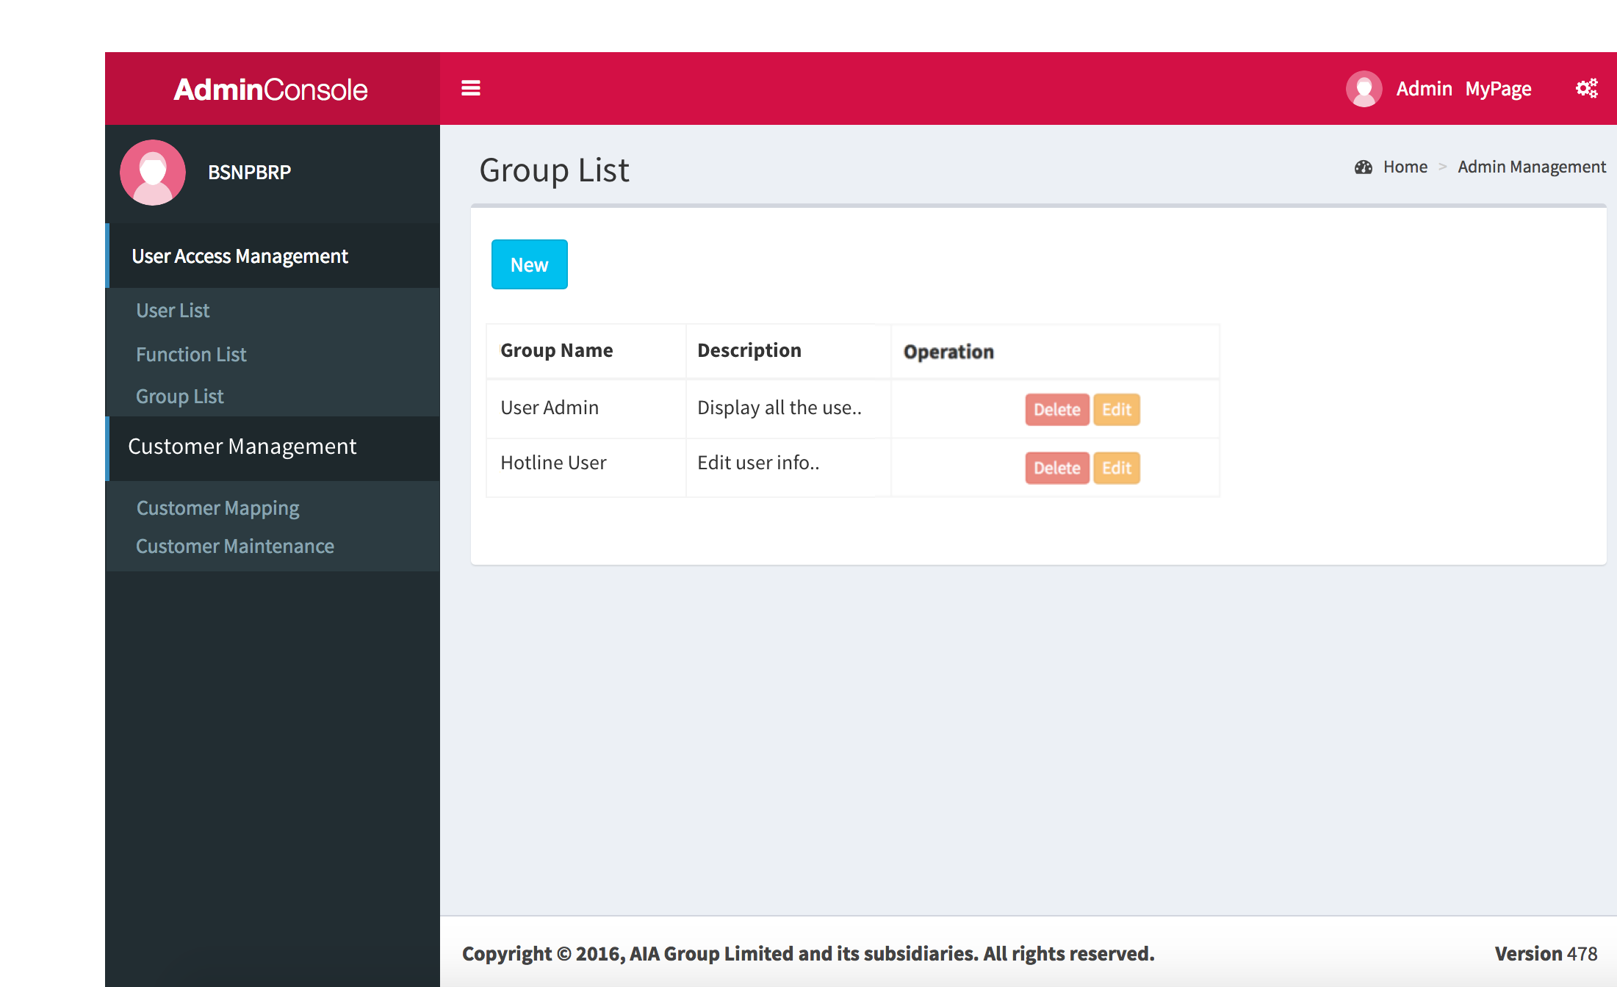

* 1. Edit Group
     1. User Interface

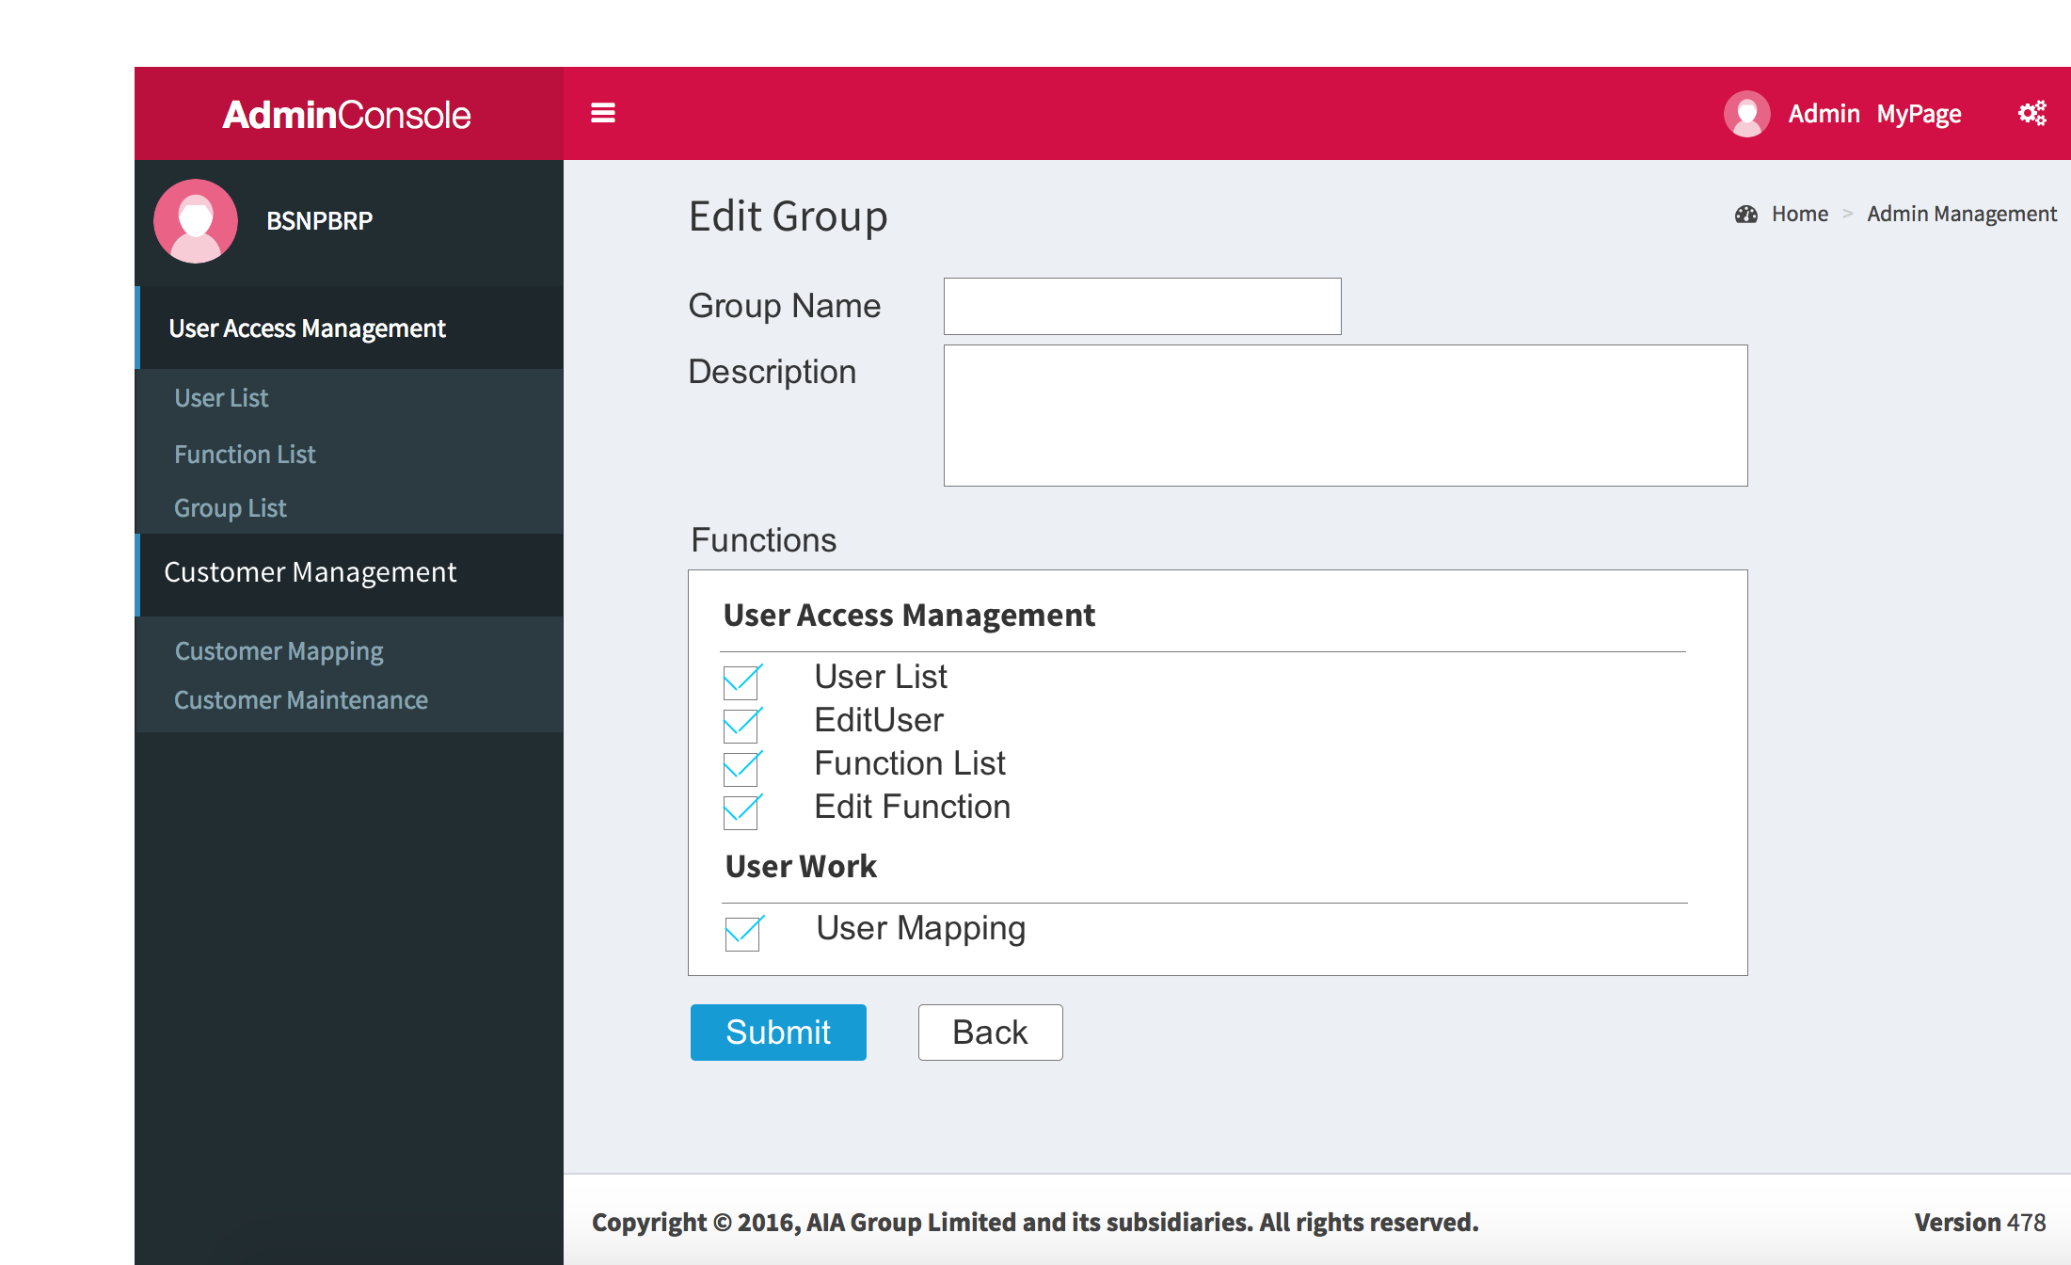

* 1. User Works
  2. User Mapping
     1. User Interface

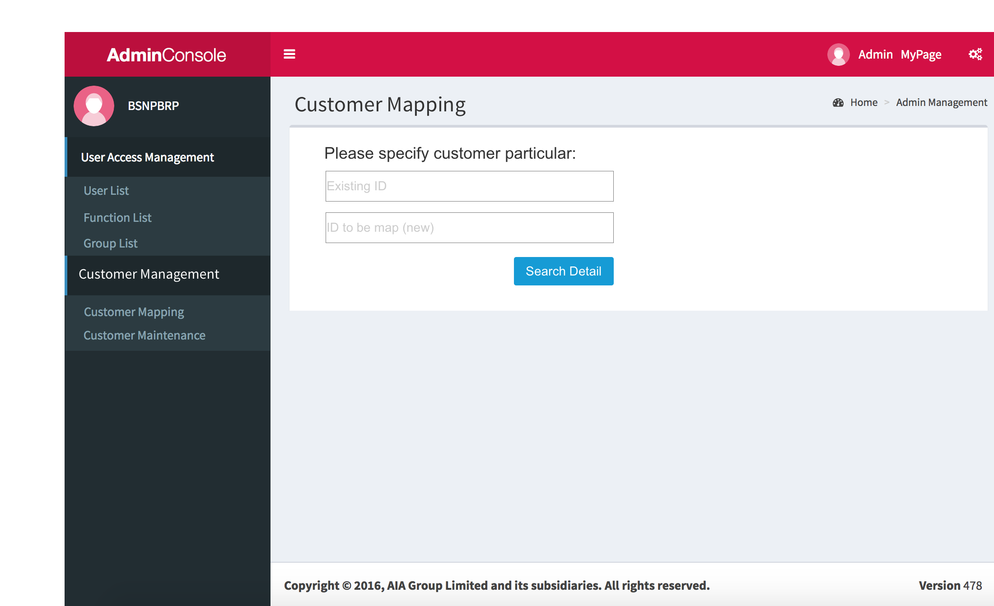

* 1. User Mapping 2
     1. User Interface

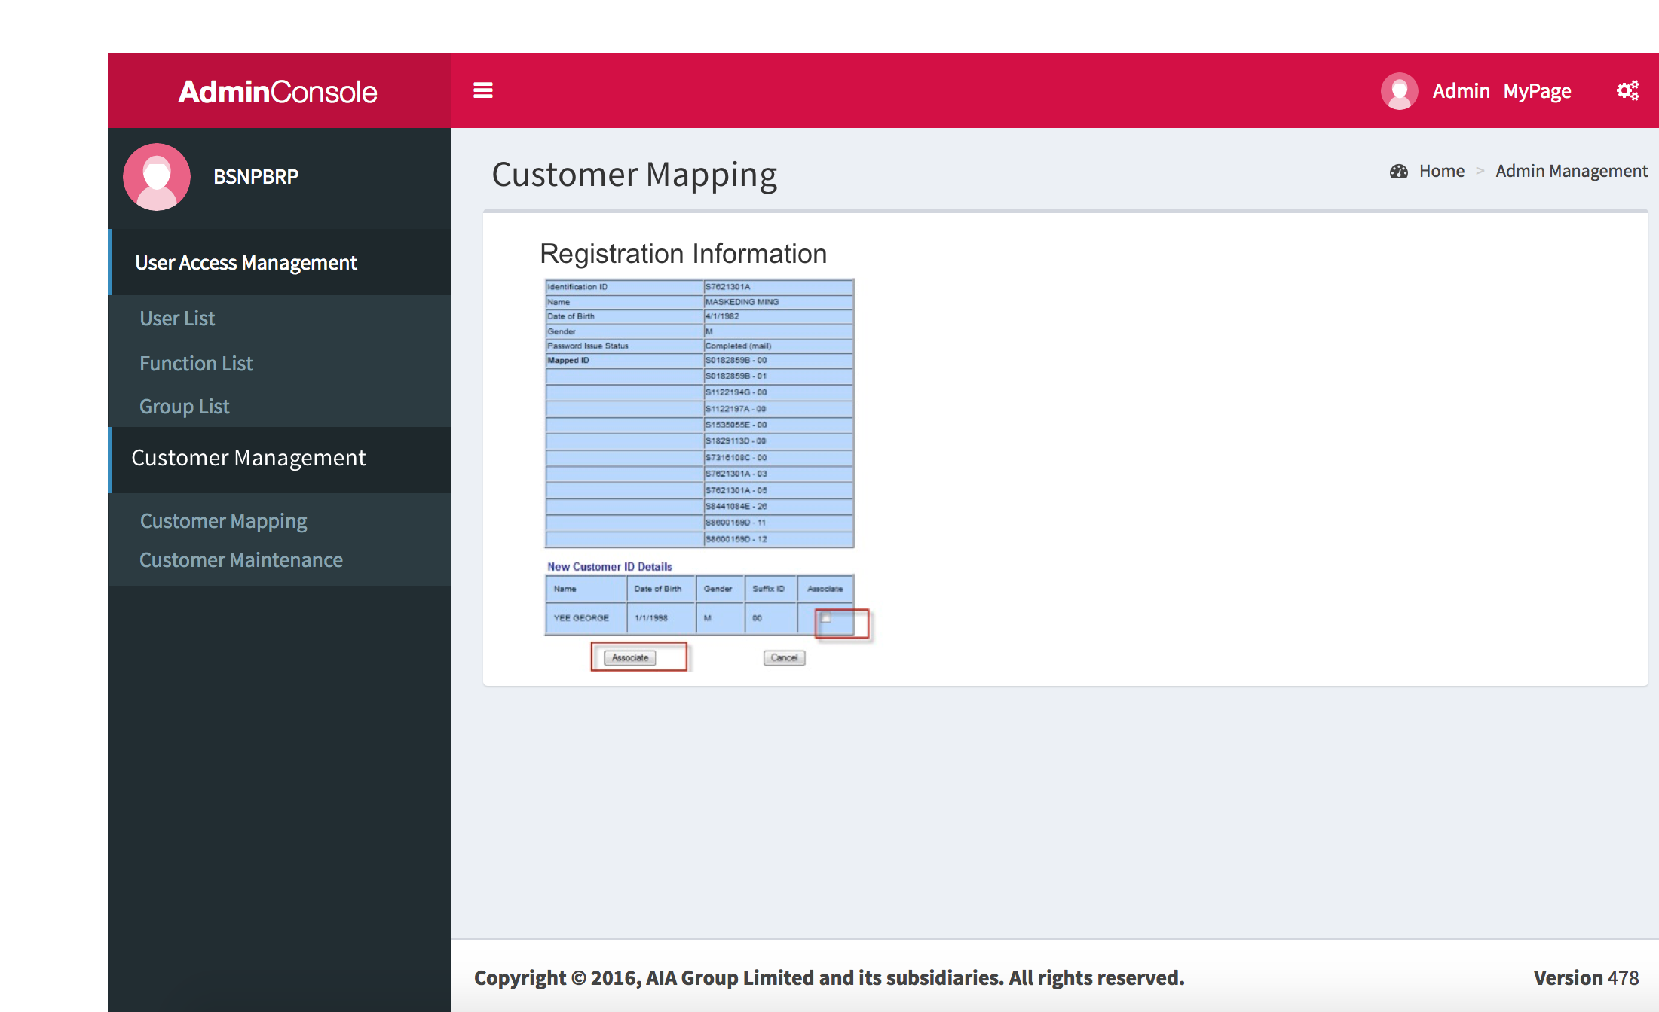

* 1. Customer Maintenance
     1. User Interface

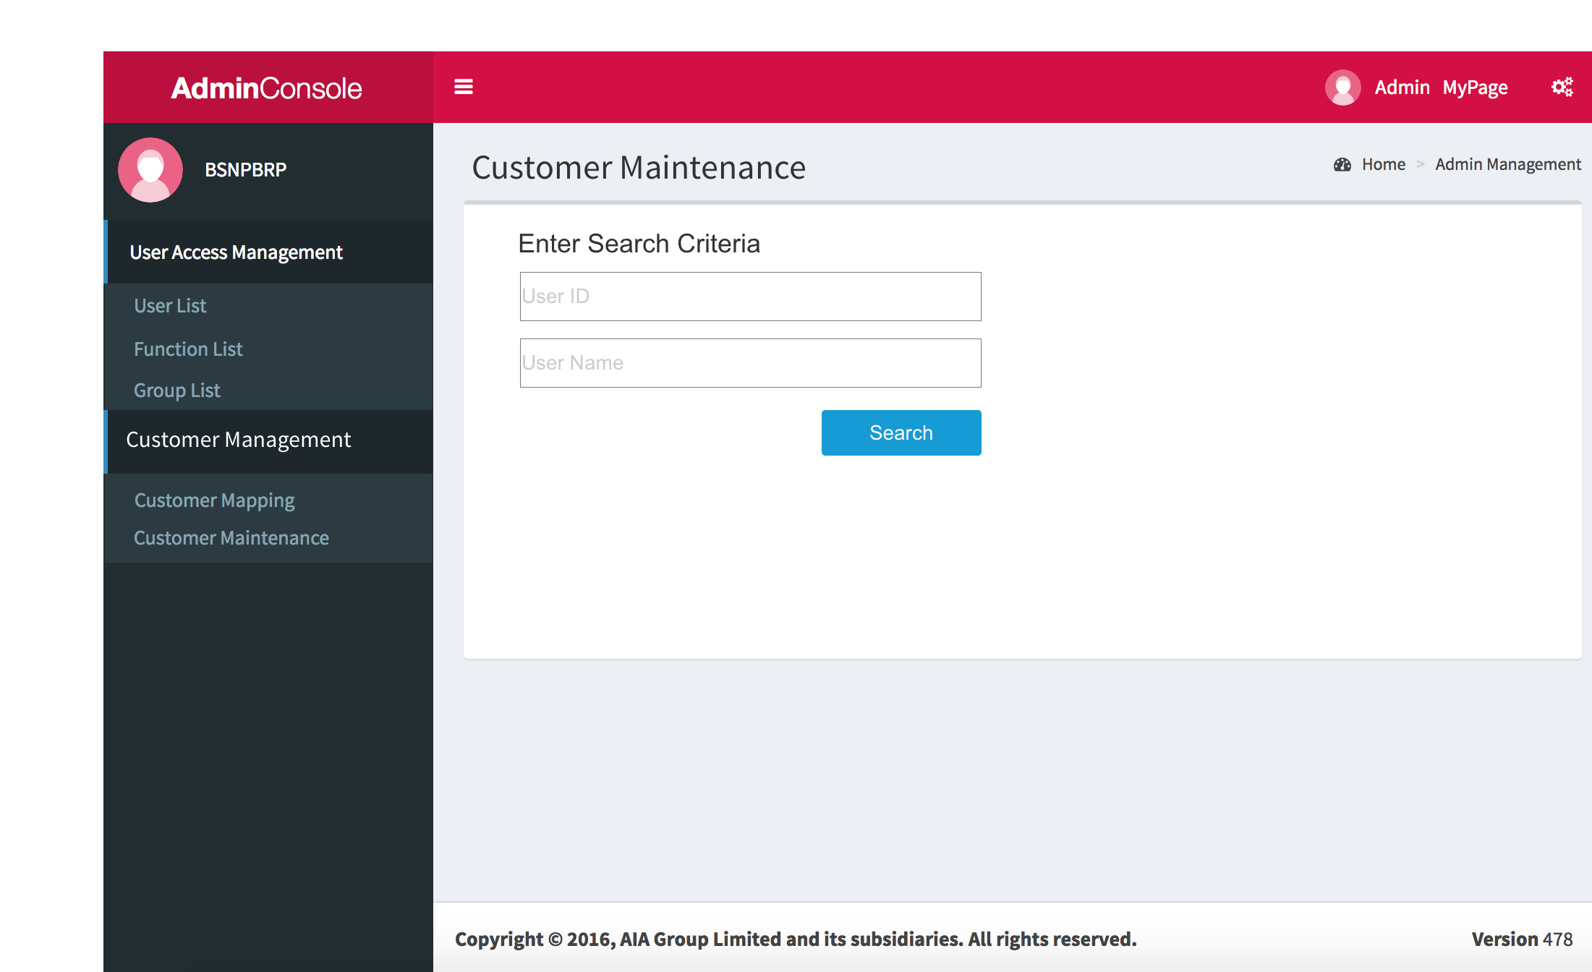

* 1. Customer Maintenance 2
     1. User Interface

