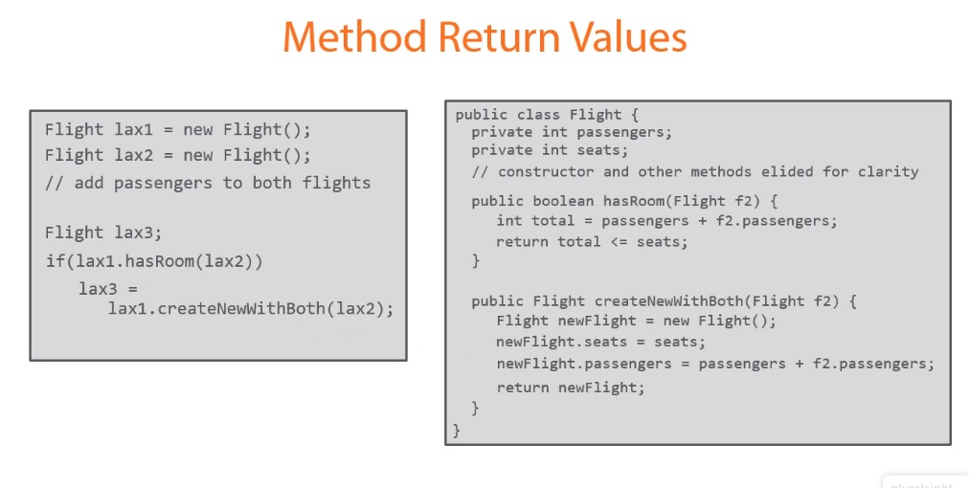
I cant understand what is meant by f2.Passengers

How do you return "Flight" class as a value of method inside the same class?

