**i. (15 Points) Implement Radix Sort on [35, 53, 55, 33, 52, 32, 25]. Note that your program should use Queue**

Radix sort was implemented by first creating a method to find the max number of digits per value given in the array. In the example above the max is 2. Following, I created the radix sort method which loops the max number of digits there is. Within this loop, another loop is iterated to find the digits from 0-9 arranging them in a sorted order correspondingly, then jumps form the 1’s place in the digits to the 10’s and so on, arranging them until finally all is sorted from least to greatest by the Radix Sort method.

During this operation I ran into minor difficulties which hindered my completion of the project. As shown in **Figure 1** there was an error in which took me awhile to finally uncover. While setting the length of the array to a variable I had not correctly used the proper constraints. Typing

_length = len[0] instead of the proper constraints _length=len(n)

noticed on line 52.

**ii. (25 Points) Implement a program that can input an expression in postfix notation and output its value [Hint: use a Stack]**

During this part of the project only one method was used to solving an expression in Postfix Notation. Implemented was an input statement to receive the expression so verification of the method will be easier and more variable. An empty stack was created to hold numbers in the expression. A ‘numerals’ and ‘operators’ variables were created to hold any digits or operators that will be included within the expression. Then a for loop was integrated to run through the string from position 0 to len(n)-1.

A problem that occurred was the creation of the n variable within the method. Initially the creation was used to run the length of the string given, but the value was set as the length of the string. This rose a problem because within the loops n was being used as the index of the string to pull each character out starting from the end of the string when implemented to start at the beginning of the string. Thus raising an error shown in **Figure 2**.

**iii. (5 Points) Create you Github account and upload you source code files and READ file. Add Github URL on Report**

On Github it was a simple creation of an account. Creating a new repository for the CSC 310 class just for starting off, then dragging and dropping files into the repository. Following was copying the url and pasting it within the project python file. Progress is shown on the right side of both **Figure 1** and **Figure 2.**

**Figure 1**

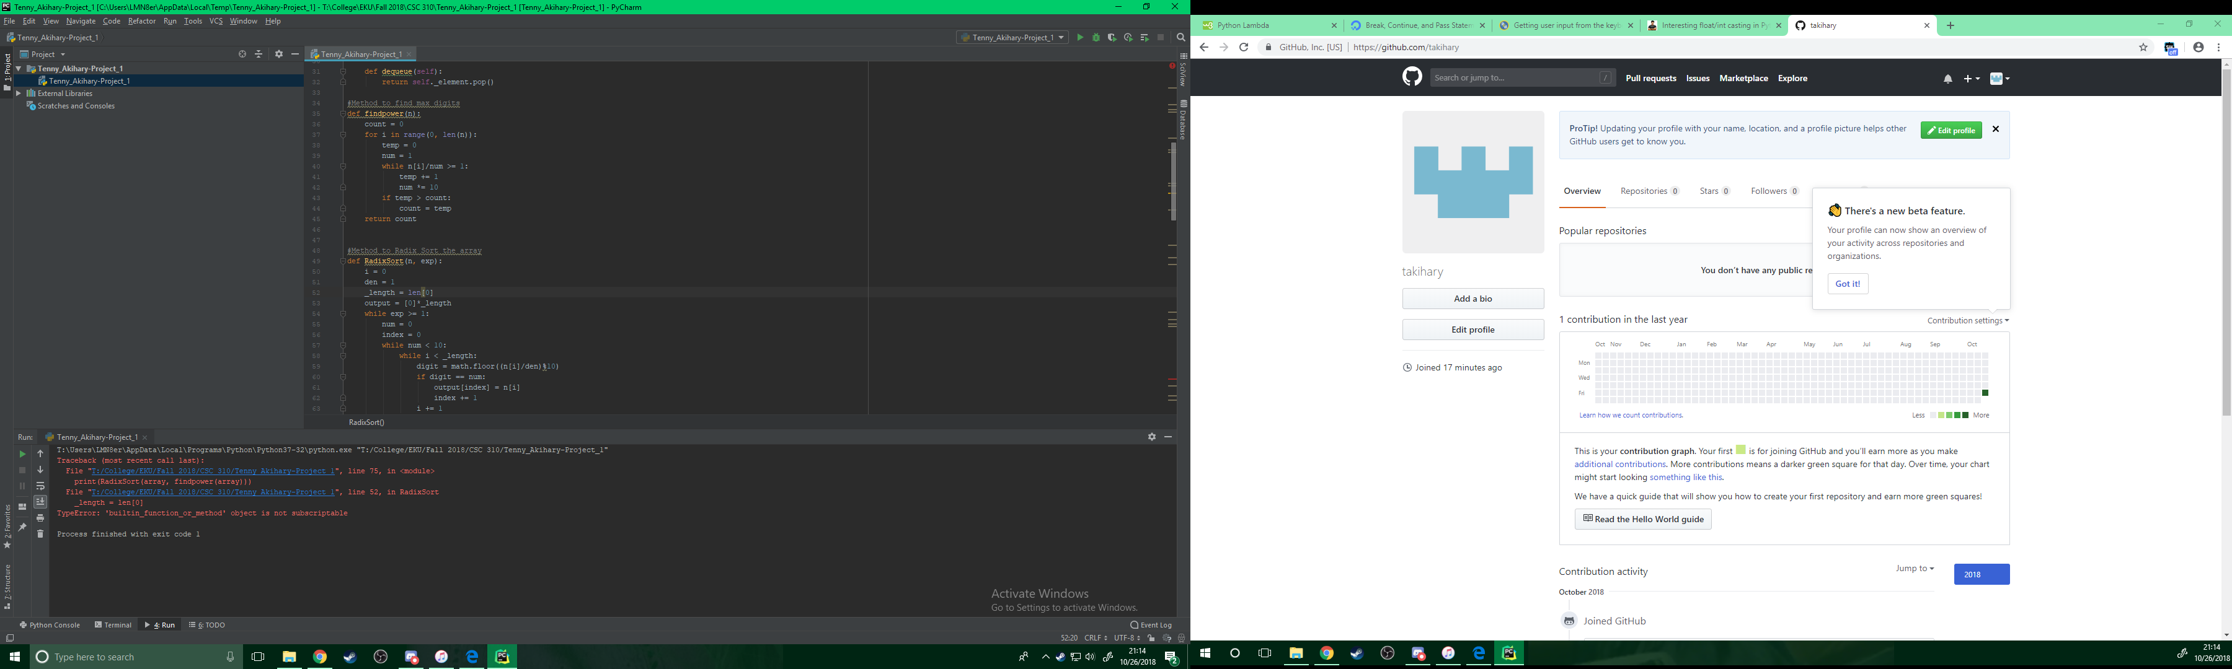

**Figure 2**

