Job 1 { job descriptions按照要求编就行}

<Graphic Designer>

Job 2 { job descriptions按照要求编就行}

<App Developer>

About me

Name: Linwei

Student number: 101088222

Your tutor’s name: Matthew Smith

Course you are doing: Unilink of ICT

Photo of me: 

Time table

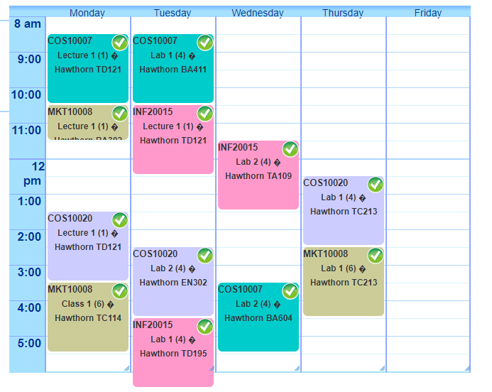

Email: 101088222@student.swin.du.au